PSALMIST GEORGE KING (1606028)– group leader - Section 1

NESLIHAN AYDIN – 1606607 – section 2

Section 3 by …

MATILDA M. J.T – 1605824 – section 4

Module Title- Project Planning

Assignment Title- EMPL4009

Module Lecturer- John Paul

PROJECT REPORT
SECTION 1: by PSALMIST GEORGE KING - 1606028

Project Title:
CHILDCARE CRECHE EXPANSION: Child creche is a safe and stimulating environment created to cate for young children, toddlers and babies. However, due to the increasing number of working parent’s families, creche is been used by many parents.
Background: the creche Extension will be from Chartham in kent to the Kensington park area in London. The need for this extension arose as the creche expressed the worry of working parents who highlighted that their children’s fundamental educational establishment is of a major concern to the people within the Kennington area. This expansion will allow for greater space and a more conducive environment to nurture the young children. Through this expansion, the creche hopes to alleviate the pressure on resources and space which will in turn give parents peace of mind whiles enabling for a suitable and well-maintained place for pre-school activities. Also, to help parents in bringing up their children with confidence in normal loving caring environment which will also be safe and secure.
Purpose: This is a response to the need for an expansion in the creche and Is aimed at children within the years of 0 to 10. According to MyMG Team 2010, (a project is defined as a specific, finite activity that produces an observable and measurable result under certain pre-set requirements). This expansion seeks to respond the issue of constraint in terms of the availability of facilities and create a suitable solution to combat this issue. This project seeks to achieve this in accordance to acceptable standards and suitable time frames to ensure the effectiveness of the expansion
To enable the effectiveness of this project, certain tools will be utilised to ensure accurate accounts of the details. The tools to be used for this project are Gantt Charts and Program Evaluation Review Technique (PERT). Gantt Charts will be intended to show calendar time in days, weeks and months to enable an analysis of a specific and suitable time frame that is achievable and well planned.
PERT tool will be used to provide a well-controlled and defined task outlines, required to complete the project. It involves identifying milestone and activities, determining the proper categorization of activities, a constructive network diagram and estimated time for each activity.

The key factors highlighted according to the definition are: specific, observable and measurable, pre-set requirements. Therefore,

SMART target is incorporated which are:
Specific objectives: creche expansion,
To expand a child creche to the Kennington park area with the view of providing a helping hand to the working mothers and giving children the proper learning they require to ensure better education.

Measurable objectives: To reduce stress and worries on child parenting by 20%. We have a budget of £100.000 to complete this project. We intend to properly allocate it to various aspects of the project that will be properly prioritized to ensure the effective use of the budget.

Achievable objectives: All parties involved in the planning have agreed on the aims of this project and are also regularly informed. Effective communication tools will be employed to ensure that the parties are constantly updated on the progress of the planning and can receive real time feedback and reports on the project. Buses and tube stations closer to area which will enable the necessary transport of resources and enable for meetings to occur with better ease.

Realistic objectives: the resources available to this project are sufficient. The Kennington area is also well noted for the working people and it is realistic and imperative to launch a child creche as the expansion will be embraced by working parents. A bigger complex will accommodate a larger number of children and will be well gated and secured.

Time-Bound objectives: the project will be completed within a specific time frame of 5 months ending 31st of March 2018.
Objectives and how they will be measured.
Objective | How it can be achieved | Expected outcome /measure
Reduce long distance travelling to the creche | Expanding to vicinities where it can be better assessed by working parents | Less travelling time for parents to the creche
Create a stimulating and well-designed atmosphere to adapt to children’s needs | By creating better space and providing better resources in the creche | Children’s educational needs can be well catered for allowing them to be creative
Promote community development and Create a secure environment and provide quality care to children | By expanding the creche and creating better systems to ensure their safety and creating a system to monitor their progress and restore trust in the security of the creche | More parents will feel confident to bring their children to the creche and trust will be restored. There will also be less complaints and encourage better moral amongst working parents.

Project scope:
is the specific features and functions that must be carried out to deliver a product or result and with the objectives to meet the Time, Cost and not to jeopardise the Quality. We also have a contingency plan (plan B).
This project involves external and internal stakeholders: Internal stakeholders consisting of: (A). Project sponsor, (B). Project team workers (C). Trade unions.
The external stakeholders comprising of Supplier, 2. The general public, 3. The media, 4. Shareholders or trustees, 5. End users of the product or service.

Stakeholders are parties with an interest in the process and the outcome of the project clear therefore communication channel between stakeholders must be established to gain their full support and help to win more resources which can secure the end success of the project. We will also need high quality material including interior decorating. All activities must be completed to produce the project deliverables and to meet the goals and objectives of the project.
Exclusions from scope: Likelihood of procuring children’s toys and games
Deliverables (including dates of completion) Service provided to the neighbour is required. Reporting to the (CEO) on weekly bases.
Constraints: It is restrictions that defines a project limitation. The impact on the scope, time or cost can have an impact on the quality of the end-product or the deliverables. Possible constraints include:
Constraints type. (Time, Human resources and Financial resources).
Time: - Effect on project- is due to the scale and complexity of the project, the time frame stated might not be sufficient and could possibly delay the expected finish date.
Human resources: - Effect on project- It is possible that the full participation of individual involved in the project can be altered by unexpected circumstances and could also hinder the timely completion of the project
Financial resources: - Effect on project - Although the budget stated is expected to cover the full cost of the project, there might be under stated estimates which could lead to the budget being insufficient. A contingency is therefore important

Assumptions: Any unknown update to the process of the project might course delay. All deliveries we assume will be on the time allocated.

Report section 2:
by NESLIHAN AYDIN – 1606607

Project Definition and Planning
- Relocation to Kennington park within 5 months’ time frame.
- Budget set by our client of £100,000
- A new nursery built to help local community e.g. working parents
- Noise level kept to a minimum during early morning as well saving on the environment making sure all equipment are turned off when off the site.

Cost & Timescale:
- A scale of 5 months in order to complete the building work and open the new nursery planned.
- A minimum of 3.5m2 per baby under 2 years old, 2.5m2 per child 2 years and 2.3m2 per child 3 to 5 years old across the entire provision
- classrooms to accommodate at least 12 children but no more than 15 children in each three age groups (Baby Toddler & preschool)
- Provision of 1 toilet for every 8 children over 2 years old and up
- A separate reception and administration space
- a separate space big enough to accommodate a professional sized kitchen 9m2 for a 36 place unit needed.
- A safe and secure outdoor play space is essential.
- Good location within the community access to adequate drop off/pick up points for parents to drop of children.
Around £100,000 roughly before working capital plus VAT here is the table below:
Franchise fee | £6,750
IT & Office equipment | £5,250
Standard equipment & fit out/resources | £29,500
Play yard equipment & surfaces | £4,730
Professional Kitchen | £23,000
Risk Assessments | £265
Initial Stocks | £840
Corporate Set up & premises Inspections | £1,120
Corporate identity uniforms & signage | £3,100
Documentation | £300
Internal training | £5,250
Third party training | £1,340
Other cost's | £2,500
Building work  130m2 @£95 per square metre | £12,350
Total: | £100,085

Risk prevention & Analysis:
- First Aider Will be available at all times on site hours.
- To avoid possible hazards – need to ensure site is kept as tidy as possible to avoid any tips or falls.
- Secure door lockers
- Incorrect lifting methods can be a result of an injury due to heavy materials.

Risk Management:
Regular supervision by site manager is needed at all time to ensure all staff on site have the correct form of training. As well as any accidents or injuries to be reported to manager immediately to be addressed.
All areas well-kept and all spillages to be addressed immediately to prevent any further accidents happening.

Risk Monitoring
Regular supervision by site manager is needed at all time to ensure all staff on site have the correct form of training. As well as any accidents or injuries to be reported to manager immediately to be addressed.

Project Report:
Section 4 – by Matilda J. Trye - 1605824

Assignments/Milestones
This assignment is to write a project plan on an extension of a creche that is based in Chatham Kent to a new location in the South West of London called the kenington Park. A new development in a sought after area with a high rate of working families and a demand for child care facilities that caters for the well being of children aged 0-5, giving them an academic and focused foundation that will give them a solid start in life both academically and socially.
This project is based on a five month planning.

Submitted. 07/11/17
Approved 01/12/17
Installation 17/02/18
Open for business 01/04/18

The following are the various milestones in this planning that will cover the project.
First and foremost is to do a risk assessment on the suitability of the premises , its location , the site itself, its water, gas, electricity and the building.
The building regulations is also looked carefully into making sure it is child friendly and caters for the needs of our project covering all necessary in the frame work of the early years foundation.
Its location is important, access to transportation and easy access to work in or drive in to the location. A research on the area, its families, its housing, jobs, shops all of which make this project sustainable in the foreseeable future.
The project is constantly reassessed to make sure it goes with the rules and regulations and to minimise setbacks.
The project caters for the ratio of children and staff that will be in the premises at every allocated time and the use of the play area and catering area is suited for the daily activities.
The creche is fully insulated in accordance with the Rules and Standard requirements of the law.
The project is fully staffed and a report is made available to the HR and accounts department who pay close attention and make available in excess of cost to prevent the slow down of the project.
When a plan is agreed on, the various responsibilities are allocated immediately to the different professional teams who will implement it successfully making the communication easy and workable.
The post implementation is reviewed within five months of the project starting, giving ample time to make corrections and amendments where necessary and to cover every loophole to meet the dead line to finish and open as scheduled.

References:

Child risk assessment (2006) accessed on November 23rd 2017 http://resources.hwb.wales.gov.uk/VTC/200809/key_skills/disc1/KSCHIL/KSCHIL12.pdf

MyMG Team (2010) accessed on November 15th 2017
www.mymanagementguide.com/basics/what-is-a-project/

Stone Eden Nursery school 2017 accessed on November 20th 2017
https://www.stoneedennursery.co.uk/franchise/setup-costs/

Appendix 1: Gantt Chart screen shot

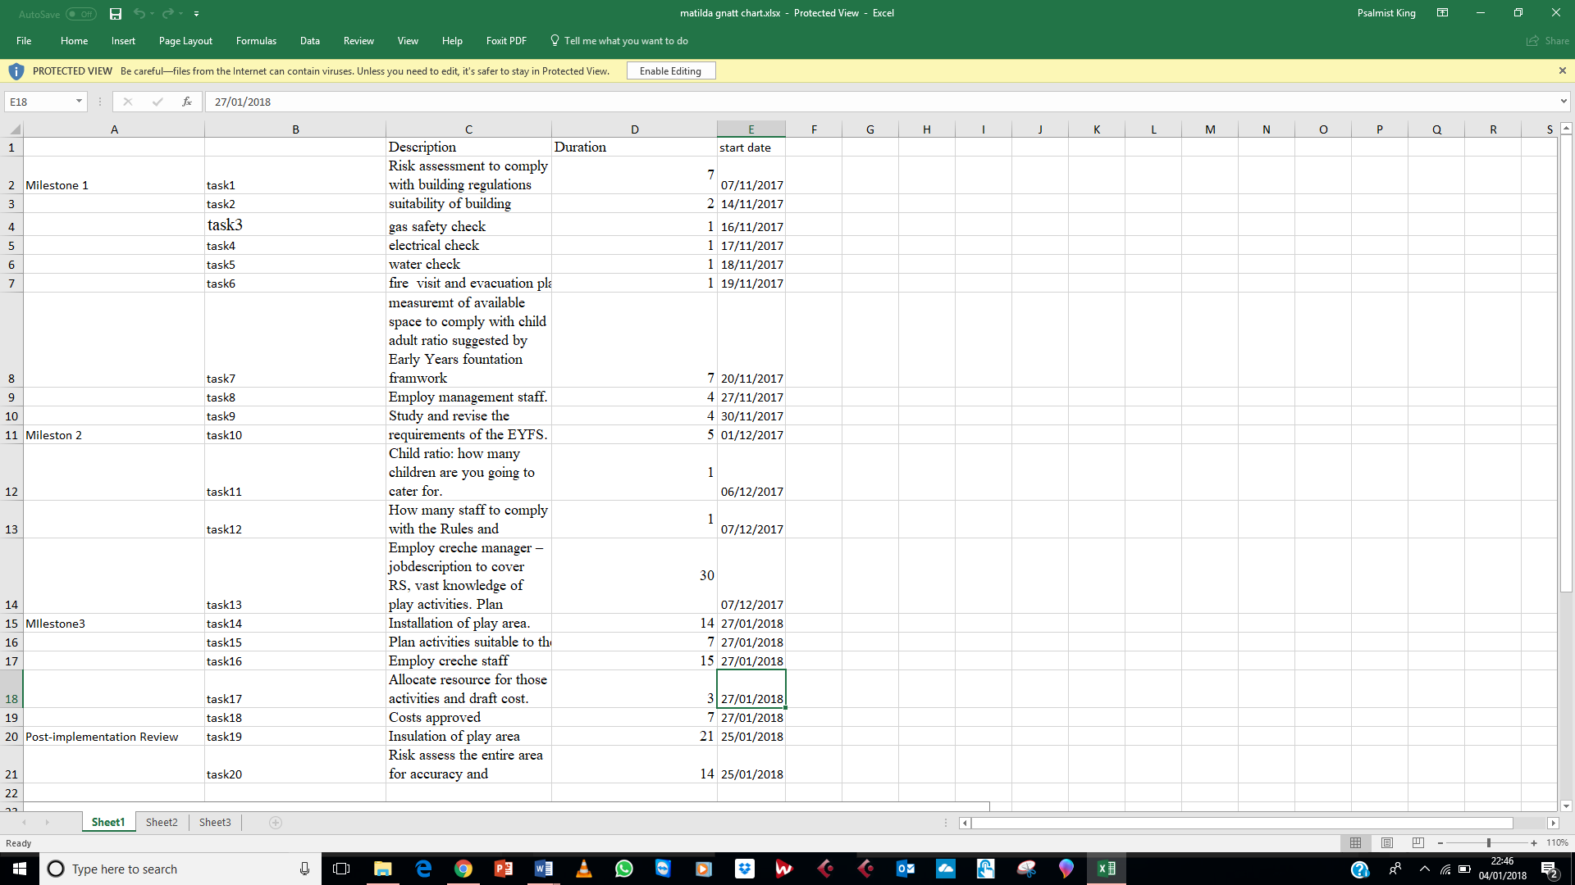

Appendix 2: Gantt Chart screen shot
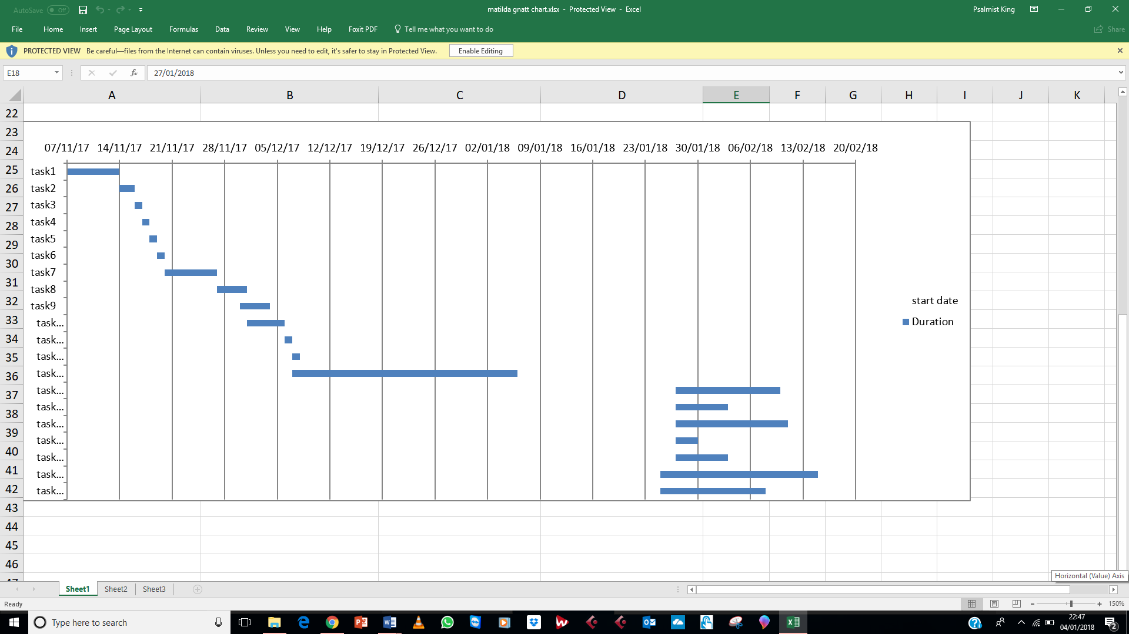

Appendix 3: PID screen shot

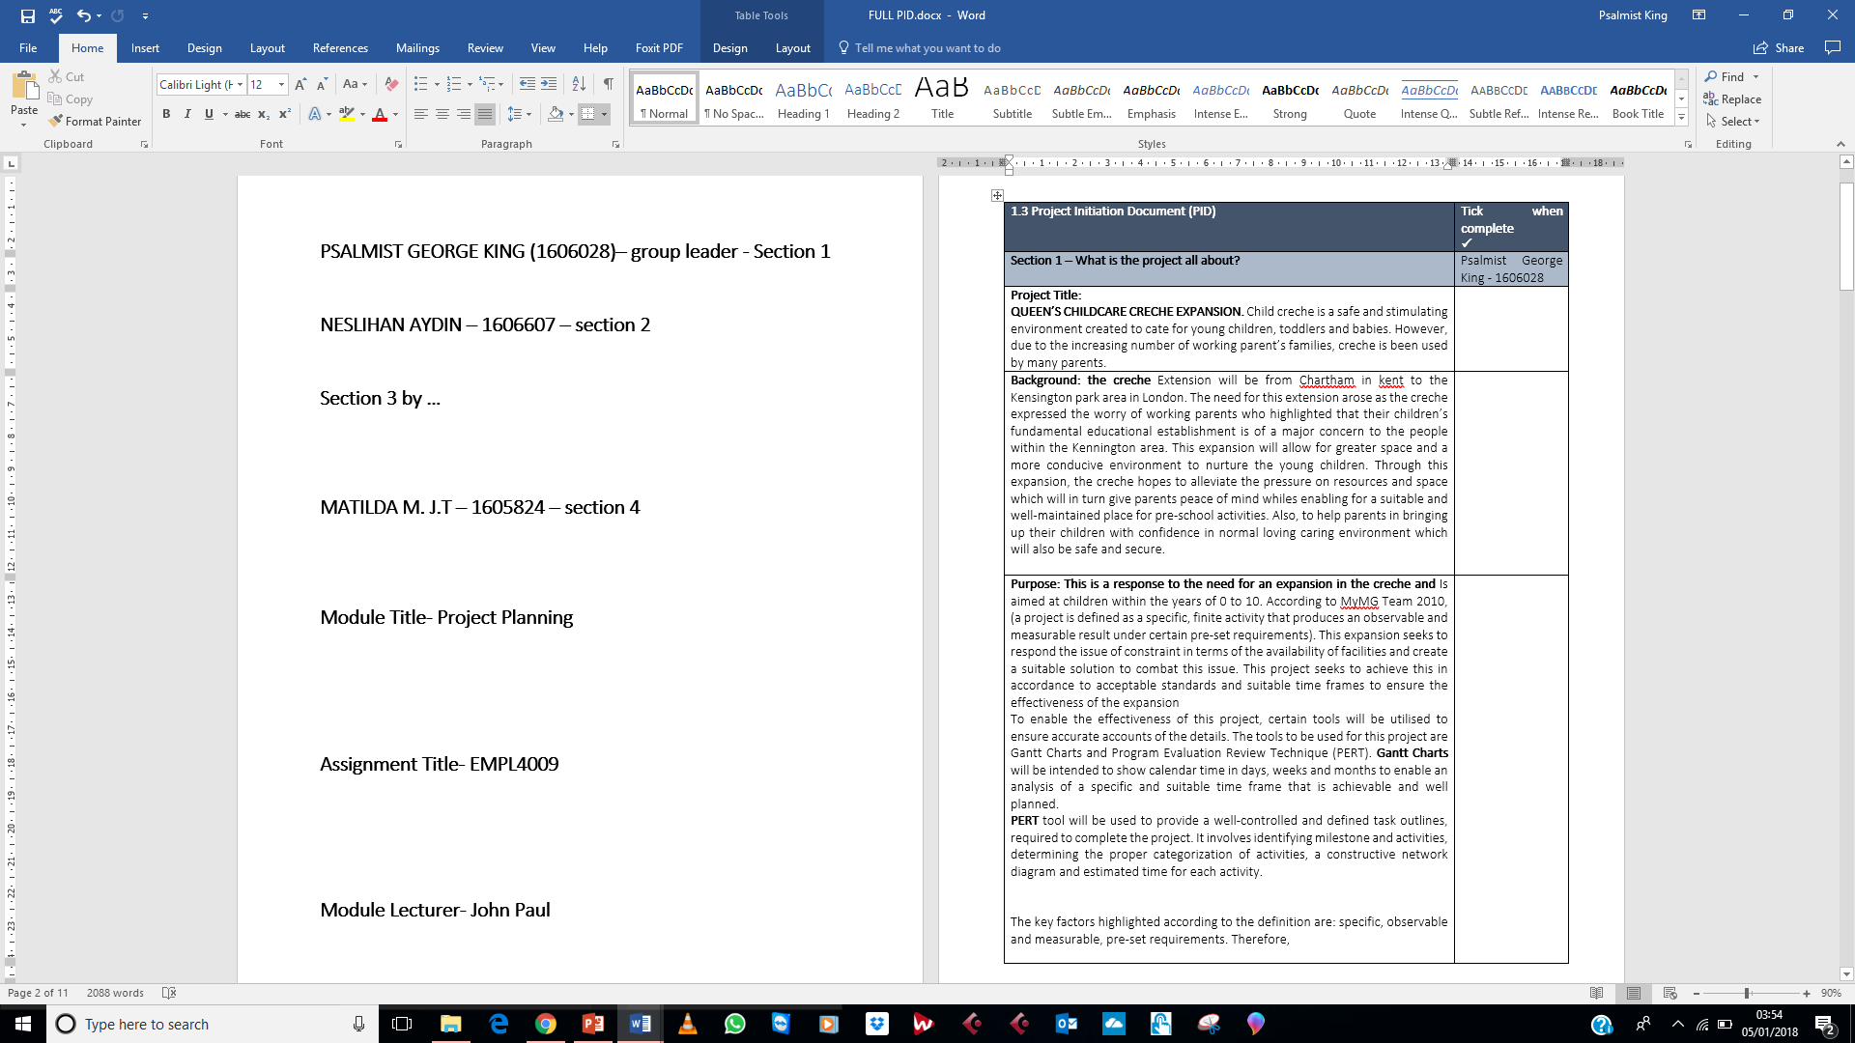

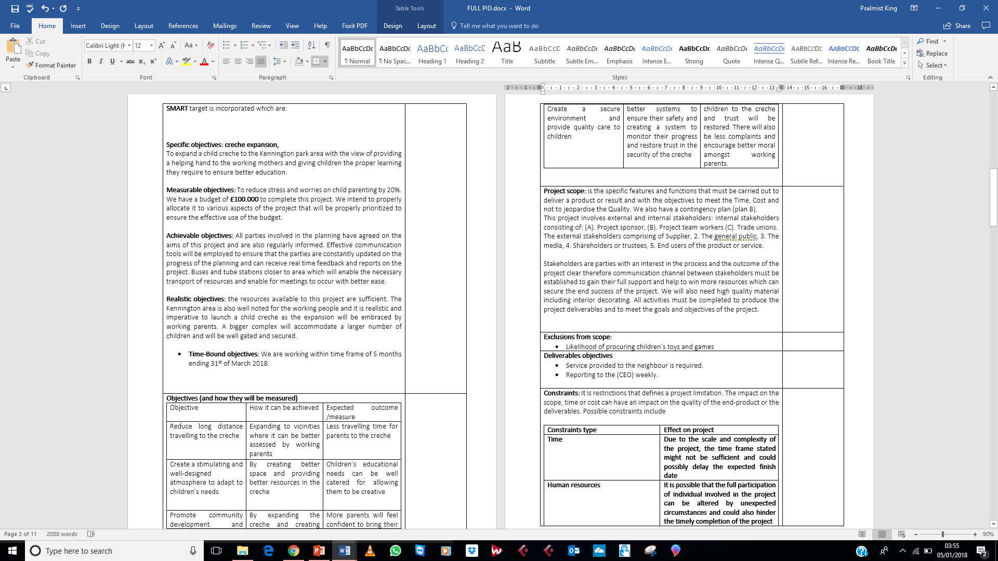

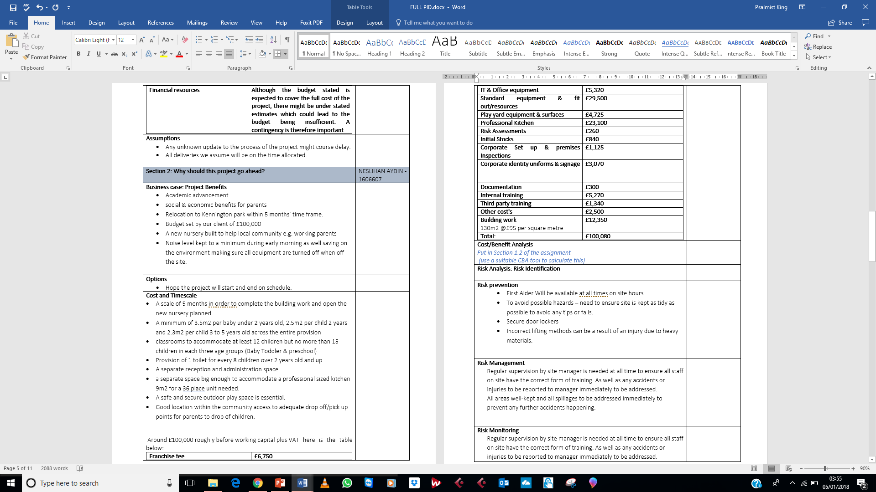

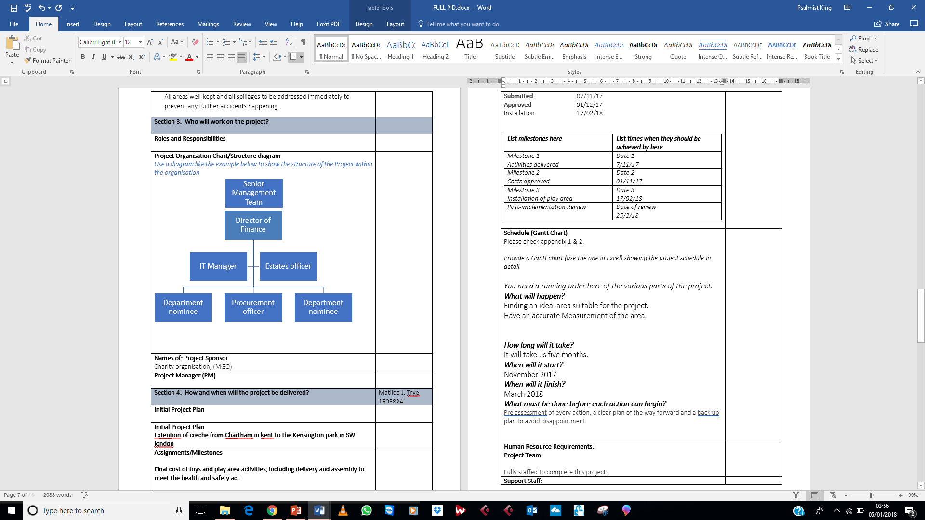

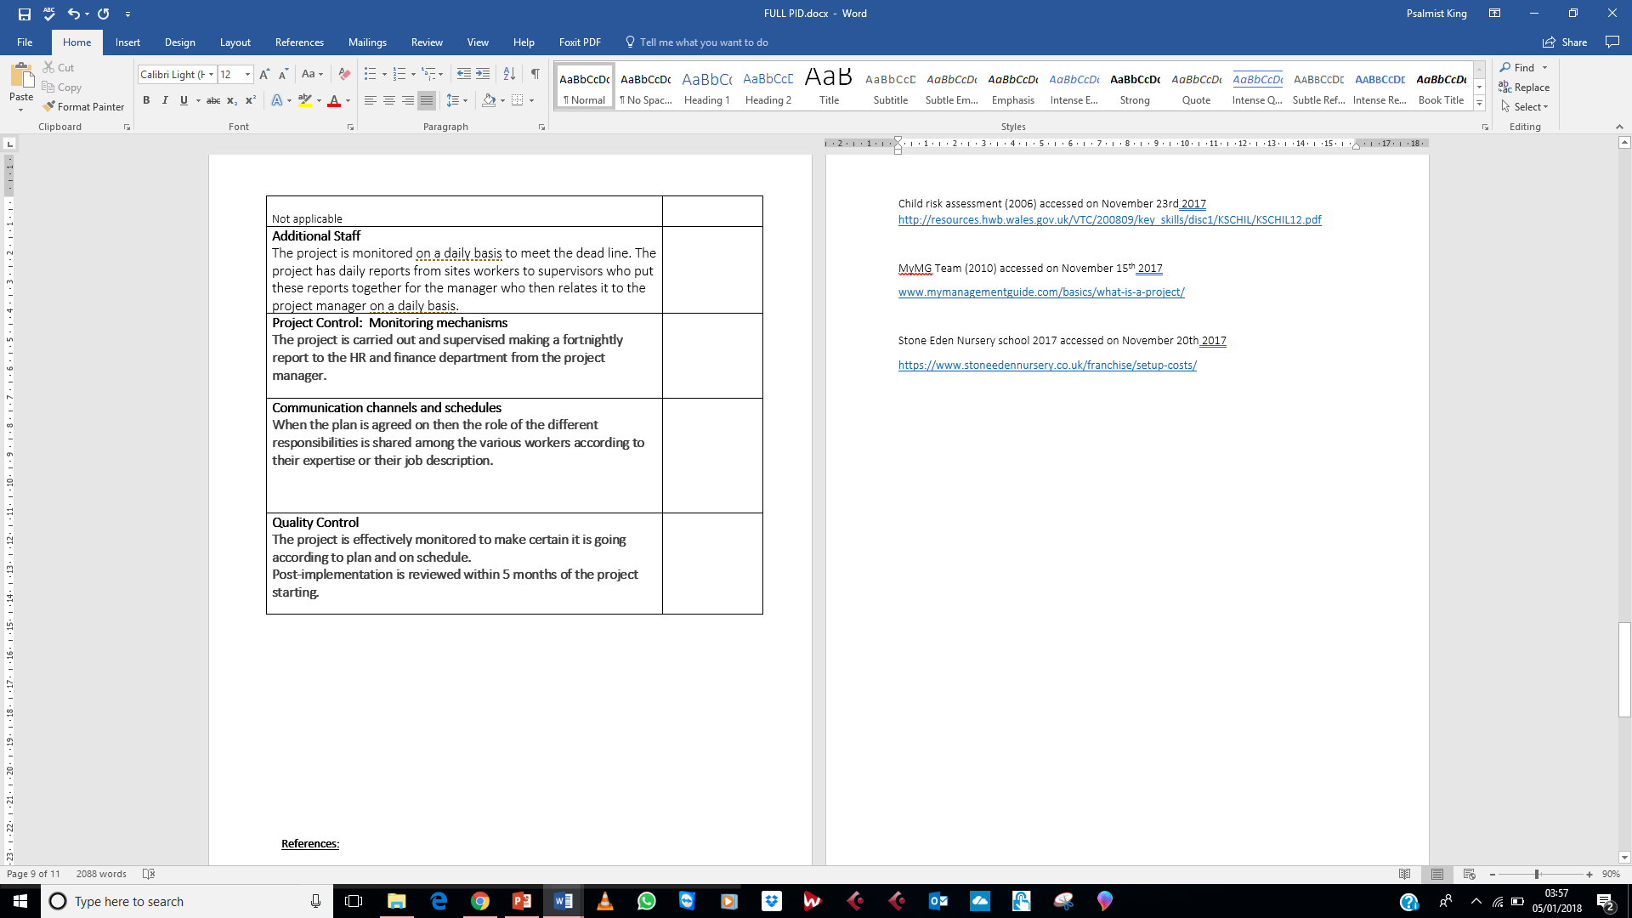

Appendix 4: PowerPoint screen shot.



