Developing Relationships and Workplace Achievement

Module code: BMSK5002

Learner Name and ID: Nadeem Arif 1711109

Lecturer Name: Domnan Miri

Introduction:
This assignment will discuss the development vehicles available to a care company. This assignment will be focusing on Helping Hands Care and Nursing at Home and the potential of an individual within an organisation as well as the benefits to the company.Helping Hands Care and Nursing at Home is a very large organisation within the care industry,they provide homecare,live In care,Dementia Care and Palliative care etc.The company was formed in 1989 and has gone from strength to strength providing care in many towns and cities across the United Kingdom. Helping Hands employees thousands of people across the UK and provides care services to private residents and nursing homes alike.
According to Helping Hands (2019) “Since our humble beginnings in Warwickshire in 1989, we’re now one of the largest and most respected providers of live-in and domiciliary care in the UK. We are local to you, with over 70 branches nationwide and thousands of trained carers.Our nationwide team is hugely experienced in providing person-centred care at home. We are made up of fully trained carers, including clinical carers and dementia specialists, together with CQC Registered Managers, live-in care specialists and a clinical team of Registered Nurses with the Nursing & Midwifery Council”.
Human Resources:
Human resources department plays an important role in any organisation and it is no different at Helping Hands. According to Tracy(2019) “Human resources defines as; The people that staff and operate an organization," as contrasted with the financial and material resources of an organization. A human resource is a single person or employee within your organization. Human resources refer to all of the people you employ.Human Resources is also the function in an organization that deals with the people and issues related to people such as compensation and benefits, recruiting and hiring employees, onboarding employees, performance management, training, and organization development and culture.”
Human Resources are responsible for hiring and firing employees and making sure they have employees’ up to date personal information at all time as this can affect their wage amounts depending on their circumstances so it is very important to keep this information up to date.Amongst other roles,human resources also have to keep up to date with any new laws which could affect the organisation or the employees and they have to make sure if there is new legislation which affects the organisation, it is their job to make sure it is implemented.
Development Vehicles:
Development vehicles are various methods which employers can put in place in order to meet the development needs of an individual at work.There are many methods which employers can use in the development of their employees,this assignment will discuss three different development vehicles which are listed below.

Employee engagement:
It is vital in the care industry to be constantly engaged with the carer as from day to day an hour to hour there may be cancellation from home visits due to a patient falling ill or going to hospital, this action helps to improve performance and service because it will save time.If there was no engagement with the employee then he/she would be acting upon the rota that was handed to them at the start of the week,this would mean the carer would visit addresses that there was no need to visit.By keeping the employee fully informed helps improve the relationship between the employers and employees.
Many employees will consider leaving their position and going to a different organisation if they feel they are made to feel undervalued or undermined,in many cases these individuals will be excellent in their positions and will consistently exceed expectation.
“Research by Glassdoor in 2016 reported that 53% of employees are confident that if they quit or lost their current job, they would be able to find a comparable position within six months. To us, this trend indicates one thing: If you don’t give employees a compelling reason to stay, they’ll find another job that does.
When competition for top talent is fierce, and the cost of training new hires is steep, you can’t afford to not engage your employees. Especially when you consider the corollary benefits of innovation, higher profits, and the sheer enjoyment of standing at the helm of a fully engaged workforce”.
Training:
It is important that an employee has the right training to carry out the role as this will ensure that task will be carried out to a very high standard.The right training will give the employee more confidence whilst carrying out the task as they will know what to do at all times.for example if a carer has gone to visit a patient and on arrival,the patient is not as normal,with the right training the carer will be able to make the necessary adjustments and log them in without panicking and keep phoning the seniors for advice as opposed to calmly dealing with the patient and then reporting the changes to the senior, lack of training could alarm the patient and make the situation worse.
According to Trruit (2011)”Training and development is a fundamental human resource management practice for any organization that aimed at a competitive advantage in the contemporary business management. Training and development enable the organisation to cope with technological changes and challenges and effectively adopting new rules in the business context.”
Some of the benefits of providing the right training to an employee are;
- Improves performance
- Increases engagement
- Improves employee retention
- Makes Tracking employee performance easier
- Delivers happier customers
According to Neill(2018)” The prime motivator for employee training is to improve performance. And when executed well, it does just that. It provides your employees with the expertise they need to fulfil their role and make an impact on your business. The skills they learn empower them to deliver a better quality of work.It also gives your hires a clear understanding of their role and responsibilities in your organisation. They know their targets and they're equipped with the tools to effectively meet them.”
Helping Hands aims to open a branch in every major town and city in the UK,providing care, security and independence for vulnerable members of our society, at the same time Helping Hands will improve the economy by creating hundreds of new jobs through expansion.
Motivation:
Motivated employees will perform much better at work and they will enjoy the role.A motivated employee will feel valued and as a result will perform to the best of their ability.It is important to provide a motivating environment which gives clear directions and goals, this will ensure the employee is aware of what is expected of them. For example, when an employee visits a patient, they will be expected to carry out their duty within the time frame allocated to the patient, the employee must do everything right and not take short cuts if they feel they are running late as this could affect the patient health and welfare.
According to Haethfield (2019) “Motivation is a powerful energy that drives and excites employees, which results in their maximum contribution. Setting and achieving goals, clear expectations, recognition, feedback, as well as encouraging management all contribute to an increase in workplace motivation. It flourishes in a positive work environment, which is why so many leaders want to learn new ways to motivate their workforce.”
Motivated staff are less likely to be absent thus ensuring the smooth running of the organisation, motivated staff are very unlikely to look elsewhere for employment and will feel their long term future is secure within the organisation.
According to an article in 22 group Ltd(2019) “Invest in your people and they will invest in you! If you’re spending company money on training and developing your workforce you should be seeing some return on investment – with your staff more able to take on new skills and responsibilities. This helps you keep more work managed in-house and saves expensive outsourcing costs! If employees are motivated at work and feel you’re investing in their long term development, the return will be higher and it is likely the employee will continue to work for the company, rather than look to go elsewhere, leading to what every company aspires to – a low staff turnover.”

Vroom’s Expectancy Motivation Theory:
Victor Harold Vroom was born on August 9, 1932 in Canada, He is a business school professor at the Yale School of Management, amongst other important positions he has held at international organisations, Victor Vroom has held a major role at American Express. According to Mulder(2018) “In 1964, Canadian professor of psychology Victor Vroom developed the Expectancy Theory. In it, he studied people’s motivation and concluded it depends on three factors: Expectancy, instrumentality and valence. Abraham Maslow and Frederick Herzberg also researched the relationship between people’s needs and the efforts they make. Vroom distinguishes between the effort people put in, their performance and the final result. His theory primarily relates to motivation within a work environment. When employees can make choices in their work, Victor Vroom argues that they will mostly choose what motivates them the most.”
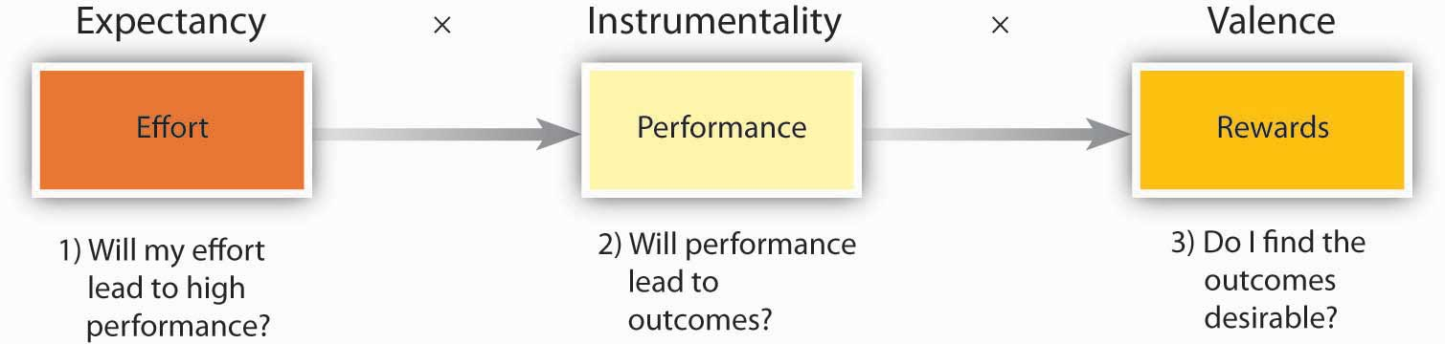

Vroom's expectancy theory assumes that behaviour results from conscious choices among alternatives whose purpose it is to maximize pleasure and to minimize pain. Vroom realized that an employee's performance is based on individual factors such as personality, skills, knowledge, experience and abilities. He stated that effort, performance and motivation are linked in a person's motivation. He uses the variables Expectancy, Instrumentality and Valence to account for this.
The key to the success of Helping hands is
- excellent performance
- rewards
- effort
- motivation
According to “Perception is an important factor in Vroom’s Expectancy Theory. An organisation might perceive that it, as an employer, offers its employees everything they need to sufficiently motivate them. For instance, a salary that’s 10% above industry average, 10 extra days off, training programmes, or career opportunities. But not all employees will be sufficiently motivated by that; each individual has a different perception. There might be employees who would appreciate more support from their supervisor. If an organisation fails in that respect, chances are the employees will be less motivated. Vroom’s Expectancy Theory of motivation is not always about employee’s personal interest in rewards. It’s also about the associations employees have regarding their performance and the result it will yield.”

Potential benefits of an Individual as well as an employer:
If an employee provides excellent service,Helping Hands rewards the employee with financial bonuses and that motivates the employee to perform at a higher level.Excellent performance is really important in the care industry because service users rely on care agencies, service users generally view carers as their own family because most service users are lonely and elderly people. Carers have to follow the strict policies and procedures of Helping Hands to provide excellent service and put a smile on service users and make them feel comfortable in their own homes. Service users who are happy with the service, generally recommend the company to other friends who may be in a similar situation requiring care at home. This will bring more business to Helping hands and ensure the long term job security of the employees.
With the palliative care, the Live-In Carers get 5-6 week contracts and in some cases family members turn up to visit their relatives and are able to interact with the carer whilst the carer is carrying out duties, this interaction can have a positive impact on the family members because they have seen the carer in action and it assures them that their relative is as comfortable as possible under the circumstances, more often than not, they will ask the company for the same carer if they require the services of the company again. That will benefit the carer financially and it will give the carer more confidence and the carer will deliver more excellent service and can lead to future promotion to senior post within the company. Vroom’s theory still exists in today’s world because all of Vroom’s belief’s and assumptions apply in the successful daily running of Helping Hands.
According to Helping Hands (2019) “Live-in care enables you to remain comfortable in your own surroundings while still being able to live each day on your terms. There are no visiting restrictions and no set meal times, so you can remain independent while still giving you and your family peace of mind that you’re in safe hands.”
PDP Plan:
According to Bright Water UK(2018) “A personal development plan is “a combination of approaches, ideas and techniques that will help you manage your own learning and growth”.
The benefits of a personal development plan are that an individual can identify their short-comings and draw up a plan accordingly to achieve their desired growth. A personal development plan is exactly that “PERSONAL” that means an individual can regularly revise their plan and check on their progress, and if need be, make changes to accommodate any unforeseen circumstances.”

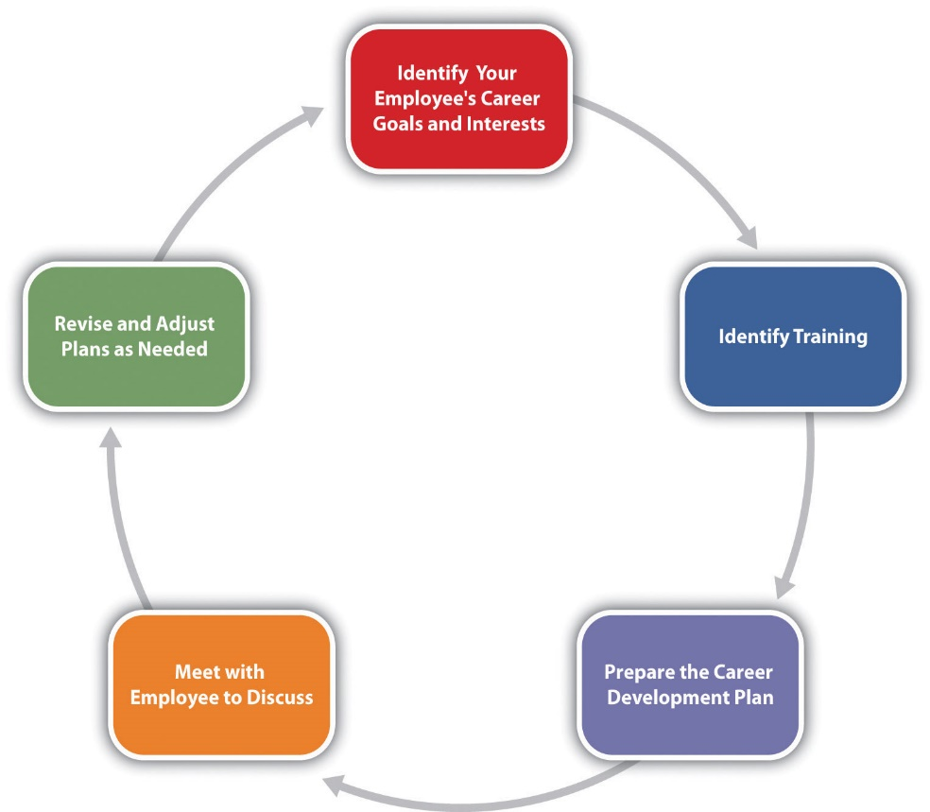
An employer should identify the needs of an individual and provide relevant training to the individual in order for the individual to carry out their task easily. The employer must make sure that every employee is up to date with the latest training the company has to offer. For example, if an employee is not up to date with the latest training then that employee should not be allowed to carry out any duties until they have completed their training. The employer must identify the strengths and weaknesses of an individual to assign them to a task where they will be able to complete the task efficiently.

Regular meetings of staff to discuss the daily tasks will ensure if an individual is unable to attend work due to unforeseen circumstances, then it will be easier for the one who is covering the absentee’s rota, will do so efficiently. For example, if a regular carer for a particular service user has to phone in sick just hours before their shift, the practise of regular staff meetings will have ensured that any covering staff would be fully aware of all the service users needs on the absentee’s rota for that shift, therefore, there should not be any issues in dealing with all the service users efficiently.
If feedback is given from every employee about every service user on their shift on a weekly basis, that will ensure even if a different carer has to attend, the task will be carried out smoothly and efficiently.
Helping Hands is a very fast-growing company all over the UK, the company needs to make sure they are not understaffed and they hire the right people and train them appropriately
, in order to maintain the excellent service and customer care that Helping Hands has become renowned for, it is vital that Helping Hands keeps practising Vroom’s Expectancy Theory to keep progressing.
According to Harper (2019) “Forecasting staffing needs is an element of strategic planning. Staffing levels affect many aspects of a small business. Too many employees drive up overhead and directly affect business profitability. Too few employees limit the ability to serve current customers and grow the business. Understaffing may make sense to the management team but have negative impact in the long run”.
Spot checks on employees regularly so they fulfil their job on time and their time management skills will be monitored on the domiciliary care so all the staff is alert on all calls. Some staff are lazy and they know certain service users are alone and vulnerable in their homes and they will be reluctant to the complaint as they fear backlash from the carer, so the staff go to calls late and try to fit in an unauthorised break in-between calls, this can lead to negative ratings for Helping Hands or loss of service users. Helping Hands prides itself in providing excellent service to the service users and making them feel independent at this stage of their lives and helping to maintain their dignity,everyone has a right to feel independent and dignified. After all, this is what the service users pay for with their life savings.
On the other hand, very often carers get abused by service users, this can be in the form of discriminatory abuse or sexual abuse,In many instances physical assault has been reported by mainly female staff who allege to have been assaulted by elderly male service users, the company takes every report of misconduct extremely seriously, whether the complainant is a carer or a service user and has a zero-tolerance policy on any type of abuse.
According to Age Uk (2019) “When you report abuse to Adult Social Services, they will listen to the information you give them and assess what action is required. They will ensure that you feel in control of what happens. You can ask for someone that you trust to support you, or you can ask for an advocate. If you (or the person you are concerned about) has difficulties or does not have the mental capacity to engage with the process, the local authority will arrange for an advocate to provide support.”
Team working will improve individual skills at the workplace and it is vital for any care worker to work as a part of a team or on their own initiative to meet the needs of a service user. When an individual is working as a part of a team,it is vital that they interact with each other to get the job done to satisfaction.

Conclusion:
This assignment has proved beyond any doubt that any organisation or corporation has to meet the needs of the employees and clients alike to survive and progress in today’s very competitive business world. This assignment focused on Domiciliary care and Home Care of whom Helping Hands are industry leaders.Home Care is a very challenging and competitive industry, in order to compete in the market the company must provide the right care for any vulnerable service user at any particular time, the service provided has to be in accordance with the needs of the service user.
This assignment has demonstrated the importance of employee motivation,training and punctuality for the smooth running of Helping Hands. It is Vital for large companies to use various development vehicles for employee development and progression within the company.This assignment also proved how Vroom’s Expectancy theory is still very much applicable in today’s modern world, and if applied correctly, it can be extremely useful.

References:

Helping Hands Care and Nursing at Home (2019) Nationwide home care specialists[Online] accessed on 03/09/2019 via https://www.helpinghandshomecare.co.uk/about-us/why-choose-helping-hands/

The Balance Career (2019) What is Human Resources? [Online] Accessed on 03/09/2019 Via: https://www.thebalancecareers.com/what-is-a-human-resource-1918144

Engagement multiplier(2019) The Purpose of Employee Engagement: Attracting & retaining top talent [Online] Accessed on 03/09/2019 Via: https://www.engagementmultiplier.com/blog/why-is-employee-engagement-so-important/

Truitt, D.L. (2011). The Effect of Training and Development on Employee Attitude as
it Relates to Training and Work Proficiency. Sage Open DOI: 10.1177/2158244011433338 http://sgo.sagepub.com.

LearnUpon(2019) The importance of employees for your business:Improves employees performance [Online] accessed on 04th September 2019 via https://www.learnupon.com/blog/importance-of-training-employees/

The Balance Career (2019) 8 ideas How to Inspire Motivation in the Workplace [Online] Accessed on 4th September 2019 Via: https://www.thebalancecareers.com/does-your-workplace-inspire-motivation-1918742

22 Group Ltd (2019) 5 benefits of a motivated workforce: Return on investment [Online] Accessed on 4th September 2019 Via: https://www.22group.co.uk/185-2/

Mulder, P. (2018). Vroom’s Expectancy Theory. Retrieved [insert date] from ToolsHero: https://www.toolshero.com/psychology/theories-of-motivation/vrooms-expectancy-theory/

Bright Water Resources Uk (2016) What is a Personal Development Plan and What Can it Mean for you? [Online] accessed on 5th September 2019Via:https://www.bridgewateruk.com/2016/09/personal-development-plan/

Chron (2019) Understaffing issues in the workplace [Online] Accessed on 5th September 2019 via https://smallbusiness.chron.com/understaffing-issues-workplace-46884.html
Age Uk Love Later Life (2019) Protection from Abuse: What will happen when I will report abuse [Online] Accessed on 5th September 2019 Via https://www.ageuk.org.uk/information-advice/health-wellbeing/relationships-family/protection-from-abuse/

Helping Hands Care and Nursing at Home (2019) Live In Carer Support You in Birmingham [Online] accessed on 5th September 2019 Via https://www.helpinghandshomecare.co.uk/our-locations/Birmingham/

Toolshero (2019) Vroom’s Expectancy theory:Perception [Online] Accessed on 5th September 2019 Via: https://www.toolshero.com/psychology/theories-of-motivation/vrooms-expectancy-theory/

