

Name- Panktibahen Mihirkumar chaudhari
Student id- 2504333
Supervisor- Dr. Helen lee
Subject- Vision for the future _Theoretical perspective on management (LCDB7008)
Topic- Managerial challenges and opportunities in adopting QR code payment systems in India.

Acknowledgement
I would like to note that my academic supervisor offered me some useful advice, constructive criticism, and regular support on the way to the final work on this dissertation. I am grateful that my university faculty availed of the academic resources and learning environment which enabled this research. I, too, credit the authors and the researchers whose academic work was the baseline of this study. I have also liked the support of my family and friends, who were patient, encouraged, and emotional through the research process. Lastly, I would recognise my personal work and determination in achieving this academic work with diligence, discipline and academic honesty.

Executive Summary
The dissertation will look into the managerial issues and opportunities of QR code payment systems adoption in the fast-changing digital business scenarios in India. Although previous literature has been mostly concerned with consumer adoption and technological efficiency, the present study uses a theory-oriented approach to emphasise the managerial perceptions, leadership processes, and organisational change processes. Under the advice of Innovation Diffusion Theory, Systems Theory and Change Management Theory, the study will incorporate the recent academic literature, policy documents, and industry reports to build up a thorough conceptual analysis.
This work finds that managers tend to view QR code payments as a means of enhancing the efficiency of operations, increasing the speed of transactions, lessening the need for cash transactions, and making customer convenience stronger. Nevertheless, there are still major aspects of challenges, such as system integration problems, the staff is not digital-savvy, employee resistance to change, cybersecurity concerns, and customer dispute management. The results underscore the fact that these issues are more managerial and organisational and less technological.
The analysis also shows that the concept of QR code payment would open strategic opportunities to decision-making based on data, enhanced service quality, and organisational agility. The shift also redefines the functions of managers and leaders, who have to shift their approaches from the old control-oriented management to the new digitally capable and human-centred leadership styles. Successful communication, employee training, and constant engagement are noted to be key success factors.
Altogether, the dissertation adds value to the fields of management and digital transformation by applying the theories of technology adoption to the managerial field. It concludes that the achievement and sustainability of the QR code payment system in India rely on managerial ability, leadership flexibility, and organisational congruence. The research can contribute to important findings for managers, policymakers, and institutions that want to empower the digital payment ecosystem in India by means of efficient managerial practices. The adopted conceptual approach is relevant to future empirical research and offers an organised platform on which to formulate managerial strategies that would be inclusive, secure, and sustainable to adopt digital payments in various Indian business sectors in the long-term implementation work nationwide.
Table of Contents
Chapter 1: Introduction – Structure 6
1.1 Background of the Study 6
1.2 Research Problem / Problem Statement 6
1.3 Rationale of the Study 7
1.4 Research Aim 7
1.5 Research Objectives 7
1.6 Research Questions 8
1.7 Scope of the Study 8
1.8 Significance of the Study 8
1.9 Expected Contributions 9
Chapter 2: Literature Review 10
2.1 Introduction 10
2.2 The Digital Payment Ecosystem in India 10
2.3 QR Code Adoption in India: Drivers and Barriers 10
2.4 Managerial Challenges in Implementing QR Code Payments 12
2.5 Opportunities Arising from QR Payment Adoption 13
2.6 Theoretical Perspectives 13
2.7 Literature Gap 14
Chapter 3: Research Methodology 14
3.1 Introduction 14
3.2 Research Philosophy 15
3.3 Research Approach 15
3.4 Research Design 16
3.5 Theoretical Framework Application 16
3.6 Ethical Considerations 17
3.7 Limitations of the Methodology 18
Chapter 4: Results And Analysis 18
4.1 Introduction 18
4.2 Managerial Perceptions of QR Code Payment Adoption 19
4.3 Key Managerial Challenges 20
4.4 Opportunities Created by QR Code Payment Systems 20
4.5 Impact on Managerial Roles and Leadership Styles 21
4.6 Integrated Theoretical Discussion 21
Chapter 5: Conclusion And Recommendations 24
5.1 Introduction 24
5.2 Summary of Key Findings 24
5.3 Theoretical Contributions 24
5.4 Managerial Implications 24
5.5 Policy and Institutional Implications 25
5.6 Limitations of the Study 25
5.7 Recommendations for Future Research 25
Reference list 27

List of Tables
Table 3.1: Theoretical Framework Application in the Study 21
Table 4.1: Opportunities Created by QR Code Payment Systems 25
Table 4.2: Integrated Theoretical Interpretation of QR Code Payment Adoption 28

List of Figures
Figure 2.1: Digital Payment Ecosystem and QR Code Integration in India 17
Figure 3.1. Exploratory and Descriptive Research Design Framework 19
Figure 3.2: Exploratory and Descriptive Research Design Framework 21
Figure 4.1: Managerial Perceptions Influencing QR Code Payment Adoption 24
Figure 4.2: Managerial Perceptions Influencing 27

Chapter 1: Introduction – Structure

1.1 Background of the Study
The last ten years saw the induced digital financial ecosystem evolve swiftly in India, which is why it is considered one of the most developed digital payment ecosystems in the world. The implementation of Unified Payments Interface (UPI) and the popularity of applications like Paytm, PhonePe, and Google Pay have increased the rate of transitioning to the use of QR code-based payment system in urban and semi-urban areas. These systems have proven to be very crucial in transforming the way in which businesses and consumers transact their financial dealings as it provides speed, convenience, transparency, and less reliance on cash (Nandru and Chendragiri, 2024). QR code payment system has become entrenched in the everyday business of small, medium and large businesses, especially in the retail sector, hospitality and services.
The adoption of QR code payment systems, however, is not only successful with the availability of technologies. It needs to be planned and managed at an effective management level, structuring, training of employees and managing change. Some of the challenges that managers have to face include resistance to digital change, security concerns, system reliability and integration with the workflow. Digital payments provide the opportunities of operational efficiency, better customer experience, and data-driven decision making, which is possible to achieve only with proper managerial control. Although they are increasingly gaining significance, very little research has been conducted on the management implications of adoption of QR code payment in India (Rafferty and Fajar, 2023). This paper can fill this gap by concentrating on the managerial issues and opportunities of the digital business environment of India, in the midst of changes.

1.2 Research Problem / Problem Statement
Even though QR code-based payment systems are widely used throughout India, a number of companies, especially small and medium-sized business, are highly challenged by the management of these technologies, both in their implementation and maintenance. Digital payment structures that already exist need more than the technological preparedness, they need shifts in managerial traditions and employee education, adoption of working processes, and alterations in leadership strategy. Some of the problems faced by managers include resistance to change, digital illiteracy of employees, security, system reliability, and integration of the QR payment systems with the current business processes (Le, 2022). Although most of the previous research concentrated on consumer moving capacity and technical effectiveness of digital payment, little research has been conducted on the managerial side of the research. This is a weakness that limits a holistic perspective of how managerial decisions, organisational structures, and leadership strategies can affect the role of effective adoption of QR code payments. Thus, the main issue discussed in the current paper is the lack of deeper investigation into the management issues and opportunities related to the introduction of QR code payments system into the dynamic digital business landscape of India (Eren, 2022).

1.3 Rationale of the Study
The purpose of this research is based on the fact that digital payment systems as an element of the digital economy of India have gained increased significance. QR code payments cease to be options but rather mandatory to business competitiveness, operational efficiency as well as customer satisfaction. The managerial aspects of adoption are very critical to understand because managers are at the core of the decision-making, change management and system integration. This work stands out as it does not put the emphasis on the consumer and technology as on the experiences and perceptions of the managers and the strategic responses. The research is practical to business managers and policy makers by proposing to analyse issues that may disrupt the company operations, employee adaptation and leadership changes. Moreover, the research fills an existing research gap in the literature of digital payment. Its results can be applied in formulation of superior managerial models, training curriculums, and policies so as to make the adoption of the payment system utilising the QR codes in India to be sustainable and effective.

1.4 Research Aim
This study is aimed to investigate managerial issues and opportunities related to the implementation of QR code payment and practises in India in terms of how these technologies are shaping managerial practise, organisational efficiency, leadership, and how organisations adapt to the digital business realm.

1.5 Research Objectives
- To analyse the experiences and perceptions that managers have towards using QR code payment systems in the Indian businesses.
- To determine the most critical managerial issues during the introduction and development of QR payment coding systems in the company existing processes.
- To determine how QR code payments have created opportunities to enhance operational efficiency, sales performance and customer engagement.
- To compare the effects of the adoption of QR code payment on the role of management, leadership approaches, and organisational processes.

1.6 Research Questions
- What is the perception of managers and small owners in India towards the adoption of QR code payment system?
- What are the issues encountered by managers in terms of implementation of and operation using QR code payment systems?
- What are the opportunities and benefits enjoyed by managers who switch to the adoption of QR code based digital payments?
- What does QR code payment system adoption do to managerial positions, leadership styles, and staff-customer relationship?

1.7 Scope of the Study
This paper aims at analysing management issues and opportunities of integrating QR code payment systems in the Indian business environment. It is restricted to the managers and small business owners in the areas like retail, hospitality and service-based businesses where their operation is based on the use of the QR codes payment. The study investigates management experience in regard to implementation process, working daily operational usage, employee coordination, interaction with customers, and management shifts influenced by the digitization of payment (Ashrafi and Easmin, 2023). It also takes into account the organisational nature of, but does not assess the technical layout and financial performance of individual payment platforms, including the integration of workflows, change management, decision-making and so forth. The research is geographically limited to India because of the peculiarities of the digital payment ecosystem in the country because of UPI and mobile-based apps. The study takes managerial and organisational approach as opposed to consumer oriented or the technological angle. Based on the practise of management and organisational change, the study will offer some perspectives into the effect of QR code payment systems on business and managerial effectiveness in the Indian context of the fast-changing digital economy.

1.8 Significance of the Study
The importance of this research is that it pays attention to the managerial aspect of the adoption of QR code payment system that has not been thoroughly studied in the current research on digital payments. With the QR code payments penetrating the business processes in India, managers must simultaneously manage the change in operations, employee adjustment, and customer requirements. This study also offers useful information to business managers by highlighting the real issues and opportunities that may occur in the process of adoption to make informed decisions and appropriate leadership plans. Policymakers and financial institutions also find the study important because it illuminates the needs of managers that can be used to design training unit programmes, to implement digital literacy, and to establish supportive regulatory systems. In scholarly terms, the study is part of the existing body of knowledge on the subject of management and digital transformation by merging the two perspectives of innovation diffusion and systems theory, as well as change management. In general, the results should help to implement digital payments in a more sustainable and effective manner, which would lead to better performance of the organisations and make the Indian digital business ecosystem more powerful.

1.9 Expected Contributions
The research is likely to have significant managerial, academic and practical implications. As a manager, it offers practical information on how the leaders can address more effectively the issue of employee resistance to the implementation of QR code payment systems, workflow optimization, and customer interaction. The results could help the managers to develop effective change management and leadership strategies in the context of digital payment. Academically, the study has a theoretical contribution to the current literature in that it formally bridges a research gap in the literature with respect to managerial experiences in digital payment adoption with reference to Indian context. It prolongs the use of organisational and innovation theories into practise of digital finance in real worlds. In practise, the study can be used to inform policymakers, payment service providers, and training institutions on areas that need managerial support and skills development. In the end, the study will foster the success and sustainability of QR code payment systems in the digital economy.

Chapter 2: Literature Review

2.1 Introduction
India has experienced a revolution in its financial environment in the last 10 years due to the use of digital payments. The key element of this shift is a QR code-based payment system, particularly in the Unified Payments Interface (UPI) platform. Although a lot of attention has been paid to the factors of user behaviour and adoption drivers, there has been little emphasis on the managerial issues and opportunities of their implementation and integration with the business processes that the study will focus on. The literature review summarizes pertinent works of the past five years, analysing (a) digital payment situation in India, (b) adoption of QR codes, (c) managerial problems and organisational change, and (d) opportunities offered by QR code systems. The area ends with the identification of gaps in the existing literature.

2.2 The Digital Payment Ecosystem in India
The development of digital payment systems in India has been fast tracked and characterized by policy backing, technological development and growing financial inclusion initiatives. Studies indicate that UPI has been the foundation of digital transactions and has contributed to a large part of the expansion recorded in digital payments. By early 2024, UPI represented a preponderate portion of digital payment volumes in India, which indicates its penetration and adoption into daily business (Shekhar, 2022).
According to a recent study of digital payment trends, the digital landscape in India has experienced tremendous growth owing to both the governmental efforts, such as the Digital India and the impact of demonetization, in addition to smartphone and internet connectivity. This growth demonstrates the high rate of growth in transactions, as digital payments are substituting cash in a variety of settings, despite such issues as cybersecurity and digital illiteracy. Although the innovation and adoption of UPI have been highly studied, these researches mainly entail the performance of UPI in the market and inclusion effects rather than the organisational or managerial aspects of the usage of these technologies in a business environment (He and Li, 2022).

2.3 QR Code Adoption in India: Drivers and Barriers
2.3.1 Adoption Drivers
Empirical studies that have been conducted in the recent past all show that QR codes have been a facilitating factor in increasing digital payments, particularly among small enterprises and retailers. Their affordability to be deployed and convenient nature of use have made them well embraced by unbanked people and small retailers to close digital and financial inclusion gaps in emergent market settings such as India.
The fact that QR codes are a payment tool that is easy to use, only a regular smartphone and access to the internet are needed, makes them a perfect option when it comes to offline-to-online (O2O) transactions, especially when it comes to micro and small businesses whose traditional terminals may be unaffordable. A different study based on the Unified Theory of Acceptance and Use of Technology (UTAUT2) model validates the claim that ease of use, facilitating conditions and social influence have a significant influence on QR-based mobile payment adoption intentions that further elucidates the process of adoption in emerging economies (Putrevu and Mertzanis, 2025).
In addition, the adoption research studies revealed that the expectancy in performance and trust determine behavioural intentions in adopting digital payment systems and QR-enabled systems as well among Indian users - indicating that technological usefulness as well as perceived reliability is important even in business applications.
2.3.2 Adoption Barriers
Along with the visible benefits, the literature also shows a number of barriers to complete adoption. The lack of awareness of merchants and consumers has remained a barrier to broad usage in certain markets and in rural or semi-urban areas where the digital divide is not as well distributed as in urban markets. The most common reasons are security concerns and the fear of fraud, data hacking. An example of this is that infrastructure constraints and security have been associated with the slow adoption and distrust of both merchants and customers (Putrevu and Mertzanis, 2024).
Moreover, the termination of some of the UPI operations, including person-to-person transactions initiated by the receivers, can also point to some wider industry efforts to combat misuse and fraud, which suggests that security issues are still shaping the development of digital payment systems.
These are the barriers to adoption in the form of awareness, security concern and structural barriers which are well reported in the technology adoption literature yet little has been done regarding how managers respond to and handle these barriers in their organisational set ups and this is the focus of the research.

2.4 Managerial Challenges in Implementing QR Code Payments
2.4.1 Operational Challenges
Despite the fact that a lot of literature has been conducted on consumer and merchant adoption of QR payments, little research specifically studies managerial experiences. What is available relates to the challenges of functionality of integrating QR payments into the current business operations processes and reliability and consistency of systems (Jiang et al. 2021). Retailers, in particular, small stores tend to struggle with the training of employees, handling of customer requests, and network connectivity all of which influence the efficiency of their operations.
Research findings on micro-enterprises make it clear that adoption is not only technological but also sociotechnical, i.e., changes in everyday activities and processes. Such changes force managers to redistribute roles, oversee employee training, and overcome the conflicts that emerge due to new processes, which have not been thoroughly researched in the existing literature.
2.4.2 Digital Literacy and Change Management
Digitization of the payment systems usually means significant changes in the skills needed by employees. A major challenge is digital illiteracy especially when it comes to the employees who are older or work in less tech-savvy settings (Zhong and Moon, 2022). The literature concerning the digital payment acceptance in rural settings points that unfamiliarity with digital tools may hinder it, hence it is important to highlight that organisational training and change management are essential factors of success.
Most of the studies, however, consider digital literacy as an end-user problem, without considering how business managers recognize, plan and solve such skill gaps among their staff. This is missing a piece in interpreting the managerial approaches necessary to instigate workforce flexibility, which is one of the central issues of your study.
2.4.3 Security and Trust Management
The security concerns do not only restrict the adoption barriers but also influence the managerial decision making in connection to investments in the QR infrastructure (Tu et al. 2022). The managers have to balance between the cost of the improved security measures and the risk of customer satisfaction and loss of business continuity. Although literature covers the issue of cybersecurity threats in digital banking in general, limited research has been done on how business managers perceive, rank, and address security risks within the QR payments context, which is a significant managerial aspect as stated in your problem statement.
2.4.4 Resistance to Change and Leadership Dynamics
One of the recurring themes in literature on organisational change is resistance to change. The opposition to the use of digital payments can be caused by the old habit, the fear of unemployment, or the fear of new technologies (Moghavvemi et al. 2021). Although the studies of UPI and digital payments refer to the behavioural intentions, fewer studies are available about the managerial efforts to guide the organisational change so that resistance can be overcome, leadership methods can be adjusted, and the organisational culture can be sensitive to digital. This disconnection between managerial practice and adoption research provides tremendous importance to comprehend the effective digital transformation.
Alongside the widely mentioned barriers to operations and technological ones, managerial issues concerning the implementation of QR code payments also spread to organisational coordination and responsibility. The managers must be in charge of real-time transaction reconciliation, error resolution, and handling of customer grievances. In contrast to cash payment, a digital payment will produce electronic records that will require management control, records, and monitoring of the systems. This adds complexity to the work of managers especially where in small and medium-sized businesses, there is usually no dedicated digital finance department.
The problem of the dependency of the vendors on the external payment service providers is another issue that was stressed in the recent research. The managers are forced to leave the management of the systems, customer support, and updates to the security to banks, fintech companies, and operators of platforms. This dependency lowers the control of the managers over continuity of operation and subjects’ firms to interruption in the services that could destroy customer confidence. Managers have then been found in a situation where they have to compromise between operational efficiency and risk mitigation strategies.
Also, there are new issues of compliance and regulatory awareness. As the laws and regulations related to online payments, data security and reporting on transactions change and evolve, the managers are in need to keep up to date and implement them without having adequate institutional advice or training. Lack of compliance may attract penalties, loss of reputation or a ban on services. These obstacles underscore the fact that the adoption of QR code payment is not a mere technical change; it is a question of governance and coordination which needs managerial skills, knowledge of risks, and adaptive leadership. These managerial burdens with governance orientation have not been fully addressed in existing literature, and hence the significance of the study in the enlargement of knowledge in areas outside technological preparedness.

2.5 Opportunities Arising from QR Payment Adoption
There are several strategic opportunities of QR payments to businesses. They are able to improve operational efficiency through minimizing cash handling, shortening the time of transactions and they can also give instantaneous settlement data which can be used to make business decisions. Research indicates that digital payments can be compared with the overall economic growth and financial inclusion initiatives, providing small enterprises with an opportunity to expose to more people and to become a part of bigger value chains (Zhong and Moon, 2025).
There are also opportunities in customer engagement that are created by the adoption of QR code. Customers are moving toward faster, non-contact, and online payment experiences, which the managers can use to create customer loyalty and competitive edge. Although these advantages have been identified in the digital payment literature, none of the studies explore how managers can strategically leverage such opportunities, both in the leadership styles and in the redesign of processes that face customers.
QR code payment system adoption also allows major opportunities in organisational learning and the development of long-term digital capabilities. Not only do QR-based transactions result in short-term improvements in efficiency, but they also stimulate the use of digital tools, analytics, and platform-based operations by organisations, which, over time, will improve the level of digital maturity. One of the key elements that can support this learning process is performed by managers who should encourage employees to share knowledge and experiment with the new skills. Organisational learning is achieved when the employees get acquainted with checking transactions, electronic reconciliation, assisting customers with failed payments, and reporting via platforms. In the long run, the competencies can lead to a higher level of operational confidence and decreased technological change resistance. Digital transformation literature proposes that organisations which view technology adoption as a learning process, but not as an implementation process, have a greater chance to realise long term returns.
In the managerial context, the introduction of QR code payments opens a chance to institutionalise the digital habits and to introduce the technological adequacy in the daily routine. The proactive managers will be in a better position to embrace new innovations in the future like integrated digital wallets, automated accounting and advanced customer analytics. This learning-based theory is consistent with the Systems Theory that underlines the human capabilities, technological dependence and organisational processes interdependence. Moreover, organisational resilience is enhanced by the creation of digital capability. The more businesses become accustomed to coping with QR payments, the more flexible they are to the changes in regulations, improvement of platforms, and customer expectations. It is in this sense that the QR code payment systems are seen as not just as the tools of transactions but also as a driver to the wider organisational change. By identifying and capitalising on this opportunity, managers can no longer afford to focus on the short-term operational advantages and develop digitally competent organisations that are ready to engage in the dynamic digital economy of India in the long term.
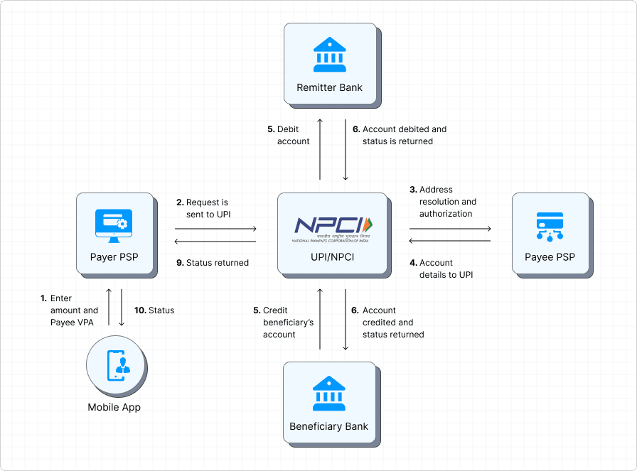

Figure 2.1: Digital Payment Ecosystem and QR Code Integration in India

2.6 Theoretical Perspectives
A lot of the studies on adoption of digital payments adopt technological acceptance models (e.g., TAM, UTAUT/UTAUT2) to describe the behaviour of individuals and merchants. Such models are useful and not adequate in forming the managerial implications. The organisational change theories, frameworks of innovation diffusion, and systems theory are common to analyse managerial issues, which have been indicated but not fully incorporated into the available literature on payment adoption.
Therefore, a definite necessity to relate adoption models to change management and organisational leadership theories to have a clearer idea of how managers can lead, integrate and maintain QR payment systems.

2.7 Literature Gap
Although the current literature sheds some light on the adoption trends of QR codes and UPI, your study fills three major gaps:
- Managerial Focus: The bulk of studies provides focus on consumer or merchant adoption behaviour as opposed to the managerial experiences, perceptions, and strategic responses of business leaders adopting QR payment systems.
- Organisational Integration and Change Management: Little is known on how managers go through organisational change, employee training, workflow integration and resistance in their respective firms through adopting QR systems.
- Strategic and Leadership Dimensions: The literature is not extensive at investigating how QR payment adoption affects managerial functions, leadership practices, and general organisational procedures - all of which will be the focus of your research questions and goals.
By contextualising your study in these gaps, your study will go beyond the adoption trends to study how managerial practices influence and are influenced by the QR code payment integration in the Indian business settings.

Chapter 3: Research Methodology

3.1 Introduction
This chapter includes the methodological framework in which the research aim and objectives of the study were adopted to investigate managerial challenges and opportunities in the adoption of the QR code payment systems in India. Since the study is a theory-based, not an empirical one, the research orientation to be considered is a qualitative and conceptual one. The chapter gives justification and reasoning behind the choice of the research philosophy, methodology, and design and justifies why they are suitable in the analysis of managerial perceptions, leadership dynamics and change in an organisation within the context of a chain of digital payments. In addition, it explains the way developed theoretical frameworks inform the analytical procedure and the interpretation of the findings. Moral issues that apply to the use of secondary data are also addressed to provide academic integrity. Lastly, the chapter appreciates the methodological weaknesses of a theory-based approach. On the whole, this research approach offers a consistent and logical basis to study the managerial aspects of QR code payments integration into the Indian context of the fast-paced digital business, which makes the research questions, theoretical framework and analytical results of the study consistent.

3.2 Research Philosophy
In this research, the research philosophy is interpretivist research, which is very appropriate in investigating the subjective meaning, perceptions, and experiences of managers who are engaged in adopting digital payment. The interpretivism approach presupposes that social realities are not objective and measurable phenomena but are constructed in the interaction of human beings and within organisational contexts. Within the framework of the QR code payment systems, leadership styles, organisational culture, employee behaviour of the employees, and the business conditions of the specific situation are the factors that affect managerial challenges, as well as opportunities (Nandru et al., 2024). The interpretivists' position also enables the research to encode these complexities by concentrating on the interpretations and reactions of the managers to digital transformation initiatives. This philosophy is very relevant to the research focus on the change in organisations, innovation resistance and adaptation to leadership. Instead of measuring the adoption outcomes, the study attempts to learn the managerial logic and decision-making process behind the integration of QR code payment. The use of interpretivism also considers the value of situational knowledge and pluralism, thus facilitating an understanding of the role of managers in the Indian digital payment system.
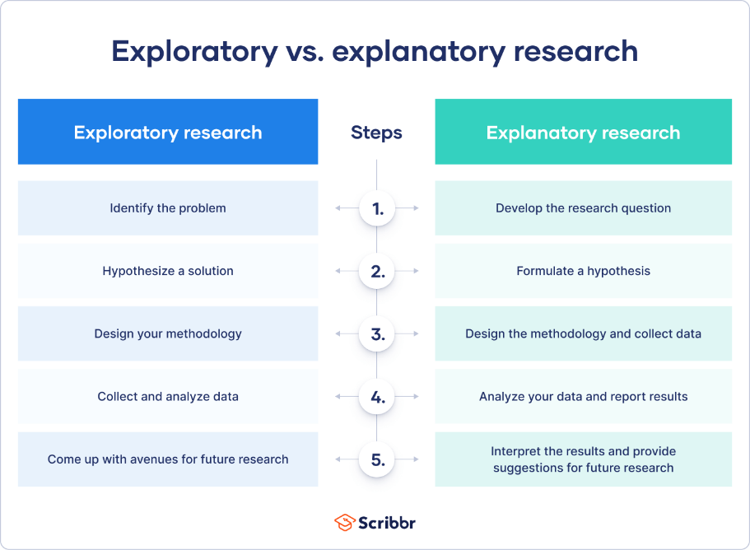

Figure 3.1. Exploratory and Descriptive Research Design Framework

3.3 Research Approach
The qualitative and theory-based research method is used in this research to obtain a thorough and contextual overview of managerial issues regarding the adoption of QR code payment. A qualitative approach is suitable because the research does not focus on testing hypotheses or quantifying causal relationships but, rather, tries to make sense and generalise on available theoretical and scholarly knowledge. The study, as a result of a significant review of academic literature, policy reports, and institutional studies, defines major managerial themes, challenges, and opportunities of digital payment systems. This method allows the paper to identify a connection between the abstract theoretical notions that include innovation diffusion and change management, with practical managerial practices that have been addressed in the literature (Trivedi and Sanchiher, 2023). Complex organisational phenomena such as leadership behaviour, employee adaptation, and system integration, which are hard to quantify, can be explored through conceptual analysis. The theoretically-based qualitative approach used to conduct the study will make sure that its results are analytical, contextually based and theoretically guided, making them relevant to the field of management as well as to the topic of digital transformation.

3.4 Research Design
The research design is based on an exploratory and descriptive research design, which is appropriate to investigate a little-studied managerial phenomenon in the Indian digital payment setting. Being a non-empirical desk-based research, it depends solely on secondary sources of data, such as peer-reviewed journal articles, academic books, industry reports, and policy documents. This design will enable a systematic and comprehensive review of currently existing knowledge on QR code payment systems and their managerial implications. The exploratory characteristics of the study make it possible to detect the new themes, patterns, and relations connected with managerial challenges and opportunities (Mehraj et al., 2024). The descriptive aspect helps to discuss the organisational processes, leadership relations, and changes in the operations that occur with the adoption of digital payments in detail. The design greatly reduces the feasibility while the primary data collection is avoided; this way, the design eliminates scholarly rigour problems. In general, the research design will serve as a systematic literature synthesis, helping to obtain a comprehensive view of how the adoption of QR code payments can affect the managerial practices of Indian businesses.
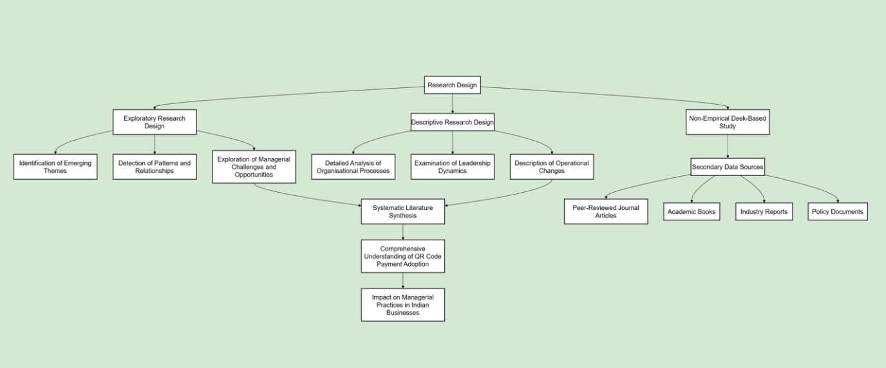

Figure 3.2: Exploratory and Descriptive Research Design Framework
(Source: Self-Created)

3.5 Theoretical Framework Application
Innovation Diffusion Theory, Systems Theory, and Change Management Theory are some of the theories used to analyse the data in this study, collectively offering a strong conceptual framework for studying the experiences of managers. To understand why and how managers make decisions to use QR code payment systems, the innovation Diffusion Theory is used based on the perceptions of usefulness, compatibility, and relative advantage. The Systems Theory points out how technology, employees, and organisational processes are interdependent upon each other, and they have to be aligned to ensure successful implementation. Change Management Theory can contribute to the understanding of resistance management, personnel adjustment, and the methods of leadership reaction in the case of a digital transformation (Rana et al., 2023). These frameworks are used throughout the analysis to make sense of managerial issues and opportunities in a systematic and theoretically based way. The combination of various theories is the reason why the research is not confined to the technological aspect of digital payment adoption, but rather the organisation and human aspects of the latter are prioritised. This multi-theoretical strategy enhances the explanatory richness and the analytic integrity of the research results.

Table 3.1: Theoretical Framework Application in the Study
Theory | Core Focus | Analytical Role | Relevance to Study
Innovation Diffusion Theory | Usefulness, compatibility, relative advantage | Explains managerial adoption decisions | Identifies why managers adopt QR code payments
Systems Theory | Technology–people–process alignment | Examines organisational integration | Highlights the need for system coherence
Change Management Theory | Resistance, adaptation, leadership response | Analyses organisational transition | Explains managerial handling of change
Integrated Framework | Combined theoretical perspectives | Holistic interpretation | Emphasises managerial and human factors

3.6 Ethical Considerations
The level of ethical consideration in this research is not high because it is a theoretically-based research and it uses secondary sources of information. There is no primary data collection, which requires human subjects, and, therefore, there are no issues of informed consent, confidentiality, or harm to the participants. However, the responsibility of ethics is ensured by following the strong standards of academic integrity. Every reference employed in the research is referenced as required to prevent cases of plagiarism and intellectual property law (Kumar et al., 2025). The study includes proper coverage of already existing literature and does not use selective or biased interpretation of findings. This is achieved through transparency by clearly attesting to data sources, theoretical perspectives and limitations of analysis. The study is a good research practice in terms of ethical conduct by subjecting the relevance and credibility of the secondary sources to critical assessment. Such measures will make sure that the process of conducting research is accountable, credible, and consistent with the applicable academic and institutional principles of ethical conduct.

3.7 Limitations of the Methodology
The methodology used in this study has a number of limitations, even though it had some strengths. The first weakness is that no primary empirical data is available, so one is limited to the possibility of validating the findings based on personal managerial experience or real-time organisational observation. The secondary literature would imply that the insights will be limited to the scope, quality, and relevance of the found literature, which might not be able to reflect the current changes in the quickly changing digital payment scenario in India (Hussain et al., 2025). Also, the research is local in India, so its findings cannot be generalised to other countries that have different regulatory and technological conditions.

Chapter 4: Results and Analysis

4.1 Introduction
In this chapter, the findings and discussion of the theoretical and conceptual analysis of the available literature on QR code payment systems adoption in India are given. Since no primary data will be collected during the study, the results are analytical and not empirical, and they are formulated via a systematic review of the existing academic literature, policy publications, and theoretical views. The analysis will be organised according to the research objectives and will be directed by the Innovation Diffusion Theory, Systems Theory and Change Management Theory. All the sections take a critical look at the role QR code payment systems play in the perceptions of managers, organisational processes, leadership practices, and effectiveness of the respective organisations. The chapter examines both opportunities and challenges of managers, and the key role of leadership and organisational readiness in the digital payment adoption. Combining theoretical knowledge and the real-world evidence of the previous research, this chapter creates a consistent and wholesome explanation of the management dynamics in the fast-changing digital payment systems in the Indian context of various business industry segments.

4.2 Managerial Perceptions of QR Code Payment Adoption
The adoption of QR code payment systems is seen by managers in India as one of the key systems that can help them improve their operational efficiency and keep up with the rivalry in the ever-growing digital economy. As noted in the literature, managers find QR-based payment fast, convenient, transparent and cheap, especially in retail, hospitality, and service-based businesses. These systems minimise cash management and ease transaction operations, which are considered to be operational benefits. The perceptions of managers are not mixed in a positive way, though. Constant fears of transaction failures, cybersecurity threats, fraud, and how to resolve customer disputes still affect managerial attitudes (Ashrafi and Easmin, 2023). In the light of Innovation Diffusion Theory, such perceptions are influenced by the perceived usefulness, relative advantage, and compatibility with the current workflows. Managers who will notice operational and customer-related benefits will be more inclined to maintain adoption and integration. Negative perceptions, on the other hand, can lessen managerial commitment and retard adoption. Altogether, the issue of managerial perception is a decisive factor in establishing the level of depth and the success of the QR code payment integration within the organisational settings in India.
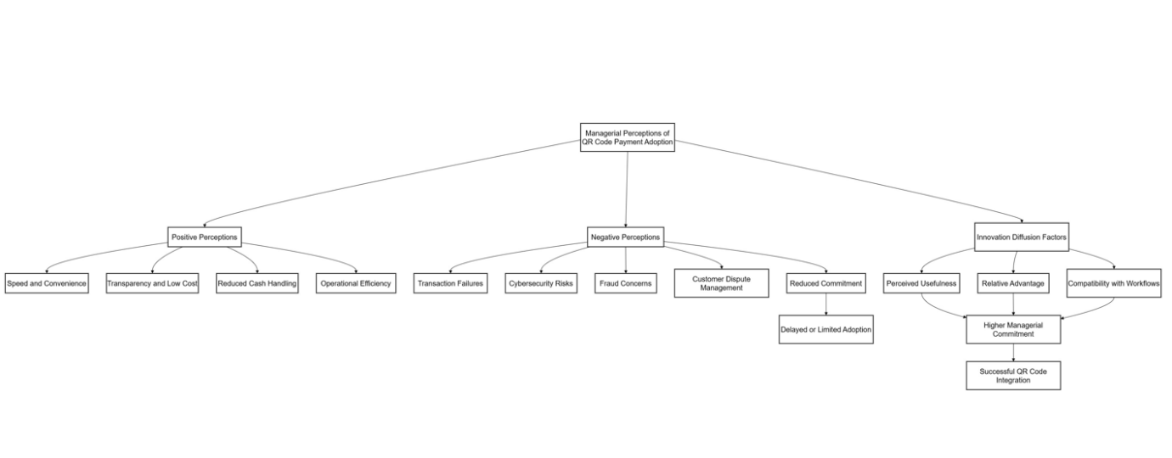

Figure 4.1: Managerial Perceptions Influencing QR Code Payment Adoption
(Source: Self-Created)

4.3 Key Managerial Challenges
The literature pinpoints that there are several managerial issues relating to the adoption and subsequent use of QR code payment systems in Indian businesses. The issues that can be found during operations are the need to align QR payments with current accounting and sales operations, unreliable network connectivity, and the presence of a hybrid cash-digital transaction environment. These are operational problems that tend to make work more complicated and heavier on the managers. The arising human issues are also important, especially the unwillingness of the employees to new technologies and the lack of digital literacy, as well as the necessity of continuous training and monitoring (Mishra et al., 2022). Managerial duties are also complicated by security issues that involve fraud prevention, data protection and customer trust management. These challenges are viewed through the lens of a Change Management Theory as an indicator of the significance of leadership, communication, and planned transition approaches. Managers need to be proactive in facilitating behavioural and procedural change in employees whilst upholding the quality of service delivery. It is repeatedly mentioned in the literature that managerial capability to manage organisational change dictates the achievement of operational disruption or long-term efficiency benefits of QR code payment adoption in various sectors of Indian businesses.

4.4 Opportunities Created by QR Code Payment Systems
Implementation of QR code payment systems has great strategic implications for managers in businesses in India. Improved operational efficiency, which is obtained through minimisation of cash handling, quicker transaction processing and easier reconciliation processes, is one of the biggest opportunities. QR-based payments are also valuable sources of digital transaction data; managers can use them to make decisions that are data-driven, track the sales performance, and determine the purchasing behaviour of customers. Moreover, the systems increase customer convenience through the provision of swift, contactless and secure payment methods and thus maximise customer satisfaction and loyalty (He et al., 2023). Within the scope of the Systems Theory, QR code payments make it easier to align the technology, organisational processes, and human resources. When properly incorporated, they facilitate easier work processes and enhanced coordination in the business processes. According to the literature, managers who can use these opportunities strategically can improve the agility, service delivery and competitiveness of the organisation. Therefore, the adoption of QR code payments, in an effective manner, leads to the development of sustainable businesses in various fields, including retail, hospitality, and service industries.

Table 4.1: Opportunities Created by QR Code Payment Systems
Opportunity Area | Key Features | Managerial Benefit | Organisational Impact
Operational Efficiency | Faster transactions, less cash handling | Reduced workload | Improved process efficiency
Data-Driven Decisions | Digital transaction data | Better decision-making | Enhanced performance monitoring
Customer Experience | Contactless, secure payments | Higher satisfaction | Increased loyalty
Systems Alignment | Technology–process–people fit | Better coordination | Organisational agility

4.5 Impact on Managerial Roles and Leadership Styles
The use of QR codes to pay changes the managerial functions and leadership styles in organisations drastically. The conventional managerial tasks, which are centred on supervision and control, are being phased out by the tasks centred on facilitation, digital coordination, and support to the employees. Managers must show flexibility, computer literacy, and teamwork in the resolution of problems. According to the literature, managers should take a proactive role in leading the employees through the technological changes without interrupting the stability of operations and customer satisfaction. Leadership has also been taken to be motivating the staff, managing opposition, and creating a culture that promotes innovation (Pradhan et al., 2025). According to Change Management Theory, there is a need to have a clear and communicated vision and constant involvement in such a transition. With the implementation of QR code payments in everyday business activities, the quality of management is increasingly determined by the capacity of uniting the technology innovation with human-focused leadership behaviours. This adjustment points to the dynamism of the managerial job in the Indian digital business context and the significance of leadership training in the processes of digital transformation.
Introduction of QR code payment systems also change the decision-making authority and accountability systems in organisations. Real-time transaction data are also becoming important to managers who monitor performance and manage cash flow and identify irregularities. This change will turn the managers into reactive supervisors into proactive decision makers whose role will be data informed. Consequently, analytical competence and digital literacy are key managerial competencies in digitally enabled business. Moreover, the capability of employees in the field of digital tools has become the responsibility of the managerial position. Managers need to be learning facilitators, who need to provide employees with the payment procedures, troubleshooting, and customer interaction procedures regarding online payments. This teaching position will involve patience, verbal communication, and constant interaction, particularly in settings where there is a heterogeneous digital literacy domain.
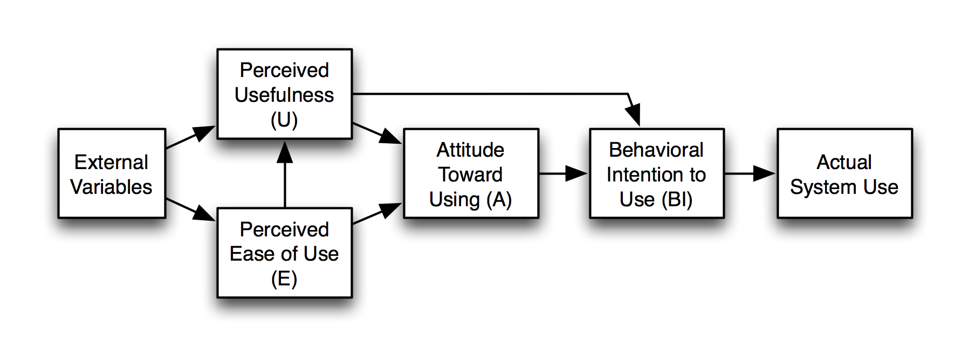

Figure 4.2: Managerial Perceptions Influencing

4.6 Integrated Theoretical Discussion
This section will unite the results of the study with the theoretical frameworks adopted in it to offer a comprehensive interpretation of the QR code payment adoption from the perspective of the manager. Innovation Diffusion Theory describes the factors of perceived usefulness, relative advantage, and compatibility on managerial adoption decisions and levels of commitment. The Systems Theory emphasises the dependency of technology, organisational processes and human resources and shows that when these aspects are not aligned, effective implementation may be inhibited (Soormo et al., 2024). The Change Management Theory will help in elucidating the areas of resistance and highlighting the leadership approaches that need to be put in place to ensure smooth organisational changes. A combination of these theories proves that the adoption of the QR code payment is not a technical upgrade but a multifaceted managerial and organisational change. The combined theoretical debate enhances the explanatory strength of the research by interconnecting managerial behaviour, leadership dynamics, and organisational structures (Zhong and Moon, 2022). This synthesis supports the conceptual contribution of the study to management and digital transformation literature in the Indian business environment.

Table 4.2: Integrated Theoretical Interpretation of QR Code Payment Adoption
Theoretical Framework | Key Concepts | Focus of Analysis | Managerial Implications | Relevance to QR Code Payment Adoption
Innovation Diffusion Theory | Perceived usefulness, relative advantage, compatibility | Explains how managers evaluate and decide to adopt QR code payment systems | Managers must assess benefits, align systems with existing workflows, and encourage adoption through perceived value | Demonstrates that adoption depends on managerial perception and commitment rather than technology availability alone
Systems Theory | Interdependence of technology, people, and processes | Examines alignment between QR technology, organisational structures, and human resources | Managers need to ensure coordination between systems, employees, and operational processes | Highlights that misalignment can hinder the effective implementation of QR payment systems
Change Management Theory | Resistance to change, leadership, and transition processes | Explores how organisations adapt to digital payment adoption | Managers must address resistance, communicate change, and support employee adaptation | Shows that successful QR adoption requires structured organisational change, not just system installation
Integrated Theoretical View | Interaction of adoption, systems, and change | Provides a holistic understanding of managerial and organisational transformation | Managers play a central role in balancing technological, human, and structural elements | Confirms QR code payment adoption as a multidimensional managerial challenge
Conceptual Contribution | Managerial behaviour, leadership dynamics, organisational structure | Strengthens the explanatory power of theory-based analysis | Encourages strategic, leadership-driven digital transformation | Contributes to management and digital transformation literature in the Indian business context

Chapter 5: Conclusion and Recommendations

5.1 Introduction
The chapter is the final part of the dissertation as it synthesises the main insights of the study and indicates how they can be applied to theory, management and policy. It revises the research purpose and discusses how the objectives have been fulfilled by using a theory-based research about QR code payment adoption in India. The chapter also gives the theoretical contributions of the study and practical implications, limitations of the study and future research directions. Altogether, it shows that the managerial views play a central role in explaining the adoption of digital payments in the changing digital business environment in India.

5.2 Summary of Key Findings
The paper concludes that QR code payment adoption in India is a challenge as well as an opportunity for managers. Operation integration concerns, digital illiteracy of the staff, security and resistance to organisational change are the main challenges. On the other hand, managers are in a better position to gain efficiency in their transactions, provide more customer convenience, and availability of online transaction information to make decisions. The results highlight the fact that the success of adoption is not about technology, but rather about managerial leadership, training programs, and proper change management in the organisations of Indian businesses.

5.3 Theoretical Contributions
The theoretical contribution of the study is that it broadens the research on digital payment adoption with consumer and technical dimensions to managerial and organisational ones. Combining the Innovation Diffusion Theory, Systems Theory, and Change Management Theory, the study provides a complex approach to the interpretation of the adoption of QR code payment. It shows that managerial behaviour, leadership dynamics and organisational alignment are important determinants of successful digital transformation. The research, therefore, contributes towards the literature of management and digital finance by connecting the theories of technology adoption to change and leadership.

5.4 Managerial Implications
The results provide valuable insights to managers who have been working in the digital economy of India. To lessen opposition to the adoption of QR code payment, managers should focus on training employees, making them digitally literate, and ensuring that they are supported. Adaptive leadership and powerful change management initiatives would be necessary to integrate digital payments into the current workflow. Transaction data that is produced through QR payments should also be used by the managers to advance the decision-making process and customer interaction. In sum, managerial effectiveness requires the creation of a balance between technological effectiveness and human-centred leadership in order to attain sustainable operational improvements.

5.5 Policy and Institutional Implications
The implications of the study for policymakers, financial institutions, and payment service providers in the digital payment ecosystem are found in India. The policymakers ought to support the ongoing technological infrastructure projects with managerial training and digital capability development programmes. Support mechanisms can also be developed by the financial institutions and regulators to meet the security issues and operational directions of the businesses. Institutional activities should aim at increasing managerial awareness, trust and competence as opposed to merely promoting volumes of adoption. This level of coordinated support can enhance organisational preparedness, improve implementation performance, and it will result in resilience.
In addition to short-term managerial and policy inferences, the results of this research highlight the fact that institutional cooperation is needed in enhancing the use of digital payment. Capacity-building programs specifically designed to suit managers of small and medium enterprises should be designed by industry associations, training institutes and payment service providers. These programs are capable of closing knowledge gaps concerning cybersecurity awareness, digital compliance and integration of operations. Additionally, the regulatory authorities can contemplate the issuance of less complex managerial directives that can elucidate the duties regarding the governance of digital transactions, resolving disputes, and data security. This would alleviate the doubts of managers and promote the confidence of further application of QR code payment systems.
On a business level, digital payment adoption must be institutionalised at organisational level by integrating it in the standard operating procedures instead of using it as an ancillary payment method. This involves organising the roles of employees, documentation of processes and incorporation of payment data in the managerial reporting systems. All these would help to build sustainable digital payment ecosystems in India as technological adoption is facilitated by managerial preparedness, institutional support, and leadership capability.

5.6 Limitations of the Study
This research must be limited in a number of ways. The study is theoretical and uses only secondary data, where empirical exploration of results is not possible. The digital payment in the Indian context can be described by rapid technological changes that might not be adequately covered in the literature. Moreover, the emphasis on managerial views does not allow for seeing experiences at the consumer level (Aurazo and Gasmi, 2024). The research has been context-specific to India, and this limits the generalisability of the research to other economies. Regardless of these limitations, the study offers some useful conceptual information on the management dynamics of payment adoption.

5.7 Recommendations for Future Research
In future studies, the study should be extended to include empirical research techniques like interviews, surveys, or case studies to include managers in various fields. Comparative research among regions or countries may lead to an improved generalisability and contextual awareness. Longitudinal studies can be used to record the strategy of digital payment innovation over time among managers (Eren, 2022). The consumer and employee views may also be included in future research to give a broad-based perspective of the adoption of QR code payments. This type of research would reinforce pragmatic significance and the enhancement of theoretical insight into digital transformation.

Reference list
- Aithal, R.K., Choudhary, V., Maurya, H., Pradhan, D. and Sarkar, D.N., 2023. Factors influencing technology adoption amongst small retailers: insights from thematic analysis. International Journal of Retail & distribution management, 51(1), pp.81-102. https://www.emerald.com/ijrdm/article-pdf/51/1/81/1043786/ijrdm-02-2022-0042.pdf
- Ananda, M.O., Annuar, S.N.S., Adam, A.A. and Sharkawi, S., 2023. The pivotal role of cashless system adoption among micro, small, and medium enterprises (MSMEs) in Malaysia: The challenges and opportunities. South East Asia Journal of Contemporary Business, Economics and Law, 28(3), pp.35-43. https://seajbel.com/wp-content/uploads/2023/03/SEAJBEL28.ISU-3_222.pdf
- Anbukarasi, M. and Sony, P.J., 2024. Evolution of Payment Systems in the Digital Era: A Comprehensive Analysis of Mobile Payments, Contactless Technology and the Disruptive Potential of Cryptocurrencies on Traditional Payment Systems. Formosa Journal of Computer and Information Science, 3(1), pp.55-68. https://www.researchgate.net/profile/Sony-Pj-2/publication/390775126_Evolution_of_Payment_Systems_in_the_Digital_Era_A_Comprehensive_Analysis_of_Mobile_Payments_Contactless_Technology_and_the_Disruptive_Potential_of_Cryptocurrencies_on_Traditional_Payment_Systems/links/67fdf5fddf0e3f544f41ac8a/Evolution-of-Payment-Systems-in-the-Digital-Era-A-Comprehensive-Analysis-of-Mobile-Payments-Contactless-Technology-and-the-Disruptive-Potential-of-Cryptocurrencies-on-Traditional-Payment-Systems.pdf
- Apasrawirotea, D. and Yawisedb, K., 2021. The factors influencing the adoption of E-payment system by SMEs. EPS, 15(8). https://www.researchgate.net/profile/Kritcha-Yawised/publication/352560708_The_Factors_Influencing_the_Adoption_of_E-Payment_System_by_SMEs_International_Journal_of_Innovation_Creativity_and_Change/links/60d052e5a6fdcc01d48b00c7/The-Factors-Influencing-the-Adoption-of-E-Payment-System-by-SMEs-International-Journal-of-Innovation-Creativity-and-Change.pdf
- Ashrafi, D.M. and Easmin, R., 2023. The Role of Innovation Resistance and Technology Readiness in the Adoption of QR Code Payments Among Digital Natives: A Serial Moderated Mediation Model. International Journal of Business Science & Applied Management, 18(1). https://www.researchgate.net/profile/Dewan-Mehrab-Ashrafi/publication/365823093_The_Role_of_Innovation_Resistance_and_Technology_Readiness_in_the_Adoption_of_QR_Code_Payments_Among_Digital_Natives_A_Serial_Moderated_Mediation_Model/links/6385bff1554def6193819f05/The-Role-of-Innovation-Resistance-and-Technology-Readiness-in-the-Adoption-of-QR-Code-Payments-Among-Digital-Natives-A-Serial-Moderated-Mediation-Model.pdf?origin=journalDetail&_tp=eyJwYWdlIjoiam91cm5hbERldGFpbCJ9
- Aurazo, J. and Gasmi, F., 2024. Digital payment systems in emerging economies: Lessons from Kenya, India, Brazil, and Peru. Information Economics and Policy, 69, p.101113. https://hal.science/hal-04954620v1/file/wp_tse_1572.pdf
- Autade, R., 2024. Navigating Challenges in Real-Time Payment Systems in FinTech. International Journal of Artificial Intelligence, Data Science, and Machine Learning, 5(1), pp.44-56. https://ijaidsml.org/index.php/ijaidsml/article/download/108/96
- Ayuningtyas, A., Adinugraha, H.H. and Sulthoni, M., 2024. Quick Response Code Indonesian Standard as a Digital Payment Solution to Increase the Turnover and Reduce the Circulation of Counterfeit Money. Journal of Education and Computer Applications, 1(1), pp.25-31. https://jeca.aks.or.id/jeca/article/download/7/4
- Azizah, S., Bintoro, B.K. and Octavyra, R.D., 2022. Determining factors of continuance intention to use qr code mobile payment on urban millennials in indonesia empirical study on mobile payment funds. ADI Journal on Recent Innovation, 3(2), pp.121-138. https://adi-journal.org/index.php/ajri/article/download/562/486
- Bhatia-Kalluri, A. and Caraway, B.R., 2023. Transformation of the digital payment ecosystem in India: a case study of Paytm. https://utoronto.scholaris.ca/bitstreams/6f86149d-f7bf-4a40-9a11-934734c1b7fc/download
- Cornelli, G., Frost, J., Gambacorta, L., Sinha, S. and Townsend, R.M., 2024, December. The organisation of digital payments in India–lessons from the Unified Payments Interface (UPI). In SUERF: The European Money and Finance Forum, SUERF Policy Note (No. 355). https://www.bis.org/publ/bppdf/bispap152_e_rh.pdf
- Dutta, N., Kar, S. and Guha, S., 2023. Informal sector in India and adoption of digital technologies. Indian Growth and Development Review, 16(3), pp.230-246. https://www.emerald.com/igdr/article-pdf/16/3/230/1320623/igdr-12-2022-0144.pdf
- Eren, B.A., 2022. QR code m-payment from a customer experience perspective. Journal of Financial Services Marketing, p.1. https://pmc.ncbi.nlm.nih.gov/articles/PMC9552149/pdf/41264_2022_Article_186.pdf
- George, A.S., George, A.H., Baskar, T. and Martin, A.G., 2023. An Overview of India's Unified Payments Interface (UPI): Benefits, Challenges, and Opportunities. Partners Universal International Research Journal, 2(1), pp.16-23. https://puirj.com/index.php/research/article/download/83/67
- He, C., He, L., Lu, Z. and Li, B., 2023. " I Have to Use My Son's QR Code to Run the Business": Unpacking Senior Street Vendors' Challenges in Mobile Money Collection in China. Proceedings of the ACM on Human-Computer Interaction, 7(CSCW1), pp.1-28. https://dl.acm.org/doi/pdf/10.1145/3579493
- Hendrawan, M.R.N.A., Marits, S.A. and Herman, S., 2023. Development of digital payment systems in Indonesia. https://jurnal.ibik.ac.id/index.php/jimkes/article/download/2328/1585
- Hussain, S., Gupta, S. and Bhardwaj, S., 2025. Determinants inhibiting digital payment system adoption: an Indian perspective. Qualitative Research in Financial Markets, 17(4), pp.716-748. https://www.emerald.com/qrfm/article-abstract/17/4/716/1257250
- Jiang, Y., Ahmad, H., Butt, A.H., Shafique, M.N. and Muhammad, S., 2021. QR digital payment system adoption by retailers: the moderating role of COVID-19 knowledge. Information Resources Management Journal (IRMJ), 34(3), pp.41-63. https://www.igi-global.com/article/qr-digital-payment-system-adoption-by-retailers/280069
- Khando, K., Islam, M.S. and Gao, S., 2022. The emerging technologies of digital payments and associated challenges: a systematic literature review. Future Internet, 15(1), p.21. https://www.mdpi.com/1999-5903/15/1/21
- Kumar, M., Singh, J.B. and Sharma, S.K., 2025. Evolving “affordances” and “constraints” in mobile payment use: a study of Indian micro-enterprises’ UPI adoption process. Journal of Enterprise Information Management, 38(2), pp.660-678. https://www.emerald.com/insight/content/doi/10.1108/JEIM-09-2023-0455/full/html
- Le, X.C., 2022. The diffusion of mobile QR-code payment: an empirical evaluation for a pandemic. Asia-Pacific Journal of Business Administration, 14(4), pp.617-636. https://www.emerald.com/apjba/article-pdf/14/4/617/365847/apjba-07-2021-0329.pdf
- Ledi, K.K., Ameza-Xemalordzo, E., Amoako, G.K. and Asamoah, B., 2023. Effect of QR code and mobile money on performance of SMEs in developing countries. The role of dynamic capabilities. Cogent Business & Management, 10(2), p.2238977. https://www.tandfonline.com/doi/pdf/10.1080/23311975.2023.2238977
- Litoriya, R., Arora, A., Bajaj, R. and Gulati, A., 2022. Adoption of Blockchain Technology in the Indian Business Market: Obstacles and Opportunities. In Blockchain Applications in the Smart Era (pp. 211-236). Cham: Springer International Publishing. http://irepo.futminna.edu.ng:8080/jspui/bitstream/123456789/15299/1/2022%20springer%2036063293-a578-42c2-967c-37c54c022826.pdf#page=217
- Maharjan, A., Danuwar, R.K., Kayestha, M., Maharjan, M., Baral, D.K., Koirala, A. and Timalsina, D.P., 2024. Analysing customers’ perception on QR payment in Kathmandu Valley: An empirical study using UTAUT and PLS-SEM. Quest Journal of Management and Social Sciences, 6(1), pp.57-73. https://nepjol.info/index.php/qjmss/article/download/67216/51482
- Mahesh, A. and Bhat, G., 2022. A systematic review and research agenda of digital payment system with reference to Unified Payment Interface. International Journal of Management, Technology, and Social Sciences, 7(2), pp.679-709. https://www.academia.edu/download/100478920/38._A_Systematic_Review_and_Research_Agenda_of_Digital_Payment.pdf
- Mahesh, A. and Bhat, S.G., 2022. India’s digital payment landscape–an analysis. International Journal of Case Studies in Business, IT, and Education, 6(1), pp.223-236. https://www.academia.edu/download/96248673/15._India_s_Digital_Payment.pdf
- Mehraj, D., Islam, M.I.U., Nissa, V.U. and Iqbal, S., 2024. Challenges and prospects in the adoption of mobile payment systems in India. https://www.intechopen.com/online-first/89664
- Mishra, V., Walsh, I. and Srivastava, A., 2022. Merchants’ adoption of mobile payment in emerging economies: the case of unorganised retailers in India. European Journal of Information Systems, 31(1), pp.74-90. https://www.tandfonline.com/doi/abs/10.1080/0960085X.2021.1978338
- Moghavvemi, S., Mei, T.X., Phoong, S.W. and Phoong, S.Y., 2021. Drivers and barriers of mobile payment adoption: Malaysian merchants' perspective. Journal of Retailing and Consumer Services, 59, p.102364. https://www.researchgate.net/profile/Sedigheh-Moghavvemi/publication/345803657_Drivers_and_barriers_of_mobile_payment_adoption_Malaysian_merchants'_perspective/links/5fae25bf299bf18c5b707ce7/Drivers-and-barriers-of-mobile-payment-adoption-Malaysian-merchants-perspective.pdf
- Nandru, P., SA, S.K. and Chendragiri, M., 2024. Adoption intention of mobile QR code payment system among marginalized street vendors: an empirical investigation from an emerging economy. Journal of Science and Technology Policy Management, 15(6), pp.1709-1733. https://www.emerald.com/jstpm/article-pdf/15/6/1709/9466962/jstpm-03-2023-0035.pdf
- Paramita, E.D. and Cahyadi, E.R., 2024. The Determinants of behavioral intention and use behavior of QRIS as digital Payment Method using Extended UTAUT model. Indonesian Journal of Business and Entrepreneurship (IJBE), 10(1), pp.132-132. https://journal.ipb.ac.id/index.php/ijbe/article/download/48600/27255
- Pradhan, K.C., Kumar, S. and Sharma, R., 2025. Adopting digital financial technology in Madhya Pradesh, Central India: opportunities, challenges, and determinants. Journal of the Knowledge Economy, 16(2), pp.10599-10638. https://link.springer.com/article/10.1007/s13132-024-02190-7
- Prawitasari, D., Badiani, F.D., Rachmawati, S.D., Ningrum, F.P. and Mufidah, N.L., 2024. QRIS in indonesia: a comprehensive literature review on adoption, challenges, and opportunities. Revenue: Jurnal Manajemen Bisnis Islam, 5(1), pp.91-102. https://ejournal.radenintan.ac.id/index.php/RJMBI/article/download/22760/7183
- Puspitasari, A. and Salehudin, I., 2022. Quick response Indonesian standard (QRIS): Does government support contribute to cashless payment system long-term adoption?. Journal of Marketing Innovation (JMI), 1(2), pp.27-41. https://papers.ssrn.com/sol3/Delivery.cfm?abstractid=4076192
- Putrevu, J. and Mertzanis, C., 2024. The adoption of digital payments in emerging economies: challenges and policy responses. Digital Policy, Regulation and Governance, 26(5), pp.476-500. https://papers.ssrn.com/sol3/Delivery.cfm?abstractid=4558978
- Rachman, A., Julianti, N. and Arkoyah, S., 2024. Challenges and Opportunities for QRIS Implementation as a Digital Payment System in Indonesia. EkBis: Jurnal Ekonomi dan Bisnis, 8(1), pp.1-13. https://ejournal.uin-suka.ac.id/febi/ekbis/article/download/2134/1180
- Rafferty, N.E. and Fajar, A.N., 2022. Integrated QR payment system (QRIS): cashless payment solution in developing country from merchant perspective. Asia Pacific Journal of Information Systems, 32(3), pp.630-655. https://koreascience.kr/article/JAKO202213043252491.pdf
- Rana, N.P., Luthra, S. and Rao, H.R., 2023. Assessing challenges to the mobile wallet usage in India: an interpretive structural modelling approach. Information Technology & People, 36(4), pp.1533-1554. https://inria.hal.science/hal-03744800/document
- Raut, N., 2024. DIGITAL PAYMENT SYSTEM IN INDIA–PATHWAY TO DIGITAL INDIA. International Journal of Management, Economics and Commerce, 1(1), pp.55-58. https://pdfs.semanticscholar.org/e74e/d8341841cd47a3377adab2c042626464cbe4.pdf
- Shekhar, S., A STUDY ON THE ROLE OF TRUST AND SECURITY CONCERNS IN INFLUENCING SMEs OWNERS'DECISION TO ADOPT QR CODE PAYMENT SYSTEM IN BIHAR. https://ijastre.org/wp-content/uploads/2023/09/vol-12-iss-4-paper-45.pdf
- Singh, N.K. and Singh, P., 2022. Identifying consumer resistance of mobile payment during COVID-19: An interpretive structural modeling (ISM) approach. Business, Management and Economics Engineering, 20(2), pp.258-285. https://aviation.vgtu.lt/index.php/BMEE/article/download/16905/11408
- Soormo, R.B., Al-Rahmi, W.M., Dahri, N.A., Alblehai, F., Alshimai, A., Aldaijy, A. and Salameh, A.A., 2024. Evaluating the influence of UTAUT factors on the adoption of QR codes in MSMEs: An application of SEM and ANN Methodologies. IEEE Access. https://ieeexplore.ieee.org/iel8/6287639/10380310/10772428.pdf
- Sudirman, A., Butarbutar, N. and Lie, D., 2022. Analysis of the effect of performance expectancy, effort expectancy, and lifestyle compatibility on behavioral intention QRIS in Indonesia. International Journal of Scientific Research and Management, 10(11), pp.4203-4211. http://repository.stiesultanagung.ac.id/id/eprint/1024/1/Article%2BIJSRM%2BNovita.pdf
- Sulistyaningsih, H. and Hanggraeni, D., 2022. Investigating the Adoption of QR Code Indonesian Standard through Organizational and Environmental Factors and Its Impact on Micro Small Medium Enterprise Performance. Global Business and Management Research, 14(3s), pp.962-982. https://www.gbmrjournal.com/pdf/v14n3s/V14N3s-67.pdf
- Suo, W.J., Goi, C.L., Goi, M.T. and Sim, A.K., 2022. Factors influencing behavioural intention to adopt the QR-code payment: extending UTAUT2 model. International Journal of Asian Business and Information Management (IJABIM), 13(2), pp.1-22. https://www.igi-global.com/viewtitle.aspx?titleid=281264
- Trivedi, H. and Sanchiher, S., 2023. Challenges in digital payment adoption in India. International Journal of Education, Modern Management, Applied Science & Social Science, 5(2), pp.32-38. https://www.researchgate.net/profile/Hemant-Trivedi/publication/375610457_CHALLENGES_IN_DIGITAL_PAYMENT_ADOPTION_IN_INDIA/links/65533164ce88b87031e554af/CHALLENGES-IN-DIGITAL-PAYMENT-ADOPTION-IN-INDIA.pdf
- Tu, M., Wu, L., Wan, H., Ding, Z., Guo, Z. and Chen, J., 2022. The adoption of QR code mobile payment technology during COVID-19: a social learning perspective. Frontiers in Psychology, 12, p.798199. https://www.frontiersin.org/journals/psychology/articles/10.3389/fpsyg.2021.798199/pdf
- Yamin, M.A.Y. and Abdalatif, O.A.A., 2024. Examining consumer behavior towards adoption of quick response code mobile payment systems: transforming mobile payment in the fintech industry. Humanities and Social Sciences Communications, 11(1), pp.1-11. https://www.nature.com/articles/s41599-024-03189-w.pdf
- Zhong, Y. and Moon, H.C., 2022. Investigating customer behavior of using contactless payment in China: A comparative study of facial recognition payment and mobile QR-code payment. Sustainability, 14(12), p.7150. https://www.mdpi.com/2071-1050/14/12/7150
- Zhou, Y., Hu, B., Zhang, Y. and Cai, W., 2021. Implementation of cryptographic algorithm in dynamic QR code payment system and its performance. IEEE Access, 9, pp.122362-122372. https://ieeexplore.ieee.org/iel7/6287639/6514899/09523747.pdf

