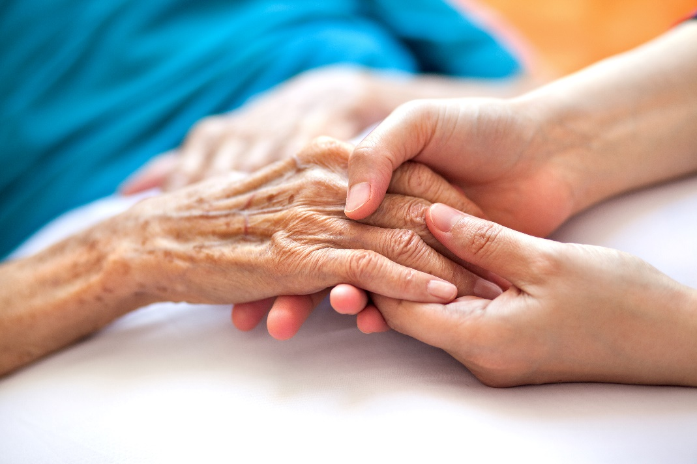
Research and Evaluation Skills for Health Care Practice.
Acute setting Dementia care and the Therapy Assistant Practitioner.

LAURA CLARK
2318467

CONTENTS PAGE

Introduction Pg3.
Case Study Pg3-4.
Overview of condition Pg4-5.
Previous approaches to condition Pg5.
Current approaches to condition Pg5-6.
Co-Production Pg6.
Clinical Governance Pg7.
Conclusion Pg8.
Reference List Pg9-11.
Appendices Pg12.

Introduction
This report shows a case study of a patient with vascular dementia attending Accident and Emergency after a fall. What impacts the condition has on the patient and her family. The changes in the approach to caring for a vascular dementia patient past and present and the continuing development of therapies including the Therapy Assistant Practitioner role in a Front of House setting.
Case Study
This case study will focus on how dementia and frailty has impacted on an individual who presents to an Accident and Emergency (A&E) department after a fall, how the role of a Therapy Assistant Practitioner (TAP) has developed to support frailer older adults suffering from vascular dementia.
Acute hospitals have a long history of having an established ‘front door service’, known as accident and emergency. The role of the TAP in this case example is based within a joint community and inhouse team called the Intermediate Care Team (ICT), who work to support frail individuals to be discharged home and to avoid readmittance as safely as possible. The TAP works alongside Allied health professions, such as OT’s and Physio’s and other multidisciplinary members, such as nurses, geriatricians, and medical staff. The key aspect of the TAP role is to screen referrals for suitability of the service, to recognise if the case is within the TAP scope of practice or needs referring to qualified therapies, to contribute towards the Comprehensive Geriatric Assessment (CGA) and support through therapy interventions. TAP’s have access to standardised and non-standardised assessments, to help recognise levels of function and risks. In addition to assessments, the TAP ensures to uphold a person centred assessment, to help set achievable and realistic SMART goals (carelearning.org.uk, 2024)&(British Geriatric Society).
A typical case example of a frail older person suffering from vascular dementia who presents to A&E after a fall is Helen. Helen is a pseudo name for anonymity. Helen is an 87-year-old lady who has a past medical history of osteoarthritis, arterial fibrillation, hip replacement, stroke, cerebrovascular disease, chronic obstructive pulmonary disease, Essential hypertension, and vascular dementia. The CGA form is completed with Helen, her husband and daughter to get all the social and environmental information to get a holistic person-centred view on where and how we can help if needed. Helen has fallen getting up wandering in the night. She has lost her balance and fell hurting her right elbow and right hip, bruising them but not fracturing them. Helen lives with her husband in a level access 2-bedroom bungalow. It has a wet room with wall fixed seat and grab rails, the toilet has been heightened and has grab rails fitted to the walls. Husband will cook and prepare food for both. They sleep in separate bedrooms due to Helen, becomes agitated and restless in the night. Helen has two times a day package of care to help with washing and dressing. Helen normally walks with a rollator Zimmer frame with supervision, so she is using it correctly and does not tend to walk more than 5 metres. Helen sleeps a lot of the day in her rising recliner chair. Helen is totally incontinent. Helen tends to be awake at night which her husband is finding hard to cope with. Their daughter lives close by but works full time and has young children to take care of. she tries to support her parents as much as she can by shopping, cleaning, and taking them to appointments but is worried about her dad copying. Helen has been experiencing challenging behaviour and does not want to listen to her husband when he tries to help her, that is why they have a care package to help in the morning and at night because she no longer recognises her husband and hits out. When Helen fell, he could not get her off the floor by himself so had to call for an ambulance since being in the hospital she has been using a steady with the health care support workers. After an emotional conversation with Helen’s family and social worker it was agreed that Helen's husband is struggling with her ongoing deterioration of Helen's condition and that respite was needed as well as talks on a possible permanent placement in a nursing home.

Overview of Condition
Vascular dementia is the second most common form of dementia after Alzheimer's. Vascular dementia usually can be caused by stroke or small vessel disease affecting the blood flow to the brain causing neurons to starve of nutrients and oxygen. This starvation to the brain causes the brain to start deteriorating and dying which spreads throughout the different spheres of the brain either causing more strokes or progression of dementia. Once diagnosed there is no cure but if diagnosed early enough the underlining conditions such as high blood pressure can be treated and managed to reduce the speed of the progression of dementia. Life expectancy is only five years with vascular dementia due to the higher risk of having a repeated stroke or heart attack, this is less than average life expectancy for someone who has been diagnosed with Alzheimer’s. It is estimated 180,000 people in the UK are currently suffering vascular dementia. In Wales the rate of diagnosis for dementia in 65-year-olds and over is 53.9% in 2021/ 22 this raised to an estimated number of 64.8% in March 2024 with vascular dementia being the second most common form.(NHS Digital,2024)&(NICE.org.uk) Each patient is an individual and everyone experiences life in different ways. Dementia does not change this but there are 7 stages to the disease that all patients gradually progress through. The first 3 stages of dementia are very mild changes in forgetfulness which often get missed. It is not until the later stages of 3 and 4 that patients are noticed to be suffering a decline in cognitive function, tested, and are diagnosed. Stages 3 and 4 patients will be more forgetful. Forgetting recent events, directions to places. Not being able to find the right words during a conversation and finding it hard to concentrate. They will find it hard to travel alone to new places, deal with finances, or complete complex tasks but may be in denial of these symptoms and will try to hide from others causing some patients to become withdrawn from their normal social lifestyle. The patient may start to have balance issues at this stage stumbling over feet or rugs. Stages 5 to 6 are classed as the mid stages this is when the patient will experience major memory difficulty which will affect them remembering where they live and needing help with day to day activities these needs significantly increase towards the end of stage 6 as patients will start to not recognise familiar people and sometimes begin to develop challenging behaviours or anxiety, they will also start developing problem with speech. Patients may still be mobile with walking aids but have become very unsteady and won’t use the aids properly without supervision sometimes not following direction. Most patients will be or start to be completely incontinent. Stage 7 is classed as the late stage; this is where most patients either have a placement in a nursing home or have 3 times a day package of care as well as having family who live with them to support them. By this stage patients will not be able to communicate, will need help to eat and drink and will have lost the ability to walk. Most patients are bed bound and cared for in bed.
Many patients’ families have said it is not just the individual that suffers from dementia after diagnosis but the whole family who love and care for them. Many suffer from constant stress, anxiety and depression when caring at home with them but also guilt and money worries when patients need to go into a home.(Alzheimers.org.uk)

Previous Approaches to the Condition
Prior to having therapy services within A&E departments a typical case, such as Helen, would have been admitted and bed based care would have been a common practice to manage the needs of someone with dementia in hospital, which has significant implications on physical, cognitive and psychosocial health. (NICE.org.uk)
Aspects of an individual’s social and environmental concerns would not have been addressed to prevent any unnecessary admission. A hospital admission would have caused additional strain to the individual’s wellbeing and independence. This in some cases causing delays in getting social care would result in patients having to stay in hospital longer creating a vicious cycle of the patient’s condition deteriorating further. (NICE.org.uk)
In some areas of Wales, such a Withybush hospital, the introduction of therapy to A&E has been developing a role in supporting a more timely and safer discharge; however it has taken some years for the assessment to be multidisciplinary …… which is known today as best practice. (Department of Health and Social Care, 2019)

Current Approaches to the Condition
With the current developments of the inhouse/community services of ICT, the new frailty team and the Joint Discharge Team patient’s like Helen are no longer overlooked. The CGA documentation is done straight away and care needs are highlighted. Reducing the delay in other services being involved and delays in patients discharge. (The Royal College of Psychiatrists')
Patients who will benefit from a community ICT follow up are highlighted before discharge by ICT TAP and therapists inhouse. This reducing the readmittance of struggling patients. Further services can be referred to or additional equipment can be put in place quicker following the visit. (Department of Health and Social Care, 2019) & (The Royal College of Psychiatrists')
The TAP can help with the deterioration of mobility while the patient is waiting for discharge from the acute setting by daily exercise and care plans.
Online mandatory dementia training for all clinical staff. Making staff more aware of the possible dementia patients and their family’s needs and who they can refer to. (Department of Health and Social Care, 2019) & (NICE.org.uk)
The increased awareness and use of Admiral Nurses to help carers of people with dementia. (Department of Health and Social Care, 2019) & (dementiauk.org)

Co-Production

For a vascular dementia patient like Helen the TAP would have to co-product internally:
with other allied health professionals within the ICT acute settings, Occupational therapists and physiotherapists, District nurses for physical assessments and prescribing of equipment. Due to the working rota of the team physiotherapists and Occupational therapists roles are blurred to work to the demands of The front of house.

A&E doctors refer patients to the ICT FOH and TAP, they then work alongside each other until patient is medically fit for discharge. The downside is inappropriate patient referrals and CGA documentation not being read. Doctors being under pressure to discharge patients quickly due to demands of the busy A&E department can miss problem areas.

Nurses and Health Care Support Workers. Help with mobilising, providing care needs, pain medication, information gathering on current conditions. Due to high demand of the department and lack of staff this can be delayed.

Frailty team
Joint discharge team.

The TAP would co-product with external teams to continue treatment plans this would mostly be in the form of making referrals either by phone or by emailing directly to the teams or via the co-ordination Hwb.
Social Workers, waiting times due to staff capacity.
Care companies/ carers, staff capacity, restrictions to certain areas, restricted to what time the calls they can do.
Admiral Nurses, staff capacity, they are only there to support the carer or family member who is caring for the patient. They can only be referred once a patient has got an official diagnosis.
Community alarms, this has to be done by phoning the council which takes a long time.
Equipment stores for delivery of equipment to patients houses. Ordering equipment for delivery is a online store. Equipment can be quite hard to find as sometimes the equipment has not been put on the catalogue using the same equipment name we use.
Community physio, staff capacity, waiting times,
Community Occupational therapy, staff capacity, waiting times,
Falls Team, staff capacity.
CLINICAL GOVERNANCE,
Clinical governance is a system which over sees the quality and safety of the services given within the NHS. There are currently seven pillars of governance that NHS services need to work to.
* Information management, * Quality clinical audit, * Staff management, * Risk management,
* Training and education, * Service user engagement, * Clinical effectiveness and audit.
For this report two of these pillars will be focused on to show how they affect the care of dementia patients.
Training and Education.
Continuous training and development ensues NHS care providers have the most up to date knowledge and skills to provide the best care possible (Castlefield recruitment,2024.)&(Flint.J,2024.). This can only be achieved by reviews, audits and research studies making sure the training provided is at the most appropriate standard.
Mandatory Training.
The Department of Health and Social Care(2019) started a review into the increasing numbers of patients seen within the NHS who had dementia, the quality of the care provided and how this could be improved. The review found that dementia services were failing in many area’s one main area was the lack of knowledge and training health care providers had on dementia, specifically nurses. Surr and Gate (2017) did a literature review which the results concur with these findings that the lack of knowledge and skills resulted in poor care of dementia patients within a hospital setting but also that this is a global problem not just the United Kingdom, the results from Surr and Gate (2017) also found that the type of training that is most effective still needed further research. A data collective study started in 2017 by Parveen et al (2021) found that it was not only the knowledge and skills that needed to be improved but the pedagogical and content of the training to also help with attitude and understanding. Gkioka et al (2020) supports this view in the research into the “Evaluation and Effectiveness of Dementia Staff Training Programs in General Hospital Settings” the findings show that a more immersive, hands on approach to training was the most effective.

Clinical effectiveness and audit.
Clinical effectiveness and audit is about the research, assessments and guidelines health care providers use to continuously find ways to update and improve services. This can cover pilot assessments and documentation.
CGA documentation,
A current focus on dementia care is to reduce the length of stay within the hospital and re admittance into the acute setting once discharged. This resulting in reduced deconditioning, confusion and delayed recovery. Comprehensive Geriatric Assessment is a piece of documentation used to collect biopsychosocial information of a patient within the hospital setting. This information can then be used by various health care providers to provide the best care plan for that individual. For example the CGA can highlight certain areas the dementia patient or their carer are struggling with such as mobility issues that further assessments from physiotherapists and occupational therapists could do to prescribe equipment to increase their independence or referrals to Admiral Nurses to help support carers who are struggling. Sohail and Cooney (2023) study into the pilot of the CGA found that using the CGA within the hospital environment had a 92.8% positive reduction in readmittance to hospital after discharge due to it effectively highlighting the need for referrals and input from various MDT’s. A literature review by Chen et al (2021) disagrees with the effectiveness in CGA’s at reducing the length of stays in hospital but finds that the documentation is effective at improving quality of life and reducing caregivers burden, but believes further investigation is needed into to see the overall benefits of the CGA documentation.
CONCLUSION
From this report it is concluded that even though there has been a vast improvement to dementia care since 2015. Taking a more individual, biopsychosocial approach has helped people get the MDT input needed quicker to help improve quality of life and reduce readmittance into hospital, but that further funding to improve staffing shortages is needed to reduce waiting times, continued research into the effectiveness of CGA’s and also improvements to the training process are needed.

REFERRENCE LIST.

Alzheimer’s Society(2018) Prime Minister’s Challenge on Dementia: What is happening and what comes next.
Available at: https://www.alzheimers.org.uk/blog/prime-ministers-challenge-dementia-what-happening-and-what-comes-next
British geriatric society(2019) Comprehensive Geriatric Assessment Toolkit for Primary Care Practitioners
Available at: https://www.bgs.org.uk/resources/resource-series/comprehensive-geriatric-assessment-toolkit-for-primary-care-practitioners
Campbell, D., Lugger, S., Sigler, G.S. and Turkelson, C., 2021. Increasing awareness, sensitivity, and empathy for Alzheimer's dementia patients using simulation. Nurse education today, 98, p.104764.
Care learning.org.(2024) What are SMART goals in Health and Social Care?.
Available at: https://carelearning.org.uk/blog/frameworks/what-are-smart-goals-in-health-and-social-care/

Chen, Z., Ding, Z., Chen, C., Sun, Y., Jiang, Y., Liu, F. and Wang, S., 2021. Effectiveness of comprehensive geriatric assessment intervention on quality of life, caregiver burden and length of hospital stay: a systematic review and meta-analysis of randomised controlled trials. BMC geriatrics, 21, pp.1-14.

Dementiauk.org(2024) Admiral Nurse Dementia Helpline.
Available at: https://www.dementiauk.org/information-and-support/how-we-can-support-you/admiral-nurse-dementia-helpline/

Department of Health and Social Care(2019) Dementia 2020 challenge: progress review.
Available at: https:/www.gov.uk/government/publications/dementia-2020-challenge-progress-review

Gkioka, M., Schneider, J., Kruse, A., Tsolaki, M., Moraitou, D. and Teichmann, B., 2020. Evaluation and Effectiveness of Dementia Staff Training Programs in General Hospital Settings: A Narrative Synthesis with Holton’s Three-Level Model Applied.

Healthcare Quality Improvement Partnership(2019) National Audit of Dementia – Round 4 Audit
Avalable at :https://www.hqip.org.uk/resource/national-audit-of-dementia-round-4-audit-report/#.XbmLBzY3aHt

NHS Digital(2024) Primary Care Dementia Data, March 2024,
Available at: https://digital.nhs.uk/data-and-information/publications/statistical/primary-care-dementia-data
NICE.org.uk(2015) NICE guidelines, Transition between inpatient settings and community or care home settings for adults with social care needs
Available at: https://www.nice.org.uk/guidance/ng27
NICE.org.uk(2024) NICEimpact Dementia, Hospital Care.
Available at : https://www.nice.org.uk/about/what-we-do/into-practice/measuring-the-use-of-nice-guidance/impact-of-our-guidance/niceimpact-dementia/ch3-hospital-care

NICE.org.uk(2016) NICE guidelines, Transition between inpatient settings and community or care home settings for adults with social care needs
Available at: https://www.nice.org.uk/guidance/qs136

NICE.org.uk(2018) NICEguidelines, Dementia: assessment, management and support for people living with dementia and their carers
Available at : https://www.nice.org.uk/guidance/ng97

Office for Health Improvement & Disparities(2024) Dementia Profile.
Available at : https://fingertips.phe.org.uk/profile/dementia

Parveen, S., Smith, S.J., Sass, C., Oyebode, J.R., Capstick, A., Dennison, A. and Surr, C.A., 2021. Impact of dementia education and training on health and social care staff knowledge, attitudes and confidence: a cross-sectional study. BMJ open, 11(1), p.e039939.

Sohail, A.A. and Cooney, E., 2023. 73 A pilot of introducing Comprehensive Geriatric Assessment (CGA) in older patients admitted to an acute hospital to prevent acute re-hospitalisation. Age and Ageing, 52(Supplement_3), pp.afad156-092.

Surr, C.A. and Gates, C., 2017. What works in delivering dementia education or training to hospital staff? A critical synthesis of the evidence. International journal of nursing studies, 75, pp.172-188.

The Royal College of Psychiatrists' (2024)The Royal College of Psychiatrists' National Audit of Dementia Care in General Hospitals.
Available at : https://www.rcpsych.ac.uk/improving-care/ccqi/national-clinical-audits/national-audit-of-dementia



