Teacher : Christopher Mafuva

Effective Team Working and Communication Term 1
Tiganuc Ioan Cosmin : 1817442
University of Wales Trinity Saint David

Table of Contents
Introduction 3
Team Work 3
Teamwork and its Significance 3
Communication 4
Communication Significance 4
Miss Akhrot Sweets Shop 4
Communication Types 5
Verbal Communication 5
Nonverbal Communication 5
Written Communication 6
Visual 6
Verbal Communication at Miss Akhrot Sweets Shop 6
Nonverbal Communication at Miss Akhrot Sweet Shop 6
Communication Theories 7
Shannon and Weaver Model of Communication 7
Sender 8
Encoder 8
Note 8
Decoder 8
Receiver 8
Noise 8
Feedback 9
Communication Model of Berlo 9
Sender 10
Message 11
Channel 11
Receiver 11
Schramm model of Communication 11
Conclusion 12
References 14

Introduction

Team Work
The capability of different individuals of a group that come together in order to work for a specific goal is known as 'Team Work'.

Teamwork and its Significance
It is not possible for a team to work together for the specific objective without the consent of all the team members and such content is known as the teamwork that is considered as one of the most significant factors upon which the success and productivity of all the businesses depend. It does not only helps the organisation but also the individual as teamwork allows the individual to interact with various other members and could learn from their expertise that could be helpful for them in the longer run. Furthermore, it was determined that through teamwork, multiple ideas could be discussed within the particular group, and the best idea could be selected in order to provide maximum benefit to the organisation. Likewise, teamwork plays an essential role in enhancing the work efficiency and overall productivity of the business as it allows the individuals to work upon the tasks rapidly and comparatively in a more efficient manner (Fidalgo-Blanco et al., 2015). Additionally, it reduces the overall burden upon an individual worker as responsibilities could be broken down and shared with other individuals and different tasks could be assigned as per the skills of the individuals working together in a team for a common objective. It was observed that teamwork could assist in enhancing the communication flow as all the employees in a team or group could share their ideas as compared to working individually in which those ideas mostly remain only with the employees and could not assist the business or organisation in achieving their common objective or goal (Goodman, 2017).

Communication
The constant process via which information and data are exchanged between two individuals or a group of individuals through the common behaviour system, sign as well as a symbol is known as communication (Ruesch et al., 2017).

Communication Significance
It was determined that effective communication could assist in the promotion of workforce motivation related to the tasks that are primary objectives of the organisation and it could assist in describing the methods through which such tasks could be done. Furthermore, it assists the workforce in improving their performances and provides them with job satisfaction that eventually enhances the overall productivity of the company. Through the effective process of communication, the influence and worker turnover rate has been identified as positive, and the absenteeism rate is reduced due to increased job satisfaction and job security. Communicating effectively could help the overall control process as it assists in behaviour control of workers in various distinct ways (Ladewig, J., 2019).

Miss Akhrot Sweets Shop
Miss Akhrot Sweets Shop is a small sweets shop in the neighbourhood of Manchester, along with delicious sweets, they also offer cappuccino and other snacks while providing a peaceful atmosphere for their customers. The motive of Miss Akhrot Sweet shop provides freshly home-baked cookies as well as brewed cappuccino to its consumers, especially in the morning in order to give a refreshing start to their morning. Miss Akhrot employs around twelve employees in which four of them are the cooks, including Miss Akhrot herself, who is the master chef alongside two cashiers and six waiters. Teamwork is exemplary as there is no glass ceiling or any blockage, which allows Miss Akhrot to communicate with her employees easily. It has been determined that due to the flexible and efficient communication system, the productivity rate of the outlet has increased alongside the individual performance of the employees. Due to effective communication by the leadership, it allows employees to share a friendly atmosphere that has enhanced the working capabilities as well as the decision making capacities of the employees. Furthermore, employees share their ideas with Miss Akhrot and are warmly received by the employer that allows them to meet varying consumer demands.

Communication Types
The company's workforce could exchange information in various ways; specifically, there are about four communication types that include verbal communication, written communication, nonverbal communication and visual communication (Ladewig, 2019).

Verbal Communication
Verbal communication is the exchange of information via speaking.

Nonverbal Communication
Nonverbal communication is carried out without speaking and through the body language of an individual that includes communicating through expressions and gestures.

Written Communication
The information exchange is carried out through the assistance of printed or in-writing communication that might involve various symbols, letters, as well as numbers (Ladewig, 2019).

Visual
This type of communication style involves communicating through different pictures, images, bar charts, graphs, as well as various kinds of presentations.

Verbal Communication at Miss Akhrot Sweets Shop
Verbal communication is considered to be the most integral and active communication type that is being implemented throughout the globe. Likewise, it is the most used communication type in Miss Akhrot Sweets Shop as well; the employer herself uses this type in order to guide her employees. Similarly, all the employees use it as an interdepartmental communication medium in order to share information and ideas as well as with their employer. This communication could be done via phone calls, meetings, one on one interaction or group discussion. Therefore, it is considered to be the most used communication type not only in Miss Akhrot Sweet Shop but throughout the world. Miss Akhrot uses verbal communication in order to guide her workforce and to make them work towards a common objective. Written presentations are also conveyed and presented through this form of communication as it is considered to be the most productive as compared to other types (Markovic, & Salamzadeh, 2018).

Nonverbal Communication at Miss Akhrot Sweet Shop
Nonverbal communication is also used alongside verbal communication in Miss Akhrot Sweet Shop, and such communication includes eye contact, expressions, body gestures and movements and body postures. The environment of Miss Akhrot Shop is quite peaceful and friendly and getting angry or showing some discomforting gestures to the consumers is strictly prohibited. Miss Akhrot use it quite effectively as well because, through her expressions, she could express her anger that could benefit the atmosphere of the outlet, and it helps the employees to realise their mistakes without being scolded in front of the consumers that could make them embarrass and could reduce their productivity. Therefore, nonverbal communication is considered to be one of the effective forms that could be used in combination with verbal communication as well (Gallois, & Giles, 2015).

Communication Theories
The communication models are considered a systematic process depiction, which assists in describing and understanding the overall communication process. It was determined that such communication models could be helpful in presenting the symbols of process. Furthermore, it assists in enhancing the traditional and old stereotyping. Nevertheless, it could neglect some primary communication elements associated with human beings (Ruesch et al., 2017).

Shannon and Weaver Model of Communication
The “Shannon and Weaver” communication model is specifically developed to create a system of communication for an organisation that is effective in transmitting the messages from receiver to sender. Such model adds up factors that could influence the whole communication process that is usually known as noise. Furthermore, it could cope up with various concepts that include the information source, channel of information, information destination, the transmitters as well as the encoding and decoding process (Gillespie & Schiffman, 2018).
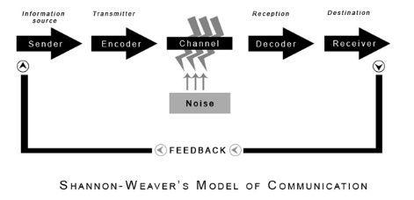

Sender
This is the source from which the message originates.

Encoder
Encoder assists in the transformation of the message into signals.

Note
The sender’s messages that are transformed in binary waves or signal are considered to compactable and could transmit the message of the sender using various cables and satellites.

Decoder
It is the signal receptor that then transforms the signals or data waves into messages.

Receiver
The individual to whom the message is sent or one who receives the messages.

Noise
External noises or disturbances from the atmosphere that could cause disruptions in the whole communication process.

Feedback
The message or response that the receiver sends back to its sender.
This model could be practically applied, and it includes all the above stages of the communication process. Miss Akhrot sends messages by calling her chefs when she is not in the outlet in order to remind them about the “sweet of the day”. However, if any noise or disruption occurs between the call, it would be considered as the transmission error. Whereas, the response by the receiver to the message of the sender is known as the feedback (Petersons, & Khalimzoda, 2016).
Sender: Miss Akhrot
Encoder: Cell Phone
Noise: Disruptions in the process of communication
Receiver: Chefs

Communication Model of Berlo
The communication model of Berlo is considered to a bit similar to the above model of "Shannon and Weaver" with the only modification that it consists of fewer stages or levels between them. The stages of such a model include the sender, message, channel and the receiver. Feedback from the receiver is not made part of the process, and this model of the communication process by Berlo is not as effective as compared to other models (Turaga, 2016).
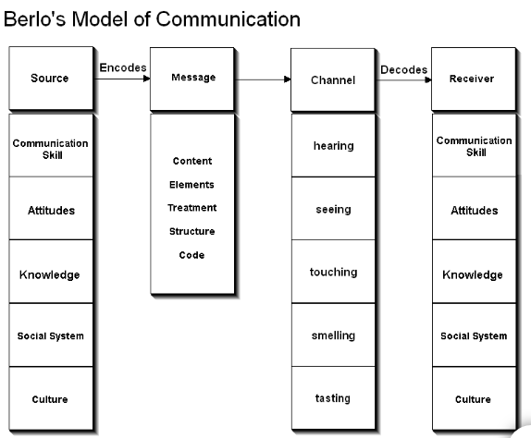

Sender
The sender is the individual that causes the message to originate, and there are various aspects associated with the sender that includes the communication skills, attitude, and data transmitting capabilities, culture as well as the knowledge and intellect of the sender.
As far as Miss Akhrot Sweet Shop is concerned, Miss Akhrot is equipped with excellent and fluent communication skills that allow her to influence her employees and to guide them regarding their responsibilities in an effective manner. Whereas, she possesses a desperate attitude and wants everything to be perfect and often gets angry at her employees. Nevertheless, she is quite capable and has a lot of knowledge regarding her shop that makes her a good guide for her team (Petersons & Khalimzoda, 2016).

Message
The message is the thing which is sent by the sender and is reached to the receiver. It could be delivered in various forms that include text, visuals, voice as well as audio.
In the case of Miss Akhrot, she originates the message and structures it effectively so that the receiver could perceive it accordingly and in an efficient manner.

Channel
The way through which the message is sent to the receiver is known as the channel.
As far as Miss Akhrot is concerned, she uses verbal as well as written communication in her meetings. Furthermore, she also uses visuals during her presentation in order to explain her objectives to the employees.

Receiver
The individual who receives the message.

Schramm model of communication
The communication model given by Schramm is a two-way process of communication that includes sender as well as the receiver. Such communication model needs two individuals who could take turns in order to send or receive messages. The aspect of this model consists of a sender, message, barriers of the communication process and the receiver.
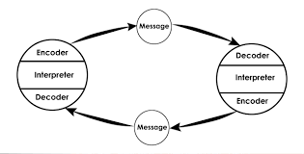
Schramm model is used by Miss Akhrot when she needs a rapid response during the meeting or phone calls. Such a model involves both senders as well as the receiver to be the part of the same experience field. Miss Akhrot and her employees work in the same field experience so such a model could be implemented in order to increase the process of communication and make it smoother in the Sweet Shop (Huang, 2003).

Conclusion
The following study describes the significance of communication and its various models that could be implemented in an organisation. It was determined that effective communication could help any organisation to accomplish its goals or objectives in an efficient manner. Effective communication could prove to be helpful in determining the desires of individuals and guides them to their destinations. Likewise, it was observed that effective communication could prove to be helpful in enhancing the productivity of a business. Furthermore, it allows the interdepartmental relations to grow that is considered to be an important part for the longer run. Through teamwork and effective communication, employees are closely related to each other as well as their employer and are highly motivated to achieve their common goals. Various types of communication could be used, such as verbal as well as nonverbal communication.

References
Huang, C., 2003. Transitional media vs. normative theories: Schramm, Altschull, and China. Journal of communication, 53(3), pp.444-459.
Turaga, R., 2016. Organisational models of effective communication. IUP Journal of Soft Skills, 10(2), p.56.
Gillespie, D.J. and Schiffman, R., 2018. A Critique of the Shannon-Weaver Theory of Communication and Its Implications for Nursing. Research and theory for nursing practice, 32(2), pp.216-225.
Ruesch, J., Bateson, G., Pinsker, E.C. and Combs, G., 2017. Communication: The social matrix of psychiatry. Routledge.
Gallois, C. and Giles, H., 2015. Communication accommodation theory. The international encyclopedia of language and social interaction, pp.1-18.
Markovic, M.R. and Salamzadeh, A., 2018. THE IMPORTANCE OF COMMUNICATION IN BUSINESS MANAGEMENT. BUSINESS MANAGEMENT, ENTREPRENEURSHIP AND ENTREPRENEURIAL TENDENCIES, p.11.
Ladewig, J., 2019. Body language: Its importance for communication with horses. Journal of Veterinary Behavior, 29, pp.108-110.
Fidalgo-Blanco, Á., Sein-Echaluce, M.L., García-Peñalvo, F.J. and Conde, M.Á., 2015. Using Learning Analytics to improve teamwork assessment. Computers in Human Behavior, 47, pp.149-156.
Goodman, D.S., 2017. Teamwork, communication and empathy: a case study examining social skills in drama class(Doctoral dissertation, Bilkent University).

Petersons, A. and Khalimzoda, I., 2016, May. Communication Models and Common Basis for Multicultural Communication in Latvia. In Proceedings of the International Scientific Conference. Volume IV (Vol. 423, p. 433).
Petersons, A. and Khalimzoda, I., 2016, May. Communication Models and Common Basis for Multicultural Communication in Latvia. In Proceedings of the International Scientific Conference. Volume IV (Vol. 423, p. 433)

