HealthyHarvest Website Redesign
UI/UX Design and Responsive E-Commerce Website Prototype
Assessment Title: HealthyHarvest Website Redesign and Prototype Development
Module Name: Web Design and Development
Module code: ACCA5019
Student Name: Cornelia Ioana Dobre
Student Number: 2333752
Submission Date: [26 / 06 /2026]

Table of Contents
1. Introduction 4
2. HealthyHarvest Website Redesign 4
2.1 Current Issues with the Existing Website 4
Navigation Issues 4
Information Architecture Issues 4
Product Information Issues 4
Trust and Credibility Issues 5
Shopping Journey Issues 5
2.2 Proposed Redesign Solutions 5
Improved Navigation 5
Improved Product Discovery 5
Improved Product Transparency 6
Improved Trust 6
Improved Conversion Flow 6
3. Responsive Design Implementation 6
3.1 Responsive Design in E-Commerce 6
3.2 Impact on User Experience 7
3.3 Impact on Mobile Sales 7
4. Implementation 7
4.1 Mood Board 7
4.2 Wireframes 8
Homepage Wireframe 8
Shop Page Wireframe 9
Product Details Wireframe 9
Cart Page Wireframe 10
Checkout Page Wireframe 11
4.3 High-Fidelity Prototype 11
Homepage Prototype 11
Shop Page Prototype 12
Product Details Prototype 12
Cart Page Prototype 13
Checkout Page Prototype 14
5. Conclusion 14
6. References 16

1. Introduction
HealthyHarvest is an online grocery delivery service that offers organic fruits and vegetables, pantry items, healthy meals, and subscription boxes. There are usability problems with the current website, though – like poor navigation, a lack of product discovery, poor product description, and poor trust-building. This project is currently in the process of being redesigned according to user interface (UI) and user experience (UX) principles to improve usability and customer engagement with the HealthyHarvest website. For e-commerce, UI/UX design is essential to effectively guide the user to find products faster and make the purchasing process more convenient. Furthermore, responsive website design means that websites will be able to function on different devices, particularly mobile phones that are widely used to promote e-commerce. This report is designed to address current website problems, to discuss responsive design factors, and to present created mood board, wireframes and high fidelity prototype.

2. HealthyHarvest Website Redesign

2.1 Current Issues with the Existing Website

Navigation Issues
The current HealthyHarvest website navigation has a limited structure and is not optimised for the user to easily find products and important sections. Lack of guidance on the homepage makes it difficult to discover the products and not as easy to navigate around[3].

Information Architecture Issues
Content and product categories are not organised clearly and structured. Information is not logically presented, which creates an inefficient user journey, making it more challenging for users to navigate the site.

Product Information Issues
The site offers minimal product information, and missing details include nutritional information, product ingredient information and product origin information. This restricts transparency and can hinder customers from making well-informed buying choices[1].

Trust and Credibility Issues
There are only a few trust indicators on the site, such as customer reviews, ratings, organic labels, and visible security measures. This can lead to a loss of trust and credibility among customers.

Shopping Journey Issues
Conversions that take place from the product browsing to checkout stage are missing from the overall customer shopping experience. Purchase process is not streamlined enough which can cause user dissatisfaction and lower transaction success rate[2].
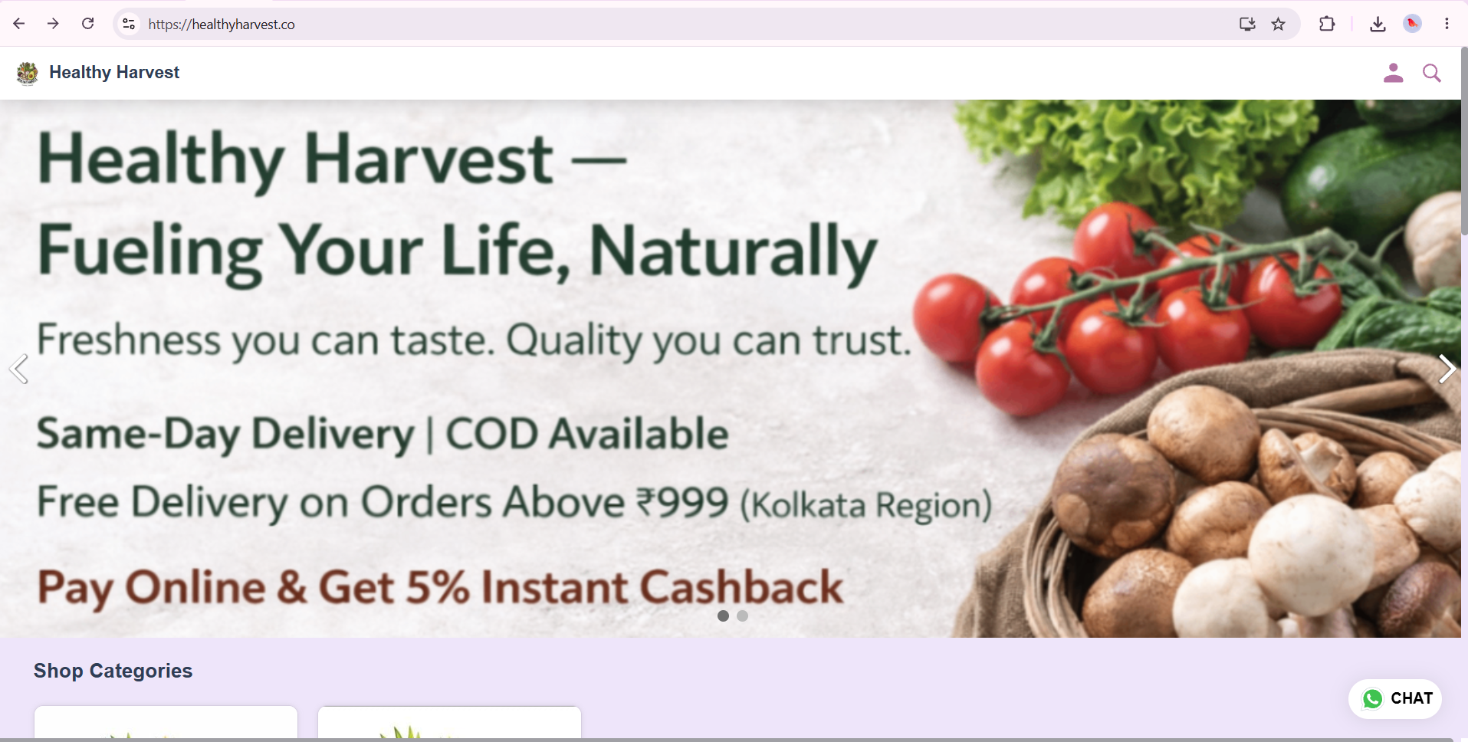
Figure 1 Existing HealthyHarvest Homepage

2.2 Proposed Redesign Solutions

Improved Navigation
The new website has a very easy to navigate menu system with direct links to important pages such as Home, Shop, Subscription Boxes, About Us and Contact to deal with the navigation issue. Moreover, a logical website structure will enable the user to make efficient use of the navigational system of the website by using it properly[4].

Improved Product Discovery
Product search, product filters and logical categorisation system improves product discovery. The features enable the user to search for products faster and to browse according to his interests and requirements.

Improved Product Transparency
These detailed product descriptions, nutrition information, farm source and organic certification signals, are featured on the newly designed product pages, helping to make informed purchasing. The additions allow to increase transparency and give additional information to the customer about the goods bought[11].

Improved Trust
The new shopping experience will feature a more streamlined interface for the shopping cart and checkout process. The enhancements eliminate any unnecessary actions, allow for easy usage, and shorten the product selection to order.

Improved Conversion Flow
The new shopping experience includes a simplified checkout process and cart interface. Improvements that remove unnecessary steps, simplify user interactions, and streamline the process from product selection to ordering.

3. Responsive Design Implementation

3.1 Responsive Design in E-Commerce
Responsive design is a webpage design method that helps webpages adjust to various screen resolutions and devices. In the e-commerce industry, responsive design is crucial as customers access e-commerce stores via desktops, tablets, mobile phones, etc. One of the primary elements of responsive design is utilising adaptable plans which move components like images, menus, and product listings to fit different screen sizes. Even modern eCommerce websites will adopt a mobile-first design, meaning that they'll first be designed for the mobile screen and then scaled up for larger screens when needed. This helps to make it more user-friendly and optimises its performance on mobile devices. Additionally, the adaptability of devices means that the users will have the same experience, functionality, and appearance no matter which device they use, thus enhancing accessibility and ease of use for the shopping process[12].

3.2 Impact on User Experience
Responsive design is very important for the user experience of an ecommerce website. Variations in screen sizes create different content and layouts that may make it easier for users to interact with features and functions presented on the website, thus enhancing usability. Responsive websites also offer better access to the content, which is readable on different devices. Optimisations of menus, buttons and product categories for various screen sizes ensure easier navigation and minimises the user's effort to find products. Moreover, a responsive design will also result in a flawless user experience, ensuring the functionality, design and usability of your site is the same on any device ranging from mobile devices to tablet devices to desktop devices. This uniformity contributes to increase user satisfaction and ease of online shopping[15].

3.3 Impact on Mobile Sales
One of the reasons for the growth of mobile commerce is responsive design, and it is important in delivering a smooth shopping experience on any device. Mobile shopping is growing, which is why it is crucial for businesses to make their online store mobile friendly. A responsive website can boost conversions as customers may view the products, add things to their shopping cart, and buy more easily. In addition, better mobile experiences have a positive influence on bounce rates, as they have reduced usability concerns and made pages easier to access. These enhancements create a greater customer experience, ensuring people can easily navigate websites irrespective of the device they are using. The advent of responsive design has become a major part of the equation for eCommerce success and mobile performance[6].

4. Implementation

4.1 Mood Board
The HealthyHarvest mood board was developed to help define the overall direction and visual identity for the site redesign. The colour of forest green, light green, warm orange, beige and white was agreed as a symbol of freshness, sustainability, trust and organic food product. The typography options worked out to be from Poppins for headlines to Open Sans for body text, which resulted in a modern and very readable user interface. The visual inspiration from the organic produce and sustainable farming techniques, healthy lifestyles, and eco-friendly packaging was also included in the mood board. Moreover, the chosen brand personality highlighted the aspects of authenticity, reliability, contemporary, and user-centric. The outcome was a wireframe and prototype that kept the same style and user experience throughout the redesign process, and was derived from the mood board.
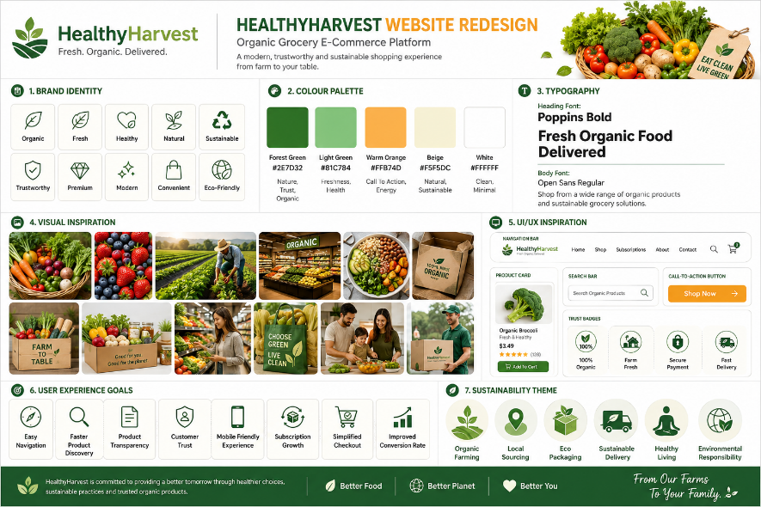
Figure 2 HealthyHarvest Mood Board

4.2 Wireframes

Homepage Wireframe
The wireframe for the homepage is designed to establish a baseline for the web site's information architecture and navigation. Contains hero section, product categories, best-selling products, trust elements, customer reviews and a newsletter subscription block. The goal of the layout was to direct users to the important actions, while enhancing the product visibility and website usability.
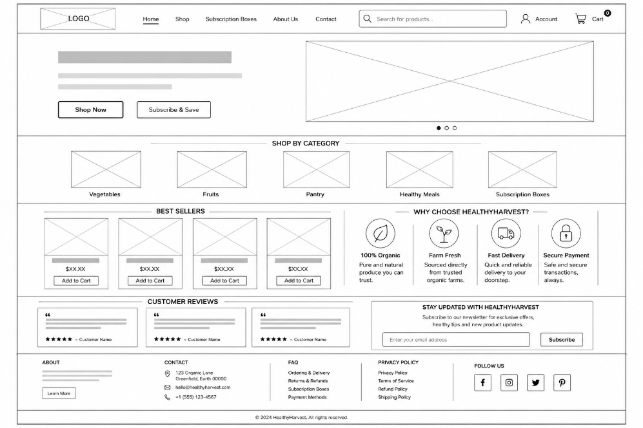
Figure 3 Homepage Wireframe

Shop Page Wireframe
The goal of the shop page wireframe was to improve product discovery and browsing. A filter panel, search function, sorting and structured product grid were added so that the user can find products easily and more efficiently navigate large product libraries[6].
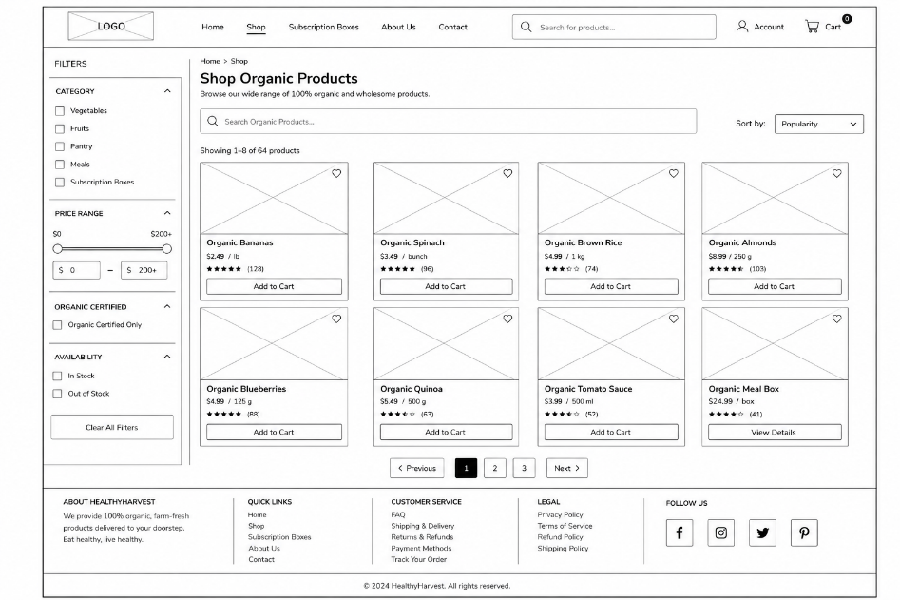
Figure 4 Shop Page Wireframe

Product Details Wireframe
The aim of the product details wireframe is to create more transparency and to make a better purchase decision. These include product images, product description, nutritional information, delivery information, customer reviews and related products. This is a structure which will provide the user with all the information he or she requires about the product before they decide to make a purchase[14].

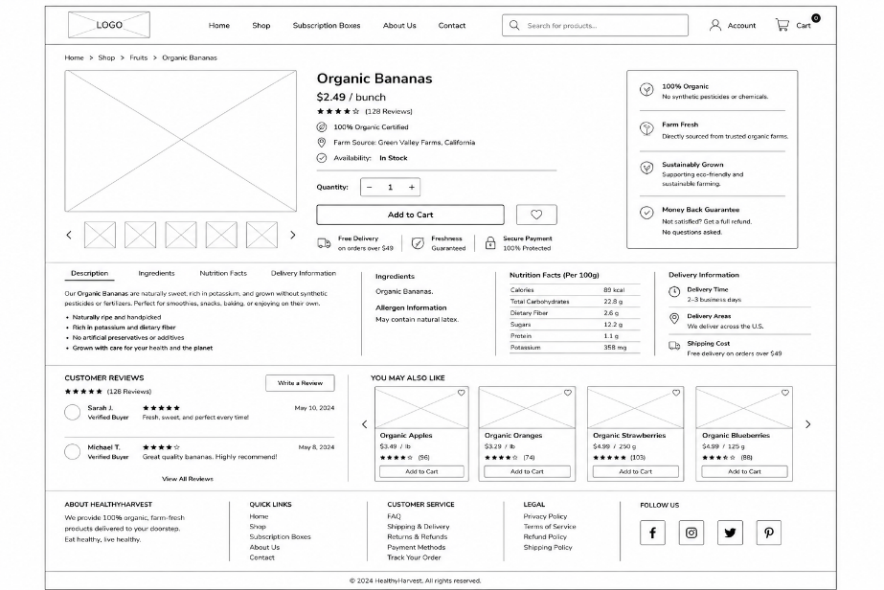
Figure 5 Product Details Wireframe

Cart Page Wireframe
The cart page wireframe was designed to make cart management easier and enhance the shopping experience. It features quantity restrictions, order summary information, coupon integration, and a prominent checkout button. These features have been created to eliminate friction in the shopping journey[17].
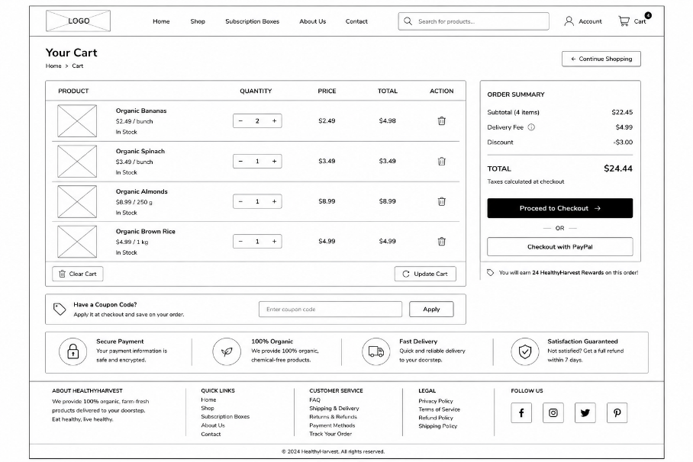
Figure 6 Cart Page Wireframe

Checkout Page Wireframe
The checkout wireframe was designed to provide a streamlined and user-friendly checkout experience. It contains delivery details, choices, payment details, order summary details, and security information. The organised design aids in the quick execution of transactions with confidence.
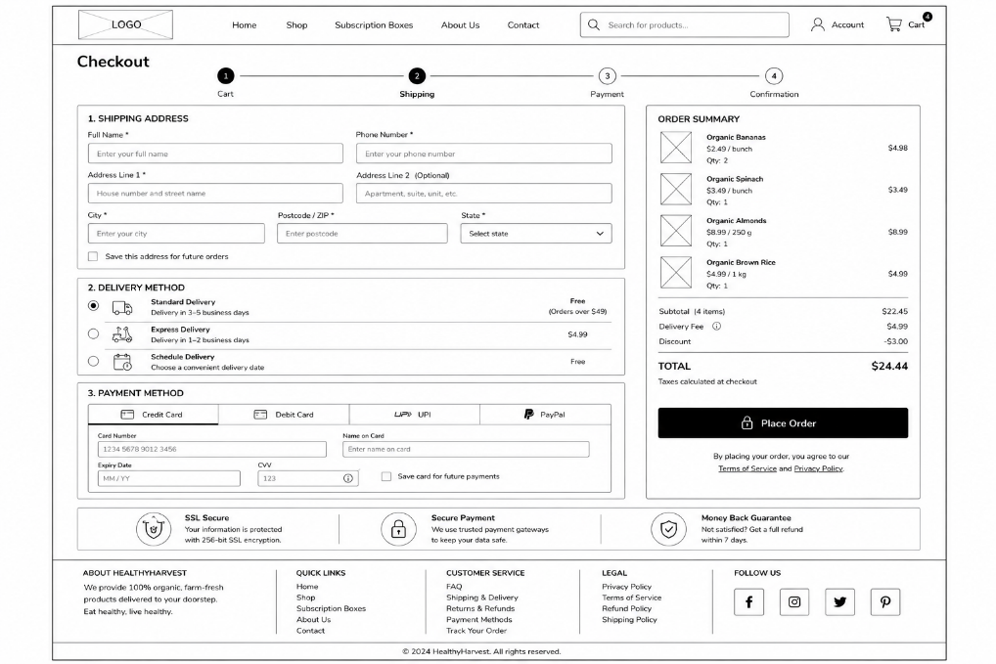
Figure 7 Checkout Page Wireframe
In general, the wireframes were useful for planning the website's structure, user journey, navigation system, and shopping flow. They offered a visual blueprint to help the final high-fidelity prototype and project consistency throughout the redesign process.

4.3 High-Fidelity Prototype

Homepage Prototype
The prototype of the homepage was developed by converting the wireframe to a visually appealing interface with the chosen colour palette and typography. Product images have been high-quality, navigation clear, category shortcuts included, trust indicators included, and call-to-action buttons added to improve usability and product exploration[8].
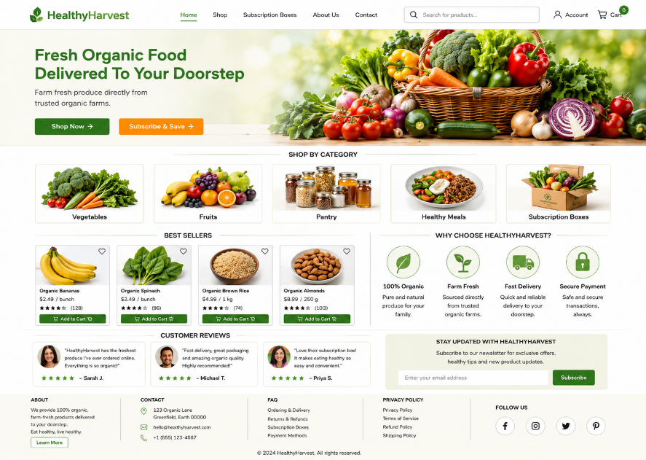
Figure 8 Homepage Prototype

Shop Page Prototype
The prototype of the shop page improved the presentation of the products with a designed product grid, search, filtering and sorting controls. These features enhance the product discovery process and facilitate customer navigation.
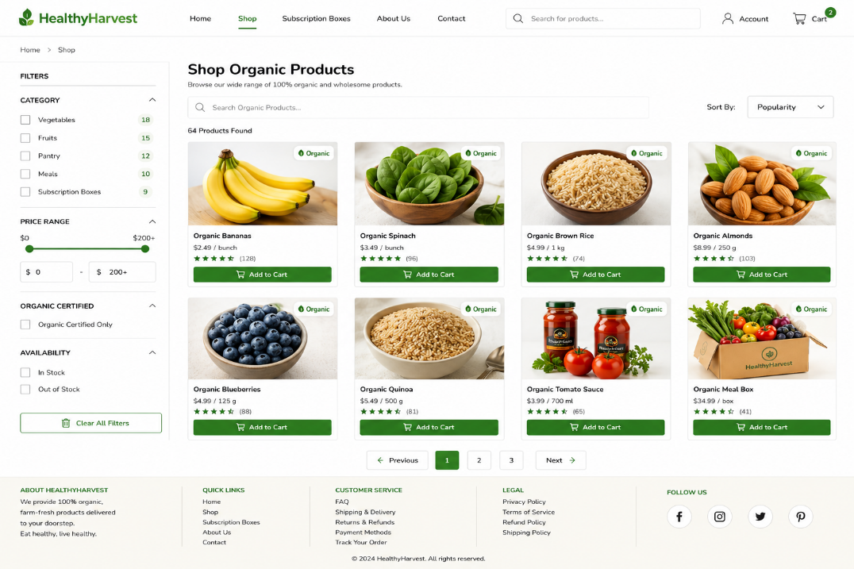
Figure 9 Shop Page Prototype

Product Details Prototype
The product details prototype features detailed product information, such as descriptions, nutrition facts, certifications, customer reviews, and similar products. The additions enhance transparency and enable customers to make informed purchasing decisions, thus boosting customer confidence[7].
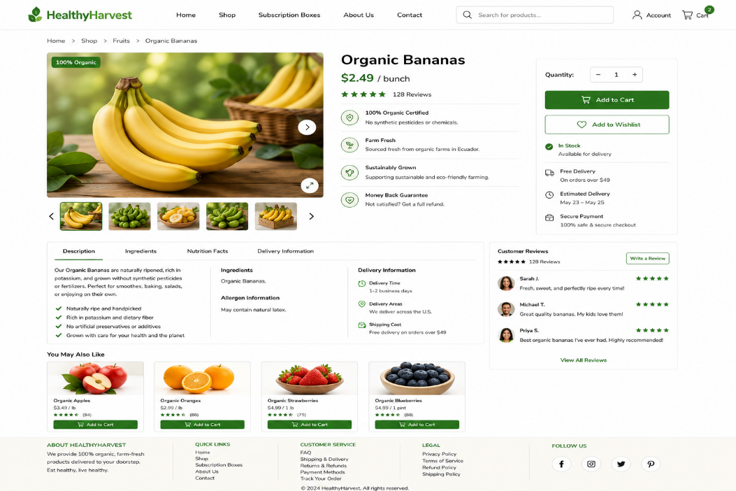
Figure 10 Product Details Prototype

Cart Page Prototype
The cart prototype features simple quantity controls, coupon functionality, order summaries, and prominent checkout actions, which are features that simplify the purchasing process. To ensure credibility along the buying process, trust badges and security indicators were added[10].
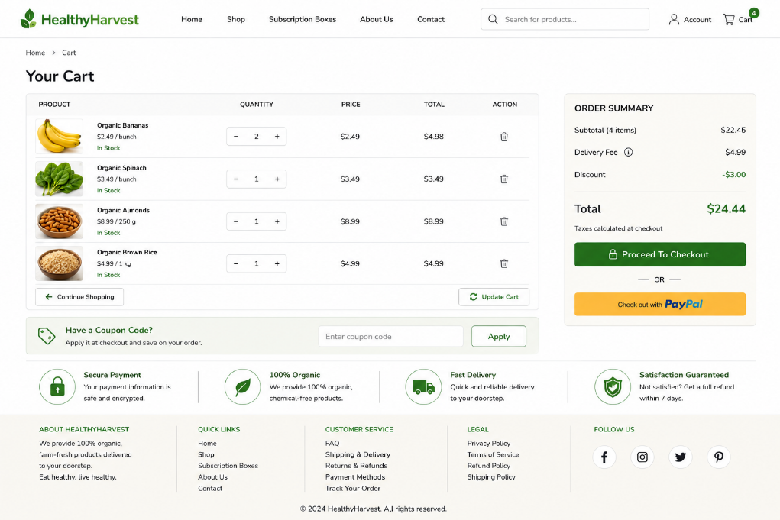
Figure 11 Cart Page Prototype

Checkout Page Prototype
The checkout prototype feature provides a simple checkout experience that includes organized shipping information, shipping options, payment options, security warranties, and order summaries. This is to ensure that the transaction is completed swiftly and efficiently.
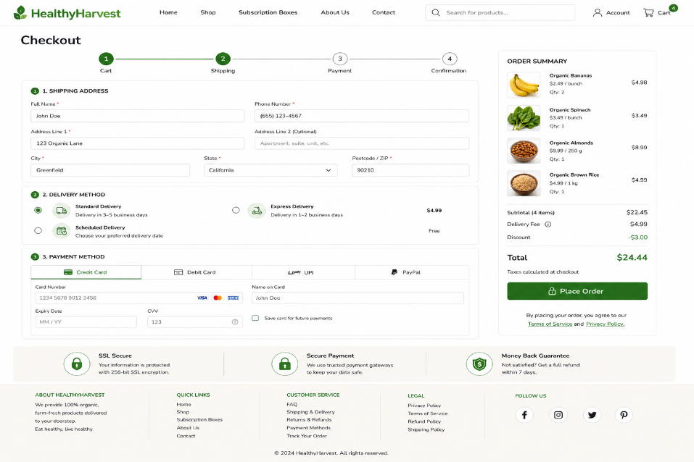
Figure 12 Checkout Page Prototype
The high fidelity prototype was successful overall with the same colors, typography, product presentation and elements to build trust, the same wireframes. The final design solves the issues on the original website, as it provides an efficient navigation system, product discovery solution, transparency and trust between the customer and an enhanced shopping experience[9].

5. Conclusion
The challenge for this project was to overhaul the website of the HealthyHarvest ecommerce platform to resolve certain usability and user experience issues that were identified. Key elements found during analysis were navigation, information architecture, transparency of the product, elements that build trust and the shopping journey. These constraints can impact customers' engagement, satisfaction and buying.
These challenges were addressed through a thorough UI/UX redesign process. The redesign process involved designing a structured mood board, wireframes and high fidelity prototypes following the concept of modern e-commerce design. The major improvements they have made were navigation, product discovery, product information, sourcing information, trust signals, customer reviews, and purchasing process. In addition, it's designed to be mobile-friendly, so that the site will look terrific on any screen.
The final prototype transformed the web site from a product catalogue into a modern, customer-centric organic food store web site. The new design will provide improved user experience for customers by being easier to navigate, more informative, and more trustworthy, while making it easier for customers to convert from discovering the product to the checkout. Also, subscription-only, trust badges and checkout streamlining all add a positive and interesting touch to the shopping experience.
Finally, the redesign demonstrates how important the principles of UI/UX design and responsive web design are in improving the user experience, customer satisfaction, and overall performance of an e-commerce website. The finished solution is in line with the vision and objectives of HealthyHarvest, which consist of providing a reliable, sustainable and customer-centric online grocery shopping experience and the ongoing engagement and growth of users.

6. References
- Aljabari, M.A., Joudeh, J.M., Aljumah, A.I., Al Gasawneh, J. and Daoud, M.K., 2023. The impact of website quality on online purchase intention: The mediating effect of e-WOM, Jordan context. International Journal of Professional Business Review: Int. J. Prof. Bus. Rev., 8(6), p.21.
- Chandrasekhar, K., Das, S., Gupta, N. and Jena, S.K., 2024. Comparative analysis of impulse buying behaviour across retail channels: a study of physical stores, e-commerce websites and mobile shopping apps. Economic Affairs, 69(2), pp.1109-1120.
- Degen, H., 2024. Information Architecture and Navigation Design. In Human-Computer Interaction (pp. vol2-176). CRC Press.
- Dua, P. and Uddin, S.F., 2022. Impact of perceived website cues on purchase experience and e-purchase intention of online apparel buyers. International Journal of Electronic Business, 17(2), pp.204-222.
- Eboseremen, B.O., Moyo, T.M., Oladimeji, O., Ajayi, J.O., Tafirenyika, S., Erigha, E.D., Akindemowo, A.O., Afuwape, A.A. and Oladega, F., 2024. Comparative analysis of AI-enhanced UI/UX design practices in e-commerce websites: A case study of the USA and the UK. International Journal of Future Engineering Innovations, 1(2), pp.48-57.
- Guo, J., Zhang, W. and Xia, T., 2023. Impact of shopping website design on customer satisfaction and loyalty: The mediating role of usability and the moderating role of trust. Sustainability, 15(8), p.6347.
- Hasan, T.I., Silalahi, C.I., Rumagit, R.Y. and Pratama, G.D., 2024. UI/UX design impact on E-Commerce attracting users. Procedia Computer Science, 245, pp.1075-1082.
- Joshi, S., Vashistha, K. and Baliyan, A.K., 2024. Revolutionising E-commerce: Personalised Recommendations for Enhancing User Engagement. Revolutionising E-commerce: Personalised Recommendations for Enhancing User Engagement (May 10, 2024).
- Li, W., Zhou, Y., Luo, S. and Dong, Y., 2022. Design factors to improve the consistency and sustainable user experience of responsive interface design. Sustainability, 14(15), p.9131.
- Lu, F., 2024. Online shopping consumer perception analysis and future network security service technology using logistic regression model. PeerJ Computer Science, 10, p.e1777.
- Lyu, Z., 2024. State-of-the-art human-computer-interaction in the metaverse. International Journal of Human–Computer Interaction, 40(21), pp.6690-6708.
- Novita, D., 2025. Optimising User Interface (UI) and User Experience (UX) on E-Commerce Platforms to Improve Customer Retention. Jurnal Teknologi dan Open Source, 8(2), pp.837-842.
- Purwaningrum, T. and Chamidah, S., 2022. Online purchase decisions: Analysis of e-service quality and information quality in Tokopedia. International Journal of Economics, Business and Accounting Research (IJEBAR), 6(3), pp.2653-2662.
- Pushpakumar, R., Sanjaya, K., Rathika, S., Alawadi, A.H., Makhzuna, K., Venkatesh, S. and Rajalakshmi, B., 2023. Human-computer interaction: Enhancing user experience in interactive systems. In E3S Web of Conferences (Vol. 399, p. 04037). EDP Sciences.
- Putri, S.D.A.E., Surianto, M.A. and Aslamiyah, S., 2022. The Effect of Price, Information Quality, and Perceived Risk on Online Purchasing Decisions in E-Commerce. Indonesian Vocational Research Journal, 2(1), pp.87-94.
- Schrittwieser, S., Ekelhart, A., Seidl, E. and Weippl, E.R., 2024, July. Safe or Scam? An Empirical Simulation Study on Trust Indicators in Online Shopping. In SECRYPT (pp. 560-567).
- Wilson, G., Brown, W. and Johnson, O., 2024. The impact of mobile technologies on consumer behaviour in retail marketing.

