Learning Log

Student ID Name: Andreea Cristina Mirica
Student ID Number: 2211629
Managing Hotel Administration BMIH6004
Lecturer’s Name: Jessica Newport
Date of Submission: 07/03/2025

Acknowledgement
I hereby declare that this report was completed without the assistance of any artificial intelligence tools or platforms. All research, analysis, and writing were conducted independently, adhering to academic integrity and originality standards.
This report reflects my own understanding based on thorough research and critical analysis of credible sources.
Table of Contents
INTRODUCTION 2
Section 1: Reflection on Experience and Personal Development 3
Section 2: Critical Analysis of Work-Based Skills and Technical Knowledge 5
Section 3: Reflection on Organizational Issues 6
CONCLUSION 7
REFERENCES 7

List of Table
Table 1 Action plan 4

List of Figure
Figure 1 ERA reflection cycle 3

INTRODUCTION
In my 10-week Level 6 hotel placement, I was placed in different departments of the hotel. The primary aim of my placement was task-centered thus the aim was to learn the functional, managerial, and customer care roles of each department. The following report discusses various learnings I made while on the placement and details how I was able to apply skills and knowledge in order to improve guest service. The situation and organizational factors that have been witnessed are also described along with recommendations to an identified dilemma.

Section 1: Reflection on Experience and Personal Development
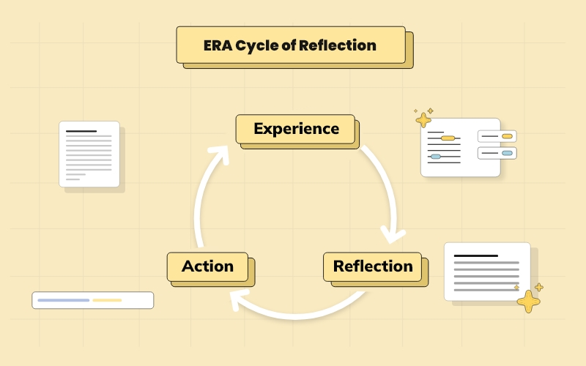
Figure 1 ERA reflection cycle
Source- Robinson (2022)
Experience:
I was able assist the supervisor of the hotel and encouraged to act as a supervisor, think as a supervisor and recommend courses of action in the department for events. This entailed being in charge of ensuring correct setups for events, quality of foods provided, and orderliness of the events’ service delivery. For instance, to ensure conducive order during events with a large turnout greater than 200 persons, I was behind the arrangement of the tables, and the delivery of orders at appropriate intervals. This was quite useful in highlighting the significance of cohesiveness of the various departments in an organization. I also discovered that to be able to meet the tight schedules when it comes to serving the guests, it is essential that the tasks are carried out by a team. Analysing the Tuckman’s team development model (2017), it is possible to say that the way I went through the forming, storming, and performing phase reflects the steps my team went through during the event organization.
Reflection:
Looking at these tasks, I can conclude that the experience helped me improve my communication and leadership skills. For example, in my case, the job involved constant interaction with different teams including the kitchen team, the cleaning crew and the receptionists. It is therefore crucial that there is effective communication in an organization so that each department fulfils the expectations of the guests. From the findings of Lewis (2016), this section elucidates that communication is one of the significant parameters that influence the effectiveness of the team work especially in the service provision field. The troubles I encountered include having to accommodate guests at the last minute or having to mediate small disputes between members enabled me to understand the importance of flexibility and hasty decision making.
Action:
Action | Objective | Timeline | Measurement of Success
Enhance leadership skills | Focus on developing managerial skills and handling pressure effectively. | 6 months | Improvement in team coordination and stress management.
Improve communication and reduce apprehension | Work on communication skills under stress, focusing on clear messaging. | 3 months | Increase in team feedback and reduced communication errors.
Develop problem-solving skills | Enhance the ability to anticipate and solve problems in real-time. | 4 months | Successful resolution of issues with minimal supervision.
Table 1 Action plan

Section 2: Critical Analysis of Work-Based Skills and Technical Knowledge
Importance of Work-Based Skills
During my work placement I found out that key employability skills like communication, teamwork and time management are crucial when trying to deliver recommended guest service. Teamwork, therefore, is a progressive process that is in a constant state of formation and evaluation based on the stages of groups Tuckman (2017). During my working field exposure, cooperation in a team maximized the group’s performance while handling power pressures for instance when facilitating large gatherings and meeting the expectations of the guests. For instance, during a conference event, I was supposed to support the kitchen and Housekeeping departments. This was the case because it was all about relaying on information on the part of the guests and their preferences. According to Lewis (2016), the hospitality industry specifically requires quality communication when catering to the customer audience. It revealed that teams that were integrated had been in a position to tackle challenges honourably while teams with poor or no integration scores faced issues to do with delays or clients’ complaints.
Technical Knowledge in Meeting Guest Service Standards
This was coupled with knowledge of technical skills field such as food safety regulation and different service handling standards that are required when addressing customers. Through being assigned in the kitchen and dining areas, I learnt the significance of food hygiene and high standards of service delivery. Comprehension of food storage and preparation processes, as well as health and safety requirements were important so that the guests ate food that met certain standard (Carter et al., 2020). Technological know-how was therefore essential to settling all manner of event setting up and addressing customers. I noticed the kitchen personnel adherence to the SOPs regarding the delivery of foods and how the receptionists made sure that the guests were checked in and out efficiently. These measures made the service delivery to be consistent and delivery of high-quality services as required by the standards of the hospitality industry.

Section 3: Reflection on Organizational Issues
Identifying Organisational Issues
Challenges faced during the organizational aspect include communication structure and the organization of resources within the hotel. The human resources more exactly the lack of staff possess a challenge to the hotel. The employees that are there sometimes struggle with all of the tasks assigned to them. I also noticed that training and development programs can be improved. For example, when I started, I thought someone will take me in and will train me, present me the departments, present me the team and introduce me to the work itself. However, it was not like that. Someone expected me and told me how my placement will run, then I went through each department on the days of my placement. When it came to completing tasks, depending on the department I either had to watch first or do as tell to me. Only at front desk employees were reluctant to let me act first because of the complexity of the systems. In all other departments, I followed provided instructions and worked with them. All staff was nice and supportive, but they were also under pressure and sometimes I was ashamed to ask more questions because I could see the amount of work they were already doing.
Impact of the Issue on Departmental Performance
According to the number of workers in hotel should illustrate the volume of work and vice versa. When these variables are not equal the hotel can experience low productivity levels or poor guest experiences (Tiberius et al., 2024). A large volume of work can increase pressure on employees, make them more likely to have conflicts, to make mistakes, to show low morale in the workplace (Raja, 2023). Additionally, it has been proven by many researchers in human resources that training and development can enhance employee productivity in workplace, quality of services and products provided and customer satisfaction (Patterson, 2024).

Proposed Solutions
Considering the budget of the hotel and the labour shortages experiences by the whole hospitality sector the best course of action for the hotel would be increased use of technology to reduce burden on employees and designing training programs with the help of long-term employees of the hotel. The use of technology such as AI boots to address customers’ requests or management systems to monitor stock can allow existing employees to focus on other tasks (Hollander, 2025). Using long-term employees with great organisational knowledge can help new employees accommodate easier in their roles, learn better the values and running principles of the hotel and pass on their tricks and tips. This can be both cost effective for the effective in terms of money and can also act as a non-monetary reward for employees: the long-term employees will feel valued for their work and contribution to the hotel and the new employees will learn better how to do their job (CIPD, 2024).

CONCLUSION
Therefore, my placed has enhanced work-based skills and technical knowledge’s to an extent of achieving guest service standards of standard. For the further professional self-development, the focus will be made on the improvement of the leadership, communication and problem-solving abilities. I will enhance the communication systems and also harmonize some operations so that they provide quality services.

REFERENCES

Carter, M., Morgan, M., & Thomas, K. (2020). Effective communication in food and beverage management: Bridging the gap between kitchen and service staff. Journal of Hospitality & Tourism Research, 44(2), 183-200.
CIPD (2024) Employee engagement & motivation: Factsheets, CIPD. Available at: https://www.cipd.org/uk/knowledge/factsheets/engagement-factsheet/#how-to-build-an-engaged-and-motivated-workforce (Accessed: 02 March 2025).
Hollander , J. (2025) Technology in hospitality: 20 trends shaping the industry in 2024. Available at: https://hoteltechreport.com/news/tech-in-hospitality (Accessed: 02 March 2025).
Hsu, C. H. C., & Huang, S. (2018). The importance of team communication and coordination in the hospitality industry. International Journal of Hospitality Management, 75, 156-168.
Lewis, J. (2016). Communication and teamwork in the hospitality industry. Journal of Hospitality & Tourism Research, 40(3), 348-365.
Patterson, J. (2024) Creating a culture of training and development in the Workplace, Forbes. Available at: https://www.forbes.com/councils/forbeshumanresourcescouncil/2023/06/13/creating-a-culture-of-training-and-development-in-the-workplace/ (Accessed: 02 March 2025).
Raja, Z.N. (2023) The negative impact of excessive workload on employee performance, LinkedIn. Available at: https://www.linkedin.com/pulse/negative-impact-excessive-workload-employee-performance-raja/ (Accessed: 02 March 2025).
Robinson, J. (2022) In-depth explanation of era cycle of reflection writing, Crowjack. Available at: https://crowjack.com/blog/strategy/reflection-models/era-cycle (Accessed: 01 March 2025).
Tiberius et al. (2024) State of hospitality industry in the UK 2024: Challenges, Statistics, and future outlook, forbesmagazines. Available at: https://forbesmagazines.co.uk/state-of-hospitality-industry-in-the-uk-2024-challenges-statistics-and-future-outlook/ (Accessed: 02 March 2025).
Tuckman, B. W. (2017). Developmental sequence in small groups. Psychological Bulletin, 63(6), 384-399.

