
Student Name  ID Number | Andrei Welkens-Covaci  1818820
Module Title | Managing Enterprise in the 21st Century
Module Code | BMSW4006_LON
Module Lecturer | Hossein Shokri
Assignment Title | World’s Coffee PPT speaker notes
Word Count | 434 |  |  | Date Submitted |  | 11/05/2020

World’s Coffee

Power Point Presentation

Speakers Notes

Contents
Product description: 4
Strengths: 4
Weaknesses: 4
Opportunities: 5
Threats: 5
Industry life cycle: 5
References: 6
Appendixes: 7

Product description:
World’s Coffee selects products that are consistent with the expectations and quality standards of the company and are meant to provide the customers utmost satisfaction. The products are of superior quality, the distribution channel well-knit and are available to the customers at reasonable prices. Such products include the wide variety of coffee beans which is a signature product of World’s Coffee, assorted syrups as well as toppings, caramel sauces, chocolate and a dedicated product line based on Italian Cappuccino. It also offers baked products and Chai latte.

Strengths:
The strategic location of World’s Coffee is one of the most important strengths. Its proximity to Hyde Park ensures that it always has a steady footfall of customers.
Another remarkable strength is the product variety which includes the unique coffee and chocolate products from across the globe.
These strengths ensure that World’s Coffee is a favourite with the customers and that its products are always relevant and high in demand in the competitive market.

Weaknesses:
The most important weakness of World’s Coffee is because it is located only at Oxford Street, London. As the World’s Coffee is present only in one destination, it considerably impacts the potential of the company to maximise its profits by delivering to new customers in new market. This, in turn, leads to its inability to invest in the development of infrastructure and facilities to be used in another market location in the UK or London. Such limits to its potential to expand the business and appeal to new customer segments, count as a significant weakness.

Opportunities:
Consumers who engage in online purchase of products is increasing rapidly in the UK and by the year 2022, it is estimated that the number will cross 50 million. Therefore, the e-commerce platform provides for a glorious opportunity for World’s Coffee provided it can capitalise on the opportunity. For example, developing and deploying a smartphone app which people can use conveniently can serve the purpose of World’s Coffee in this regard (Huang and Wood, 2017).

Threats:
The decrease in the amount of disposable incomes in the hands of the UK consumers as well as the intensity of competition in the UK coffee sector are significant threats for World’s Coffee as London alone, is home to more than 2748 coffee cafes and shops.

Industry life cycle:
It denotes the high volumes of sales, innovation and the changes in product lines. It also relates to development of products. Considering this coffee business, it’s at the start up stage and is yet to complete its journey throughout all the following four stages (John and Banerjee, 2017).

References:

Huang, Y. and Wood, B., 2017. Identify successful sales and Marketing strategies that affect customer loyalty in a small coffee shop.
John, J. and Banerjee, S., 2017. A Study of Major Factors Influencing Customer Preference for Branded Coffee Chains among Young and Middle-Aged Adults in Mumbai. SFIMAR Research Review, 11(1), pp.20-28.
.

Appendixes:
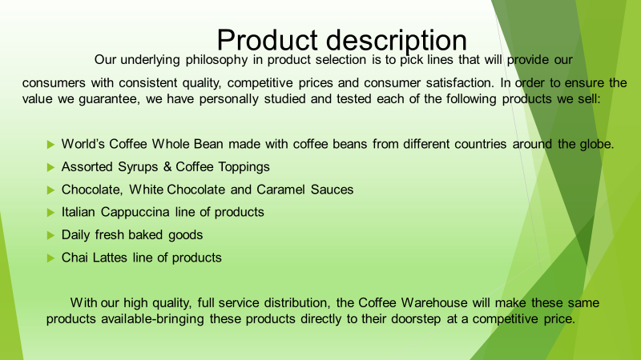

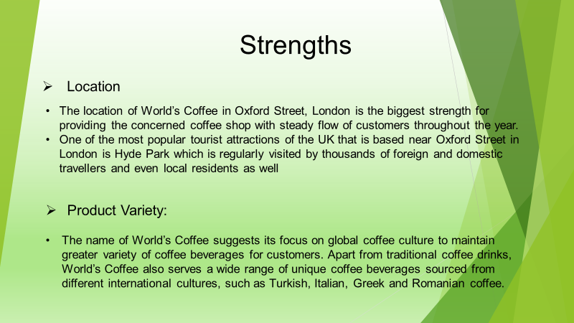
(created by author)

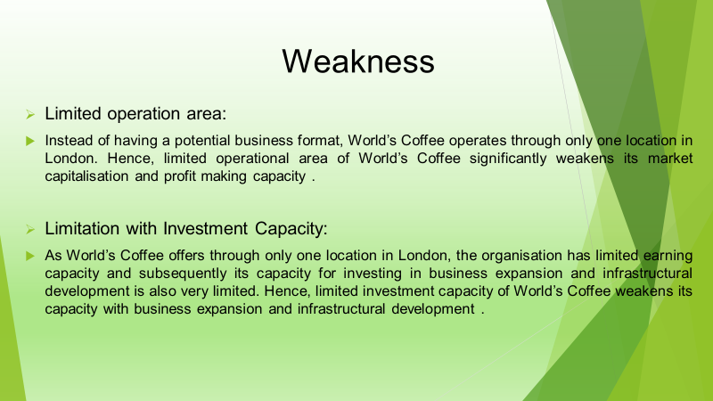

(created by author)

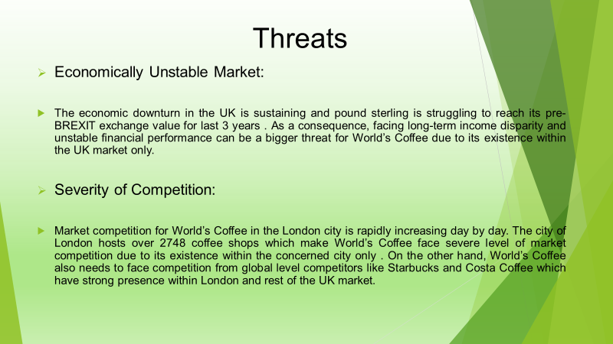
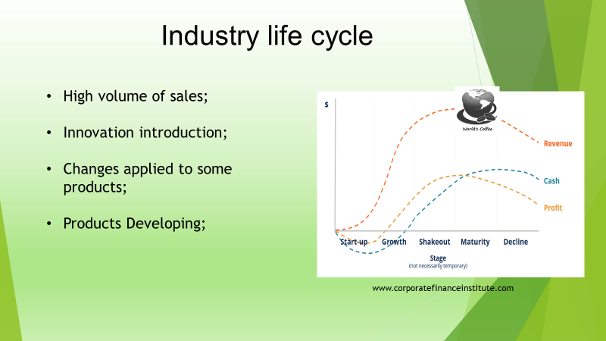
(created by author)

