Assessment 1
Human Resource Management

Table of Contents
Table of Contents 2
Introduction 2
Part A: The current state of the labour market in the UK 2
Part B: The emerging changes in Human Resourcing Strategies in the post-Covid, post-Brexit external environment 5
Conclusion 8
References 9

Introduction
This report takes account of a comprehensive review of the labour market and human resourcing strategies in the UK. As explained by Aitken-Fox et al. (2020), there has been a significant change in the UK’s labour market and the way human resources are managed (overall) due to Brexit. However, the country witnessed political issues and health-related emergencies (Covid-19), due to which, the entire landscape underwent a wide range of changes. This report underlines how the changes might have affected the human resource strategies and evaluated the current state of HRM and labour market in the country.

The current state of the labour market in the UK
UK’s government periodic reports on the labour market evaluates and summarises the current state of the sector and market. The report takes account of different critical statistics related with the labour market and accordingly, the implication on the labour market could be achieved. As per the government figures, the recent quarter (February to April 2022) demonstrated an increase in the unemployment rates in the UK. The employment rates reduced by 0.2% in the period to reach 75.6% which is still below the pre-Covid-19 period. However, the recent situation is significantly better than the period just after Covid-19 had stuck:
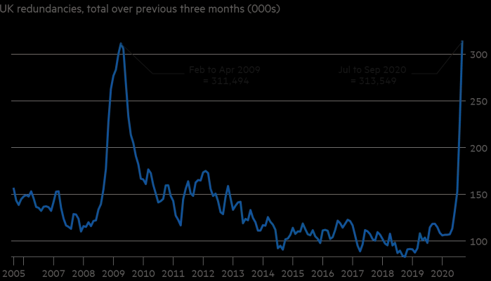
Figure 1.0: Redundancies in UK Workforce (Source: Financial Times)

On a brighter side, if the total number of employees in the country are taken into account, there has been an unprecedented increase in the figures (Leaker, 2022). This has been demonstrated as follows:
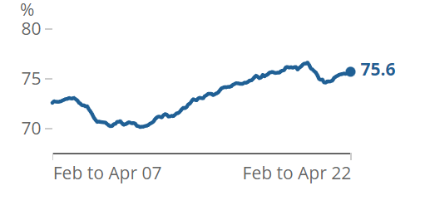
Figure 2.0: UK Employment Rates (Source: Office of National Statistics)

However, one of the biggest impacts of the pandemic could be seen among the small-sized self-employed workers. The total number of payroll workers increased to 29.6 million which is the highest number ever posted in the UK. In addition to this, there has been an increase in different factors including total actual working hours which reached to 1.04 billion hours, thereby demonstrating an increase of 12.2 million hours in a quarter (Leaker, 2022). There has been an increase in the total number of hours worked by part-time workers who managed to devote 0.6 hours more than the pre-pandemic figures.

Apart from the government estimates and reports, there have been a number of researches carried out on the topic wherein the researchers have aimed at evaluating the state of labour market in the UK by underlining the impact of Brexit and Covid-19 (Wilson et al., 2021). Simionescu et al. (2017) estimated that there would be a massive shortfall in the number of unskilled labours in the UK due to the country’s decision to leave the EU.

As further analysed by Papyrakisa et al. (2022), the impact of Brexit (leaving aside the exogenous Covid-19 event) could be deemed as rather devastating as far as the unemployment levels are concerned. After the Brexit referendum, the rate of unemployment in the country steadily increased and remained around 7.5% during the period (figure 3.0).
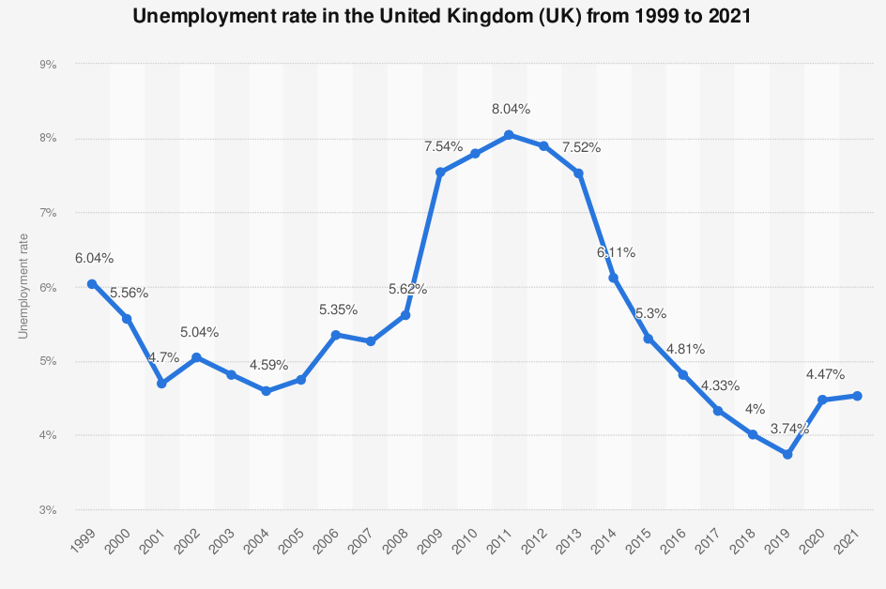
Figure 3.0: Unemployment Rates in the UK (Source: Statista)

However, the impact has not been too drastic as anticipated earlier. There are enough reasons due to which the overall level of unemployment increased in the UK that could be attributed to the companies postponing hiring processes in the UK. There has been a significant increase in uncertainty in the UK markets post Brexit (Farid, 2020). Due to these factors, the hiring and recruitment plans of multinational companies were affected and the unemployment levels went up.

Besides the quantitative factors and the increase in unemployment levels, there were various other factors which could be linked with Brexit phenomenon. As explained by Davenport and Levell (2022), there has been a constant change in the qualitative factors due to the new trade barriers which were introduced in the UK post Brexit. The overall situation for immigrant labours from different parts of the EU changed drastically as there was no longer free movement of people from and within the UK. Hence, the businesses which used to hire workers from different European countries had to postpone or cancel their mass hiring campaigns. From a qualitative perspective, Brexit has resulted in increasing the overall exposure of workers into different industries (Davenport and Levell, 2022). For instance, due to the lack of available workforce, the opportunities for female workers to work in manufacturing industries in the UK shall increase as a result of Brexit. This would be largely relevant for the industries that have been affected severely due to the trade barriers. However, the authors also concluded that exposure to new Brexit trade barriers is uncorrelated with measures of local deprivation and the impacts of the recent Covid-19 pandemic.

In addition to the impact of Brexit on the UK’s labour market, there is no doubt that the pandemic affected the overall sector rather drastically which has been demonstrated by the unprecedented high levels of unemployment and reduction in total productivity of the labour in the country. As per a report submitted by Powell, Francis-Devine, and Clark (2022) before the UK parliament, the impact of Covid-19 on the labour market was evaluated. As per the report, with the introduction of lockdowns and movement restrictions, there was dramatic reduction in the employment levels as the small and medium-sized businesses had to reduce the number of workforce. During the year 2020, the total number of people that lost their jobs (due to a variety of reasons) was close to 825,000. In addition to this, there was a massive increase in redundancies as the number of hours worked were lowest since 1994.

This could be considered as the worst impact and phase in the Covid affected labour market in the UK. With the beginning of 2021, the economic activities started to regain their pace and country started to see improvement in aggregate demand. However, due to the cumulative impact of the pandemic, the number of unemployed people in the UK reached at an unprecedented level of 8.89 million (Powell, Francis-Devine, and Clark, 2022).

As per Hamouche (2021), there were a wide range of people who were affected by the pandemic (within the labour market). It was found that the overall level of inequality within the labour market had also increased due to the impact of Covid-19. The number of unemployment levels minority ethnic groups was significantly higher than the majority ethnic populations in the country. Furthermore, the level of employment level among male workers had fallen a bit more than their female counterparts. This has further meant that the number of female workers had increased drastically and the exposure in different sectors has also increased.

Furthermore, as pointed out by Powell, Francis-Devine, and Clark, (2022), the young and oldest range of workers were the ones who lost their jobs during the period. The low paid workers were also the worst-affected as these were not generally the part of the payrolls in the companies. The overall level of employment of disabled employees in the country had also reduced due to the pandemic.

Overall, the state of the labour market in the UK has been in a phase of recovery due to the dual aspects of Covid-19 and Brexit. The situation of UK could be considered as unique as compared to any other European (or any other developed nation) because the labour market has witnessed two events which are quite uncommon. It has been illustrated by the recent government report that the average employment levels and pays are improving along with the number of job vacancies that reached to 1.3 million recently. However, the pace of such growth is slow.

The emerging changes in Human Resourcing Strategies in the post Covid, post Brexit external environment
As it has been illustrated in the previous part of the report as well, the situation of UK could be considered as rather unique as it is the only country to have faced two of the most dramatic events in the history within a span of a few years. As the labour market (as per the previous part of the report) still recovers from the two factors, it would be important to take account of the changes in the human resource strategies in the post Brexit and Covid period that will be critical for the human resource professionals in the future.

The first impact could be considered as the normalisation of remote working in the form of increased adoption of work from home (Arthur, 2021). As explained by the author, the overall level of workers permanently opting for WFH has increased drastically as there are a number of sectors and industries which showed no signs of slowdown even when the workers did not report to the traditional offices. Hence, remote working and WFH which was earlier considered as an additional perquisite offered to the workers is normalised and is considered as an integral part of the employment agreements between the workers and the employers.

In addition to this, as underlined by Sharma (2022), the overall management of human resources has become exceedingly challenging in the pandemic period as the total levels of stress among the workers has increased. This could be attributed to the poor time management, lesser breaks, and AV fatigue. The number of meeting hours have increased and the overall way in which human resources used to manage their shifts and time whilst being in the traditional office has changed. There is also an increased fear of losing the job and hence the total number of hours dedicated into work have also gone up without sufficient breaks and proper management of time. As explained by Azizi et al. (2021), human resource management strategies in the organisations which have been effective for years have been affected by disruption, uncertainty, complexity, and ambiguity.

However, as further explained by Azizi et al. (2021), there are a number of innovations which the human resource management strategies have witnessed in the period. First, the overall level of flexibility among the human resource managers in regards to dealing with the employees has increased. This can include the flexibility of timings, work shifts, weekly offs, and overall routine management. Rather than following the fixed routines and procedures, the human resource managers around the country have aimed at finding out ways through which employees can be supported through flexible work processes. In addition to flexibility, Sharma (2022) mentions that internal efficiency is one area that has gained prominence in the post Covid and Brexit era. Organisations have understood the importance of human resource management and hence internal efficiency has been improved through the introduction of digitalisation and advanced tools for training, development and communication within the HRM strategies.

As per a Deloitte’s Report, since the UK has witnessed massive unemployment during the period, it is imperative that the workforce would be affected by the overall level of fear and anxiety (Gosling, 2022). Hence, the overall role of the organisational leaders has increased even further in the period. For instance, the leaders should have a better level of communication with the workforce and must come up with measures to keep them engaged, productive and resilient.

Furthermore, as discussed before, there has been a significant increase in digitalisation and technology use in different functional areas of HRM. Starting with recruitment process, the overall process of hiring employees has gone digital with the recruiters (and job seekers) connecting over Video calls rather than physical meetings. Hence, the criteria to judge the personality and attitude of an individual which was different in a traditional manner, has completely transformed in the given phase. Furthermore, the HR techniques of shortlisting candidates has also changed with the introduction of AI and ML technologies that have saved time for the recruiters.

Hamouche (2021) emphasises that need for change in different functional areas of HRM during the post covid and Brexit period in the UK. The author illustrates that there has been a change in the working conditions in which an employee operates in the given period. It is critical that the organisations provide for a hybrid working environment so that carrying out assignments might not be too difficult for the workers. For example, Google announced that its employees will continue working remotely until at least Summer 2021 whereas Twitter's employees were given the opportunity to work remotely indefinitely (Leonardi, 2020). Such kinds of examples should not be restricted to the large enterprises but even the small and medium-sized companies should be carrying out similar changes in the HRM strategies to ensure that the workers are engaged and attached with the organisations.

Another important aspect has been pointed out by Campello et al. (2020) in regards to staffing requirements and strategies of the organisations in a post covid and Brexit environment. As per the authors, the importance of skilling has increased due to the two factors and hence the selection standards have also been impacted. This has further given the rise to the importance of learning organisations. It is expected that an aspirant should have some additional skills (such as knowledge of different digital tools) to be employable in the current scenario. At the same time, an employee also expects that the organisation should be a learning organisation and hence the importance of training and development of employees has increased. The companies must think of investing heavily in training and skill development of the employees for the achievement of employee loyalty and engagement. In absence of this, there can be a similar situation of mass resignation such as the one witnessed in the US.

In addition to this, performance management strategies of the employees in a post-covid period have also undergone massive changes. According to some authors, most organizations were overwhelmed by the challenges resulting from COVID-19, such as measuring employees' performance and the disruption in performance-based pay, that they have reduced or even abandoned performance management, due to the complexity and the novelty of this pandemic (Aguinis and Burgi-Tian2020). It is a fact that measurement of employee performance in this period could be quite critical and difficult. Hence, the standard and traditional measures of number of hours or worked or a piece rate system might need some serious revisions in the given period. Similarly, compensation management as per the performance and job requirements has undergone some changes. There is more emphasis on the critical care (such as health insurance) and other benefits offered by the organisation towards its employees.

Conclusion
The report was divided into two parts. In the first part, the current state of the labour market was discussed. After two drastic events (Brexit and Covid), the labour market after seeing massive unemployment rates and increase in redundancies, is finally recovering. However, there is still a lot to go before the market reaches the pre-covid period. In the second part of the report, the general strategies of HRM which the managers of different companies and businesses in the UK have changed and will need to change due to the two events have been discussed. There are various areas such as compensation and performance management, flexibility of work, and overall training and development of employees that should be taken into account as part of the change.

References
Aitken-Fox, E., Coffey, J., Dayaram, K., Fitzgerald, S., Gupta, C., McKenna, S. and Tian, A., 2020. The impact of Covid-19 on human resource management: avoiding generalisations. [online] LSE Business Review. Available at: <https://blogs.lse.ac.uk/businessreview/2020/05/22/the-impact-of-covid-19-on-human-resource-management-avoiding-generalisations/> [Accessed 1 September 2022].
Arthur, R., 2021. Studying the UK job market during the COVID-19 crisis with online job ads. PLOS ONE, 16(5), p.e0251431.
Azizi, M., Atlasi, R., Ziapour, A., Abbas, J. and Naemi, R., 2021. Innovative human resource management strategies during the COVID-19 pandemic: A systematic narrative review approach. Heliyon, 7(6), p.e07233.
Davenport, A. and Levell, P., 2022. Brexit and labour market inequalities: potential spatial and occupational impacts. Oxford Review of Economic Policy, 38(1), pp.50-67.
Gosling, W., 2022. COVID-19’s impact on the workforce: Insight for HR teams. [online] Deloitte United Kingdom. Available at: <https://www2.deloitte.com/uk/en/pages/human-capital/articles/covid-19-impact-on-the-workforce-insight-for-hr-teams.html> [Accessed 1 September 2022].
Hamouche, S., 2021. Human resource management and the COVID-19 crisis: implications, challenges, opportunities, and future organizational directions. [online] Cambridge University Press. Available at: <https://www.cambridge.org/core/journals/journal-of-management-and-organization/article/human-resource-management-and-the-covid19-crisis-implications-challenges-opportunities-and-future-organizational-directions/6857481FD64558659EE4C17C6DAE9AB9> [Accessed 1 September 2022].
Leaker, D., 2022. Labour market overview, UK - Office for National Statistics. [online] Office for National Statistics. Available at: <https://www.ons.gov.uk/employmentandlabourmarket/peopleinwork/employmentandemployeetypes/bulletins/uklabourmarket/june2022#:~:text=The%20UK%20employment%20rate%20increased,number%20of%20part%2Dtime%20employees.> [Accessed 1 September 2022].
Nickell, S. and Quintini, G., 2002. The Recent Performance of the UK Labour Market. Oxford Review of Economic Policy, 18(2), pp.202-220.
Papyrakis, E., Pellegrini, L. and Tasciotti, L., 2022. Impacts of the Brexit referendum on UK employment: a synthetic control method approach. Applied Economics Letters, pp.1-4.
Powell, A., Francis-Devine, B. and Clark, H., 2022. Coronavirus: Impact on the labour market. [online] House of Commons Library. Available at: <https://researchbriefings.files.parliament.uk/documents/CBP-8898/CBP-8898.pdf> [Accessed 1 September 2022].
Simionescu, M., Bilan, Y., Smrčka, L. and Vincúrová, Z., 2017. The effects of european economic integration and the impact of Brexit on the uk immigrants from the CEE countries. E+M Ekonomie a Management, 20(1), pp.29-47.
Statista. 2022. United Kingdom - Unemployment rate 2021 | Statista. [online] Available at: <https://www.statista.com/statistics/263709/unemployment-rate-in-the-united-kingdom/> [Accessed 1 September 2022].
Strauss, D., 2020. Record surge in redundancies pushes UK unemployment to 4.8%. [online] Ft.com. Available at: <https://www.ft.com/content/147178b0-0330-4943-b485-f1f4b527febf> [Accessed 1 September 2022].
Wilson, R., Barnes, S., May-Gillings, M., Patel, S. and Bui, H., 2021. Working Futures 2017-2027: Long-run labour market and skills projections for the UK. [online] Assets.publishing.service.gov.uk. Available at: <https://assets.publishing.service.gov.uk/government/uploads/system/uploads/attachment_data/file/863506/Working_Futures_Main_Report.pdf> [Accessed 1 September 2022].

