jacob nicklin
student number: 2305180 Module: Computer Architecture and Operating Systems
Operating Systems Report

Table of Contents
What Is an Operating System? 2
Types Of Operating Systems 2
Computer and Laptop Operating Systems 2
Mobile Operating Systems 2
Network Operating Systems 2
Key Functions of An Operating System 3
Use Of Windows OS CLI Commands 3
Linux OS 9
What is a Linux OS? 9
Linux Directories 9
Use Of Linux OS CLI Commands 10
Use of Windows OS scripts 15
Use of Linux OS Scripts 18
Conclusion 21

What Is an Operating System?
An Operating System is the most important software within a computer that allows for the most essential actions within a computer, laptop, phone, or tablet to be performed. Using multiple applications at the same time. [1] It manages all other programmes within the computer. It also gives options to users to directly edit, change or amend the system through the use of command lines. [2]

Types Of Operating Systems

Computer and Laptop Operating Systems
Computer and Laptop Operating Systems are usually referred to as Desktop Operating Systems [3] and conduct a range of tasks through programmes that can provide uses such as gaming, streaming media, managing databases, creating websites and browsers. The main types of computer operating systems a person would come across include Microsoft Windows, MacOS and Linux, all of which are Graphical User Interfaces (also known as GUIs). GUIs allow users of the OS to access programmes through icons which can be clicked on through the navigation panes. The final and most crucial part of an operating system is its ability to handle multiple tasks at the same time, such as running a web browser and using a database at the same time. [4]

Mobile Operating Systems
Mobile Operating Systems work differently due to the smaller technology and compressed size posed by mobile phones. The OS are also directed more towards the use of communication than creating databases or manufacturing websites, so the complexity of these OS is scaled back considerably. [3] Android and IOS are the two biggest competitors within the mobile phone OS market. Like with PCs and Laptops, Mobile phone Operating Systems are capable of running multiple tasks or keeping tasks on “standby” however, they cannot nearly hold the same amount of load stress that a laptop or computer can. Mobile Phone Operating Systems also make use of GUIs and make it much easier for the user through touchscreen.

Network Operating Systems

A network operating system bridges the gap between computer hardware/ servers and users, this could be through managing user accounts, managing access to networks. [5]
Helping network admins troubleshoot and create links and overall, controlling and managing networks. Examples of network operating systems can include items such as printers and the links they have to printing out a document or file online. Another Example are the usage of Databases and multiple personnel connecting together to modify, manage and create the database, requiring a network operating system to make sure that the database is always up to date. [6]

Key Functions of An Operating System
Operating systems must have a variety of functions due to the demand from users for accessing files, computer software and other parts of the computer, meaning the versatility of an operating system is imperative. [7]
One of the most important functions is to manage hardware such as the processor and memory and allocate their uses to certain tasks, this is evident within the windows task manager, where the user can be shown several live and self-updating graphs in which the user can be shown the overall performance of their PC, Laptop or other device that uses the windows operating system, which can all be controlled by the administrator. [8]

Use Of Windows OS CLI Commands
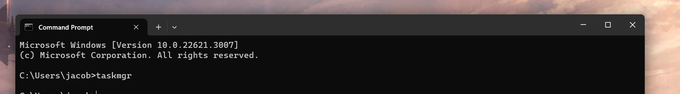
1: Taskmgr Command
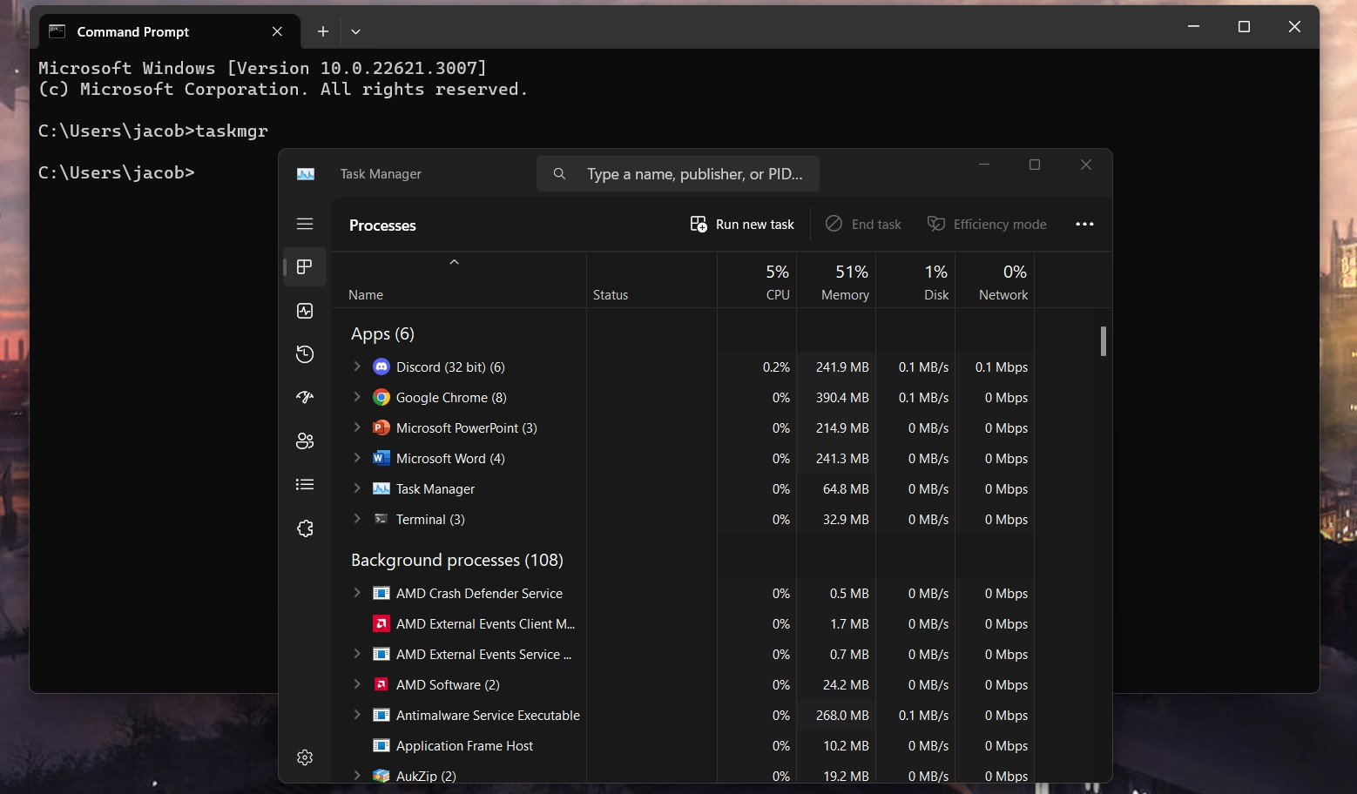
The PowerShell command using “taskmgr” was used to open the Task Manager. The Task Manager provides useful information on the current applications running within the computer. By using the PowerShell Command, it makes the task manager more accessible [9]

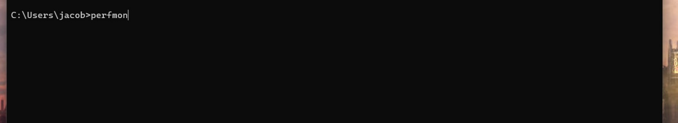
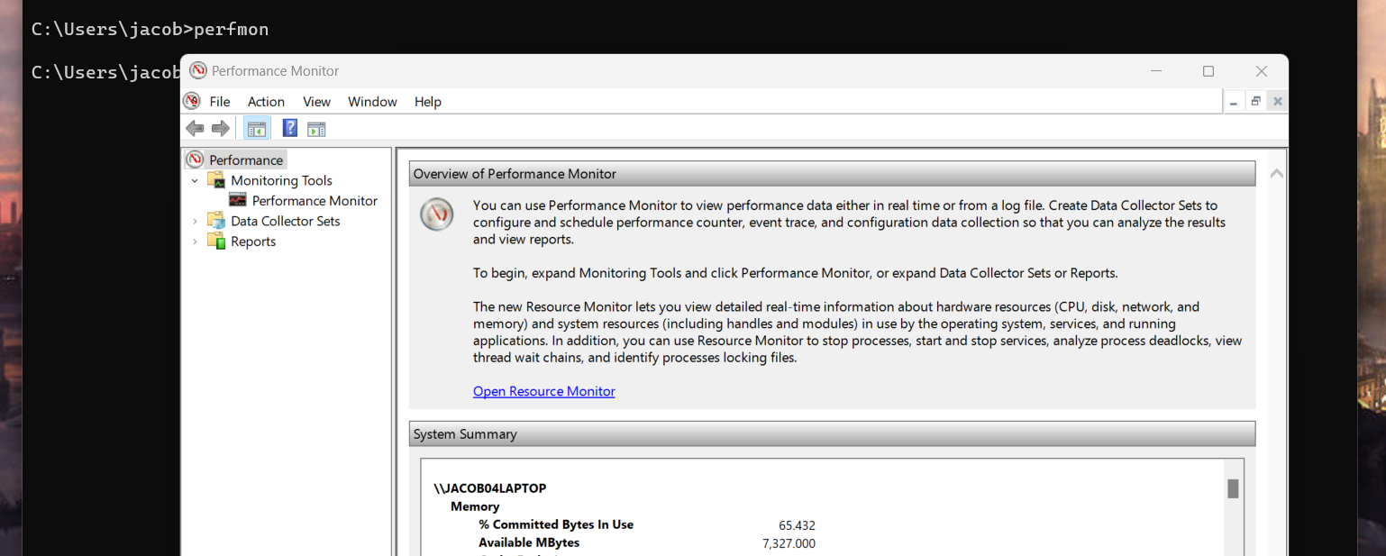
2: Perfmon Command

The use of “Perfmon” within the command prompt has brought up the performance monitor. This saves a generous amount of time when using the windows operating system as one the other way to access Performance Monitor is through navigation of links within the “Control Panel” application. [10]
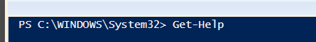
3: Get- Help Powershell

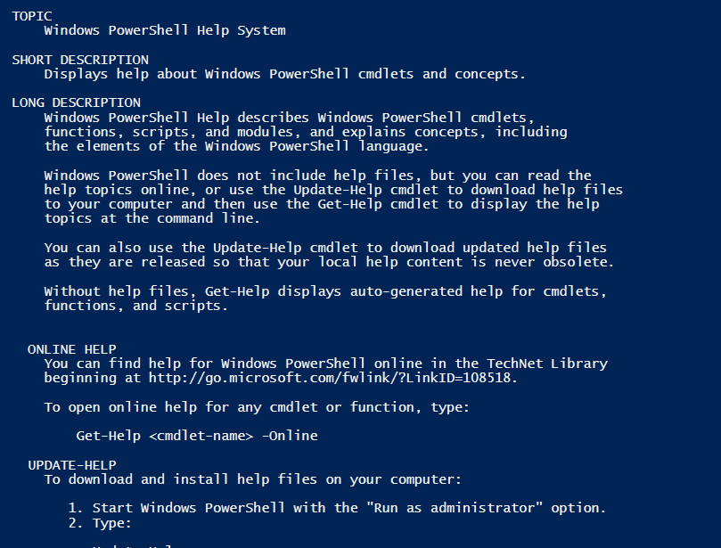
[11]The “Get- Help” command presents a large amount of information on how Powershell works and where you can find certain types of help, such as the online help.
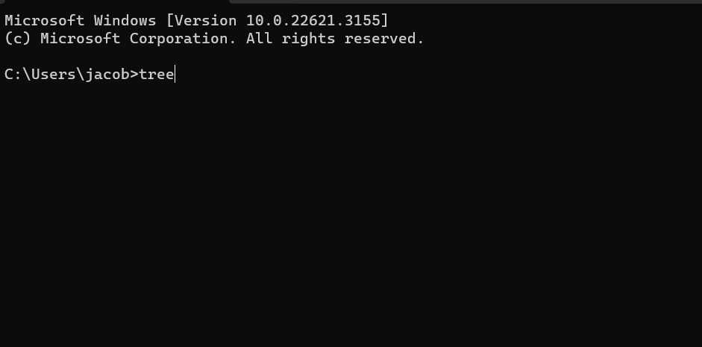
4: Tree Command

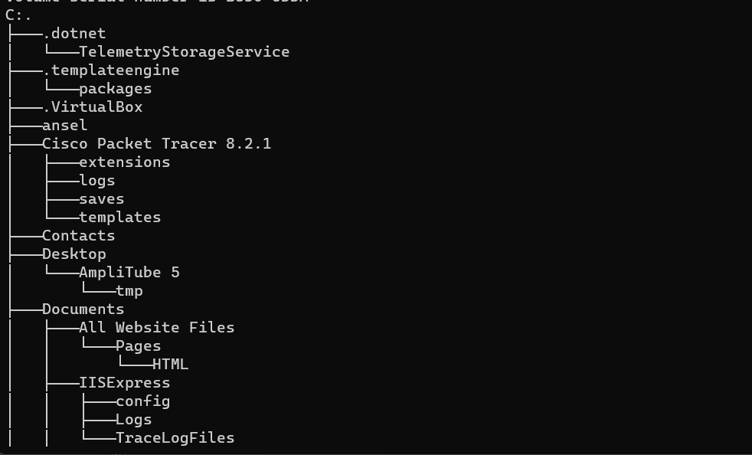
Figure 6: A tree-like pathing is structured out from the use of the command.
The Tree command displays a “tree” directory of all a computer’s files and drives. It breaks down what is contained within each file and where each file can be found along with splitting up the different drives such as C: drives and D: drives. [12]
5: Title Command
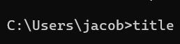
Figure 7: Use of the command 'title', the title should change to “I love Assignments”.
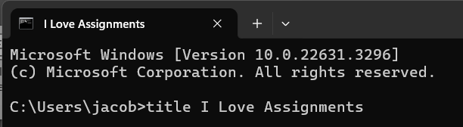
The title command performed correctly and retitled my Cmd Prompt session to “I love Assignments.” The title command is often used to give scripts.

6: Clear-RecycleBin Command
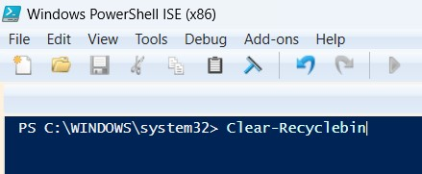
The clear RecycleBin Command [13] is used to clear the recycle bin. As shown below there is forty-eight items before the command has been run.
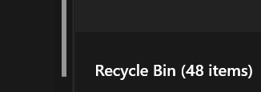
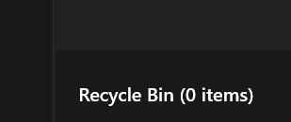
After the use of the command, the recycle bin has been cleared.

7: Echo Command
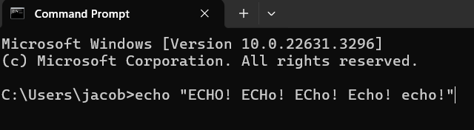
The Echo Command copies whatever input is set by the user and prints it onto the line below. [14]
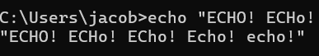
As mentioned above, the Echo Command functioned as a print statement and printed out whatever was inputted.
8: Date Command
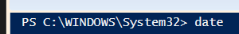
The “Date” powershell command brings up the current date along with the time. Although it does not prompt a change. [15]
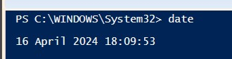
As seen above, the user is given the current time and date.

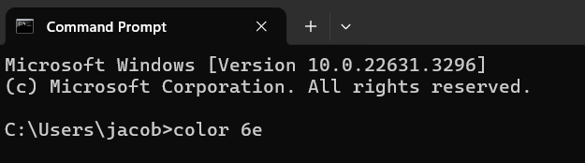
9: Colour Command
The colour command changes the foreground and background of the command prompt window for the session the user has started. It will change back to the original colour scheme afterwards. [15]
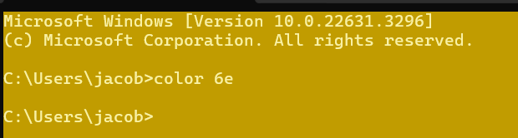
As said above, the colour scheme has shifted to a yellow colour scheme, although this will return to normal after the user restarts the session.
10: Start command
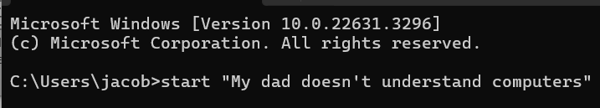
The “Start” Command will start a separate command prompt session from the current one. [16]
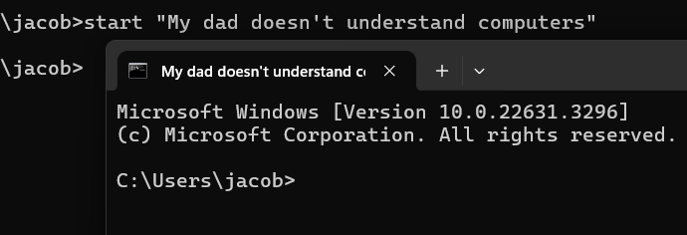
As shown above, a new command prompt window has opened, titled “My dad doesn’t understand computers.

Linux OS

What is a Linux OS?
- Linux is a more stripped-down operating system that brings more ease to the user who find themselves combatting viruses, malware, repairs, and crashes. Regarded as one of the most reliable systems in the world, Linux prides itself on being reliable, widely used and most importantly, being completely free.
- Linux also allows it’s users to customize the operating system to their own needs, such as building servers and building websites, thus making these processes (compared to windows) extremely quick. [11]

Linux Directories
- /Bin: the “bin” command means “binary” and controls all of the operating systems basic inputs and outputs and all the functions of it.
- /Lib: The “lib” command means “Library” and has important kernels that help with proper execution of commands in the terminal [18]

Use Of Linux OS CLI Commands

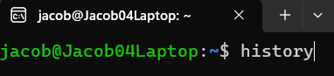
- History Command
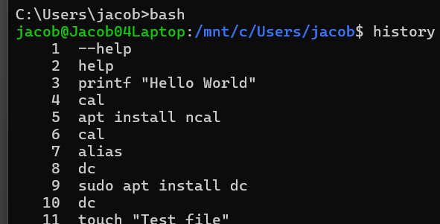
The history command allows the user to view the history of their previously used commands, allowing them to remove or change them. [19]

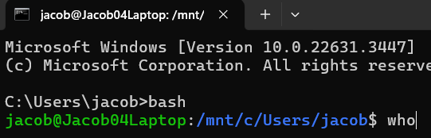
- Who command.

The Who Command Allows an admin to find who has logged into a system or computer network, showing the username and time of login. [20]
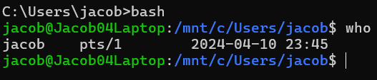
As provided in the statement above, the user “Jacob” has been shown to log on at 23:45 on the 10th of April through the Who Command.

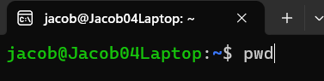
- PWD command
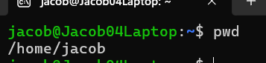
The “pwd” command shows the full path of a file or directory [21]
The directory for the current session was brought up with the use of the command.
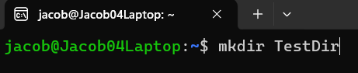
- Mkdir command
The Mkdir command creates an empty directory for a user. [22]
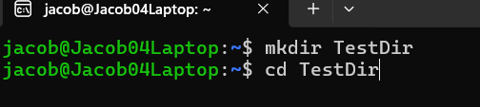
- Cd command

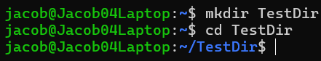
The Cd command opens a selected directory by the user. [23]

As mentioned above, the cd command has opened the “TestDir” Directory.

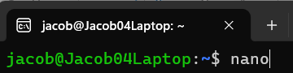
- Nano command

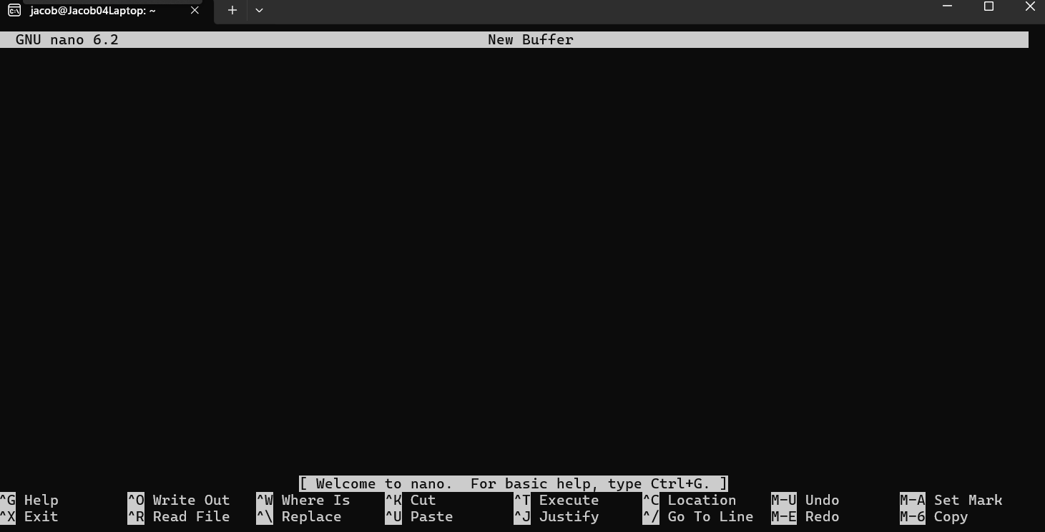
The Nano command brings up the nano text editor, which can be used to directly edit files in Linux based systems [24]

The entire layout of the Linux Command prompt changed to the Nano Text editor due to the use of the command.
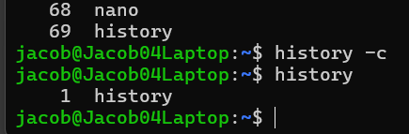
- History -c command
This command is a mix of the History command and the “Clear” command, known as “c” this command clears a user’s command history. [25] We can see that after the use of the command, the user history has been clear from 69 all the way to 1 command.

- Ls command
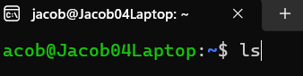
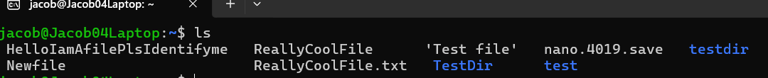
The ls command will display the information about the current directory along with files inside of it.
As shown in the screenshot, the directory information has been shown.

- Date command.
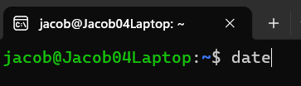
Similar to the windows date command, Linux also has this feature, although time is also included within it and does not allow modification. [26]
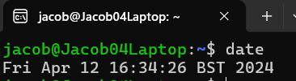

The current date and time have been brought up through the use of the command, along with the time zone.

- Rm-r command
With this command, the directory will be removed along with its contents. [27]
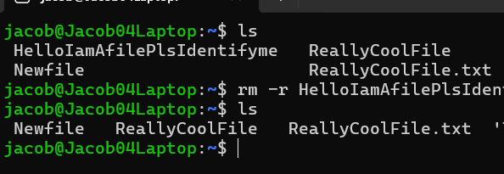
We can see that after the use of the command, the only directory remaining is “Newfile”

Use of Windows OS scripts
1.Variables
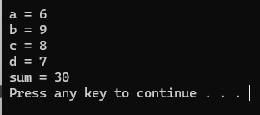
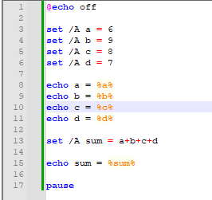

Within the two screenshots are the code and result of using the “set” command within a script. The set command assigns or “sets” a number as an environment variable and the “echo” commands prints out the variables, along with the “sum” variable adding
everything together at the end. [28]

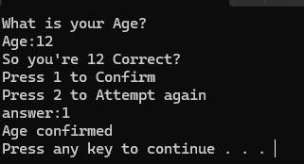
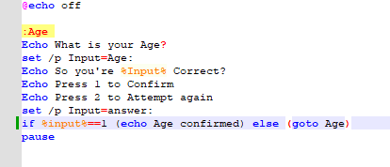
- If else Statements

The If Else statement within the script checks if the input to confirm is “1”, if it is not, it will allow you to reinput the age through “2” using the else statement, which reads the “2” input as a “false” or “negative” command, and allows the user to reinput their age. [29]

- GoTo statement
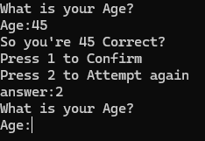
The “Goto” command directs the command prompt to a labelled line, in this case it directs it to “Age” which just repeats the process of the input. [30]

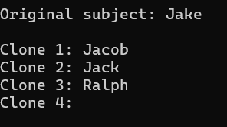
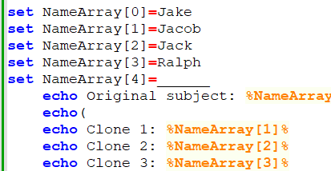
- Arrays and /P

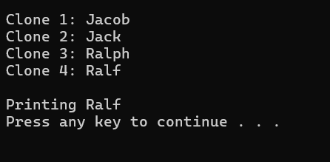
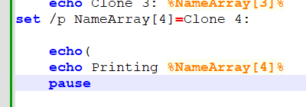
The above screenshot highlights an array, which highlights data of the “clones.” Due to the way that Cmd works, arrays have to be declared beforehand. Although you can input data by making use of a /p. As it is the same with most coding programmes, the array starts at 0. [31]

The set /p “NameArray” functions as an input command, allowing a user to enter a set variable into the cmd, in this case the set value would be “Ralf” who is “Clone 4”. Combining both arrays and /p together allows a user to create functional and updating arrays. [32]

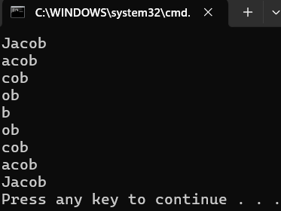
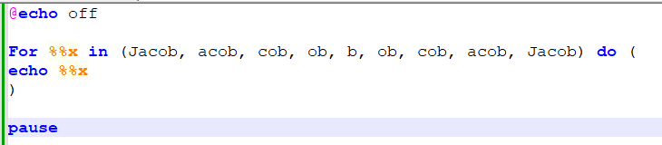
- For loop

The For loop shown in the [33] runs the “in” command until it reaches the end of the command line. Resulting in the half helix pattern seen within the terminal screenshot.

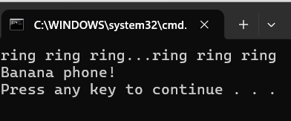
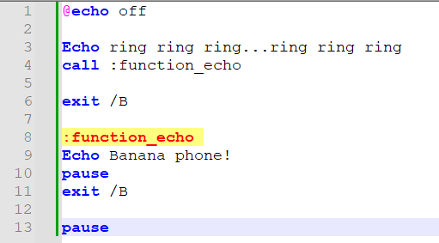
- Functions

Seen above in the script is an example of a function, specifically the call function which “calls” one batch programme without interfering with the main programme itself. It will have no effect if it’s used outside of a batch or script file. [34]

Use of Linux OS Scripts
- Variables
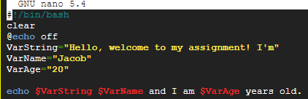

The variables in this Linux OS have the same function as the Windows operating system but are created differently due to putting “Var” before whatever you want to name the variable. Linux variables also can’t have spaces in between the code (although text quotation parts are fine). As we can see the Variables have printed out their information in the first screenshot in order to form a full sentence, while the variables in the second screenshot can be changed. [35]

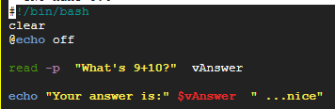
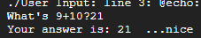
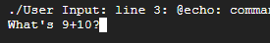
- User Input

The User Input being displayed within the screenshot uses the “read” command, seen in the 4th line of the 3rd screenshot. The command looks over the quotations and also uses “-p” to have the input variable in the same line. The last line uses said input variable to form a sentence again. [36]

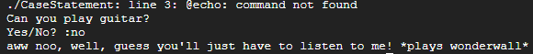
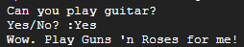
- Case Statement
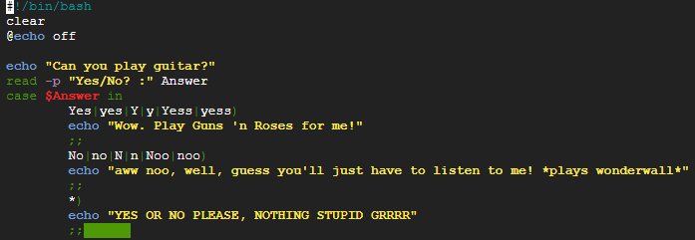

The case statement relies on expected inputs when there are limited multiple choices such as “yes/no” In this example the user is asked a yes or no question, depending on the answer they can get a different response, should they choose to respond with an improper response, the programme will tell them off. [37]

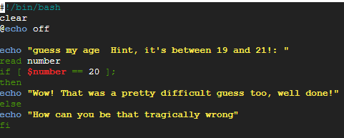
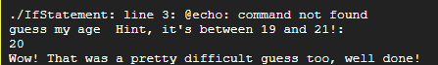
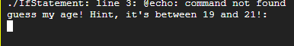
- If Statement

The If statement within the screenshots checks if the number input is 20, “if” the number is 20 then the programme will congratulate the user on guessing correctly, if not, then the programme mocks them using the “else” statement. [38] [39]

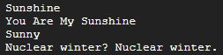
- Array
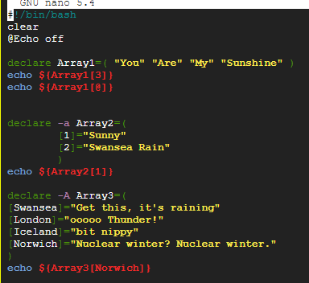

In the first array, multiple values are being held as quotations, which the array scans for the 3rd part which is “My” and prints it. The values can be selected and stored accordingly too. By grouping the variables together, it saves on space and makes the code more efficient overall. [40]

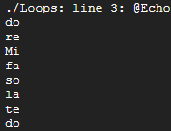
- For Loops
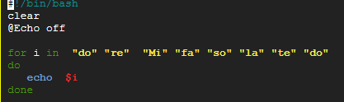

A “For” loop allows code to be repeatedly executed, in this instance it goes through the musical major scale, executing the echo command until it is finished. The “I” stands for the moving integer. The “do” is used to start code statements and the “done” ends the statements. [41]
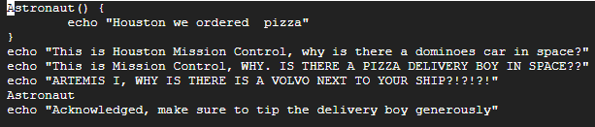
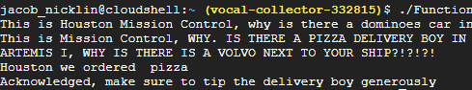
- Functions

A function command is a command that be called multiple times. The “Astronaut” command is the function in this example, with it only being called once after three echo commands. Functions are used to tidy up code and preventing rewrites, along with breaking the code into smaller adjustable sections.

Conclusion
Windows and Linux are just some of the wide varieties of operating systems. With OS’ for Mobile phones, Ais, quantum computers and networks. Each OS have their own special ways of accommodating the needs of the user.
While Linux offers a more direct way of accessing files, Windows gives a much more “ease of access” to its user, with its commands being simple to setup, input and execute. Along with giving much easier explanations of what the commands do. Scripts in windows also have a much easier setup time and can be created in a variety of platforms such as Notepad++ or Visual Studio Code.
Linux gives a more complex approach to an operating system, being less lenient and specific with its commands, scripts and directories, although the trade off is a more efficient way to optimise and use a computer.
Both do have their fair share of differences, but the goal of assisting a user to direct a computer or laptop remains the same. In that sense, the do share similarities too.

References

[1] | Lenovo, “What is an Operating System,” 31 January 2024. [Online]. Available: https://www.lenovo.com/gb/en/glossary/operating-system/?orgRef=https%253A%252F%252Fwww.google.com%252F. [Accessed 01 February 2024].
[2] | TechTarget, “What is an OS,” April 2023. [Online]. Available: https://www.techtarget.com/whatis/definition/operating-system-OS. [Accessed 01 February 2024].
[3] | TechTarget, “What is an Operating System OS,” April 2023. [Online]. Available: https://www.techtarget.com/whatis/definition/operating-system-OS. [Accessed 2024 02 05].
[4] | GCFGlobal, “Understanding Applications,” [Online]. Available: https://edu.gcfglobal.org/en/computerbasics/understanding-applications/1/. [Accessed 05 February 2024].
[5] | GeeksForGeeks, “What is a Network Operating System,” 03 November 2023. [Online]. Available: https://www.geeksforgeeks.org/what-is-a-network-operating-system/. [Accessed 08 February 2024].
[6] | F. I. f. I. Technology, “Chapter 6: Software,” 2013. [Online]. Available: https://fcit.usf.edu/network/chap6/chap6.htm. [Accessed 08 February 2024].
[7] | BBC, “Functions of an Operating System,” 2024. [Online]. Available: https://www.bbc.co.uk/bitesize/guides/zkkkw6f/revision/5. [Accessed 08 February 2024].
[8] | Microsoft Learn, “Task Manager,” Microsoft, 09 January 2019. [Online]. Available: https://learn.microsoft.com/en-us/shows/inside/task-manager. [Accessed 08 February 2024].
[9] | Dell, “How To launch Windows 11 Task Manager,” Dell, 02 February 2023. [Online]. Available: https://www.dell.com/support/kbdoc/en-uk/000192107/how-to-launch-the-windows-11-task-manager. [Accessed 18 February 2024].
[10] | IBM, “Opening Microsoft Windows Performance Monitor,” IBM, 05 January 2024. [Online]. Available: https://www.ibm.com/docs/en/planning-analytics/2.0.0?topic=monitor-opening-microsoft-windows-performance. [Accessed 18 February 2024].
[11] | Microsoft, “Microsoft Learn - Get-Help,” 2 March 2023. [Online]. Available: https://learn.microsoft.com/en-us/windows-server/administration/windows-commands/help. [Accessed 8 March 2024].
[12] | Microsoft, “Microsoft Learn: Tree,” 2 March 2023. [Online]. Available: https://learn.microsoft.com/en-us/windows-server/administration/windows-commands/tree. [Accessed 8 March 2024].
[13] | Microsoft, “Microsoft Learn - Powershell - ClearRecycleBin,” 2023. [Online]. Available: https://learn.microsoft.com/en-us/powershell/module/microsoft.powershell.management/clear-recyclebin?view=powershell-7.4. [Accessed 10 March 2024].
[14] | Microsoft, “Windows Command/Echo,” 03 February 2023. [Online]. Available: https://learn.microsoft.com/en-us/windows-server/administration/windows-commands/echo. [Accessed 5 April 2024].
[15] | Microsoft, “Windows Powershell- Get Date,” 3 February 2023. [Online]. Available: https://learn.microsoft.com/en-us/powershell/module/microsoft.powershell.utility/get-date?view=powershell-7.4. [Accessed 5 April 2024].
[16] | Microsoft, “Windows Learn - Colour Command,” 20 September 2023. [Online]. Available: https://learn.microsoft.com/en-us/windows-server/administration/windows-commands/color. [Accessed 7 March 2024].
[17] | Microsoft, “Windows Learn - Start,” 09 February 2023. [Online]. Available: https://learn.microsoft.com/en-us/windows-server/administration/windows-commands/start. [Accessed 7 March 2024].
[18] | Linux, “What is Linux?,” 2024. [Online]. Available: https://www.linux.com/what-is-linux/. [Accessed 22 February 2024].
[19] | LinuxToday, “Linux-Directory-Structure,” 28 September 2017. [Online]. Available: https://www.linuxtoday.com/infrastructure/linux-directory-structure-lib-explained/. [Accessed 16 April 2024].
[20] | DigitalOcean, “How To use Bash History Commands,” 10 November 2021. [Online]. Available: https://www.digitalocean.com/community/tutorials/how-to-use-bash-history-commands-and-expansions-on-a-linux-vps. [Accessed 10 April 2024].
[21] | IBM, “Who Command,” 24 March 2023. [Online]. Available: https://www.ibm.com/docs/en/aix/7.2?topic=w-who-command. [Accessed 10 April 2024].
[22] | I. S. University, “Introduction to HPC clusters,” November 2023. [Online]. Available: https://www.hpc.iastate.edu/guides/introduction-to-hpc-clusters/linux-commands-in-more-detail/pwd-and-ls#:~:text=The%20%22pwd%22%20command%20prints%20the,)%20of%20current%2Fworking%20directory.. [Accessed 10 April 2024].
[23] | IBM, “Mkdir.html,” 13 April 2021. [Online]. Available: https://www.ibm.com/docs/en/i/7.4?topic=ssw_ibm_i_74/apis/mkdir.html. [Accessed 11 April 2024].
[24] | IONOS, “Linux-cd-command,” 10 August 2023. [Online]. Available: https://www.ionos.co.uk/digitalguide/server/configuration/linux-cd-command/. [Accessed 11 April 2024].
[25] | Phoenixnap, “use nano text editor commands Linux,” 25 March 2024. [Online]. Available: https://phoenixnap.com/kb/use-nano-text-editor-commands-linux#:~:text=Nano%20is%20a%20versatile%20text,line%20of%20Unix%2Dbased%20systems.. [Accessed 12 April 2024].
[26] | OpenSource, “Linux Command History,” 1 April 2020. [Online]. Available: https://opensource.com/article/18/6/history-command#:~:text=To%20clear%20the%20entire%20contents,bash_history%20.. [Accessed 12 April 2024].
[27] | PhoenixNap, “Linux-Date-Command,” 1 October 2020. [Online]. Available: https://phoenixnap.com/kb/linux-date-command. [Accessed 12 April 2024].
[28] | C. University, “Computing/Unix info,” August 2023. [Online]. Available: https://www.maths.cam.ac.uk/computing/linux/unixinfo/rm#:~:text=rm%20%2Dr%20will%20recursively%20delete,will%20only%20delete%20empty%20directories).. [Accessed 12 April 2024].
[29] | IBM, “If-Then-Else Command Sequence,” IBM, 12 April 2021. [Online]. Available: https://www.ibm.com/docs/en/zos/2.4.0?topic=commands-if-then-else-command-sequence. [Accessed 17 April 2024].
[30] | M. Learn, “Goto,” 2 March 2023. [Online]. Available: https://learn.microsoft.com/en-us/windows-server/administration/windows-commands/goto. [Accessed 17 April 2024].
[31] | GeeksForGeeks, “Batch Script Arrays,” 08 June 2022. [Online]. Available: https://www.geeksforgeeks.org/batch-script-arrays/. [Accessed 17 April 2024].
[32] | S. Overflow, “What does /p mean in /p switch,” 20 October 2016. [Online]. Available: https://stackoverflow.com/questions/27773805/what-does-p-mean-in-set-p#:~:text=The%20%2FP%20switch%20allows%20you,The%20promptString%20can%20be%20empty.. [Accessed 17 April 2024].
[33] | Microsoft Learn, “For command,” 10 June 2023. [Online]. Available: https://learn.microsoft.com/en-us/windows-server/administration/windows-commands/for. [Accessed 17 April 2024].
[34] | Microsoft Learn, “How to use call command,” 02 March 2023. [Online]. Available: https://learn.microsoft.com/en-us/windows-server/administration/windows-commands/call. [Accessed 17 April 2024].
[35] | S. Parker, “Shellscript.sh,” 6 June 2023. [Online]. Available: https://www.shellscript.sh/variables1.html?utm_content=cmp-true. [Accessed 17 April 2024].
[36] | GeeksforGeeks, “Bash Script Read User Input,” 12 December 2023. [Online]. Available: https://www.geeksforgeeks.org/bash-script-read-user-input/. [Accessed 17 April 2024].
[37] | Linuxize, “Bash-Case Statement,” 18 March 2024. [Online]. Available: https://linuxize.com/post/bash-case-statement/. [Accessed 17 April 2024].
[38] | UWTSD, “Intro To Bash Scripting,” UWTSD, Swansea, 2024.
[39] | RyansTutorials, “Bash If statements,” November 2023. [Online]. Available: https://ryanstutorials.net/bash-scripting-tutorial/bash-if-statements.php. [Accessed 17 April 2024].
[40] | TutorialsPoint, “unix using arrays,” March 2024. [Online]. Available: https://www.tutorialspoint.com/unix/unix-using-arrays.htm. [Accessed 17 April 2024].
[41] | Linuxize, “Bash-For-loop,” 7 April 2024. [Online]. Available: https://www.cyberciti.biz/faq/bash-for-loop/. [Accessed 18 April 2024].

Appendices
Type Of Operating Systems

Linux Unhatched evidence Screenshots


