
Portfolio 4 components
Module title: Foreign Languages & Cultural Awareness
Module code: BMIH5003
Lecturer: Giulia Chifari
Name: MD BELAL HUSSAIN
Student ID: 2225724

Table of Contents
Component 1 - Professional reflection 3
Component 2 -Training plan 4
Component 3 - Student self-reflection 6
Component 4 - Training presentation 8
References 11

Component 1 - Professional reflection
During breakfast, an F&B worker coped with the cultural divide, and I could sense the misunderstanding as I was able to observe everything. The visitor, a Japanese businessman, asked for hot water with his dish, characteristic of numerous Asian cuisines. The service participant, unaware that hot water for dining purposes is usual in Japanese cultural customs, replied curtly and explained that hot water was not offered along with breakfast but rather delivered tea and coffee. That final sentence appeared to stun the guest a little while making him apprehensive.
This incident highlights how swiftly cultural miscommunications might emerge in a restaurant. Thus, in interactions between staff and clients with diverse cultures, the hospitality industry is believed to be the most susceptible (Yurur et al., 2021). That circumstance came to mind so clearly when I contemplated it that I understood how vital it is to learn linguistic competence and awareness to avoid such reoccurring misinterpretations in the future.
For example, language concerns may play a vital part in knowing the truth (Christiansen, Branch, and Karmowska, et al., 2020). On the other side, it is apparent that the server was unaware of the cultural importance of hot water for the Japanese dish and misread the true demands of the visitor. Training proficiency in the language used in restaurants by most customers, such as the Japanese in this case, not only aids in overcoming the interaction obstacle but also encourages simple customer relationships.
Next, cultural knowledge and awareness workshops, which are available to all of the individuals whom the hotel sector hires, are vital (Maheshkar, and Sharma, 2018). With the offering of training that informs employees about cultural norms, traditions, and etiquette of any country, workers can more effectively accept guests with different cultures who may not grasp and conceptualise their cultural conceptions and preferences. Training programmes are encouraged to apply situations and give case studies to replicate the real-world setting and to build among workers the ability to reflect on and empathise with other cultures.
Creating an atmosphere in which individuals may connect is the most crucial component that eliminates cultural disputes. The hotel staff must be instructed on how to connect with their visitors politely and intellectually fascinatingly by displaying a willingness to pay attention and acquire knowledge from various cultural backgrounds. By establishing an air of simplicity and a mindset of tolerance, hotels may retain a positive impression on tourists despite their variety and, consequently, limit the risk of misinterpretations.
The aforementioned circumstance of uncertainty occurred when a hotel guest misinterpreted the beverage and food staff highlights offered, for cultural competence and knowledge within the hospitality business. Language backgrounds may be handled, multicultural training offered, and an inclusive atmosphere built for tourists coming from varied cultural backgrounds, which in turn would help to build a good relationship with customers from other countries. I would aim to enhance these skills and behaviours to avoid such problems in the future.

Component 2 -Training plan
The training strategies will be focused on assuring adequate training of staff from the fourth level of the Placement Hotel, with an emphasis on efficient interaction and awareness of culture as well as inclusive speech.
Training Goals:
- Compile understanding of the most commonly utilised languages by hotel guests, which is one of many other essential abilities. Developing competency in the languages regularly used by hotel visitors is a necessary skill for an occupation in hotel administration (Ushakov et al., 2020).
- Make cultural knowledge an integral component of the hospitality drive that involves the staff so that they can comprehend the needs and preferences of guests from diverse walks of life.
- Create an atmosphere that is welcoming and inviting with the key principles of the hospitality industry in every connection with guests.
Training Components:
Language Proficiency Training
- Workers should attend language workshops, which would help them learn languages like Spanish, Mandarin, or Japanese on the hotel's behalf (Abramson, and Moran, 2017).
- Set up instructional resources, for instance, online programmes and cultural programmes.
- Show the workers in settings the linguistic techniques aiding them to talk and listen in the proper language.
Cultural Awareness Training
- Create culturally competent programmes that concentrate on such themes as ethnic values, customs, etiquette, and communication styles of various cultures.
- Bring variances in cultures and the manners that are observed in everyday life into the conversations to convey the idea that it also impacts visitors.
- Bring outside perspectives into the training programmes with presenters and cultural ambassadors who may deliver fresh and compelling viewpoints on cross-cultural interaction and hospitality.
Comprehensive Linguistic Instruction
- Emphasise the value of empathy, enquiry, and compassion in each visitor's interaction.
- Have instruction that helps staff become acquainted with the applicable listening techniques and the usage of body language signals so that they can grasp whatever guests want and enjoy.
- Promote a setting that encourages an inclusive and courteous attitude by integrating and supporting cultural diversity in interaction.
Implementation Plan
- Schedule regular training programmes: Dedicate specific times for other languages or social workshops and have everyone participate to establish an inclusive environment.
- Utilise multiple training techniques: Aim to adopt a variety of instructional agendas that will consist of instructional discussions, exercises in role-playing, invitations of visitors, and online resources to give information to the staff of different sorts of learning styles and inclinations.
- Monitor progress and comments: Keep periodic proof of the worker's language competence, cultural competency, and interpersonal abilities with the support of employee evaluation records, feedback from guests, and self-questionnaire. Feedback assists with determining the zones for improvement, and changing the content and arrangement of the succeeding sessions (Nedelko, and Brzozowski, 2019).
It should be noted that it will be possible to make sure that all employees receive adequate instruction with the essential competencies that are required for developing effective relationships with diverse customers. By guaranteeing that language skills, understanding of culture, and appreciation for diversity are encouraged, we may enrich the visitors' perceptions; create a chance for cross-cultural contact; and establish exceptional and strong ties with our beloved guests.

Component 3 - Student self-reflection
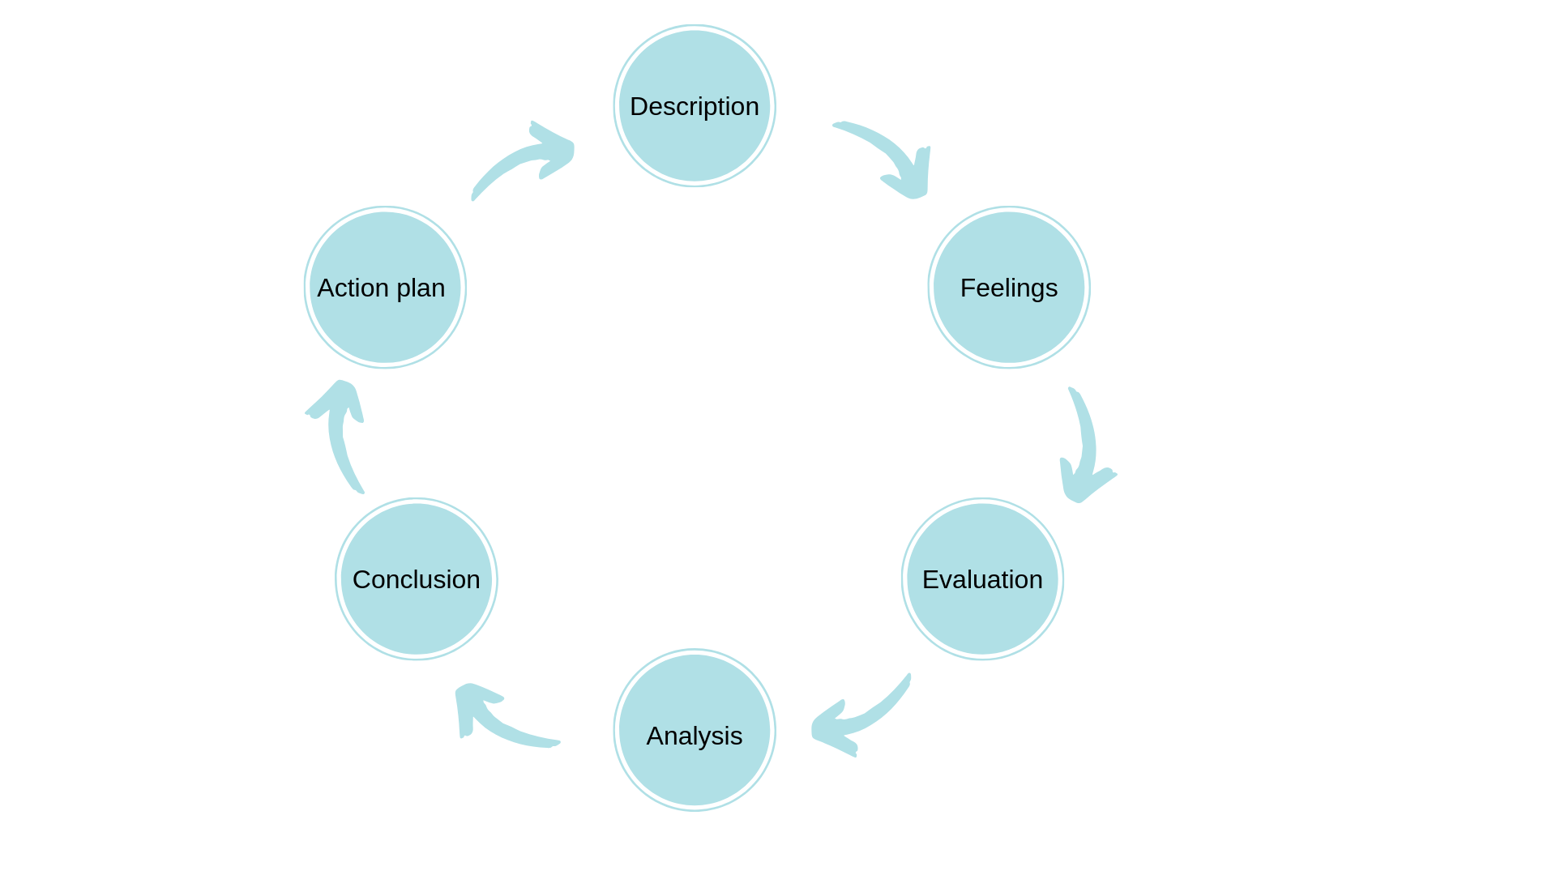
In this portfolio, I choose Gibb’s Reflective Cycle to reflect my understanding of the importance of cultural awareness (Markkanen et al. 2020) within the hospitality industry. With this self-reflection model, I can easily ask myself self-reflective questions about the importance of this topic like how did I understand the importance of cultural awareness within the hospitality industry changed over time? What did I learn as a result of this experience? And why is the experience important? In Gibb’s Reflective model, I can find my every self-reflective question answered perfectly. This model helps to bring out the importance of cultural awareness as it signifies the understanding and admiration of different cultures and their uniqueness. Moreover, I think that the advantages of cultural awareness in the hospitality industry can be productive for cultural diversity skills (Nguyen et al. 2022). Not only are these skills effective, but they are playing a major role in increasing business growth in the hospitality industry as well.
- Further, cultural awareness enhances the customer experience and to have this cultural awareness across the globe has improved the understanding of the customers. When the employees of a company can understand the needs and traditional etiquette of a customer, then they will be able to attend to and serve the customer better. And it makes the customer more satisfied and feel respected which leads to a way of improving the customer's faithfulness and enlarges the satisfaction level.
- According to me, the importance of cultural awareness in the hospitality industry can help to make a better community and employee involvement. Employees who belong to different cultures can communicate and have better skills to work as a line-up and make a better community.
- I think this cultural awareness can prevent misunderstanding and disagreement between the staff, employees, and customers in the hospitality industry (Daskalaki, 2020). By rehearsing the cultural norms and versatility for awareness and using the deliberate listening methodologies properly, they can prevent these disagreements and misunderstandings in advance of their occurrence.
- Cultural awareness is very crucial for the hospitality industry as it includes a stronger business connection. Raising stronger business connections is one of the major reasons for this awareness as it deals with overseas expenditure partners or multinational customers. It builds a kind of support and understanding of their cultures and mannerisms professionally.
- Well, I think improving functional cultural-diversity conveying skills is also valuable as the other points are discussed here. In the worldwide hospitality industry, creating and improving the functional cultural- diversity conveying skills have the greatest importance at the limit (Poort, Jansen, and Hofman, 2022). Implementing these skills has an outstanding impact on overseas professionals and it helps to cope with the vendors globally by providing them an unforgettable service from their societal surroundings.
- Adequate use of different cultural languages and sounds can be effective for cultural diversity provocations in the workplace. So, from my point of view, this can be beneficial for the hospitality industry when and how we should use the tones and sounds and when we should properly use the said things. Thus, the challenges regarding this problem can decrease.

Component 4 - Training presentation
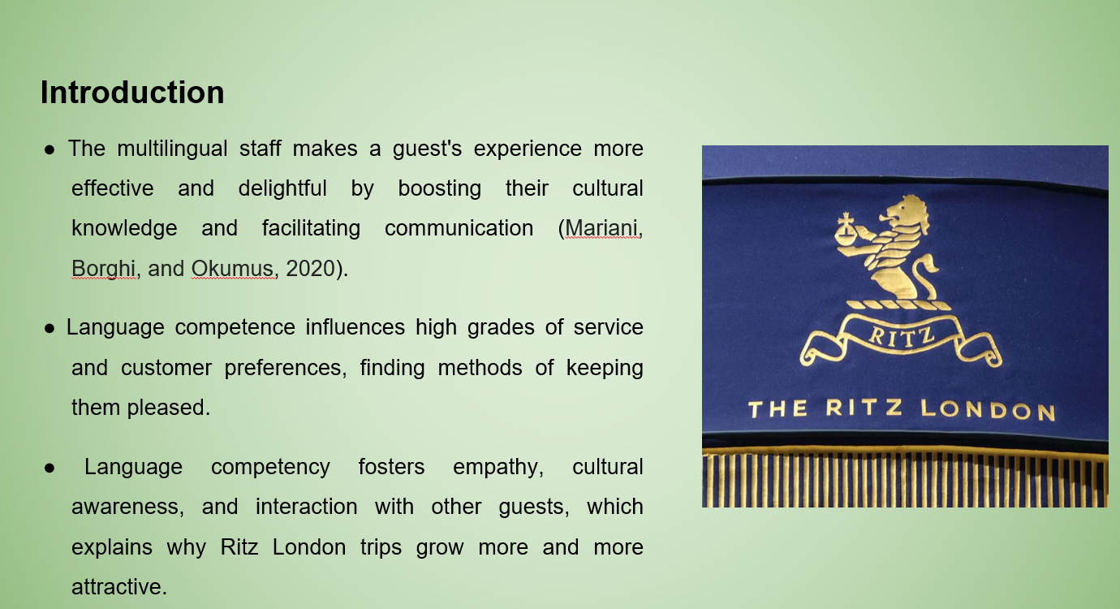
SN: The training on understanding languages and the instruction of Ritz London personnel underlines the idea that understanding linguistic abilities is crucial to effective company operations. In a global city like London, the hotel becomes a point of interest for tourists who come from diverse cultures, and multilingual workers turn this into a wonderful advantage. Based purely on their capacity to talk smoothly in different languages, the tourists are likely to have fantastic, unforgettable experiences by creating solid interactions and bonds. Additionally, this increases employees’ communication abilities, which act as a fundamental part of a high degree of service delivery by allowing for a more thorough comprehension of customers and responding to their demands. Language skills increase workers’ cultural awareness as well as compassion for people of various nationalities, generating more focused contacts with multicultural clients. Beyond the development of client happiness, diversity, and the use of additional languages among the employees of Ritz London, it is reputed to be an accommodating and inclusive environment. This training gives employees the security of knowledge about the languages often used by clients, increasing overall customer pleasure and validating the hotel’s dedication to top-quality service.
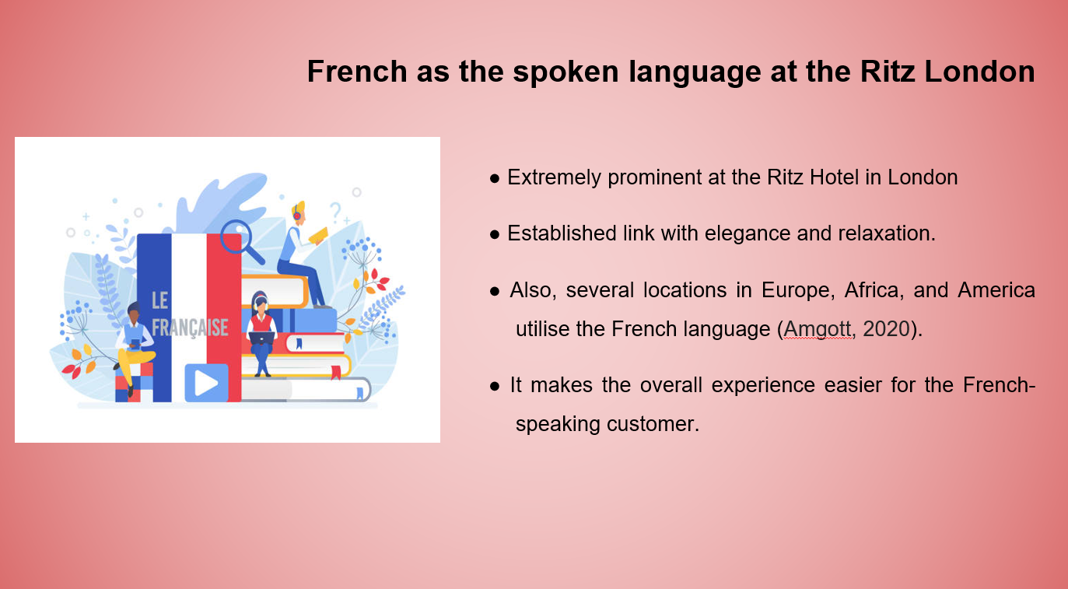
SN: At the Ritz London, probably the most commonly spoken current European language is French (Walker, 2022). Since its establishment, which is renowned as a supreme luxury location for international guests, the French language has become highly essential linguistically because of its history, providing it with flair and improvement. French is commonly understood in France or different French territories, primarily in Africa, America, and Europe.
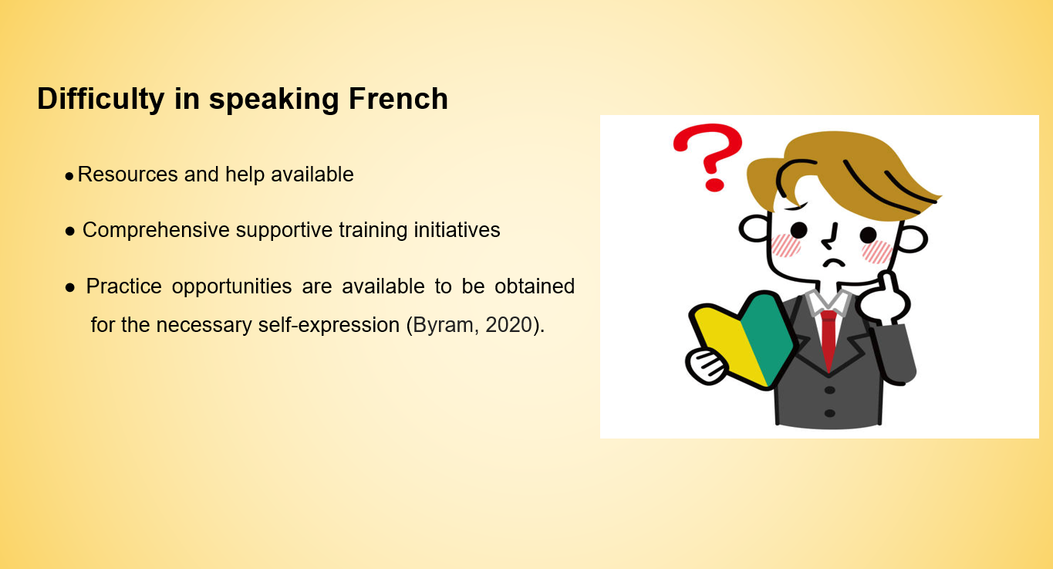
SN: French training at The Ritz London has garnered owing to its sophisticated structure. Nevertheless, the hotel's resources and help are accessible to the personnel who are determined to obtain language competence. To overcome language barriers, personnel may develop along with numerous training sessions and practice opportunities and become able to effectively communicate with French-speaking tourists and encourage a pleasant guest experience (Christou, 2022).
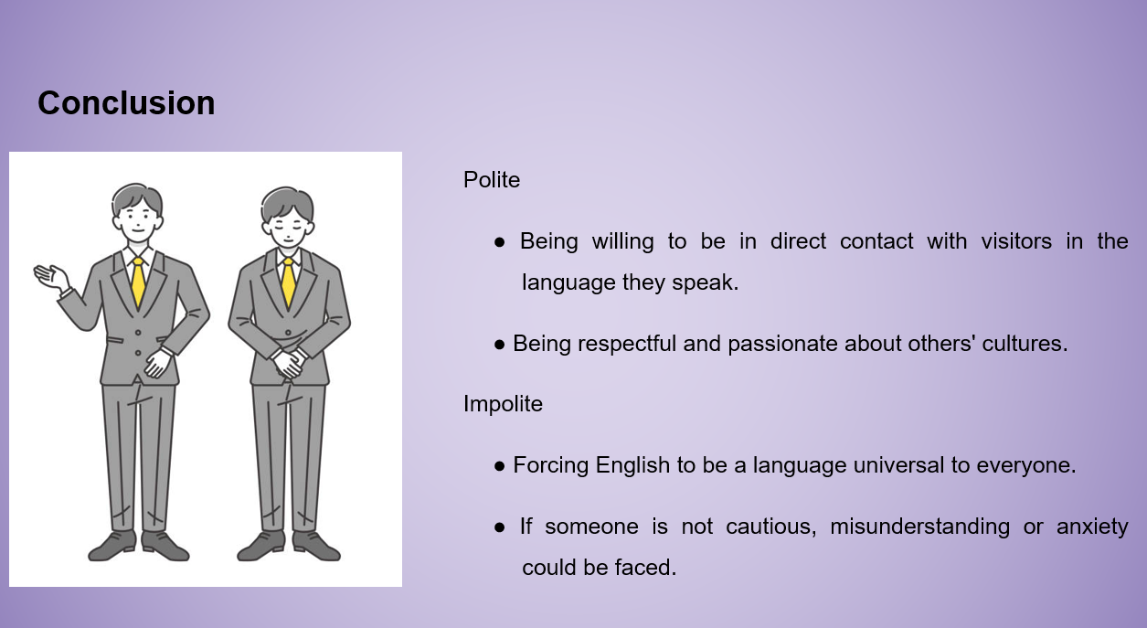
SN: Speaking fluently in languages other than English is extremely important at The Ritz London, with a thorough understanding of French consciousness being vital to establishing a positive mood with overseas visitors. Inter-personal competence which is the core of civility entails the readiness to welcome guests in their native tongue and the respect of their traditions. However, honouring the other cultures' mother tongue may result in slow talks that might be unpleasant or perplexing for those who are folks.

References
Abramson, N.R. and Moran, R.T., 2017. Managing cultural differences: Global leadership for the 21st century. Routledge. Available at: https://www.taylorfrancis.com/books/mono/10.4324/9781315403984/managing-cultural-differences-robert-moran-neil-remington-abramson (Accessed: 24 April 2024)
Amgott, N., 2020. L2 Multimodal composing abroad: Remixing languages, cultures, and identities. L2 Journal, 12(3). Available at: https://escholarship.org/content/qt4qh4p8t3/qt4qh4p8t3.pdf (Accessed: 24 April 2024)
Byram, M., 2020. Teaching and assessing intercultural communicative competence: Revisited. Multilingual matters. Available at: https://spada.uns.ac.id/pluginfile.php/253332/mod_resource/content/1/ICC%20Byram.pdf (Accessed: 24 April 2024)
Christiansen, B., Branch, J.D. and Karmowska, J. eds., 2020. Cultural Factors and Performance in 21st Century Businesses. IGI Global. Available at: https://books.google.co.in/books?hl=en&lr=&id=28XhDwAAQBAJ&oi=fnd&pg=PP1&dq=Christiansen,+B.,+Branch,+J.D.+and+Karmowska,+J.+(2020)+Cultural+Factors+and+Performance+in+21st+Century+Businesses.+Hershey+:+IGI+Global.&ots=beA7NLdI9W&sig=LOIZarOasHm7X29OUSMNXHnOexo&redir_esc=y#v=onepage&q&f=false (Accessed: 24 April 2024)
Christou, P.A., 2022. Tourism during the Late Modern Period (1750-1945). Available at: https://www.cabidigitallibrary.org/doi/pdf/10.5555/20220073027 (Accessed: 24 April 2024)
Daskalaki, E., 2020. Cultural Diversity and Indicated Intercultural Implications in the Hotel Working Environment in the United Kingdom: Underpinning the Employee’s Perspective. The Market: International Journal of Business, 1, pp.91-107. Available at: https://www.academia.edu/download/62999228/Cultural_Diversity_and_Indicated_Intercultural_Implications_in_the_Hotel_Working_Environment20200418-116086-flsm0f.pdf [Accessed on 24th April 2024]
Maheshkar, C. and Sharma, V. eds., 2018. Handbook of research on cross-cultural business education. IGI Global. Available at: https://books.google.co.in/books?hl=en&lr=&id=hipbDwAAQBAJ&oi=fnd&pg=PR1&dq=Maheshkar,+C.+and+Sharma,+V.+(2018)+Handbook+of+Research+on+Cross-Cultural+Business+Education.+Hershey:+IGI+Global.&ots=X8-EhLG3PP&sig=VPpRTSivR4bEulvDHpx41HAC_a0&redir_esc=y#v=onepage&q=Maheshkar%2C%20C.%20and%20Sharma%2C%20V.%20(2018)%20Handbook%20of%20Research%20on%20Cross-Cultural%20Business%20Education.%20Hershey%3A%20IGI%20Global.&f=false (Accessed: 24 April 2024)
Mariani, M.M., Borghi, M. and Okumus, F., 2020. Unravelling the effects of cultural differences in the online appraisal of hospitality and tourism services. International Journal of Hospitality Management, 90, p.102606. Available at: https://centaur.reading.ac.uk/91526/1/Manuscript_Accepted_ok_Final.pdf (Accessed: 24 April 2024)
Markkanen, P., Välimäki, M., Anttila, M. and Kuuskorpi, M., 2020. A reflective cycle: Understanding challenging situations in a school setting. Educational Research, 62(1), pp.46-62. Available at: https://www.utupub.fi/bitstream/handle/10024/166237/Final_version_Markkanen%2001012020%20(2).pdf?sequence=1 [Accessed on 24th April 2024]
Nedelko, Z. and Brzozowski, M. eds., 2019. Recent Advances in the Roles of Cultural and Personal Values in Organizational Behavior. Available at: https://books.google.co.in/books?hl=en&lr=&id=6q2rDwAAQBAJ&oi=fnd&pg=PR1&dq=Nedelko,+Z.+and+Brzozowski,+M.+(eds)+%E2%80%98Recent+advances+in+the+roles+of+cultural+and+personal+values+in+organizational+behavior%E2%80%99+in+Ord%C3%B3%C3%B1ez+de+Pablo,+P.+(2020)+Advances+in+Human+Resources+Management+and+Organizational+Development+Book+Series.+Hershey:+IGI+Global.&ots=e_TaOhuSRy&sig=fPKrdQW1UExlMHOp6UQ6Ar1IX0Y&redir_esc=y#v=onepage&q&f=false (Accessed: 24 April 2024)
Nguyen, N.T., Yadav, M., Pande, S., Bhanot, A. and Hasan, M.F., 2022. Impact of diversity management on organizational performance in hotel organizations: a conceptual framework. International Journal of System Assurance Engineering and Management, 13(Suppl 1), pp.186-196. Available at: https://www.researchgate.net/profile/Sagar-Pande-2/publication/355781318_Impact_of_diversity_management_on_organizational_performance_in_hotel_organizations_a_conceptual_framework/links/6184c677a767a03c14f6d682/Impact-of-diversity-management-on-organizational-performance-in-hotel-organizations-a-conceptual-framework.pdf [Accessed on 24th April 2024]
Poort, I., Jansen, E. and Hofman, A., 2022. Does the group matter? Effects of trust, cultural diversity, and group formation on engagement in group work in higher education. Higher Education Research & Development, 41(2), pp.511-526. Available at: https://www.tandfonline.com/doi/pdf/10.1080/07294360.2020.1839024 [Accessed on 24th April 2024]
Ushakov, R.N., Kryukova, E.M., Khetagurova, V.S., Mukhomorova, I.V. and Zelenov, V.V., 2020. Efficiency of hotel management. Training of specialists in hotel industry field. Journal of Environmental Management and Tourism, 11(2), pp.388-395. Available at: https://journals.aserspublishing.eu/jemt/article/view/4736 (Accessed: 24 April 2024)
Walker, J.R., 2022. Exploring the Hospitality Industry, 2/e. Pearson Education India. Available at: https://thuvienso.hoasen.edu.vn/bitstream/handle/123456789/12016/Contents.pdf?sequence=1&isAllowed=y (Accessed: 24 April 2024)
Yurur, S., Koc, E., Taskin, C. and Boz, H., 2021. Factors influencing intercultural sensitivity of hospitality employees. International journal of hospitality & tourism administration, 22(1), pp.26-44. Available at: https://www.researchgate.net/profile/Cagatan-Taskin/publication/329000331_Factors_Influencing_Intercultural_Sensitivity_of_Hospitality_Employees_Factors_Influencing_Intercultural_Sensitivity_of_Hospitality_Employees/links/5bef0c40299bf1124fd81ac3/Factors-Influencing-Intercultural-Sensitivity-of-Hospitality-Employees-Factors-Influencing-Intercultural-Sensitivity-of-Hospitality-Employees.pdf (Accessed: 24 April 2024)

