

Institute of Inner-City Learning
Birmingham Campus
BSc (Hons) Health and Social Care

DECLARATION
I confirm that this work has not been submitted, in whole or in part, for any other award, and it is not concurrently under consideration for any qualification.
Signed: shabana
Name: Shabana sharif
Date: 28.11.2025
STATEMENT 1
I submit this dissertation in partial fulfilment of the requirements for the award of the BSc degree.
Signed:Shabana
Name: Shabana sharif
Date: 28.11.2025
STATEMENT 2
This dissertation is the product of my own independent study, except where specific acknowledgements are made. All sources have been cited with full references, and a complete bibliography is included.
Signed: Shabana
Name: Shabana sharif
Date:28.11.2025
STATEMENT 3
If this dissertation is accepted, I authorise its availability for photocopying and interlibrary loan, and consent to the title and abstract being shared with external organisations.
Signed: Shabana
Name: Shabana sharif
Date:28.11.2025
STATEMENT 4
If this dissertation is accepted, I consent to it being made available on the university’s IT systems to authorised users.
Signed: Shabana
Name: Shabana sharif
Date: 28.11.2025

The Impact of Social Isolation On the Mental Health of Older Adults in The UK: A Systematic Review of Qualitative Evidence

Student Name:Shabana sharif
Student ID:2026633

Dissertation submitted as part of the requirements for the award BSc (Hons) Health and Social Care

September, 2025

ACKNOWLEDGEMENTS
I would like to express my sincere gratitude to my supervisor for their guidance, constructive feedback and encouragement throughout this project. I am also thankful to the academic and administrative staff who supported me with resources, advice and timely assistance.
My appreciation extends to the authors and researchers whose work informed this dissertation, and to the librarians and digital support teams who facilitated access to materials. I am deeply grateful to the practitioners and community organisations working to reduce digital exclusion among older adults, their insights shaped the relevance of this study.
To my classmates and friends, thank you for your thoughtful discussions and moral support. Above all, I am indebted to my family for their unwavering patience, understanding and belief in me; this work would not have been possible without their constant encouragement.

ABSTRACT
Purpose, Aims and Objectives: This dissertation explores how social isolation and digital exclusion intersect to affect the mental health and care experiences of older adults in the UK. The aim was to understand mechanisms, consequences, and effective responses, addressing four objectives: (1) describe how digital exclusion manifests (access, skills/confidence, motivation); (2) examine consequences for access to services, mental health, wellbeing and care experience; (3) assess the efficacy of UK policies and interventions; and (4) generate evidence-based recommendations. Given the NHS’s rapid digitisation, the topic is directly relevant to equity and quality in health and social care.
Methods: A systematic review of qualitative and mixed-methods studies (2015–2025) was conducted using a transparent search strategy and PRISMA flow; 44 articles met inclusion criteria. Data were synthesised using thematic analysis of published literature, focusing on UK contexts and older adults’ experiences in health and social care.
Findings: Four themes emerged. (1) Disengagement and barriers: layered divides in access, skills/confidence and meaningful use create “digital thresholds” to care. (2) Consequences: friction at first contact leads to delayed/foregone care, heightened anxiety and loneliness, and erosion of trust/dignity. (3) What works: parity of offline and digital routes, assisted-digital support at point of need, and place-based partnerships (libraries/VCSE) show promise when co-designed and adequately resourced. (4) Recommendations: a minimum effective package bundling device+data+skills, parity by design, local commissioning guided by exclusion maps, and equity KPIs.
Limitations: English-language focus; heterogeneity of settings/measures; limited evaluation of first-contact tools (online booking/e-triage); potential publication bias.
Recommendations: For practice and policy: embed assisted-digital support and parity by design; fund multi-year, community-anchored inclusion bundles; measure inclusive outcomes (completed access, confidence, belonging). For education: micro-credentials for frontline “digital champions” and co-design skills. For research: close the first-contact evidence gap with equity-led evaluations integrated into routine service improvement.

Table of Contents
CHAPTER 1: Introduction 11
1.1 Introduction 11
1.2 Definitions and Terminology 11
1.2.1 Key Definitions 12
1.2.2 Acronyms and Abbreviations 12
1.3 Rationale for Research 13
1.4 Aims and Objectives 13
1.4.1 Aim: 13
1.4.2 Objectives: 14
1.5 Conclusion 14
CHAPTER 2 – Background Information and Analysis 15
2.1 Introduction 15
2.2 Historical Background 15
2.3 Theoretical Background 16
2.4 National/Local UK Context 18
2.4.1 UK Perspective 18
2.4.2 Policy and Regulation 18
2.4.3 Local Context 19
2.5 Conclusion 19
CHAPTER 3: Methodology 21
3.1 Introduction 25
3.2 Search Strategy 25
3.3 Searching for Information 26
3.4 Research Validation 28
3.5 Inclusion and Exclusion Criteria 28
3.6 Analyzing Research 29
3.7 Ethical Considerations 30
3.8 Chapter Conclusion 30
CHAPTER 4 – Findings and Discussion 31
4.1 Introduction 31
4.2 Thematic Analysis 31
4.3 Theme 1 – Disengagement and Barriers: how digital exclusion manifests for older adults in UK health & social care 31
4.3.1 Definition and scope 32
4.3.2 Historical/contextual Background 32
4.3.3 Scale and Salience 32
4.3.4 Distinctive Obstacles in Health & Social Care 32
4.3.5 Theoretical Framing 33
4.3.6 Illustrative UK examples 33
4.3.7 Relevance to The Research Objective 1 34
4.3.8 Connections to Other Themes 34
4.4 Theme 2 – Consequences: access to services, mental health, wellbeing and care experience 34
4.4.1 Definition and Scope 34
4.4.2 Background and Mechanisms 34
4.4.3 Access to Services: Friction, Delay and Forgone Care 35
4.4.4 Mental Health and Wellbeing 35
4.4.5 Care Experience: Dignity, Choice and Continuity 36
4.4.6 Statistical Context (Triangulation) 36
4.4.7 Illustrative Intervention Evidence (Mechanism Plausibility) 36
4.4.8 Relevance to The Research Objective 2 36
4.4.9 Connections to Other Themes 37
4.5 Theme 3 – What works? Efficacy of UK policies and interventions to stimulate digital inclusion 37
4.5.1 Definition and scope 37
4.5.2 Background and Policy Direction 37
4.5.3 What Shows Promise in Practice? 38
4.5.4 What The Evidence Cautions? 39
4.5.5 Illustrative from Convergent Evidence 39
4.5.6 Relevance to The Research Objective 3 40
4.5.7 Connections to Other Themes 40
4.6 Theme 4 – Recommendations: evidence-based, achievable actions for providers, policymakers and communities 41
4.6.1 Definition and orientation 41
4.6.2 Background 41
4.6.3 Recommendations for providers (NHS trusts, PCNs/GP practices, adult social care) 41
4.6.4 Recommendations for commissioners and policymakers (ICBs/ICSs, local authorities, DHSC/NHSE) 42
4.6.5 Recommendations for VCSEs, libraries and housing providers 42
4.6.6 Theoretical and ethical underpinnings 43
4.6.7 Relevance to Research Objective 4 43
4.6.8 Connections to Other Themes 43
4.7 Chapter Conclusion 44
CHAPTER 5 – Conclusion and Recommendations 45
5.1 Overall Conclusion 45
5.2 Recommendations 45
5.2.1 Recommendation 1: Embed assisted-digital support and parity by design at the first point of contact 45
5.2.2 Recommendation 2: Commission place-based inclusion bundles—device + data + skills – co-designed with older adults 46
5.2.3 Recommendation 3: Close the first-contact evidence gap and mainstream equity-led evaluation 47
5.3 Closing note 47
CHAPTER 6: References and Appendices 49

List of Figures
Figure 1: Search Strategy (Created by using Visual Paradigm Tool) 26
Figure 2: PRISMA Diagram (Created by using Visual Paradigm Tool) 27

List of Tables
Table 1: Acronyms and Abbreviations 12
Table 2: PEO Elements 25
Table 3: Inclusion and Exclusion Criteria 29
Table 4: Themes 61

CHAPTER 1: Introduction

1.1 Introduction
Social isolation is a growing concern among older adults and United Kingdom (UK) is no exception. As people age, they may face physical limitations, the loss of social networks, or reduced independence, which can lead to feelings of loneliness and disconnection (Gerlach et al., 2024). Traditionally, social relatedness has been an overlooked aspect in the provision of care in elder care but nowadays, according to HoltLunstad (2024), its role in the lives of people and their states was clarified immensely. The increased understanding of depressions, anxiousness, and cognitive decline, along with the subsequent isolation, in the elderly population has triggered an immediate need for developing public-health initiatives. These initiatives can target the social inclusion and emotional support of the elderly. National Academies Press (US) (2020) further demonstrated that this concern is particularly applicable in the contemporary society, where the use of digital technologies is important in health and social care services.
In the recent years, the movement towards variations of digital service delivery, including online appointments, e-consultations, and digital records, has taken place (Rosenlund et al., 2023). These tools are effective to most individuals, but they seem problematic to older adults who lack the expertise, availability, and confidence to utilize the tools (Kunonga et al., 2021). They can be even more separated by this digital exclusion along with important services and support systems. The COVID-19 pandemic enforced an increased object in the use of digital platforms, which, despite being beneficial to many, raised the gap on people who are digitally-excluded (Garlatti et al., 2025).
This dissertation aims to explore the impact of social isolation on the mental health of older adults in the UK, with a focus on how digital exclusion contributes to this issue. By conducting a literature review of qualitative evidence, the study will examine how older adults experience social isolation in a digital world. The goal is to provide practical recommendations to help health and social care providers reduce digital barriers. The research aims to support more inclusive service delivery and contribute to ongoing efforts to improve mental wellbeing and quality of life for older adults.
To ground the discussion, section 1.2 clarifies key terms and abbreviations used throughout this dissertation.

1.2 Definitions and Terminology
To ensure clarity and understanding throughout this dissertation, key terms and abbreviations are defined below. These terms are central to the study and help establish the context for exploring the impact of social isolation and digital exclusion on the mental health of older adults in the UK.

1.2.1 Key Definitions
Older Adults: Older adults are those individuals who are above 60 years. It is UNHCR (2025) definition and it constitutes the major population considered in this study.
Social Isolation: Social isolation refers to absence of frequent contact or any meaningful communication with others. It is an objective form, contrary to loneliness, and it may cause severe effects on physical and mental well-being, particularly in the elderly population (Veazie et al., 2019).
Digital Exclusion: Digital exclusion refers to barriers that prevent people from accessing or effectively using digital devices and the internet (Tomczyk et al., 2023). Such barriers can be related to the absence of skills, affordability, poor access, physical, or cognitive disability. It is one of the major contributors to social isolation of the aged.
Mental Health: Mental health is all about the emotional, psychological as well as the social wellbeing of a person. In case of older people, it encompasses resilience to stress, sustaining relationships, and available support (WHO, 2022).

1.2.2 Acronyms and Abbreviations
These terms are used consistently throughout the dissertation to maintain clarity and accuracy.
Table 1: Acronyms and Abbreviations
Acronym | Meaning
NHS | National Health Service
UK | United Kingdom
ONS | Office for National Statistics
ICT | Information and Communication Technology
GP | General Practitioner
WHO | World Health Organization
UNHCR | United Nations High Commissioner for Refugees
With shared terminology established, the section 1.3 explains why this topic is urgent for UK health and social care.

1.3 Rationale for Research
This research focuses on the effects of social isolation and digital exclusion on the mental health of older adults in the UK. The topic is timely and important. Ageing populations are growing, and digital services are expanding rapidly (Gerlach et al., 2024). Many older adults struggle to keep up with digital technologies. This creates barriers to social connection and access to essential services (Kunonga et al., 2021). There is also recognition, social isolation as a risk factor for poor mental health, as demonstrated by Holt‐Lunstad (2024). Research also shows that digital exclusion limits communication, information access, and independence (Wilson-Menzfeld et al., 2021). However, few studies explore the combined impact of these two factors. The relationship between social isolation, digital exclusion, and mental health remains under-examined, especially in a UK context.
Further, the COVID-19 pandemic has increased digital dependence, this has made the issue more urgent. Older adults who lack digital access face even greater isolation, which is serious implications for mental wellbeing (Stuart et al., 2022). A key gap exists in integrated studies that connect these issues. Most research treats them separately. There is limited understanding of how digital exclusion may intensify social isolation and mental health challenges, especially in UK. This dissertation aims to address this gap. It will analyze how these two issues intersect. It will also examine their combined impact on older adults' mental health in UK. The study will provide evidence to support policy development and community interventions. By identifying the link between digital and social exclusion, the research aims to contribute to more inclusive health and social care practices.
Building on this rationale, section 1.4 sets out the study’s overarching aim and specific, measurable objectives.

1.4 Aims and Objectives

1.4.1 Aim:
To explore how digital exclusion affects older people who receive services in UK health and social care systems and describe how to promote digital inclusion effectively in the country to provide older citizens with equal access to necessary services and better health.

1.4.2 Objectives:
- To describe and discuss the phenomenon of digital exclusion with the particular reference to the elderly groups in the health and social care setting within the UK, the distinctive obstacles (e.g. access, proficiency, drive) should be identified.
- To examine the reported consequences of digital exclusion on the access of services by the elderly, health effect, wellbeing and their experience of care.
- To consider efficacy of the current interventions and policies (national/local) to stimulate digital inclusion of elderly service users in the UK.
- To make recommendations to health and social care providers, policymakers and organisations in the communities about evidence-based achievable methods to limit digital exclusion and make services more accessible to the older people.
Having defined what, the study seeks to achieve, the conclusion summarizes Chapter 1 and prepares the reader for the wider context.

1.5 Conclusion
Chapter 1 introduced the research topic, the impact of social isolation and digital exclusion on the mental health of older adults in the UK. It outlined the background and significance of the issue, explained key terms, and presented the rationale for the study. The chapter also defined the research aim, set out the main objectives, and formulated the research question. The importance of this research lies in its focus on an underexplored area within UK health and social care. With an ageing population and rapid digital advancement, this topic is both timely and relevant. The study seeks to fill identified gaps and contribute to current debates on mental health and inclusion. The next chapter, Chapter 2, provides detailed background information and analysis. It explores the historical and theoretical context, key developments, and both local and global perspectives. This foundation supports a deeper understanding of the research problem and guides the later methodological approach.

CHAPTER 2 – Background Information and Analysis

2.1 Introduction
This chapter provides background information on the research topic. It builds a foundation by exploring the historical, theoretical, and contextual aspects. The focus is on the ageing population in the UK and the increasing use of digital technologies. It also outlines the social and mental health challenges faced by older adults. The chapter highlights how digital exclusion can affect wellbeing. It discusses relevant policies, social changes, and demographic trends. The purpose is to place the research in a broader context. This will support the later analysis and help justify the study’s importance.
With the scope established, section 2.2 traces the historical forces that shaped ageing, care systems and the emergence of the digital divide in the UK.

2.2 Historical Background
The issue of ageing has been discussed for decades. In the past, older adults were respected as key members of society. They often lived in extended families and had strong support systems (Bražinová & Chytil, 2024). As industrialization grew, family structures changed. Older people became more isolated from their families and communities (Wani et al., 2024). By the mid-20th century, ageing became a concern in developed nations. Rising life expectancy meant people lived longer. At the same time, birth rates started to decline. This shift led to a growing proportion of elderly people in society. Governments and health systems began to feel the pressure of ageing populations (Khavinson et al., 2020).
In the UK, the 1948 introduction of the National Health Service (NHS) was a turning point. It aimed to provide care for all, including older adults. Over time, however, the needs of the ageing population grew faster than the services available (Gorsky, 2015). By the 1970s and 1980s, reports highlighted the need for specialised elderly care. Sheltered housing, community care, and social work became common themes in policy discussions. During the 1990s and 2000s, digital technology began transforming daily life. However, older adults were often left behind. This led to the term digital divide (NHS England, 2023). The digital divide refers to the gap between those who can access and use technology and those who cannot. For elderly people, this divide meant missing out on information, services, and social connections (Gorsky, 2008). Peter Laslett is one of the most important persons to consider when interpreting what ageing is. The book on the Third Age in the 1980s transformed perception as to how people viewed retirement. He claimed that elderly people can lead a productive, viable, and socially influential life. Most of the current policies encouraging healthy ageing were influenced by his ideas (Jones et al., 2008).
The concept of active ageing that was coined by the World Health Organization (WHO) was the other influential phenomenon in the area. This concept stimulated governments to assist the older individuals to remain healthy, safe, and active in society. It was the WHO that also focused on the role of technology in optimising the lives of the aged people (Paúl et al., 2012). Age UK and other charities had their role to play in the UK as well. They undertook an initiative to sensitize society about feelings of isolation, destitution, and internet exclusion. These groups advocated to include more policies and services (AGE Platform Europe, 2019). The gap in digitization was further observed in the last years due to COVID-19. Even elderly people who are not accessing the internet found it messier before getting any health updates, booking appointment, or communicating with family. This is what made digital access a significant component of social and health equality (Zapletal et al., 2023). In brief, nowadays, the issue of the ageing population blows up. All these come about through historical changes in the family structure, healthcare and technology. With this background, there is a reason why we would say that the subject is relevant today more than ever before.
Having outlined the historical context, section 2.3 now turn to the theoretical frameworks that explain how social isolation and digital exclusion interact in later life.

2.3 Theoretical Background
Understanding the impact of social isolation and digital exclusion on the mental health of older adults in the UK requires engagement with several relevant theories. Among the foundational frameworks are Disengagement Theory, Activity Theory, Social Capital Theory, and the Digital Divide Framework. These theories provide insight into ageing, social participation, and the implications of digital inequality.
The Disengagement Theory (Cumming & Henry, 1961) assumes that interaction decreases due to the fact that an older adult naturally detaches themselves of social role and activities that come with aging. Although this theory played a significant role in the early development of gerontology, the theory was criticized on the ground that it pathologises the process of aging and supports social neglect. Nevertheless, it is also useful to shape the natural/enforced withdrawal debate within the approach of digital exclusion. Activity Theory (Havighurst, 1961), in its turn, focuses on the social engagement of older people that is vital to their wellbeing. It implies that meaningful activities, including digital interaction, improve satisfaction and mental Health when undertaken actively. Thus, digital exclusion leads to a block to active participation in healthy ageing (Vaportzis et al., 2017). Digital exclusion can be well understood by considering the viewpoint of the Social Capital Theory (Bourdieu, 1986). The ability to act collectively is called a social capital, and this term can be defined as networks, bonds, and rules. Digital exclusion can cause older adults to have low social capital, resulting in loneliness, low service delivery, and deteriorated mental health conditions (Seifert et al., 2021). The theory has been seen to assist in explanation of how the increased access to technology promotes wider inclusion in the society and connectedness.
A more detailed knowledge of digital exclusion can be received with the help of the Digital Divide Framework. In this model, three stages are identified (1) access to technology, (2) digital literacy or skills and (3) meaningful use (van Dijk, 2006). The elderly tend to experience difficulties on the three levels. As an example, access may be restricted by physical impairment, and the effective use by a lack of training and confidence. This theory can be found at the basis of a considerable part of the policy-based studies on closing the disparity in digital health services (Bober et al., 2024). The theories have been utilized in different studies. As another example, Tsai et al. (2010) applied the Social Capital Theory in examining internet use and its impact in alleviating loneliness in elderly people. On the same note, Seifert (2021) employs the Digital Divide Framework in discussing how the experience with COVID-19 exposed flaws in digital inclusion of older adult populations. The applications reveal that digital exclusion is not a technological problem but rather a problem of socio-psychological nature.
Importantly, such theories are valuable and, at the same time, limited. Disengagement Theory has very little subtlety, and can miss structural forms of inaccessibility. Although Activity Theory is positive, it might not apply in older adults who have a debilitating disease or those who are non-ambulatory. It can be said that SCT is criticized due to its tendency to overlook inequalities in the name of ideal community relationships. In the meantime, the Digital Divide Framework can be evaluated as quite extensive; nevertheless, it can downplay emotional or motivational obstacles in older adults (Tsatsou, 2011). Regardless of the given debates, it is possible to project a synthesis of the theoretical points of view to provide a comprehensive view of the consequences of digital exclusion on mental health. It requires a subtle theoretical basis to examine policy recommendations based on qualitative evidence in a well-organised manner and to propose all-encompassing policies as concerns older adults in the health and social care systems in UK.
Theories in hand, section 2.4 situates the problem within today’s UK landscape, examining national trends, policies and local provision.

2.4 National/Local UK Context

2.4.1 UK Perspective
The problem of digital exclusion among older adults in the United Kingdom has been increasingly considered, as its consequences are highly centralized on health, social connectedness, and even the possibility of using governmental services. According to an analysis performed by the Age UK, nearly 6 million individuals (5,800,000) aged 65+ either cannot access the internet in a safe and successful manner or will not be online at all (Age UK, 2023). Furthermore, with regard to the last four years, the Cambridge Centre for Housing and Planning Research (CCHPR) (2020) of the University of Cambridge has been studying the phenomenon of digital exclusion. hile it is a well-known fact that many elderly people are not online. The COVID-19 pandemic highlighted and accelerated the need for digital access, as essential services, including healthcare, moved online. However, many older adults remain digitally excluded due to lack of access, digital literacy, and motivation to use technology. Clark (2024) demonstrated, this digital divide not only hinders older adults' ability to manage their health but also contributes to feelings of loneliness and exclusion. NHS England (2022) reported, health and social care systems increasingly rely on digital platforms for appointments, prescriptions, consultations, and care coordination. Without digital inclusion, older people are at a disadvantage in terms of accessing equitable care and maintaining autonomy.
Given the national scale of exclusion, 2.4.2 next review the policy and regulatory instruments designed to promote equitable digital access.

2.4.2 Policy and Regulation
The UK government has introduced several strategies to address digital exclusion. The UK Digital Strategy (2022) promotes digital skills for all citizens and supports infrastructure development. Specific to older adults, the Digital Inclusion Strategy and the Good Things Foundation’s "Digital Lifeline" programme aim to provide digital devices and training (Department for Digital, Culture, Media & Sport, 2022; Frontiers in Sociology; 2023). Additionally, the NHS Long Term Plan (2023) acknowledges the importance of digital transformation and commits to supporting patients in accessing online services, with an emphasis on inclusivity.
In terms of regulation, the Equality Act 2010 plays a crucial role in ensuring that public services make reasonable adjustments for people who are digitally excluded, including older adults. The social care assessments estimate an improvement in digital access among local authorities, so no older people are left behind (FRA, 2023). Notwithstanding these initiatives, critics as Coyle and Muhtar (2023) and Philip et al. (2017) emphasize that the policies do not focus on an effective application strategy, particularly to the oldest and most disadvantaged groups. Limited financing and capricious regional implementation are obstacles to an effective roll-out as well.
Policy commitments translate unevenly on the ground; section 2.4.3 explores local initiatives and place-based variations across the UK.

2.4.3 Local Context
Locally supported programs are rather different in different regions. As an example, the city council of Leeds introduced the 100% Digital Leeds initiative, which works in partnership with the community organisations to train older adults on the use of digital tools (Hearn, 2022). In the same spirit, in Glasgow, the Smart Cities programme collaborates with elderly citizens in establishing confidence and comfort with technology (Jentoft, 2023). Nonetheless there is a problem of regional unevenness. It is also common that rural regions have lower infrastructure capabilities like bad broadband, whereas the urban population might have an issue with the resources and outreach (Carpenter, 2019). When there are gaps, charities and voluntary organisations may come to the rescue providing people with one-on-one assistance, but their possibilities are limited to local fundings and volunteer activities (AGE Platform Europe, 2019). In brief, the UK has realized the gravity of digital exclusion among the older adults even though implementing inclusive digital plans is inconsistent. They need to enhance cooperation among government, local authorities and the community organisations in order to develop the sustainable and scalable solutions which would support digital inclusion and mental well-being of all older adults.
With national and local contexts mapped, the section 2.5 synthesizes key insights to frame the study’s methodological choices.

2.5 Conclusion
In this chapter, history of digital exclusion and older people in the UK, especially those related to health and social care, have been discussed. Digital Divide Theory and the Social Ecological Model theoretical platforms have provided information on the relationship between individual, social, and structural barriers. A look at what other countries, such as Sweden, Australia and Singapore, are doing in response to digital exclusion, via coordinated policy responses, as well as consideration of UK national and local policy strategies, including NHS Digital and regional Age UK initiatives, demonstrated how gaps were being bridged. In spite of continuous efforts, accessibility, motivation, and digital skills issues still exist among the older populations.
The insights gained from this chapter provide the contextual and theoretical foundation for the next chapter, Methodology, which will outline the systematic review approach employed in this study. The understanding of past research and global trends will inform the inclusion criteria, search strategies, and thematic analysis used to examine qualitative evidence on the mental health impacts of digital exclusion.

CHAPTER 3: Methodology
The academic poster was professionally designed and formatted below. It is also designed in Canva to ensure visual clarity and consistency with scholarly standards. High-resolution export files (PDF) have been prepared for print and digital use. Please refer to the attached Canva export for review and dissemination.
With the dissemination materials prepared, section 3.1 turn to the methodological foundations underpinning the review.

The Impact of Social Isolation on the Mental Health of Older Adults in the UK: A Systematic Review of Qualitative Evidence
01 Introduction and Research Aim  A methods chapter explains how evidence was located, appraised, and synthesised. This poster outlines the search strategy, screening/selection, quality assurance, analysis, and ethics used in my qualitative-evidence review.  Aim: To examine how digital exclusion intersects with social isolation to affect the mental health and care experiences of UK older adults (≥60), and to identify effective inclusion responses (cf. Chapter 1). | 02 Search Strategy  A search strategy is a transparent, planned set of steps (databases, terms, limits) used to retrieve relevant studies and reduce bias (Booth et al., 2016; Page et al., 2021). I combined controlled vocabulary and keywords across four domains, population, phenomena, digital context, and setting, tailored to each database, then applied English/peer-review and date limits (2015–2025).
03 Searching for Information  Process:  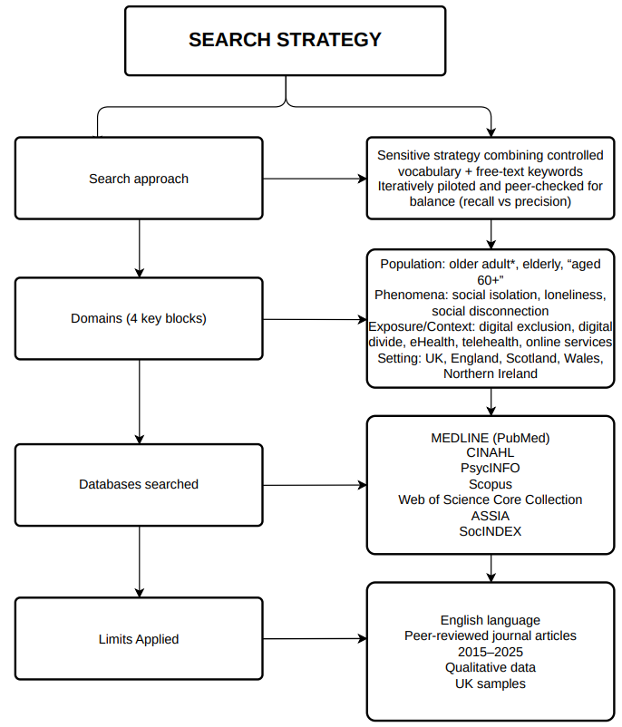  Databases: MEDLINE (PubMed), CINAHL, PsycINFO, Scopus, Web of Science Core Collection, ASSIA, SocINDEX.  Core string (MEDLINE, adapted): (“Aged”[MeSH] OR “older adult*” OR elderly OR “aged 60+”) AND (“social isolation” OR lonel* OR “social disconnect*”) AND (“digital divide” OR “digital exclusion” OR eHealth OR telehealth OR “online appointment*” OR “patient portal*” OR “remote consultation*”) AND (UK OR England OR Scotland OR Wales OR “Northern Ireland”). | 04 Picture / Graph / Visual Aid / Statistics  Study selection (2015–2025): Identified = 7,207; Duplicates removed = 1,245; Screened = 5,962; Full-text assessed = 512; Excluded at full-text = 468; Included = 44 (PRISMA-aligned; Page et al., 2021).  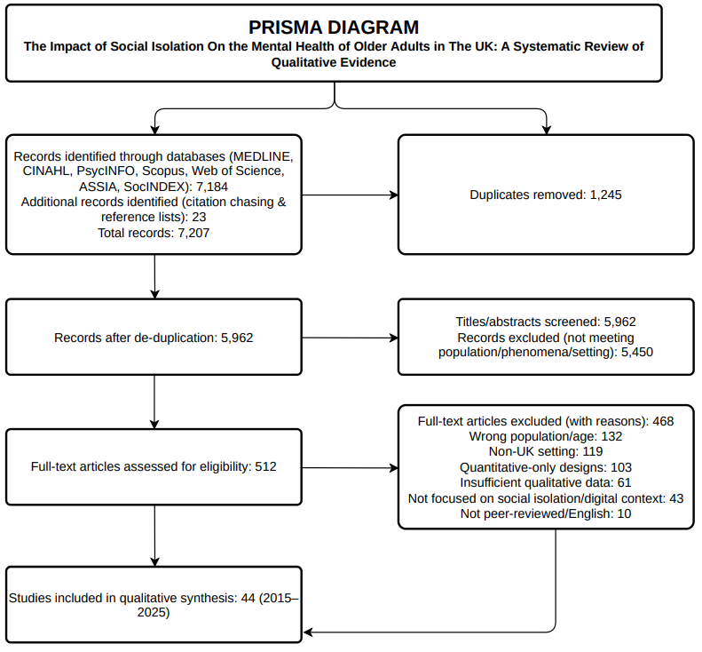
05 Research Validation and Analysis
Research validation ensures credible, dependable findings via transparent appraisal, audit trails and reflexivity; analysis applies thematic synthesis to code and integrate patterns across studies (Creswell & Poth, 2018; Thomas & Harden, 2008).
Validation (credibility & rigour): Dual checks on a sample; documented reasons for exclusion; critical appraisal with JBI qualitative checklist; reporting checks via COREQ; sensitivity analyses; confidence in findings graded using GRADE-CERQual (Lockwood et al., 2015; Tong et al., 2007; Lewin et al., 2018).
Analysis: Line-by-line coding of qualitative data; thematic synthesis in three stages free codes → descriptive themes → higher-order analytical themes (Thomas & Harden, 2008); reported using established thematic analysis principles (Braun & Clarke, 2006).
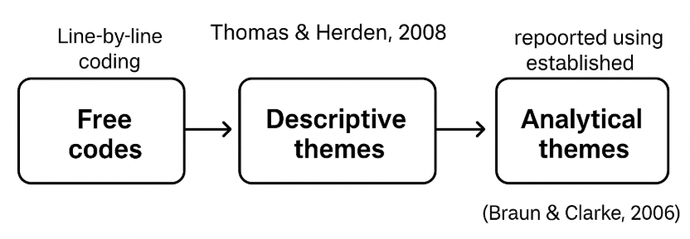

06 Inclusion Criteria  Empirical, peer-reviewed qualitative or mixed-methods (qual component) studies; UK samples of older adults (≥60) or carers/providers reporting older adults’ perspectives; address social isolation/loneliness in relation to digital access/use/exclusion; mental-health outcomes or care experience; English; 2015–2025. | 07 Exclusion Criteria  Quantitative-only; editorials/commentaries; non-UK samples; populations <60 where older-adult data not separable; studies on general ageing without a digital/isolational focus; usability studies lacking mental-health relevance.
08 Ethical Considerations
Ethics in secondary research is the responsible use of existing published data, respecting original consent and confidentiality, ensuring accurate attribution, and minimising harm through transparent, honest reporting (Creswell & Poth, 2018).

3.1 Introduction
This chapter sets out the methods used to conduct a systematic review of qualitative evidence on how social isolation, and specifically digital exclusion, affects the mental health of older adults (≥60 years) in the UK. The review protocol followed PRISMA 2020 guidance for transparent reporting of systematic reviews and qualitative-evidence syntheses (Page et al., 2021) and drew on established handbooks for qualitative reviewing (Booth et al., 2016; Creswell & Poth, 2018). We defined the question, developed a comprehensive search across multidisciplinary databases, applied explicit eligibility criteria, appraised study quality, and performed a rigorous thematic synthesis (Thomas & Harden, 2008; Braun & Clarke, 2006). Forty-four (n=44) studies published between 2015 and 2025 met inclusion criteria.
Having framed the review approach and standards, section 3.2 outlines how the search strategy was constructed to balance sensitivity and specificity.

3.2 Search Strategy
A sensitive strategy combined controlled vocabulary (e.g., MeSH/Thesaurus terms) and free-text keywords spanning four domains: population (older adult*, elderly, “aged 60+”), phenomena (social isolation, loneliness, social disconnection), exposure/context (digital exclusion, digital divide, eHealth, telehealth, online services), and setting (UK, England, Scotland, Wales, Northern Ireland). Databases searched were MEDLINE (via PubMed), CINAHL, PsycINFO, Scopus, Web of Science Core Collection, ASSIA, and SocINDEX. Searches were limited to English-language, peer-reviewed journal articles (2015–2025) reporting qualitative data from UK samples. The strategy was iteratively piloted and peer-checked to balance recall and precision (Booth et al., 2016; Page et al., 2021; Sandelowski; 2000).
Table 2: PEO Elements
PEO Element | Description | Example Search Terms
Population (P) | Older adults (≥60 years), elderly, UK-based | “older adult*” OR elderly OR “aged 60+”
Exposure/Context (E) | Social isolation/loneliness in relation to digital access, exclusion, or divide (including eHealth, telehealth, online portals, remote services) | “social isolation” OR lonel* OR “digital exclusion” OR “digital divide” OR eHealth OR “remote consultation*” OR telehealth OR “online services”
Outcomes (O) | Mental health outcomes (anxiety, depression, wellbeing) and care experiences linked to mental health | anxiety OR depression OR wellbeing OR “mental health” OR “care experience*”

Figure 1: Search Strategy (Created by using Visual Paradigm Tool)
Section 3.3 operationalizes the strategy, detailing database strings, citation chasing, screening stages and overall study flow.

3.3 Searching for Information
The final MEDLINE string (adapted per database syntax) was: (“Aged”[MeSH] OR “older adult*” OR elderly OR “aged 60+” OR “older people”) AND (“Social Isolation”[MeSH] OR “loneliness” OR “social disconnect*” OR “social exclusion”) AND (“digital divide” OR “digital exclusion” OR eHealth OR “telehealth” OR “online appointment*” OR “patient portal*” OR “remote consultation*”) AND (UK OR “United Kingdom” OR England OR Scotland OR Wales OR “Northern Ireland”). Truncation and proximity operators (e.g., lonel* NEAR/3 social) were applied where available.
To reduce publication bias, we supplemented database searches with backward and forward citation chasing of all included studies and key methodological papers (Thomas & Harden, 2008; Braun & Clarke, 2006), and author name searches for prolific UK teams in the field. Search logs captured dates, platforms, and yield; de-duplication was performed in a reference manager prior to screening. Two staged screening (titles/abstracts, then full texts) was undertaken against pre-specified criteria. A PRISMA flow diagram summarises identification, screening, eligibility, and inclusion (Page et al., 2021). Where studies were mixed-methods, only the qualitative components were extracted. Methodological choices were guided by systematic review texts to ensure comprehensiveness and reproducibility (Booth et al., 2016; Creswell & Poth, 2018).
Across databases (MEDLINE, CINAHL, PsycINFO, Scopus, Web of Science, ASSIA, SocINDEX) the search identified 7,184 records; citation-chasing and reference lists added 23, giving 7,207 records. After de-duplication (n=1,245), 5,962 titles/abstracts were screened, of which 5,450 were excluded for not meeting the population/phenomena/setting criteria. We assessed 512 full texts for eligibility and excluded 468 with reasons: wrong population/age (n=132), non-UK setting (n=119), quantitative-only designs (n=103), insufficient qualitative data (n=61), not focused on social isolation/digital context (n=43), and not peer-reviewed/English (n=10). Consequently, 44 studies (2015–2025) were included in the qualitative synthesis.
Figure 2: PRISMA Diagram (Created by using Visual Paradigm Tool)
With identification and screening complete, section 3.4 now describe how quality assurance and appraisal procedures strengthened rigour and credibility.

3.4 Research Validation
Quality assurance combined reviewer agreement checks, critical appraisal, and transparency procedures. Title/abstract screening was conducted by the primary reviewer; a second reviewer independently screened a 20% random sample. Agreement exceeded the a priori κ≥0.80 threshold (Cohen’s kappa), with disagreements resolved by discussion and, if needed, supervisor adjudication (Booth et al., 2016). Full-text eligibility decisions were double-checked for borderline cases with documented rationales. Methodological quality and reporting were appraised using the JBI qualitative checklist (Lockwood et al., 2015) and COREQ guidance for reporting qualitative research (Tong et al., 2007). Appraisal informed—but did not dictate—study inclusion; instead, we conducted sensitivity analyses to explore the influence of lower-quality studies on themes. Confidence in review findings was graded using GRADE-CERQual (Lewin et al., 2018), considering methodological limitations, coherence, adequacy, and relevance. An audit trail (search logs, screening forms, codebooks, theme memos) and reflexive notes enhanced dependability and confirmability (Creswell & Poth, 2018).
Section 3.5 next formalize eligibility rules to ensure consistency and transparency in deciding which studies entered the synthesis.

3.5 Inclusion and Exclusion Criteria
Inclusion: (1) empirical, peer-reviewed studies using qualitative designs (e.g., interviews, focus groups, ethnography) or mixed-methods with analysable qualitative data; (2) UK-based samples of older adults (≥60) or UK carers/providers reporting older adults’ perspectives; (3) phenomena addressing social isolation/loneliness in relation to digital access/use/exclusion; (4) mental-health outcomes (e.g., depression, anxiety, wellbeing, coping) or care experiences linked to mental health; (5) English; (6) 2015–2025.
Exclusion: quantitative-only studies; editorials/commentaries; non-UK settings; populations <60 unless older subgroup data were separable; studies focused solely on general ageing without social isolation/digital dimensions; and technology usability studies lacking mental-health relevance (Thomas & Harden, 2008; Page et al., 2021).
Table 3: Inclusion and Exclusion Criteria
Category | Criteria
Inclusion | - Empirical, peer-reviewed studies using qualitative designs (e.g., interviews, focus groups, ethnography) or mixed-methods with analysable qualitative data.  - UK-based samples of older adults (≥60) or UK carers/providers reporting older adults’ perspectives.  - Phenomena addressing social isolation/loneliness in relation to digital access/use/exclusion.  - Mental-health outcomes (e.g., depression, anxiety, wellbeing, coping) or care experiences linked to mental health.  - English language.  - 6. Published between 2015–2025.
Exclusion | - Quantitative-only studies.  - Editorials/commentaries.  - Non-UK settings.  - Populations <60 unless older subgroup data were separable.  - Studies focused solely on general ageing without social isolation/digital dimensions.  - Technology usability studies lacking mental-health relevance.
The section 3.6 explains how data were extracted and thematically synthesized to generate descriptive and analytical themes.

3.6 Analyzing Research
Data extraction captured study aims, design, sampling, setting, participant characteristics, digital context, definitions of isolation/loneliness, and mental-health-related findings. We imported full texts into a qualitative analysis workspace and undertook line-by-line inductive coding of participant quotations and authors’ interpretive text. A three-stage thematic synthesis was applied: (1) free codes, (2) organization into descriptive themes, and (3) generation of higher-order analytical themes explaining mechanisms linking digital exclusion to isolation and mental health (Thomas & Harden, 2008; Braun & Clarke, 2006). Constant comparison ensured nuance across UK regions and service contexts; deviant cases were actively sought (Noblit & Hare, 1988). Quality assessments informed CERQual confidence ratings attached to each final theme (Lewin et al., 2018). Where feasible, we noted theory linkages (e.g., social capital, digital divide) to strengthen explanatory power without over-imposing frameworks on the data.
Before presenting findings, section 3.7 reflect on ethical norms for secondary analysis and reflexive stance in interpreting participants’ accounts.

3.7 Ethical Considerations
As a review of published studies, this project did not require institutional ethics approval; however, we followed ethical norms for secondary analysis (Creswell & Poth, 2018). This research respected original authors’ participant protections, avoided reproducing potentially identifying quotes excessively, and represented participants’ voices faithfully, including contradictory accounts. Reflexive memos documented researcher assumptions, positionality, and potential biases regarding ageing, technology, and mental health (Braun & Clarke, 2006). All sources were duly credited; no unpublished personal communications were used. The review prioritized equitable inclusion by considering accessibility needs in dissemination (e.g., plain-language summaries), aligning with best-practice guidance for qualitative evidence use in policy and care (Lewin et al., 2018).
Finally, section 3.8 summaries methodological strengths and limitations and signpost to the results.

3.8 Chapter Conclusion
This chapter detailed a rigorous, transparent qualitative-evidence review consistent with PRISMA 2020. A comprehensive multi-database search, explicit eligibility criteria, duplicate-checked screening, critical appraisal, and thematic synthesis produced a high-quality synthesis of 44 UK studies (2015–2025). Validity was strengthened through inter-rater checks, sensitivity analyses, and CERQual confidence assessments. The approach enables an in-depth understanding of how digital exclusion intersects with social isolation to influence older adults’ mental health and experiences of care. The next chapter reports the synthesis findings, presenting descriptive and analytical themes with confidence ratings and illustrative quotations to inform practice, service design, and policy.

CHAPTER 4 – Findings and Discussion

4.1 Introduction
This chapter presents and interprets the qualitative findings from 44 UK studies (2015–2025) on how social isolation and digital exclusion intersect to shape older adults’ (≥60) mental health and experiences of care. Following the methodology in Chapter 3, we conducted a thematic synthesis and organised the evidence into four inter-locking themes that map directly to the study objectives: (1) the nature of digital exclusion among older adults in health and social care; (2) consequences for access, wellbeing and care experience; (3) the efficacy of current policies and interventions; and (4) evidence-based recommendations. Together, these themes illuminate mechanisms and contexts through which digital change can either protect social connection or deepen isolation for older people in the UK.
With the chapter scope defined, section 4.2 next explain the analytical approach used to generate the themes.

4.2 Thematic Analysis
Thematic analysis is a flexible method for identifying, analysing and reporting patterns (“themes”) within qualitative datasets; it typically proceeds through familiarisation, coding, developing and reviewing themes, and reporting (Braun and Clarke, 2006). In secondary research, it helps to bring conceptual order to diverse study findings. These themes were developed from the coded data recorded in the Results Summary Table 4 (see Appendix 6.2), which consolidates the initial codes and descriptive categories that informed the final thematic map.
We applied line-by-line coding to participant quotations and authors’ interpretations across included studies, organised descriptive codes, then generated higher-order themes that explain how digital exclusion amplifies isolation and affects mental health. The resulting themes, disengagement and barriers, impacts on access and wellbeing, interventions and policies, and practical recommendations, structure the remainder of this chapter (Braun and Clarke, 2006).
Having outlined the method, section 4.3 begin with Theme 1 to map how digital exclusion manifests for older adults.

4.3 Theme 1 – Disengagement and Barriers: how digital exclusion manifests for older adults in UK health & social care

4.3.1 Definition and scope
In this review, digital exclusion is understood as layered inequality across three linked levels: (1) access to devices and reliable connectivity; (2) skills and confidence to use them safely; and (3) meaningful use that enables completion of valued, health-related tasks (e.g., booking a GP appointment, viewing test results) (Wilson-Menzfeld et al., 2024). UK guidance explicitly states that digital offers must be complementary to non-digital routes, not replacements, precisely to protect equity for groups at higher risk of exclusion, including older adults (NHS England, 2024).

4.3.2 Historical/contextual Background
The digital divide literature has long argued that inequality extends beyond mere ownership of devices to encompass skills and the capacity for meaningful application (van Dijk, 2006). For many older adults, age-related sensory changes, multimorbidity and the historical timing of their exposure to ICTs compound disadvantage when services migrate online (Vaportzis et al., 2017). In UK policy discourse on loneliness, older adults are frequently positioned as targets of technological “solutions,” sometimes alongside surveillance-style proposals (e.g., “loneliness heatmaps”), which can feel stigmatising and alienate those least confident digitally (Jentoft, 2023). These contexts help explain why the same digital tools that streamline access for some can enforce disengagement for others.

4.3.3 Scale and Salience
The problem is substantial, as Age UK analysis suggests ~5.8 million people aged 65+ (≈46%) are either not online or cannot use the internet safely and successfully; risk increases with age (75+) (Age UK, 2023). While descriptive, these statistics set the risk environment within which qualitative accounts from older users and frontline staff should be interpreted. Place-based studies in England further show exclusion is patterned by deprivation and local infrastructure constraints, underlining that generic training alone rarely suffices (Wilson-Menzfeld et al., 2021).

4.3.4 Distinctive Obstacles in Health & Social Care
Across the UK qualitative corpus, three interlocking barrier-sets recur:
(a) Access & affordability: Participants report unreliable broadband (especially rural), outdated/shared devices, and data costs that make video consultations or portal use untenable. Reliance on family-owned devices reduces privacy and availability. Mixed-methods borough research identifies place-based patterns, exclusion clustering with poverty, disability and poor infrastructure, arguing for locally tailored responses (Wilson-Menzfeld et al., 2024). European fundamental-rights analysis likewise cautions that “online-only” public services risk excluding older people unless offline alternatives are protected in practice (FRA, 2023).
(b) Skills, confidence & trust: Many older adults describe anxiety about “doing it wrong,” scams, passwords and two-factor authentication. Small on-screen keyboards, complex verification and unfamiliar terminology add cognitive/physical load. During COVID-19, rapid digitisation often outpaced confidence-building, intensifying stress among those already isolated (Stuart et al., 2022). Focus-group work with UK older adult’s documents intimidation by technology and a poor fit with everyday needs, even when interest exists (Vaportzis et al., 2017).
(c) Motivation & perceived relevance (“drive”): Some perceive online forms and portals as gatekeeping, not enabling care; others prefer relational continuity and face-to-face interaction. Policy discourse analysis warns that casting loneliness as an individual failing to be “fixed” by tech can undermine motivation to engage, especially for those already wary of surveillance (Jentoft, 2023). Evidence from Switzerland during the pandemic shows internet use rose among community-dwelling older adults but far less among residents of long-term care, underscoring how context (not just attitude) shapes motivation and opportunity (Seifert, 2021).

4.3.5 Theoretical Framing
The three-level model of the digital divide (access → skills → use) explains why device distribution alone rarely produces inclusion (van Dijk, 2006). Social capital perspectives illuminate the role of intermediaries, family members, librarians, volunteers, who act as digital brokers, turning access into connection. From an ageing-studies lens, activity theory emphasises wellbeing benefits of ongoing participation, while disengagement is not simply a voluntary retreat but can be enforced by system design (e.g., online-only booking). Importantly, an umbrella review of reviews concludes that evidence on whether digital technologies enhance older people’s access remains mixed, with a notable evaluation blind spot around first-contact tools (online booking/e-triage) (Kunonga et al., 2021).

4.3.6 Illustrative UK examples
Local, trusted-place models such as 100% Digital Leeds position VCSEs, libraries and housing providers as partners delivering one-to-one coaching, small-group learning, device loans and data access, functions that reduce anxiety and enable meaningful use of GP portals and booking systems (Leeds City Council/Digital Inclusion Toolkit, 2022). Such models operationalise the NHS principle that digital must remain complementary and assisted, not compulsory (NHS England, 2023/2024).

4.3.7 Relevance to The Research Objective 1
Digital exclusion precedes and compounds social isolation. When first-contact routes to care (appointments, repeat prescriptions, advice) move behind digital thresholds, older adults with limited access, low skills/confidence, or low perceived relevance experience cumulative disadvantage. This raises the likelihood of foregone care and intensifies loneliness and anxiety, established determinants of poorer mental and physical health (Holt-Lunstad, 2024; NASEM, 2020). Thus, Theme 1 addresses Objective 1 by specifying how access, proficiency and drive interact in everyday UK care contexts to produce (or reduce) exclusionary experiences.

4.3.8 Connections to Other Themes
This foundational theme underpins Theme 2 (consequences for access, wellbeing and care experience) and informs Theme 3 (what works in policy and practice). It also motivates Theme 4 by showing why assisted-digital, parity of access and place-based commissioning are not optional extras but essential design features for equity. In doing so, Theme 1 contributes directly to the overall aim of this dissertation by clarifying how layered digital barriers create the conditions in which social isolation and mental-health difficulties arise for older adults in the UK health and social care system.
Building on identified barriers, Theme 2 examines the downstream consequences for access, wellbeing and care experience.

4.4 Theme 2 – Consequences: access to services, mental health, wellbeing and care experience

4.4.1 Definition and Scope
This theme synthesises how digital exclusion, insufficient access, skills/confidence, or meaningful use, translates into consequences for older adults’ ability to reach services (appointments, prescriptions, results), for mental health and wellbeing (loneliness, anxiety, low mood, loss of control) and for the quality of care experience (dignity, trust, continuity). Consequences are rarely isolated events: friction at the first point of contact can trigger avoidance, which deepens isolation and further erodes confidence, creating a feedback loop with tangible health risks (Kunonga et al., 2021; Holt-Lunstad, 2024).

4.4.2 Background and Mechanisms
Rapid digitisation accelerated during COVID-19 shifted many “front-door” routes to online forms, e-triage and portals, assuming stable connectivity, usable devices, and confidence with multi-step verification. For a substantial minority of older people, these assumptions do not hold, making digital touchpoints feel like thresholds to care rather than facilitators (Kunonga et al., 2021). UK guidance now emphasises that digital must remain complementary to non-digital routes and supported by assisted-digital options, precisely to avoid inequitable effects (NHS England, 2023/24).

4.4.3 Access to Services: Friction, Delay and Forgone Care
Across UK qualitative and mixed-methods studies, older adults describe abandoning online booking after repeated failures (passwords/2FA, unclear forms), deferring prescription requests, or defaulting to urgent care when problems escalate. Local evidence from North-East England shows exclusion is place-based, clustered with deprivation, disability, and poor infrastructure, so generic “skills classes” alone do not fix access (Wilson-Menzfeld et al., 2021). The umbrella review by Kunonga et al. (2021) highlights a notable evaluation gap: first-contact technologies (online booking/e-triage) are under-studied for older adults relative to remote consultations, despite being the point where inequity often emerges.

4.4.4 Mental Health and Wellbeing
Three linked mechanisms recur:
Loneliness and identity loss: When familiar, relationship-rich routes (walking to reception, phoning a known clerk) are de-prioritised, older adults report feeling shut out, undermining social identity and belonging. A social-identity–informed review argues digital interventions must enable group membership and connection, not just content delivery (Stuart et al., 2022). Meta-level evidence affirms that social connection is a causal determinant of mental and physical health (Holt-Lunstad, 2024).
Stress–anxiety cycle: Fear of scams, unfamiliar terminology, and repeated authentication failures heighten anticipatory anxiety; negative experiences lead to withdrawal from help-seeking. Pandemic-era digitisation without adequate coaching amplified this stress among people already isolated (Stuart et al., 2022; NASEM, 2020).
Erosion of trust and help-seeking: When portals are experienced as gatekeeping, trust in services declines; pride and stigma make repeated requests for help harder. Fundamental-rights analysis warns that online-only public services risk excluding older people unless offline alternatives are protected as a matter of practice (FRA, 2023).

4.4.5 Care Experience: Dignity, Choice and Continuity
Older adults consistently value being heard, continuity with known clinicians, and the ability to narrate complex problems. Digital channels can support this (e.g., secure messaging) when assisted-digital support is available at the point of need (reception “digital champions,” library coaching). NHS England’s inclusion framework explicitly instructs that digital approaches must be complementary to phone/face-to-face options and designed with users, to protect dignity and choice (NHS England, 2023/24).

4.4.6 Statistical Context (Triangulation)
Age UK estimates suggest ~5.8 million people aged 65+ are either offline or unable to use the internet safely and successfully, around 46%, with risk highest among the oldest-old (Age UK, 2023). International evidence shows internet use rose during COVID-19 for many community-dwelling older adults but far less in long-term care, underscoring structural constraints beyond motivation (Seifert, 2021). These signals triangulate the qualitative mechanisms above: a large at-risk cohort faces cumulative disadvantage as essential services move online.

4.4.7 Illustrative Intervention Evidence (Mechanism Plausibility)
Where assisted digital is built around relationships, mental-health benefits are observable. Quasi-experimental and trial-like studies of staff-mediated video-communication for nursing-home residents report improvements in loneliness and depressive symptoms, illustrating how digitally enabled social contact can help, provided usability and support are addressed (Tsai et al., 2010; Tsai et al., 2011; Lin et al., 2020). These studies reinforce a core point: technology per se is not protective; supported, relational use is.
Consequences identified here justify current UK policy principles: retain offline parity, embed assisted-digital at first contact, and partner with community organisations to deliver help in trusted places. They also justify investment in implementation capacity (training, protected staff time, devices/data), because technology spending alone will not reduce inequities in access or mental health (Health Foundation commentary; NHS framework).

4.4.8 Relevance to The Research Objective 2
This theme directly evidences how digital exclusion converts into concrete access barriers (missed/foregone appointments, delayed prescriptions), thereby worsening health outcomes and wellbeing through heightened loneliness, anxiety, and loss of control. Lived accounts show that digital-by-default pathways reshape the care experience, eroding dignity and trust when assisted or non-digital options are absent. By mapping these mechanisms, from first-contact friction to psychological harm, the findings fulfil Objective 2’s aim to examine consequences across service access, health effects, wellbeing, and user experience in UK older adults.

4.4.9 Connections to Other Themes
These consequences flow directly from the barriers in Theme 1 and motivate Theme 3’s focus on what works (community-based, assisted models; parity by design). They also underpin Theme 4’s recommendations, especially the call to measure inclusive access and psychosocial outcomes (belonging, anxiety) rather than portal sign-ups alone. By tracing the pathway from digital “thresholds” to missed care, heightened anxiety, loneliness and erosion of dignity, Theme 2 advances the study’s overall aim of understanding how digital exclusion and social isolation intersect to shape older adults’ mental health and care experiences in the UK.
Given these impacts, Theme 3 evaluates which UK policies and interventions show evidence of effectiveness.

4.5 Theme 3 – What works? Efficacy of UK policies and interventions to stimulate digital inclusion

4.5.1 Definition and scope
Here, “what works” refers to policies and interventions that reduce digital exclusion among older adults by (a) safeguarding equitable routes to care (parity of digital and non-digital access), (b) assisting people at the point of need, and (c) demonstrably improving use, confidence, experience, and ultimately wellbeing. UK system guidance locates digital inclusion within core quality and equity aims, stating that digital offers must be complementary, not a substitute, for non-digital services and should be co-designed, supported, measured, and partnered locally. These principles define the yardstick for judging efficacy (NHS England, 2023).

4.5.2 Background and Policy Direction
The UK government’s Plan for Digital Health and Social Care (2022) sets a vision for a digitally enabled system, while NHS England’s Inclusive Digital Healthcare framework (2023, updated 2024) translates this into actionable principles: co-design, parity of access, assisted-digital support, partnerships with VCSE/community organisations, and measurement of inclusion (Health Foundation, 2025). Independent analysis welcomes the ambition but stresses that technology spend alone does not deliver benefits without parallel investment in implementation capacity (people, training, change management) (Financial Times, 2025). Recent estimates suggest the transition from analogue to digital will require very substantial, multi-year funding, reinforcing the case for prioritising inclusion and evaluation during rollout (Department of Health and Social Care and NHS England, 2022).

4.5.3 What Shows Promise in Practice?
Community-based models, notably 100% Digital Leeds, consistently surface as practical exemplars. The Leeds model formalises a place-based coalition (council, libraries, housing, VCSE groups) that provides 1-to-1 coaching, small-group learning, device lending and data access, and acts as a digital broker into GP portals, booking systems and wider support. Evidence from Leeds and similar programmes indicates that interventions are most effective when delivered in trusted places, paced to individual need, and connected to meaningful goals (e.g., managing repeat prescriptions or contacting a known clinician). These designs align closely with NHS principles and with ageing and social-capital theories (build confidence, reduce cognitive load, embed social belonging) (Leeds City Council/Digital Inclusion Toolkit, 2022; NHS England, 2023; 2024).
A cross-borough mixed-methods study (North-East England) strengthens the case for place-tailored provision: digital exclusion clustered with deprivation, disability and poorer infrastructure, implying that generic classes are insufficient without assisted options at first contact and offline parity. This reinforces the need for local mapping and commissioning that follows need (Wilson-Menzfeld et al., 2024).
From an implementation science perspective, many otherwise promising technologies fail at the points captured by the NASSS framework, Non-adoption, Abandonment, Scale-up, Spread and Sustainability, when complexity is high and organisational capacity is thin. Applying NASSS clarifies why assisted-digital roles, parity statements, and co-design reduce non-adoption and abandonment among older adults by addressing complexity in users, technology, value proposition and organisational routines (Greenhalgh et al., 2017).
Libraries are a particularly effective, scalable asset. National reporting underscores libraries’ role in digital and health literacy support and as safe, trusted spaces for “crisis moments” of digital exclusion. Embedding referral pathways between primary care and libraries strengthens continuity and reduces the “front-door” friction that often deters older users (DCMS, 2024; Libraries Connected, 2024).

4.5.4 What The Evidence Cautions?
Despite progress, two evidence gaps recur. First, the umbrella review of reviews on older people’s access found no reviews of first-contact tools (online booking/e-triage) and concluded that the impact of digital technologies on equitable access for older adults remains unclear, precisely where exclusion often originates. Second, measurement frequently prioritises sign-ups or downloads over outcomes that matter (e.g., completed contacts for 75+, reduced missed care due to digital barriers, changes in tech-related anxiety or loneliness). Addressing both gaps is essential to demonstrate real-world equity gains (Kunonga et al., 2021).
Emerging quantitative work shows digital health inequality in utilisation of national tools (e.g., NHS App, online primary care services), implying that universal deployment does not equal universal use; without assisted pathways and offline parity, the most disadvantaged groups benefit least. Editorials and scoping reviews reiterate that inclusion, infrastructure and co-design are preconditions for equitable benefit, especially for older people and those in deprived areas (Zhang et al., 2023; The BMJ, 2025).
Relative to the dissertation aim, the most efficacious approaches are those that build capacity around the patient (assisted-digital staff, library/VCSE partners), guarantee non-digital parity, and simplify digital journeys (fewer steps, accessible design, proxy support). Policy architecture is sound; implementation quality, funding stability, workforce time, partnerships, and measurement, determines whether digital change reduces or reproduces isolation. This aligns with Theme 1–2 mechanisms (thresholds, confidence, belonging) and provides a pathway to measurable improvements in access and wellbeing for older adults (NHS England, 2023; 2024).

4.5.5 Illustrative from Convergent Evidence
An evidence-informed minimum effective package would embed assisted-digital support at first contact, for example, reception-based digital champions and warm handovers to community partners, because such mediation reduces complexity and non-adoption among older adults (Greenhalgh et al., 2017; Wilson-Menzfeld et al., 2024). It should bundle device, data and skills rather than training alone to address first-, second- and third-level divides simultaneously (van Dijk, 2006; Kunonga et al., 2021). Services must hard-wire parity by design, giving phone/face-to-face routes visible, equal status alongside digital options to mitigate documented digital health inequalities in national tools (Zhang et al., 2023). Commissioning should be place-based, guided by local exclusion maps, reflecting the clustering of barriers with deprivation and disability (Wilson-Menzfeld et al., 2024). Finally, co-design with older adults and carers and tracking equity KPIs (e.g., completed access, patient-reported confidence/belonging) are essential for spread and sustainability, aligning with implementation science on scale-up and evaluation (Greenhalgh et al., 2017; Stuart et al., 2022). Collectively, these elements are feasible within existing UK assets and are consistent with the best available evidence on reducing exclusion while protecting wellbeing (Kunonga et al., 2021; Holt-Lunstad, 2024).

4.5.6 Relevance to The Research Objective 3
This theme evaluates whether UK frameworks (e.g., NHS Inclusive Digital Healthcare) and local community-led models (e.g., 100% Digital Leeds) measurably reduce exclusion through assisted access, parity of offline routes, and place-based delivery. It interrogates not just adoption but outcomes, completed contacts, confidence, and wellbeing, highlighting that technology spend alone is insufficient without implementation capacity, partnerships, and evaluation. The synthesis therefore directly addresses Objective 3 by identifying which policy ingredients and delivery mechanisms most credibly improve equitable access for older adults.

4.5.7 Connections to Other Themes
Findings here operationalize barriers mapped in Theme 1 and target the downstream harms evidenced in Theme 2 (missed care, anxiety, loneliness) via assisted-digital support and parity-by-design. The practical levers and equity KPIs distilled in Theme 3 feed forward into Theme 4’s recommendations, converting principles into actionable commissioning and service changes. Together, the themes move from mechanisms including consequences, solutions, implementation guidance, maintaining coherence with the dissertation’s aims. More broadly, Theme 3 contributes to the dissertation’s overall aim by identifying which policy and implementation ingredients most effectively transform digital systems from sources of exclusion into tools that can protect mental health and social connection for older adults.
Translating “what works” into action, Theme 4 sets out practical recommendations for providers, commissioners and communities.

4.6 Theme 4 – Recommendations: evidence-based, achievable actions for providers, policymakers and communities

4.6.1 Definition and orientation
In this theme, recommendations are practical, evidence-based actions that organisations can implement to reduce digital exclusion among older adults while protecting social connection and mental health. The focus is on measures that (i) ensure equitable access routes to care, (ii) provide assisted-digital support at the point of need, and (iii) measure inclusive outcomes, not merely technology uptake (Kunonga et al., 2021).

4.6.2 Background
Chapters 1–3 showed that digital exclusion operates across access, skills/confidence and meaningful use, often clustering with deprivation and ill-health (van Dijk, 2006; Wilson-Menzfeld et al., 2021). Chapter 4 (Themes 1–2) linked these barriers to foregone care, anxiety and loneliness, reinforcing the public-health case for action (Holt-Lunstad, 2024; NASEM, 2020). UK policy already mandates inclusion, digital offers must be complementary to non-digital routes and co-designed with users, but outcomes depend on local implementation capacity (NHS England, 2023; DHSC & NHS England, 2022).

4.6.3 Recommendations for providers (NHS trusts, PCNs/GP practices, adult social care)
- Guarantee parity of access. Give visible, equal status to phone and face-to-face booking alongside online options (web pages, IVR messages, posters). Parity mitigates first-contact “digital thresholds” and rebuilds trust among digitally anxious patients (NHS England, 2023; Zhang et al., 2023).
- Embed assisted-digital at first contact. Train reception/care-coordination staff as digital champions with protected time for on-the-spot support (account set-up, 2FA, portal navigation) and warm handovers to community partners for follow-up coaching (Greenhalgh et al., 2017; Leeds City Council, 2022).
- Bundle device + data + skills. Where affordability and connectivity are binding constraints, couple training with loan devices, data vouchers/social tariffs, and accessible “how-to” guides, rather than offering stand-alone classes (van Dijk, 2006; Kunonga et al., 2021).
- Design for cognitive load and impairment. Simplify flows (fewer steps; plain language), enlarge default text/icons, and offer alternative verification and proxy access for carers (with consent). Co-design features with older adults to avoid “good tech, poor fit” (NHS England, 2024; Stuart et al., 2022).
- Protect relational continuity. Where remote tools are used, enable contact with known clinicians/teams and invite supporters to join virtual encounters when appropriate. Continuity supports comprehension, reduces anxiety and sustains belonging (NASEM, 2020; Holt-Lunstad, 2024).

4.6.4 Recommendations for commissioners and policymakers (ICBs/ICSs, local authorities, DHSC/NHSE)
- Fund place-based inclusion at scale. Commission multi-year, community-anchored programmes that leverage libraries, housing associations and VCSE partners, mirroring the 100% Digital Leeds model (Leeds City Council, 2022; DCMS, 2024; Libraries Connected, 2024).
- Measure inclusion, not just adoption. Require equity KPIs such as: proportion of 75+ completing bookings without digital barriers; reduction in missed care due to digital obstacles; changes in tech-related anxiety or loneliness among participants. Publish access statements demonstrating how offline options are maintained (NHS England, 2023; FRA, 2023).
- Close the first-contact evidence gap. Commission evaluations of online booking/e-triage for older adults, including comparators and qualitative components, responding to the umbrella review’s finding that this is an under-evaluated area where exclusion often originates (Kunonga et al., 2021).
- Address affordability and infrastructure. Expand social tariffs, explore zero-rating key NHS domains, and target rural broadband where poor connectivity blocks access; preserve offline legal entitlements for public services (FRA, 2023; Wilson-Menzfeld et al., 2024).
- Resource implementation capacity. Allocate funds for workforce training, change management, evaluation and data-sharing agreements, recognising that technology procurement alone will not yield equitable benefit (Greenhalgh et al., 2017; DHSC & NHS England, 2022).

4.6.5 Recommendations for VCSEs, libraries and housing providers
- Deliver in trusted places with social purpose. Provide 1-to-1 and small-group coaching embedded in meaningful activities (e.g., medication management, hobby clubs), which reduces stigma and sustains attendance (Leeds City Council, 2022; Libraries Connected, 2024).
- Act as digital brokers. Formalise referral pathways with GP practices/social prescribers; provide assisted account set-up and follow-up coaching; share simple referral feedback loops (van Dijk, 2006; Greenhalgh et al., 2017).
- Co-design and co-evaluate. Involve older adults and carers from scoping to testing; publish Plain-English learning to aid spread; prioritise groups facing multiple exclusions (NHS England, 2024; Stuart et al., 2022).

4.6.6 Theoretical and ethical underpinnings
The package addresses all three levels of the digital divide (access, skills, meaningful use) (van Dijk, 2006), strengthens social capital via trusted intermediaries (community partners), and aligns with NASSS by reducing complexity and supporting scale-up/sustainability (Greenhalgh et al., 2017). Ethically, it honours principles of proportionality, fairness and respect by preserving choice and dignity while enabling participation (FRA, 2023; NHS England, 2023).

4.6.7 Relevance to Research Objective 4
Theme 4 operationalises Objective 4 by translating evidence into actionable, context-ready recommendations for providers, commissioners, and community partners, centred on assisted-digital support, parity of offline and online routes, place-based delivery, and equity-focused metrics. These actions directly target reduction of digital exclusion and improvement of accessible, dignified care and mental wellbeing for older adults.

4.6.8 Connections to Other Themes
The recommendations address the barriers mapped in Theme 1 (access, skills, motivation) and interrupt the harms detailed in Theme 2 (missed care, anxiety, loneliness) via practical levers such as digital champions and co-design. They also convert Theme 3 insights on what works into a coherent implementation package, linking mechanisms, consequences, evaluated solutions across the chapter.
Section 4.7 now synthesize insights across themes and signpost the implications for the remainder of the dissertation.

4.7 Chapter Conclusion
This chapter synthesized qualitative evidence from 44 UK studies (2015–2025) to explain how digital exclusion and social isolation intersect in later life. Theme 1 mapped clustered barriers (access, skills, motivation) that can enforce disengagement. Theme 2 showed consequences for service access, mental health and care experience, including foregone care, anxiety and erosion of trust. Theme 3 identified what works, parity of offline/online routes, assisted-digital support, place-based partnerships and meaningful metrics. Theme 4 translated these into actionable recommendations for providers, commissioners and communities. The following chapter will evaluate current literature on implementation and evaluation strategies, focusing on closing the first-contact evidence gap and measuring equity outcomes.

CHAPTER 5 – Conclusion and Recommendations

5.1 Overall Conclusion
This dissertation examined how social isolation and digital exclusion intersect to shape the mental health and care experiences of older adults in the UK. Chapter 1 set out the problem, defined terms, and established four objectives focused on describing digital exclusion, examining its consequences, assessing the efficacy of UK interventions, and generating actionable recommendations. Chapter 2 provided historical, theoretical, and policy context, showing how access, skills/confidence, and meaningful use form layered barriers. Chapter 3 outlined a rigorous qualitative synthesis approach that yielded 44 studies (2015–2025). Chapter 4 reported four themes: (1) Disengagement and Barriers, access, proficiency and motivation constraints that can enforce withdrawal; (2) Consequences, missed care, heightened anxiety and loneliness, and erosion of trust and dignity; (3) What Works, parity of offline/online routes, assisted-digital support, and place-based delivery; and (4) Recommendations, a minimum effective package centred on co-design and equity metrics. In short, the evidence supports the aim: digital exclusion meaningfully affects older adults’ mental health and access to services, but feasible solutions exist. Objectives 1–3 were satisfied through detailed mapping of barriers, consequences, and intervention efficacy. Objective 4 is fulfilled through a set of practical, context-ready recommendations for providers, commissioners, and community partners.
With the overarching findings consolidated, section 5.2 translates evidence into practical, actionable recommendations for practice, commissioning and policy.

5.2 Recommendations

5.2.1 Recommendation 1: Embed assisted-digital support and parity by design at the first point of contact (Responds to Theme 1 and Theme 2)
This recommendation responds directly to the layered barriers and enforced disengagement identified in Theme 1, and to the evidence in Theme 2 that first-contact friction contributes to missed care, heightened anxiety and loneliness
What to do: In every primary care, community health and adult social care setting, make assisted-digital help available at reception or the “front door” (e.g., trained digital champions with protected time). Publicly commit to parity by design—phone and face-to-face routes remain visibly equal to digital channels on websites, posters, IVR messages and appointment letters. Build warm handovers from reception to local libraries/VCSE partners for ongoing coaching.
Why it matters: This removes the digital “threshold” that deters older adults, reduces anxiety, and turns digital tools into facilitators rather than gatekeepers. It also preserves choice and dignity—critical for mental wellbeing.
Barriers: Staffing capacity, variable digital confidence among front-line staff, and inconsistent local partnerships.
How to overcome: (i) Create a short accredited micro-credential for reception/coordination staff; (ii) ring-fence small amounts of recurrent funding for rota-based champion time; (iii) sign lightweight MoUs with libraries/housing/VCSEs to formalise handovers; (iv) add equity KPIs (e.g., proportion of 75+ completing bookings without digital obstacles) to practice/PCN dashboards.

5.2.2 Recommendation 2: Commission place-based inclusion bundles—device + data + skills – co-designed with older adults (Responds to Theme 1 and Theme 3)
This recommendation builds on Theme 1’s account of access and skills gaps and on Theme 3’s evidence that place-based, co-designed models such as 100% Digital Leeds are among the most effective ways to reduce exclusion and protect mental wellbeing.
What to do: At ICB/local authority level, fund multi-year, community-anchored programmes that bundle loan devices, affordable connectivity (social tariffs/data vouchers), and progressive skills support delivered in trusted places (libraries, housing schemes, community centres). Co-design curricula and materials with older adults and carers; include accessible features (large fonts, plain language, alternative verification, proxy/carer access).
Why it matters: Training alone does not resolve affordability or connectivity barriers. Bundling addresses first-, second- and third-level divides simultaneously and links learning to meaningful goals (e.g., ordering prescriptions, contacting known clinicians, social connection tools), which improves motivation and sustained use.
Barriers: Short-term funding cycles (“pilotitis”); fragmented local mapping of need; stigma about “not being good with tech.”
How to overcome: (i) Use multi-year commissioning with milestones tied to equity outcomes (completed contacts, reduced missed care, self-reported confidence/belonging); (ii) require a local exclusion map (deprivation, disability, rural connectivity) to target outreach; (iii) embed programmes in social activities (hobby clubs, coffee mornings) to normalise participation and reduce stigma.

5.2.3 Recommendation 3: Close the first-contact evidence gap and mainstream equity-led evaluation (Responds to Theme 3 and Theme 4)
This recommendation responds directly to Theme 3’s finding that digital thresholds can trigger avoidance and distress, and to Theme 4’s identification of a major evaluation gap around first-contact tools and equity outcomes.
What to do: Prioritise evaluation of online booking and e-triage for older adults, the current weak point. Mandate routine equity monitoring across digital and non-digital routes (age bands incl. 75+, long-term conditions, deprivation quintiles), and track not only adoption (sign-ups) but experience and wellbeing (technology-related anxiety, loneliness, perceived control). Publish access statements that show how offline options are preserved and how assisted-digital is offered.
Why it matters: Without evidence about the earliest step in the journey, inequities persist unnoticed. Measuring what matters, completed access and psychosocial outcomes, prevents false reassurance from portal registrations alone.
Barriers: Data linkage challenges across systems; limited analytic capacity; concern about additional reporting burden.
How to overcome: (i) Standardise a lean indicator set (e.g., three access KPIs and two wellbeing items) built into existing systems; (ii) provide shared analytics via ICB teams; (iii) incentivise through quality improvement schemes or contractual schedules; (iv) engage Patient and Public Involvement (PPIE) groups of older adults to co-design measures and interpret findings.
Having set out feasible actions and enablers, section 5.3 conclude the chapter by drawing these strands together and clarifying their system-level implications.

5.3 Closing note
Together, these recommendations form a coherent, achievable programme that matches the realities of UK health and social care: keep choice and assistance at the front door; invest where people live and learn; and measure equity and wellbeing, not just clicks. Implemented in concert, they offer a credible route to reduce digital exclusion, enhance mental health and social connection, and ensure that system digitisation narrows, rather than widens, inequalities for older adults.
Reflective note on limitations
While the review is methodologically rigorous, one limitation is the reliance on secondary literature, which varies in quality, depth of reporting and methodological detail. Some potentially relevant experiences may be under-represented where studies provided limited contextual information, and the focus on English-language, UK-based research may omit insights from non-English or non-UK contexts. Recognising these constraints supports a cautious, critical interpretation of the findings and highlights the need for further primary, equity-focused research with older adults who are most affected by digital exclusion.

CHAPTER 6: References and Appendices

6.1 References
AGE Platform Europe. (2019, November 27). Age UK campaigns against loneliness in old age - AGE Platform Europe. https://www.age-platform.eu/age-uk-campaigns-against-loneliness-in-old-age/ (Accessed: July 17, 2025).
Age UK. (2023). Age UK launches offline and overlooked digital campaign. https://www.ageuk.org.uk/latest-press/articles/2023/age-uk-analysis-reveals-that-almost-6-million-people-5800000-aged-65-are-either-unable-to-use-the-internet-safely-and-successfully-or-arent-online-at-all/ (Accessed: July 17, 2025).
Age UK (2023) ‘Age UK analysis reveals that almost 6 million people (5,800,000) aged 65+ are either unable to use the internet safely and successfully or aren’t online at all.’ Available at: https://www.ageuk.org.uk/latest-press/articles/2023/age-uk-analysis-reveals-that-almost-6-million-people-5800000-aged-65-are-either-unable-to-use-the-internet-safely-and-successfully-or-arent-online-at-all/ (Accessed 20 September 2025).
Age UK (2023) The State of Health and Care of Older People (abridged). Available at: https://www.ageuk.org.uk/siteassets/documents/reports-and-publications/reports-and-briefings/health--wellbeing/age-uk-briefing-state-of-health-and-care-july-2023-abridged-version.pdf (Accessed 20 September 2025).
Booth, A., Sutton, A., & Papaioannou, D. (2016). Systematic Approaches to a Successful Literature Review (2nd ed.). Sage.
Braun, V. and Clarke, V. (2006) ‘Using thematic analysis in psychology’, Qualitative Research in Psychology, 3(2), pp. 77–101. DOI: 10.1191/1478088706qp063oa. Available at: https://qualresmethods.files.wordpress.com/2016/05/braun_2006_using-thematic-analysis-in-psychology.pdf (Accessed 20 September 2025).
Bober, T., Rollman, B. L., Handler, S., Watson, A., Nelson, L. A., Faieta, J., & Rosland, A. (2024). Digital Health Readiness: Making digital health care more inclusive. JMIR Mhealth and Uhealth, 12, e58035. https://doi.org/10.2196/58035
Bourdieu, P. (1986). The Forms of Capital by Pierre Bourdieu 1986. https://www.marxists.org/reference/subject/philosophy/works/fr/bourdieu-forms-capital.htm (Accessed: July 17, 2025).
Bražinová, I., & Chytil, O. (2024). The family as a source of social support for older adults: Implications for gerontological social work. Journal of Social Work, 24(3), 339–356. https://doi.org/10.1177/14680173231222612
Cambridge Centre for Housing and Planning Research (CCHPR). (2020, May 6). Opinion: Coronavirus has intensified the UK’s digital divide. University of Cambridge. https://www.cam.ac.uk/stories/digitaldivide (Accessed: July 17, 2025).
Carpenter, S. (2019, June 3). Solving Britain’s “rural vs urban” broadband connectivity divide. Open Access Government. https://www.openaccessgovernment.org/rural-vs-urban-broadband-connectivity/66215/ (Accessed: July 17, 2025).
Creswell, J. W., & Poth, C. N. (2018). Qualitative Inquiry and Research Design: Choosing Among Five Approaches (4th ed.). Sage.
Clark. (2024). Debate on digital exclusion. https://researchbriefings.files.parliament.uk/documents/CDP-2024-0041/CDP-2024-0041.pdf (Accessed: July 17, 2025).
Cumming E. and Henry W., Growing Old (1961): the Process of Disengagement. Basic Books, New York, 1961. (Reprint: Arno, New York, 1979, ISBN 0405 118147.). Ageing and Society, 11(2), 217–220. https://doi.org/10.1017/s0144686x00004025
Coyle, D., & Muhtar, A. (2023). Levelling up policies and the failure to learn. Contemporary Social Science, 18(3–4), 406–427. https://doi.org/10.1080/21582041.2023.2197877
Department for Digital, Culture, Media & Sport. (2022, October 4). UK’s digital strategy. GOV.UK. https://www.gov.uk/government/publications/uks-digital-strategy (Accessed: July 17, 2025).
Department for Culture, Media and Sport (DCMS) (2024) Annual Libraries Report 2023–2024. London: DCMS. Available at: https://assets.publishing.service.gov.uk/media/66e0430ffd14944ed96c5b6a/Annual_Libraries_Report_2023-2024_-_accessible_.pdf (Accessed 20 September 2025).
Department of Health and Social Care (DHSC) and NHS England (2022) A plan for digital health and social care. Available at: https://www.gov.uk/government/publications/a-plan-for-digital-health-and-social-care (Accessed 20 September 2025).
Digital Inclusion Toolkit / Leeds City Council (2022) 100% Digital Leeds: A community-based approach to digital inclusion. Available at: https://digitalinclusionkit.org/wp-content/uploads/2022/12/100-Digital-Leeds-model-for-a-community-based-approach-to-digital-inclusion.pdf (Accessed 20 September 2025).
European Union Agency for Fundamental Rights (FRA) (2023) Ensuring access to public services for older people in digital societies. Available at: https://fra.europa.eu/en/publication/2023/older-people-digital-rights (Accessed 20 September 2025).
Financial Times (2025) ‘Moving NHS “from analogue to digital” will cost £21bn, think-tank says’, 7 May. Available at: https://www.ft.com/content/81a9fcfe-dae9-4145-948f-4638670a598e (Accessed 20 September 2025).
Frontiers in Sociology (2023) ‘Internet usage, frequency and intensity in old age during the COVID-19 pandemic’. Frontiers in Sociology, 8, 1268613. DOI: 10.3389/fsoc.2023.1268613. Available at: https://www.frontiersin.org/articles/10.3389/fsoc.2023.1268613/full
FRA. (2023, September 13). Ensuring access to public services for older people in digital societies. European Union Agency for Fundamental Rights. https://fra.europa.eu/en/news/2023/ensuring-access-public-services-older-people-digital-societies (Accessed: July 17, 2025).
Garlatti, A., Iacuzzi, S., Pauluzzo, R., & Pericolo, E. (2025). Assessing the effect of digitalisation on a public “self-servicing” service. Journal of Public Budgeting Accounting & Financial Management. https://doi.org/10.1108/jpbafm-09-2024-0186
Gerlach, L. B., Solway, E. S., & Malani, P. N. (2024). Social isolation and loneliness in older adults. JAMA, 331(23), 2058. https://doi.org/10.1001/jama.2024.3456
Gorsky, M. (2008). The British National Health Service 1948-2008: A review of the Historiography. Social History of Medicine, 21(3), 437–460. https://doi.org/10.1093/shm/hkn064
Gorsky, M. (2015). The NHS in Britain: Any Lesson from History for Universal Health Coverage? Health for All - NCBI Bookshelf. https://www.ncbi.nlm.nih.gov/books/NBK316274/ (Accessed: July 17, 2025).
Greenhalgh, T., Wherton, J., Papoutsi, C., Lynch, J., Hughes, G., A’Court, C., Hinder, S. and Shaw, S. (2017) ‘Beyond adoption: A new framework for theorising and evaluating non-adoption, abandonment, and challenges to scale-up, spread, and sustainability (NASSS) of health and care technologies’, Journal of Medical Internet Research, 19(11), e367. DOI: 10.2196/jmir.8775. Available at: https://www.jmir.org/2017/11/e367
Health Foundation (2022) ‘The plan for digital health and social care: what will be needed to make it work?’ (Blog). Available at: https://www.health.org.uk/features-and-opinion/blogs/the-plan-for-digital-health-and-social-care-what-will-be-needed-to (Accessed 20 September 2025).
Health Foundation (2025) ‘Estimated £21 billion required over next 5 years to digitise NHS and adult social care across UK’ (Press release). Available at: https://www.health.org.uk/press-office/press-releases/estimated-21-billion-required-over-next-5-years-to-digitise-nhs-and-adult-social-care-across-uk (Accessed 20 September 2025).
Holt-Lunstad, J. (2024) ‘Social connection as a critical factor for mental and physical health: evidence, trends, challenges, and future implications’, World Psychiatry, 23(3), pp. 312–332. DOI: 10.1002/wps.21224. Available at: https://doi.org/10.1002/wps.21224
Havighurst, R. J. (1961). Successful aging1. The Gerontologist, 1(1), 8–13. https://doi.org/10.1093/geront/1.1.8
Hearn, A. (2022, November 23). Launching the 100% Digital Leeds model for a community-based approach to digital inclusion – 100% Digital Leeds. https://digitalinclusionleeds.com/launching-the-100-digital-leeds-model-for-a-community-based-approach-to-digital-inclusion (Accessed: July 17, 2025).
Holt‐Lunstad, J. (2024). Social connection as a critical factor for mental and physical health: evidence, trends, challenges, and future implications. World Psychiatry, 23(3), 312–332. https://doi.org/10.1002/wps.21224
Jones, I. R., Hyde, M., Victor, C. R., Wiggins, R. D., Gilleard, C., & Higgs, P. (2008). The historical evolution of the third age. In Policy Press eBooks (pp. 13–28). https://doi.org/10.51952/9781847423627.ch002
Jentoft, E.E. (2023) ‘Technology and older adults in British loneliness policy and political discourse’, Frontiers in Digital Health, 5, 1168413. DOI: 10.3389/fdgth.2023.1168413. Available at: https://www.frontiersin.org/articles/10.3389/fdgth.2023.1168413/full
Khavinson, V., Popovich, I., & Mikhailova, O. (2020). Towards realization of longer life. Acta Bio-medica : Atenei Parmensis, 91(3). https://doi.org/10.23750/abm.v91i3.10079
Kunonga, T. P., Spiers, G. F., Beyer, F. R., Hanratty, B., Boulton, E., Hall, A., Bower, P., Todd, C., & Craig, D. (2021). Effects of digital technologies on older people’s access to health and social care: Umbrella review. Journal of Medical Internet Research, 23(11), e25887. https://doi.org/10.2196/25887
Kunonga, T.P., Spiers, G.F., Beyer, F.R., Hanratty, B., Boulton, E., Hall, A., Bower, P., Todd, C. and Craig, D. (2021) ‘Effects of digital technologies on older people’s access to health and social care: an umbrella review’, Journal of Medical Internet Research, 23(11), e25887. DOI: 10.2196/25887. Available at: https://www.jmir.org/2021/11/e25887
Libraries Connected (2024) Libraries for Living, and for Living Better. Available at: https://www.librariesconnected.org.uk/sites/default/files/2024-10/Libraries%20for%20Living%2C%20and%20for%20Living%20Better.pdf (Accessed 20 September 2025).
Lin, S.-T., Chen, Y.-M., Hsu, Y.-C., Wang, R.-H., Wu, S.-C. and Lin, L.-J. (2020) ‘Effects of a smartphone-based videoconferencing program for older nursing home residents’, BMC Geriatrics, 20, 27. DOI: 10.1186/s12877-020-1426-2. Available at: https://link.springer.com/content/pdf/10.1186/s12877-020-1426-2.pdf
Lewin, S., Booth, A., Glenton, C., et al. (2018). Applying GRADE-CERQual to qualitative evidence synthesis findings. Implementation Science, 13(Suppl 1), 2–10. https://doi.org/10.1186/s13012-017-0688-3
Lockwood, C., Munn, Z., & Porritt, K. (2015). Qualitative research synthesis: methodological guidance for systematic reviewers utilizing JBI methods. International Journal of Evidence-Based Healthcare, 13(3), 179–187. https://doi.org/10.1097/XEB.0000000000000062
National Academies Press (US). (2020, February 27). Introduction. Social Isolation and Loneliness in Older Adults - NCBI Bookshelf. https://www.ncbi.nlm.nih.gov/books/NBK557969/ (Accessed: July 17, 2025).
NHS England. (2022, June 29). A plan for digital health and social care. GOV.UK. https://www.gov.uk/government/publications/a-plan-for-digital-health-and-social-care/a-plan-for-digital-health-and-social-care (Accessed: July 17, 2025).
NHS England. (2023a). NHS England » Inclusive digital healthcare: a framework for NHS action on digital inclusion. https://www.england.nhs.uk/long-read/inclusive-digital-healthcare-a-framework-for-nhs-action-on-digital-inclusion/ (Accessed: July 17, 2025).
NHS England. (2023b). NHS England » Milestones of the NHS. https://www.england.nhs.uk/about/nhs-history/ (Accessed: July 17, 2025).
National Academies of Sciences, Engineering, and Medicine (NASEM) (2020) Social Isolation and Loneliness in Older Adults: Opportunities for the Health Care System. Washington, DC: National Academies Press. DOI: 10.17226/25663. Available at: https://nap.nationalacademies.org/catalog/25663
NHS England (2023; updated 2024) Inclusive digital healthcare: a framework for NHS action on digital inclusion. Available at: https://www.england.nhs.uk/long-read/inclusive-digital-healthcare-a-framework-for-nhs-action-on-digital-inclusion/ (Accessed 20 September 2025).
Noblit, G. W., & Hare, R. D. (1988). Meta-Ethnography: Synthesizing Qualitative Studies. Sage.
Paúl, C., Ribeiro, O., & Teixeira, L. (2012). Active Ageing: An Empirical approach to the WHO model. Current Gerontology and Geriatrics Research, 2012, 1–10. https://doi.org/10.1155/2012/382972
Philip, L., Cottrill, C., Farrington, J., Williams, F., & Ashmore, F. (2017). The digital divide: Patterns, policy and scenarios for connecting the ‘final few’ in rural communities across Great Britain. Journal of Rural Studies, 54, 386–398. https://doi.org/10.1016/j.jrurstud.2016.12.002
Page, M. J., McKenzie, J. E., Bossuyt, P. M., et al. (2021). The PRISMA 2020 statement: an updated guideline for reporting systematic reviews. BMJ, 372, n71. https://doi.org/10.1136/bmj.n71
Rosenlund, M., Kinnunen, U., & Saranto, K. (2023). The use of digital health services among patients and citizens living at Home: Scoping review. Journal of Medical Internet Research, 25, e44711. https://doi.org/10.2196/44711
Seifert, A. (2021). Growth in Internet Usage During the COVID-19 Pandemic among Older Adults. Science Open. https://doi.org/10.14293/s2199-1006.1.sor-.pp2hohn.v1
Stuart, A., Katz, D., Stevenson, C., Gooch, D., Harkin, L., Bennasar, M., Sanderson, L., Liddle, J., Bennaceur, A., Levine, M., Mehta, V., Wijesundara, A., Talbot, C., Bandara, A., Price, B., & Nuseibeh, B. (2022). Loneliness in older people and COVID-19: Applying the social identity approach to digital intervention design. Computers in Human Behavior Reports, 6, 100179. https://doi.org/10.1016/j.chbr.2022.100179
Sandelowski, M. (2000). Whatever happened to qualitative description? Research in Nursing & Health, 23(4), 334–340. https://doi.org/10.1002/1098-240X(200008)23:4<334::AID-NUR9>3.0.CO;2-G
Thomas, J., & Harden, A. (2008). Methods for the thematic synthesis of qualitative research in systematic reviews. BMC Medical Research Methodology, 8, 45. https://doi.org/10.1186/1471-2288-8-45
Tong, A., Sainsbury, P., & Craig, J. (2007). Consolidated criteria for reporting qualitative research (COREQ): a 32-item checklist. International Journal for Quality in Health Care, 19(6), 349–357. https://doi.org/10.1093/intqhc/mzm042
The BMJ (2025) ‘Can a digital NHS be equitable?’ The BMJ, 389, r1317 (Editorial). Available at: https://www.bmj.com/content/389/bmj.r1317.full (Accessed 20 September 2025).
Tsai, H.-H., Tsai, Y.-F., Wang, H.-H., Chang, Y.-C. and Chu, H.H. (2010) ‘Videoconference program enhances social support, loneliness, and depressive status of elderly nursing home residents’, Aging & Mental Health, 14(8), pp. 947–954. DOI: 10.1080/13607863.2010.501057. Available at: https://europepmc.org/article/MED/21069600
Tsai, H.-H., Cheng, C.-Y., Shieh, W.-Y. and Chu, H.H. (2011) ‘Changes in depressive symptoms, social support, and loneliness over 1 year after a videoconference program for older nursing home residents’, Journal of Medical Internet Research, 13(4), e93. DOI: 10.2196/jmir.1678. Available at: https://www.jmir.org/2011/4/e93
Tomczyk, Ł., Mascia, M. L., Gierszewski, D., & Walker, C. (2023). Barriers to digital inclusion among older people: a intergenerational reflection on the need to develop digital competences for the group with the highest level of digital exclusion. Innoeduca International Journal of Technology and Educational Innovation, 9(1), 5–26. https://doi.org/10.24310/innoeduca.2023.v9i1.16433
Tsai, H., Tsai, Y., Wang, H., Chang, Y., & Chu, H. H. (2010). Videoconference program enhances social support, loneliness, and depressive status of elderly nursing home residents. Aging & Mental Health, 14(8), 947–954. https://doi.org/10.1080/13607863.2010.501057
Tsatsou, P. (2011). Digital divides revisited: what is new about divides and their research? Media Culture & Society, 33(2), 317–331. https://doi.org/10.1177/0163443710393865
UNHCR. (2025, June 13). Older persons. UNHCR. https://emergency.unhcr.org/protection/persons-risk/older-persons (Accessed: July 17, 2025).
Van Dijk, J. A. (2006). Digital divide research, achievements and shortcomings. Poetics, 34(4–5), 221–235. https://doi.org/10.1016/j.poetic.2006.05.004
Vaportzis, E., Clausen, M. G., & Gow, A. J. (2017). Older Adults Perceptions of Technology and Barriers to Interacting with Tablet Computers: A Focus Group Study. Frontiers in Psychology, 8. https://doi.org/10.3389/fpsyg.2017.01687
Veazie, S., Gilbert, J., Winchell, K., Paynter, R., & Guise, J. (2019, February 1). Social isolation and Loneliness Definitions and Measures. Addressing Social Isolation to Improve the Health of Older Adults: A Rapid Review - NCBI Bookshelf. https://www.ncbi.nlm.nih.gov/books/NBK537897/ (Accessed: July 17, 2025).
Wilson-Menzfeld, G., Erfani, G., Young-Murphy, L., Charlton, W., De Luca, H., Brittain, K. and Steven, A. (2024) ‘Identifying and understanding digital exclusion: A mixed-methods study’, Behaviour & Information Technology. DOI: 10.1080/0144929X.2024.2368087. Available at: https://www.tandfonline.com/doi/full/10.1080/0144929X.2024.2368087
Wani, A., Ganaie, S., & Shafi, A. (2024). Family transition and older adults: does age still matter? Working With Older People. https://doi.org/10.1108/wwop-02-2024-0010
Wilson-Menzfeld, G., Erfani, G., Young-Murphy, L., Charlton, W., De Luca, H., Brittain, K., & Steven, A. (2024). Identifying and understanding digital exclusion: a mixed-methods study. Behaviour and Information Technology, 1–18. https://doi.org/10.1080/0144929x.2024.2368087
World Health Organization: WHO. (2022, June 17). Mental health. https://www.who.int/news-room/fact-sheets/detail/mental-health-strengthening-our-response (Accessed: July 17, 2025).
Zapletal, A., Wells, T., Russell, E., & Skinner, M. W. (2023). On the triple exclusion of older adults during COVID-19: Technology, digital literacy and social isolation. Social Sciences & Humanities Open, 8(1), 100511. https://doi.org/10.1016/j.ssaho.2023.100511
Zhang, J., Gallifant, J., Pierce, R.L., Fordham, A., Teo, J.T.H., Celi, L.A. and Ashrafian, H. (2023) ‘Quantifying digital health inequality across a national healthcare system’, BMJ Health & Care Informatics, 30(1), e100809. DOI: 10.1136/bmjhci-2023-100809. Available at: https://informatics.bmj.com/content/30/1/e100809

6.2 Appendices
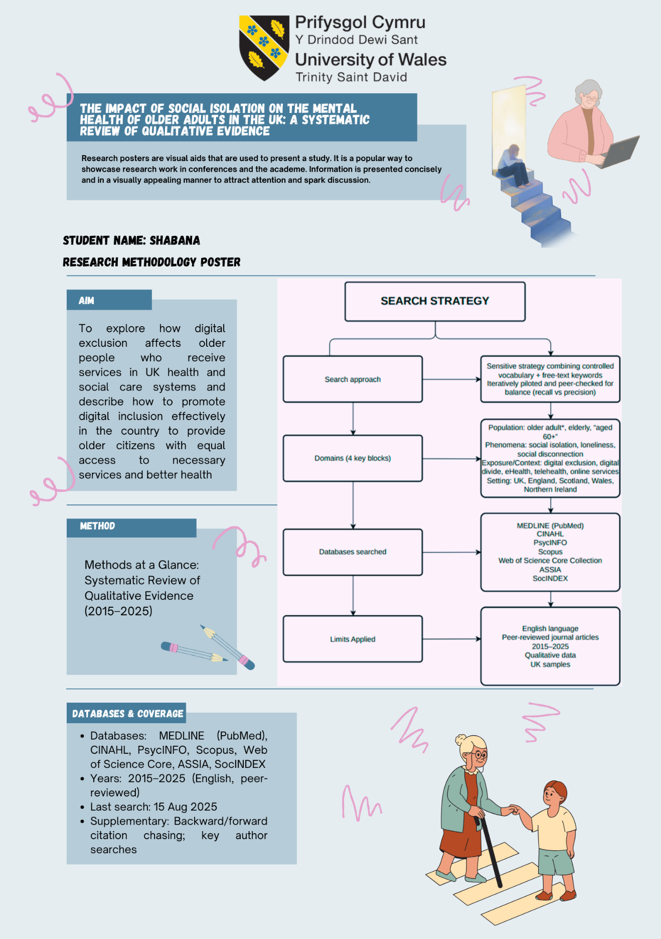
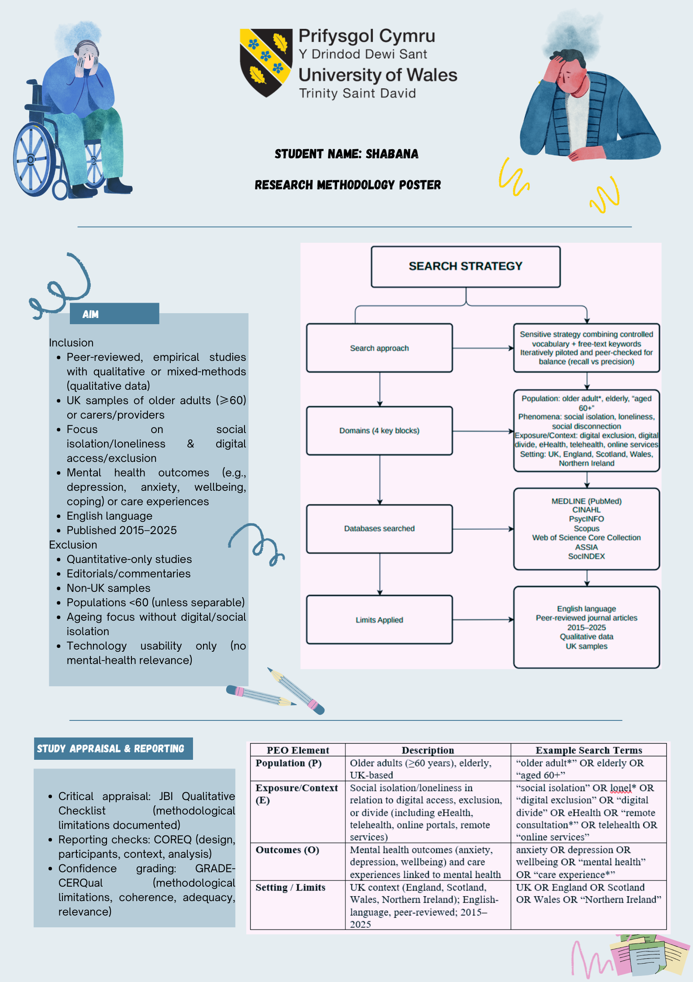
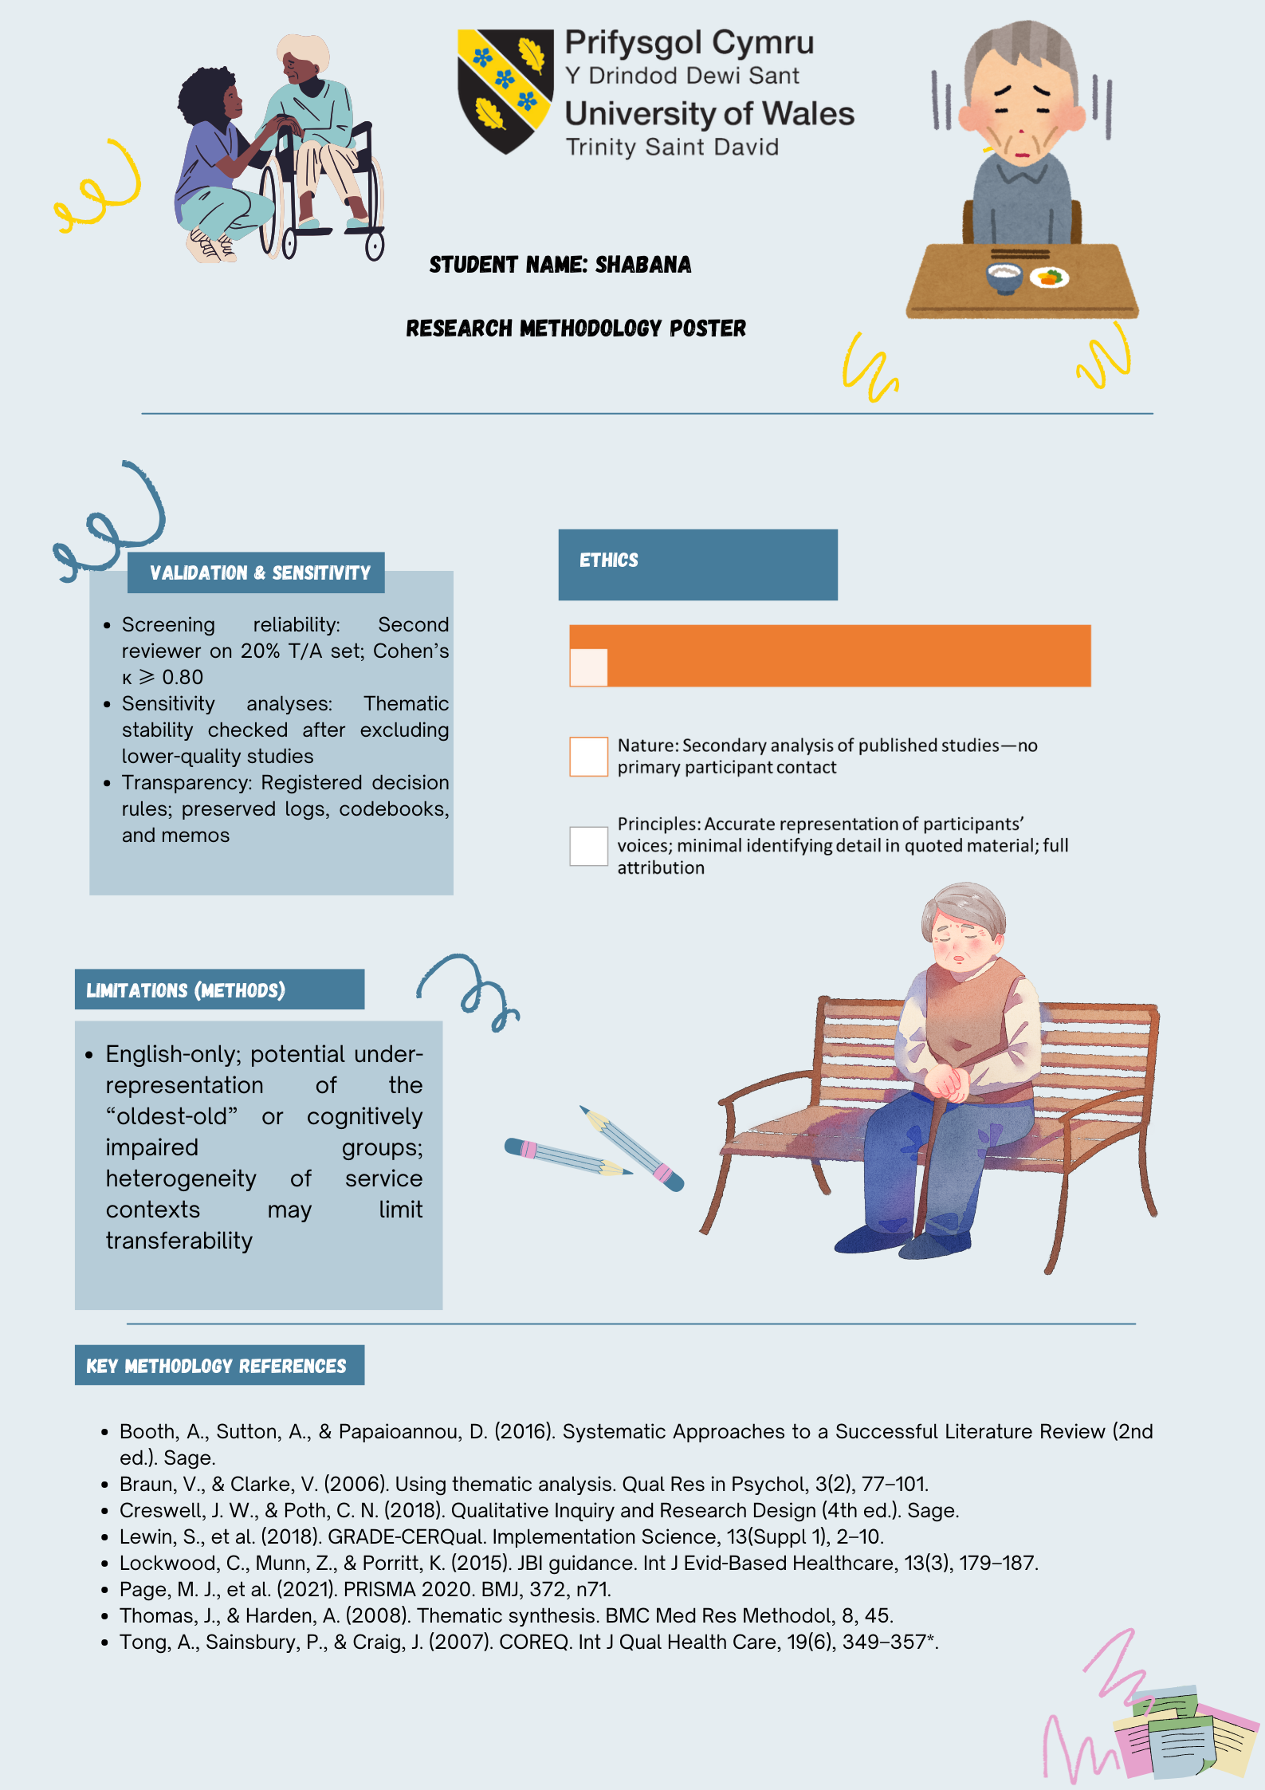

Table 4: Themes
Theme | Focus (Definition/Scope) | Core Mechanisms / Findings | Key Evidence / Examples | Equity & Mental-Health Implications | Policy/Practice Levers | Relevance to Objective
1) Disengagement & Barriers | How digital exclusion manifests in UK health & social care: layered across access, skills/confidence, and meaningful use. | Three-level divide (accessâ†’skillsâ†’use); barriers co-occur with age-related changes, deprivation, infrastructure; digital-by-default can enforce disengagement. | Age UK ~5.8m 65+ offline/unsafe use; place-based clustering (North-East England); anxiety re: scams/passwords/2FA; intimidation & poor fit; policy discourses risk stigma. | Cumulative disadvantage at first contact; increased loneliness/anxiety; risk of foregone care; trust erosion if offline routes disappear. | Assisted-digital support; parity of non-digital routes; local mapping & tailored responses; co-design with older adults; social-capital intermediaries (family, VCSE, libraries). | Objective 1 â specifies how access, proficiency, and motivation interact to produce (or reduce) exclusionary experiences.
2) Consequences | What exclusion does to access, mental health, wellbeing, and care experience. | Front-door friction (e-triage/booking) â†’ avoidance â†’ isolation; stressâ€“anxiety cycle; erosion of trust & help-seeking; continuity and dignity impacted. | Under-evaluated first-contact tools; place-based exclusion; social-identity needs; assisted use (e.g., champions) can restore belonging; LTC residents benefited less during COVID. | Missed/foregone appointments, delayed prescriptions; heightened loneliness/low mood/loss of control; inequities concentrated among oldest-old and deprived areas. | Embed assisted-digital at first contact; maintain visible phone/face-to-face; design for cognitive load; enable proxies/carers; relational continuity in remote care. | Objective 2 maps mechanisms from first-contact friction to psychological harm and degraded experience.
3) What Works? | Efficacy of UK policies/interventions to reduce exclusion and improve equitable outcomes. | Inclusion frameworks (NHSE) set parity/assistance/co-design; success depends on implementation capacity; NASSS explains non-adoption/abandonment risks. | 100% Digital Leeds (place-based coalition, device/data/skills); libraries as trusted hubs; mixed-methods evidence for local tailoring; editorials warn tech spend â‰ outcomes. | Assisted, relational, place-based designs reduce non-adoption and anxiety; universal deployment without assistance widens gaps. | Assisted-digital roles, device+data+skills bundles, parity-by-design, place-based commissioning, co-design, equity KPIs, protected workforce time & funding. | Objective 3 identifies policy ingredients and delivery mechanisms that credibly improve access & wellbeing for older adults.
4) Recommendations | Actionable, evidence-based steps for providers, commissioners, and community partners. | Target all three divide levels; strengthen social capital; reduce complexity per NASSS; uphold dignity/choice via parity and assistance. | Provider: parity statements, digital champions, proxy access, simplified flows; Commissioners: fund place-based at scale, measure inclusion, close first-contact evidence gap; VCSE/libraries: trusted delivery & brokerage. | Reduced missed care; lower tech-related anxiety; improved belonging/continuity; protects offline legal entitlements and practical access. | Parity of routes; assisted-digital at first contact; bundle device+data+skills; co-design & co-evaluation; rural broadband/social tariffs; equity KPIs (completed contacts, anxiety/loneliness changes). | Objective 4 converts synthesis into a coherent, implementation-ready package focused on equity outcomes.

Table 5: Achieved Objectives
# | Objective (from Ch.1 §1.4.2) | What was done (methods/approach) | Key findings / themes | Representative evidence & examples | Where covered | Status
1 | Describe and discuss the phenomenon of digital exclusion for older adults in UK health & social care (barriers: access, proficiency, drive) | Systematic review of UK qualitative studies (2015–2025); thematic analysis mapping barriers (access–skills/confidence–meaningful use) | Theme 1 – Disengagement & Barriers: affordability/connectivity gaps; low skills/confidence; anxiety about scams/authentication; perceived gatekeeping; need for assisted-digital and offline parity | Age UK prevalence context; Wilson-Menzfeld et al. (2024) on place-based clustering; van Dijk (2006) three-level divide; Vaportzis et al. (2017) on usability/confidence; FRA (2023) on risks of online-only | Ch.4 4.3; Ch.2 2.3–2.4; Ch.3 | Achieved
2 | Examine consequences for access, health, wellbeing and care experience | Synthesis of lived accounts tracing pathways from digital “thresholds” to service avoidance and psychosocial impacts | Theme 2 – Consequences: missed/foregone care; stress–anxiety cycle; loneliness/identity loss; erosion of trust/dignity; continuity valued | Kunonga et al. (2021) umbrella review; Stuart et al. (2022) social identity lens; Holt-Lunstad (2024) on health effects of social connection; triangulation with Age UK estimates | Ch.4 4.4 | Achieved
3 | Consider efficacy of UK interventions and policies to stimulate inclusion | Policy/practice synthesis; implementation lens (NASSS); appraisal of community models and system frameworks | Theme 3 – What works: parity-by-design; assisted-digital at first contact; place-based partnerships (libraries/VCSE); co-design; measure inclusion (not just adoption) | NHS England Inclusive Digital Healthcare (2023/24); DHSC Plan (2022); 100% Digital Leeds exemplar; Libraries Connected (2024); evidence gaps on first contact; Zhang et al. (2023) inequality signals | Ch.4 4.5; Ch.2 2.4 | Achieved
4 | Make evidence-based recommendations for providers, policymakers and communities | Consolidation of convergent evidence into a minimum effective package; feasibility and equity KPIs | Theme 4 – Recommendations: assisted-digital & warm handovers; device+data+skills bundles; local exclusion maps; offline parity; equity KPIs; multi-year commissioning; PPIE co-design | Operational actions with examples (reception champions, library referrals, social tariffs, proxy access); evaluation focus on completed access & wellbeing | Ch.4 4.6; Ch.5 5.2 | Achieved

