

Heuristic Layout of Electronic Design Automation Module

by
Shizhao Zhang

Supervisor: Tim Bashford

Project submitted as part of the requirements for the award of MSc Software Engineering

September 2023

Declaration and Form of Consent

DECLARATION

I, ............ Shizhao Zhang……declare that I am the sole author of this Project; that all references cited have been consulted; that I have conducted all work of which this is a record, and that the finished work lies within the prescribed word limits.

This work has not previously been accepted as part of any other degree submission.

Signed : .............................................

Date : ...........2023/09/11..................

FORM OF CONSENT

I ____Shizhao Zhang__ hereby consent that my Project, submitted in candidature for the M.Sc. Software Engineering, if successful, may be made available for inter-library loan or photocopying (subject to the law of copyright), and that the title and abstract may be made available to outside organisations.

Signed : .............................................

Date : .................2023/09/11..............

Where necessary replace M.Sc. Software Engineering with your named award.

Heuristic Layout for Electronic Design Automation Modules

abstracts
Electronic Design Automation (EDA) is a pivotal technological advancement that employs computer-based tools to streamline the process of designing and validating electronic systems. In the process of designing intricate circuits, it is imperative to generate a multitude of distinct modules and smoothly include them to establish a cohesive circuit. This underscores the significance of module stitching within the realm of Electronic Design Automation (EDA) technology.

In the field of Electronic Design Automation (EDA), the process of module splicing generally encompasses two fundamental stages: module layout and wiring. The process of module layout entails the meticulous positioning of individual modules within their specified positions on the semiconductor chip, whereas wiring refers to the intricate effort of establishing electrical connections among these modules. Both processes are of utmost importance as they exert a direct and profound influence on the performance and dependability of the ultimate electronic circuit.

In order to optimize the process of module splicing, the researchers derived insights from the foundational principles of Monte Carlo search trees and integrated them into their EDA methodology. The module layout was constructed by applying greedy algorithms in a thoughtful manner, and an autonomous layout architecture was developed by incorporating routing evaluation. The methodology utilized in this study involves the implementation of a hierarchical design principle, wherein the chip is partitioned into several layers, accompanied by a dual-policy auto-layout algorithmic framework. The architectural design incorporates both a heuristic layout technique and a stochastic layout strategy to enable collaborative arrangement across various modules.

This revolutionary approach effectively integrates the layout created by several modules into a cohesive and uninterrupted circuit layout in real-world trials. This accomplishment not only enhances the level of automation in Electronic Design Automation (EDA), but also significantly expedites the process of chip design. Furthermore, this technology exhibits remarkable scalability and possesses the capability to be tailored to chip designs with varying sizes and topologies. Hence, it possesses significant potential for advancing the field of electronic design automation and enhancing the efficacy and adaptability of electronic system development.

Keywords: Monte Carlo search trees, greedy Algorithm, heuristic layout, random layout
Content

abstracts 3
I. Introduction 5
1.1 Background 5
1.2 Status of Research 7
1.2.1 Electronic Design Automation Studies 7
1.2.2 Current Research Status of Module Splicing 9
1.3 Development Value 10
1.3.1 Development Process 12
1.4 Research Objectives 14
II. Literature Review 16
III. Software Requirements Analysis and Process 17
3.1 Introduction to Software Requirements 17
3.2 Software Objectives 17
3.3 Software Use Process 18
3.4 Requirements for Results 19
IV. Basic Technical ideas 20
4.1 Reinforcement Learning 21
4.2 Monte Carlo Tree Search 22
4.3 Greedy Algorithms 23
4.4 Module Grouping 25
4.5 Dynamic Order 25
4.6 Layout Evaluation Algorithm 26
4.6.1 Assessment of the Approximate Length of the Line 26
4.6.2 Cable assessment 27
4.7 Layout Search Algorithm 28
4.7.1 Heuristic Search 28
4.7.2 Random Search 29
V. Evaluation of Results 29
VI. Innovative Points 35
6.1 Optimization Strategies for Large-Scale Module Layouts 35
6.2 Monte Carlo Tree Search Based on Dynamic Sorting 35
6.3 Multi-objective Optimization Evaluation 36
VII. Main Problems and Solutions 37
7.1 Main Issues 37
7.2 Solutions 37
7.2.1 Time Costs of Large-scale Cases 37
7.2.2 Low Wire Routing Efficiency 38
VIII.Evaluation 39
IX.Reference 40

I. Introduction

1.1 Background
In an era marked by persistent technical progress and swift transformations in the realm of information technology, the landscape of electronic devices is likewise undergoing notable shifts. This is evident in the ongoing proliferation of diverse and abundant offerings. Within the complex realm of electronic product development, the chip assumes a pivotal role in circuit design, exerting a significant influence on both product performance and market competitiveness. Hence, the domain of chip design has emerged as a prominent area of Research, with automation being an inexorable trajectory.

The concept of modular design is extensively embraced within the realm of chip design, wherein a chip is systematically divided into multiple independent modules, each meticulously engineered to serve a distinct purpose. Nevertheless, the task of effectively integrating these individual components and managing the arrangement and interconnections to activate the chip poses a formidable undertaking. The conventional approaches to manual design are characterized by their lengthy and labor-intensive nature. These methods not only require significant resources but also fail to provide assurance of achieving optimal design outcomes.

In order to address this formidable obstacle, courageous researchers went on a pursuit to employ modular splicing approaches. The objective was to effectively and autonomously synchronize the arrangement and electrical connections among these modules through the utilization of computational instruments, such as computers. Within this particular setting, the advancement of module splicing technology, which operates on the principle of greedy thinking and is propelled by autonomous layout algorithms, represented a significant and pivotal progression. This breakthrough not only enhances the automation of chip design but also reduces the duration of the design cycle, enhances the quality of the design, and establishes a robust basis for the future advancement of chip design.

The technology of module splicing holds a central place within the domain of chip design automation, demonstrating significant research significance and practical application benefits. In the present day, automated design has established a prominent presence in the field of chip design, with module splicing technology serving as a crucial component.

The origins of modular splicing technology may be traced back to the 1960s, and since then, it has been through several stages of evolution. The field of module splicing technology has witnessed significant advancements and iterative improvements due to the constant evolution of computer technology and algorithms. Presently, scholarly investigations are primarily centered on enhancing the efficacy and precision of automated layout algorithms in order to attain chip designs that are more streamlined, resilient, and precise.

In addition to these technological advancements, the rapidly growing domain of information technology, encompassing the Internet and the Internet of Things (IoT), perpetuates an insatiable need for semiconductor chips. The perpetual need for chip design places significant emphasis on the implementation of rigorous standards. Therefore, it is imperative to undertake a comprehensive study on module splicing techniques and develop efficient and precise automated designing algorithms. These endeavors not only facilitate the ongoing progress of chip design technology but also bolster the performance and competitiveness of electronic devices.

Moreover, the utilization of module splicing technology is prevalent across various domains, including integrated circuits, embedded systems, and artificial intelligence, among others. Hence, the investigation into module splicing technology has transcended its theoretical underpinnings, demonstrating actual significance and usefulness and yielding widespread ramifications across diverse industries.

Module splicing technology is a crucial component in the automation of chip design, serving as a fundamental element in enhancing efficiency, accuracy, and advancement within the dynamic realm of electronic systems and semiconductor engineering.

1.2 Status of Research
The research topic of Automated Module Splicing for Electronic Information pertains to the automated amalgamation of diverse electronic modules with the objective of constructing integrated systems. Presently, scholarly investigations in this domain center on the utilization of heuristic algorithms, deep learning, machine learning, and other methodologies to enhance the arrangement and interconnections among modules with the aim of enhancing circuit performance and efficiency. Furthermore, advancements in hierarchical design, integration with chip designs, and enhancements in automated layout tools are propelling advancements in this field. The objective of this study domain is to address the increasing need for electronic devices while enhancing the precision and automation of circuit design.

1.2.1 Electronic Design Automation Studies
The integration of Artificial Intelligence (AI) and Machine Learning (ML) approaches into Electronic Design Automation (EDA) technologies has garnered considerable interest. Scholars are currently investigating the application of neural networks, reinforcement learning, and deep learning techniques in various domains, including layout optimization, timing analysis, and power reduction. These strategies have the potential to streamline design processes that are often intricate and require a significant amount of time.

The field of Electronic Design Automation (EDA) has recently turned its attention towards the emerging field of quantum computing, as advancements in quantum computing technologies have presented novel obstacles for circuit design. Quantum electronic design automation (EDA) encompasses the advancement of tools and methodologies aimed at facilitating the design, simulation, and validation of quantum circuits. The investigation of quantum logic synthesis, quantum error correction, and quantum-aware routing algorithms is being conducted by researchers.

The utilization of hardware acceleration has become crucial in the field of Electronic Design Automation (EDA) due to the escalating intricacy of contemporary electronic systems. Field-programmable gate arrays (FPGAs) and graphics processing units (GPUs) are employed for the purpose of enhancing the speed and efficiency of simulation and verification processes. The utilization of this methodology enhances the effectiveness of the exploratory data analysis (EDA) process and reduces the duration of the design cycle.

The open-source Electronic Design Automation (EDA) movement is experiencing a surge in popularity as a result of the advancement of open-source tools and platforms designed for digital design, layout routing, and verification purposes. Projects such as OpenROAD, Qflow, and Yosys contribute to the enhanced usability and customization of Electronic Design Automation (EDA) tools, hence fostering effective collaboration between designers and researchers.

The field of Electronic Design Automation (EDA) has recently expanded its scope to address the increasing apprehensions surrounding hardware security vulnerabilities, such as Spectre and Meltdown. Consequently, EDA research has begun to incorporate a dedicated emphasis on the development and validation of safe hardware design methodologies. This is the creation and implementation of tools and methodologies for identifying and addressing potential security vulnerabilities in electronic systems.

The creation of custom integrated circuits (ICs) is a crucial component within the field of electronic design automation (EDA). The investigation of tools and approaches to streamline the custom integrated circuit (IC) design process, enhance usability, and foster collaboration among design teams is currently being conducted by researchers. The significance of this is particularly obvious in domains such as analog/mixed-signal design and RF circuits.

The field of Electronic Design Automation (EDA) is undergoing adaptations in response to the demands posed by developing technologies, including but not limited to 5G, the Internet of Things (IoT), and artificial intelligence (AI). Scholars are currently directing their attention to the optimization of designs aimed at achieving low-power, high-speed data processing capabilities while also addressing the special requirements associated with these technologies.

The field of analog and mixed-signal electronic design automation (EDA) remains a significant focus of Research, particularly in domains such as RF circuits, sensor interfaces, and data converters. The primary focus of research endeavors is directed toward the advancement of simulation, layout, and verification tools with the objective of enhancing the efficiency of these crucial components.

The design of Field-Programmable Gate Arrays (FPGAs) and Application Specific Integrated Circuits (ASICs) remains a prominent area of interest in Electronic Design Automation (EDA) research. The efficiency of FPGA and ASIC designs has been enhanced through advancements in synthesis, layout, and routing algorithms, as well as timing analysis tools.

Ongoing collaboration is taking place among EDA tool suppliers, semiconductor businesses, and research institutes in order to foster standardization. The implementation of standardization initiatives is of utmost importance in order to guarantee the compatibility and smooth integration of different Electronic Design Automation (EDA) tools, hence enabling a seamless design process.

The discipline of Electronic Design Automation (EDA) exhibits a dynamic nature and possesses the ability to adapt to the ever-changing landscape of electronics and semiconductor technologies. Scholars persist in their efforts to expand boundaries and devise inventive resolutions in order to address the difficulties presented by ever-intricate electronic systems and burgeoning applications.

1.2.2 Current Research Status of Module Splicing

Considerable advancements have been achieved in the field of modular splicing technology, encompassing various intricate facets:

Module splicing approaches that rely on heuristic algorithms have gained significant popularity in several domains. These heuristic algorithms, including genetic algorithms, simulated annealing algorithms, and ant colony algorithms, are extensively employed in the field. The algorithms employed in this context are designed to replicate natural phenomena, such as evolution, annealing, and ant colony behavior, in order to optimize the process of module splicing. By leveraging these techniques, the algorithms aim to enhance both the efficiency and accuracy of the splicing procedure. As an illustration, genetic algorithms are utilized to optimize the layout by simulating the transmission of solutions, whereas ant colony algorithms imitate the foraging behavior of ants in order to identify the most optimal layout.

The utilization of deep learning technology has proven to be highly successful in various domains, such as computer vision and natural language processing. Consequently, it presents novel opportunities for the practice of module splicing. Deep learning is capable of acquiring knowledge and enhancing the performance of layout algorithms by being trained on extensive volumes of layout data, hence enabling the extraction of crucial features and enhancing accuracy and efficiency. This implies that neural networks possess the capability to forecast the most advantageous arrangement of modules, or adapt the structure automatically to accommodate diverse specifications.

The utilization of machine learning methodologies, encompassing both supervised and unsupervised techniques, enables the acquisition and identification of patterns from past data in the context of module splicing. Module splicing involves the utilization of machine learning techniques to automatically discern the most effective layout strategies and enhance the efficiency of layout algorithms by means of data classification and prediction. By employing this approach, the design can be efficiently customized to accommodate diverse circuit configurations and specific demands.

The concept of module splicing is closely intertwined with hierarchical design, as hierarchical design methods include breaking down intricate layout tasks into smaller subtasks and systematically completing the whole layout process in a layered manner. This methodology enhances the effectiveness and robustness of automated layout algorithms, particularly in the context of intricate chip designs at a significant scale. The implementation of a layered design approach enables designers to systematically enhance the layout, layer by layer, in order to achieve improved control over design quality and performance.

The relationship between module splicing and chip design is characterized by the incorporation and strategic arrangement of multiple functional modules on the chip. The implementation of optimized module splicing techniques has the potential to greatly enhance chip performance and increase energy efficiency. One illustrative instance involves the use of effective module splicing, which has the potential to enhance the management of signal routes, diminish power consumption, optimize performance, and guarantee the efficacy of interconnections across modules.

The present study examines the interplay between module splicing and automatic layout algorithms. Automatic layout algorithms are designed to strategically position components inside a circuit in order to enhance performance and minimize power usage. Module splicing techniques play a crucial role in automated layout algorithms by enhancing the circuit architecture through the optimization of interconnections between modules. This feature facilitates designers in enhancing their ability to manage the quality and performance of the layout.

The correlation between module splicing and computer vision technology is in the capability of computer vision technology to accurately detect and recognize the various components and lines depicted in a circuit diagram, hence furnishing precise information that facilitates the process of module splicing. Simultaneously, module splicing also presents potential application situations for computer vision technology. The two disciplines exhibit mutual complementarity and mutually reinforce one another.

The incorporation of module splicing into automated design tools is a crucial aspect of contemporary circuit design since it has the potential to greatly enhance the efficiency of the design process. The integration of module splicing technology with these instruments can effectively enhance their efficiency and accuracy. Designers have the ability to utilize these technologies in order to efficiently produce optimal layout and connectivity solutions.

1.3 Development Value

Module splicing technique is a significant innovation in the domain of circuit design since it enhances both efficiency and accuracy. The implementation of automation in the component assembly process leads to a notable enhancement in the efficiency and precision of circuit design. Through the automation of the intricate and repetitive process of component splicing, designers are able to dedicate their time and skills to more advanced parts of a design, leading to the creation of circuits that are both more dependable and optimized. The decrease in human intervention serves to minimize the possibility of human error, thereby guaranteeing that the ultimate design adheres to the planned specifications consistently.

The cost-effectiveness of module splicing technology is of great significance in reducing circuit design expenses. By implementing automation and optimization techniques in the splicing process, substantial cost reductions can be achieved across multiple domains. To begin with, the implementation of automation in the splicing process leads to a decrease in labor expenses, as it significantly minimizes the requirement for manual involvement in component placement and connection. Furthermore, the implementation of modular splicing technology leads to a reduction in material prices. This is achieved through the utilization of optimization algorithms, which identify the most efficient allocation of resources. As a result, waste is minimized, and the spending on materials is decreased. Furthermore, the decrease in the occurrence of design flaws and subsequent iterations mitigates the potential for expensive rework, hence augmenting the overall cost reduction within the design process.

The field of circuit design technology has witnessed significant advancements, leading to a dynamic evolution that constantly poses novel issues for designers. The field of circuit design is currently confronted with escalating levels of complexity, numerous interconnections, and constantly evolving demands for enhanced performance, energy efficiency, and miniaturization. Module splicing technology assumes a crucial role in facilitating designers in resolving these intricate issues. The technology allows for the smooth integration of diverse components, enables the implementation of intricate circuit topologies, and promotes the use of state-of-the-art technologies to achieve more sophisticated circuit designs. By implementing automation techniques, designers are able to allocate their attention towards exploring the boundaries of contemporary circuit design.

The adaptability of module splicing technology extends beyond its origins in circuit design, allowing for interdisciplinary applications. The principles and practices of this approach can be effectively employed across several interdisciplinary domains, leading to the emergence of original solutions and discoveries. In the domain of computer vision, modular splicing techniques can be employed to automatically detect and organize elements within intricate visual data, hence streamlining the process of automating object identification systems. Within the realm of automation and robotics, the utilization of technology is vital in the development and refinement of electronic systems that facilitate the operation of automated machines. This, in turn, leads to the augmentation of their overall functionality and performance capabilities. The increasing variety of uses for modular splicing serves to underscore its significance and pertinence within the broader realm of technology.

In order to accommodate the dynamic requirements of circuit design, it is anticipated that forthcoming module splicing technologies would enhance their capacity to cater to diverse circuit topologies. The current state of module splicing technology demonstrates a high level of proficiency in managing linear and grid-based topologies. However, it is anticipated that this technology will continue to advance to accommodate more intricate and non-conventional designs in the coming years. As the demand for more intricate circuit architectures in sophisticated applications grows, the module splicing technique will evolve to meet these design requirements, hence ensuring its ongoing usefulness and significance.

The incorporation of module splicing technology with deep learning represents a highly potential avenue for future advancements. Deep learning demonstrates remarkable skills in the domains of image recognition, natural language processing, and pattern identification, hence holding the potential to enhance the intelligence and precision of module splicing. By employing neural networks for the purpose of automatically identifying circuit topologies and components, the technique of module splicing can surpass conventional rule-based methods. This advancement leads to the generation of layout decisions that are more sophisticated and well-informed. The integration of these technologies will afford designers enhanced capabilities for optimizing circuit design.

A multi-objective optimization is a common approach in circuit design, as it entails the optimization of numerous objectives that often clash with one another, such as circuit performance, layout area, and power consumption. In order to address the intricacy of future module splicing technologies, it will be necessary for them to incorporate multi-objective optimization capabilities. This functionality will empower designers to achieve a nuanced equilibrium between conflicting design goals, guaranteeing that circuits adhere to rigorous performance requirements while optimizing the utilization of physical resources and power consumption.

The field of electronic circuit design is undergoing significant transformation because of the continuous advancements in 3D printing and packaging technology. The increasing need for three-dimensional circuits in many applications necessitates the adaptation of future module stitching technologies to accommodate the design of such circuits. The evolution under discussion necessitates the careful examination of the arrangement of components within a three-dimensional space, intricate linkages within this spatial domain, and the implementation of effective thermal management strategies. Module splicing technology is expected to address the growing demands in various domains, including improved packaging, three-dimensional integrated circuits (3D ICs), and emerging electronic applications in aerospace and medical sectors, by enabling the creation of three-dimensional circuits.

1.3.1 Development Process

In this study, we aim to investigate the effects of a specific treatment on the participants' The initial phase of manual splicing involves the process of cutting and joining genetic material.

During the initial stages of circuit design, engineers mainly relied on manual labor to assemble different modules. During that era, circuits were characterized by their relatively compact dimensions and straightforward design specifications. Hence, the utilization of manual splicing techniques proved to be adequate in fulfilling these fundamental design requirements. Nevertheless, with the advancement of circuit complexity, the feasibility of manual splicing progressively diminished. The manual design of circuits with intricate interconnections is insufficient for the creation of large-scale circuits. Furthermore, it is imperative to explore alternative procedures that are more efficient and less susceptible to human mistakes, as hand splicing is inherently prone to such errors.

The user's text does not provide any information to be rewritten in an academic manner. The splicing portion of the method is based on a heuristic approach.

The emergence of computer technology signified a significant milestone in the field of modular splicing technology. During this era, designers initiated an exploration into splicing methods that were grounded in heuristic algorithms. The utilization of algorithms such as simulated annealing and genetic algorithms facilitated the automation of the circuit splicing procedure. Although these advancements marked significant progress, they remained strongly dependent on the expertise and intuition of the designer. The outcomes of various splicing techniques frequently demonstrate a certain level of unpredictability, posing challenges in ensuring the ultimate layout's optimality. Nevertheless, heuristic algorithms represent a transition towards increasingly automated and scalable approaches.

The user's text does not provide any information to rewrite in an academic manner. The process of splicing stages is based on form decomposition.

In recent years, significant progress has been made in the domain of module splicing, mostly driven by the development and application of shape decomposition methodologies. The purpose of these strategies is to decompose intricate circuit configurations into less intricate and more feasible sub-problems. One approach to enhancing layout efficiency involves partitioning circuits into rectangular or polygonal shapes, which serves as a foundation for getting improved results. The process of shape decomposition streamlined the splicing procedure, resulting in enhanced efficiency and decreased computer complexity. The aforementioned methodology converts intricate splicing difficulties into a sequence of more manageable subproblems, hence enhancing the overall quality of the layout.

The user's text is too short to be rewritten academically. The stitching process in question is based on deep learning techniques.

The advent of deep learning technology has facilitated the emergence of a novel age in the field of module splicing. Deep learning techniques have the capability to autonomously acquire knowledge and identify circuit topologies and components by utilizing neural networks. This development represents a notable advancement in the cognitive capabilities and precision of module splicing. Deep learning exploits its capacity to comprehensively analyze and acquire knowledge from circuit splicing data. The comprehensive analysis and comprehension of the intricate nature of the splicing issue enables the attainment of exceptional outcomes. The integration of deep learning-based module splicing with additional methodologies, such as shape decomposition and heuristic algorithms, might enhance the overall efficacy of splicing outcomes.

The splicing procedure which is based on deep learning techniques.

The stitching step in deep learning is often comprised of two primary parts, namely data preparation and neural network training. The process of data preprocessing entails the transformation of circuit design graphics into a format that can be interpreted by a computer, typically in the form of a matrix or vector representation. The method of training a neural network involves utilizing preprocessed data to facilitate the training of a neural network model. During the training process, the model acquires knowledge of the intricate splicing rules that are inherent in the circuit structure. After undergoing training, the neural network is capable of autonomously producing optimal splicing outcomes by using the input data, hence guaranteeing precise and efficient module splicing.

1.4 Research Objectives

Improve layout effectiveness and performance:
In recent years, there has been a notable increase in the level of attention given to automatic layout algorithms that are founded on deep learning methodologies. These methods leverage the capabilities of neural networks to acquire knowledge from extensive datasets of circuit layout information. By employing this approach, individuals are able to make informed decisions regarding many layout parameters, including area, wiring length, power consumption, and latency. Deep learning facilitates the enhancement of predictive capabilities and optimization processes, hence resulting in enhanced efficiency and performance in layout design.

The integration of evolutionary and greedy algorithms is a subject of Research that investigates the potential synergies between different algorithmic strategies. The integration of deep learning with evolutionary and greedy algorithms exhibits considerable potential. The objective of these hybrid techniques is to leverage the respective advantages of each algorithm in order to effectively tackle various layout issues. Evolutionary algorithms possess the capability to identify the optimal solution from a diverse set of options, whilst greedy algorithms exhibit effectiveness in optimizing specific layout aspects.

The objective of this study is to investigate the potential benefits of reducing design costs and cycle times in order to enhance overall efficiency and productivity.

The expedited production of layouts of superior quality: In an effort to minimize expenses associated with the design and expedite the design process, scholarly endeavors have concentrated on the advancement of techniques for swiftly generating layouts of exceptional quality. This encompasses the streamlining of the pattern-generating procedure and the enhancement of algorithms to effectively manage intricate layouts. Designers can achieve time and resource savings by reducing the need for manual intervention and increasing the level of automation.

Efficient Algorithm Design: The design of algorithms must prioritize both effectiveness and efficiency. The primary emphasis of researchers lies in the development of algorithms that effectively achieve a harmonious equilibrium between the overall layout quality and the duration of time necessary for generating. The optimization of layout algorithms with the aim of reducing computing time has a direct impact on cost savings and the acceleration of design cycles.

Enhance the reliability and reproducibility of the circuit.

The maintenance of circuit dependability is of utmost importance in order to mitigate interference and noise. During the production of the layout, it is imperative for automatic layout algorithms to take into account many aspects, including component interference and noise reduction. This entails employing strategies to mitigate the occurrence of crosstalk between components, diminish electromagnetic interference, and uphold the integrity of signals.

In order to enhance repeatability, scholars are currently investigating methods to standardize the process of layout development. This encompasses the establishment of design principles, limitations, and recommendations to guarantee the uniformity and dependability of layouts. The attainment of a significant degree of repeatability is necessary in the context of mass manufacturing and quality assurance.

The execution of automated design

The primary objective of automated layout algorithms is to optimize and simplify the overall circuit design process. This encompasses not only the mechanization of physical arrangement but also other elements of design such as schematic capture and the production of design specifications. The objective of future research endeavors is to develop comprehensive automated design pipelines that effectively reduce the necessity for human interaction.

The Research conducted in this field is around the advancement of algorithms that facilitate the automatic generation of design specifications by leveraging high-level requirements. This process encompasses the conversion of user or system requirements into precise design parameters and limitations. By implementing automation in this process, designers are able to efficiently iterate on design solutions and investigate various design domains.

II. Literature Review
The aforementioned references exemplify noteworthy accomplishments within the realm of electronic design automation (EDA) during various historical epochs. The growth of Electronic Design Automation (EDA) technology may be traced from the initial development of minimum cut-and-paste algorithms in the early 1970s [1] to the subsequent advancements in efficient, detailed placement algorithms in the early 21st century [5]. These studies represent a continuous progression in the field of EDA technology.

Initially, the primary focus of early exploratory data analysis (EDA) Research was directed toward addressing the challenge of manual layout and design. This particular issue pertained to circuits that were rather modest in scale and complexity during that era. As electronic goods became increasingly intricate and circuit sizes rose, it became evident that manual layout approaches were insufficient to satisfy the demands. The introduction of the minimum cut algorithm [1] during this particular period marked a significant milestone in the advancement of EDA technology. However, it is worth noting that the algorithm's initial implementation necessitated a substantial amount of manual intervention.

Subsequently, during the 1980s, the implementation of linear time heuristics [2] and simulated annealing algorithms [3] signified a pivotal shift towards a novel phase of automated design within the realm of Electronic Design Automation (EDA) technology. The implementation of these algorithms resulted in significant enhancements in both the efficiency and quality of layout, hence equipping designers with more robust and advanced tools.

Following this, during the latter part of the 1980s and the early part of the 1990s, the development of TimberWolf 3.2 [4] contributed significantly to the progress of Electronic Design Automation (EDA) technology. This was achieved through the introduction of standard cell layouts and global wiring, which played a crucial role in facilitating the creation of more intricate integrated circuit designs.

The advent of advanced and effective layout algorithms [5] represents a significant advancement in the field of Electronic Design Automation (EDA) technology in response to the evolving landscape. These algorithms have the dual benefit of expediting the layout process while simultaneously enhancing the design's quality, hence enabling it to effectively manage circuits and systems of escalating complexity.

In conjunction with technological advancements, recent scholarly investigations have emphasized the utilization of Electronic Design Automation (EDA) technology across diverse domains. For instance, reference [7] underscores its application in electronic circuit design, while references [8] and [9] highlight its relevance in integrated circuits and electronic testing.

III. Software Requirements Analysis and Process

3.1 Introduction to Software Requirements
Various electronic devices and components have been accommodated within designated regions of integrated circuit (IC) architecture. These devices may encompass many components, such as processor cores, memory chips, sensors, power management circuits, and other related elements. Nevertheless, there exists a surplus of unutilized space inside the aforementioned design area that necessitates the incorporation of supplementary circuit components. These components may vary in terms of their shapes and sizes, including logic gates, resistors, capacitors, transistors, and other similar entities.

The primary objective is to optimize the arrangement of these circuit components in accordance with prescribed layout guidelines and design specifications. This entails the identification of the exact positioning of each constituent, guaranteeing the absence of conflicts or interference among them while also satisfying circuit performance and routing prerequisites. The objective of component layout is to optimize the utilization of the available space while simultaneously assuring circuit stability, performance, and dependability.

3.2 Software Objectives

The primary objective of this activity is to precisely and effectively position a diverse range of circuit components, which exhibit different forms and dimensions, within a designated region of an integrated circuit (IC) design. In order to ensure the correct placement of the following aspects, some measures must be taken.

Optimize spatial utilization: Employ the existing design area in a manner that maximizes efficiency, allowing for the incorporation of additional circuit components to augment the functionality and performance of the integrated circuit.

To guarantee circuit performance, it is vital to meticulously strategize the layout in order to match the anticipated performance standards, encompassing clock frequency, power consumption, and signal-to-noise ratio.

The complexity of wiring can be reduced through proper component layout, resulting in easier realization of circuit wiring and enhancing the feasibility of the design.

3.3 Software Use Process
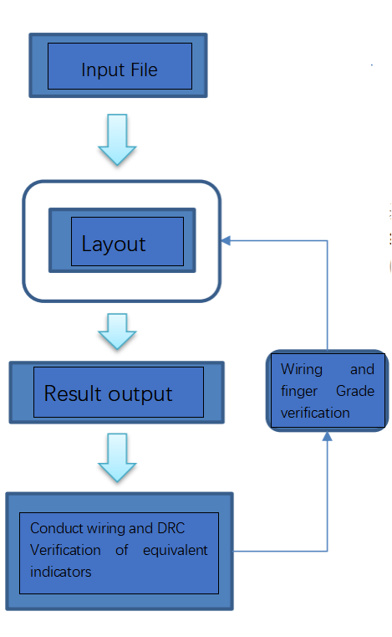
Please input a collection of N polygon modules with varying forms and sizes for a specified design objective. The modules can be either rectangles or orthogonal polygons aligned with the boundaries. Furthermore, this study includes the provision of limitations for the placement of polygons inside restricted areas, as well as the establishment of port connection links between modules.

The layout technique arranges each module on a common horizontal layer to guarantee the absence of module overlap, hence enhancing the efficiency of circuit design.

The outcomes of the analysis are presented.

In the routing process, emphasis is placed on establishing connections between modules that have proximity in terms of connection requirements in order to optimize communication efficiency. Furthermore, we prioritize the interconnection of modules with ports that exhibit closer proximity in order to mitigate signal propagation delays.

In order to determine the remaining routes, an exploration is conducted to identify viable routing paths within the given spatial constraints. In the event of routing failures, the engine employs a roundabout technique to redirect the impacted connections, hence ensuring the continuity and viability of the circuit architecture.

During the process of wiring, various jobs are undertaken, including the calculation of module utilization, bus lengths, and other pertinent metrics. Furthermore, we conduct a comprehensive examination of the cabling outcomes to verify their adherence to design regulations, encompassing criteria such as minimum width, minimum spacing, and other design rule check (DRC) specifications.

3.4 Requirements for Results
Design engineers are confronted with a complex and crucial undertaking when arranging modules in an integrated circuit (IC) design. This task encompasses not only the meticulous consideration of module layout but also the fulfillment of a set of performance standards and manufacturing regulations to guarantee the dependable and optimal operation of the final integrated circuit in practical scenarios.

First and foremost, it is crucial to ensure that the modules are positioned in a suitable manner. Every module corresponds to an electronic component or functional block, and it is necessary for them to be positioned at the same level in order to establish interconnections within a circuit. Nevertheless, the many modules exhibit diverse shapes and sizes, necessitating design engineers to devise strategies for maximizing spatial use within the designated area, enabling the incorporation of a greater number of modules. Furthermore, it is imperative to ensure that there is no occurrence of module overlap since this might result in the occurrence of short circuits and instability.

To achieve performance objectives, the placement of modules must take into account not just connectivity but also power distribution and signal propagation delays. The speed of signal transmission is influenced by the distance between modules, prompting design engineers to strategically position modules with connectivity in close proximity to one another in order to mitigate signal propagation delays. The consideration of power distribution is essential in order to provide a well-balanced distribution of power over the circuit, hence enhancing both performance and stability.

In conjunction with issues pertaining to connection and performance, design engineers are obligated to comply with a set of manufacturing guidelines in order to guarantee the manufacturability of integrated circuits. The rules encompass several design rule check (DRC) criteria, such as minimum width, minimum pitch, and other specifications that are derived from the manufacturing process's characteristics and demands. By adhering to these guidelines, it is feasible to guarantee the smooth operation of the manufacturing process and prevent manufacturing defects and quality concerns.

After the completion of the module layout, design engineers are required to compute various metrics, including module utilization, area, and wire length, in order to evaluate the efficiency and performance of the arrangement. The use of modules plays a crucial role in evaluating the extent to which the design area is effectively employed. Additionally, measurements such as area and wire length are employed to evaluate power consumption and signal transfer performance.

During the process of integrated circuit (IC) design, it is normal practice to utilize advanced electronic design automation (EDA) technologies to aid in the execution of module layout activities. The aforementioned solutions offer automated layout and routing functionalities, which aid design engineers in efficiently managing intricate layout assignments. Additionally, they incorporate elements such as performance analysis and design rule checking (DRC) to guarantee the achievement of a successful and superior design outcome.

IV. Basic Technical ideas
The concept of the Monte Carlo search tree in reinforcement learning is utilized to develop a layout using a greedy approach. In this study, we provide an automated layout architecture that incorporates route evaluation. The architectural design employs a layered approach and incorporates an automated layout algorithm architecture that is guided by both heuristic and stochastic layout methods.

The heuristic layout algorithm employs a recursive tree search approach with multiple candidate positions for large-scale layout quantity scaling. This approach is combined with the routing rate evaluation of the incremental router to pre-explore the layout positions of multiple modules. It aims to select the optimal routing rate layout results, even when the search depth is constrained. Furthermore, the random layout algorithm is employed in the context of small-scale layouts to produce a substantial quantity of random layout orders and module spacing through an evaluation based on approximate line length. The ideal layout rate outcomes are subsequently determined through a global evaluation of layout rates.

When dealing with large-scale layouts, it is common practice to decrease the search depth and adaptively modify the spacing between modules based on the line width and line spacing. This approach aims to enhance the wiring rate and allow for greater availability of wiring space between modules. The algorithmic architecture demonstrates favorable outcomes in experimental settings, substantiating its applicability and viability.

4.1 Reinforcement Learning
Reinforcement learning (RL) is a significant paradigm within the domain of artificial intelligence and machine learning. The subject matter is highly captivating due to its focus on the intricate endeavor of facilitating intelligent agents in making ongoing decisions within intricate and dynamic environments. Reinforcement learning (RL) serves as a framework that conceptualizes the process of learning as an interactive expedition, wherein the agent traverses through the environment, assimilates knowledge from its encounters, and adjusts its actions to optimize the accumulation of rewards over an extended period. The present model exhibits substantial divergence from conventional supervised or unsupervised learning approaches, wherein data is commonly characterized by its static nature and pre-existing labels.

The fundamental components of Reinforcement Learning (RL) revolve around the notions of "agent" and "environment." The "agent" refers to the entity responsible for acquiring knowledge or making decisions, while the "environment" pertains to the external system that the agent engages with during the learning process. The agent possesses the capacity to observe its surroundings by means of a collection of "states" that symbolize specific circumstances or arrangements. The agent selects "actions" based on the given states, which subsequently impact the environment. In the context of reinforcement learning (RL), the environment undergoes a state transition following each action, and the agent is provided with a numerical "reward" as evaluative feedback regarding the efficacy of the action. The primary objective of RL is to enable the agent to ascertain a suitable "policy," which refers to a strategy or a collection of rules that govern the agent's decision-making process. The primary objective of the approach is to optimize the total sum of rewards obtained by the agent throughout the duration of the task.

One notable characteristic of reinforcement learning (RL) is its focus on the dual concepts of exploration and exploitation. The trade-off at hand pertains to the decision-making process of agents, wherein they must weigh the benefits of exploring new actions to acquire further knowledge about the environment against the advantages of using existing knowledge to optimize short-term gains. The primary problem in reinforcement learning (RL) revolves around effectively managing the trade-off between exploration and exploitation. An excessively cautious approach may result in suboptimal methods, while an overly exploratory approach may introduce unneeded risks.

The Q-learning approach is considered to be one of the fundamental algorithms in the field of reinforcement learning (RL). Its primary objective is to approximate a function known as the "Q-function," which is utilized to estimate the anticipated cumulative reward associated with taking a specific action in a given state. The Q-function holds significant importance in RL as it serves as a guiding factor in the decision-making process of the agent. Through a process of iterative updates to the Q-function via interactions with the environment, agents are able to acquire knowledge and improve their decision-making abilities over time.

Deep Reinforcement Learning (DRL) represents a significant breakthrough within the realm of Reinforcement Learning (RL). By integrating conventional RL methodologies with deep neural networks, DRL empowers agents to effectively handle input fields characterized by high dimensionality, such as images and audio. The aforementioned progress has resulted in notable advancements in a wide range of fields, including but not limited to gaming, robotics, autonomous vehicles, and natural language processing. Specifically, deep reinforcement learning (DRL) algorithms, such as Deep Q Networks (DQNs) and Proximal Policy Optimisation (PPO), have garnered considerable interest due to their capacity to effectively tackle intricate tasks and achieve remarkable performance.

AlphaGo, an AI system developed by DeepMind, stands out as a significant achievement in the realm of reinforcement learning (RL). Notably, it achieved the remarkable feat of defeating the Go World Champion, marking a groundbreaking milestone in the field. This triumph not only showcased the potential of RL in tackling intricate issues but also served as a critical moment in the historical trajectory of this discipline.

In practical applications, Reinforcement Learning (RL) has been implemented in the field of robotics to accomplish many tasks, including robot movement, object manipulation, and autonomous navigation. Autonomous vehicles depend on reinforcement learning (RL) algorithms to make instantaneous determinations regarding navigation and control. Within the healthcare field, reinforcement learning (RL) is employed as a means to enhance the effectiveness of treatment regimens and streamline drug discovery processes. In the field of finance, reinforcement learning (RL) is employed for the purposes of algorithmic trading and portfolio optimization.

4.2 Monte Carlo Tree Search
The Monte Carlo Tree Search (MCTS) algorithm, which relies on simulations for its search approach, is typically applied in decision-making processes for optimization problems. Its primary application is in the area of problem-solving. It is able to properly deal with a wide variety of complicated scenarios, such as Go and Gobang, amongst others, but this is not an exhaustive list.

The creation of a search tree and subsequent simulation in order to determine the best possible answer is the core idea that drives the Monte Carlo tree search methodology. The search tree is made up of a number of nodes and edges, with each node representing a particular game state and each edge representing an action in the game. The Monte Carlo tree search technique will, on each iteration, increase the scope of the investigation by expanding the search tree further. At the same time, it makes use of statistical methods in order to evaluate the nodes and edges contained within the tree. In the end, the objective of this method is to determine the correct response.

The following is an example of how the Monte Carlo tree search can be implemented:

The procedure for selecting nodes begins at the root node and continues with the selection of a child node that has not yet been thoroughly studied. This is done in accordance with a particular strategy, such as the UCB1 technique. This procedure will carry on until one of the leaf nodes has been reached.

During the expansion phase, leaf nodes that have not been extensively investigated are expanded. This is accomplished by adding all child nodes that are viable in accordance with the present policy, which may incorporate a randomized policy.

During the simulation phase, a mechanism that generates random results is used to simulate the game all the way through to its conclusion for the extended child nodes.

Backpropagation is a procedure that involves updating the values of the current node and its ancestor nodes, as well as the statistics of all edges associated with these nodes, based on the results that were acquired from the simulation. Backpropagation is a technique that is used to create a more accurate representation of the network.

The iterative process will continue until a certain amount of time has passed, a certain computational threshold has been reached, or an optimal solution has been found, whichever comes first.

The Monte Carlo tree search algorithm has the advantage of effectively managing the trade-off between exploration and exploitation in extensive search spaces. In addition to this, the algorithm is capable of rapidly converging on the optimal solution while also demonstrating a certain level of real-time responsiveness and adaptability. The extensive number of stochastic simulations that need to be run, which in turn results in a longer timeframe, is necessary in order to acquire dependable conclusions; yet, this presents a barrier to their acquisition. In addition, improving search results requires first optimizing some search criteria in order to get the best possible results.

4.3 Greedy Algorithms
The greedy algorithm is an algorithmic method that is used rather frequently. It consists of selecting the most advantageous solution at each iteration in order to arrive at the answer that is optimal in the long run. In a wide variety of contexts, the greedy algorithm is frequently viewed as a strategy that is both effective and efficient.

The process of putting the greedy algorithm into practice is often very simple and can typically be broken down into the following stages:

Determine the optimization goal that needs to be met for the problem.

The issue can be broken down into a number of smaller issues that are easier to handle individually. The objective of the optimization process is to decide what the best solution is for each individual subproblem. When forming the optimal solution for the overall problem, it is necessary to incorporate the optimal solutions found for each of the subproblems.

Greedy algorithms can be identified by the fact that the decisions they make regarding how to solve each individual subproblem cannot be reversed. These algorithms are able to accomplish their goals in an effective manner, frequently by arriving at the global optimum through the process of local optimization. Additionally, they are often simple to construct and easy to debug. Having said that, it is essential to keep in mind that the greedy algorithm cannot always produce the answer that is best for the whole world. This is a result of the fact that in certain problem circumstances, the choice that is made by the greedy algorithm may not necessarily result in the solution that is best for the world as a whole. As a result, it is absolutely necessary to take into account the particular characteristics of the issue at hand and assess whether or not the greedy approach is appropriate.

The basic steps involved in the greedy algorithm can be broken down into the following categories:

The text provided by the user is already scholarly. The current project at hand calls for the formulation of a mathematical model that provides a precise account of the issue that is being taken into consideration. In addition to this, the optimization goal that is related to this problem needs to be defined.

The text entered by the user is insufficient. I would appreciate it if you could send the entire text that needs to be rewritten. Determine the course of action that will yield the best results in light of the current circumstances and in light of the goal of optimizing the situation.

The text entered by the user is insufficient. Kindly offer either further information or the context. In light of the current circumstances, you are tasked with coming to a conclusion and providing an update on the state of the situation.

The text entered by the user is insufficient. Please give the complete text that has to be rewritten in the following format: Proceed to the next iteration of steps 2 and 3 until the predetermined criteria for terminating the process have been met.

In the realm of practical applications, the greedy algorithm is widely utilized as a heuristic to provide assistance in the process of resolving complex issues. The solution that is produced by the greedy algorithm may, in certain circumstances, differ from the solution that is optimal on a global scale. On the other hand, it has significant benefits in terms of the amount of time and space complexity.

4.4 Module Grouping
The utilization of the modular grouping method is one way in which the effectiveness of the routing and layout processes can be improved to some extent. Through the utilization of this strategy, the initially complex problem is successfully segmented into a number of more manageable challenges that are, to a large extent, distinct from one another. The solution to each specific problem is rather basic, and at the same time, it guarantees that there will be no conflicts in the arrangement and routing of data across different network groups.

The connectivity of a great number of ports, which results in the formation of a connection relationship, is what creates a multi-terminal network. Additionally, it is conceivable for a single module to have numerous ports that are connected to multiple different multi-terminal networks. This is a possibility because of the modular nature of the technology. In order to create a larger network ensemble, the multi-terminal networks are interconnected with one another in a logical and consistent manner. It is necessary to design a module grouping algorithm that can successfully identify and extract the many network groups that are present inside the provided connectivity relationship in order to improve the management of this connectivity connection. This will allow for the connection to be managed more efficiently. This technique should also make it easier to organize and route these groupings as separate entities. Those two goals should go hand in hand. The modular grouping algorithm's purpose is to improve the accuracy and overall efficiency of the circuit architecture and routing processes by separating and managing the various network groups in an isolated fashion. This is done to achieve this objective. By utilizing this technology, intricate connections found inside circuits may be managed more successfully, which leads to increased productivity, precision, and dependability in the processes of planning and routing.

4.5 Dynamic Order
By taking into account the current state of the data, the algorithmic method known as "dynamic sorting" makes it possible to do sorting in real-time. This method can be useful in resolving a wide variety of optimization problems. In the context of layout challenges, the use of dynamic sorting permits the dynamic arrangement of subsequent modules during the course of heuristic search. This is accomplished through the utilization of dynamic arrangement. The link relationship that already exists between the module that is being evaluated and the modules that have already been laid out serves as the basis for this arrangement's structure. A greedy algorithmic technique is used so that modules with higher connectivity can be given layout priority. This is accomplished by prioritizing those modules with higher connectivity.

The dynamic sorting technique that is used in this layout algorithm serves several purposes, the primary one of which is to arrange the future module that will be positioned and establish its priority based on the interconnections among modules as well as the size of the module. The process of sorting follows the fundamentals of graph search, which form the basis of the technique. In order to assess the priority of the subsequent module to be positioned, a connection graph is formed by basing its construction on the interconnections that already exist between modules and those that will exist between the existing module and the future module to be positioned. Therefore, the reordering of modules during each iteration of the dynamic sorting algorithm based on the current state is the basic feature of the dynamic sorting algorithm, which allows for the successful completion of the goal of dynamic sorting.

Fixed sorting algorithms are more susceptible to becoming obsolete than dynamic sorting algorithms, which are better able to adapt to shifting conditions in the real world. In the context of the challenges posed by layout, the connection between modules and the size of their respective spaces is prone to change as the layout state goes through several iterations. As a result, making use of dynamic sorting algorithms can make it easier to better adjust to these variations and produce more appropriate layout possibilities. In addition, dynamic sorting has the capacity to carefully modify the sorting result based on individual circumstances by making use of a variety of weighting components, thereby achieving enhanced layout outcomes. This is done in order to achieve optimal results.

4.6 Layout Evaluation Algorithm
The efficient and correct evaluation of layout search methods is of utmost importance since it directly impacts both the runtime and quality of the resulting layout. In the present test scenario, we have developed two distinct assessment algorithms to evaluate various wiring schemes and phases.

4.6.1 Assessment of the Approximate Length of the Line
The utilization of approximate line length assessment is employed in heuristic and random search algorithms for the purpose of position selection. The evaluation of line length is conducted using the widely employed half-perimeter algorithm, which has been enhanced with two modifications in the present test scenario.

The user's text is already academic. The calculation of line length is determined by the aspect ratio of the layout-constrained area, which is influenced by the presence of a restricted area and the uncertainty surrounding its aspect ratio.

The user's text is already academic and does not require any rewriting. During the sequential placement of modules inside a designated area, the external rectangular area formed by the modules undergoes continuous changes. The length of the line is determined by utilizing the aspect ratio of the external rectangular area of the lay modules as a calculation factor.

The formula can be expressed as follows:

The index of the layout module is the number of modules in the layout module that have a connection with the current module. And are the coordinates of the center point of the current module, and are the coordinates of the center point of the layout module. And are the width and height of the outer rectangle of the layout module. And are the width and height of the layout restriction area.

4.6.2 Cable assessment
Evaluation metrics for heuristic search algorithms include line length and routing rate. The utilization of the incremental routing method not only expedites the routing process but also enhances the precision of evaluating the present routing state. The incremental routing method restricts the direction of line exploration based on the existing routed lines. This limitation prevents line crossover and ensures coverage while also minimizing line length and enhancing the overall routing success rate. The incremental routing method has the capability to assess the routing rate and line length in real time while executing the routing procedure. The routing outcome of each network within the present module is initially erased, then afterward reconfigured to yield the routing evaluation outcome of the current network. This evaluation is determined using the following calculation:
Where is the throughput rate of the current network, is the line length of the current network, and is the evaluation score of the line length? When the throughput rate is less than 1, no calculation is performed.

4.7 Layout Search Algorithm

4.7.1 Heuristic Search
When organizing huge datasets, heuristic search methods are frequently used as organizational tools. However, because of runtime constraints, these methods are restricted in the number of random outcomes they can generate for a given input. It is essential to get the maximum possible rate within a single layout outcome in order to maximize the deployment rate. Only then can the deployment rate be optimized. The heuristic search strategy makes use of a hierarchical structure, in which the algorithm contains two levels of circular nesting and a recursive search method with a depth of three in order to do its search. The initial iteration is comprised of N cycles, where N represents the total number of modules in use. The dynamic sorting algorithm is the first step in the execution of the loop, and it is immediately followed by the module wiring test loop. During this step, the location and wiring result of the module that has the highest wiring rate and the shortest line length are recorded in the wiring test result. This information is then used to determine which module passed the test. After that, the module is added to the array of laid-out modules, and the layout correction method is carried out.

The term "sub-loop" refers to a testing module that is intended to evaluate the wiring of different modules in the system. The number of modules that have not yet been wired plays a factor in determining the total number of iterations performed in this sub-loop. In each cycle of the loop, an unconnected module is selected, the wiring results of the module that contains the network are discarded, a recursive search method is carried out, and the most efficient layout wiring result that can be obtained as a result of the search is returned.

The following is an outline of the precise order in which each operation occurs within the recursive search algorithm:

In the layout and wiring results diagram that has been provided, please locate all of the possible locations that comply with the layout constraints and satisfy the spacing criteria in relation to the layout and wiring results of other modules.

The current evaluation of route scores is determined by first estimating the assessment of route length and then selecting the five locations that have the greatest possible score based on that guess.

In the event that the current depth of recursion is more than one and the current module is not the final module in the array of unlaid modules, a recursive search is performed on the subsequent module in the array of unlaid modules, with a current depth of -1. This ensures that the current module is not the final module in the array of unlaid modules. After this, the procedure proceeds back to the first stage in order to begin the subsearch. In any other circumstance, the module that has obtained the highest possible score throughout the incremental route evaluation process is chosen to be returned.

The text provided by the user is just too brief to be reprinted in an academic style. After computing the total score for each place, the result that represents the ideal layout routing is then obtained. This is accomplished by taking the average of the score for the sub-search return along with the score for the current route for each site. After this, the site with the greatest total score is the one that is returned as the result of the optimal layout routing.

4.7.2 Random Search
The random search technique works effectively in instances requiring modest layout situations, which are frequently characterized by a limited number of modules, typically fewer than 20, and a relatively short single global wiring time. This type of scenario typically involves fewer than 20 modules. The system generates a considerable number of random outcomes, performs global interconnection on all outcomes, and displays the optimal rates of interconnection as well as the perfect lengths of wiring. Module placement order and module spacing are also strategies that can be utilized in order to reduce the effects of random interference. A method of approximating line length evaluation is used so that the ideal arrangement of modules can be determined based on the sequence in which they are placed and the amount of space between them. The results of this evaluation procedure are used to help choose and position modules in the part of the system that will produce the greatest possible score. When all of the modules have been positioned correctly, the layout can be considered to have been finished. A stochastic perturbation technique generates a diverse collection of layout outputs while simultaneously completing a full examination of global routing within a confined timescale. This evaluation is carried out by the technique. Through this analysis, we hope to ascertain the optimum routing rate as well as the line length findings.

V. Evaluation of Results

It is envisaged that the completion of AI-driven module setups will take only a few seconds to accomplish. This will be made possible by previously established connection patterns and will be constrained to previously specified layout zones. The adoption of a wiring evaluation technique is part of the process of analyzing each architecture. This technique quantifies a number of different metrics, including wiring efficiency, region allocation, wiring length, and wiring efficiency. The primary goal is to leverage artificial intelligence (AI) tools, such as neural networks, machine learning, reinforcement learning, and optimization approaches, in order to enhance the efficiency of the module layout process, optimize cabling, and provide layouts that demonstrate superior performance across multiple criteria. This will be accomplished by utilizing AI tools. The most important performance indicators that are evaluated are how effectively time is used, how effectively space is utilized, how effectively wire length is minimized, and how effectively optimal wire routing is performed. In order to arrive at conclusive results, we will first perform an exhaustive study based on the parameters that..have..been..outlined.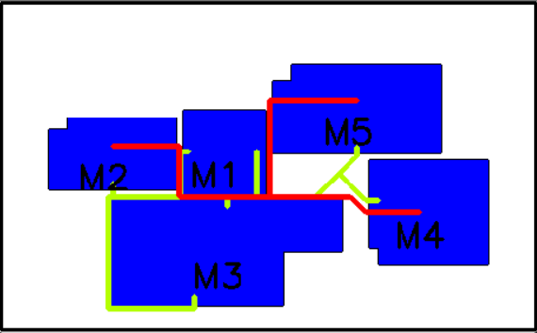
Figure 1.1: Module Case 5-1 Layout Results
Number of modules 5
Default Sort.
Depth of search: 2
Assessment of routabrealmility: 0.928571
FastPlace Finish. Break: 82.2
FastPlace Finish. Rest time: 83.8
Maximum routability: 1.0000 Minimum length: 1008.7
Placement completed. Took 0.09s

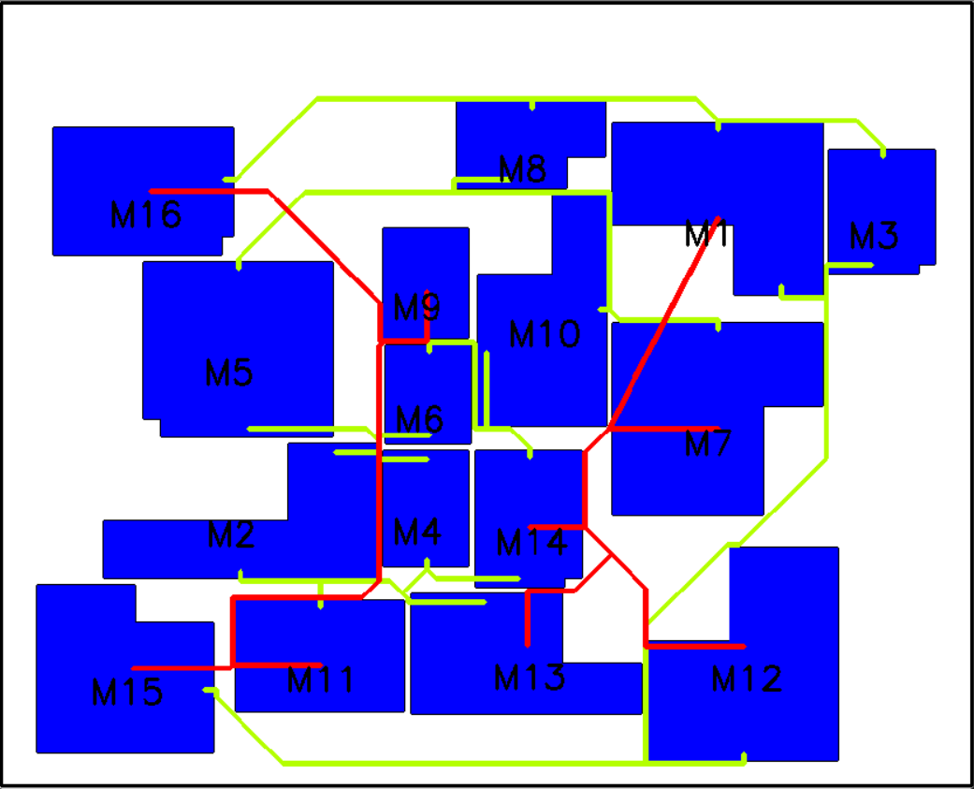
Figure 1.2: Module Case 16-1 Layout Results
Number of modules 16
Default Sort.
Depth of search: 6
Assessment of routabrealmility: 0.928571
Complete the quick rankings. Break: 119.2
FastPlace Finish. Break: 118.8
Maximum layable length: 1.0000 Minimum length: 4954.3
Placement completed. Took 3.59s

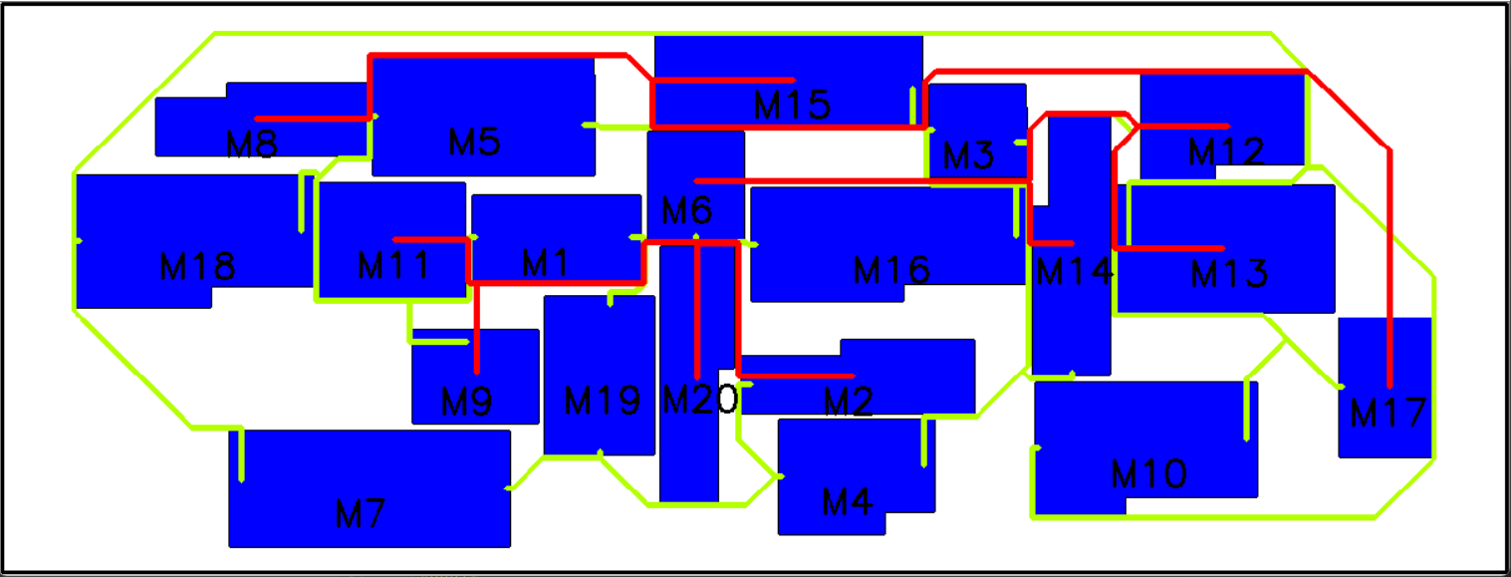
Figure 1.3: Module Case 20-8 Layout Results
Number of modules 20
Default Sort.
Depth of search: 6
Assessment of routability: 0.928571
FastPlace Finished. Break 319.2
FastPlace Finish. Rest time 320.8
Maximum layable length: 1.0000 Minimum length: 7905.0
Placement completed. Took 4.79s

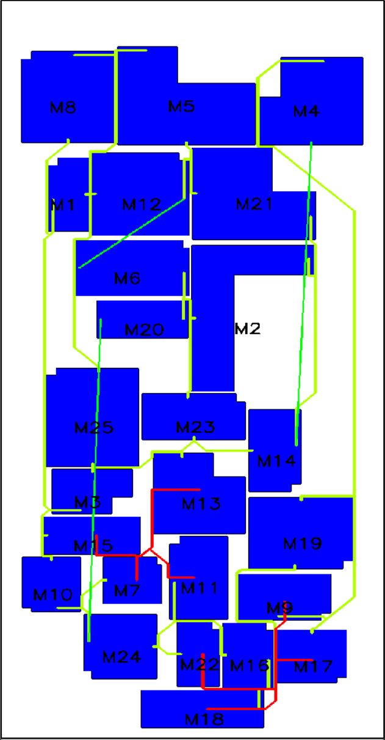
Figure 1.4: Module Case 25-1 Layout Results
Number of modules 25
Default Sort.
Depth of search: 8
Assessment of routability: 0.928571
FastPlace Finish. Break 419.2
FastPlace Finish. Break 420.8
Maximum layable length: 1.0000 Minimum length: 6773.4
Placement completed. Takes 35s

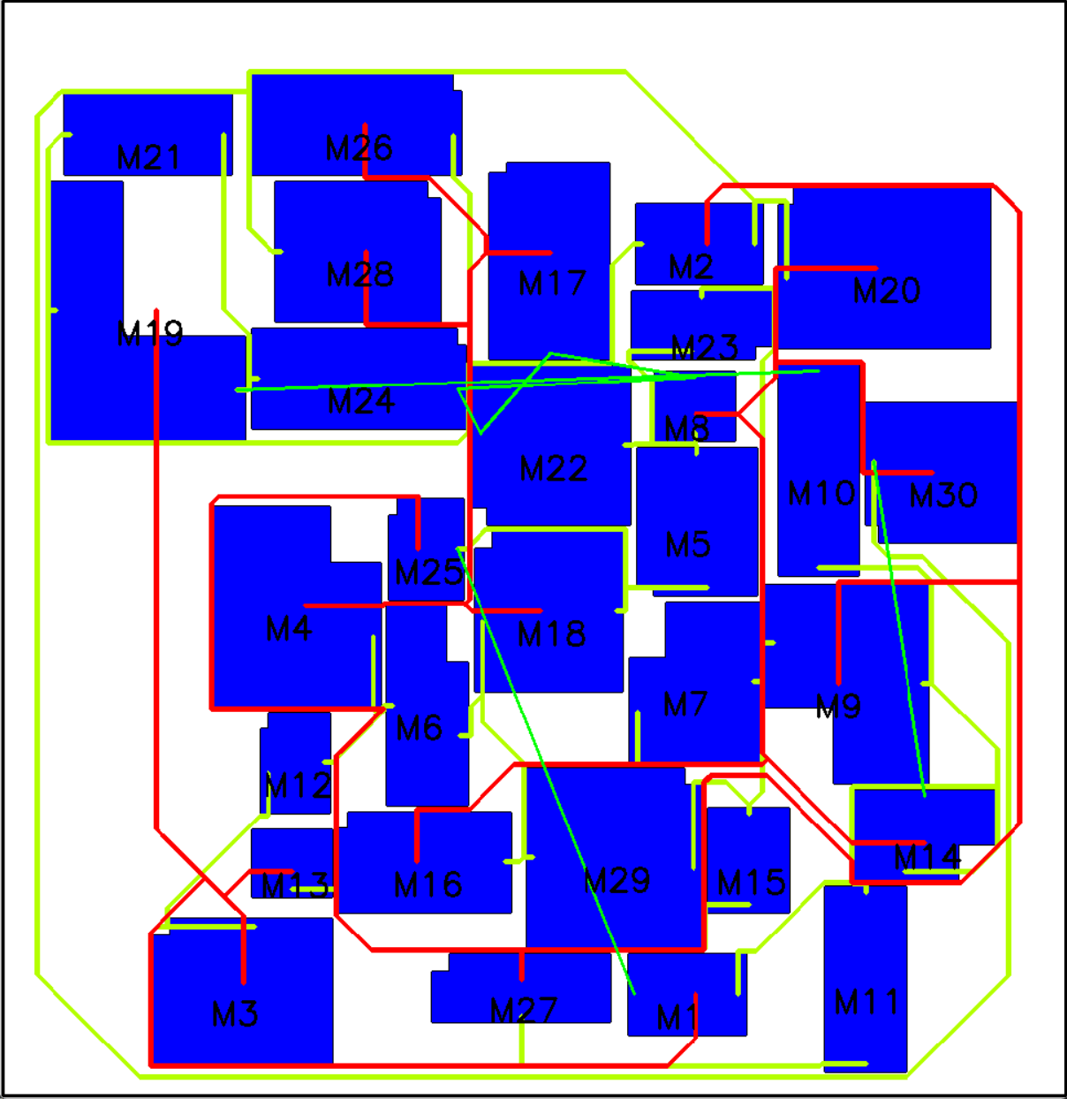
Figure 1.5: Module Case 30-1 Layout Results
Number of modules 30
Default Sort.
Depth of search: 10
Assessment of routability: 0.928571
FastPlace Finish. Break: 619.2
FastPlace Finish. Break: 720.8
Maximum routability: 1.0000 Minimum length: 16011.0
Placement completed. Took 45.1s

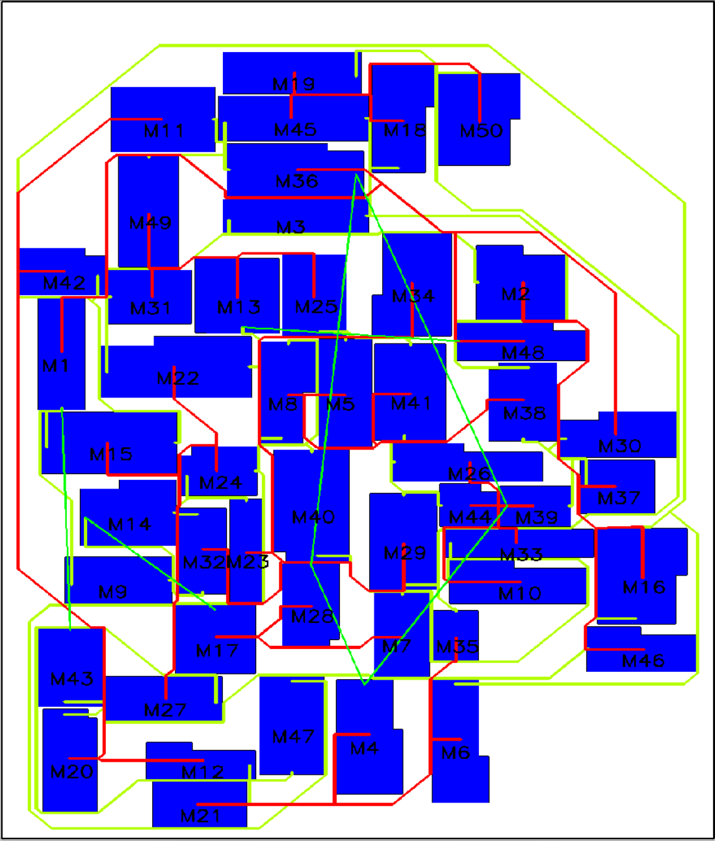
Figure 1.6: Module Case 50-2 Layout Results

Number of modules 50
Default Sort.
Depth of search: 16
Assessment of routability: 0.928571
FastPlace Finish. Break: 619.2
FastPlace Finish. Break: 720.8
Maximum routability: 89.27% Minimum length: 24816.3
Placement completed. Took 140.7s

Within the specified area, the problem of module overlap is effectively resolved as a result of the application of the program, which results in extremely beneficial outcomes for the automated assembly of those modules. The goal of the solution that has been provided is to cut down on the overall surface area that is taken up by constructed modules inside confined areas.

In addition to this, it makes it easier to do the fundamental geometric rotation of a variety of polygons, such as angles of 0 degrees, 90 degrees, 180 degrees, 270 degrees, MX, MY, MXR90, and MYR90. It is of the utmost importance that polygons not be placed in areas that are not allocated for their use. Examining the wiring interface, which ensures the effective completion of the wiring process and enables one to verify the correctness of the polygon assembly, can be done to achieve this verification.

VI. Innovative Points

6.1 Optimization Strategies for Large-Scale Module Layouts
In the context of the large-scale layout scenario, it is vital to recognize that the algorithm has some limits that prohibit it from assuring that the layout will be completed within the allotted amount of time. These restrictions prevent the algorithm from ensuring the completion of the layout. As a consequence of this, we made certain improvements in order to alleviate the concerns regarding the amount of time spent and the effectiveness of the layout. The search depth was shortened in order to make the algorithm more time-efficient. Additionally, we make use of a dynamic adjustment of module spacing that takes into account line width and line spacing. This allows for an improved area allocation for wiring, which in turn helps to improve the effectiveness of the wiring process. In addition, a significant amount of Research has been carried out in the field of algorithm optimization, including the implementation of parallel computing and the use of search methods that are more expedient. It is hypothesized that these attempts have the potential to boost our capability of addressing the complexity involved with large-scale layout scenarios, augment the efficacy of algorithms, and elevate the general quality of layout outputs.

6.2 Monte Carlo Tree Search Based on Dynamic Sorting
According to the findings of our inquiry, the factors that have an effect on the outcomes of the layout may be broken down into two distinct categories of choice variables: the order of the layout and the position of the layout. (1) The concept of layout order refers to the systematic order in which modules are arranged, and the factors that have an impact on layout order can be broken down into two distinct categories of constituent parts. Both the network connectivity that exists between modules, as well as the size of the modules themselves, are significant factors that play a role in the configuration of the modules. These factors play a role in the decision-making process for the layout order. In this work, we provide an innovative method for figuring out the sequence in which dynamic layouts should be applied. The primary goal is to integrate the inter-network connection pair relationship with the module sizes in order to dynamically determine the layout modules that require connection in each iteration of the process. This will accomplish the core purpose. In this strategy, a connection graph is built by employing the graph search technique. This graph illustrates the connection between the modules that are currently being used and the modules that will come after them. Through examination of this network, one can ascertain the order of precedence for the installation of the modules. It is the responsibility of the layout position to determine the relative positioning of the necessary layout modules in relation to the modules that are already present. In addition to this, it determines the distance between the modules, which has a direct bearing on the ease with which lines can move between the modules. In the course of this Research, we make use of a method for approximating the length of lines using an estimation methodology in order to establish the priority of placement places. Utilizing this strategy increases the likelihood of successfully routing the line.

6.3 Multi-objective Optimization Evaluation

The incremental routing evaluation is based on a proprietary set of integrated routing algorithms that were derived from the geometric line exploration routing approach. These algorithms were used to determine the best possible routes to take within the network. When used for networks with multiple terminals, the algorithm for routing accomplishes its task by successively routing each port in order. It accomplishes this by using the connection locations that were used for previously routed ports as potential connection locations for ports that come after them, which results in efficient routing. In addition to this, the method determines the routing rate as well as the line length. The capacity of this technology to greatly cut down on the amount of time spent on routing is one of the most prominent advantages of using it. In addition to this, it makes it possible to evaluate the impact that each layout has on the routing rate in a manner that is separate from the others.

The algorithm known as the semi-perimeter, which is used rather frequently, is used to determine the estimated length of the line. The computation of line length is dependent on the aspect ratio of the confined zone since there is a confined region present, which also has an undetermined aspect ratio. The layout flexibility in this confined region is thus constrained. The rectangular area that surrounds the organized modules goes through consistent transformations as new modules are placed in their designated slots one after the other. When calculating the length of a line, it is necessary to take into account the aspect ratio of the outer rectangular region. This ratio serves as the calculation's coefficient. We integrate the question of proportionality into this method, and we designate this role as the principal objective by making it the focus of our attention. Within the framework of our heuristic search technique, it is possible to gain near-optimal results by way of an iterative process. These results may be obtained for the line length as well as the center of gravity.

VII. Main Problems and Solutions

7.1 Main Issues
The Monte Carlo Tree Search (MCTS) method provides a significant benefit in reducing the impact of the presence of local optima in large-scale examples. When running iterative searches for the layout order, using the same strategy results in a considerable increase in the amount of time that must be spent searching. This is something that must be acknowledged since it is important. Additionally, in the context of large-scale applications, modules usually require a bigger number of wire path choices in order to improve the overall success rate. This is necessary in order to ensure that the highest possible success rate is achieved.

The Monte Carlo tree search technique, proves its superiority in the setting of large scenarios by effectively reducing the problem of local optima through the application of stochastic exploration. This helps to ensure that the best solution is found. As a result, the application of this strategy increases the possibility of locating the global optimal solution. However, this strategy requires a huge number of searches and iterations, which considerably increases the amount of time that must be invested.

In addition, larger scenarios often involve a greater number of modules, which makes it necessary to take into consideration a wider variety of alternatives and wiring path options. This is because larger situations typically involve more modules. To improve the efficiency of the wiring, it is necessary to take into consideration extra wire paths, which results in an increase in the amount of work that must be done computationally.

7.2 Solutions

7.2.1 Time Costs of Large-scale Cases
During a Monte Carlo tree search, a variety of strategies are used to effectively manage the search depth in order to find the optimal solution. Concurrently, during the process of constructing Monte Carlo trees, pruning operations are utilized in order to eliminate unfavorable scenarios, cut down on unnecessary amounts of time, and cut costs associated with computational processes.

It is common practice to utilize heuristics in order to reduce the complexity of the search process. These heuristics enable the identification of nodes within the search tree that require further study, as well as those that may be temporarily overlooked. This allows for the complexity of the search process to be reduced. The application of heuristics in the search process can be generated from either domain expertise or historical data, which enables us to concentrate our efforts on the most favorable pathways. Heuristics can be derived from either subject expertise or historical data.

In addition, the technique of pruning plays an essential part in the execution of the Monte Carlo tree search. The process of pruning entails deleting branches from the search tree that do not meet the required criteria or are unlikely to lead to a viable response. This is done in order to improve the likelihood of finding the correct solution. This method helps to conserve both time and computing resources, which ultimately results in an increase in search effectiveness.

To successfully prioritize prospective nodes during the search operation and avoid wasting time on less desirable domains, it is vital that precise procedures for evaluating the significance of individual nodes be formulated at the same time. This is to ensure that adequate time is not spent on less attractive domains. In order to direct the path that the investigation will take, these strategies can include an analysis of the returns that are anticipated, the risks that must be considered, or any number of other relevant indications.

7.2.2 Low Wire Routing Efficiency
When working with modules of significant scale, one of the most major challenges involves the intricate arrangement of space and the networks that are related to it. We employ a method that is both dynamic and adaptable in order to overcome the consequent complexity of wiring. Using this approach requires dynamically altering the spacing between modules and increasing the intervals that exist between them. Through the utilization of this technology, not only are we able to increase the current capacity for wiring, but we are also able to refine the specificity of port wiring, hence improving the efficiency as well as the layout of the wiring system. The inherent adaptability of this tuning mechanism makes it possible to automatically re-calibrate the location of modules within the system in response to insufficient throughput. As a result, interconnectivity is improved, and problems associated with congestion and signal interference are reduced. This approach achieves a well-balanced equilibrium by efficiently optimizing the utilization of space while also achieving optimal cable conditions. This is accomplished by maximizing the potential of the available space. As a consequence of this, the flow of data between the interconnected modules becomes more streamlined and quicker, leading to a significant increase in the effectiveness of the layout.

VIII.Evaluation
The proposed algorithm integrates network connectivity and module size to enhance the efficiency of line routing and reduce layout time. This is achieved by dynamic adjustments of layout order and location. The subsequent analysis provides a comprehensive assessment of the algorithm.

The algorithm employs a dynamic sorting algorithm to determine the arrangement order of modules. The optimization of the layout order is achieved through a dynamic allocation of modules in each round, taking into consideration the interconnections between modules and their respective sizes. The use of this dynamic sorting method results in a layout order that is more aligned with the specific requirements, hence leading to a reduction in both the length and quantity of wire required. The algorithm additionally employs a search strategy based on graphs to enhance the efficiency of the search process. This is achieved by constructing a connection graph, which allows for the determination of the priority of the layout modules that are needed. By employing this approach, the algorithm achieves a higher efficiency in completing the designing process and enhances the rate at which the wiring path is established.

Additionally, the algorithm employs a technique for estimating the length of lines at specific layout placement places. This estimation approach is used to determine the priority of these placement locations, hence enhancing the potential for effective line routing. This method holds significant importance in the context of large-scale layouts because ensuring a consistent line layout rate becomes challenging due to the extended line lengths inherent in such layouts. However, through the process of estimating the approximate lengths of lines, it becomes possible to calculate line lengths with greater accuracy, hence enhancing the rate at which the line layout is improved. Furthermore, the algorithm has the capability to dynamically adapt the spacing between modules in order to enhance the availability of space for wire, hence resulting in an improved rate of wiring path.

The technique has been extensively employed in practical applications, particularly in the domain of circuit layout designs, yielding favorable outcomes. An instance of the algorithm has been employed in the arrangement of circuitry for mobile phone chips, resulting in an enhanced wire rate and expedited layout completion, hence augmenting design efficiency. Furthermore, it is possible to optimize this algorithm to accommodate various layout specifications. In the context of high-speed communication circuit design, it is possible to enhance the stability and reliability of the circuits by optimizing the layout order and location in accordance with various communication protocol requirements.

In general, the algorithm enhances the arrangement order and positioning by dynamically sorting and changing the distance between modules. This results in improved line wiring efficiency and reduced layout duration, making it highly valuable in practical applications. Simultaneously, the algorithm possesses the potential for optimization in accordance with diverse layout specifications, exhibiting notable adaptability and versatility. Nevertheless, the algorithm's effectiveness is constrained when confronted with extensive layout scenarios, necessitating more investigation into novel optimization strategies to address this issue.

IX.Reference
[1] Breuer, M. A. A class of min-cut placement algorithms. In Proc. 14th Design Automation
Conference (DAC 1977) 284–290 (IEEE, 1977).
[2] C. M. Fiduccia and R. M. Mattheyses, "A Linear-Time Heuristic for Improving Network Partitions," 19th Design Automation Conference, 1982, pp. 175-181, doi: 10.1109/DAC.1982.1585498.
[3] Gelatt,M.P.Vecchi, S. Kirkpatrick,C.D. Optimization by Simulated Annealing[J]. Science, 1983, 220(4598):671-680.
[4] C. Sechen and A. Sangiovanni-Vincentelli, "TimberWolf3.2: A New Standard Cell Placement and Global Routing Package," 23rd ACM/IEEE Design Automation Conference, 1986, pp. 432-439, doi: 10.1109/DAC.1986.1586125.
[5] Min Pan, N. Viswanathan and C. Chu, "An efficient and effective detailed placement algorithm," ICCAD-2005. IEEE/ACM International Conference on Computer-Aided Design, 2005., 2005, pp. 48-55, doi: 10.1109/ICCAD.2005.1560039.
[6]Zhao Yu Research on Pipeline Path Layout Optimization Based on Heuristic Algorithms [D]. Northern Polytechnical University, 2022. DOI: 10.26926/dcnki. gbfgu.2022.000618]
[7]Lu Zenghui. Research on the Application of electronic design automation EDA in Electronic Circuits [J]. East China Science and Technology, 2022, No.433 (03): 69-71
[8]Liu Chao, Wang Jun, Zhang Tianyi. Analysis of the Development Trend of Integrated Circuit EDA Industry [J]. China Integrated Circuit, 2021,30 (06): 32-37
[9]Hao Zeliang. Exploring the Application Analysis of EDA Technology in Electronic Circuit Design [J]. Electronic Testing, 2022, No.493 (16): 11-13. DOI: 10.16520/j.cnki.1000-8519.2022.16.024
[10] Tao Luo and D. Z. Pan, "DPlace2.0: A stable and efficient analytical placement based on diffusion," 2008 Asia and South Pacific Design Automation Conference, 2008, pp. 346-351, doi: 10.1109/ASPDAC.2008.4483972.
[11] Bo Hu and M. Marek-Sadowska, "Multilevel fixed-point-addition-based VLSI placement," in IEEE Transactions on Computer-Aided Design of Integrated Circuits and Systems, vol. 24, no. 8, pp. 1188-1203, Aug. 2005, doi: 10.1109/TCAD.2005.850802.

