BSC Health and Social care. Changemakers: creativity and value creation. BMHP5014_BIRM. E portfolio evidence of learning compromising of 4 separate items. Dr Azora Hurd. Fozeea Jabeen (1914129)

Task 1:

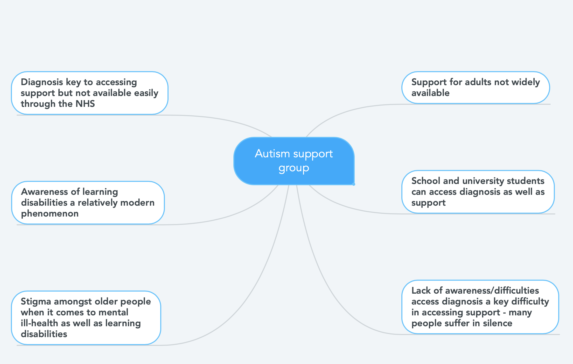

In order to understand what support is available for people on the autism spectrum, it is important to look at educational settings such as schools and colleges. A brief exploration of the support available in the education sector highlighted the fact that once people on the autism spectrum live education, they are often left with little support compared to when they were in education. This then leads the researcher to look at the reasons why there is a discrepancy in support available.

Due to the medical model of disability being used in the United Kingdom, support for people in the autism spectrum is often dependent on a diagnosis which is very difficult to have confirmed under the limited resources of the National Health Service (NHS) (Grahame et al, 2021). The lack of diagnoses available was also attributable to a lack of understanding and awareness in older people about hidden disabilities such as autism. This lack of understanding results in the average age of people on the autism spectrum being significantly younger than the average age of the wider UK population (Grahame et al, 2021).

A further barrier to all the people accessing support for mental health and learning disabilities was the fact that such conditions carried a lot of stigma and negative connotations which result in people suffering in silence. Due to the generational differences in attitudes as well as support available between younger and older people, the researcher decided to develop the idea of a support group for adults on the autism spectrum. Moreover, exploring these ideas also help to identify that there is a gap in support available for carers of people on the autism spectrum. Therefore, a support group which would raise awareness as well as allow people to socialise with like-minded people who would support both service users and their carers.

Task 3:

Almost 1 and 10 adults in the United Kingdom are thought to be on the autism spectrum; support and awareness of autism has only taken place in the last 20 years (Devarakonda, 2013). Educational support in the form of the Special Educational Needs Code of Practice (2014, cited by Hafidh, 2021), meaning that older adults did not benefit from disability protection or support due to a lack of awareness at the time.

Older adults can often struggle through their daily lives with the difficulties that come with being on the autism spectrum not knowing or understanding the nature or cause of their difficulties (Tejada, 2014). Due to this historic lack of support and intergenerational difference between people on the autism spectrum, it is important to raise awareness and change attitudes in the older generation around accepting autism and seeing it as a condition, not a disability; to take away the stigma associated with being on the autism spectrum (Tejada, 2014). The stigmata associated with having a learning disability such as autism is often cited as a key barrier in adults accessing support as well as advice on obtaining a diagnosis (Hafidh, 2021).

We propose to open a support group aimed at people over the age of 30 where daily drop-in sessions will be carried out as well as special interest activities in order to create a social and ‘safe space’ for older people on the autism spectrum. This support group will help people feel less isolated as well as raising awareness of the variety of ways in which the autism spectrum affects people differently on different days. It will also aim to support friends, family and carers of the target group. Supporting service users as well as their immediate carers and loved ones is in keeping with person centred care and holistic care which are guiding principles of the national health service and also a highly cost-effective way of delivering social care (Grahame et al, 2021). By delivering support to multiple individuals at the same time, a support group is highly cost-effective compared to individual interventions such as psychotherapy or counselling which take place on a one-to-one basis.

Task 6:

To Whom It May Concern:

I am writing to you in order to request funding for an autism support group for people over the age of 30 years old as well as their friends, family and carers. The support group will aim to fill a gap in the existing market as a support for adults on the autism spectrum is currently primarily delivered within an educational setting. Due to intergenerational differences in awareness of as well as attitudes towards disability and especially hidden disabilities, it is important to raise awareness of the varying ways in which autism can affect not only the person who is on the autism spectrum but also on those around them.

Due to people on the autism spectrum being three times more likely to experience mental health difficulties such as depression, anxiety and treatment for these conditions requiring long-term interventions, it is far more cost-effective to put support groups such as this in place in order to build emotional resilience within the autistic community (Hafidh, 2021). Studies have shown that every pound spent on preventative care such as support groups for vulnerable service users saves £3 in future costs due to a reduced level of medical intervention being required in the future (Arango et al, 2018).

Moreover, preventative care is also beneficial for service users as well as those around them due to the fact that it builds awareness and emotional resilience; traits which are important to maintain long-term mental health (Arango et al, 2018). Therefore, the funding of this support group would not only help meet the needs of a vulnerable group, but is also in your organisation's financial interest due to long-term cost saving implications. Finally, delivering support to a group rather than individuals has cost saving benefits as well as helping service users to develop their social skills.

A detailed business plan as well as implementation strategy is available on demand and we can furnish you with further details as required. We look forward to hearing back from you and your kind consideration for this funding request.

Yours truly,

Fozeea Jabeen
Funding manager
Autism Support West Midlands
Email: F.Jabeen@ASWM.org.uk

Task 7
Email 1:

Dear Fozeea,

We are interested in hearing more about your exciting idea for a support group for autistic adults. We are currently working with people on the autism spectrum, advocating for their rights and we think we may be able to help you develop your idea as well as introducing you to potential funding bodies and partners. Please can you tell us a little bit more about yourself and your proposal? I am interested to know more about your ideas.

We look forward to hearing back from you and developing a strong working relationship in the future.

Kind regards,

Emily Rutherhford
Specialist Mentor
My preferred pronouns are she/her
Diversity and Ability
Website: www.diversityandability.com
Freephone: 08009788303 Mobile: 07745535666

Email 2:

Dear Emily,

Thank you for reaching out to me and your offer of support. I first had this idea was talking to a friend about the care package being offered to her autistic brother. As a parent and caregiver, myself, I could empathise with her difficult situation at the time. As a working mother, I am highly organised and motivated and used my effective time management skills in order to network for and research this idea; pitching it to interested parties in order to ascertain the level of interest. As a carer myself, I am particularly aware of the fact that the needs of carers often have left when discussing the needs of disabled people. My idea will aim to rectify this. Working in the financial services sector, I’ve learnt to deal with a varied and diverse clientele and I am to use the skills to further this project.

I will happily provide you with further details and suggest a face-to-face meeting to go over my proposal more fully and in depth. Please let me know when you are free for either a web conference or a physical meeting along with your choice of venue.
I look forward to working with you.

Kind regards,
Fozeea Jabeen
Funding manager
Autism Support West Midlands
Email: F.Jabeen@ASWM.org.uk

Reference:
Arango, C., Díaz-Caneja, C.M., McGorry, P.D., Rapoport, J., Sommer, I.E., Vorstman, J.A., McDaid, D., Marín, O., Serrano-Drozdowskyj, E., Freedman, R. and Carpenter, W., 2018. Preventive strategies for mental health. The Lancet Psychiatry, 5(7), pp.591-604.

Devarakonda, C., 2013. Autism and flexi schooling.

Grahame, V., Dixon, L., Fletcher-Watson, S., Garland, D., Glod, M., Goodwin, J., Grayson, Z., Heron, S., Honey, E., Iversen, R. and Kasim, A.S., 2021. A clinical and cost-effectiveness trial of a parent group intervention to manage challenging restricted and repetitive behaviours in young children with autism spectrum disorder: study protocol for a randomised controlled trial. Trials, 22(1), pp.1-13.

Hafidh, R., 2021. Ontology Modelling for Adaptive Coordination of Education, Health and Social Care Interventions for Children and Young People with Special Educational Needs and Disabilities: Smart-School Care Coordination System (Doctoral dissertation, University of East London).

Tejada, S., 2014. First Generation Americans' Perceptions on ASD: A comparison of generational worldviews on services.

