

THE INFLUENCE OF EXPERIENTIAL MARKETING ON THE ATTRACTIVENESS OF SHOPPING MALLS IN CHINA

A Dissertation submitted for the
Master of Business Administration (MBA) 2018

Submitted: May 2018

Researcher: Genglin He
Student Number: P144547
Supervisor: Dr Antje Cockrill

Declaration/Statements page

This work has not previously been accepted in substance for any degree and is not being concurrently submitted in candidature for any degree.

Signed ...................................................................... (candidate)

Date ........................................................................

STATEMENT 1

This work is the result of my own investigations, except where otherwise stated.
Other sources are acknowledged by footnotes giving explicit references. A bibliography is appended.

Signed ..................................................................... (candidate)

Date ........................................................................

STATEMENT 2

I hereby give consent for my work, if accepted, to be available for photocopying and for inter-library loan, and for the title and summary to be made available to outside organisations.

Signed ..................................................................... (candidate)

Date ........................................................................

Acknowledgements
The study of the overall MBA is about to be over, during the study of two years, I have received the help from many people both for study and living, I want to thank those who have helped me.

First, I want to thank my thesis supervisor Dr Antje Cockrill, who offers high patience and encouragement in the process of writing for this thesis. Her continuous support and guidance help me solve many research difficulties for which I can successfully complete the thesis and try my best to achieve the best. In addition, her appropriate care and thoughtfulness let me feel the sufficient kindness and warmth; I appreciate her help very much.

Secondly, I want to thank the working staff at the school, especially the lecturers of MBA, they teach me a lot of useful professional knowledge and skills which will benefit me in my whole life.

Lastly, I want to especially thank my family and friends, they offer the sufficient support and encouragement to me when I was writing this thesis for which I can successfully complete my graduation thesis.

Abstract
With the arrival of experienced economy, the consumption behavior and consumption concept of people has changed significantly. The unique experience is getting more and more important. How to create attractive experience environment for the consumers to meet their personalized and diversified consumption needs has become the key to success of shopping mall. Therefore, studying the influence of experienced marketing on attractive power of Chinese shopping mall which is a big help to the specific practice in experienced marketing for administrator of shopping mall. Through the analysis and study of relevant literature review, the dissertation found some useful research achievement and theories which can be used as the theoretical background for this dissertation. On this basis, the dissertation further proposed study assumption and built theoretical model. In addition, in order to verify the relationship between experienced marketing and attractive power of shopping mall better, the dissertation sent out online questionnaires to 143 interviewees with the shopping experiences in shopping mall. The analysis results show that experienced marketing has a significant positive influence on attractive power of shopping mall. Through combining relevant study, the dissertation offers suggestions for future development of shopping mall industry.

Contents

Chapter 1: Introduction - 10 -
Introduction - 10 -
1.1 Research Background - 11 -
1.2 Development status of the shopping mall in China - 11 -
1.2 Opportunity for change - 14 -
1.3 Research Rationale - 14 -
1.4 Aim and Objectives of the Research - 15 -
1.5 Structure Overview - 16 -
Conclusion - 16 -
Chapter 2: Literature review - 17 -
Introduction - 17 -
2.1 Literature research of experience marketing - 18 -
2.1.1 Definition of experience - 18 -
2.2.2 Concept of experience economy - 18 -
2.2.3 Characteristic and influences of experiential economy - 20 -
2.2.4 Concept of experiential marketing - 25 -
2.2.5 Strategic Experiential Modules (SEMs) - 27 -
2.2 Literature Research of Attractiveness of shopping mall - 30 -
2.2.1 Concept of shopping mall - 30 -
2.2.2 The development status of the shopping malls in China - 31 -
2.2.3 Connotation of Attractiveness of shopping mall - 32 -
2.3 Dimension of Attractiveness of shopping mall - 33 -
2.3 The relationship between experience marketing and shopping mall - 35 -
2.4 Research hypothesis and theoretical model - 36 -
2.4.1 Influence of sense marketing on attractiveness of shopping mall - 37 -
2.4.2 Influence of feel marketing on attractiveness of shopping mall - 38 -
2.4.3 Influence of think marketing on attractiveness of shopping mall - 39 -
2.4.4 Influence of action marketing on attractiveness of shopping mall - 40 -
2.4.5 Influence of related marketing on attractiveness of shopping mall - 41 -
Conclusion - 42 -
Chapter 3: Research Methodology - 42 -
Introduction - 42 -
3.1 Research Aims and Objectives - 43 -
3.2 Research Paradigm - 43 -
3.3 Research Approach - 45 -
3.3.1 Exploratory Research - 45 -
3.3.2 Descriptive Research - 46 -
3.3.3 Causal Research - 46 -
3.4 Research Methods - 47 -
3.4.1 Primary and Secondary Research - 47 -
3.4.2 Qualitative and Quantitative Research - 48 -
3.4.3 The advantages and disadvantages of the online questionnaire - 48 -
3.5 Research Design - 50 -
3.5.1 Sampling and Sample size - 50 -
3.5.2 Questionnaire design - 51 -
3.5.3 Piloting the Questionnaire - 52 -
3.5.4 Sending the Questionnaire - 52 -
3.5.5 Data analysis - 52 -
3.5.6 Limitations of the research - 53 -
3.5.7 Reliability and Validity - 53 -
Conclusion - 53 -
Chapter 4: Data collection and diDATA COLLECTION AND ANALYSIS - 54 -
Introduction - 54 -
4.1 Descriptive statistics - 55 -
4.1.1 Demographics of the respondents - 55 -
4.1.2 Descriptive statistics of respondents’ shopping behavior - 57 -
4.1.3 Descriptive statistics of the scale - 60 -
4.2 Cross tabulation analysis and chi-square tests - 62 -
4.2.1 Gender & goals - 62 -
4.2.2 Gender & habits - 63 -
4.2.3 Age and goals - 64 -
4.3 Reliability and validity analysis - 65 -
4.3.1 experience marketing量表的信度和效度分析 - 65 -
4.3.2 Reliability and validity analysis of the attractiveness of shopping mall scale - 66 -
4.4 Correlation analysis - 67 -
4.4.1 Overall correlation analysis - 67 -
4.4.2 Multi-dimension correlation analysis - 68 -
4.5 Regression analysis - 69 -
4.5.1 Regression analysis of experience marketing and attractiveness of shopping mall - 70 -
4.5.2 Regression analysis of the experience dimension of various dimensions and attractiveness of shopping mall - 71 -
4.5.3 Regression analysis of experience dimensional variables and situational attractiveness in experience marketing - 74 -
4.5.4 Regression analysis of sustained attractiveness and various dimensional variables of experience marketing - 76 -
4.5.5 Regression analysis of various dimensions and overall attractiveness of experience marketing - 78 -
4.6 Dissertation - 81 -
4.6.1 Distribution of samples - 81 -
4.7.2 Complete discussion of research results - 84 -
Conclusion - 86 -
Chapter 5：Conclusions and Recommendations - 88 -
Introduction - 88 -
5.1 Achievement of objectives: - 88 -
5.2 Main findings - 89 -
5.3 Recommendations for management - 91 -
5.4 Limitations of research - 93 -
5.5 Prospects for the future - 94 -
Conclusion - 94 -
Bibliography - 96 -
Appendix 1 – Online questionnaire - 106 -

List of Figure and Table
Table 1: Adapted From Economic Distinctions - 27 -
Table 2: Demographics of the respondents - 65 -
Table 3：Consumer behavior of the respondents - 68 -
Table 4 Function Formulas for Various Dimensional Variables - 71 -
Table 5: Descriptive statistics of experiential marketing - 72 -
Table 6 Descriptive analysis of attractiveness of shopping mall - 72 -
Table 7: Cross tabulation analysis of gender & goals - 73 -
Table 8: Chi-Square Tests for gender &goals - 73 -
Table 9: Chi-Square Tests income gender &preferences - 74 -
Table 10: Cross tabulation of age & goals - 75 -
Table 11: Chi-Square Tests for age &goals - 76 -
Table 12 Cronbach's Alpha of experience marketing scale - 77 -
Table 13 KMO and Bartlett's Test of experience marketing scale - 77 -
Table 14 Cronbach's Alpha of attractiveness of shopping mall scale - 78 -
Table 15 KMO and Bartlett's Test of attractiveness of shopping mall scale - 78 -
Table 16 Correlation analysis of experiential marketing and attractiveness of shopping mall - 79 -
Table 17 The multi-dimensions of correlation analysis of experiential marketing and attractiveness of shopping mall - 80 -
Table 18 experience marketing与attractiveness of shopping mall 的model summary - 83 -
Table 19 ANOVA of the various experience variables and attractiveness of shopping mall - 83 -
Table 20 Regression coefficient of experience marketing and attractiveness of shopping mall - 83 -
Table 21 Model summary of experience dimensions and attractiveness of shopping mall - 85 -
Table 22 ANOVA of the experience dimension dimensions and attractiveness of shopping mall - 85 -
Table 23 regression coefficient of experience marketing and attractiveness of shopping mall - 86 -
Table 24 Summary of the assumptions about the attractiveness of shopping mall - 87 -
Table 25 Model summary of experience dimension and situational attractiveness - 88 -
Table 26 ANOVA of experience marketing various dimensional variables and situational attractiveness - 88 -
Table 27 Regression coefficients for each dimension variable and situational attractiveness of experience marketing - 89 -
Table 28 The various dimensions of experience marketing research on the situational attractiveness - 90 -
Table 29 Regression analysis of various dimensions and sustainable attractiveness of experience marketing - 91 -
Table 30 ANOVA of experience marketing various dimensional variables and situational attractiveness - 91 -
Table 31 Regression coefficients for various dimensions of experience marketing and sustainable attractiveness - 92 -
Table 32 Summary of studies on sustained attractiveness for various dimensions of - 93 -
Table 33 Regression analysis of each dimension of experience marketing and overall attractiveness - 93 -
Table 34 ANOVA of experience marketing dimensions and overall attractiveness - 94 -
Table 35 Regression coefficients for each dimension variable and overall attractiveness of experience marketing - 94 -
Table 36 Summary of research on the overall attractiveness of various dimensions of experience marketing - 95 -

Chapter 1: Introduction

Introduction
The main research of this article is the influence of experience marketing on the attractiveness of shopping malls in China. Therefore, as the initial chapter that leads the whole article, in this chapter, the researcher conducts the sufficient illustration for the reason of research in this article by following the principle of properness. And on the base of detailed description for the fields and backgrounds of the related subjects, the researcher introduces the research purpose and research hypothesis of this article for which the research direction and the detailed implementation steps of this article are demonstrated.

1.1 Research Background
Shopping mall was origin in the beginning of the twentieth century, it was popular in the developed countries such as the United States in the 1950s and 1960s for which a new fashion of business management was raised and gradually it started to be popular around the world by the comprehensive management mode of shopping, food and drink, leisure, entertainment and tourism etc. and the perfect environmental facilities (Cui, 2014). The emergence of shopping mall effectively breaks the limit of retailing, and it changes the passive and subordinate position of retail business to some extent and achieves the organic combination with the related industry, it strengthens the production of guidance and the enhancement of consumption, it can be said that the development of shopping mall industry is the "distribution revolution" of retail industry (Gan, 2012). Moreover, shopping mall plays more and more significant function for the improvement of the urban business environment, the change of consumption and leisure mode, the optimization of investment structure and the contribution for the prosperity of economy (Liu, 2013).

1.2 Development status of the shopping mall in China
Starting from the beginning of 1990s, with the continuous acceleration of the Chinese economic reform and the city construction process and the gradual improvement for the living demand of the residents, shopping mall started to appear in China as the new investment type of real estate (Cui, 2014; Li, 2015). With the rich types of operation, diversified experiences, comfortable environment, shopping mall rapidly fills the demand of the residents for daily consumption and entertainment with the standardized products and becomes more and more popular among the Chinese consumers (Liu & Zhang, 2015). According to the report from the Ministry of Commerce in China (MOFCOM) (2017), by the end of 2017, the number of shopping malls in China has exceeded 4000, it is expected that by 2025, the number of new sales will reach 7,000. China has become the most active market for the construction of shopping mall in the world.

However, there is always a crisis concealed in the back of prosperity. With the gradual saturation of demand in the shopping mall market, the risk of excessive supply by stage has been gradually accumulated (Liu,2013). The ever-increasing competition in the industry has made more and more sellers face the threat of investment difficulties and business failures (Cui, 2014; Zhang, 2015). In addition, the serious homogenization will inevitably cause the tiredness of consumption, and the higher vacancy rate also means shopping mall cannot guarantee the sufficient and continuous customer flow to support its normal operation (Yu, 2013; Gan, 2012).

In addition, changes in social economy and consumer demand have further aggravated the crisis in shopping mall. On the one hand, With the rapid development of internet economy and stimulation of online shopping competition, consumers are changing their shopping habit gradually, and mass consumption is evolved into more fragmented and more casual buying behavior. And as a result, besides meeting the rigid demand of consumption, the needs of shopping environment and experiences are more emphasized. (Wang, 2014; Chen,2016). On the other hand, with the continuous strengthening of the total consumption in the Chinese society on the pulling effect of economy, the tendency of upgrade for the consumption structure has been continuously accelerating (Deng, 2011). From the purchase for survival to the purchase for improvement, the progress of the consumers from the commodity to the experience becomes more significant (Chen, 2016; Liu,2013). Shopping is not just to simply meet the shopping demand, it is a way of leisure and alleviation of pressure, people expect to enjoy more fun of life from shopping (Guo, 2015). This means people no longer focus on the pleasure of material brought by the product itself, they focus more on the satisfaction of spiritual level in the meantime of consumption (Li et al., 2012). These new changes in consumer attitudes and needs not only affect consumer behavior and choices, but also indicate the advent of the experience economy era. At the same time, the traditional marketing model showed weak, and began to lose its attractiveness to the new generation of consumer groups (Yu, 2013).
The report from China Chain-Store & Franchise Association (CCFA) (2016) pointed out that the recent prosperity of shopping mall industry in China reflects the lagging from the mature business market in the west. The reason is that the demand driven by the dividend of population has not been saturated; The new experience brought by shopping mall has not reached its fatigue period. Nevertheless, nearly 50% of China's shopping centers are still at a loss, and the overall success rate is below 20%. And in the next five years, China will have more than 1/3 of the shopping malls face the threat of closure (MOFCOM, 2017).

In the crisis, more and more developers began to realize the importance of experience. They began to remodel around models such as consumer experience upgrades and personalized business (Deng, 2011). However, due to the development history of shopping centers in China is relatively short, people lack sufficient management experience. This has caused many developers to be influenced by conservative thinking in the process of transforming shopping mall, most of the shopping mall are not reflected with the feature of experience consumption in a better way for their design and management and they lack the vivid experience subject (Chen, 2016; Li, 2015). The renovation of shopping mall one by one is just the unilateral passion of the developers, the consumers do not pay sustainable attention, of course the expected economic and social benefits are not achieved (Zhang, 2014). Therefore, the renovation of failure has made the development of shopping centers once again into trouble.

1.2 Opportunity for change
It's worth noting that changes of times seem to create new opportunities while bringing crisis. Under the influences of experienced economy, how to create attractive experienced environment for consumers so as to meet their personalized and diversified consumption needs has become the key to success of shopping mall (Shan & Wan, 2015). As a brand new marketing way produced along with experienced economy, the core advantage of experienced marketing is that it can formulate the marketing strategies which is proper for the preference of consumers according to the changes of outer economic environment (Wei, 2015). Therefore, experienced marketing can create a life in terms of spirit and cultural atmosphere which consumers are in need of, thus helping consumers to find their potential inner needs and stimulate their own consumption desires (Xue et al., 2015). While shopping mall with its diversified formats and one-stop shopping pattern, as a typical new type retail industry, is full of abundant customer experience and is very proper for applying experienced marketing, which is an advanced marketing means. Therefore, the researcher hope to deeply study experienced marketing to find out the relationship between it and attractive power of shopping mall. Thus it can help shopping mall to seize the opportunities of era development better and greet challenges and get rid of predicament.

1.3 Research Rationale
For a long time, the western countries have formed a mature system for the theoretical research on the experience marketing, its business value has been sufficiently confirmed and verified in the actual application. Therefore, with the rapid development of economy in China for the recent years, the concept of experience marketing starts to be spread in China. More and more people start to focus on the research on the theory and practice of experience marketing. Due to the difference of the eastern and western culture and the development level of regional economy, most of the enterprises in China are still at the stage of exploration for the practice of experience marketing. While the theoretical research on it in the academic field is concentrated on the general theoretical perspective, the comprehensive and deep analysis and research have not been conducted. Especially the experience marketing for a certain industry or enterprise, the research lacks the pertinence and precision, it has not formed a complete theoretical system of experience marketing for China to reference.

Therefore, the research object selected in this article is the shopping mall industry of China, its key is to explore the influence of experience marketing on its attraction. The researcher hope that they can establish the relational model between the experience marketing and the attractiveness of shopping mall by the current achievements of theoretical research so that they can further apply the theory on experience marketing into the specific practice. To enhance and optimize the theoretical system of experience marketing in China, in the meantime of that, to provide the practicable and feasible suggestion for the industrial development of shopping mall of China in future.

1.4 Aim and Objectives of the Research
The main purpose of research in this article is to explore the influence of experience marketing on the attractiveness of shopping malls in China under the background of experience economy. To better achieve the overall target, the researcher divides it into the following targets;

- Identification of the concepts and components of experience marketing and the attractiveness of shopping malls;
- Exploration of the relationship between the experience marketing and the respective components for the attractiveness of shopping malls;
- Assessment of the influence of experience marketing on the attractiveness of shopping malls;
- Development of recommendations for sustainable long-term developments.

1.5 Structure Overview
In order to carry on study work better, the researcher perform simply overview for the main structure of the dissertation according to the logical order of implementing study target.

Based on this chapter, chapter 2 will be considered as the literature overview to deeply discuss relevant study results of experienced marketing and attractive power of shopping mall so as to supply theoretical support for achieving the study target of this dissertation.

Chapter 3 will discuss the methodology of this dissertation on the basis of literature overview and supply instructions for carrying on specific study and investigation through clear study examples and method.
Chapter 4 is mainly the collection and analysis of investigation data so as to verify and discuss the research results of this dissertation.

Chapter 5 is mainly the conclusions and assessment of the whole dissertation and proposes suggestions for development of future industries according to study findings.

Conclusion
In this chapter, the researcher elucidates the status and the crisis of the shopping mall industry in China from the angle of history and the influence brought by the experience economy with the change of the external environment. And analyze the connection between the shopping mall and the experience marketing. Confirm the research problem and research reason, research purpose and research target of this article. Therefore, in the next chapter, the researcher will clearly identify the concepts and components of experience marketing and the attractiveness of shopping mall in the summary of the reference and explore the relationship between the respective elements.

Chapter 2: Literature review

Introduction
Based on the research of the existing literature, this chapter summarizes theories on experience marketing and attractiveness of shopping mall and develops the literature review. First of all, this chapter sets forth systematically the background and characteristics of experience marketing and identifies and discusses the dimensional features of experience marketing on that basis. Second, the chapter studies relevant concepts of attractiveness of shopping mall and focuses on discussing its influence factors. Lastly, the chapter will choose appropriate theories as its research basis by combining the issue studied in this dissertation, and put forward to the research hypothesis and build a theoretical model to explore the effect of experience marketing on attractiveness of shopping mall.

2.1 Literature research of experience marketing

2.1.1 Definition of experience
Experience is interpreted as ‘cognition in a certain environment’. In reality, everything people do can be known as experience, which is interpreted as personal experience, or a feeling mapped to human mind by some behaviors (Jiang & Hu, 2011, pp.24-25). Therefore, different experiences can be produced even though in the same experience environment (Wang, 2012, pp.15). However, the experience is not created without foundation, while it is a comprehensive psychological process which can emotionally resonate with the participator based on the foundation of interaction between the participators and the experience contractor and the experience proffer (Li, 2015, pp.157; Chen, 2016, pp. 182-183). Therefore, when the concept of experience is injected into the economic life, it is valued by the economy and other related field and it has the benefits to promote the economy, so the experience economy is born. The appearance of experience makes the original goods value-added to become a new source of value (Shan & Wang, 2015, pp.69).

2.2.2 Concept of experience economy
The pressure of consumers and people who are expecting the economic prosperity and development, which will promote the development of technology society to experience production (Toffler, 1970). In economic development and transformation, an important concept in the new economic system is "experience economy"(Zhang, 2010).Gilmore & Pine II (1998, pp. 97) put forward, “experience economy had actually arrived, it was a brand new type of economy after the product economy, commodity economy and service economy. Its appearance has changed the mode of production and operation of the company, and it has also changed the way consumers purchase and consume (Hu, 2013). The experience economy has brought new ideas to the business activities of the company, bringing more opportunities and options to consumers in participating in economic operations (Su, 2011). It is noteworthy that each economic form has a corresponding marketing model, along with the changes in the economic era, the marketing model also will change (Liu, 2015). in figure 1.
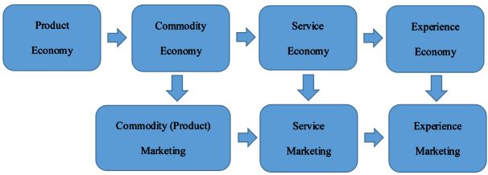
Figure 1: The evolution of marketing model ( Liu, 2015)

compared with the traditional economic form, experience economy pays more attention to the personalisation of consumers and meets their personal feelings. Different consumers, different consumption experience will result in completely different experience feelings, and with the constant change of consumers, the same experience will not be produced any more (Chen & Fan, 2013). Pine II & Gilmore (1999, pp. 98-99) compared traditional economy with the experience economy in figure 2.

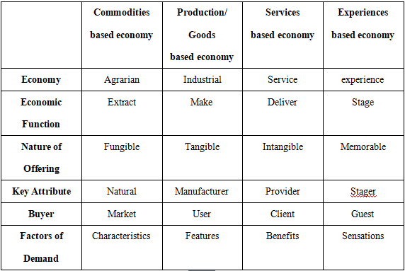
Table 1: Adapted From Economic Distinctions (Pine II &Gilmore, 1999)

According to results obtained from above comparison, by virtue of the service as the core, experience economy creates memorable memories for the consumers. And through the product as the materials of experience allow the consumers to pursue the sensibility and situation as well as enjoy themselves ( Cui, 2014, pp.81-82). Different from the strong product function, beautiful design and low price emphasized by traditional economy, the experience consumption begins to focus on shaping the brand sense value and thinking cognition to make consumers concentrate on themselves, which changes the consumers’ consumption habits inadvertently, so that it can find new value and space of survival for products (Deng, 2011, pp.81-82).

However, no matter which kinds of experience occurred, they are all concluded from the interaction between consumers and products. During the process of consumption, the memory of feeling experience will be preserved by consumers for a long time, and gradually form an important basis for repeat purchase (Jiang & Hu, 2011, pp 19). Arrival of experience economy is the necessity of development of economic society, its reflects that people's consumption psychology and consumer behavior are moving towards an updated and more advanced state (Zhang, 2010, pp. 17).

2.2.3 Characteristic and influences of experiential economy
At the current stage, the rapid development of social economy and technology deeply impact the consumption concept and behaviors and further push the change of structure and pattern of consumption demand (Chen & Fan, 2013). At the experience economy era, the demand of consumers for product and service that show their personality becomes higher and higher, the psychology of "nonconformity" is strengthened more and more by the day passed (Du & Fang, 2015). The consumption demand and methods of people appear with new features:

- The demand on the spiritual level gradually becomes the dominant demand
Maslow (1943) thinks when the basic material requisite of human is greatly satisfied, they will focus more and more on the spiritual needs of higher levels. With the fast development of material civilization, the living standard and consumption demand of people is being improved continuously (Gan, 2015). People no longer focus on the enjoyment on the aspect of material brought by the products alone during the consumption, instead they focus more on the satisfaction of spiritual level obtained in the meantime of consumption (Li et al., 2012). The impact of the demand for social intercourse, respect and self-realization becomes more and more significant on the behaviors of individuals (Maslow, 1943). During the experience economy era, consumers start to focus more on the emotional demand, the situational intimacy between themselves and the product and service. They prefer those products and services that could induce the resonance of self-psychology or achieve the self-value (Liu & Zhang, 2015). While experience is a kind of intangible high value-added products and its essence is to bring the consumers with happy consumption experience and pleasant consumption feeling on the base of the product function (Zhou, 2015). Therefore, it is far from enough to meet the psychological demand of the customers by attracting the customers with products alone. The consumers hope that they can receive an unforgettable experience, a kind of pleasant enjoyment and emotional satisfaction in the meantime of consumption and services through the stimulation of the sense of consumers (Shan, 2015).

- The consumption pattern is gradually transformed from passiveness to activeness
Under the traditional economy, the management activities of an enterprise are developed with the focus on the product, what the consumers focus on for the purchase of products are the quality and function. In addition, price is also an important element that attracts consumers (Wang & Cui, 2013). Therefore, in the meantime of improving the quality and performance, enterprises always attract consumers through the promotional activities such as the reduction of price and discounts etc (Wei, 2014). While the consumers can only passively accept the unilateral induction and control from the managers of the enterprise, they can only select and purchase the commodities from the limited kinds and patterns provided and designed by the manufacturer (Zhou, 2015). However, with the arrival of experience economy, the awareness of consumers for the participation of marketing activities of enterprises is further strengthened, not only do they focus on the product itself, they pay much attention to the process of the product, they like to show their unique personality and self-value in the consumption and obtain the maximum sense of achievement and satisfaction (Guo, 2015). With the maturity of the consumers for consumption, the consumers are no longer satisfied with the passive acceptance for the product and service, instead they are eager to participate in the design and manufacturing of product and service, and they even expect for the participation in the process of production and consumption of the product and service, they are eager to participate in the whole process and experience every detail in the consumption process (Xue, 2015). The active participation of consumers is the significant feature of consumption demand under experience economy (Wang, 2012).

- The individual demand of consumption becomes more and more significant
The experience comes from the state of mind and the psychological feeling of consumers (Wei, 2014). Therefore, even under the same experience environment, the experience generated will be completely different (Zhang, 2010). During the experience economy, the tendency of differentiation and consumption individuation brought by the difference of psychological characteristics among the consumption groups must become more and more obvious (Chen, 2016). While the popular and standardized products will not arise the purchase interest of consumers and the demand for products and service will become more and more fastidious (Gan, 2012). The purpose for the purchase of the commodities no longer limited to the basic demand for survival, they hope they can purchase the specific product and service that match the self-concept of dream. People lay their interest on the product or service that can induce the formation of personalized image and show the unique personality (Du & Fan, 2015). Pursuit of fashion and image to show their personality and self-development gradually becomes the aspiration and demand of consumers of new generation (Guo, 2015).

- The cultural connotation of consumption is gradually being focused
Under the tendency when the social division of labor is refined and specialized by the day passed, most of the consumers are lack of enough professional knowledge and the identification and assessment on the product, but their mental demand for the information and knowledge related to the commodities does not disappear for this reason. On the contrary, it is strengthened by the day passed (Shan, 2015; Wei, 2014). This is because of the increase of uncertainties in modern society and the desire of human beings for mental stability and balance. Therefore, the consumers hope that they can get the knowledge and information that are useful to them in the meantime of purchasing the product and service (Liu, 2014). With the development of the society, people have a higher requirement on the quality of life, their demand for cultural products also continuously increases. Consumers start to focus on the cultural connotation of consumption and seek the product and service related to culture, they focus more on the cultural value and deposit of the product to improve their own cultural cultivation and quality (Wei, 2014; Xue, 2015). After consumption concept was recombined by cultural demand, consumers are no longer satisfied with the humanized, pleasurable performance of goods and they hope that the product can show their living style and the unique core value in the back of their style (Wang, 2015). People hope that they can improve their cultural literacy and taste in the consumption to show their value selection and cultural thinking (Liu et al., 2013).

5. The symbolic consumption becomes the new fashion
Symbolic consumption refers to the symbolism in the consumption which can clearly show the selfvalue orientation of consumers (Chen, 2010). Bourdieu (1980) thinks that the taste, personality and living style of people reflected from the selection for the consumer goods of material and culture constitute the symbols and emblem for the differentiation of their social position. Conspicuous consumption is a kind of typical symbolic consumption and what it reflects is the social position and glory related to money and economic capital (Veblen, 1899). For a long time, not only does consumption meet the basic demand of people, it is also the process of social performance and communication (Liu & Zhang, 2015). Under experience economy, it is very likely for the consumers to express and transmit certain kinds of significance and information with the help of consumption, including position, identity, personality, taste, interest and recognition (Xia, 2014). It is very likely for the consumers to express and transmit certain kinds of significance and information with the help of consumption, including position, identity, personality, taste, interest and recognition (Rhea, 2014). In the meantime, not only do the consumers consume the commodity itself, they also consume a certain kind of social-cultural meaning of which this commodity symbolizes (Yu, 2013). Therefore, symbolic consumption behavior is not based on the differentiation of products and the decision on benefit analysis, it focuses more on the impact of the product or service on their consumption concept and living style (Hu, 2014).

In general，the coming of experience era accelerates the update of marketing methods. With the development and prevalence of experience economy, the consumers have gradually raised their concern and cognition of experience consumption (Wang & Fu, 2013). Even in modern society, human’s consumption behavior is not only to meet the basic physiological and material needs, but especially to find the spiritual satisfaction and a fine experience through the shopping process (Wang, 2012). Therefore, Enterprises need to conduct the accurate positioning for the products in the selected target market and they need to create the unforgettable experience for the customers in accordance with the customers' characteristics to attract new customers and improve the customers' loyalty and further improve the enterprise value (Wang & Cui, 2015).

Not only that, the arrival of the experience era has also accelerated the speed of the marketing approach (Wang, 2011). In today’s rapid economic development, the traditional marketing can no longer adapt to the changes of the market environment with the intensification of market competition. The rising product levels and increasing product categories give consumers more personal choices (Walter,et. al., 2013). When people are choosing their needed products, it has already been beyond the pursuit of using value of the products. People focus more and more on the added value beyond the functional value of the products (Liu, & Zhang, 2015). Therefore, in order to better meet the requirements of experiential economy, the marketing model of enterprises must also be adjusted as soon as possible. Enterprises must keep up with the changing needs of consumers and adopt the corresponding experiential marketing strategy to retain their competitive advantages in the increasingly fierce competition.

2.2.4 Concept of experiential marketing
Experience marketing is evolved from the basis of traditional marketing, until the end of the 20th Century, with the economic development and changes, experience marketing as a new marketing model has gradually been widely accepted by people (Wang & Cui, 2013). Therefore, creating a valuable customer experience has become the ultimate destination of company for developing the experience marketing (Jiang & Hu, 2011). However, as of now, there is still no researcheritative and unified definition of academic marketing for academic marketing.

Schmitt (1999) was the first scholar who put forward the concept of experience marketing. He believes that experience marketing was “a marketing and management model driven by experience” and stated that experience marketing would completely replace the traditional marketing based on the core of functional value. On the basis of this theory, Yang (2010) further proposed that experience marketing is the marketing concept of the company combining with the customer's sense, feel, think, act and relate, and the designing of marketing concept of company should followed the content above. This type of definition underscores the consumer as an individual with both rationality and sensibility, there are still some unknown rational components existing in an emotional way. In the process of developing experience marketing, company should fully explore the emotional needs of consumers, and design corresponding marketing concepts according to different needs.

However, based on the business point of view, Deng (2011) put forward that experience marketing is a social and management process, in this process, enterprises need to know the experience demand of customer, and according to different customer experience needs to create personalized customer experience, achieve the goal of enterprise profit. Similarly, Zhang (2013) also thinks that the starting point of experience marketing is to meet customer demand, to provide customers with valuable meaningful experience, so as to achieve the satisfaction of customers' psychological and emotional, the final destination is to attract and retain customers, make profits. In general, these definitions confirm the importance of experience marketing, but ignores the interaction between consumers and the experience process. Enterprises should pay more attention to optimize their own marketing methods in the process of experience marketing.

Researcher worth noting is that consumer plays a necessary role in experience marketing activities, and the definition of experience marketing from the perspective of customers helps enterprises to grasp the needs of consumers psychology better (Chen, 2016). Therefore, Schmitt (2011) further clarified the definition of ‘experience marketing’ and mentioned that “experience marketing regarded consumers as perceptual consumption; based on the consumer’ experience, the enterprises begin to develop new products and new activities to emphasize the communication and exchange with consumers and trigger the consumers’ psychology and spiritual response, so that it will increase the value of products to meet the mutual needs.”

According to above mentioned viewpoints, the researcher found that the experience marketing used products provided by enterprises as carrier, personalized services as channel, and marketing environments as rendering. A kind of beautiful feelings beyond the economic level were given to customers through interaction so as to stimulate their desire of purchase or repeat purchase. Customers gained satisfaction from experiences, enterprises got profits through marketing process, so the win-win target was achieved ultimately

2.2.5 Strategic Experiential Modules (SEMs)
Schmitt (1999) suggests that the consumer experience is diverse and complex, but it can be divided into different forms and each of them has its own unique structure and process. These forms of experience are created by certain experiential media and can effectively achieve some kinds of marketing purpose. Schmitt (2011) defined these forms as “strategic experiential modules (SEMs),”in this way, the whole framework of experience marketing has been formed. SEMs are divided into two categories: one is that consumers derive from their psychological and physiological experiences, that is, sense experiences (Sense); affective experiences (Feel); creative cognitive experiences (Think). The other is the experience that needs to be generated through interaction with related groups, that is, shared experiences, including physical experiences, behaviours and lifestyles (Act); and social-identity experiences that result from relating to a reference group or culture (Relate).

In the field of theoretical research, Schmitt’s SEMs has been widely used. For example, Wang & Fu (2013) used the sense experience and emotional experience of SEMs to study consumers’ experience, and they put forward the new dimension of experience on this basis, covering achievement experience, spirit experience and soul experience. Similarly, Chen (2010) divided the dimension of consumer experience into functional experience, sense experience, emotional experience, social experience and knowledge experience when studying consumption experience. It is noteworthy that although these scholars integrated the influence factor-emotional experience into the study, they ignored the action experience and the positive initiative of consumers in the experience. Pine & Gilmore (2011) did profound research on this point. They believed experience marketing designed the marketing through consumers’ sense, emotion, thought, action and association. The consumers are both rational and reasonable and the customers’ experience is just the key to study the consumers behavior and business operations.
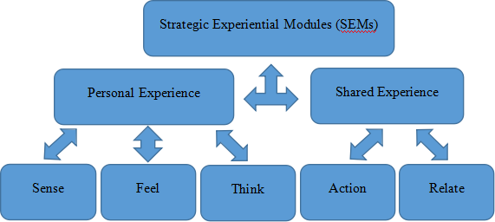
Figure 2：Strategic experiential modules (Schmitt, 1999)

Sense Marketing
Sense experience makes full use of human sense system, through the eyes, ears, nose and other sensors to form visual, auditory, olfactory, tactile and taste sense stimulation, which formed the most direct personal experience process (Rhea, 2014). Sense marketing is the reaction of human body function and psychological function to produce the external objects, thus formed the difference of products of different companies, and it also can stimulate the purchasing power of customers, which make the product appreciate as well. (Hulten, 2011).

Feel Marketing
Feel experience is the inner experience of consumer participation, it mainly focus on how to find factors that can be stimulated for customer, which will be taken into products and make consumers have a positive feelings and identity (Walter, et al., 2015). The main purpose of feel marketing is to touch the inner feelings of consumers. The brand creates a good experience for consumers, and then makes consumers feel good about it and expect it, when people buy something or communicate with them, they drive consumers' emotions and feelings, and entice them to make impulsive decisions (Same & Larimo, 2012; Wang, 2014,).

Think Marketing
Think experience is to inspire consumers enlighten intelligence, and it offered the consumers the thinking experience used in solving problem, guide consumers to use divergent thinking and convergent thinking by some unusual methods, such as surprise, interest and a provocative answer, which makes consumer devote themselves into exploration or thinking (Chen, et al., 2016). By using thinking marketing, enterprises can inspire people's intelligence and creativity, when consumers desire to master knowledge or willing to try, they will be smoothly involved in the activities of the enterprise. (Rhea, 2014; Homburg, et al., 2017).

Action Marketing
The purpose of action experience is to affect the consumer's physical behavior, lifestyle and social communication, then showing different ways of doing things, lifestyle, and interact with consumers, enrich consumer life, sublimation of their experience (Xue, 2017). The purpose of action marketing is also to influence the tangible consumers experience, companies sell lifestyle and products, and consumers have immersive and interactive experience (Tynan, et al., 2014). Typically, consumer lifestyles and life consciousness are either voluntary or motivated, or initiated through idol roles, with strong incitement and guidance (Schmitt & Zarantonello, 2013).

Related Marketing
Related experience contains the components of sense, emotion, thinking and action experience, mainly through increasing the additional meaning of products, to enhance the value of product experience (Li, 2012). Related marketing can make consumers find association with others and the society through transmitting the experience to the consumers, which by the consumers’ emotional, identity, thinking and so on,. Eventually make the consumers’ approval on the culture, thus stimulates their soul to produce psychological resonance, and realize the sublimation of self-feelings (Walter, et al., 2015; Du & Fan, 2015).

In the literature review above, the researcher critically reviewed the development history of experiential marketing and the existing theoretical research results. By contrast, researcher thinks Schmitt’s SEMs (2010) have the important referential value as the theoretical model used for studying experience marketing. Thus, it is used for building the research hypothesis and theoretical model as a key theoretical basis. In addition, this dissertation studies the impact of experiential marketing on the attractiveness of product marketing. Therefore, relevant studies on Attractiveness of shopping mall will be identified and discussed below.

2.2 Literature Research of Attractiveness of shopping mall

2.2.1 Concept of shopping mall
Shopping mall, originated from western developed countries and regions, is a kind of commercial polymers with Highly integrated (Zhang, 2014). It is dominated by the retail industry of large scale as the commercial subject and it combines many specialty stores and commercial service facilities with multiple functions with the plan, including culture, entertainment, leisure, education, food and drink, etc (Wu，2010). It is the commercial space of which the developers conduct the uniform planning, construction and management (Jiang, 2012). The effect of commercial accumulation generated thereof can sufficiently meet the consumers for their one stop shopping and the demand for daily recreational activities (He, 2013). In China, shopping mall is generally referred to the shopping places dominated by the closed and independent buildings located at the core trading areas or central business district of cities (Liu, 2013). The construction area of its subject is generally over 50 thousand square meters and the respective items of functions and the configuration of facilities are complete. It can provide the rich products and services to meet the multi-level, diversified demand of different income groups.

2.2.2 The development status of the shopping malls in China
With the rapid development of China’s economy and the advancement of urbanization, the gradual formation of capital markets for commercial estate in China enables the prosperity of the shopping mall industry (Zhang, 2014). After the fast development for 10 years, the market demand for shopping mall in China is gradually saturated (Liu, 2013). However, a variation of the external management environment and consumers' demand makes the problem of high homogeneity and low efficiency in the operation of shopping mall become more and more obvious. The development of the whole industry comes to a halt and collapse seems inevitable (Gui, 2012).

In recent years, due to the lucrative profits of commercial real estate and the deliberate rendering of the media, investing in and building new shopping mall has gradually become a trend for developers (Hu, 2013). Especially from 2004 to 2008, the successful cases and huge development space of shopping mall brought more encouragement to developers (Han, 2015). The less expensive land transfers, the ease of construction and the substantial tax credits have made the investment plans for these shopping mall very profitable. As a result, developers have built almost identical shopping mall in various cities (Xia, 2012). From 2003 to 2013, the number of shopping malls in China increased from 236 to 3,500. By 2014, the total area of shopping malls in China accounted for 44% of the world, and continued to increase (Xin, 2010).

However, due to developers blindly pursuing profit maximization and some local governments excessively pursuing their achievements, they neglected the actual economic development level of the city and the real needs of the market, making the number and scale of shopping mall far exceed the carrying capacity of the region, resulting in some areas (Xia, 2011; Su, 2013). The shopping mall lacks sufficient consumer population to maintain its normal operations (Zhao, 2013). The statistics for 2017 show that the vacancy rates of shopping malls in China's first-tier cities are all higher than the 5% alert rate. Among them, the vacancy rate in Shenzhen is 5.7%, the vacancy rate in Guangzhou is 5.4%, and the vacancy rate in Beijing is 6.7%. The vacancy rate is 8%. This ratio is expected to increase by 2% to 3% in the 2018 cycle. The situation in second-tier cities is even more serious. The vacancy rate of shopping mall is higher than 10.5% (Liu, 2013). The problem of unbalanced regional development and phased temporary oversupply is threatening the development of shopping mall (Qian, 2010). The serious homogeneity trend also makes the shopping mall gradually lose its advantage in the fiercely competitive market environment (Ma, 2014) .

It is worth noting that, at this stage, the profitability of China's shopping mall mainly comes from the fixed rents of shops or the sales commissions of businesses (Su, 2013). A higher vacancy rate not only means a reduction in direct income, but it may also result in the lack of some functions in the shopping mall, which in turn affects the overall functioning (Han, 2012). In addition, serious homogeneity can also lead to consumers' aesthetic fatigue and ultimately lose customers (Xiao, 2016). Therefore, how to meet the needs of consumers and enhance the Attractiveness of shopping mall s has become the key to the success of shopping mall (Wei, 2011).

2.2.3 Connotation of Attractiveness of shopping mall
Attractiveness is the power to gather and attract customers, including brand, environment, service, reputation and other abilities to inspire consumers. and the extent of attractiveness is reflected in customer volume, turnover ratio and satisfaction, among which satisfaction is the most important one (Teller & Reutterer., 2008, pp.127). Therefore, the Attractiveness of shopping mall is to create a diversified shopping environment and experience for customers and providing intimate and personalized services as much as possible so that customers feel satisfied to generate satisfaction (Alavi, et al., 2016, pp. 293-295). Satisfaction indicates the overall capacity of business form of attracting and gathering customers. Meanwhile, satisfaction shall be turned to loyalty of customers that is patronage intention and motivation to attract consumers for patronage all the time, which shows sustainable attractiveness of the business form (Dębek, 2015; Teller & Reutterer, 2008, pp. 132-136). Therefore, above opinions can indicate a close relation between satisfaction and patronage intention, so only the combination of them reflects the attractiveness of a business form.

2.3 Dimension of Attractiveness of shopping mall
In current researches, the definition of attractiveness of shopping mall is mostly linked to its properties. Ruinartz & Kumar (1999, pp.5-7) determines the dimensions of attractiveness of shopping mall , including shopping environment and diversity, parking, shopping environment and specialty. Wong & Yuan (2001, pp. 76-86.) based on the perspective of consumers develop “SCATTER” to evaluate the attractiveness of shopping mall , containing 5 factors and 21 properties that is location, quality and diversity, popularity, auxiliary facility and sales intensive. But the most representative idea proposed by Reinartz & Kumar (1999, pp. 13) thinks that attractiveness is polyhedral and contains a series of observation items and can be controlled by the management supervisor. Based on the concept, Teller & Reutterer (2008, pp. 133-136) divide the Attractiveness of shopping mall into three dimensions that is situational attractiveness, sustainable attractiveness and overall attractiveness.

It is noteworthy that overall attractiveness is customer satisfaction in the perspective of customers, which mainly reflects consumers are satisfied with the shopping mall or not and the impression on the shopping mall of consumers doing their first shopping or at shopping (Alavi, et al., 2016, pp. 297-304). If customers are generally satisfied with their trip to the shopping mall, it means the overall attractiveness of the shopping mall is good (Dębek, 2015). Not only that, the relationship between the three dimensions is also mutually reinforcing. The core of sustainable attractiveness is to make sure that consumers patronize the shopping mall again. And the motivation of patronage shows the willingness of customers to patronize the shopping mall again, add consumption quantity and recommend it to people around after their first shopping (Andreassen, 1998, pp. 178-194; Dick & Basu, 1994, pp. 99-113). (Bloemer & Ruyter, 1998, pp. 499-513; Yu & Dean, 2011, pp. 234-250) think that consumers are more likely to visit again if they have higher overall satisfaction. In the perspective personal psychology of customer, customer satisfaction leads to pleased feeling and emotion. In other words, shopping satisfaction enhances customers’ purchasing behavior. According to ‘classical conditioning’ law, it will drive customers to repurchase and consume from the same vendor (Luo, 2013).

Through the study of the above scholars' research results, the researcher thinks that the theory of Teller & Reutterer is a highly valuable reference for study on attractiveness of shopping mall. Therefore, the researcher intends to use it as an important theoretical basis to build the research hypothesis and theoretical model in this dissertation.

In the above literature review, the researcher clarified the concept of shopping mall and attractiveness, and analyzed the development status of shopping malls in China. Based on this, it discusses the important role of attractiveness for shopping mall . And discuss the results of the relevant research results of the attractiveness, and select the appropriate theoretical model for this study. Therefore, in order to better study the impact of experiential marketing on the attractiveness of shopping mall s in China, the researcher will comprehensively analyze the impact of the experience economy era on consumers in the following literature review, and further explore the direct relationship between shopping mall and experience marketing.

2.3 The relationship between experience marketing and shopping mall
With the development of times and improvement of living standard, people’s lifestyle and consumption habits are changing. Shopping is no longer a pure and purposeful business activity, but an enjoyable social recreation, even an experience to adjust life and seek excitement (Ingene, 1984 pp. 15-26; Kim, et al., 2015, pp. 54-61). For shopping mall, a planned commercial agglomeration, it is agglomerate effect in the perspective of consumers delivers practicability and happiness-oriented shopping concept and value to consumers (Oppewal & Holyoake, 2004, pp. 63-65; Babin et al, 1994, pp. 697-701.). Thus, shopping mall as an island in the city is not only a shopping place to buy essential articles for daily use, but also a cultural and vigorous living place for leisure and entertainment, consumption and enjoyment.

The most significant superiority of shopping mall from the traditional retailing is the function of combining the consumption and experience (Yu, 2013). To deepen the understanding of the consumers to this experience consumption and to be loved by the consumers rely on the propaganda and advocacy of the shopping mall (Xue, et al., 2012). Every shopping mall should determine its own experience subject so that it can reflect its unique brand feature and leave the deep impression to the consumers (Cui, 2014). Experience marketing is based on products or services, creating a profound experience that consumers cannot forget, thus helping consumers to find their potential inner needs and stimulate their own consumption desires, so as to realize the export of product information and the introduction of brand value (Chen, 2010; Wang & Fu,2013). Which makes it a natural fit with experience marketing. The use of experiential marketing can not only help the shopping mall to form distinctive features and enhance its attractiveness. It is more conducive to getting rid of the crisis brought about by homogenous competition. For the development of enterprises usher in a new turning point. This is where the significance of this study comes from. Based on this, this dissertation proposes research hypotheses and constructs a theoretical model, as shown below.

2.4 Research hypothesis and theoretical model
The theme of this dissertation is research on the influence of experiential marketing on attractiveness of shopping mall. Therefore, this chapter proposes corresponding research hypotheses aiming at major issues in the research and builds the theoretical model on the influencing mechanism of experiential marketing on Attractiveness of shopping mall, so as to turn the issues into the relations between measurable variables. The research model is shown in Figure 3.
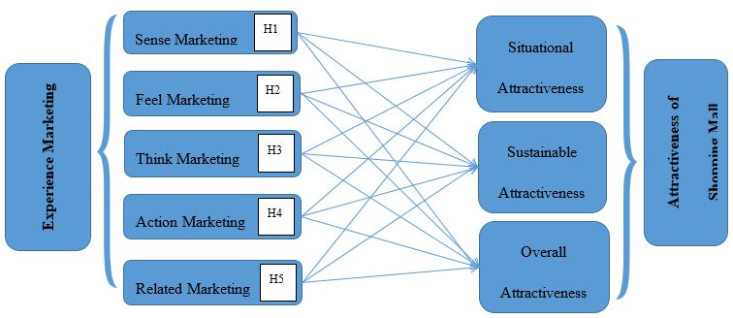

Figure 3: The Impact Relationship Model of Experiential Marketing on Attractiveness of shopping mall

In this research, the researcher sets experiential marketing as the antecedent variable, and Attractiveness of shopping mall as the outcome variable. By studying and summarizing relevant literature, the researcher divides experiential marketing into five dimensions by referring to strategic experiential modules (SEMs) by Schmitt (2011) that is ‘sense', ‘feel’, ‘think’, ‘act’ and ‘relate’, and divides Attractiveness of shopping mall into three dimensions by combining the theory of Teller & Reutterer (2008) that are ‘situational attractiveness’, ‘sustainable attractiveness’ and ‘overall attractiveness’. On the basis, the researcher discusses and analyses the relation between the experiential marketing and Attractiveness of shopping mall, and the relation among dimensions of variables, thus put forward the research hypotheses of this dissertation; ‘experiential marketing has a positive impact to attractiveness of shopping mall ’. In order to better validate this hypothesis, researcher subdivides it into five parts to discuss, as shown below:

2.4.1 Influence of sense marketing on attractiveness of shopping mall
The sense marketing is established by the creation of consumer perception experience, mainly covering vision sense, auditory sense, touch sense, tactile sense and smell sense (Rhea, 2014). The temperature, humidity and smell are controllable in an enclosed shopping mall, and these perceptible factors make customers feel comfortable, and attract customers to stay here for a long time (Dennis, 2005). In addition, comfortable sense experience also creates a relax shopping atmosphere for customers that will improve customers’ intention to stay and revisit the shopping mall, as well as the frequency of consumption in the shopping mall (Bellenger et al.,1977, pp.33-37; Wakefield and Baker,1998, pp. 539; Stoltman, et al., 1991).

According to the results of scholars above, the researcher finds that a good sense experience will result in high customer satisfaction. The shopping mall integrates sense into its marketing, such as brand logo, music, style, theme and so on, to trigger customers’ acceptance, sense of belonging and excitement so that the Attractiveness of shopping mall is improved. Therefore, the researcher proposes the hypothesis on the basis that

H1: Sense marketing has an obviously positive effect on the attractiveness of shopping mall
H1a: Sense marketing has an obviously positive effect on the situational attractiveness of shopping mall
H1b: Sense marketing has an obviously positive effect on the sustainable attractiveness of shopping mall
H1c: Sense marketing has an obviously positive effect on the overall attractiveness of shopping mall

2.4.2 Influence of feel marketing on attractiveness of shopping mall
In daily life, people are all trend to pursue good feelings. After the potential consumers confirm the purchasing motivation, the consumption behavior still need be stimulated by products or promotion activity, so as to influence the consumer’s consumption behavior (Same & Larimo, 2012, pp. 17). In the process of consumption, the emotion of customers to great extent affects their shopping behaviors, and the most attractive experience is the emotional experience touching the heart (Wang, 2014, pp. 123). Thus, a shopping mall can create special emotional experiences for customers by creating various circumstances and ambience to cause their emotional changes that the resonance generates between emotional marketing and the inner experience of customers and by which customers are included into the circumstance through spiritual enjoyment, so that the strong acceptance and customer satisfaction are generated (Stoltman, et al., 1991; Walter, et al., 2015, pp.147). The effect will improve the staying time of customers in store and have a positive effect on their total expenditure and extra consumption in the directly way, as well as their overall favor ability of the shopping mall (Baker,1998, pp. 533). Therefore, the researcher proposes the hypothesis on the basis that

H2: Feel marketing has an obviously positive effect on the attractiveness of shopping mall
H2a: Feel marketing has an obviously positive effect on the situational attractiveness of shopping mall
H2b: Feel marketing has an obviously positive effect on the sustainable attractiveness of shopping mall
H2c: Feel marketing has an obviously positive effect on the overall attractiveness of shopping mall

2.4.3 Influence of think marketing on attractiveness of shopping mall
Thinking marketing is to create cognitive and problem-solving experience for consumers by providing creative experience that arouses consumers' surprise and interest for concentrated or dispersive thinking (Homburg, et al., 2017, pp.348). Shopping mall can associate itself with some social activities and hot events by hosting, undertaking and sponsoring a series of marketing activities, to attract the attention of the public and / or the media, creating topics for consumers. Shopping mall gives a novel experience and stimulates curiosity and thinking of customers when they visit, the customers will be attracted to the shopping mall (Chen, et al., 2016, pp. 78). Therefore, the researcher proposes the hypothesis on the basis that

H3: Think marketing has an obviously positive effect on the attractiveness of shopping mall
H3a: Think marketing has an obviously positive effect on the situational attractiveness of shopping mall
H3b: Think marketing has an obviously positive effect on the sustainable attractiveness of shopping mall
H3c: Think marketing has an obviously positive effect on the overall attractiveness of shopping mall

2.4.4 Influence of action marketing on attractiveness of shopping mall
Action marketing refers to the experience activities created by enterprise and in which the consumer can participate. These activities include body experience, lifestyle experience, long-term behavior pattern experience and interactive experience (Xue, 2017, pp. 4-5). It is worth noting that consumers' behavior patterns and shopping habits often embody their values, shopping mall requires in-depth understanding of the customer's real ideas and creats a unique shopping experience (Zhang, 2013, pp.23). By holding shopping carnivals, food and culture festivals and other activities, shopping mall can create a variety of experience opportunities for consumers, which in turn influence and change people's way of life in a subtle way (Schmitt & Zarantonello, 2013, pp. 61-62). In addition, the communication and interaction between service staffs in shopping mall service staff and consumers and between consumers are also the factors that cannot be ignored in the implementation of action marketing (Stoltman, et al., 1991). Shopping mall should actively guide the interaction between consumers to create a happy and harmonious shopping atmosphere and enhance their own attractiveness. Therefore, the researcher proposes the hypothesis on the basis that

H4: Action marketing has an obviously positive effect on the attractiveness of shopping mall
H4a: Action marketing has an obviously positive effect on the situational attractiveness of shopping mall
H4b: Action marketing has an obviously positive effect on the sustainable attractiveness of shopping mall
H4c: Action marketing has an obviously positive effect on the overall attractiveness of shopping mall

2.4.5 Influence of related marketing on attractiveness of shopping mall
Relate experience is the highest level of experience. It enables consumers to find a sense of group belonging and realize their own values. It is the result of all experience strategies (Du & Fan, 2015, pp. 519). The relate marketing links the individual consumer to the social background and the cultural background embodied in a brand, and makes the consumers who use the same product to form a group. When consumers feel that other consumers are from the same group, their service experience is enhanced (Grove & Fisk, 1997, pp. 72-74) because people choose products or shops depending on their self-concept and how they want to be seen, thereby satisfying the desire for self-esteem and identity. (Rintamaki et al., 2006, pp. 21-24). The self-concept to reinforce sociality by service and products can enhance the novelty and pleasure consumers experience in shopping (Diep & Sweeney, 2008. pp. 399-400). As public activity space in modern city, shopping mall has a good environment and a variety of commercial types, which provides a favorable opportunity to consumers for social activities (Oppewal & Holyoake, 2004, pp. 65). It may also result in consumers staying longer in the shopping mall and consuming more project activity. Therefore, the researcher proposes the hypothesis on the basis that

H5: Relate marketing has an obviously positive effect on the attractiveness of shopping mall
H5a: Relate marketing has an obviously positive effect on the situational attractiveness of shopping mall
H5b: Relate marketing has an obviously positive effect on the sustainable Attractiveness of shopping mall
H5c: Relate marketing has an obviously positive effect on the overall Attractiveness of shopping mall

Conclusion
In this chapter, the researcher conducts the critical review and comment on the achievements of theoretical research on the experience marketing and the Attractiveness of shopping mall in the summary of reference respectively. The concepts and components of experience marketing and the Attractiveness of shopping mall are clearly identified, and on the base of that, the research hypothesis and the theoretical model of this article are suggested which explore the relationship between the respective elements in detail. Therefore, the research targets at the first and second stage of this article have been achieved. While in the next chapter, the researcher will select the appropriate research method in accordance with the research hypothesis in this article and conduct the critical assessment.

Chapter 3: Research Methodology

Introduction
The research method of this dissertation is to determine the way of data collection and generation on the basis of reviewing the theoretical background and research design provided by literature review, according to the established research objectives and purposes. And the methods and steps of the date analysis process are summarized. Thus provides the scientific guidance scheme for the research decision of the whole thesis. Therefore, on the basis of further refinement and expansion of the research objectives, the researcher will discuss the research paradigm and methods of his choice in depth, and clarify his research design. Finally, the researcher will discuss the reliability and effectiveness, as well as the limitations and ethical considerations of the re, so as to provide further reference and improvement for future research.

3.1 Research Aims and Objectives
The main purpose of research in this article is to explore the influence of experience marketing on the attraction of shopping mall under the background of experience economy. To better achieve the overall target, the researcher divides it into the following targets;

- Identification of the concepts and components of experience marketing and the attractiveness of shopping mall;
- Exploration of the relationship between the experience marketing and the respective components for the attractiveness of shopping mall;
- Assessment of the influence of experience marketing on the attractiveness of shopping mall;
- Development of recommendations for sustainable long-term developments.

At the present stage, the relevant literature review and research hypotheses required in this dissertation have been determined. Therefore, this chapter will discuss the research process of this dissertation and explain the method of data collection and its related basic principles, so as to achieve the goal of this study.

3.2 Research Paradigm
Research paradigm refers to the basic world outlook shared by scientists of a particular discipline. It is composed by its unique perspective, the basic assumptions, concept system and research methods. It indicates the basic ways in which scientists view and explain the world (Denzin & Lincoln，2003). Research paradigm can also be viewed as a philosophical model or framework to guide scientific research, namely, the basic assumptions and knowledge structures that underpin research and development in the field of research (Golafshani, 2003). Research paradigm originated from the world outlook and belief system based on specific ontology and epistemology, and shared by the scientific community (Holloway, 1997). Therefore, Research Paradigm can act as the lens for researcher to observe the world, and reflects the researcher' view of the world.

In this study, the researcher uses positivism as the research paradigm. This is because that empirical research attempts to find the causal relationship between dependent and independent variables in order to make the prediction of reality (Golafshani, 2003). According to the paradigm of positivism, science should seek to find all the laws or rules in the universe, while these already existed laws and rules have nothing to do with any personal perception. People can experiment or observation of reality to determine the causal relationship and test hypotheses about these relationships. The main aim of positivism research is to form explanation rather than understanding. The research carried out is objective and no the effect of personal prejudice. The data collected in the empirical study can be measurable (Oates, 2007, p. 284; Ramm, 1992, p. 57; Lee，2004, p. 8).

The main purpose of this dissertation is to study the influence of experiential marketing on the attractiveness of sales. The researcher hopes to find out the relationship between experiential marketing and marketable attraction by means of observation, and to assume and test whether there is a causal relationship between dependent variables and independent variables. The researcher hopes that the hypothesis can be refuted by empirical investigation or corroboration. In the ontology of positivism, theory and explanation should be regarded as the best knowledge currently approaching reality. Some assumptions seem to be true for all observations, and after reasonable peer review, people can accept that they are true. If they find something wrong, it is wrong (Oates, 2007, p.285; Ramm, 1992, p.52). Bassey (2002, p. 37) clearly defines the intent of empirical research, and he thinks, 'for positists, the purpose of the research is to describe and understand world phenomena and share this understanding with others'.

3.3 Research Approach
Most studies can be divided into three different categories; Exploratory, descriptive and causal. The ultimate purpose of each study is different and can only be used in certain ways (Bryman, 2006). A good grasp of these three aspects will bring deeper views and higher quality information for the investigation and research of this dissertation. Finding an appropriate balance between exploratory, descriptive and causal studies will also be the key factor to achieve the goal of this study. Therefore, on the basis of following the principle of legitimacy, the researcher will further explore and compare the differences among the three, so as to better distinguish and clarify the research methods of this dissertation.

3.3.1 Exploratory Research
Exploratory research is a preliminary study of hypotheses or theoretical ideas (Burns & Bush, 2000). Exploratory research is carried out to gather preliminary information to help determine the nature of the problem and to make assumptions, instead of providing the ultimate and decisive solution to existing problems (Stebbins, 2008). Exploratory research can provide researcher with a better understanding of the problem, but the results are usually of no practical use for decision-making (Waters, 2007). Exploratory reseach usually take the form of open questions in which participants can leave responses to questions in the form of public text comments. Text comments may not be statistically measurable (unless there is a proper code) but participants can provide richer, higher-quality data, so you can find new initiatives or problems that should be addressed (Stebbins, 2008).

3.3.2 Descriptive Research
Descriptive research, also known as statistical research, is intended to explore and explain the information found through exploratory research (Malhotra, et al., 2006). Unlike exploratory research, descriptive research is systematically planned, designed, and formatted to collect quantifiable data (Burns & Bush, 2000). In addition, descriptive research may be characterized by an attempt to identify, describe, or identify, while analytical research attempts to prove why, or how it occurs (Stebbins, 2008). It is worth noting that, although descriptive studies are usually preceded by explanatory studies, descriptive studies cannot be used as a basis for a causal relationship because of their low internal validity requirements (Knupfer & McLellan, 1996).

3.3.3 Causal Research
Causal research, also known as explanatory research, is an attempt to connect difference ideas in order to understand causal relationship. In causal research, researcher can try to explain what is happening (Malhotra, et al., 2006). Similar to descriptive studies, causal research also provision of conclusive statistics (Stebbins, 2008). The purpose of causal research study is to test the hypothesis about causal relationship (Churchill, et al., 2006). For example, if the goal of the researcher is to determine which variables (cause) cause an act (effect), then a casual study is needed (Burns & Bush, 2000). Causal research can help researcher understand which variables are the cause and which are the influencing factors, and it can help researcher determine the course of the relationship between variables and the effects to be predicted (Knupfer & McLellan, 1996).

In this study, the researcher mainly used causal research to explore the impact of experience marketing on the attractiveness of marketing. Based on the literature review, the researcher determined the antecedent variable (experience marketing) and outcome variables (male attractiveness) of the study, and proposed the hypothesis of this study that ‘experiential marketing has a positive impact to attractiveness of shopping mall ’. This belongs to the category of causal research and coincides with the positivist paradigm chosen by the researcher. Therefore, the researcher need to further determine the nature of the relationship between causality variables and predictive effects, and scientifically verify this idea.

Research Methods
A research method is a system for collecting and/or analyzing the data (Bowen, 2009). Finding and collecting valid data can provide good convenience for research work. Therefore, in order to better screen out suitable research methods, it can be roughly divided into the following two aspects;

3.4.1 Primary and Secondary Research
The Primary research aimed at meeting the unique and specific needs of researcher, usually involves providing questions and gathering information directly to customers and potential customers in the target market. Research can include interviews, surveys, questionnaires, focus groups, and measurements (Stebbins, 2008). Secondary research is a type of research that has been edited, collected, organized and published by others. It includes reports and studies from government agencies, industry associations, or other enterprises in the industry (Kitchin, 2014).

In this dissertation, the researcher access the Internet and school libraries to quickly and accurately obtain a large number of second-hand research materials related to the subject, which will be appropriately used in literature reviews which constitute the theoretical background and research assumptions of this dissertation and the research hypothesis. In addition, the researcher also collected first-hand research data by issuing online questionnaires to provide the necessary data support for further validation of the hypothesis.

3.4.2 Qualitative and Quantitative Research
Qualitative research is mainly exploratory research. It is used to understand underlying causes, opinions, and motivations (Bryman, 2016). It provides an in-depth understanding of the problem or helps to develop ideas or assumptions for potential quantitative research (Merriam, 1998). The methods used in qualitative research is often inductive, which means that they develop theories or seek meaningful patterns is based on the data they collected. This involves the transition from specific to general, sometimes referred to as a bottom-up approach (Denzin & Lincoln, 1994). Therefore, based on the demand of the casual research and the positivist paradigm selected by the researcher, qualitative examination will not be applied in the investigation of this research.
Quantitative research is usually related to positivist paradigms (Denzin & Lincoln, 1994). It usually involves collecting data and converting it into numerical form for statistical calculations and conclusions (Denzin & Giardina, 2005). The main focus of quantitative research is deductive reasoning, this deductive reason in tends to range from general to concrete. This is sometimes referred to as a top-down approach (Bryman, 2016). Similarly, this research method can help researcher effectively obtain the quantitative data needed for research. Therefore, as the main research method of this article, quantitative research provides the essential data support for the research hypothesis and casual relationship suggested by the researcher. In addition, as the main method for the collection of quantitative data, online questionnaire will be sufficiently discussed.

3.4.3 The advantages and disadvantages of the online questionnaire
First, as a kind of structural investigation method, the result of online questionnaire is easier to conduct the quantitative process and analysis (Lumsden, 2007). And it can effectively break the limit of region and allow the investigations of multiple interviewees at the same time for which the cross-border investigations of large scale can be possible (Montag & Reuter, 2008). In addition, online questionnaire can effectively avoid the direct contact of the researcher and the participants for which the interference by the anthropic factor can be reduced to the minimum and it creates a relatively comfortable and independent environment for the participants to answer the questions, it also protects and conceals the privacy of the participants to the maximum (Evans& Mathur, 2005).

However, online questionnaire needs to rely on the Internet as a medium. Therefore, without the access to the internet, it is impossible for an individual to complete an investigation, they may be eliminated from the research (Montag & Reuter, 2008). In addition, the dishonest questions cannot be neglected, for the concern of privacy protection or the influence of certain social prejudice, some interviewees may not answer the questions by the facts (Evans & Mathur, 2005). The researcher cannot confirm if the interviewees have seriously considered these questions before the answer (Van Selm & Jankowski, 2006). Therefore, the researcher need to conduct a strict selection for the result of feedback.

In addition, based on the consideration of practicality, some research methods have not been applied, such as interview, focus group, observation and case research. The reason for the refusal is mainly because these methods requires the direct participation and contact of the researcher, the result of research is easy to be affected by the subjective factors (Lumsden, 2007). Moreover, the capability of the researcher decides the quality of data, while the unprofessional operation may cause the misleading results. That is why they cannot meet the research demand of this article.

3.5 Research Design
Research design is the framework or blueprint for carrying out research projects (Malhotra, 2004). It should clarify and specify the process steps required to obtain information (Bordens & Abbott, 2012). So, the researcher will fully discuss the following steps in accordance with the logical order studied in this dissertation;

3.5.1 Sampling and Sample size
Sampling is the method of selecting a representative sample from the study population (Altmann, 1974).. Its main purpose is to infer the general situation through the study of the sample (Cochran, 2007). But purposive sample is a non-probabilistic sampling method (Oliver & Jupp, 2006). The researcher select and identify the people who they think can provide the information they need as a sample according to their research objectives and their own subjective analysis (Etikan, et al., 2016). Therefore, Purposive sample is also called judgment sampling, selective sampling or subjective sampling (Cochran, 2007). Because the main purpose of this dissertation is to study the impact of experiential marketing on the attractiveness of shopping malls in China . Therefore, the dissertation will use the purposive sample method to select respondents who are familiar with shopping mall as the research sample of this dissertation, and those who have never visited sales of shopping mall will be abandoned. At the same time, considering the limited number of respondents and the recovery rate of valid questionnaires, objective sampling is an appropriate sampling method used in this survey (Guarte & Barrios, 2006).

According to Sekaran (2003), the number of the sample can determine the accuracy of the results and whether the results are extensible. Therefore, the selection of appropriate sample quantity is the key to this study. Based on the research paradigm in this dissertation, the selected samples need to be large enough for researcher to feel that sufficient data have been collected (Descombe, 2014). Therefore, in order to make the results of the study more precise and accurate. The researcher are keeping the sample size of the study between 150 and 200. The number is large enough to get some useful information, but not too large to be managed (Acharya, et al., 2013).

3.5.2 Questionnaire design
Questionnaire is a kind of carrier to understand the responses and opinions of the subjects in written form, and to obtain details and information (Lumsden, & Morgan, 2005). Therefore, the questions designed in the questionnaire should reflect the true purpose of the survey and be easily accepted by the participants (Montag & Reuter, 2008). Problems should be arranged in basic logical order, and usually from general to concrete, from simple to complex (Lumsden, 2007). At the same time, too many problems can also reduce the enthusiasm and participation of the respondents, and have a negative impact on the effectiveness of the results (Evans & Mathur, 2005).. In addition, the wording and presentation of the question should be clear and concise to avoid interfering with the accuracy of the investigation because of ambiguity(Lumsden, & Morgan, 2005).

Based on these principles, the researcher design 32 closed-end questions to collect the quantitative data needed for the study. The whole questionnaire can be divided into three parts. The first part is about some basic demographic problems, which mainly involve the basic information of the respondents, including gender, age, occupation and income. The second part of the problem is focused on understanding the daily shopping habits and behavioral preferences of the respondents. The third part, as the core of this dissertation, is designed by researcher on the basis of literature review and research hypotheses, and is shown in the form of Likert Scale. In addition, the researcher translates it into Chinese and add it to Sojump Survey (Chinese survey software) after the design of the questionnaire is completed.

3.5.3 Piloting the Questionnaire
The pilot study is to distribute small-scale questionnaires to individuals and gathers information from a limited number of respondents (Montag & Reuter, 2008).. This helps researcher understand how to make collecting procedures of key data. Therefore, prior to the formal submission of the questionnaire, the researcher have contacted 30 general public for a pilot study for testing the accuracy of the questionnaire and trying to identify potential problems. While under the test results, the researcher made some corrections to the questionnaire, including adjusting the order of answers, removing some repetitive questions, and redesigning and supplementing the third part of the questionnaire, to make the whole questionnaire more reasonable.

3.5.4 Sending the Questionnaire
In this study, the researcher used Sojump Survey to publish and recall questionnaires. The survey and the description of the questionnaire was linked to the Internet and social media platforms, such as QQ, WeChat, Weibo and so on. The researcher expected it to take two weeks to complete the survey.

3.5.5 Data analysis
After completing the sample collection, the researcher used excel and SPSS software for statistical analysis and testing of all data, and the findings incurred are shown in graphics and tables.

3.5.6 Limitations of the research
There may be some shortcomings to be noted in the study. It collects raw data mainly by virtue of online questionnaire, while the results of it may be affected by subjective factors. Respondents may deliberately conceal and/or evade some questions owing to personal privacy, thus affecting the authenticity of the findings. In addition, some objective factors may also cause the number of questionnaires recovered fails to meet expectations, which affects the effectiveness of the findings.

3.5.7 Reliability and Validity
Reliability is a measure of the stability or consistency of test scores. It can also be considered the importance of testing or research results (Litwin & Fink, 1995). Therefore, for the data with research and use value, they must be both reliable and valid (LoBiondo-Wood & Haber, 2014). It is essential to follow the principles of reliability and consistency for this research, as well as the research activities must be carried out in a fair and open manner.

Conclusion
In this chapter, the study method of this dissertation was mainly discussed and the study way mainly focusing on quantitative analysis and the investigation method mainly focusing on questionnaire were defined. Therefore, in the next chapter, this dissertation will conduct data analysis on the survey results and test hypotheses.

Chapter 4: Data collection and diDATA COLLECTION AND ANALYSIS

Introduction
As mentioned in chapter three, the researcher will analyze and present the data collected by online survey in this chapter, and fully discuss and verify the hypothesis of the influence of experiential marketing on the Attractiveness of shopping mall . All collected data will be displayed graphically and tabulated so that researcher can better annotate and illustrate their analysis results, which is helpful to researcher to annotate and explain the results of the analysis. The appendix of this article includes all copies of the original data and related tables for inspection and inspection by the researcher. In addition, according to the sampling method mentioned in the third chapter, researcher screened 170 online questionnaires, 143 valid questionnaires were obtained. Using SPSS software to process the data, the results are as follows;

4.1 Descriptive statistics
According to the design method of this questionnaire, the descriptive statistics of the sample will be divided into the following three parts;

4.1.1 Demographics of the respondents
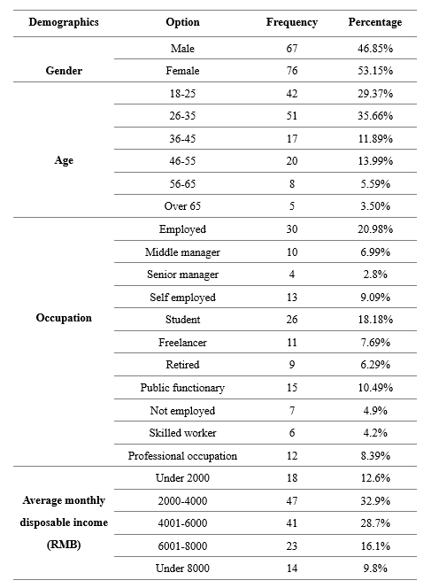
Table 2: Demographics of the respondents
Table 2 shows the frequency statistical results of the demographics classification variables in the sample. They will be presented in the form of different types of the chart accompanied by necessary textual descriptions to observe the statistical results more clearly and intuitively.

Gender of the respondents

Figure 4: Gender of the respondents

Figure 4 shows that the proportion of female respondents is 53.15%, and that of male respondents is 46.85%. The proportion of female respondents is slightly higher than that of men, but the gap is relatively small. Overall, respondents have a relatively even distribution of gender.

Age of the respondents

Figure 5: Age of the respondents
Figure 5 shows that most respondents were between 18 and 35 years old. There are relatively few respondents between the ages of 36 and 55. The number of respondents aged over 56 is the lowest, less than one-tenth of the total number.

Occupation of the respondents

Figure 6：Occupation of the respondents
Figure 6 shows that employees and students have the highest percentage of respondents, close to half of the total number. Respondents from other occupations are relatively evenly distributed.

Average monthly disposable income of the respondents

Figure 7：Average monthly disposable income of the respondents

Figure 7 shows that the average monthly disposable income of the majority of respondents is between 2001 and 6,000 yuan, which is at the level of lower middle income. The average monthly disposable income is less than 2,000 yuan, or relatively less than 8,000 yuan.

4.1.2 Descriptive statistics of respondents’ shopping behavior
Table 3：Consumer behavior of the respondents
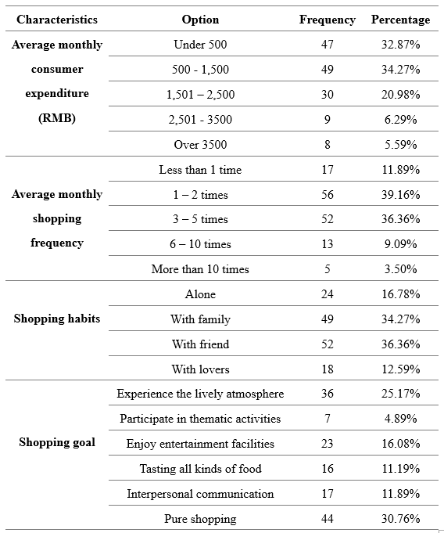
Table 3 shows the statistical results of the frequency and frequency of the categorical variables of the consumer behavior in the sample. In order to be able to observe the statistical results more clearly and more intuitively, they will be presented in the form of different types of charts, together with the necessary text descriptions.

Average monthly consumer expenditure of the respondents

Figure 8: Average monthly consumer expenditure of the respondents
Figure 8 shows that the average monthly consumption of the majority of respondents is below 1,500 yuan, which is at a lower level of consumption. In addition, about a quarter of respondents spend an average of between 1501 and 2500 yuan per month. The average monthly consumption of more than 2,500 yuan was the smallest, accounting for only one-tenth of the total.

Average monthly shopping frequency of the respondents

Figure 9: Average monthly shopping frequency of the respondents

Figure 9 shows that the average monthly shopping frequency for most respondents was between 1 and 5 times, and there were fewer respondents below 1 or more than 10 times. And nearly one-tenth of respondents had an average monthly shopping frequency of 6 to 10 times.

Shopping habits of the respondents

Figure 10: Shopping habits of the respondents
Figure 10 shows that less than one-sixth of respondents choose to shop on their own, and more respondents tend to be accompanied by others, especially friends or family members.

Shopping goals of the respondents

Figure 11：Shopping goals of the respondents

Figure 11 shows that nearly two-thirds of respondents are visiting the shopping mall for other purposes than shopping. Among them, the lively atmosphere was favored by most respondents. On the contrary, only a small number of respondents are interested in participating in the shopping center's thematic activities.

4.1.3 Descriptive statistics of the scale
According to the design method of the scale in the questionnaire, the dimensions of the experience marketing and attractiveness of shopping mall respectively corresponds to multiple research variables in the scale. Therefore, the researcher will transform the original data appropriately to better meet the needs of statistical analysis. As follows:
Table 4 Function Formulas for Various Dimensional Variables
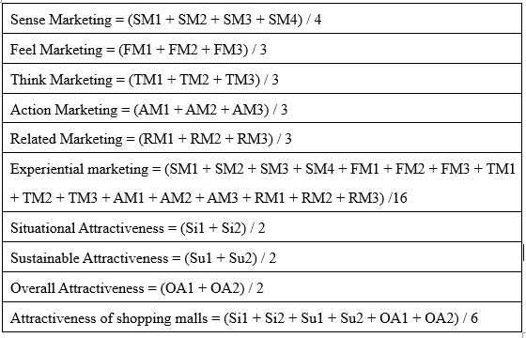
Table 4 shows that the operation principle of each dimension in the experience marketing and attractiveness of shopping mall . According to the corresponding function calculation method in SPSS, the researcher divides a few research variables equally, and then establish the corresponding new variables, i.e. the dimension variables needed for the research. These dimensional variables will be fully applied to other analytical methods in addition to descriptive statistics.

Descriptive statistics of the experienced marketing
Table 5: Descriptive statistics of experiential marketing
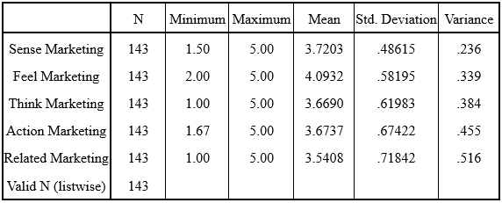
Table 4 shows that the average value of each dimension of experience marketing is greater than 3.5, and the highest average value of feel marketing is 4.09. It shows that the respondents' overall evaluation of the experience marketing is at an above average, and mainly comes from feel marketing. The residual values are relatively close. So it can be said that, for the interviewees, the attractiveness of the shopping mall is relatively balanced, and the overall level is above average.

Descriptive statistics of the attractiveness of shopping mall
Table 6 Descriptive analysis of attractiveness of shopping mall
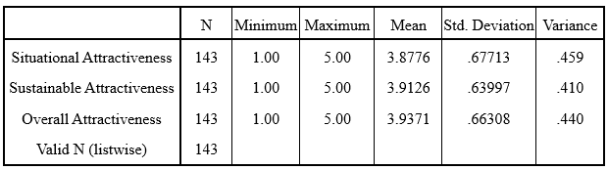
Table 6 shows that the average value of all dimensions of attractiveness of shopping mall is greater than 3.5, and the values are relatively close. Therefore, it can be shown that, for the interviewees, the appeal of the shopping mall is relatively balanced, and it is generally at a medium-upper level.

4.2 Cross tabulation analysis and chi-square tests
Cross tabulation analysis and chi-square tests are used to measure whether the two variables have significant interrelationships. Test results are measured by Person Chi-Square and Sig value is less than 0.05. If the Sig value is less than 0.05, then there is a significant difference between the two variables which proves that the hypothesis is valid. On the contrary, if the Sig value is greater than 0.05, then there isn't a significant difference between the two variables which proves that the hypothesis is invalid.

4.2.1 Gender & goals
Table 7: Cross tabulation analysis of gender & goals
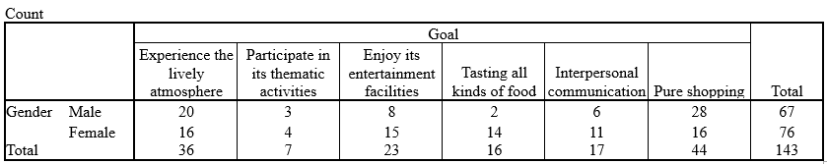
The statistical results in Table 7 show that the experience the lively atmosphere and pure shopping are the main goals of male respondents. The distribution of visits by female respondents is relatively balanced, but the interest in participating in thematic activities is not high.
Table 8: Chi-Square Tests for gender &goals
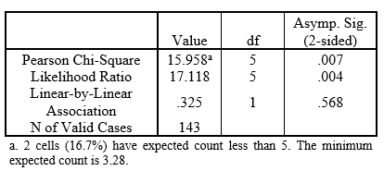
The test results in Table 8 show that Sig.(2-sided) is 0.007, which is less than 0.05. Therefore, the original hypothesis is established, and gender differences have a significant difference in the choice of the visit purpose.

4.2.2 Gender & habits

Table 9: Cross tabulation of gender & habits
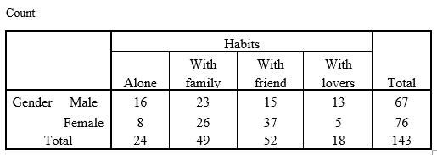

表7的统计结果显示出，相对对于女性受访者而言，男性受访者对独自购物的接受的程度更高，并且没有明显的选择偏好。相反，女性受访者则更多的表现出对同伴的依赖，她们大多数会选择家人或者朋友陪伴购物。

Table 9: Chi-Square Tests income gender &preferences
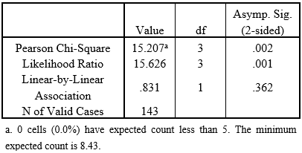

The test results in Table 9 show that Sig.(2-sided) is 0.002, which is less than 0.05. Therefore, the original hypothesis holds that there is a significant difference in the preferences of different genders for shopping habits.

4.2.3 Age and goals
Table 10: Cross tabulation of age & goals
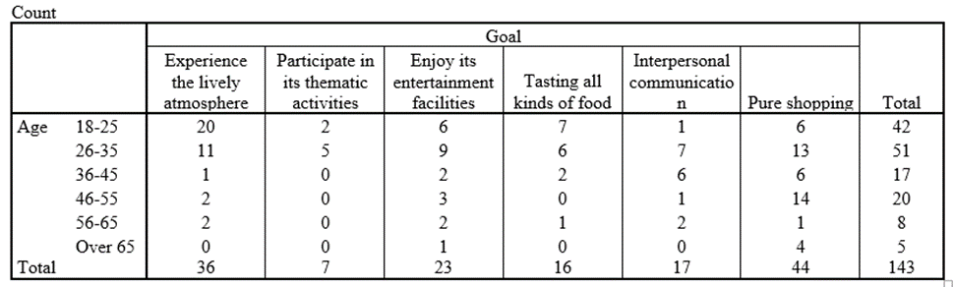

The statistical results in Table 10 show that experiencing a lively atmosphere as well as enjoying entertainment and food are the main purposes of young respondents' visit to shopping mall. But the proportion of entertainment and leisure as the purpose is in a significant decline with the increase of the age level. On the contrary, the proportion of social and pure shopping rises significantly. Especially in the 46-55 age group, basically their main purpose is pure shopping. The interviewees of different age groups have a significant tendency to choose the purpose of the interview overall.

Table 11: Chi-Square Tests for age &goals
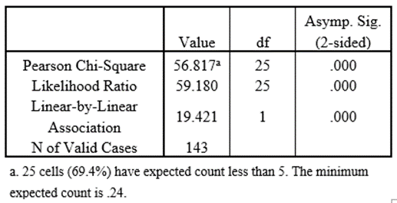
The test results in Table 11 show that Sig.(2-sided) is 0.000, which is less than 0.05. Therefore, the original hypothesis is established, indicating that there is a significant relationship between the age difference and the choice of visit purpose.

4.3 Reliability and validity analysis
This article need to analyze the reliability and validity of the sample after completing the sample statistics. Reliability analysis is mainly to analyze the reliability of the questionnaire. The higher the reliability is, the smaller the data error is, and the higher the reliability is. In this dissertation, the Cronbach's coefficient is chosen to measure the reliability of the data. Usually the coefficient above 0.6 is acceptable, that is, the reliability of the questionnaire is higher. Validity mainly refers to the actual results measured can reflect the extent of what you want to examine the contents. It mainly measures and analyzes the validity of the questionnaire. It is generally considered acceptable if KMO is greater than or equal to 0.8.

4.3.1 experience marketing量表的信度和效度分析
Table 12 Cronbach's Alpha of experience marketing scale
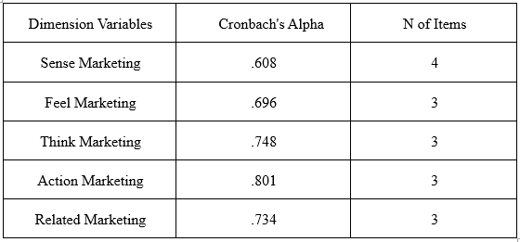
The statistical results in Table 12show that the Cronbach's Alpha values of the five-dimensional variables in the experience marketing scale are 0.608, 0.696, 0.748, 0.801, and 0.743, respectively, which are higher than 0.6. It shows that the overall reliability of the scale of experience marketing is high.

Table 13 KMO and Bartlett's Test of experience marketing scale
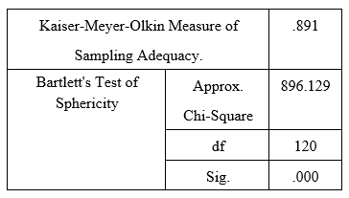
The statistical results in Table 13 show that the value of KMO and Bartlett's Test in the experience marketing scale is 0.891, which is greater than 0.8. This indicates that the overall scale of the experience marketing scale is high. In addition, because the dimension variables of each experience marketing in the scale have been determined, no additional exploratory factor analysis is performed.

4.3.2 Reliability and validity analysis of the attractiveness of shopping mall scale
Table 14 Cronbach's Alpha of attractiveness of shopping mall scale
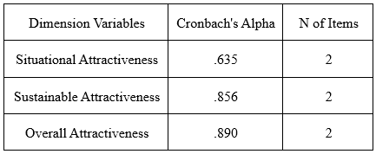
The statistical results in Table 14 show that the Cronbach's Alpha values of the three dimensions in the attractiveness of shopping mall scale are 0.635, 0.856, and 0.890, respectively, which are all higher than 0.6. The overall reliability of the attractiveness of shopping mall scale is high.

Table 15 KMO and Bartlett's Test of attractiveness of shopping mall scale
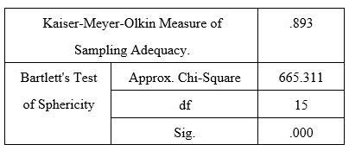
The statistical results in Table 15 show that the value of KMO and Bartlett's Test for the attractiveness of shopping mall scale is 0.893, which is greater than 0.8. This indicates that the overall sensitivity of the attractiveness of shopping mall scale is high. In addition, since the dimensionality variables of the attractiveness of shopping mall in the scale have been determined, no additional exploratory factor analysis is performed.

4.4 Correlation analysis
Correlation analysis is a measure of the close relationship and closeness between factors. In this dissertation, we will use Pearson product-moment correlation coefficient to measure the correlation between experience marketing and attractiveness of shopping mall . In general, the P value is positively correlated between 0 and 1, and the closer it is to 1, the higher the correlation degree is. In addition, the correlation test can preliminarily verify the hypothesis of this study and prepare for the subsequent regression analysis. Therefore, this dissertation will analyze the correlation between different dimensional variables according to the research hypotheses proposed in the literature review.

4.4.1 Overall correlation analysis
Table 16 Correlation analysis of experiential marketing and attractiveness of shopping mall
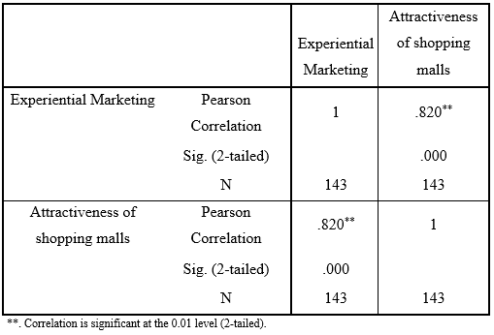
The statistical results in Table 16 show that the Sig. (2-tailed) value is 0.000, which is less than 0.05, indicating that there is a significant positive correlation between the experience marketing and the attractiveness of shopping mall at the 0.01 level. The correlation coefficient is 0.820. However, the overall correlation analysis can not fully explain the correlation between the various dimensional variables, so it needs an in-depth multi-dimension correlation analysis.

4.4.2 Multi-dimension correlation analysis
Table 17 The multi-dimensions of correlation analysis of experiential marketing and attractiveness of shopping mall
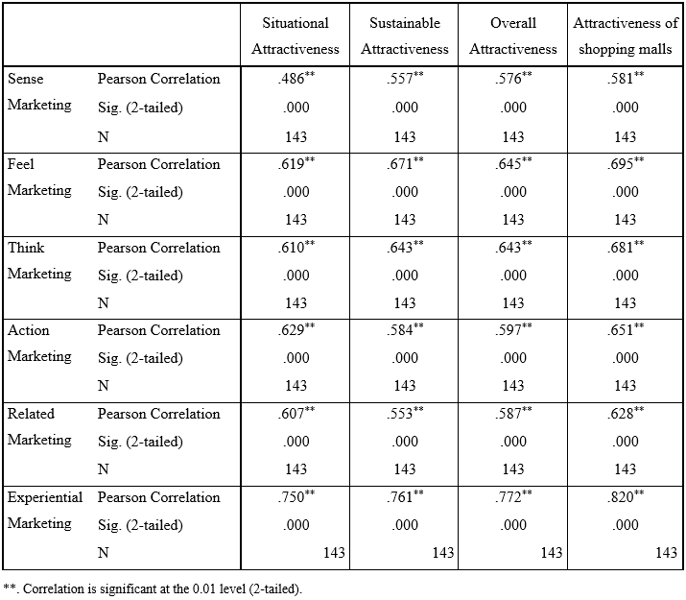
The statistical results in Table 21 show the Sig.(2-tailed) values of each dimension between the experience marketing and the attractiveness of shopping mall , both of which are 0.000 and less than 0.05, indicating that all the dimensional variables are between the experience marketing and the attractiveness of the shopping mall . At the 0.01 level there is a significant positive correlation. It is worth noting that because the correlation analysis did not consider the causality of the variables in the operation, the research hypothesis “experiential marketing has an obviously positive effect on the attractiveness of shopping mall ” cannot be fully verified. Therefore, this article needs to continue the regression analysis of the two research variables: experience marketing and attractiveness of shopping mall .

4.5 Regression analysis
Regression analysis is mainly used to determine the relationship between the independent variable and some dependent variable. R² measures the Goodness of Fit of multivariable linear regression model. The larger the R² value is, the better the fitting degree is, and the range is usually between 0 to 1. Adjusted R² is the result of excluding the influence of the number of independent variables on R², it has higher reference value than R². In addition, F value is the significant test value for the whole model. The larger the F value is, the higher the influence of independent variables on dependent variables is. The T value is a significant test value for regression parameters. The larger the T value is, the more significant the independent variable has on the dependent variable. Tolerance and VIF are used to detect the existence of significant collinearity between different arguments. Generally the tolerance value is greater than 0.2 and the VIF is less than 10 is considered to have no significant collinearity, which indicates that the independence of the independent variables is higher, the analysis results are more accurate.

4.5.1 Regression analysis of experience marketing and attractiveness of shopping mall
In accordance with the structural sequence of the research hypothesis, this article first performs an overall regression analysis of the experience marketing and attractiveness of shopping mall . Since only two research variables are involved, independent variable (experience marketing), and dependent variable (attractiveness of shopping mall ). Therefore, simple linear regression is considered suitable. The analysis results are as follows;

Table 18 experience marketing与attractiveness of shopping mall 的model summary
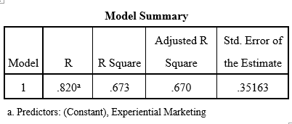
The statistical results in Table 18 show that the adjusted R² value is 0.670, which means that experienced marketing can explain 67% of Measures of Variability in attractiveness of shopping mall .

Table 19 ANOVA of the various experience variables and attractiveness of shopping mall
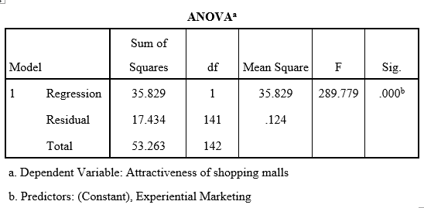
The statistical results in Table 19 show that the F value is 289.779, and the corresponding Sig value is 0.000 and less than 0.05, indicating that the model passed the significance test. In other words, experience marketing can be used as an independent variable of attractiveness of shopping mall to enter regression analysis.

Table 20 Regression coefficient of experience marketing and attractiveness of shopping mall
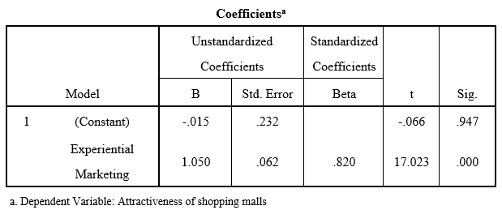

The statistical results in Table 23 show that the t value is 17.023, which corresponds to a Sig value of 0.000 and less than 0.05. The test of significance passed. This means that experience marketing has a significant impact on attractiveness of shopping mall . Therefore, the research in this dissertation assumes that "H: experiential marketing has a significant positive effect on the attractiveness of shopping mall " is verified.

4.5.2 Regression analysis of the experience dimension of various dimensions and attractiveness of shopping mall
Based on the above analysis results, this dissertation will continue to examine the impact relationship between the various dimensions of experience marketing and attractiveness of shopping mall . Because it involves five independent variables (sense marketing, feel marketing, think marketing, action marketing, related marketing). And a dependent (attractiveness of shopping mall ). Therefore, the simple linear regression method will be abandoned, and multiple regression analysis will be selected. The analysis results are as follows;

Table 21 Model summary of experience dimensions and attractiveness of shopping mall
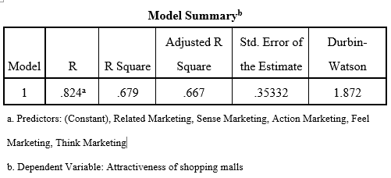
The statistics in Table21 show that the adjusted R² value is 0.667. This means that the experience marketing dimensions can account for 66.7% of measures of variability in attractiveness of shopping mall .

Table 22 ANOVA of the experience dimension dimensions and attractiveness of shopping mall
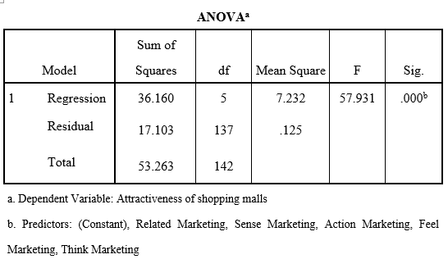
The statistical results in Table 22 show that the F value is 57.931, and the corresponding Sig value is 0.000 and less than 0.05, indicating that the model passed the significance test. Therefore, sense marketing, feel marketing, think marketing, action marketing, and related marketing can all be used as independent variables of attractiveness of shopping mall to enter regression analysis.

Table 23 regression coefficient of experience marketing and attractiveness of shopping mall
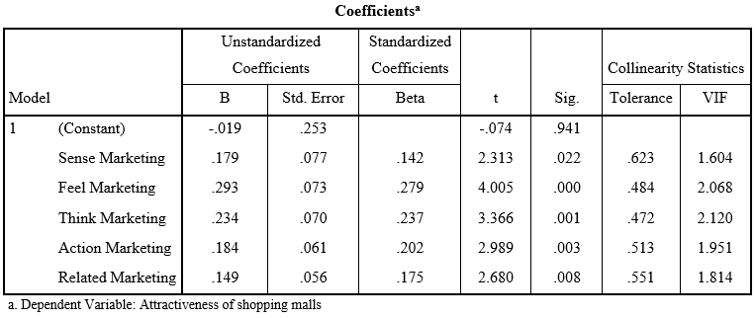
The statistical results in Table 23 show that the tolerance of each independent variable is greater than 0.2; and the VIF value is less than 3. Therefore, there is no significant collinearity in the regression analysis between the various dimensional variables of the experience marketing and the attractiveness of shopping mall . In addition, the t values of each independent variable were 2.313, 4.005, 3.366, 2.989, 2.680, respectively, and the corresponding Sig values were 0.022, 0.000, 0.001, 0.003, and 0.008, respectively, and both were less than 0.05. All significant tests passed. This means that sense marketing, feel marketing, think marketing, action marketing, and related marketing all have significant influence on attractiveness of shopping mall . Therefore, the following five research hypotheses have been verified, as shown in Table 24.

Table 24 Summary of the assumptions about the attractiveness of shopping mall
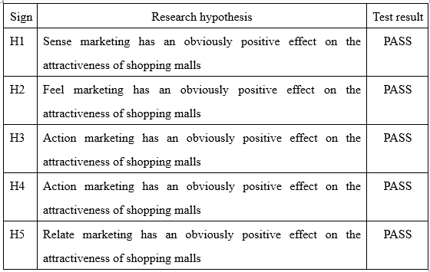
In addition, in order to further analyze the correlation between the various dimensions of the experience marketing and attractiveness of shopping mall . This article will continue to use multiple regression analysis to test the hypothesis.

4.5.3 Regression analysis of experience dimensional variables and situational attractiveness in experience marketing
In this part of the regression analysis, the independent variables are sense marketing, feel marketing, think marketing, action marketing, related marketing. The dependent variable is situational attractiveness. The analysis results are as follows;
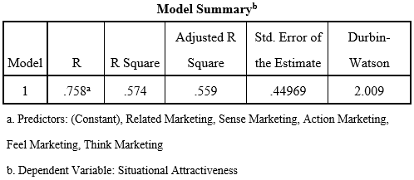
Table 25 Model summary of experience dimension and situational attractiveness
The statistical results in Table 25 show that the adjusted R² value is 0.559, which means that each dimension variable of the experience marketing can explain the measures of variability of 55.9% in the situational attractiveness.

Table 26 ANOVA of experience marketing various dimensional variables and situational attractiveness
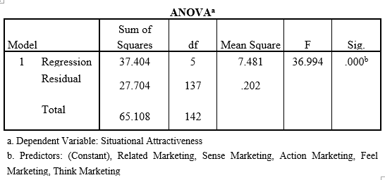
The statistical results in Table 26 show that the F value is 36.994, and the corresponding Sig value is 0.000, which is less than 0.05. This indicates that the theoretical model passed the significance test. Therefore, the five-dimensional variables of the experience marketing can be used as the independent variable to situational attractiveness.

Table 27 Regression coefficients for each dimension variable and situational attractiveness of experience marketing
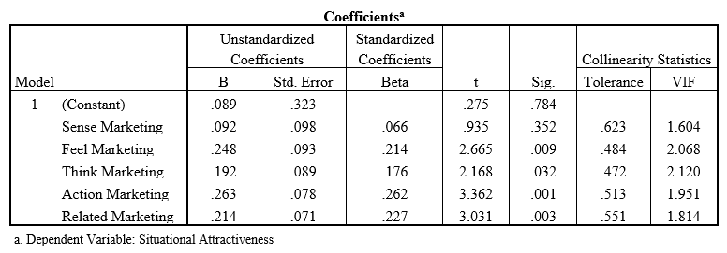
The statistical results in Table 27 show that the tolerance values of the five independent variables are all greater than 0.2; and the VIF values are all less than 3. Therefore, there is no significant collinearity in the regression analysis of each dimension and situational attractiveness of experience marketing. In addition, since the t-value of sense marketing is 0.275, the corresponding Sig value is 0.325, which is greater than 0.05. The significance test failed. It shows that the sense marketing has no significant effect on the situational attractiveness. The t values of the other independent variables are 2.665, 2.168, 3.362, and 3.031, respectively, and the corresponding Sig values are 0.009, 0.032, 0.001, and 0.003, respectively, which are all less than 0.05. All significant tests passed. This means that feel marketing, think marketing, action marketing, and related marketing all have significant effects on the situational attractiveness. Therefore, the following five research hypotheses have been tested, as shown in Table 28.

Table 28 The various dimensions of experience marketing research on the situational attractiveness

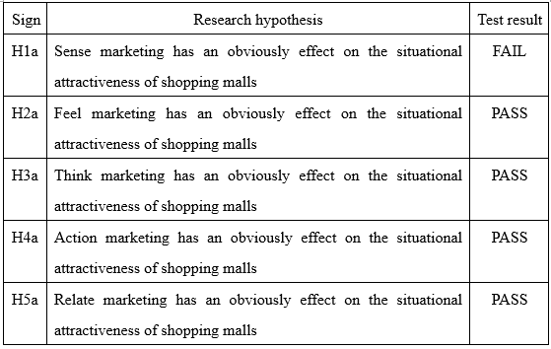

4.5.4 Regression analysis of sustained attractiveness and various dimensional variables of experience marketing
In this part of the regression analysis, the independent variables are sense marketing, feel marketing, think marketing, action marketing, related marketing. The dependent variable is situational attractiveness. The analysis results are as follows;

Table 29 Regression analysis of various dimensions and sustainable attractiveness of experience marketing
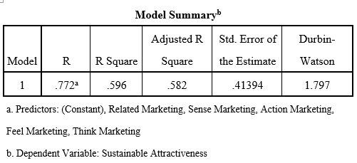
The statistical results in Table 29 show that the adjusted R² value is 0.582, which means that each dimension variable of the experience marketing can explain 58.2% of the measures of variability in the sustainable attractiveness.

Table 30 ANOVA of experience marketing various dimensional variables and situational attractiveness
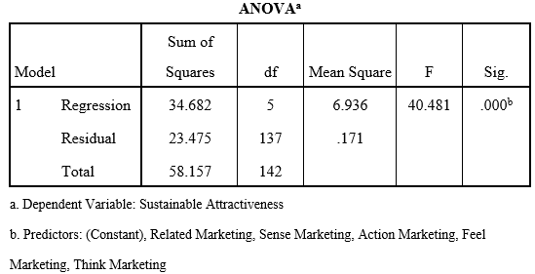

The statistical results in Table 29 show that the F value is 40.481, and the corresponding Sig value is 0.000, less than 0.05 indicates that the theoretical model passed the significance test. Therefore, the five-dimensional variables of the experience marketing can be used as the explicit variable of the sustainable attractiveness.

Table 31 Regression coefficients for various dimensions of experience marketing and sustainable attractiveness
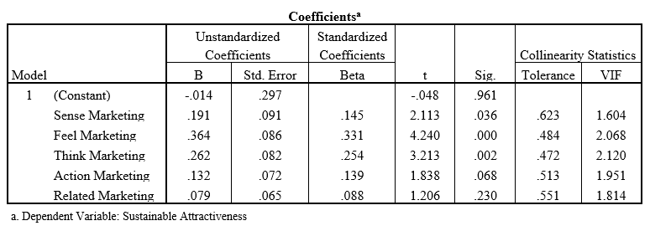
The statistical results in Table 31 show that the tolerance values of the five independent variables are all greater than 0.2; and the VIF values are all less than 3. Therefore, there is no significant collinearity in the regression analysis of each dimension variable of the experience marketing and sustainable attractiveness. In addition, because the t values for action marketing and related marketing are 1.838 and 1.206, respectively, the corresponding Sig values are 0.68 and 0.23, respectively, which are all greater than 0.05. Significant tests failed. It is shown that action marketing and related marketing have no significant influence on the sustainable attractiveness. The t values of the remaining variables are 2.113, 4.240, 3.362, and 3.213, respectively, and their corresponding Sig values are 0.036, 0.000, 0.002, and 0.003, respectively, and both are less than 0.05. All significant tests passed. This means that sense marketing, feel marketing, and think marketing all have significant effects on sustained attractiveness. Therefore, the following five research hypotheses have been tested, as shown in Table 27.
Table 32 Summary of studies on sustained attractiveness for various dimensions of
experience marketing
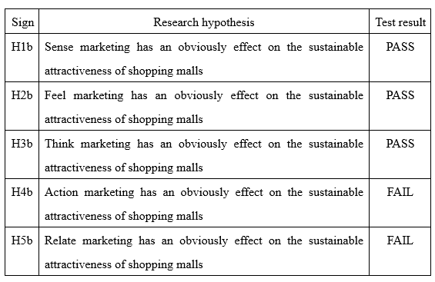

4.5.5 Regression analysis of various dimensions and overall attractiveness of experience marketing
In this part of the regression analysis, the independent variables are sense marketing, feel marketing, think marketing, action marketing, related marketing. The dependent variable is overall attractiveness. The analysis results are as follows;
Table 33 Regression analysis of each dimension of experience marketing and overall attractiveness
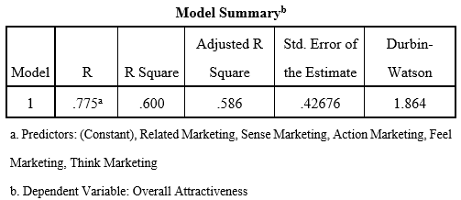
The statistical results in Table 33 show that the adjusted R² value is 0.586, which means that the experience marketing dimensions can explain 58.6% of the measures of variability in the overall attractiveness.

Table 34 ANOVA of experience marketing dimensions and overall attractiveness
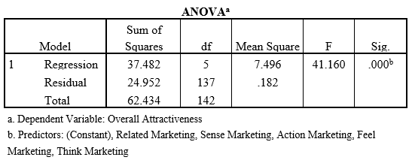
The statistical results in Table 34 show that the F value is 41.160, and the corresponding Sig value is 0.000 and less than 0.05, indicating that the theoretical model passed the significance test. Therefore, the five-dimensional variables of experience marketing can be used as an explanatory variable of overall attractiveness.

Table 35 Regression coefficients for each dimension variable and overall attractiveness of experience marketing
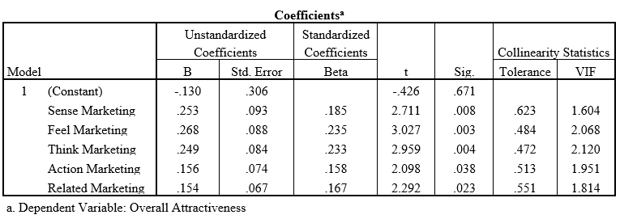
The statistical results in Table 35 show that the tolerance values of the five independent variables are all greater than 0.2; and the VIF values are all less than 3. Therefore, there is no significant collinearity in the regression analysis of each dimension variable and overall attractiveness of experience marketing. In addition, the t values of each independent variable were 2.711, 3.027, 2.959, 2.098, and 2.292, respectively, and their corresponding Sig values were 0.008, 0.003, 0.004, 0.038, and 0.023, respectively, and both were less than 0.05. It shows that all significant tests were passed. This means that sense marketing, feel marketing, think marketing, action marketing, and related marketing have a significant impact on overall attractiveness. Therefore, the following five research hypotheses have been verified, as shown in Table 36.
Table 36 Summary of research on the overall attractiveness of various dimensions of experience marketing
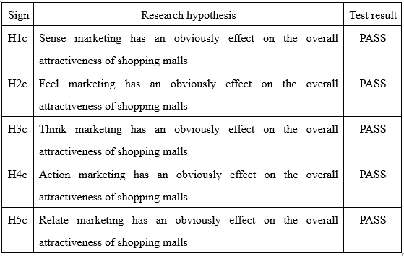

In the above regression analysis, all the research hypotheses in this dissertation have been tested, and the assumptions H1a, H4b, and H5b failed to pass the verification. Therefore, next the researcher will fully discuss and analyze the results of the research combined with the literature review of this article.

Dissertation

Distribution of samples
The statistical results of the sample show that the proportion of female interviews accounts for a majority during all the 143 interviewees from the statistics results of samples. The statistics result is also embodied in the study of Zhang (2014), and she thinks the restriction of traditional gender roles is also an important reason for this situation. females undertake the responsibilities from the family more, which makes shopping is treated as the activities of females traditionally. However, Wang (2015) put forward a different point of view, she thinks, with the shift of social value, the concept of family division of labor becomes more and more blurred, male gradually play more roles in the family, and their chances of acting as final decision makers in the purchase process are gradually increasing (Huang, 2012; Liu, 2014). Therefore, with the development of society, gender distribution will be more balanced in future shopping trends (Xi, 2016). This also interprets why the proportion difference of interviewees in different gender is not large from the side angle in this investigation.

In addition, the young interviewees under the age of 35 accounts for an absolute majority. The result may be related to the investigation method of this dissertation. The online questionnaires are mainly issued through social media, and this makes the interviewed group are the acquaintance of investigation staff. More of them are at the age from 18 to 65. And the young account for a rather high proportion. And this makes the interviewees presents the tendency of becoming younger as a whole. However, what is worthy of being noticed is that this statistic result is also reflected in the study of Guo (2015), and he pointed out more and more young consumers begin to show higher interests in shopping mall. Also, with the prevailing of online shopping, New generation shopping is more dependent on trial and touch than any time ever.

Because it may be affected by age factors, among the interviewees, the proportion of students and employees are relatively a bit high. However, a relatively comprehensive occupation topography complies with the market positioning features of shopping mall. When studying the marketing strategy of shopping mall, Wang (2016) found that Shopping mall meets the consumption multiple-level and diversified needs of different consumer group by its own all-round service and diversified formats compared to other retail format. This also makes most of Shopping mall do not have a target market in traditional meaning, and any consumers will be possible to be its potential clients and their needs can be found therefrom (Zhang, 2015).

Similarly, the monthly disposable income of interviewees may be influenced by the age and occupations, and it is generally at a medium and even low level. On the one hand, the income of most students comes from the support of other members in the family and/or part-time job. This means the income is limited. On the other hand, influenced by the working environment and working nature, the employees and the young people especially who cannot often obtain too high salary with few work experiences. While as the group accounting for a majority, their income level affects the entirety directly. More than that, the level of salary also determined the consumption ability. As a result, the middle-down consumer group in the interviewees occupied an absolute dominant position. However, it doesn't mean that the survey is meaningless. On the contrary, when studying the characteristics of the shopping mall consumers, Wang (2015) found that although the personal consumption power of the middle-low income groups is limited. But considering the overall scale and the market demand, it is quite possible for them to become the main consumer groups in the market. This finding is verified in this dissertation.

In the survey of shopping behavior, only 1/6 chose to shop alone, while more interviewees tended to be accompanied by others, especially friends or family. The results were also reflected in the study of Guo & Yuan(2016). They found that only 23% consumers chose to shop alone, while 77% consumers take shopping as an effective way to build well relationship with family and friends. In addition, gender differences are also reflected in the choice of shopping habits. Nearly 1/5 of male choose to shop alone, compared with 1/10 of female. The results were also reflected in the study of Zhang(2016), in which 85.4% of female consumers chose to shop with someone else. As a result, female interviewees were more dependent on their companions than male. This may be due to the fact that female view shopping more from a interpersonal perspective, which makes them more socially involved in shopping activities and have a happier emotional experience as well as a higher level of shopping enthusiasm than male consumers (Hoch, 2013).

The different purpose of the interview also shows the difference in the consumption behavior and the consumption idea of interviewees. In the cross-analysis with gender, the lively atmosphere is popular with interviewees. However, the male showed a marked tendency on the choice of interview purpose that is focusing more on pure shopping than on other purposes. This may be because males view shopping more as a means and works which must be done (Gu, 2015). Therefore, they lack sufficient interest to participate in shopping(Wang, 2015). In addition, in the cross-analysis with age, interviewees of different age groups also had different choice of interview purpose. As the age level increases, the interviewees' interview purpose gradually shift from entertainment and leisure to social and purely shopping. On the one hand, after the material needs have been greatly satisfied, the spiritual needs have gradually become the dominant needs. As a result, the proportion of social interaction is beginning to rise dramatically. On the other hand, the increase of life pressure makes people's consumption start to be rational. Especially for the middle-aged group, they need to face many other economic pressures such as supporting their parents and raising their children at the same time, which makes pure shopping almost been their only purpose. It is worth noting that, as the age level continues increasing, the proportion of pure shopping is greatly reduced, and the specific gravity distribution of each project tends to be balanced. This may be the compensatory consumption of some older people, who tried to compensate for past consumption aspirations under the conditions of financial permission that had not been realized earlier for various reasons (Wang, 2014).

The above is a full discussion of the sample. Next, this article will provide in-depth analysis of the research results.

4.7.2 Complete discussion of research results
The results of data analysis show that H1a : sense marketing has an obviously positive impact to situational attractiveness；H4b: Action marketing has an obviously positive effect on the sustainable attractiveness of shopping mall; H5b: Relate marketing has an obviously positive effect on the sustainable attractiveness of shopping mall; these three assumptions failed to pass the test. Although the correlation analysis proves that there is a significant correlation between the variables of each dimension, in the regression analysis, they fail to pass the test of significance between independent variables and dependent variables. In other words, during the H1a test, there is a significant positive relationship between sense marketing and situational attractiveness, but no significant causality. The same goes for H4b and H5b. Therefore, the researcher will discuss the three hypotheses in order to better explore the possible factors.

Sense marketing is an independent variable and situational attractiveness is a dependent variable in H1a hypothesis. When there is no significant causal relationship between the two variables, it is shown that sense marketing has no significant effect on situational attractiveness. According to Hulten (2011)research, sense marketing is a marketing process that integrates the senses of the person and the main factors are color, music, style, theme, and so on. And thus it triggers customer's identity, a sense of belonging or excitement. Situational attractiveness refers to the ability of shopping mall to attract customers at a certain time. The main performance is that customers are willing to stay and spend time to consume (Wang, 2010). Therefore, the relationship between the two variables can be explained that the influence of sense marketing makes shopping mall attractive to customers at a certain time. But the attraction does not last long enough to allow customers to stay for a long time, resulting in less significant impact. The reasons may mainly come from two aspects. On the one hand, because of the high vacancy rate of the shopping mall in China, the needs of some consumers can't be completely satisfied, and the serious homogenization will inevitably lead to consumption fatigue. As a result, the customer's willingness to stay is low. On the other hand, because most of the respondents involved in the study are young, they are more likely to be attracted by the lively atmosphere and new things. But their personalized demand for consumption has also caused them to be more and more picky about shopping. It may make it difficult for them to stay and spend time to consume.

What is worthy of being noticed is that in the assumption of H4b and H5b, all dependent variables are sustainable attractiveness while independent variables are action marketing and relate marketing respectively. On the condition that the two assumptions are invalid, it indicates that both action marketing and relate marketing will not have a significant influence on sustainable attractiveness. During the study of Xue (2017), action marketing is considered as an experience activity created by enterprises which the consumers can take part in. While sustainable attractiveness refers to the willing of the customers to revisit shopping mall (Andreassen, 1998). Therefore, when the experience activity of shopping mall can not obtain general acceptance of consumers, the shopping enthusiasm of consumers may be lowered and the consumption amount will be reduced. This also means that sustainable attractiveness of shopping mall wears off gradually. In addition, from the investigation for the interviewees regarding the shopping objectives, the writer found that just a very few young interviewees were interested in taking part in experience activities, while the rather low participation willing of the consumers also interprets that the assumption of H4b cannot be verified. While relate marketing is intended for passing experience on to consumers so that customers are associated with many aspects such as emotion, status, and considerations or associated with other society (Grove & Fisk, 1997). Therefore, when this transmission is blocked, the correlation will be greatly reduced, and then it will affect the sustainable attractiveness. For example, because the impact of action marketing on the constant attractiveness is not significant, this may indirectly lead to a decrease in the effect of related marketing.

Although these three assumptions fail to pass the test, the overall conclusion can be drawn that experiential marketing has a positive impact to attractiveness of shopping mall.

Conclusion
In this chapter, this article uses SPSS to analyze survey data. The first is the descriptive statistics of the sample, and then the crosstabulations are used to compare different variables. On this basis, the reliability and validity of the research scale were analyzed. Finally, the research hypothesis was correlated and regression analysis. The test results show that all the hypotheses have passed the verification except H1a, H4b, and H5b. It shows that the research hypothesis of this article is passed as a whole. In addition, this article combines the literature review to conduct in-depth analysis of the research results. In the next chapter, this article will summarize the full text and make recommendations.

Chapter 5：Conclusions and Recommendations

Introduction
In the chapter four, the researcher verified the study assumption in this dissertation through data analysis and discussion for the investigation results. Therefore, the dissertation will perform overall assessment for the performance of study target and summarize the main study achievement in this dissertation. In addition, the dissertation will demonstrate the study limitation and deficiency of the dissertation from the objective perspective. So that the suggestions can be proposed for the future study.

5.1 Achievement of objectives:
The objectives of this research are as follows:
- Identification of the concepts and components of experience marketing and the attractiveness of shopping mall;
- Exploration of the relationship between the experience marketing and the respective components for the attractiveness of shopping mall;
- Assessment of the influence of experience marketing on the attractiveness of shopping mall;
- Development of recommendations for sustainable long-term developments.

Based on the literature review, this article first clarifies the concept of experience marketing and the attractiveness of marketing products. And according to the results of Teller & Reutterer (2008), the constituent dimensions of the shopping mall attraction identified in this dissertation are respectively situational. Attractiveness, sustainable attractiveness, and overall attractiveness. In addition, the researcher also refers to Schmitt's (1999) theory and divide the component dimensions of experience marketing into sense marketing, feeling marketing, think marketing, action marketing, and related marketing. Therefore, the first research goal of this dissertation has been achieved.

According to the dimensionality division standard which has been confirmed, the researcher proposed the study assumption of this dissertation that "experiential marketing has an obviously positive impact to attractiveness of shopping malls. " and built up a study model as shown in Figure 3. Based on this, the dissertation discussed the relationship between experiential marketing and attractive power of shopping malls at each dimensionality respectively through literature review and proposed the corresponding assumption. Therefore, the second study target of this dissertation has been achieved.
Through data analysis of investigation results, this dissertation verified the study assumption. The results showed that each kind of assumption excluding the three assumptions including H1a, H4b and H5b was all verified. This shows that as a whole, experiential marketing has an obviously positive impact to attractiveness of shopping malls. Therefore, the third study target of this dissertation has been achieved. While the fourth study target is being demonstrated fully in subsequent suggestions.

5.2 Main findings
During the discussion of current development condition of Chinese shopping malls, the researcher found that industrial competition in serious homogenization is the main threat which shopping malls faces. Also, lacking of unique experience theme and exact market positioning is the key to cause the problem. On the one hand, lacking of unique experience theme results in unobvious difference between shopping malls and department stores. The high similarity also causes that the attractive power of the whole industry is reduced. On the other hand, because of the own strong containment of shopping malls, most of shopping malls do not have a clear and exact market positioning. Perhaps, this development mode is more adaptable for earlier expansion. However, when the market competition is getting more and more fierce day by day, no feature often means no attractive power. Therefore, forming more vivid theme feature and exact market positioning is the future development tendency of shopping malls, while how to utilize experiential marketing reasonably is the key to success of shopping malls.

In addition, through literature review and investigation study of experiential marketing and attractive power of shopping malls, the researcher found that the five dimensionalities including sense marketing, feel marketing, think marketing, action marketing, and related marketing are independent with each other but also influenced by each other. Any one marketing method can be used individually and exert their respective different influence effects, however, when they are treated as a whole, the role of experiential marketing will be further expanded to form a complete customer experience process. On the contrary, one stronger progressive relationship is shown between situational attractiveness, sustainable attractiveness, and overall attractiveness. The researcher found that only when situational attractiveness exerts effects can sustainable attractiveness and/or overall attractiveness play the role. The former is the precondition of occurrence of the latter. In addition, a stronger associated relationship is shown between sustainable attractiveness and overall attractiveness. The former is the necessary and sufficient condition of the latter. Moreover, in the investigation results, the researcher found that the differences on population characteristics and consumption behaviors of the interviewees will have a significant influence on the whole effect of experiential marketing and thus the attractive power of shopping malls will be influenced. Therefore, the researcher think that the influences of these potential relationships shall also be considered when applying experiential marketing to the operation process of shopping malls specifically.

5.3 Recommendations for management
Based on the findings, the researcher makes the following recommendations:

Building up a unique experience theme and shopping environment
A distinctive theme endows shopping malls the soul and the feature for being distinguished from the rest of the industry, enabling consumers to experience the characteristics and atmosphere of shopping malls as soon as they enter into the shopping malls. In the meantime, it also helps shopping malls integrate with the scattered and complicated clues to leave a complete and deep impression on the consumers. Under a specific theme environment, building up characteristic experience activities can stimulate consumers' secondary consumption, which is a thorough exploration of the internal advantages of shopping malls. It not only increases the attractive power of shopping and under the setoff of theme atmosphere, these features and advantages are more dynamic. Therefore, shopping malls shall synthesize the local conditions and customs, customer needs, shopping psychology and other relevant factors in the radiating area to confirm consumer group, and then design the theme of shopping malls and express and highlight the theme through environment layout space design and image planning, etc. so as to form a unique differentiation competitive advantage.

- Paying attention to its own details and enhancing sense experience
Sense experience is the first contact experience for the customers. When the sense of consumers receives the information from shopping malls, the experience begins. They will sense the surrounding environment firstly, including sense of shell temperature, auditory feeling and so on. Therefore, shopping malls must pay attention to the sense experience of the customers. In terms of music, temperature, and other more details, the management and control shall be put in place so as to maintain the sense comfort and satisfaction of the customers.

- Paying attention to customer psychology and meeting emotion experience
With the enhancement of material standard of living and cultural quality level of consumers, the objective for consumers to purchase products or services is not only limited to requirement of life necessities, but out of an emotional appeal, and more and more controlled by perceptual factor. Therefore, the layout of shopping malls and service of staff shall take customer psychology into consideration more. For example, shopping malls shall be arranged warmly and harmoniously so that customers can feel relaxed and pleased. While the service personnel is the most closely associated with the customers and shopping malls. Therefore, the services of the service personnel shall be more considerate, more human, thus satisfying the customers' emotional needs.

3. Chasing fashion and novelty, and stimulating think experience
Shopping malls achieves the goal of stimulating think experience of customers generally through the theme activities it holds and the products supplied by it. Wherein, the theme activities of shopping malls shall rely on culture and be on the premise of studying fashionable fashion or a fresh and interesting hot spot nowadays, so as to enhance the participation of customers and achieve the purpose of stimulating customers' think experience; In the meantime, when shopping malls selects products to enter the market, it shall consider whether it meets its own characteristics and is suitable for the targeted customer group, chasing novelty and stimulating customers' think experience based on this.

4. Positioning targeted customer group and leading action experience
Nowadays, shopping malls is gradually becoming a kind of life style and a kind of consumption pattern for the people. Therefore, at the beginning of completion of the construction of shopping malls, through the analysis and research on the urban environment, economic development status, and customers' consumption level, etc., its own targeted customer group is effectively positioned so that customers can like and enjoy the process of revisiting and treat it as a part of life. The main force stores where social function exists in shopping malls are introduced so that customers can communicate and interact with others pleasantly. In addition, shopping mall can be associated with social activities and hot events through hosting, undertaking, and sponsoring, etc., so that consumers can have a more realistic feel for shopping mall.

5. Enhancing the own quality and chasing associated experiences
The positioning of shopping malls will no longer be the location of shopping but be the commercial space for meeting customer needs and building up perfect shopping experience of customers. With constant changes of consumption needs and personal pursuit of consumers, shopping malls must keep up with the steps of the consumers closely and treat meeting needs of consumers as the goal always, and strive to enhance its own quality and enhance the evaluation from the customers so that the coming customers can find out their sense of belonging in shopping malls to ensure that the visiting shopping malls becomes the symbol of their identity and status.

5.4 Limitations of research
Because the main purpose of this dissertation is to study the impact of experiential marketing on the attractiveness of Chinese shopping malls. Therefore, the study more focuses on experiential marketing and the influence relationship with the attractive power of shopping malls. Thus, the features and inner advantages of shopping malls itself may be ignored. In addition, because the researcher do not have academic background of statistics themselves, the utilization of SPSS software and methods of data analysis mainly rely on the self-study of researcher. As a result, under the condition of limited knowledge, researcher' interpretation of data may be insufficient. The another limitation is that the study may not take full consideration of the discrepancies in different cultural backgrounds and related influences.

5.5 Prospects for the future
In this study, the target of this dissertation has been fully achieved. However, considering the limitation of this study, the researcher will propose some improved suggestions so as to supply better help for future study. On the one hand, if time permits, the capacity of sample can be further enhanced and the feasibility of interview can also be considered. In addition, some professional knowledge about statistics can be studied more systematically to enhance the grasping on SPSS, AMOS and other related software. Moreover, the influences of different factors shall be considered evenly during the study, including introducing mediating variable.

Conclusion
The chapter is the final conclusion of this dissertation. The main purpose of this dissertation is analysing the influence of experience marketing on the attractiveness of shopping malls in China. The study results show that experiential marketing has an obviously positive impact to attractiveness of shopping malls as a whole. Therefore, the main purpose of this dissertation has been realized. This will be good supplementary to perfect existing experienced marketing theoretical system in China. Similarly, it can also be used as a reference to be used in specific practice. The dissertation discussed the development status and the existing problems in shopping mall industry in the study background of chapter 1 and defined the objective and target of this study on this basis. In the literature review of chapter 2, the dissertation discussed the relevant concept and constitutional dimensionality of experienced marketing and attractive power of shopping mall respectively, and proposed the study assumption and study model of this dissertation on this basis. In chapter 3, the study method of this dissertation was mainly discussed and the study way mainly focusing on quantitative analysis and the investigation method mainly focusing on questionnaire were defined. In chapter 4, the dissertation mainly conducted analysis for the data collected through SPSS and drew a conclusion and discussion. In chapter 5, based on the previous conclusions and findings, the researcher proposed reasonable suggestion and drew a conclusion.

Bibliography
Acharya, A. S., Prakash, A., Saxena, P., & Nigam, A. (2013). Sampling: Why and how of it. Indian Journal of Medical Specialties, 4(2), 329-331.

Alavi, S. A., Rezaei, S., Valaei, N., & Wan Ismail, W. K. (2016). Examining shopping mall consumer decision-making styles, satisfaction and purchase intention. The International Review of Retail, Distribution and Consumer Research, 26(3), pp. 293-304.

Alreck, P., & Settle, R. B. (2002). Gender effects on Internet, catalogue and store shopping. Journal of Database Marketing & Customer Strategy Management, 9(2), 132-137.

Altmann, J. (1974). Observational study of behavior: sampling methods. Behaviour, 49(3), 253-257

Andreassen, T. W., (1998). Customer loyalty and Complex Services. International Journal of Service Industry Management, 9(1), pp. 178-194.

Atwal, G., & Williams, A., (2017). Luxury brand marketing: the experience is everything. In Advances in Luxury Brand Management. pp. 47.

Babin, B. J., Darden, W. R., & Griffin, M. (1994). Work and/or fun: measuring hedonic and utilitarian shopping value. Journal of consumer research, 20(4), pp. 697-701.

Bellenger, D.N., Robertson, D.H., and Greenberg, B.A., (1977). Shopping Centre Patronage Motives. Journal of Retailing, 53(2) pp. 33-37.

Bloemer, J., & Ruyter, K. d. (1998). On the relationship between store image, store satisfaction and store loyalty. European Journal of Marketing, 32(5/6), pp. 499-513.

Bordens, K. S., & Abbott, B. B. (2002). Research design and methods: A process approach. McGraw-Hill.

Bryman, A. (2006). Integrating quantitative and qualitative research: how is it done?. Qualitative research, 6(1), 97-113.

Burns, A. C., & Bush, R. F. (2000). Marketing research. Globalization, 1(7).

Chen, J. Y., Qu, D., & Cheng, Y, X., (2016). Consumer-Participating Mode of Experience Marketing for Agricultural Products. Innovation and Management. pp.76-78..

Chen, R., (2016). Understand the Humanistic Experience Marketing From the Consumer's Point of View. Market Modernization, (9), pp. 180-183.

Chen, S., (2010). Research on Customer Value Strategy Based on Customer Experience. Value Engineering, (10), pp. 17-19.

Chen, Y. Y., & Fan, X. C., (2013). On experiential marketing. [Online]. Available at:
http://www.hdjjgl.cn/ch/reader/create_pdf.aspx?file_no=HDJJ200302042&year_id=2003&quarter_id=2&falg=1 [Accessed 9 November 2017].

Cochran, W. G. (2007). Sampling techniques. John Wiley & Sons.

Cui, P., (2014). Research on retail store experience marketing. Management World (6), pp. 81-87.
Dębek, M. (2015). What drives shopping mall attractiveness?. [Online]. Available at: https://www.degruyter.com/downloadpdf/j/pjap.2015.13.issue-1/pjap-2015-0026/pjap-2015-0026.pdf [Accessed 5 December 2017].

Deng. Q.X., (2011). Research on Experiential Marketing. Beijing: Capital University of Economics and Business Press, pp. 19-20.

Dennis, C., (2005). Objects of desire: Consumer behavior in shopping centre choices.
Basingstoke: Palgrave Macmillan.

Denzin, N. K., & Giardina, M. D. (2016). Introduction. In Qualitative Inquiry—Past, Present, and Future Routledge.

Denzin, N. K., & Lincoln, Y. S. (1994). Handbook of qualitative research. Sage publications, inc.

Dick, A., & Basu, K., (1994). Customer loyalty: toward and integrated conceptual framework. Journal of the Academy of Marketing Science, 22, pp. 99-113.

Du, J. A., & Fan, X. C., (2015). Research on customer satisfaction model based on experience, (5), pp. 517-520.

Etikan, I., Musa, S. A., & Alkassim, R. S. (2016). Comparison of convenience sampling and purposive sampling. American Journal of Theoretical and Applied Statistics, 5(1), 1-4.

Evans, J. R., & Mathur, A. (2005). The value of online surveys. Internet research, 15(2), 189-192.

Gan, S.J., (2012). The Polymerization Effects of Constituent Elements in Shopping Mall. Guangzhou : South China University of Technology Press.

Grewal, D., Baker, J., Levy, M., & Voss, G. B. (2003). The effects of wait expectations and store atmosphere evaluations on patronage intentions in service-intensive retail stores. Journal of retailing, 79(4), 218-221

Guarte, J. M., & Barrios, E. B. (2006). Estimation under purposive sampling. Communications in Statistics—Simulation and Computation®, 35(2), 277-284.

Guo, Q. H., (2015). Marketing Analysis of Shopping Mall in Experience Economy. [Online]. Available at: http://www.xdsyzzs.com/shangyeliutong/1277.html [Accessed 2 December 2017].

Homburg, C., Jozić, D., & Kuehnl, C. (2017). Customer experience management: toward implementing an evolving marketing concept. Journal of the Academy of Marketing Science, 45(3), pp. 348-350.

Hulten, B., (2011). Sensory marketing: the multi-sensory brand-experience concept. European Business Review, 23(3), pp. 218-223.

Ingene, C.A., (1984). Productivity and functional shifting in spatial retailing:private and social perspectives. Journalof Retailingand Consumer Services. 60 (3), pp. 15-26.

Ismail El-Adly, M. (2007). Shopping malls attractiveness: a segmentation approach. International Journal of Retail & Distribution Management, 35(11), pp. 936-950.

Kasriel-Alexander, D. (2016). Top 10 global consumer trends for 2016. Euromonitor International.

Kim, J. W., Lee, F., & Suh, Y. G. (2015). Satisfaction and loyalty from shopping mall experience and brand personality. Services Marketing Quarterly, 36(1), pp. 54-61.

Knupfer, N. N., & McLellan, H. (1996). Descriptive research methodologies. Handbook of research for educational communications and technology, 1203-1209.
Jiang, T., & Hu, Z. M., (2011). Enterprise based on brand experience: a study of consumer behavior patterns. Enterprise Vitality, (2), pp. 16-27.

Li, G. M., Qian M. H., & Gou, Y, Z., (2012). Research on experiential marketing strategy based on interactive guidance, (1), pp. 74.

Li, X.L., (2015). Experiential Marketing and Brand Building. Management World, (1), pp. 157.

Liu, F. J., & Lei, B.Y., & Wang, Y.X., (2012). Consumption demand and marketing strategy in the era of experiencing economy. Chinese industrial economy, (8), pp. 81-86.

Liu, J.T., (2013).Research on Experiential Marketing Strategy of Retail Industry. Modern commerce industry, (5), pp.79-80.

Liu, .L., (2015). Review of Experience Marketing Research. Business Circles, (9), PP. 110-116.

Liu, Y., & Zhang, D.W., (2015). Experience the value of marketing. Jiangsu Commercial Forum, (5), pp.72-78.

Luo, H.C., (2014), An empirical study on the determinants of service loyalty: The perspective of the transaction process. Management Review, (11).

Lumsden, J. (2007). Online-questionnaire design guidelines. Handbook of research on electronic surveys and measurements, 59-67.

Lumsden, J., & Morgan, W. (2005). Online-questionnaire design: Establishing guidelines and evaluating existing eupport.

Ma, D., H., (2014). A Literature Review on the Research about Consumer Behavior in Shopping Mall. Modern marketing, 2014, 4(1): 22-28.

Malhotra, N., Hall, J., Shaw, M., & Oppenheim, P. (2006). Marketing research: An applied orientation. Pearson Education Australia.

Merriam, S. B. (1998). Qualitative Research and Case Study Applications in Education. Revised and Expanded from" Case Study Research in Education.". Jossey-Bass Publishers.

Montag, C., & Reuter, M. (2008). Does speed in completing an online questionnaire have an influence on its reliability?. CyberPsychology & Behavior, 11(6), 720-721.

Oliver, P., & Jupp, V. (2006). Purposive sampling. Sage.

Oppewal, H., & Holyoake, B. (2004). Bundling and retail agglomeration effects on shopping behavior. Journal of Retailing and Consumer Services, 11(2), pp. 63-65.

Pine II, P. G., & Gilmore, J. H., (1998). Welcome to the Experience Economy. [Online]. Available at: https://hbr.org/1998/07/welcome-to-the-experience-economy [Accessed 5 November 2017].

Pine, B. J., & Gilmore, J. H. (2011). The experience economy. Harvard Business Press. (76), pp, 93-96.

Reinartz, W. J., & Kumar, V. (1999). Store-, market-, and consumer-characteristics: The drivers of store performance. Marketing Letters, 10(1), 5-23.

Rhea, D. (2014). Experiential Marketing: A New Framework for Design and Communications By Bernd Schmitt. Design Management Review, 25(4), pp. 23-25.

Robinette, S., Brand, C., & Lenz, V., (2000). Emotion marketing. McGraw-Hill Professional Publishing.

Reinartz, W. J., & Kumar, V. (1999). Store-, market-, and consumer-characteristics: The drivers of store performance. Marketing Letters, 10(1), pp. 5-23.

Shan, S.S., & Wang, J., (2015). Analysis of Consumer Demand and Marketing Innovation in the Era of Experience Economy. Modern marketing, (7), pp. 69.

Stebbins, R. A. (2008). Exploratory research. The SAGE encyclopedia of qualitative research methods, 1, 323-326.

Timothy, D. J. (2005). Shopping tourism, retailing and leisure. Channel View Publications.

Toffler, B., (1970). Future Shock. 1st ed. [E-book] New York: Bantam Books, pp. 25-27. Available at:
https://archive.org/stream/FutureShock-Toffler/Future-Shock_-_Toffler#page/n21/mode/1up [Accessed 5 November 2017].

Same, S., & Larimo, J. (2012). Marketing theory: Experience marketing and experiential marketing. [Online]. Available at:
https://www.researchgate.net/profile/Siiri_Same2/publication/268016525_Marketing_Theory_Experience_Marketing_and_Experiential_Marketing/links/54ddde360cf2814662eb9d53.pdf [Accessed 13 November 2017].

Schmitt, B., (2011). Experience Marketing: Concepts, Frameworks and Consumer Insights. [E-book] New York: Now Publishers Inc. pp. 15-38. Available at:
https://books.google.co.uk/books?id=X7Ya16wdXxkC&printsec=frontcover&hl=zh-CN&source=gbs_ge_summary_r&cad=0#v=onepage&q&f=false
[Accessed 29 November 2017].

Schmitt, B., & Zarantonello, L. (2013). Consumer experience and experiential marketing: A critical review. In Review of marketing Research, pp. 59-63.

Schmitt, B. H., (1999). Experiential Marketing: How to Get Customers to Sense, Feel, Think, Act, Relate.[E-book] New York: Simon and Schuster. Available at:
https://books.google.co.uk/books?id=a9vN9sSn_l8C&printsec=frontcover&hl=zh-CN#v=onepage&q&f=false [Accessed 9 November 2017].

Stoltman, J. J., Gentry, J. W., & Anglin, K. A. (1991). Shopping choices: the case of mall choice. [Online]. Available at:
http://www.acrwebsite.org/volumes/7198/volumes/v18/NA-18
[Accessed 12 December 2017].

Teller, C., & Reutterer, T. (2008). The evolving concept of retail attractiveness: what makes retail agglomerations attractive when customers shop at them?. Journal of Retailing and Consumer Services, 15(3), 127-143.

Tynan, C., McKechnie, S., & Hartley, S. (2014). Interpreting value in the customer service experience using customer-dominant logic. Journal of Marketing Management, 30 (9-10), pp.1073.
Van Selm, M., & Jankowski, N. W. (2006). Conducting online surveys. Quality and quantity, 40(3), 448-451.

Wakefield, K.L., & Baker, J., (1998) Excitement at the Mall: Determinations and Effects on Shopping Response, Journal of Retailing,74(4), pp. 532-539.

Walter, N., Cleff, T., & Chu, G. (2013). Brand experience’s influence on customer satisfaction and loyalty: a mirage in marketing research. International Journal of Management Research and Business Strategy, 2(1), 131-143.

Wang, T., & Cui, G.H., (2013). Interpretation and Construction of Experiential. Marketing Under the Background of Economic Form Evolution. Economic Management, (20), pp. 43-49.

Wang, X.Y., (2012). Research on the Consumer Behavior Patterns in Experiencing Economy. Beijing: Capital University of Economics and Business Press, pp. 15-23.

Wang. S., & Fu, X.Z., (2013). Experience Marketing and Customer Experience Value Analysis Model. Economic Management , (21), pp. 34-37.

Wang, X., (2014). Influence of Service Experience on Customer Consumption Emotion and Satisfaction. Business research, (6). pp.116.

Wang,Y.l,, (2014) Analysis of the Differences in Consumption of Residents in China ECONOMIC RESEARCHGUIDE , (23)

Waters, C. K. (2007). The nature and context of exploratory experimentation: An introduction to three case studies of exploratory research. History and Philosophy of the Life Sciences, 281-284.

Wei, Y.Z., (2015). Research on Experience Marketing Strategy Under the Background of Experience Economy. [Online]. Available at:
http://doc.mbalib.com/view/ed63975c9bff38293679c8fecf4c7928.html [Accessed 30 November 2017].

Wong, G.,Yu, L., and Yuan, L., (2001). SCATTER: an instrument for measuring shopping center attractiveness. International Journal of Retail & Distribution Management, 29 (2), pp. 76-86.

Xue, W., Pei, Y., & Li, D. (2015). Analysis of the profit model of enterprise experience marketing based on customer experience. In Logistics, Informatics and Service Sciences (LISS), pp. 3-5.

Yu, K., (2013). Research on the core competence of shopping mall. Commercial Times, (34), pp. 15.

Yu, Y. T., & Dean, A., (2011). The contribution of emotional satisfaction to consumer loyalty. International Journal of Service Industry Management, 12(3), pp.234-250.

Zhang, E.B., (2010). The Outline of Experience Consumption. [E-book] Chendu: Southwestern University of Finance and Economics Press, pp. 3-21. Available at: https://read.douban.com/reader/ebook/11587878/ [Accessed 5 November 2017].

Zhang, R. X., (2013). Analysis of Experiential Marketing. Management Observer. (22), pp. 22-24.

Zhang, X.Y., (2014). Gender Differences in Shopping Center Consumer Behavior. Business Times, (16), 16-18.

Appendix 1 – Online questionnaire
Research on the Influence of Experiential Marketing on Attractiveness of shopping mall
This is a brief questionnaire designed to research on the Influence of Experiential Marketing on ATTRACTIVENESS OF SHOPPING MALLS IN CHINA. It should take around 3-5 minutes to complete. This questionnaire follows the principle of voluntary participation, so participants have the right to withdraw at any time. The identify of all participants will remain anonymous and the information obtained will strictly only be used as a research tool by the researcher for the purpose of this dissertation. Participants cooperation in completing this questionnaire would be greatly appreciated.
(Please tick the relevant boxes)

Q1. Have you ever visited the shopping mall? (Please tick the relevant boxes)
Yes | No
☐ | ☐

Q2. Which one of the following best describes gender? (Please tick the relevant boxes)
Male | Female | Prefer not to say
☐ | ☐ | ☐

Q3. Which one of the following best describes age? (Please tick the relevant boxes)
18-25 | 26-35 | 36-45 | 46-55 | 56-65 | Over 65 | Prefer not to say
☐ | ☐ | ☐ | ☐ | ☐ | ☐ | ☐

Q4. Which one of the following best describes your current occupation? (Please tick the relevant boxes)
Employed | ☐ | Public functionary | ☐
Student | ☐ | Skilled worker | ☐
Self employed | ☐ | Freelancer | ☐
Retired | ☐ | Professional occupation | ☐
Senior manager | ☐ | Not employed | ☐
Middle manager | ☐ | Other (please specify) | ☐
Prefer not to say | ☐

Q5. Which one of the following best describes your average monthly disposable income (RMB) ? (Including family-funded and part-time income) (Please tick the relevant boxes)
Under 2,000 | ☐ | 2,000 - 4,000 | ☐
4,001 - 6,000 | ☐ | 6,001 - 8,000 | ☐
Over 8,000 | ☐ | Prefer not to say | ☐

Q6. Which one of the following best describes your average monthly consumption at the shopping mall (RMB) ? (Please tick the relevant boxes)
Under 500 | ☐ | 500 - 1,500 | ☐
1,501 - 2,500 | ☐ | 2,501 - 3,500 | ☐
Over 3,500 | ☐ | Prefer not to say | ☐

Q7. How often do you shop at shopping mall on a monthly basis? (Please tick the relevant boxes)
Less than 1 time | ☐ | 1 - 2 times | ☐
3 - 5 times | ☐ | 6 - 10 times | ☐
More than 10 times | ☐

Q8. When you visit this shopping mall, you prefer? (Please tick the relevant boxes)
Alone | ☐ | With family | ☐
With friend | ☐ | With lovers | ☐
Other | ☐

Q9. Do you have a purpose other than shopping to visit the shopping mall? (Please tick the relevant boxes)
Yes | No
☐ | ☐

Q10. What are your goals for visiting the shopping mall?
Experience the atmosphere of the festival | ☐ | Participate in its thematic activities | ☐
Enjoy its entertainment facilities | ☐ | Tasting all kinds of food | ☐
Interpersonal communication | ☐ | Other | ☐

Q11. Please evaluate the shopping mall according to your own real experience, select a appropriate score from 1 to 5 and draw a "√". (Please tick the relevant boxes)
( 1: Strongly Disagree; 2 : Disagree; 3 : Neither Agree Nor Disagree; 4 : Agree, 5 : Strongly Agree )
No. |  | 1 | 2 | 3 | 4 | 5
1 | The decoration style of this shopping mall are distinctive
2 | The temperature in this shopping mall is comfortable
3 | The music in this shopping mall is pleasant
4 | The fragrance of this shopping mall is appealing
5 | Visiting this shopping mall makes me feel relaxed
6 | This shopping mall can creates a comfortable atmosphere
7 | The service offered in the shopping mall is considerate
8 | The design style of this shopping mall can inspire my divergent thinking
9 | The theme activities organized by this shopping mall capture inspire my interest
10 | The environment, goods, services and people in this shopping mall have given me a novel experience
11 | This shopping mall makes shopping more fun
12 | Visiting this shopping center has enriched my spare life
13 | Visiting this shopping mall has become a part of my life
14 | During my visit in this shopping mall I have had pleasant interactions with other people
15 | Buying in this this shopping mall presents my identity, taste and social status
16 | I get to know like-minded people in this shopping mall, giving me a sense of belonging
17 | This shopping mall gave me a good impression on my first visit
18 | I am willing to stay here for a long time
19 | I enjoy shopping in this shopping mall
20 | I will continue to visit and shop in this shopping mall
21 | I am satisfied with the shopping center as a whole
22 | I will recommend this shopping mall to other people
Thank you for your participation and cooperation

