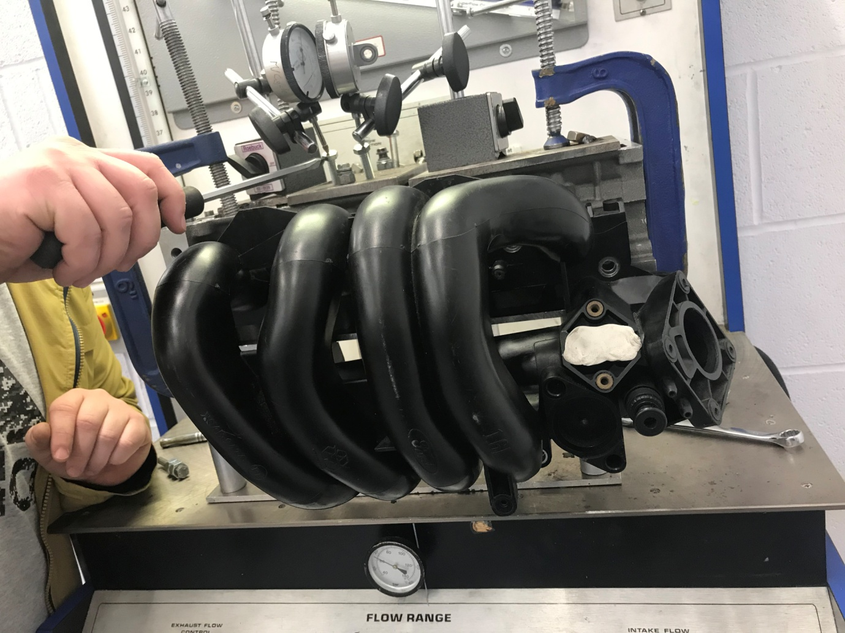
Alexander Wright (1701086)

Powertrain Design & Efficiency
Powertrain Technology
Contents
1 Introduction 2
2 Methodology 3
2.1 Testing Procedures 3
3 Testing Results & Analysis 5
3.1 Engine Data & Info 5
3.2 Engine Measurements and Weights 5
3.2.1 Valvetrain Component Weights 5
3.2.2 General Measurements 5
3.3 SF-110 Flowbench Figures and Results 6
3.3.1 Bare Cylinder Head 6
3.3.2 With Standard Inlet Manifold 6
3.3.3 Flared Entry to Inlet Port 7
3.4 Cylinder Head Flow Capabilities and Conclusion of Test Results 8
3.5 Flow Coefficient Graphs and Data 9
3.5.1 CFM Per Square Inch Graphs 9
3.5.2 Flow Coefficient (CF) Graphs 10
3.6 Camshaft Profile 11
3.7 Air Flow through the Engine 12
3.7.1 Calculating the HP (horsepower) per cylinder 12
3.7.2 Calculating Engine Power from Test Flow 12
3.7.3 Calculating Engine Speed from Peak Power 12
3.8 Valve Modifications 13
3.9 Inlet Port Modifications 14
4 Summary 16
5 Bibliography 17
6 Appendix 18
6.1.1 Graphs Illustrating CFM against valve lift for the various cylinder head setups 18

Introduction
Over the past century, internal combustion engine technology has made much significant advancement, specifically with regards to engine control systems and design. Despite this, the physical moving components have barely changed in basic operation, with the main rotating assembly remaining almost completely unchanged, as the basic fundamentals of engine operation still stand. What has changed vastly over the years, is cylinder head and valve-train design
With regards to internal combustion engine development; maximising performance and efficiency are key aspects for any engineer to consider. This directly links in with cylinder head development, with the importance of the flow of gas in and out of the engine being paramount to efficient operation and performance.
“Nowhere is fuel so plentiful that its inefficient use in quantity can be considered a substitute for power obtained by efficient burning. All other factors being equal, the competition engine that burns its fuel more efficiently will produce greater power. Hence, good cylinder head design is of utmost importance to any engine – be it a racing engine or a low powered production power-plant.” - (Smith, 1977)
The process of getting the charge of air and fuel into the combustion chamber with the maximum possible efficiency, in the attempt to achieve the highest possible’ Volumetric Efficiency,’ is one of the primary goals for internal combustion engine design.
The simplest way to maximise volumetric efficiency, is to compress the induction charge, which can be done via forced induction (Turbocharging and Supercharging), however on a naturally aspirated engine, this is much harder to achieve, as the induction charge is entering the intake at atmospheric pressure, meaning that the pressure difference between the cylinder and the inlet isn’t as large as it would be with the use of forced induction.
Because of this, the intake and port design in a naturally aspirated engine is; more than an equivalent engine with forced induction, very important towards maximising volumetric efficiency and achieving more performance.
The following report will demonstrate the flow capabilities of a standard production cylinder head by performing a series of flow tests utilising the SF-110 Superflow Bench. From this, alongside any data obtained from research and measurements, the flow properties can be closely analysed, and any possible redesign considerations can be made based on the appropriate research and calculations.

Methodology

Testing Procedures
The primary research and testing for this report were carried out with a series of practical tests performed on the 1.6 Zetec cylinder head. The first to be performed was the weighing of the valve-train components, including the hydraulic lifter, valve, spring, retainer and collets; measured using a high accuracy bench scale (results detailed in section 3.2.1.).
This was then followed by general measurements, such as the valve and port diameters, bore x stroke, in addition to the head gasket thickness (results detailed in section 3.2.2.). Obtaining many of these measurements can be done with the use of vernier callipers, with the ability to measure inner and outer dimensions with a high degree of accuracy. Measurement of the stroke is achieved via the use of a Dial Bore Gauge, which has the same functionality as a DTI (Dial Test Indicator), only with a larger scale to suit the stroke of an engines crankshaft.
Measuring the camshaft profile was achieved by mounting the cam itself on a bench lathe, secured at both ends. With a DTI (Dial Test Indicator) positioned on one of the cam lobes. By manually turning the camshaft in increments of 1° (360° rotation), datum points could be taken at each interval, providing a complete profile of the lobe, identifying the lift values (mm) at any given point.
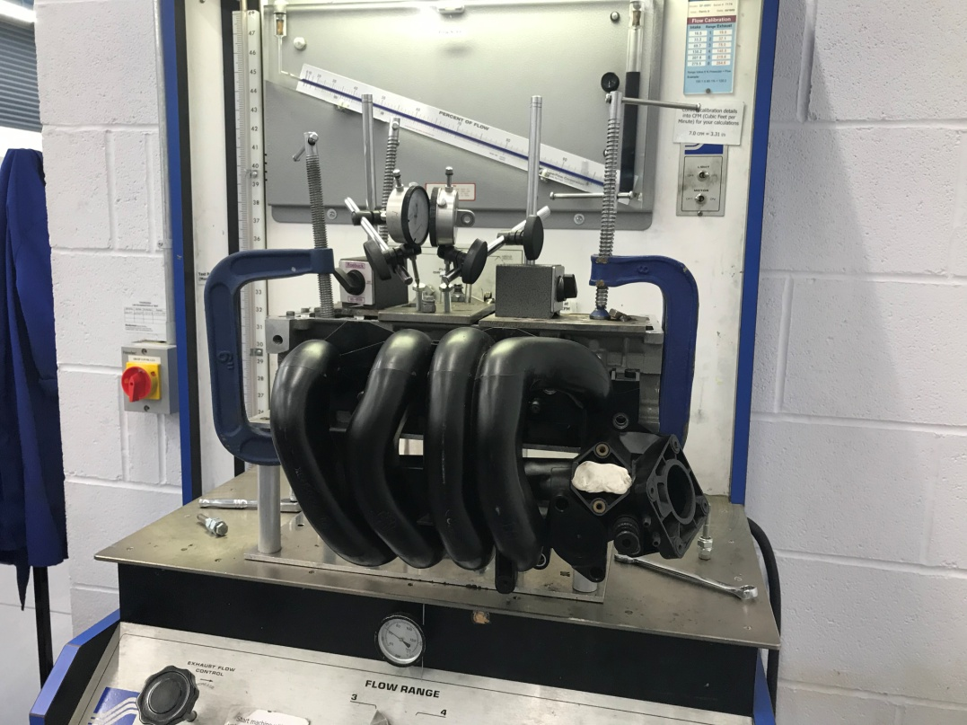
Utilising the SF-110 Flowbench, the inlet side of the cylinder was then tested for its flow properties. For testing and comparison purposes, the head was flowed bare, with the standard inlet manifold, and also with a slight modification to the inlet port, simply with a smoothed edge. The cylinder head is mounted to the flowbench via an adapter (containing a cylinder/tube with the same bore as the tested engine) with 2 mounting flanges to allow both sealing surfaces to remain airtight during testing. Upon the top of the head, a steel adapter plate featuring angled thread inserts is fitted allowing for manual adjustment of the valve lift, as well as the mounting of the DTI’s to determine the lift values.

Zetec 1.6 16V cylinder head on the SF-110 Flowbench with the inlet manifold fitted ready for testing. Note the DTI gauges fitted on a specifically designed steel mounting plate to allow measured adjustment of the valve lift via the 2 bolts pressing upon the hydraulic lifter.
Safety note: When performing the flow test, the option to wear P.P.E (personal protection equipment) is to be considered if using the bench for an extended period of time, in the form of ear defenders, however it is not completely necessary. Steel toe capped boots are to be worn at all times while present in the workshop.
The flow test was performed with valve lift increments of 0.5mm, until maximum lift was reached. An extra datum point was taken at 8.5mm to explore the effects of higher lift with unmodified inlet ports, which proved to produce negligible flow benefits. This process was then repeated twice to test both the inlet manifold and inlet port modification. When operating the flowbench, close attention must be paid to the LPS (litres per second) scale, to prevent the fluid within the machine from being blown out, causing possible damage.
Displayed upon the flow calibration card of the machine is a conversion table, which provides the figures needed to multiply the Flowscale percentage by when utilising different ranges:
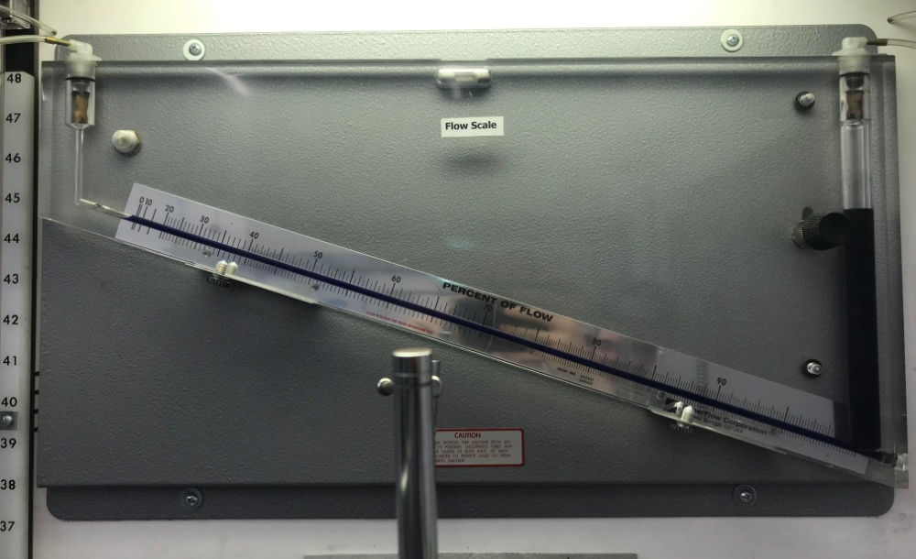
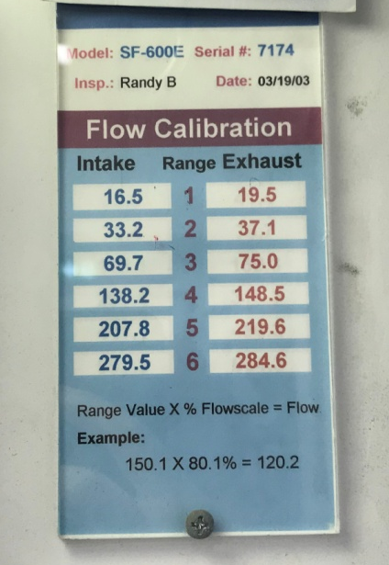
$Range Value ×Flowscale \left(\%\right)=Flow$
Left: SF-110 Calibration Card, Right: Flowscale (%)

Testing Results & Analysis

Engine Data & Info
The Cylinder Head utilised for testing was removed from a Ford Sigma Engine (Zetec 1.6), with a commonly used valvetrain configuration, with 4 valves per cylinder, (2 exhaust, 2 inlet) and 2 camshafts.
Configuration | Capacity | Bore x Stroke | Maximum Power @RPM | Maximum Torque @RPM | Compression Ratio
Inline 4-cylinder, 16 valve, dual over-head camshafts (DOHC) | 1.6 L; 97.4 cu in (1,596 cc) | 79 mm × 81.4 mm (3.11 in × 3.20 in) | 100 PS (74 kW; 99 hp) @6000rpm | 145 Nm (107 lb-ft) @4000rpm | 11.0:1

Engine Measurements and Weights

Valvetrain Component Weights
Collets (pair): 1g
Valve: 38g
Valve Spring: 20.4g
Spring Retainer: 7.7g
Hydraulic Lifter: 23.8g

General Measurements
Inlet Valve Diameter: 26mm
Exhaust Valve Diameter: 24mm
Inlet Port Diameter: 30mm
Head Gasket Depth: 0.38mm
Bore: 78.4mm
Stroke: 81.8mm
From measuring the Inlet Port Diameter, the Area can be calculated using the following equation:
$$A=\frac{πD^{2}}{4}=\frac{π{×30}^{2}}{4}=706.86{mm}^{2}$$

SF-110 Flowbench Figures and Results

Bare Cylinder Head
Valve Lift | Reading | Modifier | Litres per Second | CFM | CFM Per Square Inch | CF
0.5 | 49 | 16.5 | 8.085 | 17.1311448 | 7.817955065 | 0.056652
1 | 87 | 16.5 | 14.355 | 30.4165224 | 13.88085899 | 0.100586
1.5 | 74 | 33.2 | 24.568 | 52.05664384 | 23.7565269 | 0.172149
2 | 91 | 33.2 | 30.212 | 64.01560256 | 29.21410741 | 0.211696
2.5 | 54 | 69.7 | 37.638 | 79.75040544 | 36.39482903 | 0.263731
3 | 61 | 69.7 | 42.517 | 90.08842096 | 41.11267724 | 0.297918
3.5 | 70 | 69.7 | 48.79 | 103.3801552 | 47.17848208 | 0.341873
4 | 72 | 69.7 | 50.184 | 106.3338739 | 48.52643871 | 0.351641
4.5 | 82 | 69.7 | 57.154 | 121.1024675 | 55.26622186 | 0.40048
5 | 43 | 138.2 | 59.426 | 125.9165629 | 57.46317844 | 0.4164
5.5 | 45 | 138.2 | 62.19 | 131.7731472 | 60.13588441 | 0.435767
6 | 46 | 138.2 | 63.572 | 134.7014394 | 61.4722374 | 0.445451
6.5 | 48 | 138.2 | 66.336 | 140.5580237 | 64.14494337 | 0.464818
7 | 48 | 138.2 | 66.336 | 140.5580237 | 64.14494337 | 0.464818
7.5 | 49 | 138.2 | 67.718 | 143.4863158 | 65.48129636 | 0.474502
8 | 49 | 138.2 | 67.718 | 143.4863158 | 65.48129636 | 0.474502
8.5 | 49 | 138.2 | 67.718 | 143.4863158 | 65.48129636 | 0.474502

With Standard Inlet Manifold
Valve Lift | Reading | Modifier | Litres per Second | CFM | CFM Per Square Inch | CF
0.5 | 49 | 16.5 | 8.085 | 17.1311448 | 7.817955065 | 0.056652
1 | 86 | 16.5 | 14.19 | 30.0669072 | 13.72130889 | 0.09943
1.5 | 66 | 33.2 | 21.912 | 46.42889856 | 21.18825373 | 0.153538
2 | 79 | 33.2 | 26.228 | 55.57398464 | 25.36169764 | 0.18378
2.5 | 48 | 69.7 | 33.456 | 70.88924928 | 32.35095914 | 0.234427
3 | 51 | 69.7 | 35.547 | 75.31982736 | 34.37289409 | 0.249079
3.5 | 63 | 69.7 | 43.911 | 93.04213968 | 42.46063387 | 0.307686
4 | 70 | 69.7 | 48.79 | 103.3801552 | 47.17848208 | 0.341873
4.5 | 74 | 69.7 | 51.578 | 109.2875926 | 49.87439534 | 0.361409
5 | 79 | 69.7 | 55.063 | 116.6718894 | 53.24428692 | 0.385828
5.5 | 81 | 69.7 | 56.457 | 119.6256082 | 54.59224355 | 0.395596
6 | 83 | 69.7 | 57.851 | 122.5793269 | 55.94020018 | 0.405364
6.5 | 85 | 69.7 | 59.245 | 125.5330456 | 57.28815681 | 0.415132
7 | 85 | 69.7 | 59.245 | 125.5330456 | 57.28815681 | 0.415132
7.5 | 86 | 69.7 | 59.942 | 127.009905 | 57.96213512 | 0.420015
8 | 87 | 69.7 | 60.639 | 128.4867643 | 58.63611344 | 0.424899
8.5 | 87 | 69.7 | 60.639 | 128.4867643 | 58.63611344 | 0.424899

Flared Entry to Inlet Port
Valve Lift | Reading | Modifier | Litres per Second | CFM | CFM Per Square Inch | CF
0.5 | 47 | 16.5 | 7.755 | 16.4319144 | 7.498854858 | 0.05434
1 | 83 | 16.5 | 13.695 | 29.0180616 | 13.24265858 | 0.095961
1.5 | 64 | 33.2 | 21.248 | 45.02196224 | 20.54618543 | 0.148885
2 | 81 | 33.2 | 26.892 | 56.98092096 | 26.00376594 | 0.188433
2.5 | 47 | 69.7 | 32.759 | 69.41238992 | 31.67698082 | 0.229543
3 | 58 | 69.7 | 40.426 | 85.65784288 | 39.09074229 | 0.283266
3.5 | 66 | 69.7 | 46.002 | 97.47271776 | 44.48256882 | 0.322337
4 | 75 | 69.7 | 52.275 | 110.764452 | 50.54837365 | 0.366293
4.5 | 81 | 69.7 | 56.457 | 119.6256082 | 54.59224355 | 0.395596
5 | 86 | 69.7 | 59.942 | 127.009905 | 57.96213512 | 0.420015
5.5 | 90 | 69.7 | 62.73 | 132.9173424 | 60.65804839 | 0.439551
6 | 93 | 69.7 | 64.821 | 137.3479205 | 62.67998333 | 0.454203
6.5 | 47 | 138.2 | 64.954 | 137.6297315 | 62.80859039 | 0.455135
7 | 48 | 138.2 | 66.336 | 140.5580237 | 64.14494337 | 0.464818
7.5 | 49 | 138.2 | 67.718 | 143.4863158 | 65.48129636 | 0.474502
8 | 49 | 138.2 | 67.718 | 143.4863158 | 65.48129636 | 0.474502
8.5 | 48 | 138.2 | 66.336 | 140.5580237 | 64.14494337 | 0.464818

Cylinder Head Flow Capabilities and Conclusion of Test Results
As Displayed in 3.3.1, 3.3.2 and 3.3.3, the results for the various inlet setups provided clear differences in the flow capabilities.
With the bare cylinder head, the peak flow coefficient (CF) is achieved at 7.5mm of valve lift. This is because; at high lift, the port has become a restriction, due to the port area being smaller than the valve lift. To get around this, the most effective route would be porting out the inlet to achieve a larger diameter, removing this restriction (the wall thickness of the inlet port dictates how much material can be removed). With a certain level of material removed from the wall of the inlet port, the lift then becomes the restriction to achieving better flow, therefore coupling porting with a larger profile camshaft, can deliver noticeable gains in flow coefficient (CF), something which is very desirable in competition and high-performance engines.
Throughout the range of valve lift points, the inlet manifold proves to be a slight restriction, which is to be expected from a standard inlet manifold fitted to an engine in a mass production vehicle, balancing low manufacturing costs with performance. In the case of the Ford Sigma engine, the inlet manifold is constructed from plastic, formed in a cast to minimise manufacturing costs. The design of the manifold itself maximises the length of the runners, thus in turn; increasing the volume of the inlet system. This is done to capitalise on the pulse wave effect that occurs within the inlet, caused by the difference in pressure between the induction of the engine (negative pressure) and the atmospheric pressure within the intake (prior to the throttle body). This difference in pressure causes a high velocity ‘wave’ of air, which if timed correctly (based upon the calculations made by the engineers responsible for designing the engine and length of the inlet runners) can help supply the cylinder with more air at lower engine speeds, providing a larger quantity of power and torque at a lower point in the RPM range, which in a road car application is a desirable to improve drivability.
“The least restrictive intake system is clearly that with the straightest runner within the packaging constraints of the engine design. Either straight or slightly converging along its length to accelerate the flow gently towards the engine, at the end nearest the valve great attention is made to the intake port dimensions to encourage air to flow past the valves when open, and flow with ease into the cylinder.” - (High Power Media, 2013)
With cylinder heads being manufactured using the casting process, the un-machined surfaces such as the inlet ports, remain rough in texture. Roughness on the walls of the ports can also cause turbulence within the air/fuel mixture.
The theory behind having smoothed edges to an inlet port is to reduce turbulence within the intake, and improve the velocity of the airflow. Despite this, turbulent air can also be a desirable factor, as this can help to create a more homogenous air/fuel mixture, thus in turn providing a better burn during the combustion stroke, as the fuel particles are distributed throughout the air evenly. However as previously mentioned, this can come at the cost of flow, therefore rounding off the corners of the inlet port (similar to the effect of inlet trumpets on throttle bodies) can reduce turbulence and improve the flow coefficient (CF). During the test, this was achieved by using white tack to smooth off the rough entry to the port, as there was no option to machine the inlet port. While this provided a smooth edge, it also reduced the overall diameter of the inlet port, ultimately meaning the flow values were lower than with just the bare head.

Flow Coefficient Graphs and Data

CFM Per Square Inch Graphs

As displayed in the graphs in section 3.5.1, the addition of the standard inlet manifold has greatly reduced the CFM Per Sq.In values throughout all points of valve lift, primarily due to restrictions in the manifold design (as explained in section 3.4.)

Flow Coefficient (CF) Graphs

Similarly to the CFM Per Sq.In values, the fitment of the inlet manifold reduced the peak flow coefficient (CF) figures by around 0.05 when compared to the bare cylinder head.

Camshaft Profile

Smoothed Profile of the Camshaft Lift Values

Air Flow through the Engine

Calculating the HP (horsepower) per cylinder
For this calculation, the data set obtained from the test with the inlet manifold fitted will be used, as this will replicate the true engine power.
$$Average Air Flow \left(CFM\right)=1.67×HP Per Cylinder$$
Firstly, the mean CFM for this test must be calculated:
$$Total of all CFM Values=727.9139861$$
$$Mean CFM=\frac{727.9139861}{17}=42.81846977$$
The HP Per Cylinder can be calculated by rearranging the original formula to:
$$HP Per Cylinder=\frac{42.81846977(Average Air Flow \left(CFM\right))}{1.67}=25.64 (HP)$$
By multiplying this number by 4, the theoretical HP of the engine can be worked out:
$$25.64×4=102.56(HP)$$
The claimed output from the standard engine is 99hp (as detailed in section 3.1), now confirming that the CFM values obtained during the test accurately replicate the true power output of the engine (factor in parasitic losses and other factors towards the minor difference between the theoretical power output and claimed figure).

Calculating Engine Power from Test Flow
As with the HP per cylinder calculations, the data set from the inlet manifold test is to be used:
$$HP=0.43×\left(128.4867643(Max Test Flow CFM)\right)×{(\frac{10}{25" (Test Pressure)})}^{0.5}$$
$HP=34.94$
While the theoretical HP figures using the calculation per cylinder may produce a similar figure to what’s claimed, the calculated engine power is far short of what’s considered healthy for a 1.6 Zetec engine.

Calculating Engine Speed from Peak Power
$$RPM=\frac{2000×(Max Test Flow CFM)×{\left(\frac{10}{Test Pressure}\right)}^{0.5}}{CID Per Cylinder }$$
Before entering all the figures into the equation, the capacity of each cylinder must be found in Cubic Inches (CI):
$$CC Per Cylinder=\frac{1586}{4}=399 CID Per Cylinder=\frac{399}{16.387}=24.3485CI$$
$$RPM=\frac{2000×(128.4867643)×{\left(\frac{10}{25}\right)}^{0.5}}{24.3485 }=6675RPM$$

Valve Modifications
Increasing valve diameter is a popular modification when carrying out cylinder head work, particularly when used in conjunction with the corresponding valve seat modifications. With a larger valve diameter and curtain area, theoretically the airflow into the cylinder will improve at any given valve lift.
A common form of valve modification is what’s known as a ‘multi angle valve seat.’ Most poppet valves within regular production engines have a single 45° cut, to allowing for an effective sealing surface. When creating a multi angle seat, additional angles are ground into the valve seat to improve airflow around the valve. The positioning of these angles is critical to their effectiveness, as the valve must still be seated correctly and seal efficiently, while also producing flow gains.
Correct re-cutting of the valves with multiple angles can produce noticeable CFM gains when tested on a flow bench, as demonstrated below by - (John Maher racing, 2013)
(Test performed on a VW 1600cc Air-Cooled engine, with 35.5mm Inlet valve).
Red line: straight out of the box with no mods
Green line: 3 angle valve job
Blue line: 3 angle valve job plus 30° backcut on the valve
Overall gain in flow @ .500″ lift: 14cfm
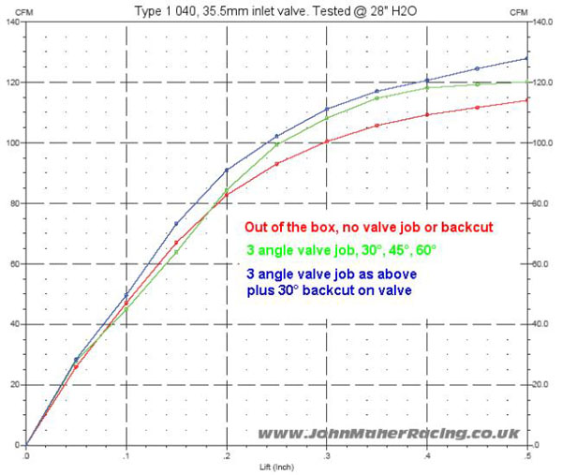
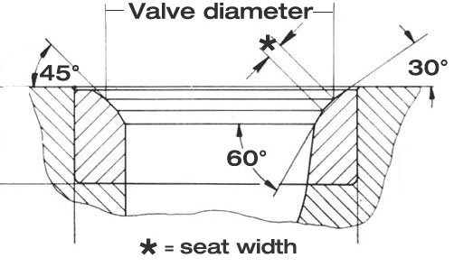
An example of a 3 angle valve job, with a 45° seating area - (John Maher racing, 2013)

Zetec 1.6 Inlet to Exhaust Valve Ratio:
$$\frac{26}{24}=1.083 :1$$
A valve modification performed by many engine builders on a Ford Sigma engine is to increase the diameter by around 2-3mm, which is the maximum the cylinder head dimensions will allow without excessive machining.

Inlet Port Modifications
As previously stated in section 3.4, ‘porting’ out the inlet, i.e. removing material from the walls of the inlet ports; increases volume. This in turn can assist flow into the cylinder when the port becomes a restriction at high valve lift. The casting marks within the ports are suboptimal when chasing higher flow coefficients. With the Inlet manifold, at maximum lift (8mm), a CF value 0.424899 was reached (optimal CF = 1).
Porting of the cylinder head may only be necessary when the port itself becomes a restriction (when the port area is smaller than valve diameter), which is reflected in the testing results, with the CF values maxing out before peak lift.
As previously mentioned in section 3.4, the rough surface of the inlet ports, which remains from the casting process during the production of the cylinder head, is additional material that can be removed to increase port volume.
Removing the rough port surface is a major consideration when carrying out porting work, as any larger protrusions material left over from the casting process can restrict and disrupt airflow. A ‘Polished’ port wall surface is commonly aimed for with the theory of the smoother surface helping to increase air velocity and flow. However this is a common misconception that is regularly made, as the ‘wetting’ effect that occurs with the fluid (air/fuel mixture), whereby it maintains contact with the port wall surface and can ultimately lead to low intake air velocities. The difference between the 2 surfaces in terms of peak flow can more often than not be completely negligible, as the air velocity near the port wall will always be minimal, with rougher surfaces possibly possessing minimal flow advantages. Therefore, the main goal with regards to inlet porting would be to simply increase the size of the port accordingly, achieving the right balance between peak flow and air velocity.

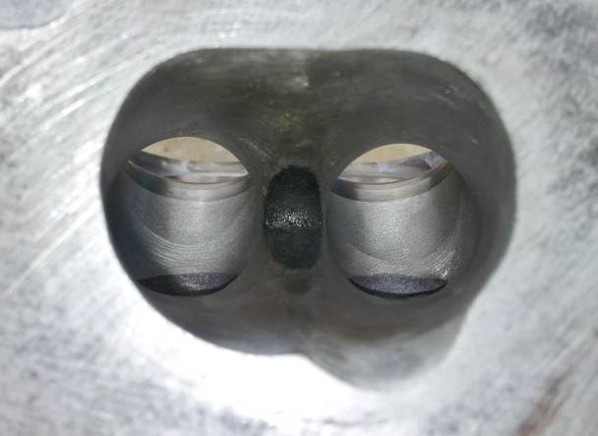
An example of extensive porting performed on a 2.0 16V Zetec cylinder head, with a moderately rough finish still present to avoid ‘wetting’ effect.

-(Passion Ford, 2012)

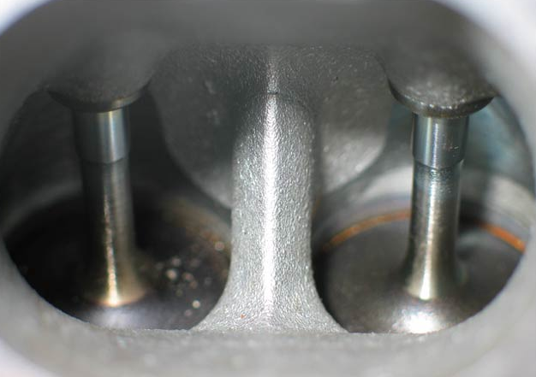
The rough casting marks within a factory cylinder head.

-(Stewart, 2004)

Summary
The design of the standard cylinder head leaves a lot to be desired. The possibilities for modifications to the cylinder head and valvetrain are clear, and there are number of different avenues to take when aiming to improve flow coefficient (CF). In summary, ‘Porting’ would allow for larger inlet flow values, using the correct method for modification, i.e. avoiding excess ‘polishing,’ to minimise the wetting effect, while also removing as much material as possible to ensure that the port doesn’t remain a restriction at high lift values, especially when used in conjunction with higher profile performance camshafts.
With regards to the inlet valves, multi angle valve jobs would provide noticeable improvements in CFM, particularly when the valve diameter is also increased. Dimensions of the Zetec’s cylinder head would theoretically allow a valve diameter increase of around 2-3mm, with the corresponding seat modifications to improve the sealing capabilities.
When it comes to making cylinder head modifications, there can be a large quantity of misinformation out there, with much conjecture around certain subjects, such as the optimal design for porting techniques and valve seat angles. With this in mind, the best route to take when doing development work would always be to make research based judgements and decisions, using credible sources of information, and primarily, physical testing results. While it may be a costly approach, doing development work through trial and error, as well as research based work is often the best approach towards tasks of this nature.

Bibliography
High Power Media, 2013. Archive - Induction System. [Online]
Available at: https://www.highpowermedia.com/Archive/category/induction-system/the-air-trumpet
[Accessed 2 February 2020].
John Maher racing, 2013. The importance of the 3 angle valve job. [Online]
Available at: https://johnmaherracing.com/tech-talk/3-angle-valve-job/
[Accessed 6 February 2020].
Passion Ford, 2012. Passion Ford - Zetec cylinder Head Work. [Online]
Available at: https://passionford.com/forum/general-car-related-discussion/438809-zetec-cylinder-head-work-pictures.html
[Accessed 2 February 2020].
Smith, P. H., 1977. The Design and Tuning of Competition Engines. 6th ed. Cambridge: Robert Bentley, Inc..
Stewart, M., 2004. Fords 2.0 VVT Zetec Engine. [Online]
Available at: https://www.mwstewart.co.uk/articles/duratecvvt/
[Accessed 2 February 2020].

Appendix

Graphs Illustrating CFM against valve lift for the various cylinder head setups

