Voice Acting VS AI
People believe that sometime in the distant future, robots are going to end up taking most of our jobs (Hurd, W. 2023), but something very similar is happening right now. Loads of working folk are worried that AI is going to leave them jobless as it will be cheaper and easier for their employer, especially those jobs that involve the arts. Some jobs are already being taken, but not entirely. Robots can now perform multiple tasks, which can take away parts if people’s jobs. ScienceNewsToday (2025) says that “According to a landmark 2013 Oxford University study, nearly 47% of U.S. jobs were considered at risk of automation over the next few decades”. Companies want to try and have robots and humans work together, but it is still a fear humans have, as it is a real possibility. I want to try and get rid of this stigma people seem to have for the use of AI and how it can be used as a tool to help us with our work, instead of people fearing about what it could end up doing in the future, and maybe someday, we will all be able to work together for a better and easier life.

What is Voice Acting?
Voice Acting is when you use your voice to perform. You don’t see the actor, instead you hear them. The actor must make sure that they can use emotion and tone correctly in order for them to get their message through to the audience. Voice acting can be used on radio, television, animation, films, audiobooks, etc (Alburger, R. J. 2007). Recently, there have been many voice actors that have come forward and talked about their concerns with AI coming into the business. Not only could this effect voice actors on finding job, but it also puts them at risk of their voices being exploited (Davenport, T. 2023). If voice actors aren’t careful, their voices can be used for AI, and they may not be paid for their voices to be used. Rodenburg, P (1997) says that “Storytelling is universal to every society and culture that has ever existed”. Using our voices to tell a story shouldn’t be something AI can easily take away from us. For years, humans have been telling stories, and there is always a story that people love, whether it be for nostalgic reasons, it brings a certain feeling, or because it is relatable. AI could never recreate these stories (Verner, A. 2025). Rodenburg, P (1997) also says that a storyteller is there to entertain the audience with the quality of their voice while telling these stories. AI could never do that. AI doesn’t have the quality and raw emotion of a human voice to show the audience what we are feeling (Yoon, D. Oh, G, E, Kent, R. 2026). Due to prompts and the development of AI, you can start to add in some emotion into their sentences, but it doesn’t sound the same as when being spoken by a human. AI could never recreate human emotion (Stage One. 2025). This is what makes stories more entertaining.

What is AI?
AI, also known as Artificial Intelligence, came about in the 1950s. Mathematician, Alan Turning, had a theory that AI could be possible. Turning said that computers could potentially have the thought process with that of a human. He could not prove his theory yet as computers were not as advanced in his time. Instead, this theory came to be called “the Turning test”. In 1956, mathematician professor, John McCarthy, organized a meeting with a group of researchers to discuss Turning’s theory. That’s when it was given the name “Artificial Intelligence” (AI). Years later, as computers improved and excitement for AI grew, the first AI was created, and it was a chatbot called “ELIZA”. From then on, AI began to develop over the years, into physical robots, editing pictures and videos, or coming up with prompts where it can talk back to you, or answer questions (Coursera. 2025). AI is already being used in the filming industry and has loads of helpful qualities. AI is used to create crowds of people in the background of shots, without the production team needing to hire extras. It is also used in making actors look younger, whether it be for final editing or if there is a flashback in the media. AI can also be used for lighting within scenes. It can also be used to fix lip-syncing with the dialogue, if something ever went wrong with the audio. All of the points stated previously are in need of consent from the actor, to make sure they're OK with being put through AI for refining. AI can also help the team to safely create stunts or help with planning said stunts. Actors can also use AI to help them learn lines or to help them perform their emotions correctly (Stage One. 2025). Actors should not be worried about AI taking their jobs, instead they should be welcoming it and thinking of it as a tool to help them make them better at their job.

What’s happening now?
As AI continues to develop, with it now getting better with accents, voice qualities, and with it being available 24/7, actors are beginning to worry about the availability of future jobs. Stage One (2025) says “Despite dramatic headlines, industry leaders from Pinewood to Netflix to BFI consistently affirm that storytelling is - and always will be - a human driven craft.” This statement proves that actors have nothing to worry about, and that people are always looking for human actors. AI is only used in the industry for editing and to be used as a tool to help people's jobs go by a lot easier. Actors shouldn't try to completely avoid AI but think of it more as a collaborative tool. All AI is doing is reshaping the industry to make it better than before, and that is just something that actors should adapt to. Reddy, A (2025) states that “Finding the right balance between tech and human creativity is crucial” and I couldn’t agree more. No one can physically stop technology from continuing to grow, and we should learn to adjust to this change.

The Environmental Impacts of AI
I want to be as unbiased as possible in my writing of this essay, but I do also want everyone to know the problems that AI has caused for the planet, I want to go in depth so people know how bad it can be if not taken care of properly. There is no denying that AI can be used to help combat climate change, but how it is currently being done is harming our planet in many ways. First of all, there are data centres being built everywhere by big corporations which doesn't only affect the wildlife around it, but also the people living nearby. More Perfect Union (2025) produced a video of a couple who live next day centre, and they show problems that come with living so close. In the video you can see that there is “sediment” in the water which comes from the data centres, and they also don't have any pressure in their taps, and because of this, they're having to preserve water in massive bottles so they can be used at a later date. They also have had to replace a lot of household items due to them not working anymore because of the issues the sediment was causing. The data centre that is close by to them also gives off a lot of light pollution which is also causing problems for them. Due to these data centres being built in cities where people reside, they are using up a lot more electrical energy than we usually would, which then causes electricity bills to increase for the people in the surrounding area (Ludwig, M. 2025). Due to this excess amount of electricity being used, it is also causing them to release greenhouse gases which contribute to climate change (UNEP. 2025). Data centres are also taking a lot of fresh, clean water so that they can cool their computer systems. Just recently, the UNU (2026) have published an article about how the world has officially entered a “Water Bankruptcy”. Although the increase in these data centres may not be the root cause, they certainly do play a big role in our loss of water. They also add substances to their water so they can continue to use it for longer, which can also be dangerous to us and wildlife. Data centres also require rare minerals and other materials which are usually mined unsustainably. If we want to continue to use AI, companies who run the data centres need to make sure that they are using all of their resources sustainably, making sure that no harm is coming to any human being due to their work.

Theatre
I also want to talk about theatre as a whole. Theatre has been around for centuries, a lot longer than film and television. I guess you could say that voice acting is a ‘sub-genre’ or any type of acting. I would like to show how far theatre has come and how important in can be in some cases. Carlson, M (2018) states that “one of the most striking features of modern performance activity and performance theory has been the steadily growing interest in performance’s social or political function”. Theatre shapes us all culturally and gets us to talk about difficult topics, because usually, they are important. It in no means has the intention of making anyone upset, but it is there to tell the stories of lives you may not even acknowledge. What has interested me in my research is that many communities can come together and talk about their shared experiences through theatre. It may even be lifesaving to do it on theatre with other people instead of talking about these stories by yourself, as no one would then dare to stand up to you with a crowd watching. Researching into Drag has also inspired me. Drag has also been around for centuries, since Shakespeare’s time, but it got popular in the 1950s. Drag does not shy away from breaking gender norms that we as a society had just agreed on one day. Not only does it invite everyone to have a new hobby, but I feel like it also helps us be more confident in ourselves. If men can dress up as woman and be happy, why can’t the other genders dress in whatever they want and also be happy? Moving on, in 2004, James Bau Graves, who is the director of Portland’s Center for Cultural Exchange, had invited the playwright, Marty Pottenger, to come to his place of work and “use art to create a public response”. This was a result of the US Border Patrol deporting immigrants back to their home country, due to the tragic events of 9/11. Bau Graves stated that “laws meant to be anti-terrorist have in fact become anti-immigrant”. But before the CCE had closed in 2006, they had raised money and worked with these immigrants to make art, more specifically, theatre, for inform and educate the natives (Cohen-Cruz, 2010). Kendrick, L. Roesner, D. (2011) both delved into “Radical Voice”, which explains that it is supposed to “be understood as a persuasive multiplicity of vocal art forms”. This shows that we really need to use our voice, and sometimes shout, to really get our point across, so that the privileged can hear us. This all explains that theatre, therefore voice acting, is so important. Yes, it may be the traditional way of doing things, but it is something we have been doing for years, and it has such an impact, especially on those who are in marginalised groups. It makes them feel seen and heard and shows they’re not alone in whatever it is they are going through. Telling these stories can really educate the privileged and help us all be better people in the long run.

The Pros and Cons of Voice Acting and AI
The Pros and Cons of AI
Pros
AI does have a lot of benefits and can be used in everyday life to make tasks a lot easier. First of all, it can simply make a timetable for you so you can efficiently execute your work. AI can also help a lot with creativity. If there is an idea you can’t quite get to work, AI can help you with the outcome of this idea, or you can ask it to generate ideas for you, and something could catch your eye. It can also complete tasks more efficiently than humans can, whether it be time consuming or repetitive. AI has been trained to do these sorts of tasks quickly and accurately. AI can help students with their studies, or produce individual classes for them, depending on their skill set. It has even been used to help learn languages and even aid with pronunciations. Furthermore, AI has also supported scientists with their research on the environment and climate change. AI has helped work out the effects of climate change, and with the help of satellites, has also been able to assess weather patterns, natural disasters, and check the quality of water and air (Masterson, V. 2024). AI has been used in hospitals for people’s health, where it can detect when something is wrong (Forouzanfar, M. Varnosfaderani, S, M. 2024) The more we use AI to support us, it gets better with its tasks over time.

Cons
Although AI can help us in loads of different ways, it also has a lot of disadvantages too. AI can easily be accessed by anyone, and anyone can use it for malicious intent, whether it be for spreading misinformation or using it to create deepfakes. Even though AI has developed significantly in the past few years, it can still give us information that isn’t very accurate, so it usually needs a human to oversee these errors. AI is also very costly, with money and the environment. Information has come out recently that corporations are building a lot of data centres to run AI. These data centres are grand in size, which harm the local wildlife. Since so many people are using AI, the corporations are using water to cool down their systems. They are adding chemicals to the water just so they can use the same water to cool everything down, but then this means this water cannot be reused for human consumption or be given back to the wild (Kenny, R. Lunj, A. Kis, A. 2025) (Dempsey, M. 2025). The field also has its limitations, and artists are claiming that AI is stealing their work to generate images, since it needs to learn how this art should look and they are doing so without the artists consent (Good Law Project, 2025). Even though I stated previously that AI can help with creativity, it can also have some negatives. Due to AI being able to come up with ideas for you, it doesn’t allow you to use your own creativity, which diminishes that skill over time. As also stated previously, AI doesn’t have the same emotional depth that humans do, and any art that is made by AI doesn’t have that same connection with the audience than any art that is made by humans. Rodenburg, P (1997) says “it is under threat, as in the last few decades technology has eroded our need to use our voices, and education has not encouraged enough clear and formal speaking.” The biggest downside to AI becoming so big in recent years is that it can replace jobs, as it can do tasks more efficiently and for the greater amount of time, without it needing rest. Furthermore, people are also afraid of what AI can do in terms of war, with military drones or AI powered weapons, and they can be easily recreated. AI needs a mass amount of data in order to develop, and this could mean an invasion of privacy as it can take your personal information. As we all continue to use AI, it invites the risk of us becoming too reliant on it, which further confirms AI can diminish our cognitive skills, as people will use AI to think for themselves, instead of using their brain for these decisions. Furthermore, if you continue to use AI, there won’t be any time for you to build connections with other people in the industry, which is always helpful to have, so then people know your name and possibly get you more work in the future.

The Pros and Cons of Voice Acting
Pros
An advantage of voice acting in terms of AI is that when you direct an actor, it will help them with their skills and make them better with their work and any future work they do, but with AI, it won’t be able to learn these skills straight away. Also, even though this may be a problem due to the company, but the actors need to be literate and clear when they speak, but there are some AI websites that are not able to pronounce words correctly. You are able to fix this with some adjustments, but it is much easier to hire an actor who has the experience so that they can easily say these words. Voice acting enables you to impact all sorts of audiences. AI isn’t able to do that because it doesn’t have the same emotional depth in their words as an actor would, and therefore, audiences aren’t able to connect with it as much as the companies would like. Another reason why voice acting is better is that if there is too much traffic going to one AI website, the website could potentially shut down due to it working overdrive to accommodate to everyone’s needs, but with a voice actor, they would be able to give you their work at a specific time and date (depending on working hours) with no complications, and you won’t be waiting hours for them to get back to you. AI also needs time to load up any prompts you may have for them, which can be time consuming, while if you direct an actor on how to act in a certain way, they will be able to give you many kinds of prompts which will be perfect for whatever genre you are working with, and once again, even direct them so that the actor does exactly what you want them to do.

Cons
Despite voice acting having so many good qualities, there are also a few downsides where AI can upstage it. The biggest downside to voice acting would be expenses. The equipment for voice acting can be expensive, making sure that you get a good microphone, a buffer, a screen, a headset/headphones, or even some squares of foam to put on your walls for soundproofing the room. In the end, all of this can be expensive for the actor to pay for, if they are working from home or in their own office. It can also be expensive for a company to pay the actor work their work, and using AI can be a lot cheaper in the long run (unless you are investing in the AI service, depends how much you are investing). Actors also need to have breaks or holidays, or they could even have some personal problems going on, which could disrupt the schedule production has made for everyone in the showpiece, while AI doesn’t need breaks and is accessible at all times of day, every day. When voice acting, there is always the chance of technical difficulties that could, once again, disrupt the schedule, and you may not get the work in on time. Since AI is available to everyone, it has had a lot of work done in developing so that everyone can use it for whatever, so there shouldn’t be any problems when using it, therefore, getting the work in on time, without the worry of there being an error. Looking through auditions takes a huge amount of time. Having to look through hundreds of videos, no one knows how long it really takes, especially if you are taking breaks in between, but when you use AI, all you can do is look for the perfect voice that fits the chosen character. No more looking through auditions when all you can do is find that voice yourself. There are always new and upcoming actors coming into the industry all the time, but because they don’t have the experience, they may be difficult to manage, and not have developed all of their skills yet, but with AI, you don’t have to worry about it learning any skills or waiting for it to have that experience. And with the prompts that come with generative AI, they will already have some of those skills for you. You won’t have to wait for them to develop it, which saves a lot of time as well.

What needs to happen?
If companies, especially the acting industry, want to continue to use AI in their work, then there are a few things that need to be done to ensure a safe and fair workspace. Companies should favour the need of their employees instead of profits, guaranteeing a straightforward end goal with AI implemented into their work, and make sure these profits line up with their investments. It is also helpful to make sure that everyone is using AI professionally, so that it learns how to work for you, which is why we all need to learn how to collaborate with AI, but that does mean that we all have to be responsible with how we use it. Another good concept would be to make sure that you use an AI company that isn’t biased and only has good intentions with what they’re wanting to accomplish. Making sure that they are following any laws that have been formed ethically.

Questionnaire
I sent out a questionnaire to a lot of my peers. I sent it out to peers who work in the industry and to peers who are non-professional, to try and make the answers completely unbiased. Beforehand, I had sent two audio files to my peers. One of myself reading an extract from a book, where I tried to add emotion when talking as the characters and tried to add a sense of wonder when I spoke about what they were doing. The other audio file was of the same extract from the book, but instead, I used a generative AI service for text-to-speech, picked out a voice that I deemed fit to read that part of the story, and made that voice also tell the story. I asked my peers to listen to both audio files and then answer the questions. There were no glitches or sound issues with the AI voice over, and I liked the voice that I had picked out, as I felt it was a comforting sort of voice to read out a children’s book. But when I recorded myself, it was completely unedited, and there were parts where you could hear me breathing, or my microphone peaked when I pronounced a P. I decided to keep the unedited version in, to once again, keep it unbiased, seeing as the voice recording I took of myself was unprofessional, maybe there would be some people who preferred the AI voice over because of it. The questionnaire was completely anonymous, and I did not have any say in what my peers had chosen as their answers. My questionnaire had a total of 12 answers.

- Do you use AI?
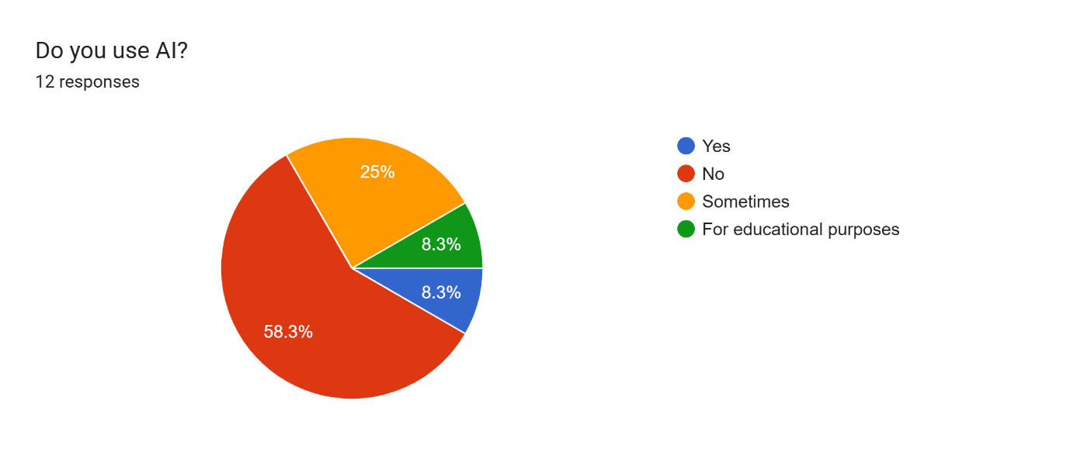
This was my first question, as I wanted to see if any of my peers indulged in AI. 58.3% of the results said that they didn’t use AI at all, which tells me these people have never once used AI and never will. 25% of the respondents said that they do sometimes use AI. This makes me believe that they may use it for certain questions or ideas they may have. 8.3% said that they use AI for educational purposes, which is exactly what I had done for my questionnaire. Lastly, 8.3% said yes, and that they do use AI, which makes me think that they use it rather frequently, whether it be for work or during their spare time.

- What were your initial thoughts of AI before listening to the two audios?
I wanted to ask this question so I could get a clear idea of what my peers thought. Since it is a mix of people in the industry and people who don’t I was hoping to have at least some divide in the answers, but that wasn’t really the case. Majority of the answers I had gotten were very negative towards AI. A lot of people said that AI shouldn’t be used for creative purposes and that it should stay out of the industry. A few people also did mention its environmental impacts and also the fact that it could potentially take people out of a job. Someone also did mention the idea of having a human speaking brings in the connection to the audience, but with an AI, they did not feel that connection, which is something that did stand out to me. There are a few people who did talk about the idea of using AI as a tool to help us with our work, which is something that I have also been discussing within my work, as the development of AI is inevitable. However, there was only one person who did see AI to be positive as a whole. They believe that AI is something that should be welcomed into our work and that it helps with our creativity, and that it shouldn’t be something to be afraid of.

- What are your thoughts on AI now after listening to the two audios?
I also really wanted to ask this question as I was hoping for people to listen to the AI audio I had made and decided that their opinions had changed, but considering the answers from my questionnaire, that wasn’t exactly the case. People’s opinions on AI had stayed negative, despite my own voice acting audio that was raw, unedited, and had multiple issues that didn’t deem it professional, yet the responders still preferred that one. A lot of responses said that the AI sounded very monotone throughout the excerpt of the story, the pacing was the same the entire time, held little to no emotion, and didn’t differentiate between the characters, which someone said that it made it difficult to figure out which character was talking. Someone even said that they believed that the AI degrades the value of the writing as it doesn’t take into account the emotion behind the writing. Lastly, one respondent said that they thought of it to be rather scary, as they thought that the AI voice didn’t sound as artificial as they thought it would, and the idea of AI continuing to develop, frightened them. But they made a good point when they mentioned that an emotionless and monotone performance would not be accepted on TV or in theatre, and because of that, it shouldn’t be accepted in voice overs/voice acting as well.

- Which voice did you prefer?
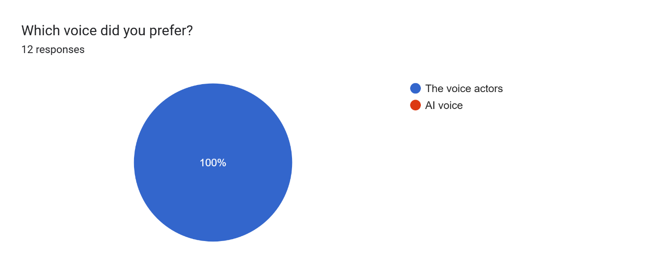
The answers for this question surprised me immensely, as I did genuinely believe that there would be some responders for the AI voice, even if it was just one, but 100% respondents chose the voice actors audio instead of the AI. I suppose this does make sense considering the negative feedback I had seen from previous questions, but even the person who said that they indulged in AI still said that they preferred the voice actor. I guess this does go to show that human voice just has something that AI voices don’t, and that is quality, emotion, and connection.

- Why?
I was expecting to have some answers for the AI voice, so I was hoping for some reasonings on as to why people liked it, but since no one said that they liked the AI voice, it does make me believe that AI really does have no place in the creative industry. A lot of the responses mostly repeated on why they didn’t like the AI version and preferred the voice acting version, mostly saying there was a lack of emotion, the voice was monotone, and lack of pausing. A lot of people did mention that for the voice acting one, it was a lot easier to distinguish which character was speaking, and there was a lot more character in it and therefore, felt more real and relatable. One person then went on to say that the voice actor is what draws you in to the story, which makes you feel a lot more immersed in it, and when the voice actor also fully immerses themselves into the story, it could become quite addicting for the listener. Multiple responses also said that the voice actor brought a sort of warmth to the scene while the AI did not, due to the monotone voice and lack of pauses. Due to the voice actor bringing more life into the excerpt, the listeners were able to construct the scene a lot better in their heads. Someone also said that the voice actor was able to help them understand the vibe of the situation, as the AI sounded more harsh and tense, which made them think something wrong was going to occur in the story, and that the voice actor had inflections on the words that the AI did not.

- Did you notice anything wrong with the voice acting?
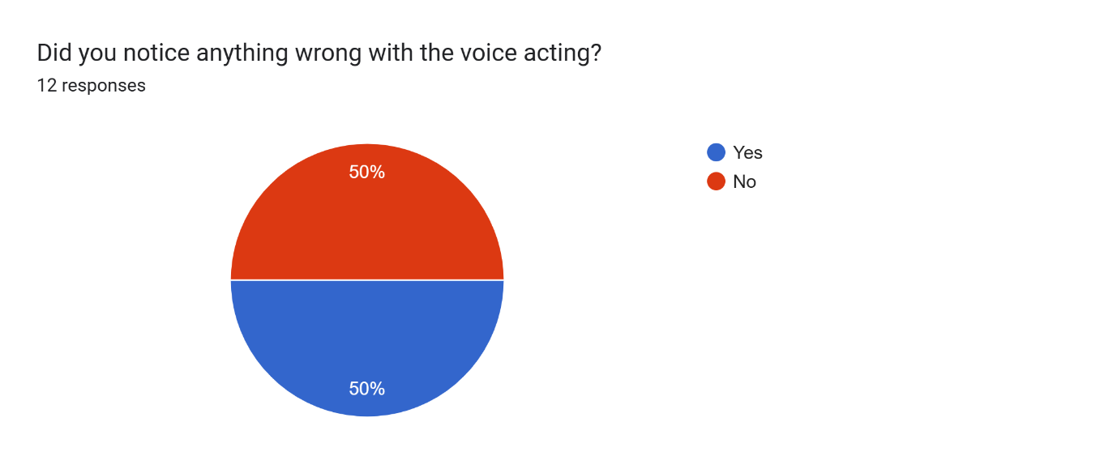
I asked this question because I knew that I had recorded the voice acting unprofessionally, so I wanted to see if people picked up on that and hoped that they wouldn’t say no for biased reasons. Luckily, the responses came back 50-50. Respondents probably said yes because they had picked up on the actual recording quality of the audio, or they had some criticism for the voice acting. I assume the other half of respondents said no, either due to the off chance that they didn’t hear the audio issues that happened, or because they are biased in their answers and prefer a human voice to AI.

- If yes, what was wrong?
I asked this question as I wanted to see if anyone picked up on the quality issues in the recording, but to also show that there are some recordings that aren’t always professional, therefore, there are always issues that can arise with a human voice recording. A lot of responses had picked up on my breathing which was obvious. That isn’t something that I had intended, I may had just placed the microphone too close, but that did help me with the ‘unprofessional’ quality I was trying to achieve. Someone had also picked up on the microphone peaking whenever I would pronounce a ‘P’ or an ‘S’. This was also something that wasn’t on purpose, but as stated before, I am glad these issues happened, or else I wouldn’t have though to send the listeners something unprofessional, which I believe helps my case in making this questionnaire unbiased, as the AI definitely sounded a lot more professional that I did, in my opinion. Someone did also mention that the voice acting itself could have been bigger, with more emphasis and energy on the situation. Overall, the listeners seemed to have enjoyed the voice acting, but they did realise the audio issues that had come with it.

- Did you notice anything wrong with the AI?
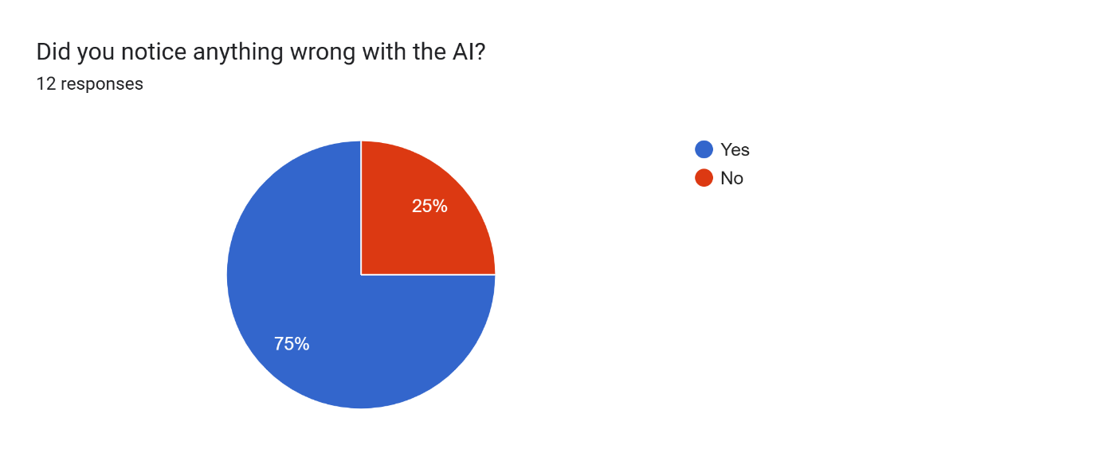
I asked this to mimic the last question, but I also wanted to see if anyone thought there were any audio issues with the AI as well. I had listened to it back once finished, and I didn’t notice anything out of the ordinary, but I wondered if the listeners had maybe noticed something that I didn’t. Apparently, they had as 75% said that there was something wrong with the AI audio, I’m happy that the other 25% said no. I like to think that these people answered with an unbiased mindset, or they really did not just notice any audio issues with the AI.

- If yes, what was wrong?
I wanted to know why people thought there was something wrong with the AI audio, because as stated previously, I did not notice anything wrong with it. A lot of the responses repeated what they had done before, about the lack of emotion and pauses, but that isn’t exactly what I was looking for. This may have been my fault, and I should have been specific when writing the question. Someone did, however, take note that the AI sounded robotic to them, but I am unsure if that is due to the audio quality or due to the fact the AI sounded emotionless. They went on to say that the AI had an inappropriate tone for the scene, and that there were also no changes in its tone, when explaining what was going on. Someone else said that they just found the AI voice rather boring due to it not showing of any qualities of the scene, and if they did ever listen to an audiobook with an AI, that they would switch it off immediately. Everyone knew that it was an AI audio, but this shows that AI is just not developed enough for this sort of work. Since the AI kept the same pacing, and no emotion in the voice, the listeners knew it wasn’t a real voice and they found it quite off putting, with someone even referring to it as ‘uncanny’. One respondent said that the AI knew where the emotion should be, but just couldn’t go through with it, and they thought that the pauses it did take felt calculated, and they related it back to the real world, where life can be very unpredictable and chaotic, to which the AI did not perform.

- What did you like about the voice acting?
Since I had asked people what they thought had went wrong, I now wanted to know what it was that they liked about the voice acting. Someone had said that they liked the different voices I had given to the characters, so you could identify who was talking. I hadn’t changed my voice, all I did was give each character a different kind of quality, so you would know who is talking. Another person even mentioned different accents for the two characters, which is not something I remember doing, but if it helped them to figure out which character was talking, I’m not complaining, as that was my intention. Two listeners wrote that they liked to imagine someone was actually reading the book to them, which is nice, and that could have a calming effect for people, and could bring them to a simpler time.

- What did you like about the AI?
I once again asked this to mimic the last question, to see if there was anything that anyone liked about the AI recording, abandoning all of the negatives. Many spoke about how clear the AI sounded, and the pronunciation was excellent as well. One person mentioned that if they had not known it was an AI speaking, that they would have thought it was a human, therefore, finding it convincing. Someone else said that they enjoyed the pacing, which made the recording easy to follow.

Collaborations
During my research, I had collaborated with quite a few of my peers. They had asked me to do voice acting for them and I happily obliged, only if they answered me one question: Why pick me to voice act when AI is easily accessible? They all gave me detailed answers on why I was the easy choice. The first person expressed that his work was based on verbatim and life story theatre, so having someone who was real with a Welsh accent speak the parts, instead of it being an AI, it added to the immersion and connected it more to verbatim theatre. AI is something he heavily disagreed with and he believes that theatre is supposed to connect people, and it shows a sense of community, while AI does not do that. The second person said that he wanted to explore with human interaction and also the lack of it in the recent years, so considering what my research was about, he found it interesting for me to perform a lifeless, monotone, but happy voice, instead of a personal character one, which blurs the line between real and fake, so the audience are unsure whether to trust this voice, which would then force them to make a choice (this was something that was important in his project). I was happy the two of them were able to give me a reasoning as to why they would pick me to do it instead of using an AI, and if it helped them out more with their work, I was honoured.

Interview
I had an interview with someone who works in the S4C called Marc Griffiths. He is a radio presenter and podcast producer, and I really wanted to get his opinion on AI, as he is an industry professional, which makes me think his opinion is a lot more important.
The first question I asked him was “What is your job?” so that I could get to know him a lot more, and to also see the severity of how AI could affect his job. Griffiths said that when he was in Year 11 in school, he had the opportunity from a local radio station called Radio Ceredigion to do a Saturday show, where he would record programmes, research, producing, editing, or even cleaning, where he stayed for 5 years, where he got even more opportunities. It gave him the idea to go freelance where he then got a job working for the BBC in Radio Cymru. Griffiths stated that he has been working there for 26 years on every Saturday. What he does is that he presents and also plays song requests that people have asked for. He had also started up his own company in 2009 called Stiwdio Box, where he would go into schools and do radio workshops with the children. He used to work for New Media in the BBC as a producer where he would travel around the country and record outside, and he noticed children would love to come and see how everything worked and decided he could do something with the information. Griffiths still does the radio workshops in school to this day. It always ended in the children making a radio show for their school, which was recorded on a CD so they could always listen back to it. In 2014, Griffiths then started his own radio station called Cymru FM, where he promotes the Welsh language and also the Welsh music scene. He’d noticed that when he went to schools, a lot of children only knew a select few of Welsh songs, so he really wanted to get a lot more songs out there, and now some of these schools play his radio station to subject them to this music. Recently, Griffiths has started to do podcasts as well, and he has been doing them for the past two years. He started off with audio podcasts, as audio is something he is familiar with, but since people like to watch things, he has now recently added in video podcasts as well. Griffiths does also do voice overs as well, whether it be for adverts TV and radio or sometimes for the Welsh Government, where he can record in both English and Welsh. Griffiths has also done a few audiobooks, where authors have come in and asked for him to read their books.
The second question I asked was “Do you use AI?”. Griffiths stated that he had used AI before, but it was for pictures or posters for social media as he has no experience in design, but he does not use AI in any of his audio work. He has expressed that he has looked into AI for editing, as it is only recently he has been making videos with the podcasts, and he finds editing the videos to be time consuming. He shares that he edits audios every day, so it is something he is used to and it comes easily to him, but when it comes to videos, he does not know much. He said that he looked on the AI service ‘CapCut’ to edit his videos, but it didn’t quite appeal him, and what put him off the most were the prompts, to tell the AI what to do for the editing, which he also found time consuming, so he would now prefer to edit the traditional way. Griffiths said that in terms of using AI for voice overs, it is something he doesn’t agree with, as he knows there are people out there trying to make money with their voice, so he doesn’t like that it could replace jobs.
My next question to Griffiths was “How do you feel about AI as a tool to help people with work?”. I gave him an example as AI could be a tool for actors to learn their lines, but he said he was drawn to a blank as he does not AI for helping him with anything. He doesn’t doubt that there are ways AI can help, but it isn’t something that he had researched on.
My last question was “Do you think AI could ever replicate human emotion?”. As he had stated previously, there are prompts we can put into the AI which could help with it. Griffiths says that it could potentially, as AI is always developing, but it worries him as his voice is already out there due to his work, and he asks what is stopping AI taking his voice and possibly using it, so then he wouldn’t have to go to work every day. I guess to answer the question, nothing is stopping the AI from doing that. He expresses that he doesn’t think it’s possible in this point in time for AI to replicate human emotion, because you need people to be talking to the audience and answering them, and Griffiths finds there to be something quite nice about being live and connecting with the people, but it could always develop to do that someday.

Conclusion
In my opinion, I believe that AI has no place in the arts, as it diminishes our creative skills, and then it could make it so we cannot think for ourselves, and then we are completely dependent on AI. Also, due to all the environmental issues AI has, it isn’t good considering the state of our world now. We’re supposed to be fixing it, not harming it anymore. I do also believe that human connection is so important, and we are not connecting with anyone if we are using AI. Once again, if we are dependent on AI, we can lose these skills, and then we may not be able to have those human connections anymore. I do think that if companies want to continue their use of AI, they need to find a sustainable way of doing so. It can be useful for many other things, I just think that it really doesn’t belong in the arts.

Bibliography
Alburger, R. J. (2007). The Art of Voice Acting. 3rd edn. Oxford: Elsevier Inc.
CareerGuide. (2024). Exploring Voice Actor Pros and Cons: A Detailed Insight. [Online] Available at: https://careereguide.com/lifestyle/voice-actor-pros-and-cons/ [Accessed 10 March 2026]
Carlson, M. (2018). Performance: A Critical Introduction. 3rd ed. Oxfordshire: Routledge.
Cohen-Cruz, J. (2010). Engaging Performance: Theatre as a call and response. Oxfordshire: Routledge.
Coursera. (2025). The History of AI: A Timeline of Artificial Intelligence. [Online]. Available at: https://www.coursera.org/articles/history-of-ai [Accessed 10 December 2025].
Davenport, T. (2023). How Generative AI Is Entering Voiceover. [Online]. Available at: https://www.backstage.com/magazine/article/ai-voiceover-explained-76362/ [Accessed 8 November 2025].
Dempsey, M. (2025). What’s the big deal about AI data centres?. [Online]. Available at: https://www.bbc.co.uk/news/articles/ckg2ldpl9leo [Accessed 5 March 2026].
Evans, M. (2023). The Impact of Theatre on Society: How it Shapes Culture and Sparks Conversations. [Online]. FreeYork. Available at: https://freeyork.org/people/the-impact-of-theatre-on-society-how-it-shapes-culture-and-sparks-conver [Accessed 30 March 2026].
Forouzanfar, M. Varnosfaderani, S, M. (2024). The Role of AI in Hospitals and Clinics: Transforming Healthcare in the 21st Century. [Online]. Available at: https://pmc.ncbi.nlm.nih.gov/articles/PMC11047988/ [Accessed 18 March 2026].
Good Law Project. (2025). AI giants are stealing our creative work. [Online]. Available at: https://goodlawproject.org/ai-giants-are-stealing-our-creative-work/ [Accessed 6 March 2026].
Harvard Online. (2023). The Benefits and Limitations of Generative AI. [Online]. Available at: https://www.harvardonline.harvard.edu/blog/benefits-limitations-generative-ai [Accessed 4 March 2026].
Hurd, W. (2023). “Will Robots Take My Job?”. [Online]. Available at: https://www.presidency.ucsb.edu/documents/article-will-hurd-will-robots-take-my-job [Accessed 17 March 2026].
Italia Conti. (2025). How to Become a Voice Actor in the UK: A Beginner’s Guide for Young Talent. [Online]. Available at: https://www.italiaconti.com/how-to-become-a-voice-actor-in-the-uk-a-beginners-guide-for-young-talent [Accessed 7 December 2025].
Kendrick, L. Roesner, D. (2011). Theatre Noise: The Sound of Performance. Newcastle upon Tyne: Cambridge Scholars.
Kenny, R. Lunj, A. Kis, A. (2025). AI’s thirst for water. [Online]. Available at: https://sustainableict.blog.gov.uk/2025/09/17/ais-thirst-for-water/ [Accessed 5 March 2026].
Khan, A. (2024). Artificial Intelligence: A Guide for Everyone. New York City: Springer.
Ludwig, M. (2025). As Towns and Cities Fight Off Data Centers, Calls Grow for a National Moratorium. [Online]. Available at: https://truthout.org/articles/as-towns-and-cities-fight-off-data-centers-calls-grow-for-a-national-moratorium/ [Accessed 19 March 2026].
Masterson, V. (2024). 9 ways AI is helping tackle climate change. [Online]. Available at: https://www.weforum.org/stories/2024/02/ai-combat-climate-change/ [Accessed 18 March 2026].
More Perfect Union. (2025). I Live 400 Yards From Mark Zuckerberg’s Massive Data Center [video]. Available at: https://www.youtube.com/watch?v=DGjj7wDYail [Accessed 18 March 2026].
Nexford Team. (2026). How Artificial Intelligence Will Change the World. [Online] Available at: https://www.nexford.edu/insights/how-will-ai-affect-jobs [Accessed 17 March 2026].
Niroula, B. (2023). The Impact of AI on the Future of Voice Acting. [Online]. Available at: https://www.researchgate.net/publication/373862073_The_Impact_of_AI_on_the_Future_of_Voice_Acting [Accessed 9 November 2025].
Outlier. (2025). AI Voice Acting: How Professional Voice Actors Are Shaping the Future of Technology. [Online]. Available at: https://outlier.ai/blog/ai-voice-acting-how-professional-voice-actors-are-shaping-the-future-of-tech [Accessed 9 November 2025].
Power, C. (2008). Presence in Play: A Critique of Theories of Presence in the Theatre. Netherlands: Rodopi.
Reddy, A. (2025). Is Artificial Intelligence Replacing Voice Artists?. [Online]. Available at: https://www.analyticsinsight.net/artificial-intelligence/is-artificial-intelligence-replacing-voice- [Accessed 21 February 2026]. (come back for disadvantages ai)
Rodenberg, P. (1997). The Actor Speaks: Voice and the Performer. London: Bloomsbury Publishing.
ScienceNewsToday. (2025). Will Robots Replace Humans? What Automation Means for Jobs. [Online]. Available at: https://www.sciencenewstoday.org/will-robots-replace-humans-what-automation-means-for-jobs [Accessed 21 January 2026].
Sheikh, S. (2020) Understanding the role of artificial intelligence and its future social impact. Pennsylvania: IGI Global.
Stage One. (2025). AI in Acting What Performers Need to Know. [Online]. Available at: https://stageonetalent.co.uk/ai-in-acting-what-performers-need-to-know/ [Accessed 15 January 2026].
TimesPro. (2025). What Are The Pros And Cons Of Generative AI?. [Online]. Available at: https://timespro.com/blog/pros-and-cons-of-generative-ai [Accessed 6 March 2026].
Tuhin, M. (2025). The Pros and Cons of Artificial Intelligence. [Online]. Available at: https://www.sciencenewstoday.org/the-pros-and-cons-of-artificial-intelligence [Accessed 4 March 2026].
UNEP. (2025). AI has an environmental problem. Here’s what the world can do about that. [Online]. Available at: https://www.unep.org/news-and-stories/story/ai-has-environmental-problems-heres-what-the-world-can-do-abo [Accessed 19 March 2026].
UNU. (2026). World Enters “Era of Global Water Bankruptcy” UN Scientists Formally Define New Post-Crisis Reality for Billions. [Online]. Available at: https://unu.edu/inweh/news/world-enters-era-of-global-water-bankruptcy [Accessed 5 March 2026].
Verner, A. (2025). Why AI Narrators Will Never Be Able to Tell a Real Human Story. [Online]. Available at: https://lithub.com/why-ai-narrators-will-never-be-able-to-tell-a-real-human-story/ [Accessed 17 March 2026].
Wild, L. (2025). The Growing Impact of AI on Voice Actors: Preserving the Human Element in a Tech-Driven Industry. [Online]. Available at: https://www.voiceactorsnews.com/2025/03/07/the-growing-impact-of-ai-on-voice-actors-preserving-the-h [Accessed 9 November 2025].
Yoon, D. Oh, G, E. Kent, R. (2026). Perceiving emotion in human and AI voices: sensitivity to acoustic cues in Korean speech. [Online]. Available at: https://www.sciencedirect.com/science/article/pii/S0024384125002086 [Accessed 17 March 2026].

Questionnaire
https://docs.google.com/forms/d/e/1FAIpQLScOqqGT18RJ_3um83QCHu-cBHCPKPVz04R6o0bRoHmJnan_6A/viewform?usp=sharing&ouid=116752469219682254636

My recording:
va narnia.m4a

AI recording:
ai narnia.mp3

Conversations
Giffiths, M. (2026). Interview. Gabrielle Rees, 24 March.
Rees, T. (2026). Text. Gabrielle Rees, 23 January.
Davies, C. (2026). Email. Gabrielle Rees, 17 February.

AI
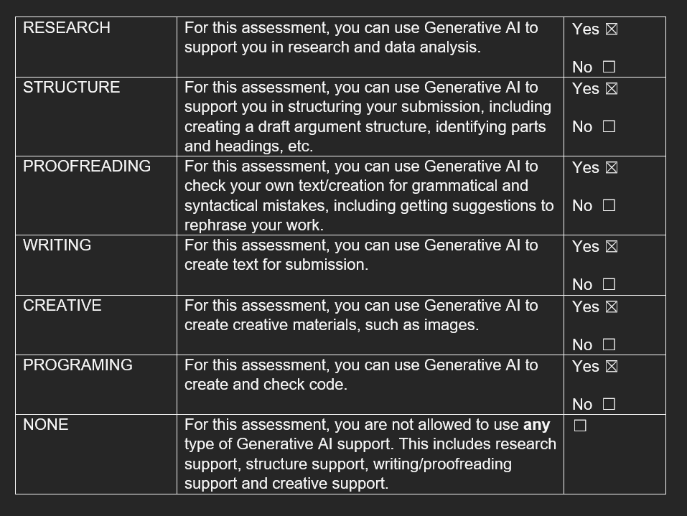
I acknowledge the use of ElevenLabs [https://elevenlabs.io/?utm_source=bing&utm_medium=cpc&utm_campaign=uk_pmax_voicegen_english&utm_id=569466665&utm_term=elevenlabs.io&utm_content=voice_cloning_signal&utm_source=bing&utm_medium=cpc&utm_campaign=uk_pmax_voicegen_english&utm_id=569466665&utm_term=elevenlabs.io&utm_content=voicegen_pmax&msclkid=3338dbe7f23c1cca8a96b22d881a96cf] on 11th March to use in my questionnaire for my essay.
I used the prompt(s):
1. Narnia: The Lion, The Witch, and The Wardrobe, pages 13-16
I confirm that I have not presented any AI generated text as my own work. I confirm I have copies of my drafts, notes, and other resources I used before, and after the use of AI tools which I may be asked to provide in evidence.

