
Skills for the Workplace
Module Assignment Submission
Student Name: | Nicola Dacosta
Student Number: | 2016821
Module No: | BMSK4006
Module Title: | Part 2 Reflection

Statement of Confirmation of Authenticity
By the act of making this submission, the student declares that this is the work of the student named above. The work has not, in whole or in part, been knowingly presented elsewhere for assessment, or where assessment has been built on a previous assessment, this has been identified. Where materials have been used from other sources it has been properly acknowledged. If this statement is untrue, the student acknowledges that an assessment offence has been committed.
Attention is drawn to the plagiarism and unfair practice policies of both the University and of ILM.

Contents
Introduction 3
Description 3
Gibbs reflection model 4
Feelings and evaluation 4
Analysis 6
Action plan 6
Conclusion 7
References 8

Introduction

This report focuses on my critical expression over various subjects that I have learned in this module. My journey has remained progressive and enlightening throughout the business report and I have gained sufficient knowledge on the subject matter. However, it is not limited to books, and I need to learn and grow continuously. This report will discuss my journey and learning with the scope for my professional prospects (Allison et al.,2016)

Description

The process of researching and formulating a business plan has given me valuable skills that I can take on into future occupations, opportunities, and life events. I started by thinking of an idea. Which business did I want to delve into the financial side of? I had already been an entrepreneur and found myself opening a tanning business a few years ago. This prompted me to see what my finances could look like if I undertook a role as a professional, self-employed spray tanner.
After thinking of this idea, I decided to look at the finances of my business. This included how much my products would be, how much it would cost me and how well my business could perform. I needed to look at how I would finance my business venture. I looked at loans and savings that I may have at that point in my life. This was an interesting way to look at how I could finance my business if I were to really go ahead with my plan.
I finally concluded my assignment and reflected on what I had written. This really made me think I had written an extensive business plan that I could use in the future.
In this reflection I am going to use Gibbs reflective model (Gibbs, G.1988) to monitor my progress and see how well I did in writing a plan. To do this I need to describe what has happened, then analyse and evaluate it. I will then conclude and set an action plan as to what I would do if the opportunity to write a business plan rose again.
I am going to do a GAP analysis to see how better I could progress within my business venture and how I can improve.

Gibbs reflection model
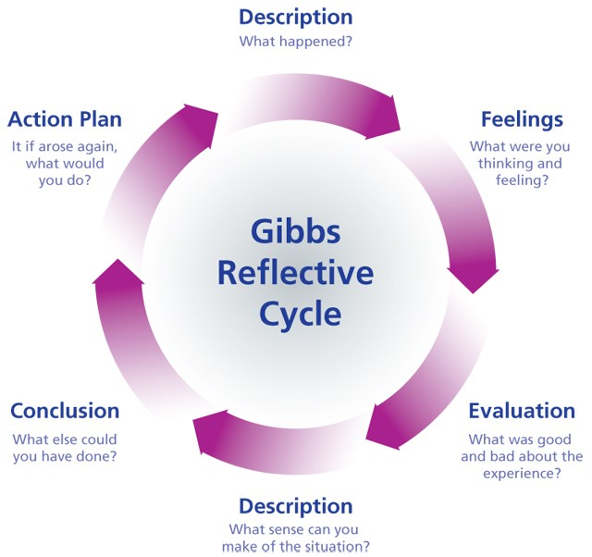

Feelings and evaluation

I would like to be able to open my own spray tanning business as use this plan as a model for me to do so. Now I am currently working for companies’ house, which is the complete opposite to my business proposal. I enjoy my job but always feel I am not fulfilling my full potential and doing something that I would enjoy, like spray tanning. The only thing restricting me from opening a spray tanning business is the funds. I am fearful that if I were to leave companies house, I would not be able to provide for my family with my spray tanning business and working as a sole trader. To bridge the gap between my current state and desired state I am going to begin saving and save my university grants so that I have financial backing for my business.
I did not like the maths part of my assignment as I am not mathematically inclined. I felt very anxious and did not want to do it. I pushed through and managed to create a 5-year plan with financial figures as back up. This really boosted my confidence and made me feel like my numeracy was not as bad as I had once thought.
I did not like how much time the assignment as I am not mathematically inclined. I felt very anxious and did not want to do it. I pushed through and managed to create a 5-year plan with financial figures as back up. This really boosted my confidence and made me feel like my numeracy was not as bad as I had once thought.
I did not like how much time the assignment took. It was extremely time consuming, but very interesting. If I did not like the assignment, I would have disliked this much more. I feel like I should have managed my time and written the assignment over a period instead of in one or two sittings. This would have allowed me to delve more into my spray tanning business, which I was extremely interested in creating a plan for.
Writing skills is also an essential job skill as it is a primary skill that is needed in the workplace and in the community. Writing equips us with communication and thinking skills. I do struggle with this as my spelling and grammar is not my strong point, I struggle with this a lot I can help myself with reading and using spell check to make sure

I am confident and understandable in any written task I may have.
I really enjoyed researching my business and looking at what I would need to do if I did decide to open a self-tanning business. It is something that I may look back to in the future and use to further myself and my occupation.
I also enjoyed learning about the laws and legislations around being a spray tanner and working self-employed. I knew it was a hard job to consider but did not realise how much extra work had to go into being a sole trader.

Communication is also a vital strength it involves listening, speaking, observing, and empathising it is also helpful to understand through face-to-face communications and over the telephone and digital communications like email and social media.
This is one of my strongest attributes I have had many years of experience and I feel I
am engaging interesting and approachable I can listen attentively and with understanding and I can adapt well to any situation to clearly communicate with different types of people. I enjoy communicating and feel this is a strength of mine.

Making decision is an important factor with any type of business whether it be big or small taking the bold steps of ensuring a good outcome by the decisions that are made.
I do this by making choices gathering information and assessing alternative resolutions I anticipate outcomes and allow for any risks or uncertainties. This is something I am developing and hope to become better at.

My organisational skills were good with this assignment. I managed to complete all the homework’s given to us so that helped me with my assignment. However, as I previously said I should have given myself more time to complete the assignment so that I could go more into my topic and look at different finances, such as profit and balance sheets. I do think that not being mathematically minded worried me and caused a lot of anxiety which made me not want to start the assignment. Looking back this did not affect my assignment at all and I should have started sooner and put all the homework’s I had completed into one functioning assignment so that I could use my time wisely with researching etc.

Analysis

Below shows a table of Strengths, weaknesses, opportunities, and threats. (SWOT)

SWOT analysis

Strengths  Qualified spray tan specialist  Good organisation skills  Friendly and sociable | Weaknesses  Self-Belief  Funds  Family commitments
Opportunities  Take out a loan  Open my own salon  Advertise my services | Threats  Competition  Anxiety  Overworked

Action plan

My action plan will be to have more self-belief and work on my confidence to believe I can and will achieve my goals I can listen to podcasts and improve my skillset by researching and learning new things. I can address my anxiety through mindfulness and learn to understand my weaknesses which may be holding me back and can have a effect on my future I can also enhance my strengths by learning new skills which will enable me to grow and succeed in the employability area.

This will allow me to look deeper into the market and gather more information about how I could improve the business model. For example, researching other spray solution brands could mean I drive down my outgoings but at the same time maintain the same quality of tans or even find a better tan solution.

Also, things like business cards and barrier cream can potentially be reduced in cost with a little more research.

I would also like to research new ways of marketing to keep my client base full as it is important to continually find new customers as not all customers remain loyal customers. So, it is important to have an ever improving marketing scheme that adapts with the way tanners consume their information.

By improving my on my anxieties and self confidence I can be in a place where I can be more thorough in my business plan preparations if this process is required again in the future.

Conclusion

In conclusion I think I wrote a convincing business plan but wish I had not let my anxieties take over so that I could look deeper at the spray tanning business and what it would cost to open one. This would help me with my business ventures in the future in case I wanted to open my own spray tanning company in the future.

My action plan is to take time to go deeper into my business plan and to add more to it so that it is useable. This would include wider research into tanning solution and barrier cream in order to reduce the cost or improve the quality or both. I would also cost up a marketing strategy that would be durable and adapt with the needs of the customers that I would be targeting.

Should I undertake these actions the result would be a more robust and ready to use business plan

References

Allison, B., Hilton, A., O’sullivan, T., Owen, A. and Rothwell, A., 2016. Research skills for
students. Routledge.
Gibbs, G. (1988) Learning by doing ; A guide to teaching and learning methods. London FEU
Maund, A., Schriek, M., Tinkler,P, 2017. Certificate in Higher Education: Skills for the Workplace Student Yearbook.

