

M4X01508

Introduction into computer programming

Assignment on:
Lottery numbers

Submitted to
Gaynor Thomas

Daniel Algie 1706977

Contents

Introduction 3

Loops 3

[1]While loop 3

[2]For loop 3

User guide 3

Moscow Chart 4

Screen shoots 4

[3]Program Code 6

Conclusion 8

Flowchart ………………………………………………………………………………………………………………………………………….9
………………………………………………………………………………………………………………………………………………………..10
………………………………………………………………………………………………………………………………………………………..11

References 12

Introduction
In this assignment the author will be building a program to generate 6 random lottery numbers for the customer. They will be including a Moscow chart to show what was wanted and what was not included in the program, also there will be a ‘how to’ guide for the customer to understand how to use the program.

Loops

[1]While loop
The while loop is used to make sure the program and task it is asked to do is true, if the programme is false the while loop will loop back to fix the problem. The while loop was used in the program to stop duplicate lotto numbers by checking the lotto numbers and if any duplicates were found the while loop would run the number again to produce a new lotto number.

[2]For loop
The for loop is used to generate a task a number of times you want it to complete, for example, for generating the lotto numbers the author used the for loop to generate the number of times it wanted to print a random number.

User guide
This is to help the customer run the program
- To run the program press ctrl and f5
- Once the program is running if the user is ready to use press Y to continue, if not ready press N to use another time
- Once the lotto numbers are displayed, press any key to continue
- To see more lotto numbers repeat this process

Moscow Chart

Must have | Should have | Could have | Won’t have
Generate 6 lotto numbers | Ascending order | Bonus ball | Choice of language
No duplicate numbers | Question asking ready to receive lotto numbers | Different colour writing | Option to choose specific numbers
Be in ascending order | Welcome to page | Different colour background

Screen shoots

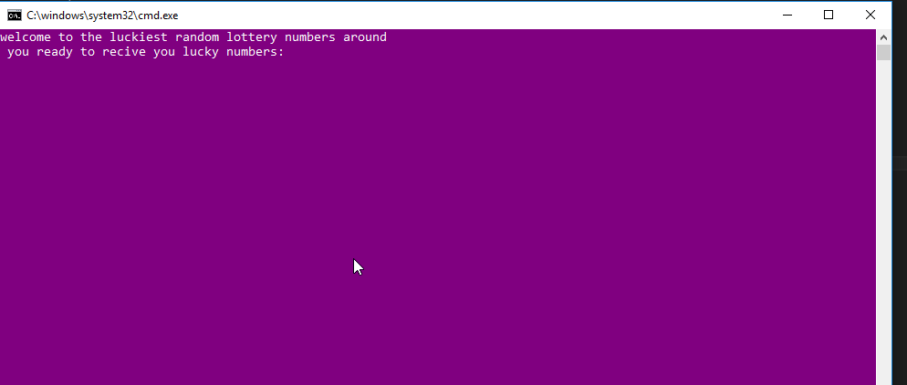
This is the start of the program where the customer decides whether or not to proceed.

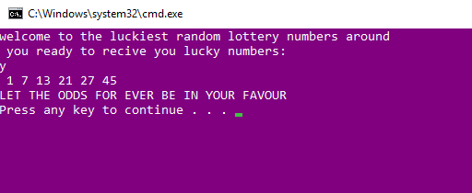
This is where the customer has chosen yes and the lotto numbers are displayed.

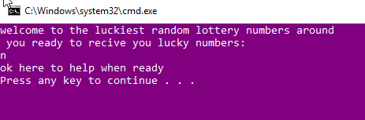
This is if the customer isn’t ready to use the program.

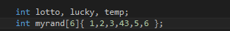

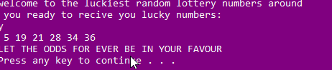
This is where the author chooses the numbers but still runs on random numbers.

[3]Program Code

#include <stdio.h>
#include <stdlib.h>
#include <time.h>
void main()//
{

int lotto, lucky, temp;//int lotto is used to show 6 random number,int lucky is a loop counter, int temp used to hold number when numbers are sorting in to order
int myrand[6];//creates 6 random numbers
int flag = 1;//this is to stop dublicate numbers
int low = 1;//lowest number can generate
int high = 49;//highest number can generate
char choice = 'y';//y is the choice to see the numbers
system("color 5f");//alter colour of dialog and text
srand(time(NULL));// to prevent sequence repetition between runs
printf("welcome to the luckiest random lottery numbers around\n ");//displays title
printf("you ready to recive you lucky numbers:\n");//asking the choice question
scanf(" %c", &choice);//user inputs choice
if (choice == 'y')//if user inputs choice = y
{

for (lotto = 0; lotto < 6; lotto++)//for loop generate numbers for the duration this example is 6 times
{

myrand[lotto] = rand() % (high - low + 1) + 1;//generates 6 numbers for int lotto

}

while (flag == 1)
{
flag = 0;
for (lucky = 0;lucky < 5;lucky++)//making sure numbers arnt the same
{
for (lotto = lucky + 1;lotto < 6;lotto++)
{
if (myrand[lucky] == myrand[lotto])
{
myrand[lotto] = rand() % (high - low + 1) + 1;

flag = 1;//generates new lotto number

}
}
}

for (lucky = 0;lucky < 5;lucky++)
{
for (lotto = lucky + 1;lotto < 6;lotto++)
{
if (myrand[lucky] > myrand[lotto])//makes numbers in order of size
{
temp = myrand[lotto];//moves lotto number to temp
myrand[lotto] = myrand[lucky];//moves number to my rand lucky to lotto
myrand[lucky] = temp;//moves number from temp to lucky
//creates numbers smallest to largest

}
}
}

}

for (lotto = 0; lotto < 6; lotto++)
{

printf(" %d", myrand[lotto]);//displays 6 lotto numbers in order of size

}

printf("\nLET THE ODDS FOR EVER BE IN YOUR FAVOUR\n");//thankyou messeage
}
else//other choice != y
{
printf("ok here to help when ready\n");//display choice
}
}

Conclusion
In conclusion, the assignment went well. Everything the author wanted to add to the program and achieve was completed successfully. The objective was to complete a program to give the customer random lotto numbers in ascending order and with no duplicates, also include a user guide so the customer knew how to use the program with minimal difficult. The author was happy with the final product and wouldn’t change anything with the program.

Flow chart
Displaying the numbers

This is the flow chart for stopping duplicate numbers

This is the flow chart to ascend the lotto numbers in correct order

This is the complete flow chart when pieced together

References

[1] | zentut, "zentut," [Online]. Available: http://www.zentut.com/c-tutorial/c-while-loop/. [Accessed 25 4 2018].
[2] | t. point, "tutorials point," [Online]. Available: https://www.tutorialspoint.com/cprogramming/c_for_loop.htm. [Accessed 25 4 2018].
[3] | dyclassroom, "dyclassroom," [Online]. Available: https://www.dyclassroom.com/c/c-while-loop. [Accessed 25 4 2018].

