Student name : Valentina Obreja
Student ID : 1808708
Lecturer name : M. Kalam
Module : BMSW5106

KNOWLEDGE AND INFORMATION MANAGEMENT SKILLS FOR THE WORKPLACE

Table of contents

1. Introduction 3
1.1 Aim and Objective 3
1.2 Company Background 3
2. The relationship between knowledge, information and data 4
3. The relationship between individual knowledge and organisational knowledge 5
4. Apply analysis and modelling techniques to identify knowledge assets 6
4.1 Literature Review 8
4.2 Methodology 8
4.3 Findings 9
5. Evaluate actual and potential knowledge assets 9
6. Required to create, store, apply and integrate knowledge 10
7. Consider the importance of Intellectual Property rights 11
8. Explain “contribution knowledge assets” for organization 12
9. Evaluate “knowledge requirements” of organization 13
10. Evaluate the firm’s framework for enabling the knowledge sharing 14
11. Recommend improvements based on their current framework 15
12. Application of relevant theories and models 15
12.1 Systems theory 15
12.2 Scientific management 16
13. Conclusion 16
14. References 18

1. Introduction

1.1 Aim and Objective
The aim of this project is to establish an understanding and knowledge of various challenges or barriers of “managing knowledge and information” in the Primark. This report further has a primary objective of identifying and implementing a suitable management information system.

1.2 Company Background
Primark is a fast-fashion retailing giant of UK. It is renowned for offering a wide variety of apparel at affordable prices. It was established in 1969 by Arthur Ryan. It is a UK based company and a subsidiary of Associated British Food Plc, a retail and food processing company. They have a turnover of 7.79 billion pounds in 2019. They have over 78,000 employees working in 373 locations all across Europe and the USA (Primark.com, 2020). The Product of Primark comprised of a diverse range that includes confectionery, beauty products, footwear, accessories, homeware, menswear, womenswear, children’s clothing and baby clothing. The most vital knowledge asset of the company is its current CEO Paul Marchant who is responsible for formulating tactic and plan of the company. Furthermore, its other “knowledge assets” include their deep expertise of key personnel.

Figure 1: Primark store at Birmingham
(source: Primark.com, 2020)
In this study, the relationship between information, data and knowledge of Primark is critically analysed. The association between organisational knowledge and individual knowledge is also evaluated through this report. The modelling techniques along with analysis will be implemented in this report to identify “knowledge asset”. The “potential” and “actual” knowledge assets are also evaluated in this report. The requirement of forming, integrating, storing and applying knowledge asset is analysed. The significance of “intellectual property rights” is also discussed. The significant contribution of “Knowledge asset” on the Primark organisation is also evaluated in this report.

2. The relationship between knowledge, information and data
Data is known as the compilation of fact, events or object that reflects something specific, however, data does not come in an organised manner. These are unstructured figure and facts that have very insignificant influence on a manager of a Primark organisation. It may reflect a trend in the working environment or may indicate a specific pattern of sales for a time period. Subsequently, information is usually found as an answer to the questions that start with “what”, “Who”, “Where”, “When” and “how many”. Information Technology is primarily responsible for converting data into information in Primark organisation. Primark produces a large quantity of data in its multiple function and department. On the other hand, Knowledge is critically connected to doing a specified task and indicates understanding and know-how.
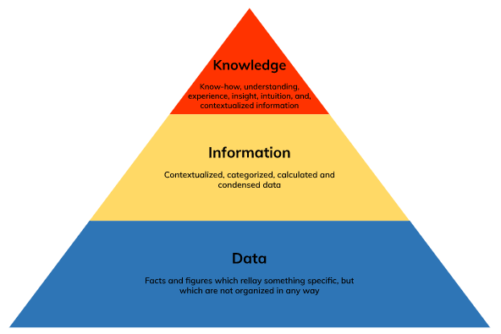
Figure 2: Relationship between knowledge, information and data
(Source: Ibidunni et al., 2018)
The knowledge and understanding possessed by each employee of Primark is the product of their experiences and comprised of the norms by that the employee analyses any new input from their surroundings. In Primark, it has become embedded only not in repositories or documents, but also in organisational practices, norms and routines. Primark has a unique organisational structure that is responsible for the flow of within the organisation. It uses various technological resources to store its transform its data into organised information and communicate it to its workers to make them more aware of the current demand and demand of the market so that they can work accordingly. The HR of the Primark is also responsible for communicating the relevant information to their different department.

3. The relationship between individual knowledge and organisational knowledge
“Individual knowledge” is that data or information that a person collects, store, classify, retrieve, search and share in their regular activities. It is a responsibility to knowledge workers for their own learning and growth. It is a “bottom-up” methodology of Knowledge management. It is the flow of information between the employees. It an essential aspect of every organisation as the absence of sound flow of data and information the organisation cannot achieve its goals or objective. However, “Individual knowledge” and “organisational knowledge “are related to each other.
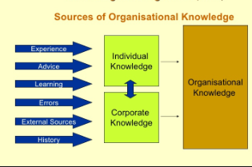
Figure 3: Source of organisational Knowledge
(Sourcee: Ibidunni et al., 2018)
Organisational knowledge crucially depends upon the participation or contribution of an individual to fuel and sustain the “intra-firm knowledge dynamic”. In the “fundamental level”, knowledge is established solely by an individual based on their capacity to add relevant meaning to identity pattern, information and conclusion drawn from a unique experience. Only by the contribution or participation of individuals or employees does knowledge converts institutionalised in an organisation (Ibidunni et al., 2018).
Furthermore, knowledge transferring primarily takes places in social interaction among individuals. Hence, to seek knowledge an organisation ultimately depends upon the human capacity to utilise existing knowledge and to integrate it into decision making to steer the performance of the establishment to reach the goal of the organisation. Despite the integral role of the individual in organisational knowledge, individual knowledge’s role is under-investigated by many IC and KM studies. However, it can be concluded that organisational knowledge is a spectrum of individual knowledge. Hence, an organisation like Primark promotes and motivates its employees to share their ideas and innovation within the organisation.

4. Apply analysis and modelling techniques to identify knowledge assets
AIAI has formulated dissemination and teaching concept for the management of “knowledge asset” in the organisation. The establishment is required to promote the significance of “knowledge management” and should teach how “knowledge management “can be achieved across different functioning division. Nowadays, the techniques and methods of Artificial Intelligence regarding Knowledge management have grown significantly to towards identifying and structuring the knowledge asset of the organisation. There are many tools or models to sustain the modelling, capture, validation, maintenance and verification of knowledge (Dalkir, 2017). KADS is the methodology used by the Primark organisation for “knowledge-based system development”. This methodology considers the formation of the “knowledge-based system” as the modelling action.
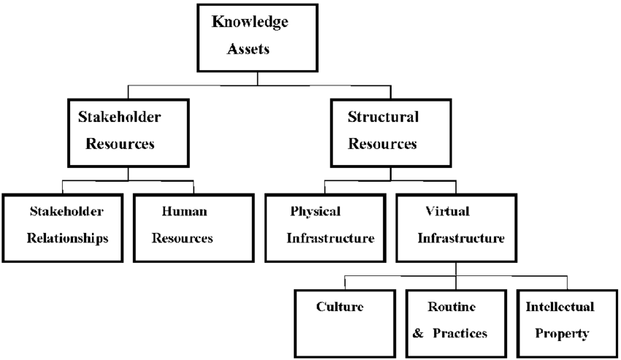
Figure 3: Knowledge Asset
(Source: Dalkir, 2017)
Here every model reflects a specific picture on the issues of “engineering an application”. This model approach is expanded to “knowledge management”. “Enterprise modelling” is another useful technique for the management of knowledge. It is usually done to achieve a higher understanding of the organisation. Dieng and Hug, (1998) reflect a preliminary survey of some techniques, tools and methods aims to recognize and manage knowledge and data of the company. The examples of various kinds of knowledge asset that needs to be identified in Primark are:
- Technical product and design
- Technical know-how
- R and D patents and results
- Manufacturing technology
The codified asset of Primark includes:
- Operating guidelines
- Company process
- Knowledge-based system
- Documented expertise
- Lesson learnt laboratory and workbooks
The human knowledge asset of Primark includes:
- Marketing expertise
- Management expertise
- Operational expertise
To knowledge producer or developer it is difficult to ascertain that if knowledge assets identification is a “black art” requiring in-depth data or knowledge of the organisation and efficient “intuitive skills”, otherwise it is the simple matter of querying the senior experts that take the sound decision or whether to ask the employees in which the individual search for knowledge whenever they face any problem. The answer between the two; identification of knowledge asset by implementing a mixture of “knowledge modelling” and “ask an employee” method as it is essential to respond to the several questions regarding every “knowledge asset”.

4.1 Literature Review
According to Knowledge Management (KM) or Intellectual Capitals (IC) literature, an organisation is viewed as a combination of its IC and KM, both of these are necessary to enhance the outcome of the companies. IC refers to the knowledge resources of the organisation. IC of an organisation can be divided into two aspects; Human Capital (HC) and Structural Capital (SC). HC refers to the amalgamation of the existing knowledge and experience of the workers and SC includes Relational Capital (RC) and Organisational Capital (OC). RC is the combined value of the external relations of the organisation with its stakeholders and OC is the embedded knowledge of the organisation. According to the theory of Machlup (1979), “knowledge exists as a series of stock and flow in different modules of IC”.

4.2 Methodology
The exploratory nature of the research states that the qualitative methodology should be utilised to formulate an insightful and rich outcome and generates a sound understanding of the complicated concept of Knowledge. An interview is held with 16 managers from a diverse industrial sector. The Respondent had various profiles which comprise of both large enterprise (LE) and small and medium enterprises (SME) as exposed in “Table 1”. “Semi-structured interviews” were utilised to allow the respondent to express their opinion regarding the research topic. Open-ended questionnaires were used mostly to allow the respondent to efficiently elaborate on their opinion. Furthermore, thematic evaluation was utilised to soundly interpret the data of the interview and analysing the primary findings by comparing the responses of different intervene on the same question. The qualitative analysis software NVivo software was utilised to recognise the theme within the glean insight and data.

No. | Size | Industry | Job Title
1. | LE | Manufacturing | Account Managers
2. | LE | Oil and Gas | Operations Manager
3. | LE | Manufacturing | Director of Strategy
4. | LE | Logistics | Supply Planning Manager
5. | LE | Education | Department Chair
6. | LE | Consulting | Business Developer
7. | LE | Healthcare | Managing Director
8. | SME | Education | Vice- President
9. | SME | Pharmaceuticals | VP of Business Development
10. | SME | Healthcare | Sales Manager
11. | SME | Technology | Chief scientist
12. | SME | Consulting | HR consultant
13. | SME | Manufacturing | Marketing Manager
14. | SME | Technology | Content Manager
15. | SME | Consulting | Managing Director
Table: 1 Respondent Profile

4.3 Findings
When the managers were asked about the contribution of individual knowledge, the majority of the responders believe that the knowledge of the company depends upon their employees. They also state that performance of the organisation is steered by the organisational knowledge. They further stated that improving and developing “individual knowledge” of the workers of the establishment can lead to improvement of both the organisational knowledge and performance of the organisation.

5. Evaluate actual and potential knowledge assets
“Knowledge assets” can be categorised depending on the level of uncertainty connected with the benefits that can be derived in the future. This category includes two kinds of “knowledge asset”; “actual knowledge asset” and “potential knowledge asset”. Actual knowledge assets are those expenditures that have the capability to generate benefits in the future. This indicates the integral intellectual resources of the organisation (Natalicchio et al., 2017). It is the amount of knowledge possessed by the workforce of an organisation in for of learning, ideas, information, insight, memory, technical skills and the capabilities of the employees to share this knowledge with one another to perform more efficiently. Some of the examples of actual knowledge asset of Primark organisation are technical product and design, technical know-how, R and D patents and results and manufacturing technology.
Potential knowledge asset is the expenditure that has a high uncertainty surrounding future-benefits. The customer data-based software is used by the Primark on a regular basis. The continuous use of the software has a measurable benefit to the organisation and can be considered a knowledge asset. However, if the company invest money on its development it may not meet the returns of investment. Investing in these assets is very risky. Hence, unsound investment in potential knowledge asset can have adverse output. The Primark organisation comprised of some potential knowledge, investment on which can result in a negative outcome or not meet the return of investment. These include customer database system of the company.

6. Required to create, store, apply and integrate knowledge
Formulating information or knowledge comprised of recording the decision-making process and the workflow to recognise the key knowledge workers of the company. An establishment requires Knowledge workers to create, disseminate and use knowledge. This primarily includes engineers, Scientist, designers and others. Knowledge employees are an integral part of every organisation (Wilson and Campbell, 2016). However, it is not necessary that only the knowledge worker is responsible for contributing to organisational knowledge, individuals like experience managers who does not include in the category of Knowledge workers also have a broad wealth of knowledge.
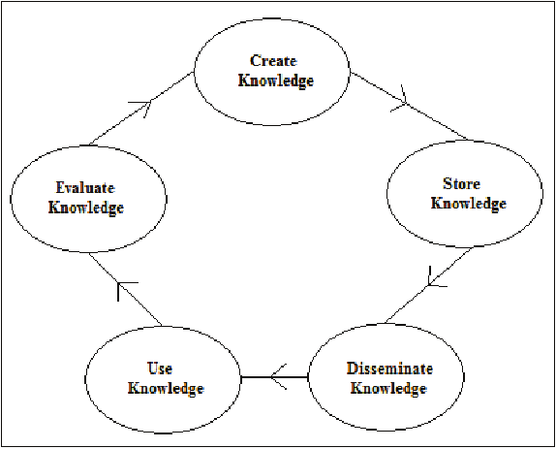
Figure 4: create, store, apply and integrate knowledge
(Source: Wilson and Campbell, 2016)
Once the knowledge is has been created by the knowledge workers, now it is essential that this knowledge is stored in an organised manner. Nowadays, technological resources are utilised to store or document knowledge. The document management system is utilised by Primark to store knowledge in an organised and structured manner for smooth access. After storing created knowledge in a document, now the organisation requires to implement it to improve the performance of the workforce. It is essential to soundly implement the collected knowledge to achieve the goal of the organisation. It is also essential that the workforce use the knowledge in an integrated manner to maximise the outcome. Proper coordination of the employees is essential to increase the intensity of the implemented knowledge.

7. Consider the importance of Intellectual Property rights
In the recent era, innovation is the driving force of every organisation. It leads to the growth and development of “Intellectual property”. Developing, leveraging and identifying innovation can provide economical advantage to the organisation. “Intellectual property” is not restricted to technical organisation; however, it is important for all organisations that invest large funds in development and research for establishing indigenous services and product. Intellectual property rights are important as it offers an incentive to the person for creating something new. It also offers recognition to investors and creators. They also ensure the “material reward” for intellectual property (Rushing, 2019).
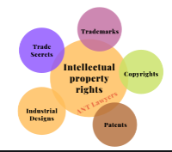
Figure 5: Intellectual Property rights
(Source: Rushing, 2019)
They also assure the availability of the original or initial product. They are essential for the growth of business in the technological sector. Intellectual property also has a vital impact on international trade. With the advancement of digitalisation, the chance of innovative ideas being stolen by any other part has increased in a significant manner. Intellectual property plays an important role in safeguarding such innovative ideas. Moreover, the intellectual property rights importance varies in a different part of the globe. However, every country that depends on international trade implements strong measures to safeguard “intellectual property rights”.

8. Explain “contribution knowledge assets” for organization
The “knowledge assets” defines to the overall accumulated intellectual types of resources of firms. As opined by Lawong et al. (2018), it is primary applying for possessing knowledge by organization along with its workforce based on “information, understanding, learning, insights, memory, technical and cognitive skills” as well as modified capabilities. It can be said that a firm can be entirely perceived by providing some portfolio based on competencies and these are entirely supported by “internal resources”. The overall route from entire knowledge assets to recognising competitive advantage needs the proper strategic management based on the knowledge of firms. On the other hand, Yoke and Ngang (2017) said that the organization can be able for utilizing their mainly available capabilities so that they can provide the differentiation of its support of businesses as well as their major work processes. For ensuring the organization, which have the relevant knowledge assets and it helps them in sustaining the overall competitive advantage for their organization.
It can be said that the overall performance of Primark can be majorly traced by identifying their contribution in knowledge assets that are approximately found as 80% of their current liabilities. Alreemy et al. (2016) opposed the previous opinions and added that the entire set of assets is utilized in generating activities based on high volume. It can be recognized that it is very crucial for Primark to give products in allowing margin instead of tight up all the products based on long-term debts. Primark invested total amount, which is above “£34.6m in 2015” in the new assets, while at the recent time they reduced their “current liabilities” by “over £23m”. This resulted the “asset turnover” to decrease from above “12% and ROCE by approximately 8.6% in 2015”. It has also found that Primark has already raised their retail process through making the contradiction of their “low budget price policy” on their products.

9. Evaluate “knowledge requirements” of organization
For firms, knowledge is referred as the most significant “strategic asset” and it helps to identify, share, capture or acquire, unlearn and reuse knowledge. “knowledge management” is defined as the systematic process that involves the “clarifying, collecting, disseminating, reusing and clarifying the information. As stated by Lawong et al. (2019), it can be said that entire KM process deals with the “explicit knowledge” as well as “tacit knowledge” and these are required for firms. All these activities are entirely managed through the proper “knowledge management” and it mainly evaluates the overall level of knowledge along with the “knowledge management” of firms. In case of Primark, the entire “KM system” has provided the help in their management in making effective decisions on how they can effectively perform their organizational operations. On the other hand, Gokhale et al. (2017) makes an argument and added that
Primark operates the proper “returns policy”, where the certain products can be returned to all stores in some condition in which they can sold their products provided the customer also makes the receipt of purchase available through using effective digital equipment within firms. This includes the system for processing customers through providing the “returns desk” where the refunds can be issued to their customers or some exchanges are made depending on needs of customer. Dubey and Tiwari (2020) agrees and previous opinions and said that the overall mix of their operations can allow for the innovation in “Primark” as choose of some aspects based on concepts can help them to come up with the efficient mix and it helps to meet their “low cost strategy”. As they implement “lean operations”, they can mainly continue their operations to ensure the optimum use of resources and all employees are trained on that concepts so that the firm can easily meet their strategy based on involving some efficient level of “knowledge management”.

10. Evaluate the firm’s framework for enabling the knowledge sharing
In Primark, there exists significant differences between the performance of firms and individuals’ based on the concerned knowledge that is majorly required for managing effectively the firms. These processes are made within organizations based on their effective communication system. As opined by Varadharajan et al. (2018), the notable fact is that these facts of firms affect the individuals, who belong from the “single sentiment entities”. These entities are entirely made of different types of “non-sentient group entities” and it has been consisted of sentiment components for individuals. On the other hand, Lim (2016) the proper connections are made through identifying the limited channels of communication. It can be said that if “explicit knowledge” is separated from the “individual knower” based on the knowledge base of firms. Furthermore, for individuals, the overall “coordination of knowledge processes “is largely defined as an “implicit cognitive process” along with some “conscious decision”. It helps to lead entire business can be effectively handled by skilled management employees within this firm.
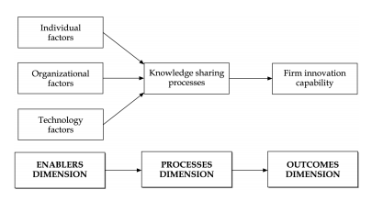
Figure 6: firm’s framework for enabling the knowledge sharing
(Source: Varadharajan et al. 2018)
In a firm, the “implicit component of knowledge process coordination” is confined for individuals. It is significant to implement explicitly “organizational knowledge management processes” in coordinating as well as integrating the firm’s individual as well as explicit stores of knowledge. Gokhale et al. (2017) said that it helps to ensure that the entire processes of knowledge of organization are executed successfully. Employees of Primark have followed those steps, which helps to fulfil the requirements of stakeholders by providing responses to as well as by interacting with their “external environments” in which they have existed. Therefore, for groups or individuals, firms need to acquire knowledge based on the needs of their “stakeholders” along with “knowledge of their environments” as well as the ability in applying the knowledge efficiently for surviving or prospering their existence in entire competitive international business markets.

11. Recommend improvements based on their current framework
It can be recommended for Primark based on their current framework for the betterment of their operations in measuring management skills for their enterprise.
- They have to improve their communication system so that the entire information system can be performed properly and information can be easily transferred to different departments.
- They have to change their leadership planning strategy as it is directly related to their information management skills. It has caused for their financial causes and as a result, their entire business positions are harmed. It reduces their product innovation that has negatively affected their entire business. It also lades the firm in providing several low qualities of services as well as products. They have to implement such a strategy through which these problems are solved properly.
- They have to implement modified equipment in their firm so that the proper innovation can be made such as wireless digital equipment for performing effective communication system within internally.

12. Application of relevant theories and models

12.1 Systems theory
It is based on some concepts such as “entropy, subsystem as well as synergy”, where entropy is defined as the overall tendency for running down the harmful situation that are used in business issues. In the next step, all the members are working together and they include those parts that can produce the larger than other parts that can be produced by their own contribution. As opined by Lim (2016), the subsystem is defined as those aspects in business, that are built on the entire subsystems and it can be beneficial to make another subsystems by the firms.
By implementing this theory in firms such as Primark, the employees can interact with firms as a whole they can be implemented in this organization in operating business operations so that the organization can gain the profit. It can have slowly developed the overall compensation for employee base to provide relaxation employees as “stock prices “are decreased. In this theory, the major three parts are identified as activities, which are required to complete the entire business process in performing the business operations. On the other hand, Varadharajan et al.(2016) by recognizing the drawbacks and back holes in the “activities system” can be “updates and work” according to several continuous connection with entire “external environment” for firms in form of providing feedback.

12.2 Scientific management
The principles of scientific management are identified based on the principles of “top-down approach” and it helps to properly examine their entire business operations. As per the concept of this theory, it can be said that several six responsibilities are defined to properly manage the employees such as command, control, organize, forecast and plan. As opined by Varadharajan et al. (2016), those principles are important for manger so that they can effectively manage their team. Taylor had proposed few “scientific management principles” for performing better operations for their management process in Primark. This theory is helpful based on eth comparison of other theoretical approaches. By defining “roles and responsibilities”, “centralization and decentralization” of “authority and responsibility”, work division, unity of their command along with the unity based on directions as well as other principles. On the other hand, Lim (2016) it becomes more popular as well as proven as the beneficial principle for handling the organization in efficient manner along with maintaining their operations.

13. Conclusion
In this report, the importance of knowledge management in an organisation is critically studied. The relationship between knowledge, information and data in Primark organisation also closely studies. The relationship between organisational knowledge and individual knowledge is also evaluated through this report. An interview is also conducted concerning 16 managers from the different industrial sector to evaluate the importance of individual knowledge in an organisation. The Actual and potential knowledge of an organisation is also evaluated through this report. The requirement of creating, storing and applying the knowledge is also evaluated. The importance of intellectual property rights is also discussed in this study.

14. References
Alreemy, Z., Chang, V., Walters, R. and Wills, G., 2016. Critical success factors (CSFs) for information technology governance (ITG). International Journal of Information Management, 36(6), pp.907-916.
Dalkir, K., 2017. Knowledge management in theory and practice. MIT press.
Dieng, R. and Hug, S., 1998. Comparison of Personal Ontologies Represented through Conceptual Graphs. In ECAI (Vol. 98, pp. 341-345).
Dubey, R.S. and Tiwari, V., 2020. Operationalisation of soft skill attributes and determining the existing gap in novice ICT professionals. International Journal of Information Management, 50, pp.375-386.
Gokhale, P. and Vibhor, A., CommVault Systems Inc, 2017. Application of information management policies based on operation with a geographic entity. U.S. Patent 9,633,216.
Ibidunni, A.S., Ibidunni, O.M., Oke, A.O., Ayeni, A.W. and Olokundun, A.M., 2018. Examining the relationship between tacit knowledge of individuals and customer satisfaction. Academy of Entrepreneurship Journal, 24(1).
Lawong, D., Ferris, G.R., Hochwarter, W. and Maher, L., 2019. Recruiter political skill and organization reputation effects on job applicant attraction in the recruitment process. Career Development International.
Lawong, D., Ferris, G.R., Hochwarter, W. and Maher, L.P., 2018, July. The Impact of Recruiter Political Skill and Organization Reputation on Applicant Attraction. In Academy of Management Proceedings (Vol. 2018, No. 1, p. 10296). Briarcliff Manor, NY 10510: Academy of Management.
Lim, K., NEXTLABS Inc, 2016. Analyzing activity data of an information management system. U.S. Patent 9,407,662.
Machlup, F., 1979. Stocks and flows of knowledge. Kyklos, 32(1‐2), pp.400-411.
Natalicchio, A., Ardito, L., Savino, T. and Albino, V., 2017. Managing knowledge assets for open innovation: a systematic literature review. Journal of Knowledge Management.
Primark UK. 2020. About Us | [online] Available at: https://www.primark.com/en/aboutus [Accessed: 28 April 2020].
Rushing, F.W. ed., 2019. Intellectual Property Rights in Science, Technology, and Economic Performance: International Comparisons. Routledge.
Varadharajan, P., Dornemann, H.W., Polimera, R. and Kandasamy, A., CommVault Systems Inc, 2018. File manager integration with virtualization in an information management system with an enhanced storage manager, including user control and storage management of virtual machines. U.S. Patent 9,939,981.
Wilson, J.P. and Campbell, L., 2016. Developing a knowledge management policy for ISO 9001: 2015. Journal of Knowledge Management.
Yoke, T.C. and Ngang, T.K., 2017. A study on soft skill development among final year diploma in business studies students. MOJEM: Malaysian Online Journal of Educational Management, 3(2), pp.32-50.

