

LEVEL 7 ASSESSMENT REPORT
Master of Business Administration

International Marketing: Principal And Practices LCMB7026

Student Name- HARSHKUMAR MANOJKUMAR PATEL

Student ID- 2503790

Lecturer Name- Dr. Mustakkima Afrin

Word Count - 5214

Country- UK & USA | Industry- ZARA

Table of Contents
1. Introduction 3
2. Brand and country overview 3
3. Comparative macroenvironment and socio-cultural context 5
4. STP and positioning comparison 8
5. International marketing mix (7Ps) 10
6. Directional development strategy in the USA 14
7. Performance evaluation 16
8. Ethical evaluation 18
9. Recommendations and conclusion 19
10. Reflective account 21
References 23

1. Introduction
Zara was established by Amancio Ortega Gaona and Rosalía Mera Goyenechea in 1975. Their first shop was in central A Coruna, in Galicia, Spain, where the company is still based. Zara is a particularly convenient brand to study in the context of international marketing as it shares both a globally identifiable brand with significant localisation. With a highly integrated model that connects design, sourcing, distribution, and retail execution, Zara being the flagship fashion brand in the Inditex portfolio enables the firm to respond swiftly to consumer demand without sacrificing its strong sense of brand consistency (Inditex, 2025). The UK and USA are the right markets to compare due to their large size, high income, fashion conscious and digitally connected, but differing in scale, culture code, shopping geography, and consumer expectations. Those distinctions render them a powerful challenge of whether Zara is able to maintain standardisation in the areas where they can add value and change where locality counts.
It is the aim of the report to compare the Zara international marketing mix (UK and USA) using PESTEL and socio-cultural analysis, comparing STP and the 7Ps and the question as to whether the current brand direction is sustainable and ethical. The report then evaluates the performance of Zara based on the current company statistics and concludes with the recommendations and a reflection of the research process.

2. Brand and country overview
Zara is based in Spain and is still intimately linked to the fast response business model of Inditex where trend identification, design, sourcing, logistics, and feedback on retail locations are closely aligned. They initially called it 'Zorba' after the classic 1964 film Zorba the Greek, but after learning there was a bar with the same name two blocks away, rearranged the letters to read 'Zara'. In FY2024, Zara and Zara Home sales amounted to 27.8 billion euro, and the group sales were 38.6 billion euro, which indicates that Zara remains the powerhouse of the portfolio (Inditex, 2025). It was also reported that the company had 1,759 Zara stores worldwide as of 31 January 2025, including 108 Zara stores in the United Kingdom and 99 Zara stores in the United States in the Zara and Zara Home concepts (Inditex, 2025). This scale is important since it indicates that the two markets are not marginal test markets but are both strategically important.
Zara has the UK and the USA as its host markets, although they have different roles in the network. The UK is an established European market with high urban retailing and fashion consciousness whereas the USA is a much bigger and more geographically distributed market where Zara needs to integrate flagship stores, local malls, and online fulfilment. The store locators are a mirror of that difference since in the UK listing major regional cities and Greater London are highly concentrated, in the US one can see large clusters of states California, New York, Texas, Florida, and New Jersey (Zara, n.d.-a; Zara, n.d.-b). The logic of entry by Zara can be interpreted through incremental internationalisation: the brand initially gained a presence via physical retailing in iconic destinations and then expanded the relationship, by layer-on-layer, through app-based shopping, delivery, repair and pre-owned offerings.
It is as well important to mention that Zara is neither a luxury house nor a discount store. It is attractive because it lies in the middle ground between fashion-oriented design, frequent replenishment of assortment, and clean store experience, which is more high-end than low-end high street competitors. The above positioning contributes to the reasons why the brand is very portable across nations. The same promise can be identified by consumers in the UK and the USA, although they may not necessarily shop in the same manner. Whether Zara needs to be local or global is not the strategic question, but rather how local should be adapted to prevent irrelevance without diluting the brand identity.

3. Comparative macroenvironment and socio-cultural context
The macroenvironment in the UK and USA is generally favourable of Zara, however the type of the opportunity is not the same. Both markets are politically and legally relatively stable, regulated consumer economies with high consumer protection norms, but with varying operational frictions. The supply-chain accuracy and the management of customs become more significant in the UK and the local fulfilment, state-level planning of retail, and regional merchandising become more of a priority in the USA because of the scale of the market and the dispersal of consumer behaviour. Both are wealthy markets economically, although the USA has a material richer per-capita basis. World Bank statistics reveal that the United Kingdom has a GDP per capita of US53,246 in 2024 and the US has a GDP per capita of US84,534 in 2024, indicating that there is more headroom in disposable income in the United States, but also a more competitive and fast-moving consumer market (World Bank, 2026). Zara is thus confronted with a traditional trade-off: the UK is more dense and fashion literate, USA more scaled and able to spend.
Still, the social and cultural contrasts aren’t always obvious. When viewed through frameworks like Hofstede’s, both nations lean heavily toward personal freedom and a relaxed approach to life - traits that line up with Zara’s vibe: clothes meant for standing out, designs tied to what's now popular, plus seamless digital buying experiences (The Culture Factor, 2026). Nevertheless, the UK is much more individualistic and long-term oriented and the USA is a little more hierarchical, a little more uncertainty avoiding and a little less long-term oriented. The Culture Factor also describes Britain as a definite yet modest society, in which success is appreciated but communication tends to be indirect and restrained; American communication, in turn, is less indirect, less formal and more self-assertive (The Culture Factor, 2026). In the case of Zara, it would be the same brand architecture but the tone of execution can change. In the UK, editorial subtlety and undertoned premium communication can be accommodated, whereas in the US, straightforward convenience, service and value messages are advantageous.
There is also a difference between the retail geography and shopping habits between the two countries. The UK market is small enough, allowing Zara to establish a good city-centre presence and quick omnichannel delivery, but the USA needs a broader network of destination stores since customers are distributed among states and cities. That increases the digital dependence of the American market in terms of discovery, checking inventory through apps, and trustworthy returns. What this makes the US is not merely a larger UK version, but a retail structure with different values that place an emphasis on the convenience of its services as it does on fashion sense.
One market runs on digital ease, the other thrives on smooth app use - Zara’s connected system fits right into both. Pressure builds in each place to cut fabric scraps along with emissions, turning reuse ideas into real priorities instead of just press talk. Waste builds fast when fashion feeds on resources, shows a European report card. Clothes drain power and stuff long before bins overflow - specialists worldwide have flagged it (EEA, 2024; UNEP, 2022).

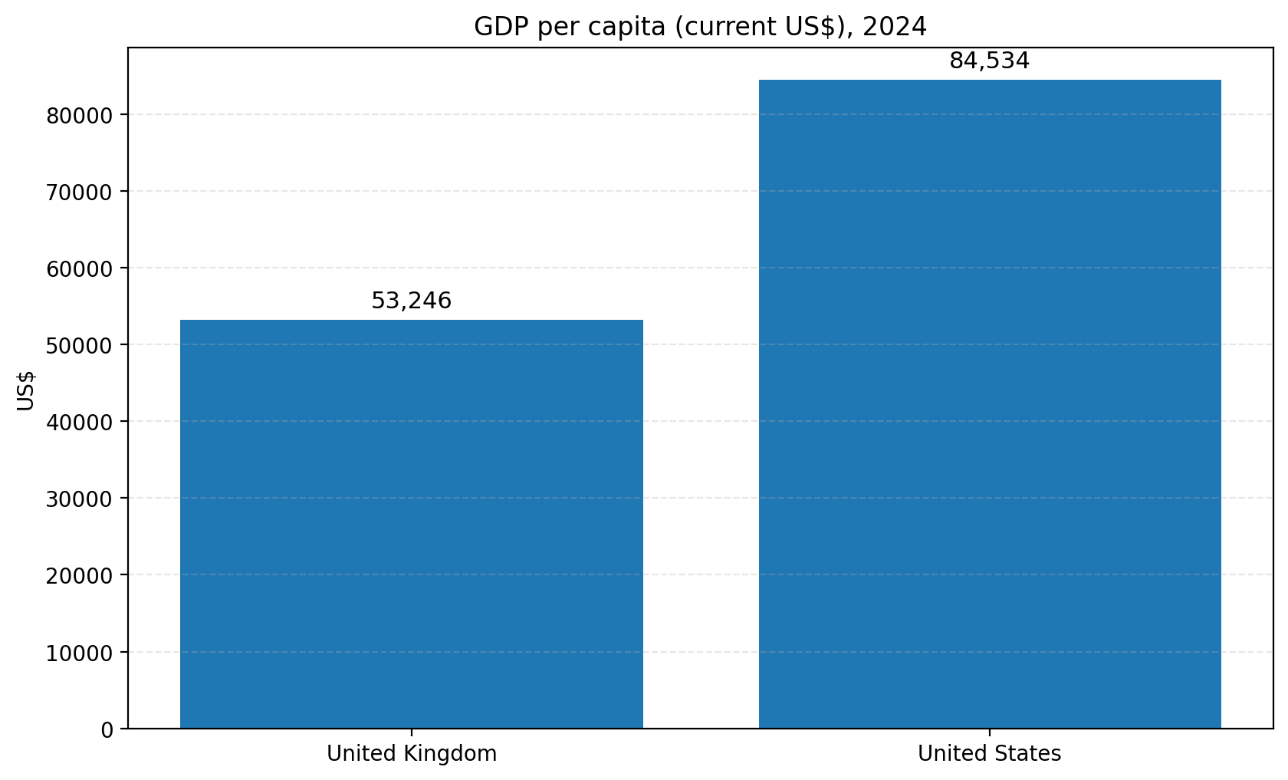
Figure 1. GDP per capita comparison for the UK and USA, 2024. Source: World Bank Data (2026).
Table 1. PESTEL snapshot of the UK and USA for Zara
Factor | United Kingdom | United States
Political / legal | Stable, high-regulation retail market with post-Brexit trade frictions that make precision logistics important. | Stable, highly regulated consumer market, but retail execution must work across a much larger geography and different state-level realities.
Economic | GDP per capita is lower than in the USA, so value-for-design matters and pricing discipline is important. | Higher GDP per capita supports spending power but also raises expectations for service, novelty, and convenience.
Social / cultural | More individualistic, more long-term oriented, and more understated in communication. | Highly individualistic and indulgent, with more direct communication and strong convenience expectations.
Technological | Strong digital adoption and a compact market support app-led omnichannel shopping. | High digital maturity, but scale makes inventory visibility and fulfilment especially important.
Environmental | Pressure to reduce textile waste and justify fast fashion through circular services. | Similar environmental pressure and rising expectations for sustainable retail practices.
Legal / ethical | Circularity, repair, and clear consumer information support legitimacy. | Same ethical expectations, with strong pressure for transparent service and responsible sourcing.

4. STP and positioning comparison
The segmentation in Zara in the UK and USA is based on fashion conscious consumers who respect speed, freshness and brand credibility and not loud logo status. Young professionals, university students, style-sensitive families and urban consumers seeking trend relevance without premium prices are the main demographic groups in both countries. Psychographically, Zara is aiming at customers who like newness, shop online and then make purchases, and who are not averse to using a variety of channels to shop, compare, and buy. In terms of behaviour, the brand enjoys the high frequency of purchase: workwear updates, seasonal updates, event dressing, impulse shopping following new drops. This is a broad enough segmentation that enables it to scale but specific enough to have a unique brand personality.
The different market structures vary in terms of targeting. Zara in the UK can be confident of a relatively focused group of urban consumers with concentrated location in cities centres and malls, particularly in London and other larger cities in UK. In the USA, targeting is more selective and wider: Zara needs to focus on more metropolitan areas and destination stores, but it cannot expect a uniform national coverage. The US stores list is highly concentrated in California and New York with other nodes in Texas, Florida, New Jersey, Illinois and Washington, indicating that it is more market-by-market than nationally retail rhythm (Zara, n.d.-b). Practically, it implies that the US target audience is a little more convenience oriented, geographically more dispersed, and dependent on the app and store locator. Targeting in the UK, on the other hand, can be backed up by better city-centre pedestrian traffic and reduced store catchment.
Positioning is the same in both countries but not the same in terms of emphasis. Zara positions itself as a brand of fast-fashion with a higher aesthetic, that is, it is a company competing between value stores and high-end high-street brands. This positioning is supported by product curation that is led by fashion and a somewhat less assertive brand voice in the UK. The USA positioning of Zara is more inclined towards the trend speed, convenience in a mall and the plausibility of being a global style brand that is more European than American fast-fashion competitors. The mere perceptual reading would thus position Zara higher in terms of style and design as compared to the mass-market basics brands, but lower in terms of exclusivity and material prestige as compared to luxury. The effectiveness of such positioning is that it is aspirational without the need to spend on luxury.
The strategic implication that is the most crucial is that Zara does not require two entirely different models of STP. Rather, it requires a single global target segment in terms of two local shopping realities. The UK segment is high density urban, fashion literate; the US segment is broader, more fragmented and more service sensitive. The brand also performs well when it maintains the identical promise of fashion but varies the channel through which the promise is fulfilled. It is precisely such an adaptation that the international marketing theory suggests: the value proposition will be familiar, whereas the implementation will be market-structure calibrated.
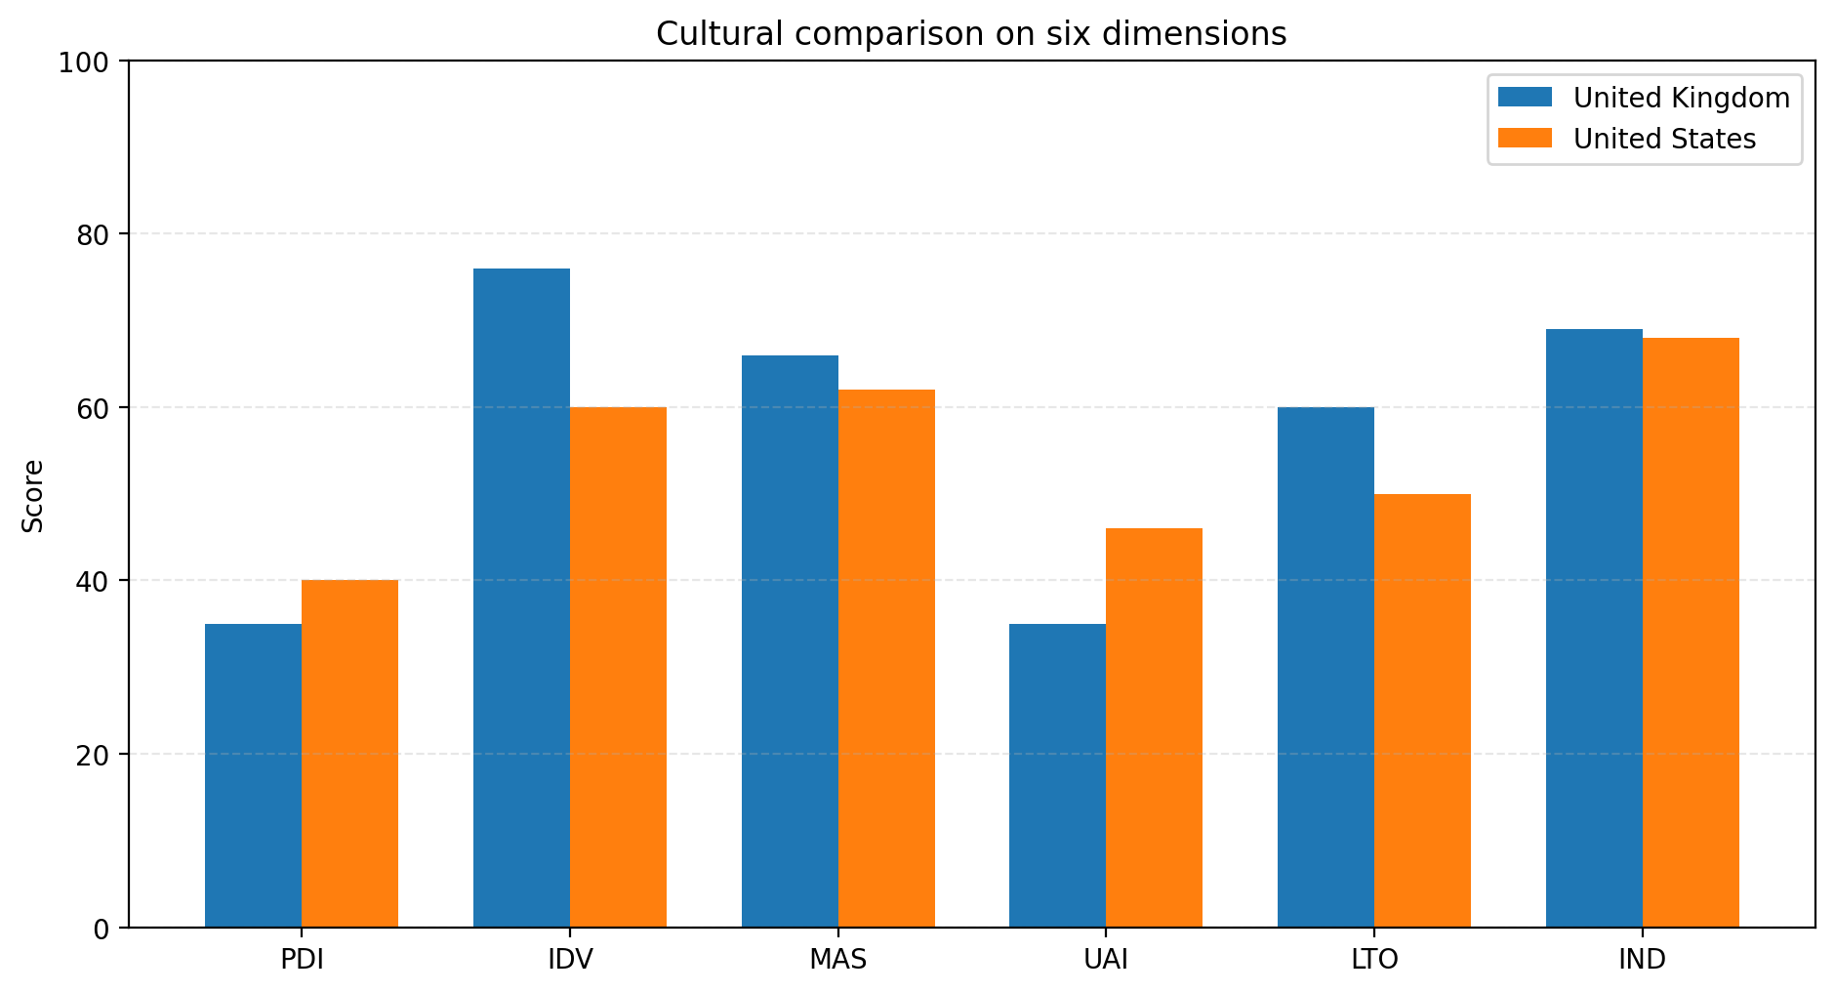
Figure 2. Cultural comparison using six dimensions commonly associated with Hofstede-style analysis. Source: The Culture Factor (2026).

5. International marketing mix (7Ps)
Zara is one of the leading luxury fashion labels in the world. Zara’s offer products for men, women and children. It offers jeans, trousers, tops, skirts, knitwear, T-shirts, shoes, bags and accessories. All these are the product strategy in the marketing mix of Zara. The marketing mix of Zara is largely brand-level standardised, but operationally customised in a manner that counts. Product-wise, the two markets are offered the identical core Zara promise: fast-move fashion, women, men, kids, beauty, and home assortment, frequent limited-edition edits, and collaborations. However, the emphasis of the product mix differs. The UK market will be more responsive to trans-seasonal layering, smart-casual, office wear, and fashion-led outerwear whereas the US market will demand more extensive coverage in the area of the casual wear, athleisure, wider size expectations, and climate diversity. The fact that Zara can turn around new collections fast is an asset in both environments, yet local shopping needs to be sensitive to varying weather, modes of commute, and lifestyle codes. Product-life extension is also included in the product strategy of the company due to the wider move into the repair and donation and pre-owned services (Zara UK, n.d.; Zara US, n.d.). This is important since the product will not only be the garment itself; it will be the entire lifecycle experience of owning, repairing, reselling, and properly disposing of the product.
Pricing is widely available-premium, as opposed to discount-based. Zara does not tend to engage in intense price wars, but adopts a value-as-design rationale: customers will pay more than at the fundamental retailers due to the superior style, faster turnover, and a more refined in-store experience. UK is a bit more price-sensitive due to the lower GDP per capita, which is compared with the USA: in the UK, price points should be closer to the competitor levels. Zara can continue to maintain a bit more space of premium perception in the US, particularly in flagship and mall stores, yet it must continue to prove value against a broad range of casual and middle-income competitors. What is important is that none of the prices are set in brand logic but adjusted by local taxes, exchange rates, assortment mix, and promotional intensity. It also depends on perceived value: UK shopper might feel happier with a slightly toned down premium, whereas US shoppers will demand more explicit value validation in a market full of options.
Location is the place where the most structural difference is seen. The UK is focused, having 18 Zara stores in Greater London and further coverage in cities like Manchester, Glasgow, Cardiff, Bristol and Leeds depicting a small national footprint (Zara, n.d.-a). The US on the other hand is very expansive in geography and densely concentrated with 23 stores in California, 17 in New York, 11 in Texas and quite large presence in Florida and New Jersey (Zara, n.d.-b). This implies that the UK would be able to afford high-density coverage of its city centres and rapid access to customers, in contrast to the US that needs to integrate flagship stores with a more powerful omnichannel support. The digital aspect of Zara is particularly significant in this regard: the store locator, app stock visibility, delivery, and store collection minimize the disadvantage of the distance. Strategically speaking, place does not only relate to the retail real estate, but also on the logistics, app architecture, and the possibility of transforming online intent into offline traffic or vice versa.
Promotion is very much standardised in terms of visual identity but locally oriented in terms of performance. The typical features of Zara include editorial imagery, owned digital platforms, browsing via apps, and limited external advertising instead of heavy promotion through the mass-media. That low-key voice suits the market preferences of subtlety and read between the lines communication in the UK (The Culture Factor, 2026). In the USA, the message must be more to the point, with more obvious accentuation to convenience, newness, and service. In both markets, Zara is increasingly promoting itself more through digital interaction than the traditional above-the-line advertising, which allows the brand to maintain its high-quality credibility whilst spending less than its rivals who rely heavily on paid media.
The same strategy is supported by the people, process, and the physical evidence elements. Speed and control are conveyed through staff, app journeys, repair options, packaging and modern store design. The 2024 performance of Inditex also mentions the implementation of the soft tag alarm technology and the intensified integration of stores and online, which means that the customer experience is becoming even more streamlined and more digital (Inditex, 2025). The importance of physical evidence can be explained by the fact that Zara stores are both a part showroom, a part fulfilment point, and a brand stage. The predetermined design, illumination, the signs, as well as the digital touch points all announce a fast, contemporary, global brand. On the whole, 7Ps of Zara present a global template and local adaptation rather than the localised strategy.
Table 2. Comparison of Zara’s 7Ps in the UK and USA
Element | United Kingdom | United States
Product | Emphasis on smart-casual, layering, and fashion-led outerwear; circular services support product life extension. | Greater need for casualwear, athleisure, climate variety, and broader size/fit expectations.
Price | Accessible-premium pricing with tighter sensitivity to competitor benchmarks and overall affordability. | Accessible-premium pricing with more room for brand theatre, but intense mid-market competition.
Place | Dense urban presence, especially London, plus strong city-centre and mall access. | Clustered regional presence across major states, with heavier dependence on omnichannel fulfilment.
Promotion | Understated, editorial, and digitally driven; fits British preference for subtle communication. | More direct convenience-led messaging and stronger emphasis on service and newness.
People | Store and digital touchpoints support a clean, knowledgeable, and premium-feel service experience. | Same service aim, but with a stronger need to support scale, queries, and returns.
Process | Fast browsing, store collection, repair and donation options, and integrated online/offline journeys. | Same process architecture, but with more emphasis on stock visibility and fulfilment reliability.
Physical evidence | Minimalist store design, clear signage, packaging, and app-first visibility reinforce the brand. | Flagship-and-mall stores, strong signage, and digital interfaces signal contemporary credibility.

6. Directional development strategy in the USA
The selective market penetration approach backed by service-based differentiation should be the directional development strategy in the USA that Zara would adopt. The brand is already established in large fashion and retail centres in the US, however, the sheer mass of the country leaves a possibility of further penetration in high-value metropolitan centres without saturating the store base. The reasonable course of action would be to enhance the presence of flagships in major cities, enhance localisation of product edits to meet climate and lifestyle variations, and rely on the app as a key connector between fractured geography and national brand image. Due to the fact that the USA is a high-income market with the GDP per capita of 2024 being US$84,534, the opportunity is not merely more volume, it is greater basket value, more retention, and more frequent repeat visits (World Bank, 2026). Swift service recovery, expanded fulfilment choices and enhanced after sales services are also rewarded in the market.
This plan is also aligned with the existing corporate direction of the brand. According to Inditex, its growth priorities include product proposition, customer experience, sustainability, and technology, further investments in commercial space, logistics, and online platforms (Inditex, 2025). In the USA, that is that Zara must not go on a blind store-expansion spree. Rather, it ought to leverage data to determine where a brick-and-mortar store provides sufficiently high service and brand theatre to make the price worth it. The best development trajectory thus lies in a hybrid form: fewer and better stores, more localized content, higher reliability fulfilment, and more circular services to the customer journey. This will also secure the brand against the overexposure risk in a market where retail rents and operating costs may be expensive.
This is more of a market penetration/product development orientation as opposed to a pure geographic expansion play in strategic terms. Zara already enjoys a significant presence in the US, and the value here is to make it even more meaningful, rather than expanding the map. This is financially more sustainable and in line with the fast-response operating model of the brand.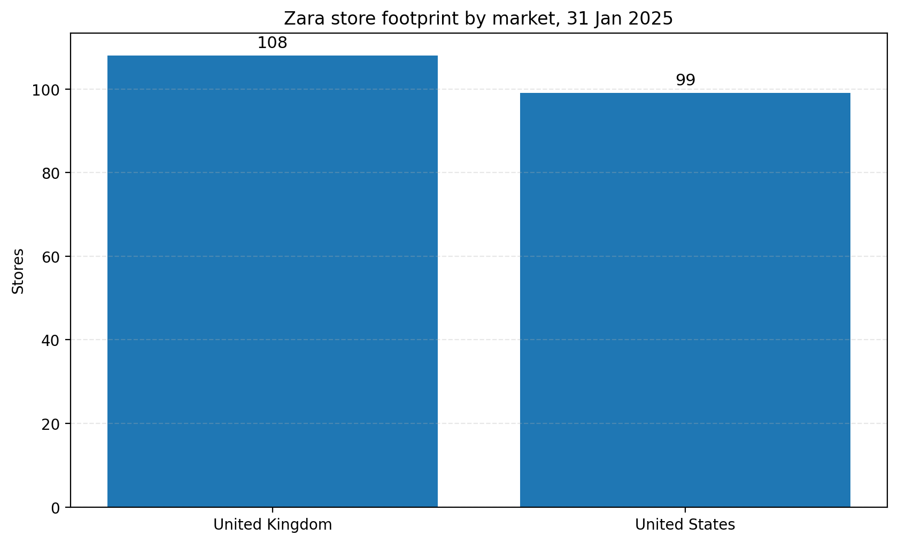
Figure 3. Zara store footprint by market. Source: Inditex FY2024 results (2025).

7. Performance evaluation
When compared to information that it releases, the strategy of Zara seems to be effective in the two markets. As of FY2024, the company achieved net sales of €38.6 billion, with Zara and Zara Home generating the largest share of the group turnover of 27.8 billion (Inditex, 2025). The sales online increased by 12.0 to reach €10.2 billion, active app users increased to reach 218 million, online visits increased to 8.1 billion which shows that the customer proposition is performing both on physical and digital touchpoints (Inditex, 2025). In the case of country-level evaluation, Zara has no individual sales in the UK and the US, so the coverage of stores, store localisation, and the depth of services are convenient proxies. It is on that ground that both the UK and the USA are strategically well-off: the UK is well-networked with stores and has a relatively small market, whereas the USA is large enough to support 99 Zara/Zara Home stores, as well as a high concentration of the target markets.
The UK market is particularly efficient, as opposed to being large. Zara can gain visibility with less logistics issues in London compared to the USA because of its concentration, good fashion literacy, and easy access to omnichannel. The American market, in its turn, is a volumetric and reach game: the brand must be successful due to the clustering of major states and due to the distance being compensated with the help of the app. Repeat engagement, conversion and brand salience, in both instances, are more important measures of success than just the number of stores. The high sales growth, increasing online interactions and the ongoing store optimisation imply that the international marketing of Zara is producing commercial outcomes but is not making the brand irrelevant. The size of customer base is also relevant, as it demonstrates that Zara is not simply banking on boutiques or on its luxury positioning, it is maintaining mass-market relevance without going generic.
The store-network evidence supports the fact. The UK store map indicates a developed yet high-visibility London and other urban centres footprint and a US footprint that is extensive enough to support the national relevance without assuming that all shoppers act alike. That is a balance that is strategically relevant: a brand can only be global when its expressions feel plausible locally. The current performance of Zara indicates that the brand has reasonably attained this balance in the two countries.
Table 3. Performance indicators used as proxies for market success
FY2024 group sales | €38.6 billion, up 7.5% (Inditex, 2025)
Zara and Zara Home sales | €27.8 billion, up 6.6% (Inditex, 2025)
Online sales | €10.2 billion, up 12.0% (Inditex, 2025)
Customer engagement | 218 million active app users and 8.1 billion online visits (Inditex, 2025)

8. Ethical evaluation
The moral scene is ambivalent. On the favorable side, Zara has developed observable circularity offers in both markets. In the UK, it provides repair and used clothes collection, in the USA it advertises on pre-owned services, which enable customers to repair, resell, donate, or purchase used clothes (Zara UK, n.d.; Zara US, n.d.). These efforts are a reaction to a grave industry issue. Water, land, and raw materials take a hit when people buy more clothes, says the European Environment Agency. Greenhouse gases rise along with that strain. The UNEP calls fashion tough on resources. Waste piles up because of how garments are made and tossed away (EEA, 2024; UNEP, 2022). The circular services offered by Zara thus minimize the ethical risk of the company and enhance brand legitimacy.
Another ethical concern is transparency. Due to the fast-response model employed by Zara, people are able to observe the product cycle very easily, as opposed to the labour, sourcing, or lifecycle implications of each product. In the UK as well as the USA, that creates a distance between the apparent sustainability message and the more difficult question of the extent to which the brand can demonstrate the production processes at scale that can be deemed responsible. Ethically-marketing wise, the more powerful Zara will be in advancing the idea of circularity, the more significant it is that statements be supported by quantifiable results, and not just by brand narratives.
Nevertheless, there is structural tension in the business model with ethical tension. Zara is also a fast-fashion brand, and fast fashion may promote overconsumption due to high turnover of products, and brief product life-cycles. Even when a company sells repair and resale, the broader model can continue to drive the demand to purchase additional clothing than what consumers truly require. The point of tension is particularly applicable to rich markets like the UK and USA where environmental and social price of additional consumption can hardly be overlooked. The ethical issue is not that Zara has not done anything but rather that the magnitude of its circular programs is so substantial to counter the consumption that it generates. Currently, the solution is partially. The brand has taken the correct direction, yet its moral standing remains based on more supply-chain visibility, greater durability communication, and more quantifiable circular impacts. This is to say that there is an indication of ethical improvement, but not complete.

9. Recommendations and conclusion
Zara must maintain standardisation of its global brand image but more profoundly, on a market level. To start with, it must enhance local merchandising in the USA by refining assortment to be more climate-specific, casual dress-specific, and size-specific, and retaining the same core design language. Second, it needs to enhance the omnichannel convenience in both markets, particularly enhance the stock visibility, fulfilment reliability, and store collection experience. Third, it must increase the repair, used, and donation services beyond symbolic sustainability and make them a normal routine of the customer. Fourth, the promotion must be equally visual in both the US and UK but a bit more direct and a bit more restrained. Lastly, Zara ought to release more transparent market-level sustainability indicators in order to be able to test ethical claims more easily. These would enhance the business performance and reputation.
The second suggestion is to use the UK as an experiment of the circular retail format and the USA as an expansion market of refinement of the services. The UK market is small and urban; so, Zara can experiment with novel in-store service concepts and can monitor the outcomes faster with limited complexity of its operations. The same ideas should be implemented only in the USA, where the market is bigger and more fragmented and only then, once they are tested in the selected cities. Such sequence mitigates risk and contributes to the prevention of unnecessary costs. It is also logical to international marketing whereby the standardisation must be maintained at the brand identity level but modified at the execution level.
To sum up, Zara has an excellent position in both the United Kingdom and the USA due to the compatibility of the model of a rapid response with the need to have new things frequently, digital comfort, and a strong sense of value-based design. UK prefer solid, style-based, low-key implementation; the USA compensates size, geographical location and service. The optimal approach of international marketing of Zara would then be neither complete standardisation nor complete localisation, but a rigorous adaptation in a single consistent global brand. It is that equilibrium that makes the brand commercially solid and strategically plausible.

10. Reflective account
My process of research commenced with a description of the task and explanation of the country choice, using Gibbs reflective cycle. The update by the tutor who changed the assignment to a different market pairing to Zara in the UK and USA meant that I had to re-do the evidence base as the marketing mix, market context and comparative logic had to change. The initial step that I undertook was to find authoritative sources that could be used to back up strategy and existing market facts. This covered the official websites of Zara UK and the USA, annual results of Inditex 2024, the World Bank data, and the country comparison tool of The Culture Factor. That rendered the work more trustworthy than depending on general commentary alone and minimized the chances of repetition of outdated assumptions.
The quality of my thinking was also altered by using comparative tables and charts. They assisted me in passing the stage of enumerating facts and discovering patterns, e.g., the more intense store network in the UK and the higher degree of concentration in the USA being state-based. This ensured the end recommendations are more accurate since each recommendation might have an easy finding attached to it as opposed to a general impression.
The experience in the process oscillated between confidence and caution and confidence. I felt good at first since Zara is a well-documented brand, and the comparison of the UK and the USA is intuitive, yet I also noted that I could not find most of the numbers discussed in the realm of fast-fashion as they are either dated or paywalled. This was to ensure that I was keen not to use weak sources or unsupported claims. The most difficult task was to find a balance in the word limit between breadth and depth. To handle that, I focused on sources that had a direct impact on the argument and utilised them to develop a systematic comparison instead of attempting to gather a plethora of unrelated facts.
During the stage of evaluation, the most beneficial analytical habit that I discovered was the comparison of sources. Inditex annual report, as an example, indicated the size of Zara global business and Zara own stores locators indicated how this size is spread in the UK and USA in a different proportion. The cultural comparison data assisted in explaining why the same brand can be successful in both markets despite the difference in the tone of communication and retail location. This action enhanced my analysis since it challenged me out of description to interpretation. It also revealed to me that a good report is not just about locating the data, but also about making a decision on which data actually alters the recommendation.
Analysis of what went well and what could have been improved is the next step in the cycle of Gibbs. The discipline of using official or highly credible sources and then connecting them to the theory instead of showing them individually was what worked well. What might have been done would be to have been faster in the first scoping phase; I took time to look at several sources before nailing the final structure. Had I done the assignment again, I would start with a more precise evidence plan, such as a list of metrics necessary to complete the macroenvironment, STP, 7Ps and ethics, such that all the sources gathered would directly be used in a report section.
The reflection concludes that effective international marketing writing requires source discipline, selective comparison and a distinct connection between evidence and recommendation. Next time, I would start with a more focused research plan, decide the precise metrics I require first and write out the structure first so that the data collection is in aid of the argument and not to distract it. I would also predetermine a provisional word budget of each part at the start as that would make the report more balanced, and prevent over-writing one part and under-developing the other.

References
European Environment Agency (2024) 'What are the environmental impacts of the textile industry?' Available at: https://www.eea.europa.eu/en/about/contact-us/faqs/what-are-the-environmental-impacts-of-textiles (Accessed: 18 April 2026).
Inditex (2025) 'Inditex Group Annual Report 2024'. Available at: https://www.inditex.com/itxcomweb/api/media/604197b9-50de-4f4f-ab84-c1e379cb3fd0/Inditex_Group_Annual_Report_2024.pdf?t=1741989136588 (Accessed: 18 April 2026).
Inditex (2025) 'FY2024 Results'. Available at: https://www.inditex.com/itxcomweb/api/media/16843322-c524-4f36-b84f-133989e4e569/INDITEXFullYear2024Results.pdf?t=1741760450878 (Accessed: 18 April 2026).
The Culture Factor (2026) 'Country comparison tool'. Available at: https://www.theculturefactor.com/country-comparison-tool (Accessed: 18 April 2026).
UNEP (2022) 'The environmental costs of fast fashion'. Available at: https://www.unep.org/news-and-stories/story/environmental-costs-fast-fashion (Accessed: 18 April 2026).
World Bank (2026) 'GDP per capita (current US$)'. Available at: https://data.worldbank.org/indicator/NY.GDP.PCAP.CD (Accessed: 18 April 2026).
Zara (n.d.-a) 'Find your Zara Store | ZARA United Kingdom'. Available at: https://www.zara.com/uk/en/z-stores-st1404.html (Accessed: 18 April 2026).
Zara (n.d.-b) 'Find your Zara Store | ZARA United States'. Available at: https://www.zara.com/us/en/z-stores-st1404.html (Accessed: 18 April 2026).
Zara UK (n.d.) 'Repair | Help'. Available at: https://www.zara.com/uk/en/help-center/Repair (Accessed: 18 April 2026).
Zara UK (n.d.) 'General Information | Zara Pre-owned'. Available at: https://www.zara.com/uk/en/help-center/ZaraPreownedInfo (Accessed: 18 April 2026).
Zara US (n.d.) 'General Information | Help | ZARA United States'. Available at: https://www.zara.com/us/en/help-center/ZaraPreownedInfo (Accessed: 18 April 2026).
Zara US (n.d.) 'Join Life / About'. Available at: https://www.zara.com/us/en/z-join-life-mkt1399.html (Accessed: 18 April 2026).

