ASSIGNMENT: 1

MODULE: International Meetings Management

Module Code-BMIH6007

STUDENT NAME: Ruksana Begum

STUDENT NUMBER; 2118820

TUTOR: Kathryn Flynn

DUE DATE: 9-2-24

PRESENTATION LINK: https://uowtsd-my.sharepoint.com/:v:/g/personal/2118820_student_uwtsd_ac_uk/EZPGNtVnnddBnT62ERk4uswBIBdjXMcG8dAU5Rg1M_Ky1w?referrer=Teams.TEAMS-WEB&referrerScenario=MeetingChicletGetLink.view.view
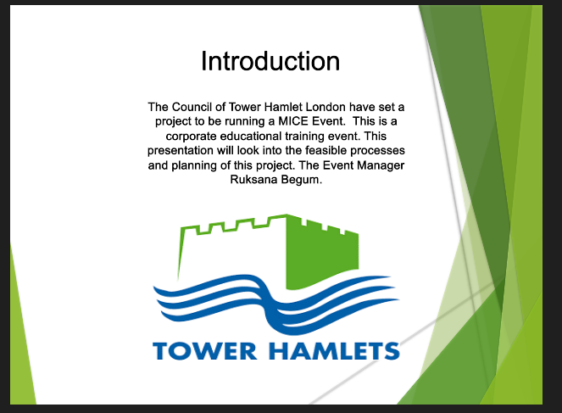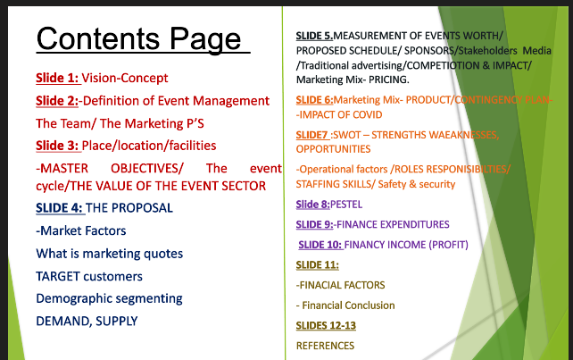

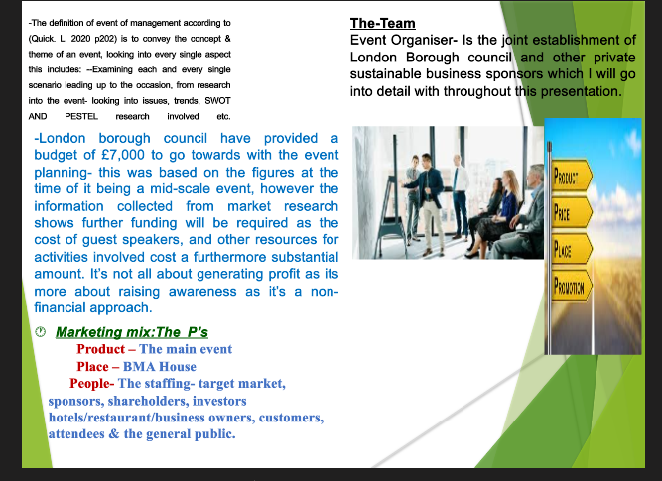
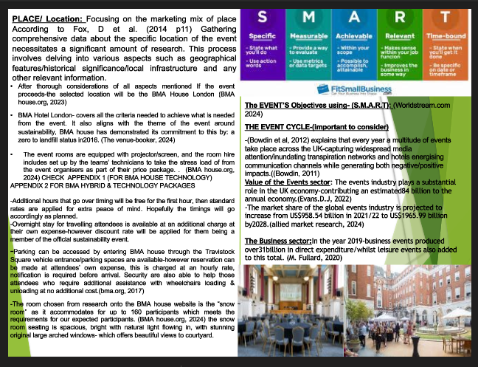
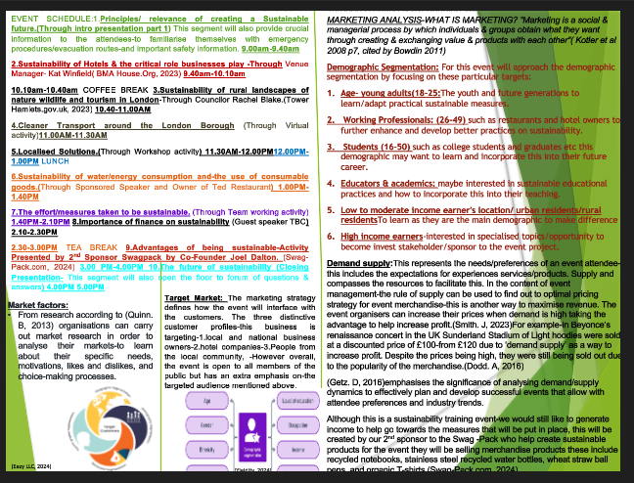

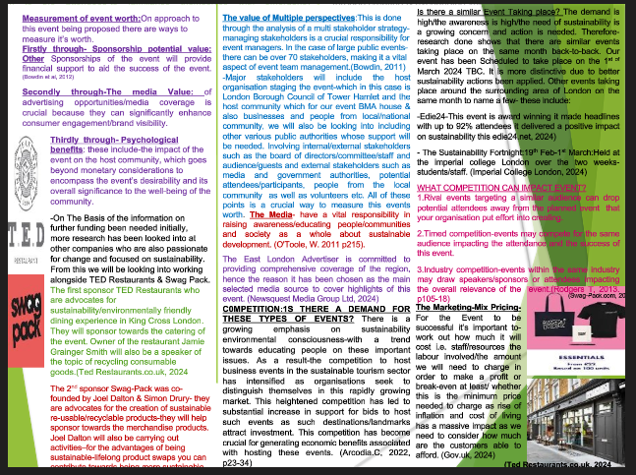

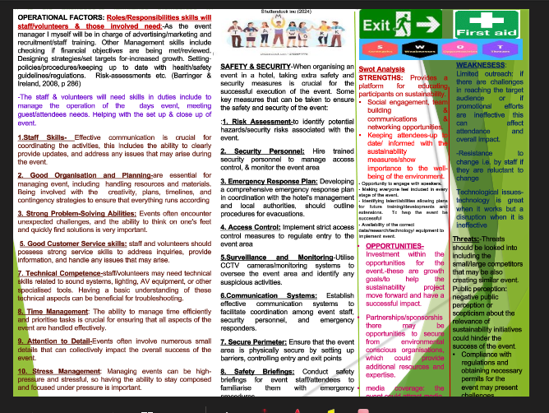

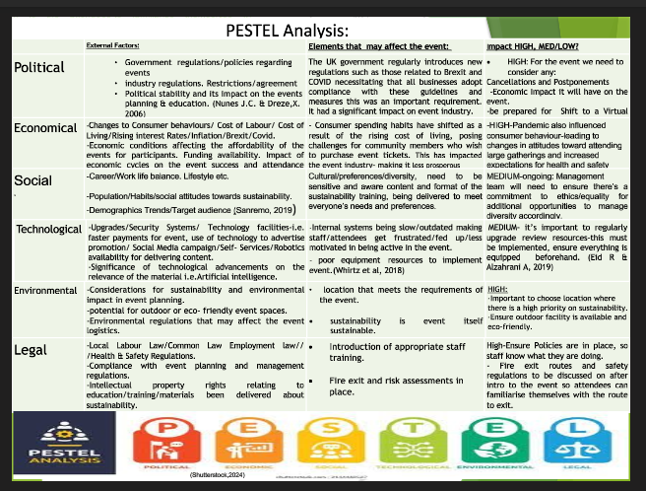

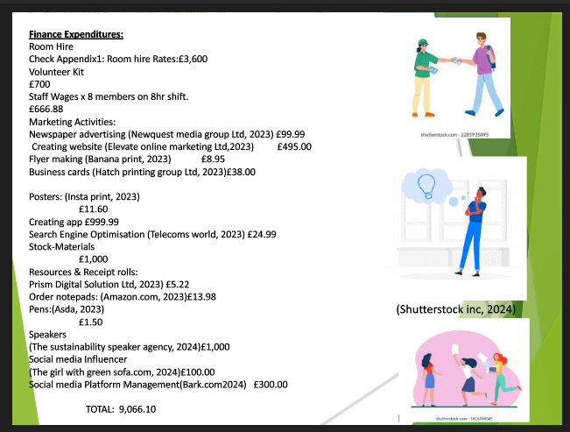

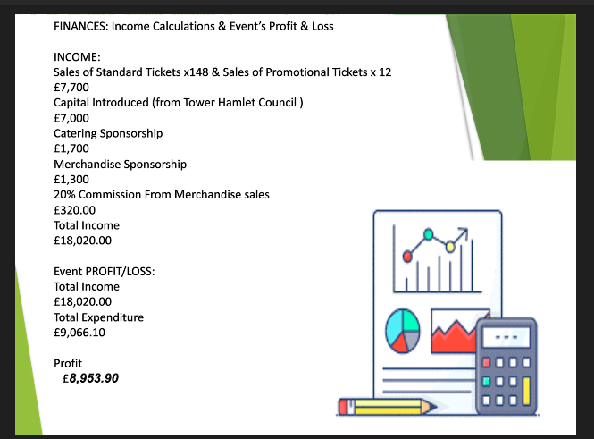

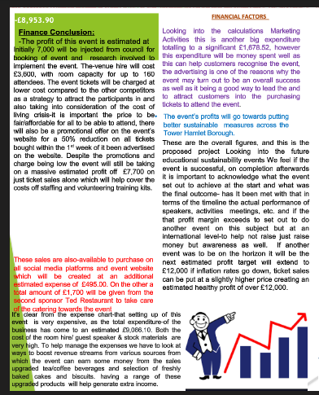

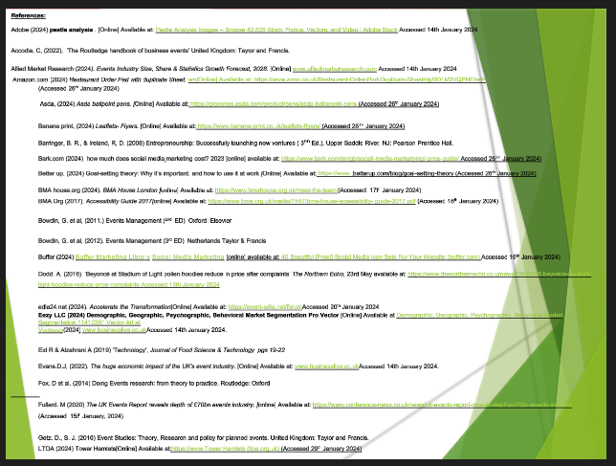


References:

Adobe (2024) pestle analysis . [Online] Available at: Pestle Analysis Images – Browse 42,525 Stock Photos, Vectors, and Video | Adobe Stock Accessed 14th January 2024

Accodia. C, (2022). ‘The Routledge handbook of business events’ United Kingdom: Taylor and Francis.

Allied Market Research (2024). Events Industry Size, Share & Statistics Growth Forecast, 2028. [Online] www.alliedmarketresearch.com Accessed 14th January 2024

Amazon.com (2024) Restaurant Order Pad with duplicate Sheet. am[Online] Available at: https://www.azon.co.uk/Restaurant-Order-Pad-Duplicate-Sheet/dp/B01M2VQPHF/ref=
(Accessed 26th January 2024)

Asda, (2024) Asda ballpoint pens. [Online] Available at: https://groceries.asda.com/product/pens/asda-ballopoint-pens (Accessed 26th January 2024)

Banana print, (2024) Leaflets- Flyers. [Online] Available at: https://www.banana-print.co.uk/leaflets-flyers/ (Accessed 26TH January 2024)

Barringer, B. R., & Ireland, R, D. (2008) Entrepreneurship: Successfully launching new ventures ( 3RD Ed.). Upper Saddle River, NJ: Pearson Prentice Hall.

Bark.com (2024) how much does social media marketing cost? 2023 [online] available at: https://www.bark,com/en/gb/socail-media-marketying/-price-guide/ Accessed 26TH January 2024)

Better up, (2024) Goal-setting theory: Why it’s important, and how to use it at work [Online] Available at: https://www..betterup.com/blog/goal-setting-theory (Accessed 26th January 2024)

BMA house.org (2024). BMA House London [online] Available at: https://www.bmahouse.org.uk/meet-the-team/(Accessed 17t^{h} January 2024)

BMA.Org (2017). Accessibility Guide 2017[online] Available at: https://www.bma.org.uk/media/1547/bma-house-acsessibility- guide-2017.pdf (Accessed 16th January 2024)

Bowdin, G. et al, (2011.) Events Management (^{2nd} ED) Oxford: Elsevier

Bowdin, G. et al, (2012). Events Management (3rd ED) Netherlands Taylor & Francis

Buffer (2024) Buffer Marketing Library Social Media Marketing [online] available at: 40 Beautiful [Free!] Social Media Icon Sets For Your Website (buffer.com) Accessed 16th January 2024)

Dodd. A, (2016). ‘Beyoncé at Stadium of Light pollen hoodies reduce in price after complaints’ The Northern Echo, 23rd May available at: https://www.thenorthernecho.co.u/news23542185.beyonce-stadium-light-hoodies-reduce-price-complaints Accessed 16th January 2024

edie24.net (2024). Accelerate the Transformation[Online] Available at: https://event-edie.net/forumAccessed 20th January 2024
Eezy LLC (2024) Demographic, Geographic, Psychographic, Behavioral Market Segmentation Pro Vector [Online] Available at Demographic, Geographic, Psychographic, Behavioral Market Segmentation 11412281 Vector Art at Vecteezy www.businesslive.co.ukAccessed 14th January 2024.

Eid R & Alzahrani A (2019) ‘Technology', Journal of Food Science & Technology pgs 19-22

Evans.D.J, (2022). The huge economic impact of the UK's event industry. [Online] Available at: www.businesslive.co.ukAccessed 14th January 2024.

Fox, D et al. (2014) Doing Events research: from theory to practice. Routledge: Oxford

Fullard. M (2020) The UK Events Report reveals depth of £70bn events industry. [online] Available at: https://www.conference-news.co.uk/news/uk-events-report-reveals-depthps70bn-events-industry (Accessed 15t^{h} January, 2024)

Getz. D., S. J. (2016) Event Studies: Theory, Research and policy for planned events. United Kingdom: Taylor and Francis.

LTOA (2024) Tower Hamlets[Online] Available at:https://www.Tower Hamlets (ltoa.org.uk) (Accessed 29th January 2024)

Imperial college London (2024) Imperial Zero Pollution [online] Available at: https://www.imperial.ac.uk/sustainability/ (Accessed 20th January 2024)

Lesonky.R, (2020) 'Small Business Strategy' Forbes, 26th October[Online] Available at: https://www.forbes.come/sites/allbusiness/2020/10/26/email-marketing-still-the-most-powerful-tool-to-take-your-business-to-the-next-level/ (Accessed 25TH January 2024)

Newsquest Media Group Ltd (2024) ‘News’ [online] Available at: https://www.eastlondonadvertiser.co.uk/news/ Accessed:18th January 2024

Nunes J.C. & Dreze,X. (2006) 'Your Loyalty program is betraying you' Harvard Business Review. P 124-131

O’Toole, W. (2011) Events feasibility and development: from strategy to operations. Elsevier: Oxford
Quick. L, (2020) Managing Events: Real Challenges, Real Outcomes. Sage London
Quinn, B. (2013). Key concepts in event management. United Kingdom SAGE. Publications Ltd. http://www.doi-org.ezoproxy.uwstd.ac.uk/10.4135/9781473914742

Prism Digital Solution Ltd, (2023) Trade till rolls.[Online] Available at:
https://www.tradetillrolls.co.uk/57x40-till-rolls? (Accessed 26th January 2024)

Rodgers. T (2013) Conferences and conventions: a global industry. 3rd edition. Routledge: Oxford
Sanremo,(2019) Lighten Your Carbon Footprint [Online] Available at:
https://www.sanremouk.com/learn/sustainable-coffee-shop-ideas-for-2019/(Accessed 25th January 2024)

Schmitt, B.H. (1999) 'Experiential Marketing' Journal of Marketing Management, vol15, p53-67.

Seven-Events.co.uk (2024) Safety steps you need to take to prevent the spread of covid-19 in events. [Online] Available at: https://www.sevenevents.co.uk/blog/safety-steps-prevent-spread-covid-19-events/ (Accessed 20th January 2024)

Shutterstock Inc (2024) Person Distributing Flyers royalty-free images . [Online] Available at: https://www 612 Person Distributing Flyers Images, Stock Photos, 3D objects, & Vectors | Shutterstock(Accessed 13th January, 2024)
Smith. A (2012)Events and urban regeneration: the strategic use of events to revitalise cities. Routledge: Oxford

Swag-Pack.com, (2024) About Us [online] Available at: https://swag-pack.com/swag-pack-about-us,Accessed 18th January 2024

The venue-booker (2024) Top ten sustainable hotels and conferences venues September 2021 [online] Available at: https://www.thevenuebooker.co.uk/news/sustainable-conference-hotel-uk(Accessed 13th January, 2024)

Ted Restaurants.co.uk (2024) Welcome to T.E.D- A Taste of seasonal Britain [online] Available at: https://www.tedrestaurants.co.ukAccessed 18th January 2024

Telecoms world, (2024) Business Listing. [Online] Available at: https://www.telecomsworld.com/business-listing?ppc_keyword=your%20bisiness%20listed&utm_term=your%20listed&utm_term=your%20business%2020listed&utm_campaign=utm_source=adwords&utm_medium=ppc&hsa_acc=6770579360&hsa (Accessed 29th January 2024)

The girl with green sofa.com (2024) the rise of social media influences [online] available at: https://www.thegirlwiththegreensofa.com/home/2018/1/10/social-media-influencers Accessed 18th January 2024

The sustainability speaker agency (2024) The #1 international environmental and sustainability speaker’s agency [online] available at: https://www.sustainability-speakers.com/#:-:text=How%20Much%20Does%20A3100%20 (Accessed 26th January 2024)

Torrington. D, Hall. L, Atkinson. C, Taylor. S , (2020) Human Resource Management, Pearson Education Limited, Harlow.

Tower-Hamlets.gov.uk (2024) ‘Our East End’ [online] Available at: https://www.towerhamlets.gov.uk/News_events/Our_East_End/Our_East_End.aspx Accessed 18th January 2024

Tower Hamlets.gov.uk (2023) Mayor & Councillors [Online] Available at: https://democracy.towerhamletys.gov.uk/mgMemberIndex.aspx?bcr=1(Accessed 17th January 2024)

Tower-Hamlets.gov.uk (2024) ‘Our East End’ [online] Available at: https://www.towerhamlets.gov.uk/News_events/Our_East_End/Our_East_End.aspx Accessed 18th January 2024

Wirtz J, Patteson P.G, Kunz W, Grubber T, Lu V.N, & Paluch S, (2018) ‘Brave New World: Service of robots in the frontline’ Journal of Service Management, pg907-1

Worldstream.com (2024) Everything you need to know about marketing objectives. [Online] Available at: Everything You Need to Know About Marketing Objectives (wordstream.com)
(Accessed 8th February 2024)

Yieldify (2024) Demographic Segmentation defined with 5 marketing examples [online] Available at: Demographic Segmentation Defined With 5 Examples - Yieldify(Accessed: 22ND January 2024)

Zippia Inc, (2022) What Benefits does International hotels Offer?[[online] Available at: https://www.zippia.com/answers/(Accessed: 22ND January 2024)
APPENDICIES
APPENDIX 1:

BMA HOUSE: SNOW ROOM HIRING RATES:
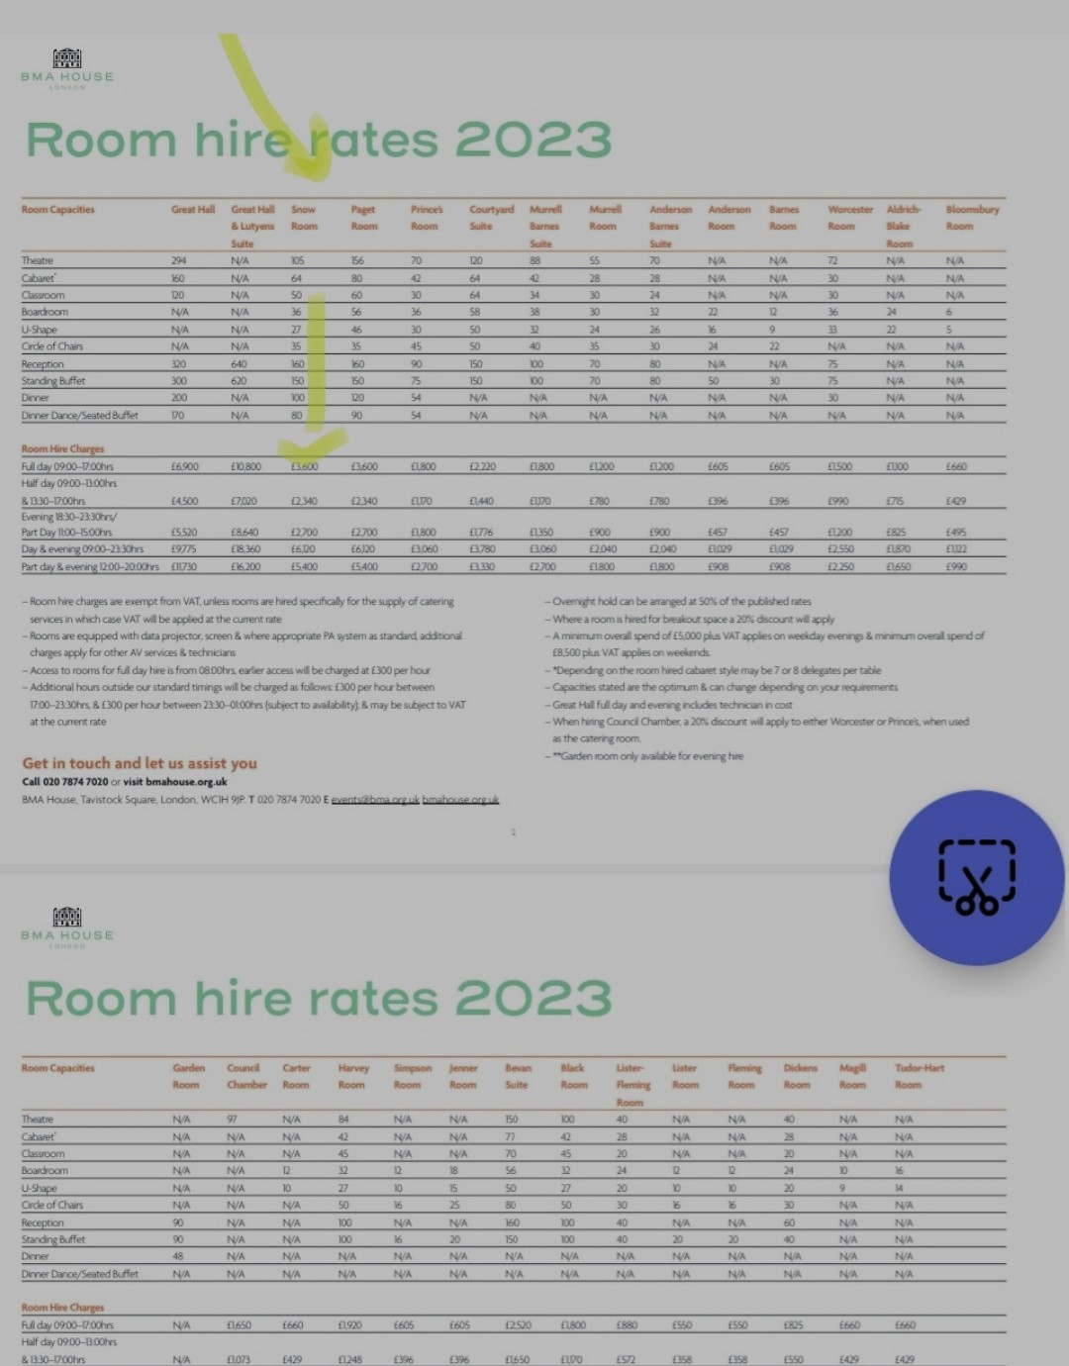
Room Capacities Great Hall Great Hall Snow Paget Prince’s Courtyard Murrell Murrell Anderson Anderson Barnes Worcester Aldrich- Bloomsbury
& Lutyens Room Room Room Suite Barnes Room Barnes Room Room Room Blake Room
Suite Suite Suite Room
Theatre 294 N/A 105 156 70 120 88 55 70 N/A N/A 72 N/A N/A
Cabaret
*
160 N/A 64 80 42 64 42 28 28 N/A N/A 30 N/A N/A
Classroom 120 N/A 50 60 30 64 34 30 24 N/A N/A 30 N/A N/A
Boardroom N/A N/A 36 56 36 58 38 30 32 22 12 36 24 6
U-Shape N/A N/A 27 46 30 50 32 24 26 16 9 33 22 5
Circle of Chairs N/A N/A 35 35 45 50 40 35 30 24 22 N/A N/A N/A
Reception 320 640 160 160 90 150 100 70 80 N/A N/A 75 N/A N/A
Standing Buet 300 620 150 150 75 150 100 70 80 50 30 75 N/A N/A
Dinner 200 N/A 100 120 54 N/A N/A N/A N/A N/A N/A 30 N/A N/A
Dinner Dance/Seated Buet 170 N/A 80 90 54 N/A N/A N/A N/A N/A N/A N/A N/A N/A

Room Hire Charges
Full day 09:00–17:00hrs £6,900 £10,800 £3,600 £3,600 £1,800 £2,220 £1,800 £1,200 £1,200 £605 £605 £1,500 £1,100 £660
Half day 09:00–13:00hrs
& 13:30–17:00hrs £4,500 £7,020 £2,340 £2,340 £1,170 £1,440 £1,170 £780 £780 £396 £396 £990 £715 £429
Evening 18:30–23:30hrs/
Part Day 11:00–15:00hrs £5,520 £8,640 £2,700 £2,700 £1,800 £1,776 £1,350 £900 £900 £457 £457 £1,200 £825 £495
Day & evening 09:00–23:30hrs £9,775 £18,360 £6,120 £6,120 £3,060 £3,780 £3,060 £2,040 £2,040 £1,029 £1,029 £2,550 £1,870 £1,122
Part day & evening 12:00–20:00hrs £11,730 £16,200 £5,400 £5,400 £2,700 £3,330 £2,700 £1.800 £1,800 £908 £908 £2,250 £1,650 £990
– Room hire charges are exempt from VAT, unless rooms are hired speciﬁcally for the supply of catering
services in which case VAT will be applied at the current rate
– Rooms are equipped with data projector, screen & where appropriate PA system as standard, additional
charges apply for other AV services & technicians
– Access to rooms for full day hire is from 08:00hrs, earlier access will be charged at £300 per hour
– Additional hours outside our standard timings will be charged as follows: £300 per hour between
17:00–23:30hrs, & £300 per hour between 23:30–01:00hrs (subject to availability); & may be subject to VAT
at the current rate
– Overnight hold can be arranged at 50% of the published rates
– Where a room is hired for breakout space a 20% discount will apply
– A minimum overall spend of £5,000 plus VAT applies on weekday evenings & minimum overall spend of
£8,500 plus VAT applies on weekends.
– *Depending on the room hired cabaret style may be 7 or 8 delegates per table
– Capacities stated are the optimum & can change depending on your requirements
– Great Hall full day and evening includes technician in cost
– When hiring Council Chamber, a 20% discount will apply to either Worcester or Prince’s, when used
as the catering room.
– **Garden room only available for evening hire
2
Get in touch and let us assist you
Call 020 7874 7020 or visit bmahouse.org.uk
BMA House, Tavistock Square, London, WC1H 9JP. T 020 7874 7020 E events@bma.org.uk bmahouse.org.uk

APPENDIX 2:
BMA HYBRID & TECHNOLOGY PACKAGES


