Name: Georgi Ivanov

ID: 1814701

Topic: Shell

Lecturers name: Dr. Kenny Tang

Module: Introducing the Modern Workplace

Module № LCBB 4003

Introduction of the report.
This report is a research on Royal Dutch Shell Group. It is analysis of the key areas of the company’s structure and culture using the methods and theory based on authors like Fatehi, Hofstede and others. I will include diagrams, graphs which will show what is the structure of the company and there are comparisons of the national culture in the UK, Netherlands and Shell as an organization.
Introduction of the company.
The history of the brand could be traced back to the late 19th Century when the creator of the company Marcus Samuel senior imported seashells from the Far East. When his sons inherited the company, they have expanded the family business to kerosene export to Asia and they have decided to use Shell as a name of their company.
In 1897 the kerosene sales were dominating the business’s turnover and the name Shell was chosen for the new organization for import and export – the Shell Transporting and Trading Company. In 1907 the company merged with Royal Dutch and formed the Royal Dutch Shell Group, but the new company became known very quickly as Shell for short (Shell.com, 2019). In 2018 Shell operates in more than 70 countries, has more than 82,000 employees and has a revenue of $388.4 billion (Shell.com, 2019).
Structure.
The structure of an organization has been established in order to coordinate the work within that organization which was divided into smaller tasks. The way that coordination was achieved, by who and with what is crucial for the way the organization looks like (Olson, 2005).
According to Fatehi (1996), there are three main models of organizational structures which are basic:
- Functional;
- Geographical;
- Product;
One of the ways to organize a business structure is by a specific product type. In this way each product group is a part of a reporting structure which is being managed by an executive who is responsible for everything that is related to that product line (pingeboard.com, 2019).
The organizational structure of Shell has many levels, and it is divided on different basis such as functions, goods, services and geographical regions. The organization is very centralized and follows a collaborative hierarchical structure. The five different departments of Shell organization are:
- Exploration and production;
- Gas and power;
- Refining and marketing;
- Chemical production;
- Trading and shipping;
(theshowgoesonsite.wordpress.com, 2016).

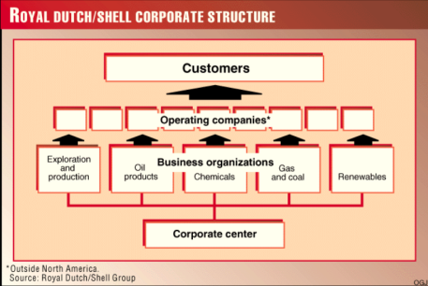
Source: theshowgoesonsite.wordpress.com

The functional structure is a structure which is based on an organization that has been divided up into smaller groups which have specified roles or tasks. Each of the groups is formed as a department which has a manager or director who is reporting to an executive one level up in the hierarchy.
Shell has 11 service companies in total which are sharing the management service functions given by the headquarters. The company has a very complex structure and a wide outlet network which allows it to function perfect under an organic matrix structure. It means that the employees are grouped on a product simultaneously and function basis, relying greatly on collaboration and communication for solving objectives (theshowgoesonsite.wordpress.com, 2016).
The tasks within business organization can be divided geographically. It involves grouping of the activities in accordance to geographical or regional locations. The territorial divisions are becoming a whole administrative unit in order to cater to the need of the localities. In this way the Regional Manager practically becomes the chief controller of his region. The divisions of a geographical structure can include districts, territories or regions (Devaney, 2019).
The following diagram demonstrates all three structural methods of Fatehi geographically, function and product within Shell Group: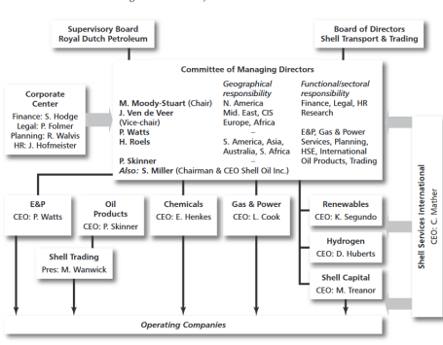
Source: theshowgoesonsite.wordpress.com, 2016

As it could be seen from the diagram Shell has very complicated structure. The geographical structure of the company has many branches around the world. Shell has branches representing the company in North America, Middle East, CIS, Europe, Africa, South America, Asia, Australia and South Africa. Having all these branches around the world makes Shell one of the leaders in the industry and shows that they are very well organized and represented around the globe.
It could be concluded from the diagram above that the functional structure of Shell is very complex, but well organized. The different functional responsibilities within Shell are divided in Legal, Finance, Planning, Human Resources, Research, Exploration and production (E & P), Gas & Power Services, Health, Safety and Environment (HSE), International Oil Products, Trading.
Chain of command.
The chain of command in the business structures is borrowed from the military. Traditionally within a business organization, each employee is responsible to one supervisor, and the supervisor reports to a higher-level supervisor or manager and the chain continues to the very top of the organization. Within this type of structures, the lines of authority are very clear (Dobson, 1999, p104-109).

Span of control.
In 1922, in the UK, Sir Ian Hamilton has developed the concept of ‘span of control’. The concept is referring to the number of subordinates that are controlled by a supervisor directly. Hamilton studied the British military leaders and found that they were not capable to control directly more than three to six people. These findings were accepted to be called the “rule of the thumb’ ever since (Inc, 2018).

In the diagram bellow it could be seen that despite the fact that Shell has a very complex hierarchical structure the tasks are divided very well by the different departments. Every level of management is responding to its superiors which creates order within the organization.
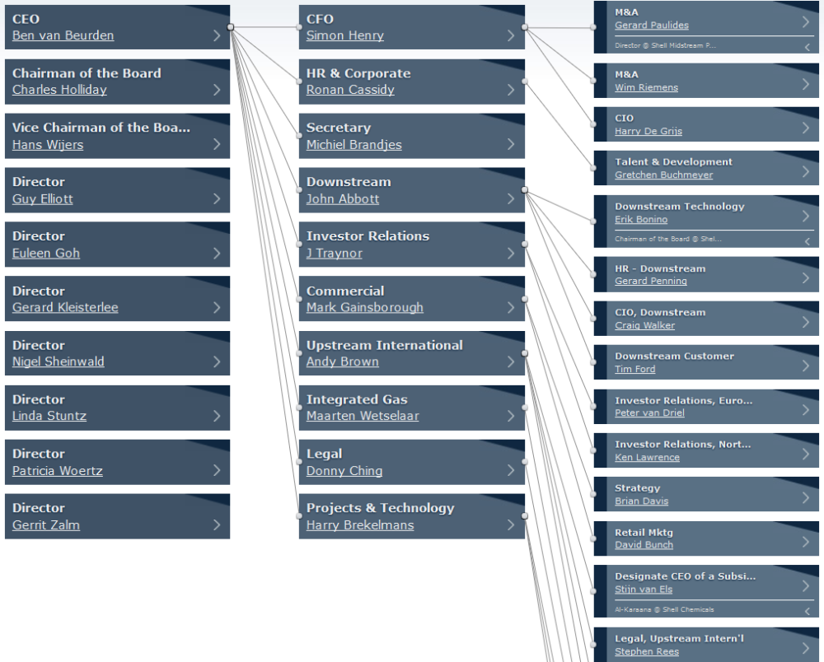
Source: theshowgoesonsite.wordpress.com, 2016

Culture.
Organizational culture can be explained as a combination of different values which are emphasized by an organization. The performance is higher when organizations are following certain value and sustainability, but an organization’s results and performance can vary depending on the culture of that organization (Cho et al., 2013).
One theory used to evaluate company culture is Hofstede’s five dimensions. In his studies, Hofstede us evaluating country culture, but his model could be applied for studying the organizational culture as well.
Hofstede’s five dimensions:
- Power distance.
It could be defined as the extent to which the people involved in institutions and organizations with less power accept and expect that the power is distributed unequally. In this way it could be concluded that inequality is represented – more versus less – but defined from the bottom, not from the top (Hofstede, 2011).
The power distance index within Shell is quite low - 39 from 100 if we apply that index for the headquarters of the company which is in Netherlands and consider the fact that the company is incorporated in England and Wales. Another fact which should be considered is that Shell operates on nearly every continent and the national culture may affect the organizational culture of the company in the different countries.
- Uncertainty Avoidance.
Risk avoidance and uncertainty avoidance are not the same. Uncertainty avoidance is dealing with the society tolerance for uncertainty. It indicates to what extent a certain culture is programing its members to feel either comfortable or uncomfortable in certain situations which are unstructured (Hofstede, 2011).
The uncertainty avoidance index within Shell is almost in the middle 45/100. Again, if it is considered that Shell is linked mainly with the UK and Netherlands where its headquarters are it shouldn’t be a surprise that the index for Shell is quite balanced. For example, the index for UK is 35 and Netherlands 53 which means that company is in balance between the results of the index for those countries. If there is a research what would that index be in the different countries in which Shell operates, the final data for national culture might differ from the data Shell has as a company and the data which shows the same index for UK and Netherlands.
- Individualism versus Collectivism.
The collision between Individualism and Collectivism can be defined as the degree to which people in a society are unified into groups. On the side of the individualists it could be discovered that there are cultures in which the connections between individuals are not strong: everyone is supposed to look after her/himself and her/his family. On the side of the collectivist it could be discovered that there are cultures in which people from their birth are strongly connected into groups, very often these groups are the families (Hofstede, 2011).
The individualism index for Shell is quite high – 80/100 which is not a surprise at all. Shell is a typical representative of the western countries and culture which is considered as mainly individual. As a comparison with the countries in which the headquarters of the company are located, in UK it is 80/100 and in Netherlands 89/100. This means that the population in these countries is mainly consisted with people who consider themselves as individualists and they are more self-sufficient and independent.
- Masculinity - Femininity.
Fundamental issue for any society in the world is the Masculinity versus its opposite, Femininity, as a societal characteristic and not as an individual which refers to the distribution of values between the different genders. ‘Masculine’ is the term used for the assertive pole and the modest and caring pole is called ‘feminine’ (Hofstede, 2011).
The Masculinity index of Shell is 50/100 which means that the company is driven by competition, achievement and success which means they are motivated by success and are trying to be always first and the best.
As a comparison with UK and Netherlands, where the headquarters of the companies are there is a big difference in the index for Netherlands which is 14. The Dutch are famous with their patience and long conversations until they reach a compromise and agreement. The situation in UK is the opposite. The UK society is very masculine, and they are the opposite of the Dutch. British people will try to win and to be the best.
- Long-term versus short-term orientation.
It is considered that this dimension is strongly correlated with the growth of the economy recently. The corresponds of the long – term pole were sharing values as having a sense of shame, thrift, relationships by status while values shared by the opposite side – the short-term pole, were respect of traditions stability and personal steadiness (Hofstede, 2011).
The organizational culture within Shell should be considered as long-term orientated. Usually the oil companies are setting long-term goals and missions which they follow very strictly and consecutively. For example, Shell has set a very ambitious goal of reaching net-zero global emissions by 2070, which will be beneficial not only for the company, but for the humanity as well (Shell.com, 2019).
In the following diagram there is a comparison using Hofstede’s five dimensions between Shell and the countries in which the company’s headquarters are located.

Source: (Hofstede-insights.com, 2019).

Organizational Culture and Leadership.
The organizational cultures and microcultures are making the connection between culture and leadership clearer. When people end up calling a culture in such system, usually it is a result of the implanting of what a leader has forced on a certain group that has worked out. In this sense, culture is ultimately embedded, ultimately manipulated and created by leaders. Such dynamic processes of management and cultural creation are the essence of leadership and they make people realize that leadership and culture are two sides of the same coin (Schein, 2010).

Conclusion.
Royal Dutch Shell Group has positioned itself as one of the global leaders in the oil production. It operates on almost every continent which can be considered as a big success, but it could be a great burden as well. Being a global leader is not only a great achievement, but a great responsibility as well. In nowadays the human race has so many challenges that it needs to face. Organizations like Shell needs to take the risk and the responsibility to lead humanity to a new era and find sustainable and ecological friendly solutions for the prosperity of the whole planet.

References:
Cho, I. et al. (2013) ‘The relationship between Organisational Culture and Service Quality through Organisational Learning Framework’. Total Quality Management & Business Excellence, 24 (7/8), pp. 753-769. [Online]. Available at: https://web-a-ebscohost-com.ezproxy.uwtsd.ac.uk/ehost/pdfviewer/pdfviewer?vid=1&sid=993d2aa6-3472-44d4-8095-0ce0ff90bba4%40sessionmgr4008 [Accessed on: 8th August 2019].
Dobson, M. S. and Dobson, D. S. (1999). Managing up. American Management Association International.
Devaney, Erik. (2019) ‘7 Types of Organizational Structure & Whom They Are Situated For’. https://blog.hubspot.com/marketing/team-structure-diagrams [Accessed: 19th July 2019].
Fatehi, K. (1996). International Management: A Cross – cultural and Functional Perspective. University of Indiana.
Hofstede, G. (2011) ‘Dimensionalizing Cultures: The Hofstede Model’, Online Readings in Psychology and Culture, 2(1). [Online]. Available at: https://doi.org/10.9707/2307-0919.1014 [Accessed: 9th August 2019].
Hofstede-insights (2019) ‘Country comparison’ https://www.hofstede-insights.com/country-comparison/the-netherlands,the-uk/ [Accessed: 14th August 2019].
Inc ‘Span of Control’ 2018. https://www.inc.com/encyclopedia/span-of-control.html [Accessed: 16th July 2019].
Olson, M. Eric, Slater, F. Stanley and Hult M. Tomas (2005) ‘The Performance Implications of Fit among Business Strategy, Marketing Organization Structure, and Strategic Behavior’, Journal of Marketing, 69 (3), pp. 49–65. [Online]. Available at: https://journals.sagepub.com/doi/pdf/10.1509/jmkg.69.3.49.66362 [Accessed: 15th July 2019].
Pingboard ‘Types business organizational structure’ 2019. https://pingboard.com/blog/types-business-organizational-structures/ [Accessed 19th July 2019].
Pointpark ‘4 types of organizational structures’ 2019. https://online.pointpark.edu/business/types-of-organizational-structures/ [Accessed 19th July 2019].
Schein, H. E. (2010) Organizational Culture and Leadership. 4th edn. San Francisco: John Wiley and Sons
Shell ‘Brand history’ 2019. https://www.shell.com/about-us/our-heritage/our-brand-history.html [Accessed: 15th July 2019].
Shell ‘Sustainable energy future’ 2019 https://reports.shell.com/sustainability-report/2018/sustainable-energy-future/climate-change-and-energy-transition.html [Accessed 14th August 2019].
Theshowgoesonsite ‘Royal Dutch Shell: Pocket full of shells’ 2006. https://theshowgoesonsite.wordpress.com/2016/05/09/royal-dutch-shell/ [Accessed: 16th July 2019].

