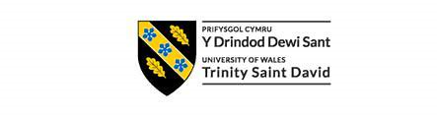

Dissertation
LCBB6000
BA (Hons) Business Management
University of Wales Trinity Saint David (London Campus)

Cover page:
- Daniela Vasileva
- ID 2235335
- BABM
- University of Wales Trinity Saint David

- Supervisor: PhD, DProf Afzal Sayed Munna
- 21/12/2025

Bridging generational divides: Strategies for managing boomers, gen X, millennials, and gen Z in a diversified workplace: A case of Pret A Manger

Contents
Chapter 1: Introduction 2
Chapter 2: Literature review 4
Chapter 3: Research methods and methodology 12
Chapter 4: research 16
Chapter 5: Conclusion 16
Chapter 6: References and bibliography 16

Chapter 1: Introduction
Introduction
Generational diversity is an important yet often overlooked aspect of worker diversity in today's globalised business environment. Modern organisations are increasingly challenged to integrate people from several generations, each with unique beliefs, attitudes, and communication styles shaped by different socioeconomic and technical experiences. (Eisner, 2005; Costanza et al., 2012). Pret A Manger, a leading UK-based food and beverage retailer known for its vibrant workplace culture, strong service orientation, and people-focused management, employs a multigenerational workforce that includes Baby Boomers (born 1946-1964), Generation X (1965-1980), Millennials (1981-1996), and Generation Z (1997-2012). Managing such a diverse workforce necessitates a thorough understanding of generational dynamics, leadership development, and inclusive communication methods.
Uncontrolled generational differences can cause workplace conflict, communication breakdowns, and disengagement (Kapoor and Solomon, 2011). When appropriately used, generational diversity promotes creativity, knowledge sharing, and organisational resilience (Staff and Schulenberg, 2010). Effective management of intergenerational connections is critical to sustaining performance and customer satisfaction, especially in the hospitality and retail sectors, where service quality, teamwork, and collaboration speed are essential. Post-pandemic trends, such as hybrid work arrangements, mental health priority, and rapid digitalisation, have contributed to generational differences in views towards work, leadership, and communication (CIPD, 2024). As a result, understanding how different generations work together at Pret A Manger is both strategic and human resource essential.
Statement of the problem
The growing generational diversity at Pret A Manger's staff creates both possibilities and problems for effective management. While the organisation encourages inclusivity and collaboration, different generations' expectations for leadership, involvement, and communication could undermine cohesion and performance. For example, older employees could prefer face-to-face contact and job stability, whereas younger generations may value digital interaction, flexibility, and rapid progress (Twenge, 2010; Deal et al., 2010). Misalignment in these areas may result in less engagement, lower productivity, and increased turnover. As a result, there is a need for evidence-based ways to effectively manage intergenerational gaps at Pret A Manger, ensuring inclusion, participation, and harmony across age groups.
Theoretical framework
This study is based on Social Identity Theory (Tajfel and Turner, 1986) and Generational Cohort Theory (Mannheim, 1952). Social Identity Theory explains how people categorise themselves into social groups (for example, by age or generation), which influences intergroup perceptions, behaviours, and prejudices. According to Generational Cohort Theory, people who grow up in comparable historical, technological, and cultural environments create shared attitudes and beliefs that last a lifetime. These categories together inform the study's research of how generational identities influence communication, participation, and perceptions of inclusion at Pret A Manger. Integrating all of these concepts enables an in-depth understanding of both the social-psychological and behavioural dynamics that influence generational interactions in the workplace.
Statement of the purpose
The primary objective of this study is to examine how Pret A Manger can effectively manage a multigenerational workforce by identifying generational differences in employee engagement, communication preferences, and perceptions of inclusion. The study aims to assess the organization's existing HRM and leadership practices to determine their effectiveness in building generational harmony and diversity. The findings are intended to add to both managerial practice and academic theory by providing practical suggestions for sustainable, inclusive workforce strategies in hospitality and retail contexts.
Research questions
- How do different generations (Baby Boomers, Generation X, Millennials, and Generation Z) differ in their engagement levels at Pret A Manger?
- What are the preferred communication methods and tools across generations in the workplace?
- How do employees across generations perceive inclusion and fairness within Pret A Manger’s HR policies and organisational culture?
- How does Pret A Manger’s leadership approach generational diversity through current management strategies?
- What strategies can Pret A Manger implement to enhance intergenerational collaboration and inclusion?
Significance of the study
This study provides theoretical and practical contributions to the areas of human resource management, diversity and inclusion, and organisational behaviour. Theoretically, it contributes to generational management literature by bringing known theories to a contemporary service-based organisational framework. It provides practical insights for HR professionals, team leaders, and senior managers at Pret A Manger and throughout the hospitality industry. Understanding generational preferences allows for the development of more inclusive HR policies, communication practices, and leadership training programs that promote collaboration, engagement, and retention. Furthermore, as Pret A Manger continues to recover and develop in a post-pandemic market, embracing generational diversity is essential for assuring long-term growth, innovation, and competitive advantage (Cennamo and Gardner, 2008).
Definition of terms
Generational diversity: The coexistence of multiple generational cohorts—Baby Boomers, Generation X, Millennials, and Generation Z—within the same workplace, each with distinct values and expectations (Parry and Urwin, 2011).
Inclusion: The active, intentional, and ongoing effort to ensure that all employees feel respected, valued, and integrated into organisational culture (Roberson, 2006).
Employee engagement: The emotional and cognitive commitment of employees to their work and organisation (Kahn, 1990).
Communication preferences: The preferred channels and styles of workplace interaction, which may differ across generations (Myers and Sadaghiani, 2010).
Generational cohort theory: A sociological framework explaining how shared life experiences shape generational values and behaviours (Mannheim, 1952).

Chapter 2: Literature review
This chapter critically examines the theoretical and practical literature on managing a multigenerational workforce. It provides a conceptual foundation for the study of Pret A Manger by examining the nature of generational cohorts, their unique characteristics, and the fundamental theories explaining generational behaviour at work. It investigates four key characteristics of generational management: communication, engagement and motivation, inclusion and diversity, and strategic HRM responses. This chapter relies on Five Generations at Work: How We Win Together, For Good (Robins and Dunne, 2024) to identify both converging and diverging generational expectations, as well as practical and theoretical gaps in existing studies. The review continues by highlighting the importance of an integrated, evidence-based strategy to generational inclusion in people-centred service businesses like Pret A Manger.
Based on these themes, this literature review serves as the foundation for the current research by linking existing theoretical perspectives to the study of multigenerational inclusion at Pret A Manger. Despite plenty of research on generational characteristics and workplace values (Parry & Urwin, 2011; Lyons & Kuron, 2014; Robins & Dunne, 2024), there is a significant gap in empirical research focussing on the UK hospitality sector, where fast-paced, team-based environments rely heavily on cross-generational collaboration. The current study aims to fill this gap by investigating how Pret A Manger uses inclusive HRM practices to enhance engagement and motivation across age groups, connecting theory to practice through quantitative analysis of employee perceptions.
Defining generations in the workplace
Generations are typically characterised as groups of people born within a specific historical period who have shared unique experiences that form their values, attitudes, and actions (Mannheim and Kecskemeti, 1997). Generational identity is thus formed by socio-cultural and technological surroundings, economic cycles, and formative historical events (Parry and Urwin, 2011). In modern workplace research, four generations dominate Western literature:

Generation | Birth years | Core traits | Key values
Baby boomers | 1946–1964 | Loyal, disciplined, team-oriented | Stability, loyalty, respect for hierarchy
Generation X | 1965–1980 | Independent, pragmatic, self-reliant | Autonomy, flexibility, efficiency
Millennials (Gen Y) | 1981–1996 | Collaborative, tech-savvy, feedback-driven | Purpose, work-life balance, ethics
Generation Z | 1997–2012 | Digital natives, entrepreneurial, socially conscious | Speed, inclusivity, innovation

According to Robins and Dunne (2024), these groups are distinguished by mindset archetypes rather than age itself. In Five Generations at Work, they highlight that successful inter-generational collaboration occurs when businesses acknowledge "five mindsets" that coexist in the workplace, each providing unique types of creativity, discipline, and innovation. Their book views generational variety as a chance to "win together" by promoting respect and mutual learning rather than rivalry among age groups.
While such typologies assist businesses in developing inclusive practices, critics argue against overgeneralisation. After controlling for characteristics such as term and role, Costanza et al. (2012) and Lyons and Kuron (2014) discovered minimal statistically significant variations in core work values. As a result, the generational viewpoint should be used as a practical tool, not a definitive framework.
Whereas Mannheim's (1952) generational theory provides a sociological framework for analysing shared experiences, current scholars argue its continued relevance. According to Lyons and Kuron (2014), globalisation, technology, and dynamic professional stages have masked the gaps between generations. They argue that differences in work attitudes may be due to life stage or circumstance, rather than separate cohort identities. This comparison shows that, while Mannheim's paradigm is historically relevant, it risks oversimplifying contemporary workforce diversity. As a result, this study critically analyses Mannheim's theories, recognising their significance while including current perspectives that better reflect Pret A Manger's dynamic, multigenerational work environment.
Theoretical perspectives on generational differences
Generational cohort theory – Generational Cohort Theory, developed by Mannheim in 1952 and Pilcher (1994), states that individuals who experience similar historical and cultural experiences during their teenage years develop long-term attitudes that identify them from other cohorts. Parry and Urwin (2011) believe that these shared experiences generate distinct patterns in work ethics, leadership expectations, and communication preferences. In Pret A Manger's context, older employees shaped by pre-digital norms may prioritise relationships and job stability, whereas younger workers raised in the digital economy value flexibility and quick feedback.
Tajfel and Turner's (1986) Social identity theory supports Mannheim's sociological approach by explaining how people categorise themselves and others into social groups (for example, by generation). This classification may promote in-group and out-group biases, affecting communication and collaboration (Burmeister et al. 2018). When organisational cultures favour one generational standard, such as seniority or digital fluency, other cohorts may feel excluded. Understanding these identity dynamics helps HR professionals to create inclusive systems that acknowledge all generational viewpoints.
Robins and Dunne (2024) extend these theories through what they call "cross-generational learning loops," arguing that mutual mentoring, in which Boomers provide wisdom and institutional knowledge, and Gen Z provides digital fluency and innovation, fosters shared growth and organisational resilience. Their "Win Together" concept promotes balancing experience and experimentation, believing that age diversity becomes a strategic asset when knowledge exchange is intentional and bi-directional.
The theories discussed in this section form the analytical foundation for the current study. Mannheim's Generational Cohort Theory describes how shared experiences influence workplace ideals, helping to identify crucial generational variables in the survey. Tajfel and Turner's Social Identity Theory helps analyse attitudinal variances, specifically how employees categorise themselves across age groups. Robins and Dunne's (2024) "Win Together" approach puts these ideas into action by demonstrating how organisations may transform theory into inclusive HRM practice. These theories together serve as the foundation for the study's conceptual diagram, which illustrates the relationship between communication, inclusion, engagement, and generational belonging at Pret A Manger.

Mannheim (1952)-Generational cohort theory
Shared historical experiences
Cohort-based values
Tajfel & Turner (1986)-Social identity theory
In-group/out-group dynamics
Generational identity formation
Robins & Dunne (2024)-“Win Together” framework
Cross-generational learning loops
Inclusion, trust, and collaboration

Characteristics and work preferences
Generational characteristics shape how people view motivation, communication, and technology use. Table 2.1 highlights the most often reported characteristics in academic and practitioner literature (Eisner, 2005; Staff and Schulenberg, 2010; Wiedmer, 2015):
Generation | Communication preference | Motivational drivers | Technology orientation
Boomers | Face-to-face, formal | Recognition, stability, loyalty | Learning-oriented
Gen X | Email, concise | Autonomy, efficiency, balance | Competent
Millennials | Collaborative tools, chat | Purpose, feedback, teamwork | High users
Gen Z | Social media, video | Social impact, rapid feedback | Digitally fluent

Robins and Dunne (2024) support these findings, stating that generational strengths can be employed through “adaptive empathy” - managers' ability to transition between analogue and digital communication modes according to their audience. To meet different preferences, Pret A Manger team leaders may combine app-based shift updates and in-person briefings.
Generational diversity and inclusion
Inclusion is defined as identifying, appreciating, and using differences to improve organisational outcomes (Shore et al., 2011). Generational inclusion aims to ensure that employees of all ages feel valued, supported, and empowered. According to research, failing to include generations results in less engagement, knowledge gaps, and inter-age tensions (Burmeister et al., 2018).
According to Robins and Dunne (2024), intergenerational inclusion relies on “a shared purpose” - a "why" that transcend age. They note that organisations that succeed across generations develop purpose-driven cultures in which Boomers' institutional commitment complements Gen Z's societal consciousness. This highlights Pret A Manger's brand values of community, care, and constant improvement.
Academic studies support this viewpoint. CIPD (2024) points to inclusive HR strategies, such as cross-age mentoring and flexible scheduling, as critical to prejudice reduction. Similarly, Kunze, Boehm and Bruch (2011) discovered that views of age fairness significantly affect organisational loyalty across generations. As a result, inclusion must address not only visible diversity, but also the psychological climate of respect and belonging.
Empirical research in the hospitality and retail industries emphasises the significance of generational diversity for organisational success. For example, a CIPD (2024) case study on McDonald's UK found that cross-age mentoring increased engagement and reduced turnover among younger employees. These findings are consistent with Robins and Dunne's (2024) "Win Together" concepts, indicating that when companies like Pret A Manger encourage shared purpose and flexible working practices, generational difference becomes a source of innovation rather than conflict.
Communication across generations
Communication breakdowns are among the most frequently mentioned issues in multigenerational teams (Gursoy, Chi, & Karadag, 2013). Boomers typically favour formal meetings and handwritten memos; Gen X prefers email, while Millennials and Gen Z prefer digital and real-time formats like as instant messaging. These differences might lead to misunderstandings, particularly in fast-paced customer-facing sectors. According to Robins and Dunne (2024), intergenerational communication needs "translation layers." Leaders must act as mediators, interpreting the tone and channel preferences of each generation. Pret A manager's flat team-based hierarchy allows them to apply these ideas through inclusive daily briefings, mixed-age discussion pods, and "buddy" systems. The authors highlight that listening is the most undervalued generational skill: “The future of work belongs to those who listen across time” (Robins and Dunne, 2024).
Research studies verify this argument. Mencl and Lester (2014) found that managers trained in adaptive communication techniques reported higher trust and cohesion across age groups. Thus, communication flexibility, rather than standardised behaviour, is a factor of multigenerational effectiveness.
Although age differences influence communication preferences, research suggests that organisational culture and job responsibilities may play a more important role in structuring interactions. Mencl and Lester (2014), for example, discovered that communication patterns were frequently similar among functional teams, regardless of age, indicating shared professional norms rather than generational differences. Similarly, Gursoy et al. (2013) claim that staff members in hospitality environments adapt communication to suit service demands rather than personal preferences. This suggests that Pret A Manger's team-based culture and flat structure may help to reduce generational communication gaps by using group principles and situational expectations.
Engagement and motivation across generations
Employee engagement, defined by Kahn in 1990 and developed by Robinson (2021) as the psychological contexts of meaningfulness and safety that motivate personal involvement at work, differs with generation. Boomers frequently link participation with loyalty and recognition; Generation X emphasises autonomy and balance; Millennials seek purpose and ongoing feedback; and Generation Z prioritises rapid progress and technological integration (Wiedmer, 2015).
According to Robins and Dunne (2024), these drivers are all related to trust. Their "Five Generations Framework" recognises trust as the common element that connects involvement across age groups. They suggest three engagement strategies for cross-generational teams: empowerment, feedback parity, and purpose alignment are key to creating flexible contribution styles and alignment with organisational values.
Schaufeli et al. (2002) and Alfes et al. (2013) give empirical evidence that involvement influences the relationship between perceived inclusion and organisational effectiveness. As a result, generational engagement methods must consider psychological safety, job flexibility, and technology fluency.
Empirical evidence strongly supports Robins and Dunne's (2024) trust-based approach. Schaufeli et al. (2002) and Alfes et al. (2013) found that perceived trust and inclusion increased engagement and performance. However, generational differences in trust expectations indicate that contextual HR practices are critical for maintaining cross-generational engagement.
Challenges in managing multigenerational teams
Despite the potential advantages, managing a multigenerational workforce brings many challenges (Parry and Urwin, 2011; Lyons and Kuron, 2014):
Stereotyping: The assumption that older workers resist change or that younger workers lack loyalty affects trust (Burmeister et al., 2018).
Technological gap: Rapid digitalisation could exclude employees with less technical knowledge.
Value conflict: contrasting opinions towards authority, flexibility, and feedback can lead to team fractures.
Succession gaps: Failure to strategically manage generational transitions risks losing institutional knowledge.
Robins and Dunne (2024) warn that "age barriers" may occur when HR practices prioritise parental leave over phased retirement. They argue for "life-stage flexibility," a benefits concept that acknowledges that job, caregiving, and health connect throughout life, not just at particular ages.
Evidence from the UK service sector demonstrates the practical challenges of intergenerational management. According to CIPD (2024), age-diverse teams at John Lewis enhanced problem-solving and customer service when led by inclusive leaders, demonstrating how fair HR policies foster collaboration and prevent intergenerational conflict.

Strategic HR responses to generational diversity
To effectively manage generational diversity, full HR interventions that promote equity and adaptability are required (Parry, 2014; CIPD, 2024). Key strategies include: Flexible benefits and work arrangements: offering a variety of benefits (childcare support, holidays, and phased retirement) correlates with different life stages.
Reverse mentoring: younger employees teach seniors about digital tools, while seniors contribute organisational knowledge (Chaudhuri and Ghosh 2012).
Targeted learning and development: training programs that mix technology and soft-skill modules promote lifelong learning.
Age-diversity teams: mixing age groups in project teams promotes creativity and mutual respect.
Inclusive leadership: emotionally intelligent and adaptable leaders effectively bridge generational expectations (Goleman, 1998).
Robins and Dunne (2024) agree with these methods but highlight that initiatives should be co-created rather than forced. Their "Win Together Compass" advises businesses to incorporate generational inclusiveness into leadership KPIs and track success using engagement data segmented by age cohort.
Pret A Manger shows these HR strategies through inclusive training, flexible scheduling, and their "Pret Academy" learning platform, which promotes continual development across all age groups. Reverse mentorship and wellbeing programmes support Robins and Dunne's (2024) strategy by converting inclusiveness and adaptation into measurable employee engagement outcomes.
Conceptual models for managing generational diversity
Kupperschmidt's generational cohort model - Kupperschmidt (2000) stated that each generation has shared value systems that shape leadership and professional relationships. Applying this theory allows HR managers to connect management strategies with cohort-specific motivators.
Multigenerational workforce integration model - Temi Omovigho Olajide-Arise et al., 2024, proposed an idea that combines organisational methods (such as training, mentoring, and communication) with generational demands to achieve harmony. The concept emphasises participatory HRM, which ensures that decision-making takes into account input from all ages.
Robins and Dunne’s “Win Together” framework - Building on these foundations, Robins and Dunne (2024) present a contemporary model based on five principles: respect, empathy, purpose, collaboration, and learning. They suggest that generational integration works best when businesses "treat difference as data" and develop inclusive systems based on shared human needs rather than chronological age. Their concept is especially relevant to Pret A Manger's people-centric culture, which underlines teamwork and mutual respect as core brand values.
Advantages of a Multigenerational Workforce
Scholars broadly accept that age-diverse teams provide competitive advantages (Cennamo and Gardner, 2008; Lyons and Kuron, 2014).
Knowledge transfer: experienced personnel mentor new staff members, keeping institutional memory.
Innovation: cross-generational teams combine historic knowledge with modern concepts.
Resilience: Diverse viewpoints improve problem-solving under uncertainty.
Customer insight: worker age diversity reflects different client bases - essential in retail and hospitality industries such as Pret A Manger.
Succession planning: intergenerational collaboration promotes leadership continuity.
According to Robins and Dunne (2024), these benefits can only be realised if organisations actively promote intergenerational trust. Otherwise, diversity causes conflict rather than strength.
Critical gaps and synthesis
Despite deep research, three major gaps still remain:
Contextual gap: most of the generational literature is centred in the United States, with fewer research looking at European service industries like hospitality or retail.
Integrative gap: many studies focus on single dimensions - communication, motivation, or inclusion, rather than understanding them in general.
Practical gap: limited study relates theory to actionable HR practices inside specific firms, such as Pret A Manger.
Five Generations at Work (Robins and Dunne, 2024) fills some of these gaps by giving a practitioner framework based on real-world case studies (including Pret A Manger's industry competition). However, confirmation by observation in individual organisations is limited, which explains this dissertation's applied quantitative method.
This dissertation fully addresses these issues by evaluating Pret A Manger's generational inclusiveness practices using quantitative methods. It provides background knowledge into the UK hospitality industry, includes communication, engagement, and inclusion factors, and makes practical recommendations for improving age-diverse collaboration in fast-paced, people-centred service environments.
Summary
This chapter examined the theoretical and empirical framework for managing a multigenerational workforce. It defined generational cohorts and investigated their varying values, communication preferences, and engagement factors. The discussion combined traditional theories (Mannheim's Cohort Theory, Tajfel and Turner's Social Identity Theory) with modern frameworks like Robins and Dunne's Win Together approach. Key concerns, such as stereotyping, communication gaps, and different views were investigated alongside strategic HR solutions such as flexible benefits, reverse mentoring, and inclusive leadership.
Overall, the evidence shows that generational diversity is not necessarily problematic; rather, it becomes so when organisations fail to maximise on its learning potential. The next chapter describes the research approach used to investigate these dynamics at Pret A Manger, offering actual data to help inform generational inclusion strategies.

Chapter 3: Research methods and methodology
Introduction
This chapter explains the methodological framework that will guide the study. The chapter follows the Research Onion model proposed by Saunders, Lewis, and Thornhill (2019) and systematically describes the research philosophy, approach, methodological choice, strategy, time frame, data collecting and analysis methodologies, and ethical concerns. The goal is to ensure transparency and consistency, so that future researchers can apply the methodologies used in this study on generational inclusion and engagement at Pret A Manger.
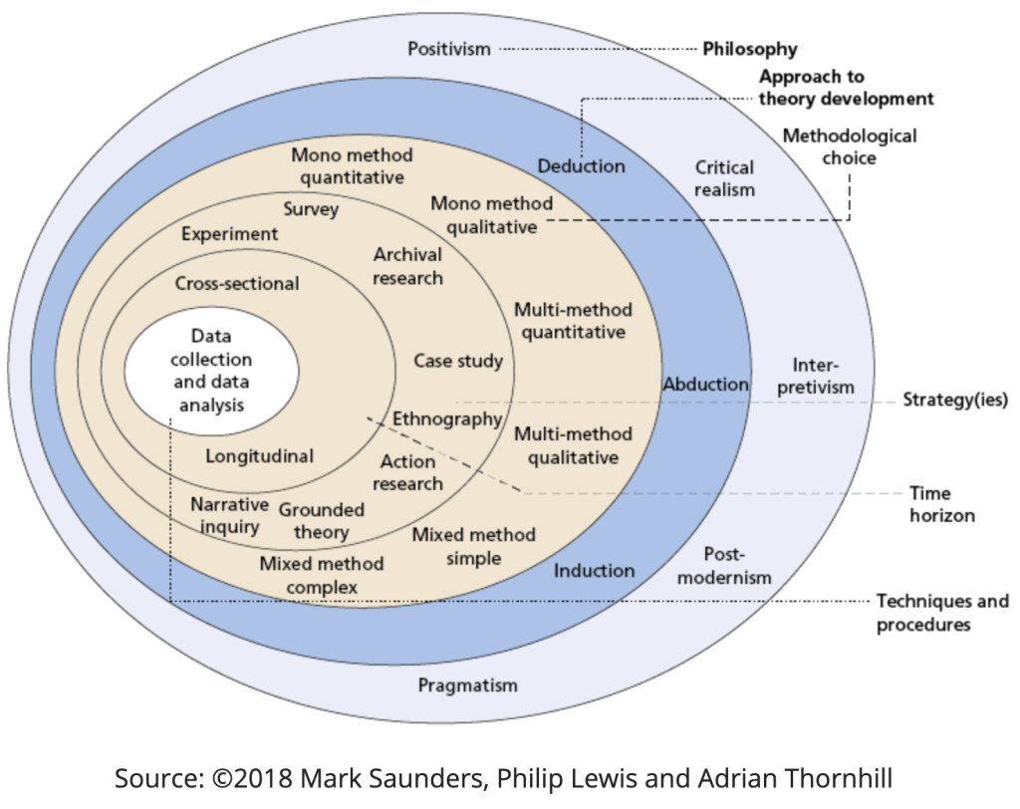
Research philosophy: positivism
The research philosophy, which expresses the researcher's perspective on how knowledge develops, is located on the outer layer of Saunders' Research Onion. This study follows a positivist ideology, which holds that social reality can be objectively evaluated and described using empirical data. Positivism believes that truth is observable and quantifiable, so choosing scientific methods and numerical analysis (Saunders, Lewis and Thornhill, 2019). This philosophical viewpoint fits well with the study's goal of assessing generational differences in communication, motivation, and inclusion using measured data rather than subjective interpretation. As a result, the researcher tries to maintain objectivity and neutrality while assuring the dependability and consistency of results through statistical analysis.
While positivism serves as a solid foundation for objective evaluation, it has limits in capturing nuances or emotionally charged elements in workplace dynamics. Generational behaviour frequently includes subjective factors such as identity, meaning-making, and interpersonal interactions, which may not be fully reflected by numerical indicators alone. Recognising this limitation improves methodological transparency and indicates that, while the study focusses on measurable characteristics, deeper qualitative interpretations might need supporting analytical approaches. This thought improves the academic rigour of the philosophical justification.

Approach to theory development: deductive
The second layer of the Research Onion discusses the approach to theory development. A logical approach will be taken, with existing ideas on generational behaviour, motivation, and inclusion (e.g., Lyons & Kuron, 2014; Robbins & Dunne, 2024) empirically evaluated in the context of Pret A Manger. Deduction begins with the formation of hypotheses based on recognised frameworks, such as generational theory and engagement models, which are then tested using acquired data. This top-down reasoning assures that the research findings either confirm or deny current knowledge, thereby adding to the literature with evidence-based insights.
The deductive method also allows the research to directly add to ongoing arguments regarding whether generational differences have a significant effect on workplace behaviour or if such discrepancies are overestimated. By empirically investigating generational views in a real-world organisational context, the study not only examines existing assumptions but also identifies areas where theoretical generalisations may not entirely fit with current organisational reality.
Methodological choice: quantitative mono-method
The third layer of the Research Onion focusses on methodological choices. This study uses a mono-method quantitative approach, relying only on numerical data acquired through structured surveys. The quantitative approach enables the objective evaluation of factors such as engagement, communication satisfaction, and inclusion, allowing for statistical comparison across generational cohorts (Baby Boomers, Gen X, Millennials, and Gen Z).
Quantitative research is especially useful for large samples where generalisation is essential, and it is consistent with the positivist paradigm, which values objectivity, replicability, and statistical reliability (Creswell & Creswell, 2018).
To improve methodological reliability, the survey instrument will include several dimensions organised into theme sections such as communication satisfaction, motivation drivers, engagement, and perceptions of inclusion. Each construct will consist of 3-5 Likert-scale items adapted from validated research instruments. During the pilot phase, internal reliability will be assessed using Cronbach's alpha, with a target threshold of 0.7 or higher. Content legitimacy will be assured through expert evaluation and cross-checking against current generational frameworks. These measures increase the quantitative design's credibility and precision (Cronbach, 1951; Bashar, 2023).
Research strategy: case study
Moving forward in the Research Onion, the research strategy determines how the analysis will be performed successfully. This project uses a case study approach, focussing on Pret A Manger, an international food retail brand with a varied and multigenerational team. The case study provides an in-depth look at Pret's HR policies, communication channels, and inclusion efforts. It gives contextual content while staying quantitatively orientated. Case studies are useful when the difference between phenomenon and context becomes unclear, and researchers want to understand organisational behaviour in real-world contexts (Yin, 2018).
Pret A Manger was selected because of its unique organisational characteristics, including high employee diversity, a strong service-based culture, and clear hierarchical structures that allow generational relationships to occur in everyday work practices. Compared to other food-service companies, Pret maintains strong global expansion, depends largely on people-centred operations, and invests in structured internal communication and training systems, making it a perfect environment for studying generational inclusiveness. The choice has been theoretically and practically justified.
Time horizon: cross-sectional
The time horizon shows another layer of the Research Onion. This study will use a cross-sectional design, meaning that data will be collected at a single point in time rather than over time. The cross-sectional approach is ideal for measuring generational perceptions in Pret A Manger's workforce at this point in time. Although long-term studies could monitor changes over time, the cross-sectional method is efficient and providing relevant comparative insights across age cohorts (Bell, Bryman & Harley, 2019).
A cross-sectional study cannot detect changes over time or establish causal connections between variables. Because generational attitudes might change thanks to organisational change, external factors, or individual career advancement, the results only reflect the time of data collection. A continuous method may be more appropriate for future research that attempt to examine changing generational processes.
Sampling strategy
To ensure representativeness, stratified sampling will be used so that each generation - Boomers, Gen X, Millennials, and Gen Z - is proportionally represented. Purposive sample will focus on relevant responsibilities within each stratum, such as team leaders, assistant managers, general managers and operation managers who are directly affected by Pret's multigenerational dynamics. This combined method creates a compromise between representativeness and relevance, ensuring that data accurately reflect demographic variety and organisational hierarchy.
The study intends to collect a minimum of 8-10 respondents from all generations to ensure statistical reliability and meaningful group comparisons. To reduce non-response bias, follow-up reminders will be sent via internal communication channels, and participation will be encouraged through clear messaging highlighting the value of employee input. Non-response patterns will be examined to determine whether specific generations or roles are under-represented, and these patterns will be mentioned as one of the study's limitations.
Data collection methods
Data will be collected through a structured questionnaire delivered via Pret's internal communication network and emails. The survey will include closed-ended questions with Likert scales to assess generational perceptions of engagement, motivation, and inclusiveness and two open questions.
Questions are drawn from proven constructs in previous generational research (e.g., Lyons & Kuron, 2014; Parry & Urwin, 2021) and tailored to Pret's context. Before being fully deployed, the instrument will go through a pilot test to ensure clarity, dependability, and internal consistency.
All responses will be anonymised to protect participants' privacy, and participation is absolutely voluntary.
Although the study is mainly quantitative, the inclusion of two open-ended questions allows for brief qualitative insights, but these responses are not going to be subjected to a complete thematic analysis; rather, they will be summarised using descriptive content analysis to detect common ideas.

Data analysis techniques
The collected data will be evaluated with descriptive statistics. Descriptive analysis (means, frequencies, and averages) will summarise response patterns. The data will be processed in Excel, and the results will be provided in the form of tables, graphs, and charts. Quantitative analysis allows for objective examination of hypotheses, which is consistent with the positivist and deductive underpinnings of research.
Ethical considerations
The study will comply with to the ethical standards of the University of Wales Trinity Saint David, as well as the UK's Data Protection Act (2018). All participants will provide informed consent and be ensured of their privacy and confidentiality. Participation will be voluntary, with the option to withdraw at any time without consequence.
No sensitive personal information will be collected, and all data will be securely saved and deleted after the project is completed. Ethical approval will be needed prior to data collection.
Assumptions, delimitations, and limitations
The key assumptions are that participants would reply honestly and that generational identification effects workplace perceptions. Limitations include a concentration on a single business (Pret A Manger) and the lack of regional differences. The limitations include potential sample error, a cross-sectional design (which cannot determine causality), and limited ability to generalise beyond the case organisation.
Potential biases include self-reporting bias, in which employees overstate positive experiences, and social attractiveness bias, in which respondents provide answers that they believe reflect well on the organisation. Furthermore, because the study focusses on a single organisation, organisational culture may influence perceptions despite generational identity, limiting external generalisations.
Timeline
A detailed Gantt chart presents all essential stages, from instrument design, pilot testing, and data collecting to statistical analysis and final write-up, ensuring that the project stays on track within the dissertation deadline.

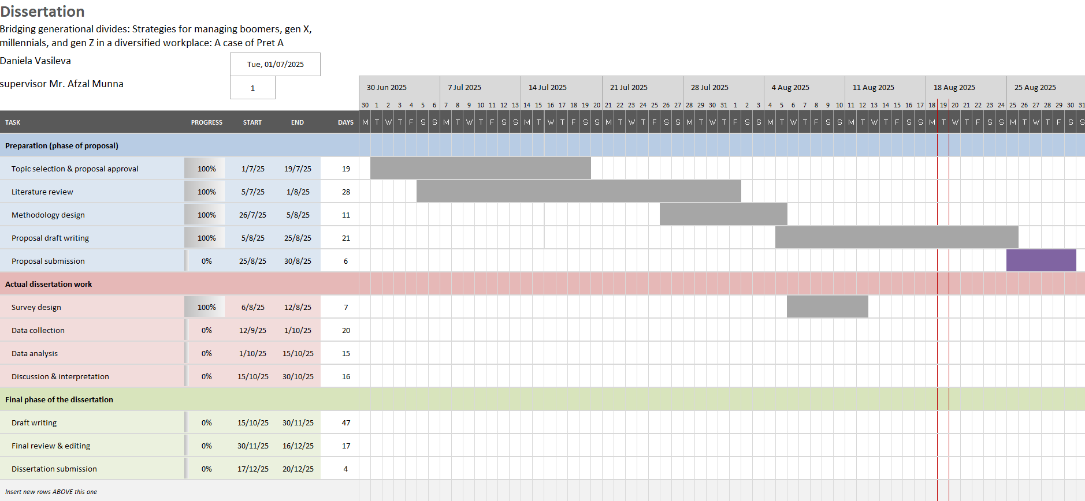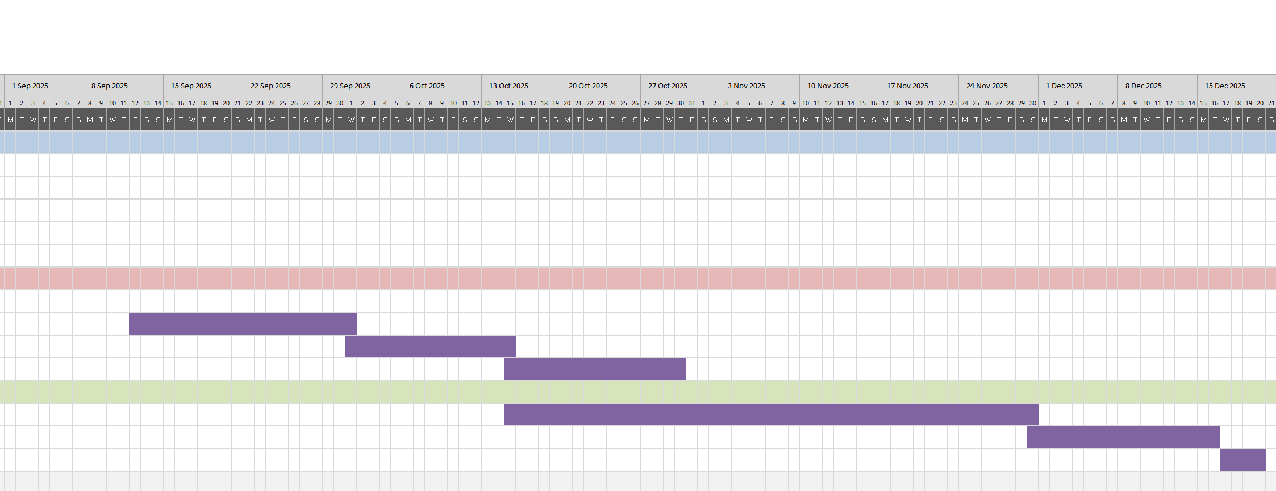

As a summary, this chapter has illustrated the logical connection between research philosophy (positivism), approach (deduction), method (quantitative), strategy (case study), and time horizon. These methodological choices fit in with the research goal - to objectively evaluate generational gaps in engagement and inclusion at Pret A Manger - and ensure that the study is both accurate and credible.

Chapter 4: Research
This chapter summarises the findings of a quantitative survey conducted among Pret A Manger employees regarding intergenerational participation, communication, inclusiveness, and perceptions of organisational practices. The goal of this chapter is to examine the data gathered from eight participants representing different generations and managerial positions. The findings are organised around the study objectives set in Chapter 1 and are based on the methodological approach provided in Chapter 3. The study focusses on descriptive patterns, emerging themes, and generational differences in motivation, communication styles, inclusivity, and perceptions of HR and leadership practices.
A total of eight Pret A Manger employees completed the survey. Participants represented two generations: Generation X (1965–1980) and Millennials (1981–1996). No Baby Boomer or Generation Z employees participated in the study, despite the fact that some respondents stated that they often collaborate with these generations in their stores.
Participants held operational and managerial positions such as Team Leader, Assistant Manager, General Manager, and Operations Manager for periods which vary from one to fifteen years. This provides a balanced representation of opinions from both frontline and management positions.
Research question 1: How do different generations differ in their engagement levels at Pret A Manger?
Motivation and meaningfulness
Overall, both Generation X and Millennial respondents expressed moderate to high motivation, with scores varying between three to five. Generation X participants reported consistently higher engagement, with several scores of 5 for motivation, meaningfulness, and appreciation. Millennials were slightly more diverse, with several scoring 3 for motivation and recognition. This suggests that years of service and managerial workload may have an impact on engagement, particularly among mid-level managers facing increased operational obligations.
Engagement drivers
Across generations, the most commonly chosen engagement drivers were job security, learning and development, team collaboration, opportunity for growth and purpose-driven work.
These results show that Pret employees prioritise both stability and development-related motivators. There is no significant generational difference in the factors that impacted engagement; instead, the data reveals a shared corporate culture where development, teamwork, and security are essential motivators.
Recognition and feedback
While positive feedback was typically good (4 or 5), recognition varied, with some Millennial managers rating it as low as 3. This reveals variations in managerial recognition procedures, which may have an effect on employee engagement.
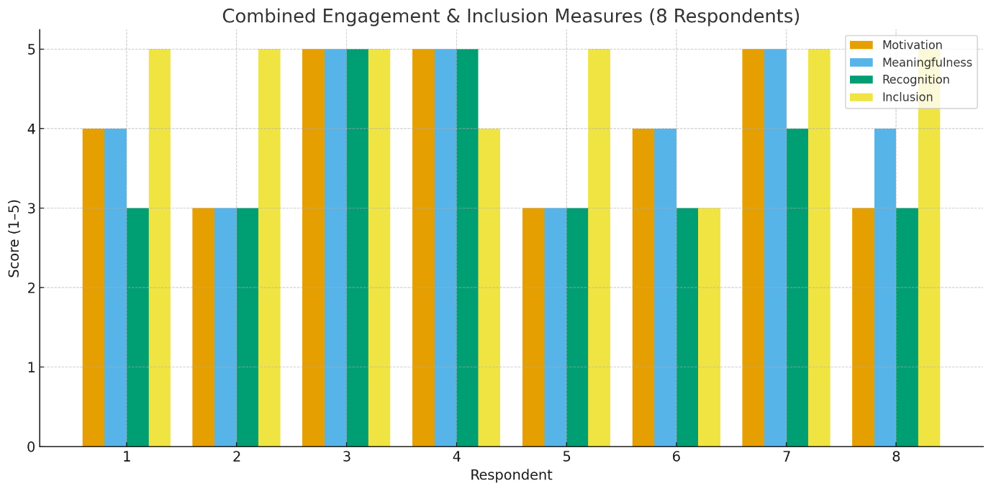
Research question 2: What are the preferred communication methods and tools across generations?
Communication channel preferences
Face-to-face communication is still the most preferred method among respondents, regardless of age. WhatsApp, emails, and team software (e.g., Zoom, MS Teams) were all regularly used, particularly by managers. There were no significant generational differences in preferred communication methods, showing that Pret's workforce is digitally educated. Certain respondents, particularly Generation X supervisors, indicated a wider range of communication methods, but younger employees were more selective, relying heavily on WhatsApp and email.
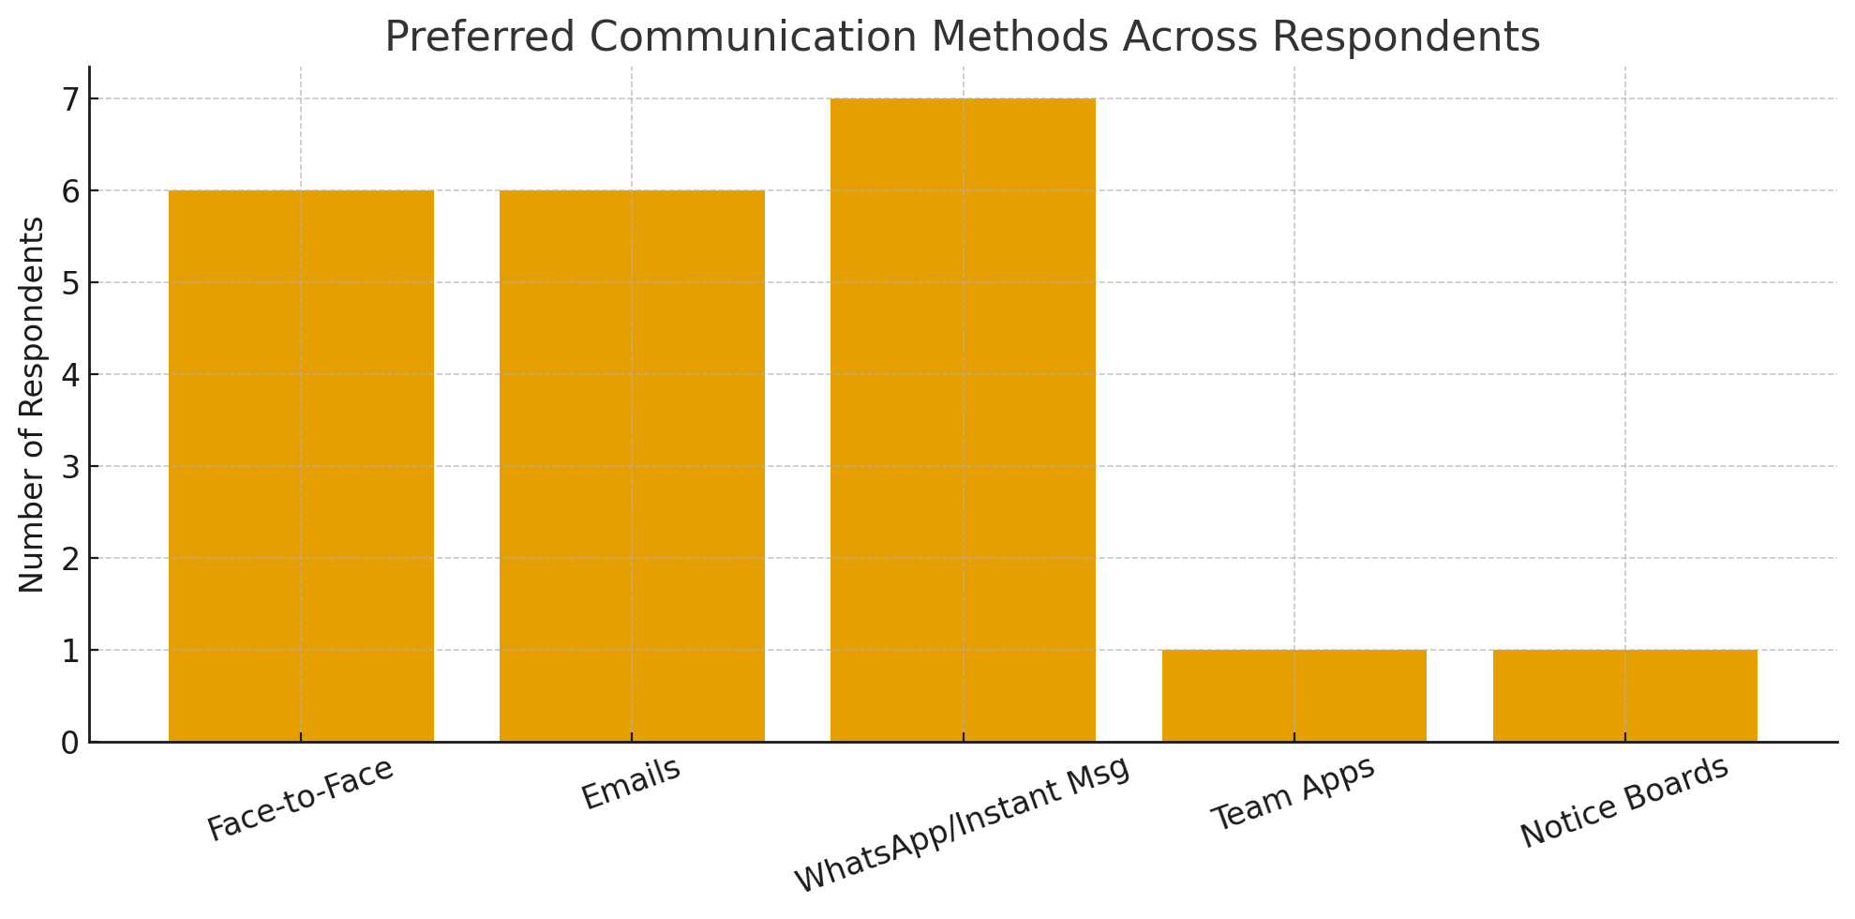
Communication comfort across generations
Every participant gave a score of 5 for feeling comfortable communicating with colleagues of different generations. This demonstrates an effective basis of psychological safety and adaptability within shops.
Communication effectiveness of management
Perceptions of communication effectiveness ranged from 3 to 5. While some appreciated managerial communication, others noted that messages were not always clear or consistent. The findings suggest that communication breakdowns are caused less by age differences rather by inconsistent leadership communication methods across shops.
Research question 3: How do employees across generations perceive inclusion and fairness within Pret's HR policies and culture?
Sence of inclusion, age inclusivity, fairness in promotions and development and experiences of age-related bias:
Respondents strongly agreed that they feel included and respected regardless of age, with nearly all scoring 5. This is a big strength for Pret A manger and corresponds with the company's equality and belonging efforts. The majority of respondents feel that company supports an age-inclusive culture, ranking 4 or 5. Employees see the environment as respectful and collaborative. Views differed on whether all generations are treated fairly in terms of promotion and development chances. Some employees scored as low as 3, showing gaps in perceived consistency of promotion criteria and equal access to development opportunities. This implies that, while inclusion is strong, perceived fairness may vary by shop and managerial level. Although most respondents had not personally experienced age-based stereotyping, several stated observing: assumptions that older staff struggle with technology, younger employees creating speedy communication shortcuts, unconscious bias affecting performance expectations or upskilling. These examples show slight age-related biases that affect daily interactions.
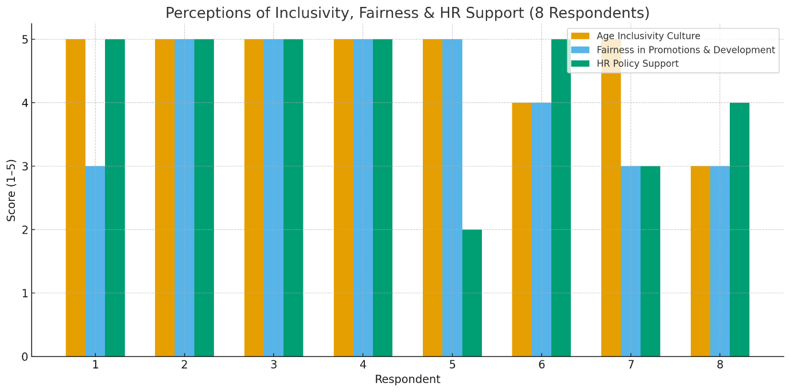
Research question 4: How does Pret’s leadership approach generational diversity through current management strategies?
Leadership adaptability, support for intergenerational collaboration and HR policy support:
Managers regularly assessed their capacity to adjust their leadership styles as high (4 or 5). This shows that Pret's leadership style encourages adaptability and understanding of generational differences. The majority of respondents agreed that management supports intergenerational collaboration. They also reported constantly learning new skills from teammates of various ages, indicating effective knowledge-sharing procedures across shops. Perceptions of HR policies were mixed. Some respondents believe present policies meet different generational needs, while others scored 3 suggesting confusion or lack of clarity about policy communication and explicit generational differences. This identifies a possible area for policy revision and improved communication.
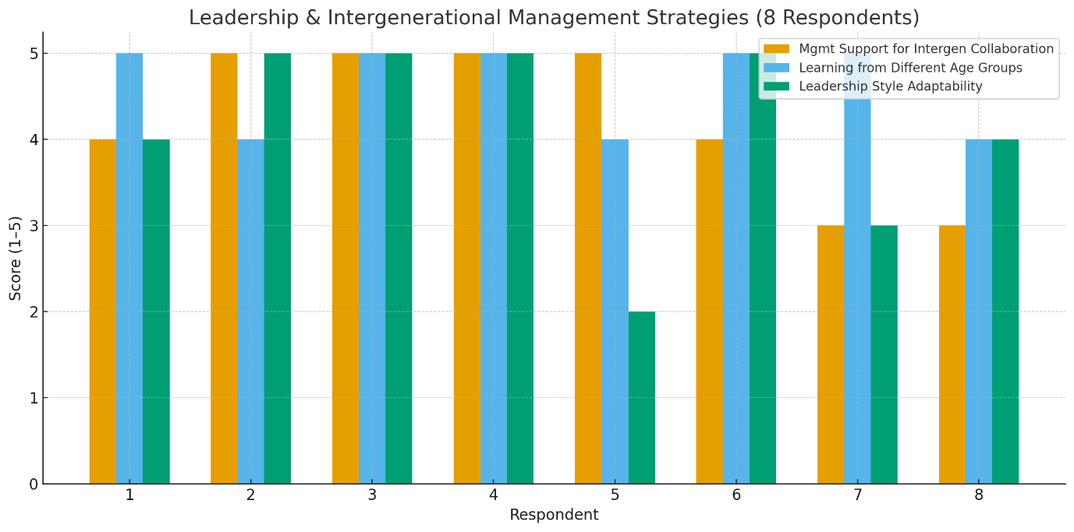
Research question 5: What strategies can Pret a Manger implement to enhance intergenerational collaboration and inclusion?
Reverse mentoring - Openness to reverse mentoring ranged from "maybe" to "yes." Respondents who supported the proposal saw it as an opportunity to improve digital skills for older workers, promote cross-generation understanding, and reduce stereotypes. Those who responded "Maybe" emphasised the necessity of structure, clear expectations, and psychological safety.
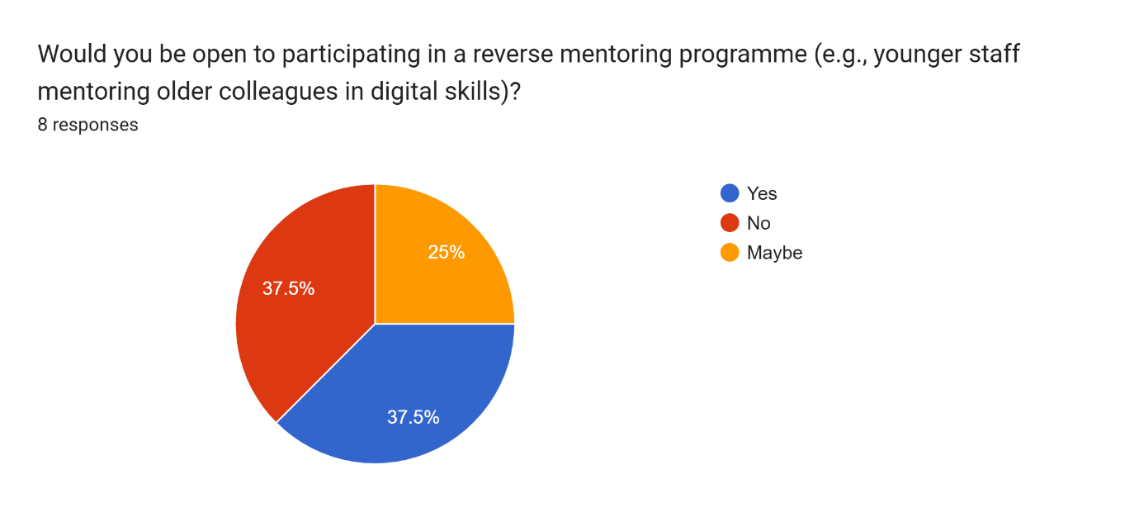
Communication challenges in mixed-age teams - Communication issues include differing expectations for feedback tone, different levels of proficiency with digital technologies, mixed preferences for detail vs. rapid communication, and diverse resolution of conflicts methods. These findings suggest that communication issues are more stylistic than cultural and can be addressed through planned actions.
Suggested organisational strategies - Respondents recommended numerous measures for improving intergenerational collaboration such as implemented cross-generational mentoring programs, provided training on unconscious bias, communication styles, and collaborative work, encouraged shared learning among younger and older staff, standardised communication guidelines throughout shops. These suggestions are consistent with contemporary HR practices for age-diverse workplaces.
In conclusion, the findings presented in this chapter provide a detailed picture of generational engagement, communication, and inclusion inside Pret A Manger, based on the responses of eight employees representing Generation X and Millennials. Although the small sample limits statistical generalisation, the data offer meaningful insights into how employees from different age groups experience workplace practices and organisational culture.
Overall, the quantitative results show that Pret's engagement levels generally favourable, with participants of both generations expressing great motivation, a sense of meaningful work, and high levels of appreciation in some shops. Generation X respondents reported slightly better and more consistent engagement levels, but Millennials reported greater variation, especially in recognition and feedback. These findings indicate that position demands, years of service, and managerial duties may have a greater impact on engagement than generational identification.
The chapter also demonstrates excellent communication harmony among age groups. Face-to-face communication is still the preferred method, but digital tools like WhatsApp and email are widely used by all respondents, indicating a technologically savvy workforce. Employees reported feeling comfortable communicating across generations, and no significant communication barriers emerged. When challenges did appear, they related not to age differences but to inconsistent messaging or variations in managerial communication practices across shops.
In the context of inclusiveness and fairness, respondents reported a strong sense of belonging and respect within Pret A Manger. Employees completely agreed that they feel respected regardless of age, and that the organisation encourages an inclusive culture. Nonetheless, diverse opinions on fairness in promotion and development opportunities show potential inconsistencies at the shop level, implying that while organisational inclusiveness is solid, the practical application of HR regulations might vary. While age-related stereotyping has not received much attention, some basic biases, such as assumptions about older workers' digital skills or younger workers' speed, remain and may influence day-to-day interactions.
Insights into leadership and organisational practices reveal that managers see themselves as adaptive and supportive of intergenerational collaboration. Knowledge sharing between older and younger staff is a significant strength across shops. However, inconsistent awareness of HR policies and how they address generational demands suggests an imbalance between formal company goals and employee understanding, indicating a need for improved communication and leadership alignment.
Finally, participants proposed constructive suggestions to promote intergenerational collaboration, including formal cross-generational mentoring, unconscious bias training, clearer communication guidelines, and a stronger focus on shared learning practices. These recommendations underscore employees’ openness to strategic actions - specifically reverse mentoring - as a tool to increase inclusion, remove prejudices, and create mutual understanding.

Chapter 5: Conclusion

Chapter 6: References and bibliography
- Alfes, K., Shantz, A.D., Truss, C. and Soane, E.C. (2013). The link between perceived human resource management practices, engagement and employee behaviour: a moderated mediation model. The International Journal of Human Resource Management, [online] 24(2), pp.330–351. doi:https://doi.org/10.1080/09585192.2012.679950.
- Bashar, H.U. (2023). How to Calculate Alpha in Excel: 4 Suitable Methods - ExcelDemy. [online] ExcelDemy. Available at: https://www.exceldemy.com/how-to-calculate-alpha-in-excel/ [Accessed 29 Nov. 2025].
- Bell, E., Bryman, A. and Harley, B. (2019). Business Research Methods. 5th ed. [online] Oxford: Oxford University Press. Available at: https://studylib.net/doc/26009510/bell--e.--bryman--a.--and-harley--b.--2019-.-business-resea... [Accessed 2 Nov. 2025].
- Burmeister, A., van der Heijden, B., Yang, J. and Deller, J. (2018). Knowledge transfer in age-diverse coworker dyads in China and Germany: How and when do age-inclusive human resource practices have an effect? Human Resource Management Journal, 28(4), pp.605–620. doi:https://doi.org/10.1111/1748-8583.12207.
- Cennamo, L. and Gardner, D. (2008). Generational differences in work values, outcomes and person‐organisation values fit. Journal of Managerial Psychology, 23(8), pp.891–906. doi:https://doi.org/10.1108/02683940810904385.
- Chaudhuri, S. and Ghosh, R. (2011). Reverse Mentoring: A Social Exchange Tool for Keeping the Boomers Engaged and Millennials Committed. Human Resource Development Review, 11(1), pp.55–76. doi:https://doi.org/10.1177/1534484311417562.
- CIPD and Brinkley, I. (2024). Survey report. [online] Available at: https://www.cipd.org/globalassets/media/knowledge/knowledge-hub/reports/2024-pdfs/8625-good-work-index-2024-survey-report-1-web.pdf?utm_source [Accessed 26 Oct. 2025].
- Costanza, D.P., Badger, J.M., Fraser, R.L., Severt, J.B. and Gade, P.A. (2012). Generational Differences in Work-Related Attitudes: A Meta-analysis. Journal of Business and Psychology, 27(4), pp.375–394.
- Creswell, J.W. and Creswell, J.D. (2018). Research design: Qualitative, quantitative, and Mixed Methods Approaches. 5th ed. [online] London: SAGE Publications. Available at: https://spada.uns.ac.id/pluginfile.php/510378/mod_resource/content/1/creswell.pdf.
- Cronbach, L.J. (1951). Coefficient alpha and the internal structure of tests. Psychometrika, [online] 16(3), pp.297–334. doi:https://doi.org/10.1007/bf02310555.
- Deal, J.J., Altman, D.G. and Rogelberg, S.G. (2010). Millennials at Work: What We Know and What We Need to Do (If Anything). Journal of Business and Psychology, [online] 25(2), pp.191–199. doi:https://doi.org/10.1007/s10869-010-9177-2.
- Eisner, S.P. (2005). Managing Generation Y. S.A.M. advanced management journal, 70(4), pp.4–15.
- Goleman, D. (1998). Working with emotional intelligence. [online] New York: Bantam Books. Available at: https://www.academia.edu/44384606/WORKING_WITH_EMOTIONAL_INTELLIGENCE.
- Gursoy, D., Chi, C.G.-Q. and Karadag, E. (2013). Generational differences in work values and attitudes among frontline and service contact employees. International Journal of Hospitality Management, 32(4), pp.40–48. doi:https://doi.org/10.1016/j.ijhm.2012.04.002.
- Kahn , W.A. (1990). Psychological Conditions of Personal Engagement and Disengagement at Work. [online] Scribd. Available at: https://www.scribd.com/document/327997881/Kahn-1990-Psychological-Conditions-of-Personal-Engagement-and-Disengagement-at-Work.
- Kapoor, C. and Solomon, N. (2011). Understanding and managing generational differences in the workplace. Worldwide Hospitality and Tourism Themes, 3(4), pp.308–318. doi:https://doi.org/10.1108/17554211111162435.
- Kunze, F., Boehm, S.A. and Bruch, H. (2011). Age diversity, age discrimination climate and performance consequences-a cross organizational study. Journal of Organizational Behavior, [online] 32(2), pp.264–290. doi:https://doi.org/10.1002/job.698.
- Kupperschmidt, B.R. (2000). Multigeneration Employees: Strategies for Effective Management. The Health Care Manager, 19(1), pp.65–76. doi:https://doi.org/10.1097/00126450-200019010-00011.
- Lyons, S. and Kuron, L. (2014). Generational differences in the workplace: A review of the evidence and directions for future research. Journal of Organizational Behavior, [online] 35(S1), pp.139–157. doi:https://doi.org/10.1002/job.1913.
- Mannheim, K. (1952). Essays on the sociology of knowledge : Mannheim, Karl, 1893-1947 : Free Download, Borrow, and Streaming : Internet Archive. [online] Internet Archive. Available at: https://archive.org/details/essaysonsociolog00mann/page/4/mode/2up [Accessed 26 Oct. 2025].
- Mencl, J. and Lester, S.W. (2014). More Alike Than Different: What Generations Value and How the Values Affect Employee Workplace Perceptions. Journal of Leadership & Organizational Studies, 21(3), pp.257–272. doi:https://doi.org/10.1177/1548051814529825.
- Parry, E. (2014). Generational Diversity at Work. [online] Routledge. Available at: https://api.pageplace.de/preview/DT0400.9781351224178_A30937269/preview-9781351224178_A30937269.pdf?utm_source.
- Parry, E. and Urwin, P. (2011). Generational Differences in Work Values: A Review of Theory and Evidence. International Journal of Management Reviews, 13(1), pp.79–96. doi:https://doi.org/10.1111/j.1468-2370.2010.00285.x.
- Pilcher, J. (1994). Mannheim’s Sociology of Generations: an Undervalued Legacy. The British Journal of Sociology, 45(3), pp.481–495. doi:https://doi.org/10.2307/591659.
- Pret a Manger (2023). Doing the Right Thing 2023 Environment, Social and Governance Report. [online] Available at: https://downloads.ctfassets.net/4zu8gvmtwqss/4Del22LGAqZlRUOGab1KkA/b1426f6d8f13bb467ddf3268e2d3d2cc/Doing_The_Right_Thing__ESG__Report_2023.pdf [Accessed 19 Oct. 2025].
- Roberson, Q.M. (2006). Disentangling the meanings of diversity and inclusion in organizations. Group & Organization Management, 31(2), pp.212–236. doi:https://doi.org/10.1177/1059601104273064.
- Robinson, A. (2021). Employee Engagement Theory: Definition & Examples. [online] teambuilding.com. Available at: https://teambuilding.com/blog/employee-engagement-theory.
- Saunders, M., Lewis, P. and Thornhill, A. (2019). Research Methods for Business Students. 8th ed. [online] United Kingdom : Pearson. Available at: https://www.researchgate.net/publication/330760964_Research_Methods_for_Business_Students_Chapter_4_Understanding_research_philosophy_and_approaches_to_theory_development [Accessed 2 Jul. 2025].
- Schaufeli, W.B., Salanova, M., González-romá, V. and Bakker, A.B. (2002). The measurement of engagement and burnout: A two sample confirmatory factor analytic approach. Journal of Happiness Studies, 3(1), pp.71–92. doi:https://doi.org/10.1023/a:1015630930326.
- Staff, J. and Schulenberg, J.E. (2010). Millennials and the World of Work: Experiences in Paid Work During Adolescence. Journal of Business and Psychology, 25(2), pp.247–255. doi:https://doi.org/10.1007/s10869-010-9167-4.
- Tajfel, H. and Turner, J. (1986). Social Identity and Intergroup Relations. Contemporary Sociology, [online] 14(4), p.520. doi:https://doi.org/10.2307/2069233.
- Temi Omovigho Olajide-Arise, Oni, B.O., Ogundele, J.I. and Ndudi, R. (2024). An Integration of Multigenerational Workforce Practices and Employee Engagement. FUOYE Journal of Public Administration and Management, [online] 2(1), pp.2992–4863. Available at: https://www.researchgate.net/publication/380826691_An_Integration_of_Multigenerational_Workforce_Practices_and_Employee_Engagement.
- Twenge, J.M. (2010). A Review of the Empirical Evidence on Generational Differences in Work Attitudes. Journal of Business and Psychology, [online] 25(2), pp.201–210. doi:https://doi.org/10.1007/s10869-010-9165-6.
- Yin, R.K. (2018). Case Study Research and Applications: Design and Methods. 6th ed. [online] SAGE Publications. Available at: https://ebooks.umu.ac.ug/librarian/books-file/Case%20Study%20Research%20and%20Applications.pdf [Accessed 1 Nov. 2025].

