Planning A Programme.



(Image by Rachel Jones)

Rachel Jones
2308282
ECYW5005

I did not use AI to structure this work.

Index.

Front Page 1

Index 2

In Depth Analysis 3-9

Appendix 10-15

Reference List. 16-18

Planning A Programme.

As part of the BA Youth Work and Social Education degree (level 5), students are required to complete 200 hours of face-to-face engagement with young people within their chosen youth organisations during placement.
Students are expected to develop their practice and demonstrate the ability to facilitate relevant youth work programmes independently, driven by the needs of young people.

Over the course of their placement at the Well-Being Centre, Steer the Enterprise, the student fully immersed themselves in practice and quickly built strong relationships with the group of young people and peers attending Well-Being Wednesday, a weekly programme funded by Children in Need.
The group consists of NEET (Not in Education, Employment, or Training) young people who have not attended a formal school setting for some time.

Consulting young people.
Although outdoor experiential learning (Kolb,1984) is at the heart of Steer the Enterprise, the young people attending Well-Being Wednesday have a voice and choice in shaping their sessions.
Regular group consultation through methods such as white board charts, discussions, and preference lists ensures high levels of active engagement and participation through empowering young people to have their say in matters that affect them, facilitating provision they collectively helped shape. (Wag,2022).
Through the consultation process, the student recognized that cooking was unanimously expressed as an activity the group wanted to do more often.
The student proposed to the lead youth worker the idea of running a cooking programme that combines fun with skill development and knowledge.
The programme would actively engage young people in an activity they are interested in while also incorporating a Level 2 Food Safety and Hygiene accreditation (Gov UK, 2023).

Implementing the programme.
The student sourced a free food safety and hygiene level 2 course from Welsh government for young people aged 14 years and over. However, as some participants were younger, the student contacted The Food Standards Agency to request permission for those under 14 to take part. The request included a brief overview of STEER’s work with young people and the aim of incorporating the e-learning course into a programme focused on healthy eating and outdoor bushcraft sessions.
The student oversaw the whole registration and implementation of the e-learning and indoor cooking while a trained colleague facilitated the bushcraft sessions.
(Appendix 1).

Recognising Balance in Schools.
In 2009 Public Health Wales (Gov UK, 2024) enforced the Healthy Eating in Schools measure requiring local Authority’s to integrate and educate healthy eating and balanced lifestyles into school curriculum.
The National quality award also introduced in 2009 by Welsh government imbedded Health and well-being into formal schools’ settings, linking the importance of food, nutrition as well as physical exercise has on a young person’s well-being.
By 2021 schools wanting to obtain this award had to meet certain criteria of Public Health Wales Healthy school scheme (PHW,2024) With schools expressing access to balanced, affordable nutritious food within school hours for all young people. (Ibid)
The main objective and focus expressed by the Department of Education is to educate young people to sustain healthy lives and combat child obesity (DFE,2022).

Amid the cost-of-living crisis, many financially struggling families rely on free school meals, yet many more do not qualify. Educating young people on affordable, sustainable lifestyle choices that carry through to adulthood is crucial. (Uk Parliament, 2023).

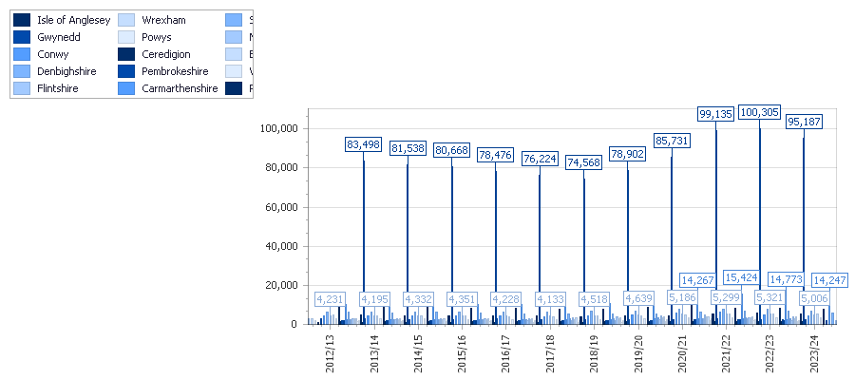
Pupils eligible for free school meals within secondary schools Wales.

(StatsWales,2024).

This group of young people are NEET (not in education, training or employment) meaning they are not exposed to school curriculum or culture.
Albert Banduras 1977 social learning theory (Very well mind,2024) suggest that learning and attitudes develop through observation. We are influenced by our surroundings and peers’ behaviours, imitating through association and observation.
With proven links between good physical and mental health both equally as important as the other (Mentalhealth,2022) young people leading well balanced lifestyles contributes to overall wellbeing of their everyday lives while navigating the transition through emotions and change of adolescence (Gov Wales, 2019).
The group of young people while taking part in monthly reviews expressed, low mood, lack of motivation and poor sleep and eating patterns.

Outcomes for young people.
This program, developed in response to young people's interest in cooking, was designed to be engaging and skill-building while incorporating non-formal learning. (WAG, 2022)
To enhance their experience, participants completed a Food Hygiene Course at their own pace within the 8-week program.
Upon completion, each young person received a laminated level 2 food hygiene and safety accreditation certificate opening job opportunities in the food industry. The program fostered a sense of achievement, empowering participants with the confidence and skills to complete their goals. (NOS,2019). (Appendix 2).
As stated by the National Occupational Standards assisting young people to manage risk, adhering to health and safety, being aware of their surroundings whilst participating in the programme, equips young people with safeguarding techniques that can be applied to independent living. (NOS,2019).
The group worked in pairs or, depending on the dish, as a whole. This fostered social interaction, teamwork, and group discussions about the cooking process and ideas for future sessions. With dynamics within the group already well established, Tuckman (1965) would refer to this as “performing “collaborating with confidence needing little input from the youth worker (Mindtools, 2025). (Appendix 3).

Evaluating the programme.

After each session the young people were given a targeted evaluation form to complete, the focus of the evaluation was to see if the young people felt they could confidently follow the recipes, if they would use the recipe again at home independently and what they would want to create next. The evaluation was used to measure and monitor the overall success of the programme, as stated by Sapin (2013 p. 242) evaluation outlines strengths, weaknesses, aims, objectives and targets but also enables young people to reflect on their growth throughout the programme. (Appendix 4).

Summary.
Kolb’s experiential learning theory (NHS) emphasizes that young people learn best through experience and active participation. This programme successfully met its objectives by fostering skill development, knowledge acquisition, enjoyment, and accredited outcomes. It also aligned with the five pillars of youth work (Wag,2022. P.8)
• Inclusive - Young people played an active role in shaping the programme, from selecting recipes to making decisions about outdoor cooking promoting inclusivity for all involved.
• Participative – With the group well established and in a consistent “Performing “stage recognised by Tuckman’s group work dynamics theory (Hughes, 2025), the group demonstrated strong collaboration and engagement. Drawing from UNICEF’s Hart’s Ladder of Participation, the programme encouraged high levels of active involvement. Although initially designed by the student youth worker, it was developed through consultation, allowing participants to choose recipes and complete accreditation at their own pace.
• Empowering – Developing new skills and knowledge each session fostered confidence culminating in the completion of a Food Health and Hygiene accreditation. Additionally, taking home their culinary creations each week provided a sense of achievement and empowerment.
• Educative- The programme served as a valuable learning experience, enabling young people to excel, gain accreditation and develop essential life skills and knowledge.
• Expressive – Each participant was able to tailor recipes to their induvial taste, style and creativity. Through evaluation they reflected on and shared their opinions about their creations.

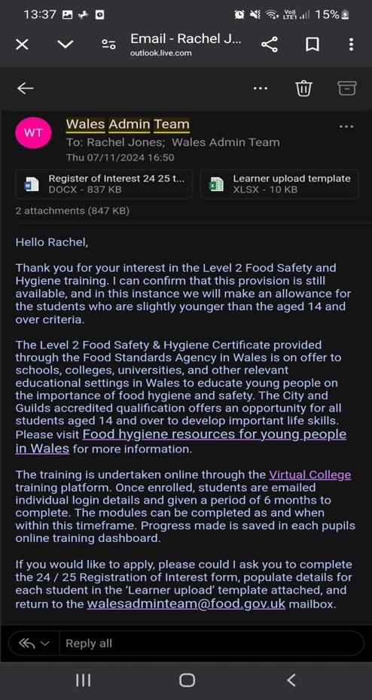
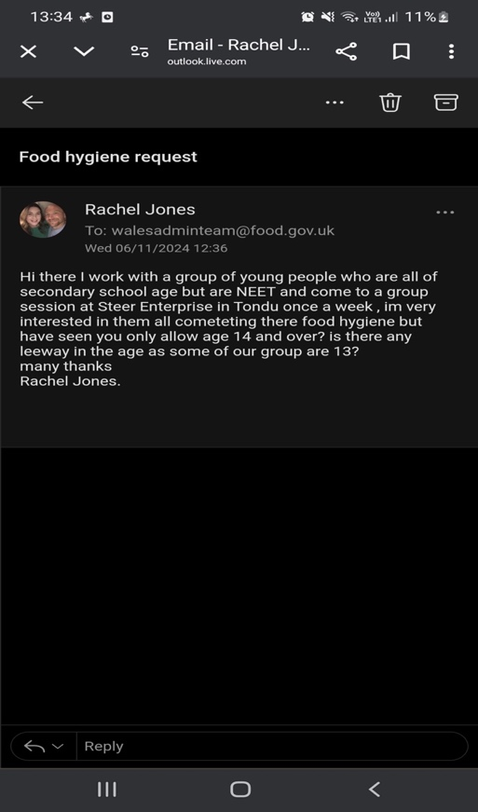
Appendix 1.

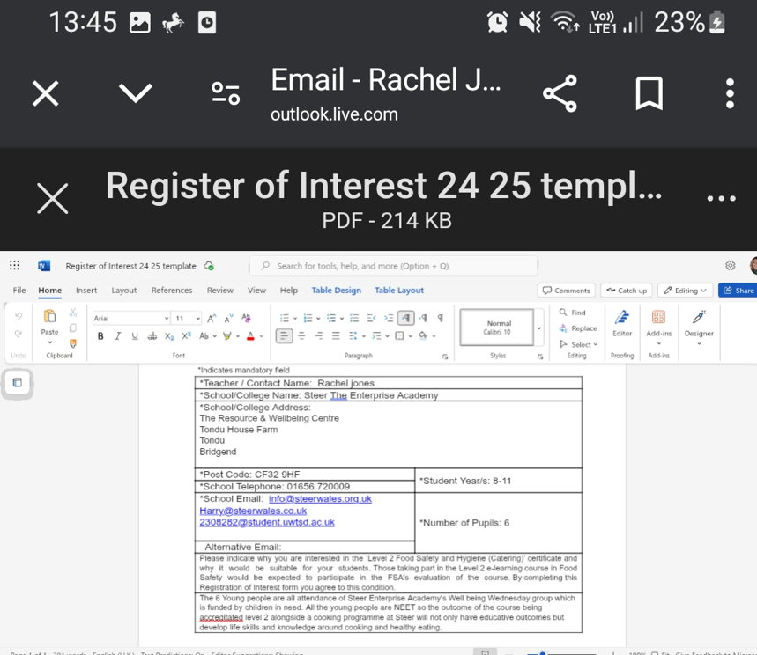

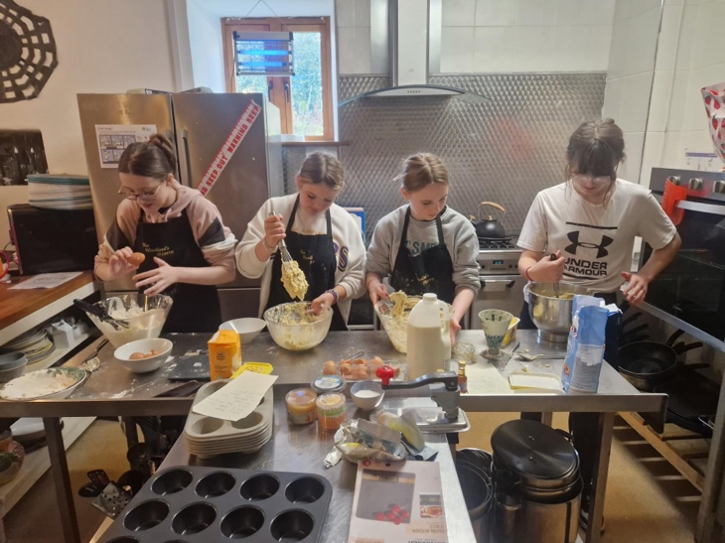
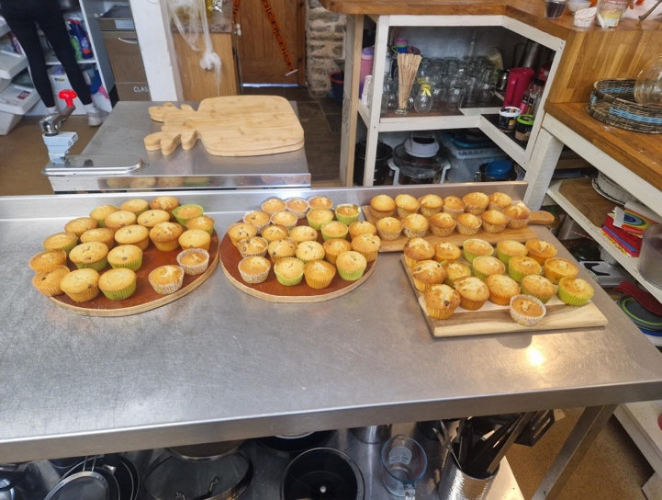
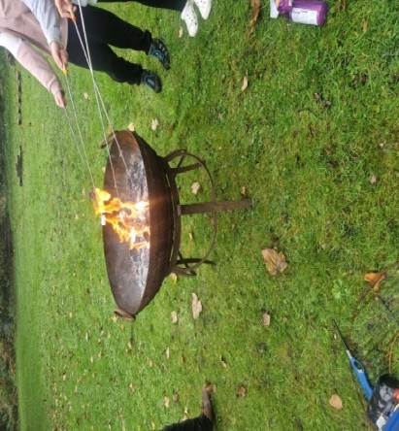

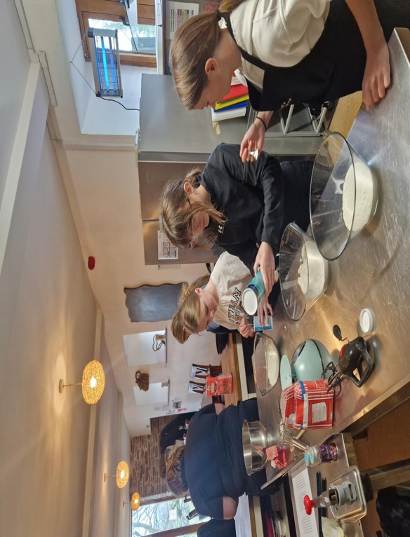
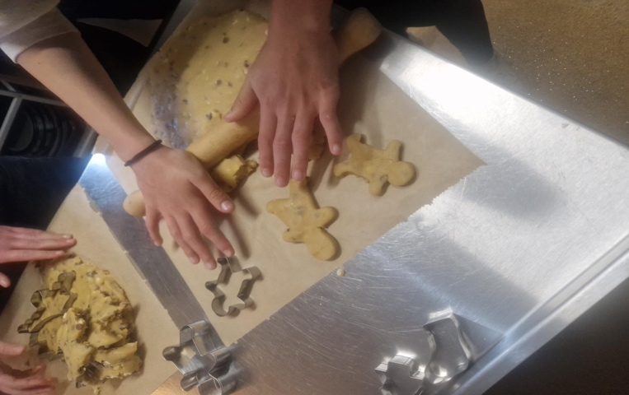

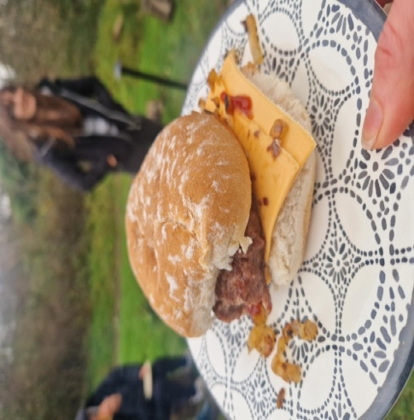
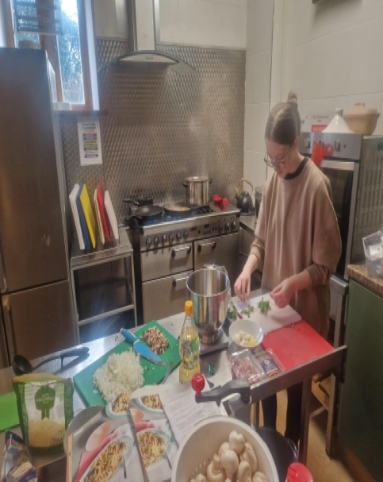

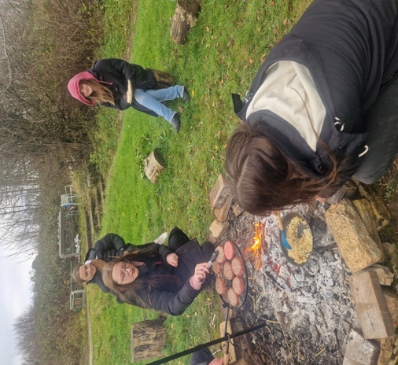
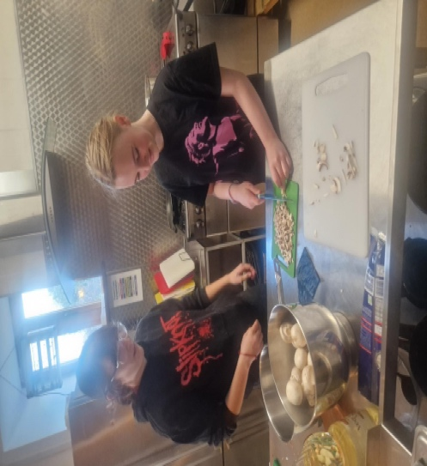
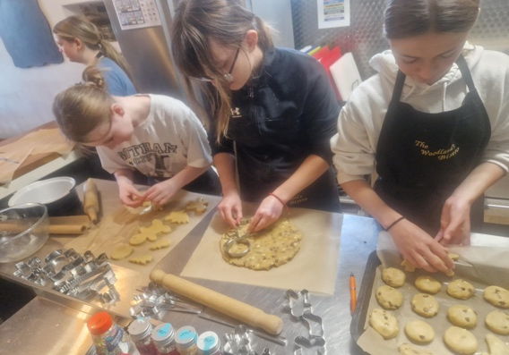

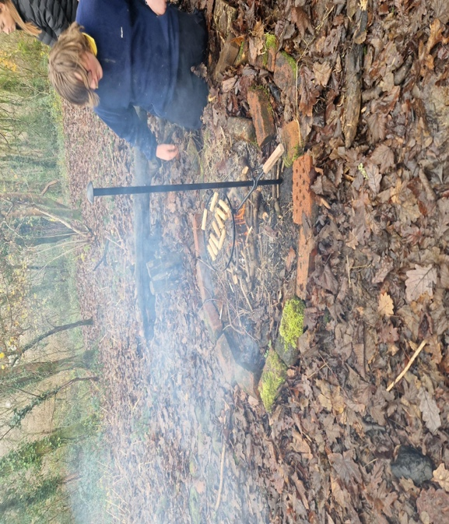
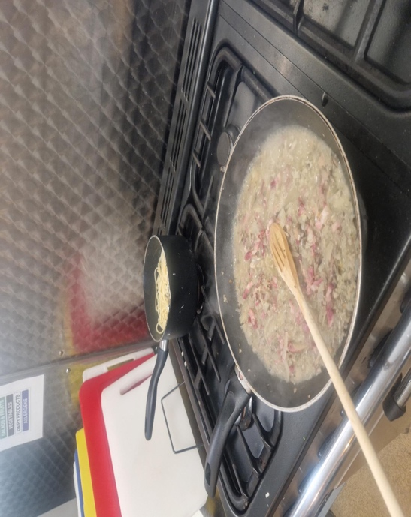
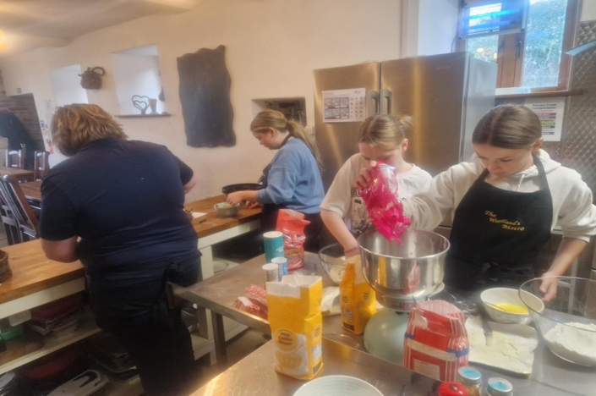

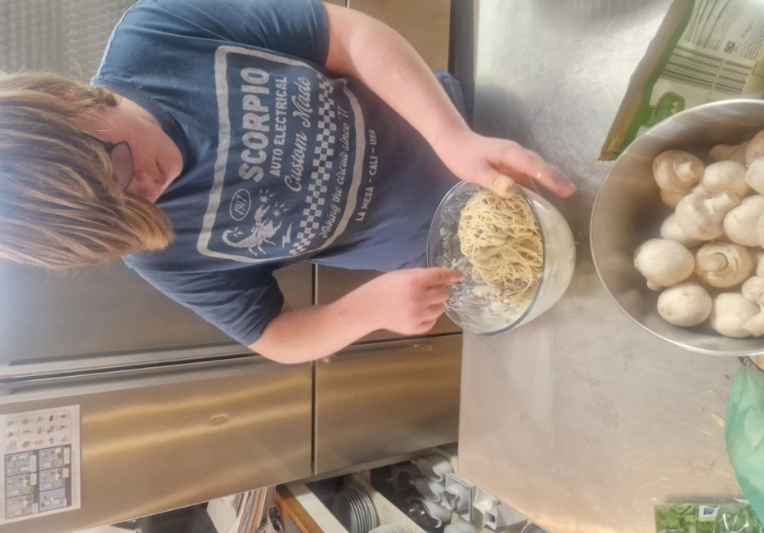

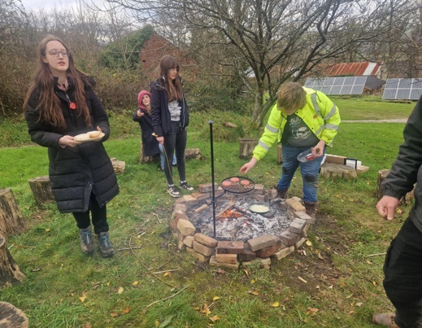

Appendix 3.

Appendix 2.

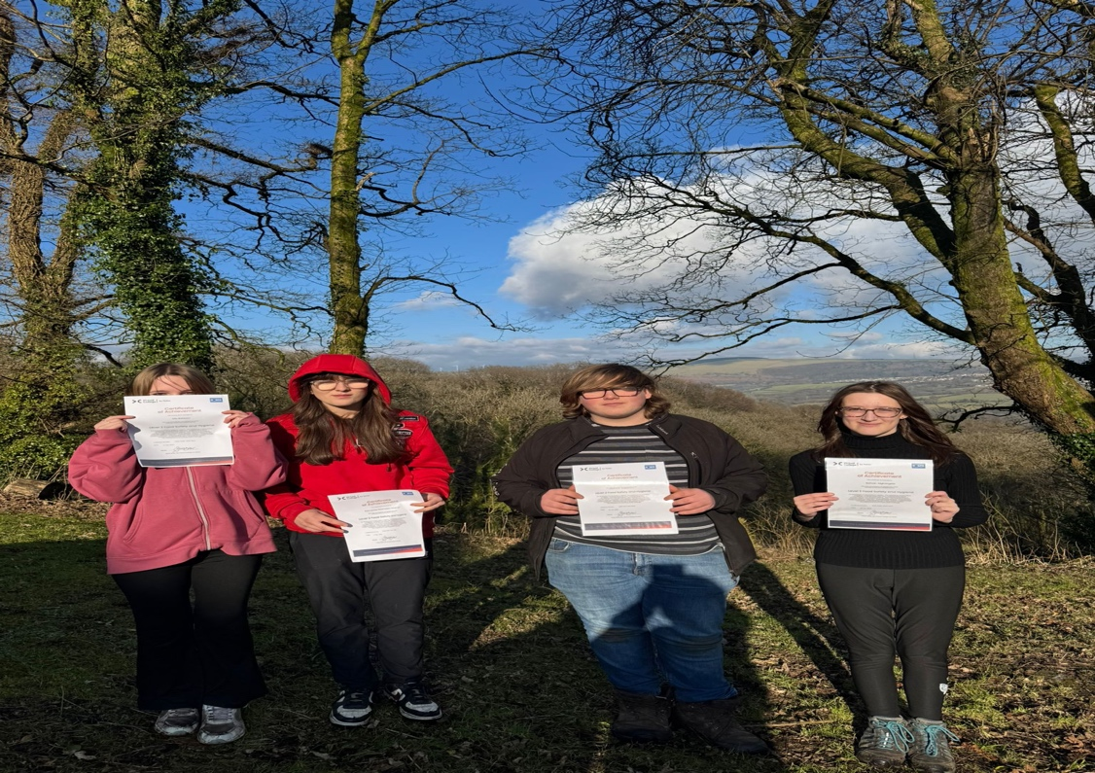

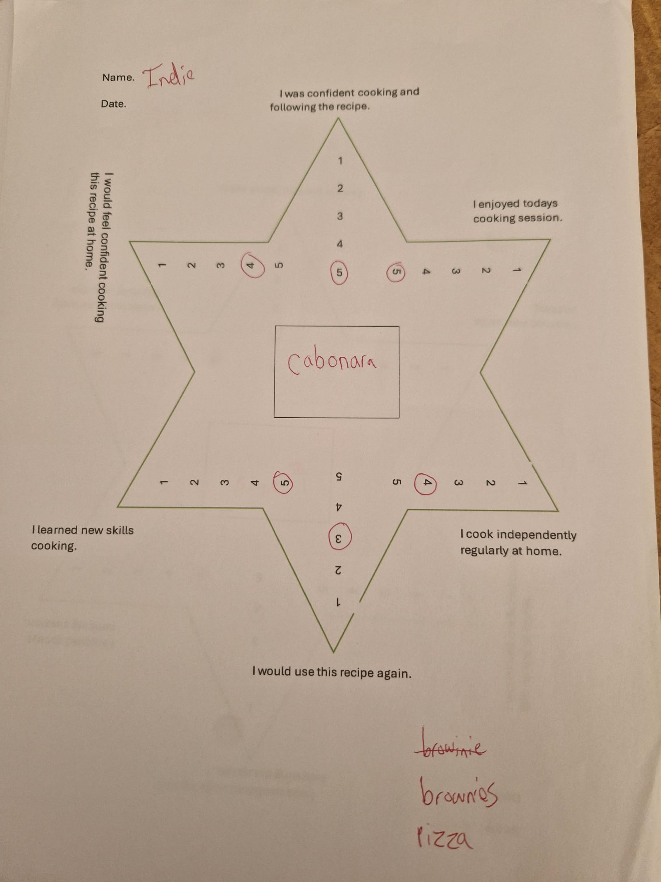
Appendix 4.

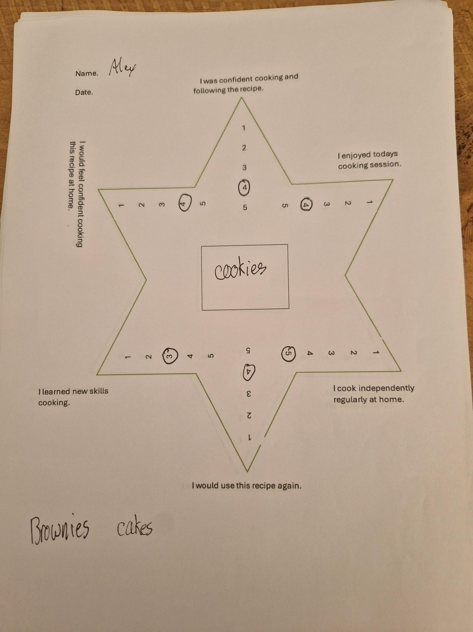
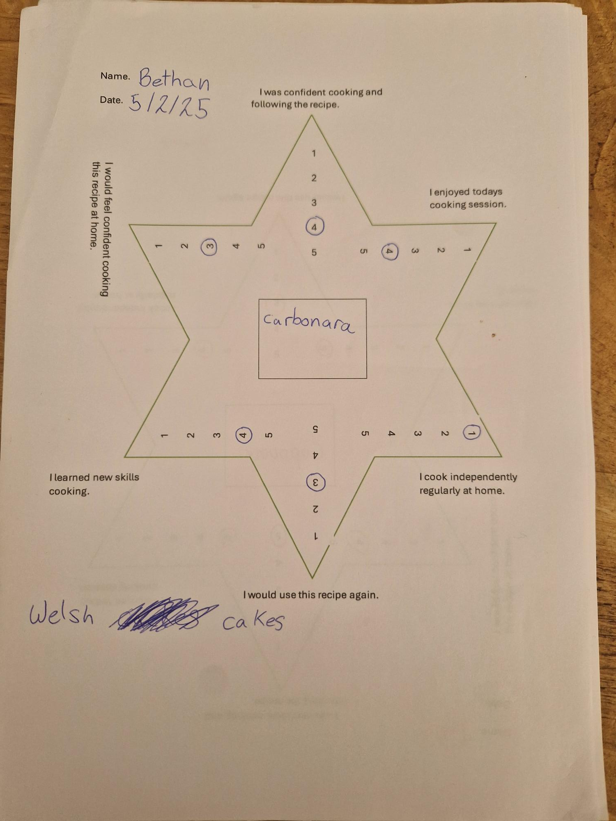
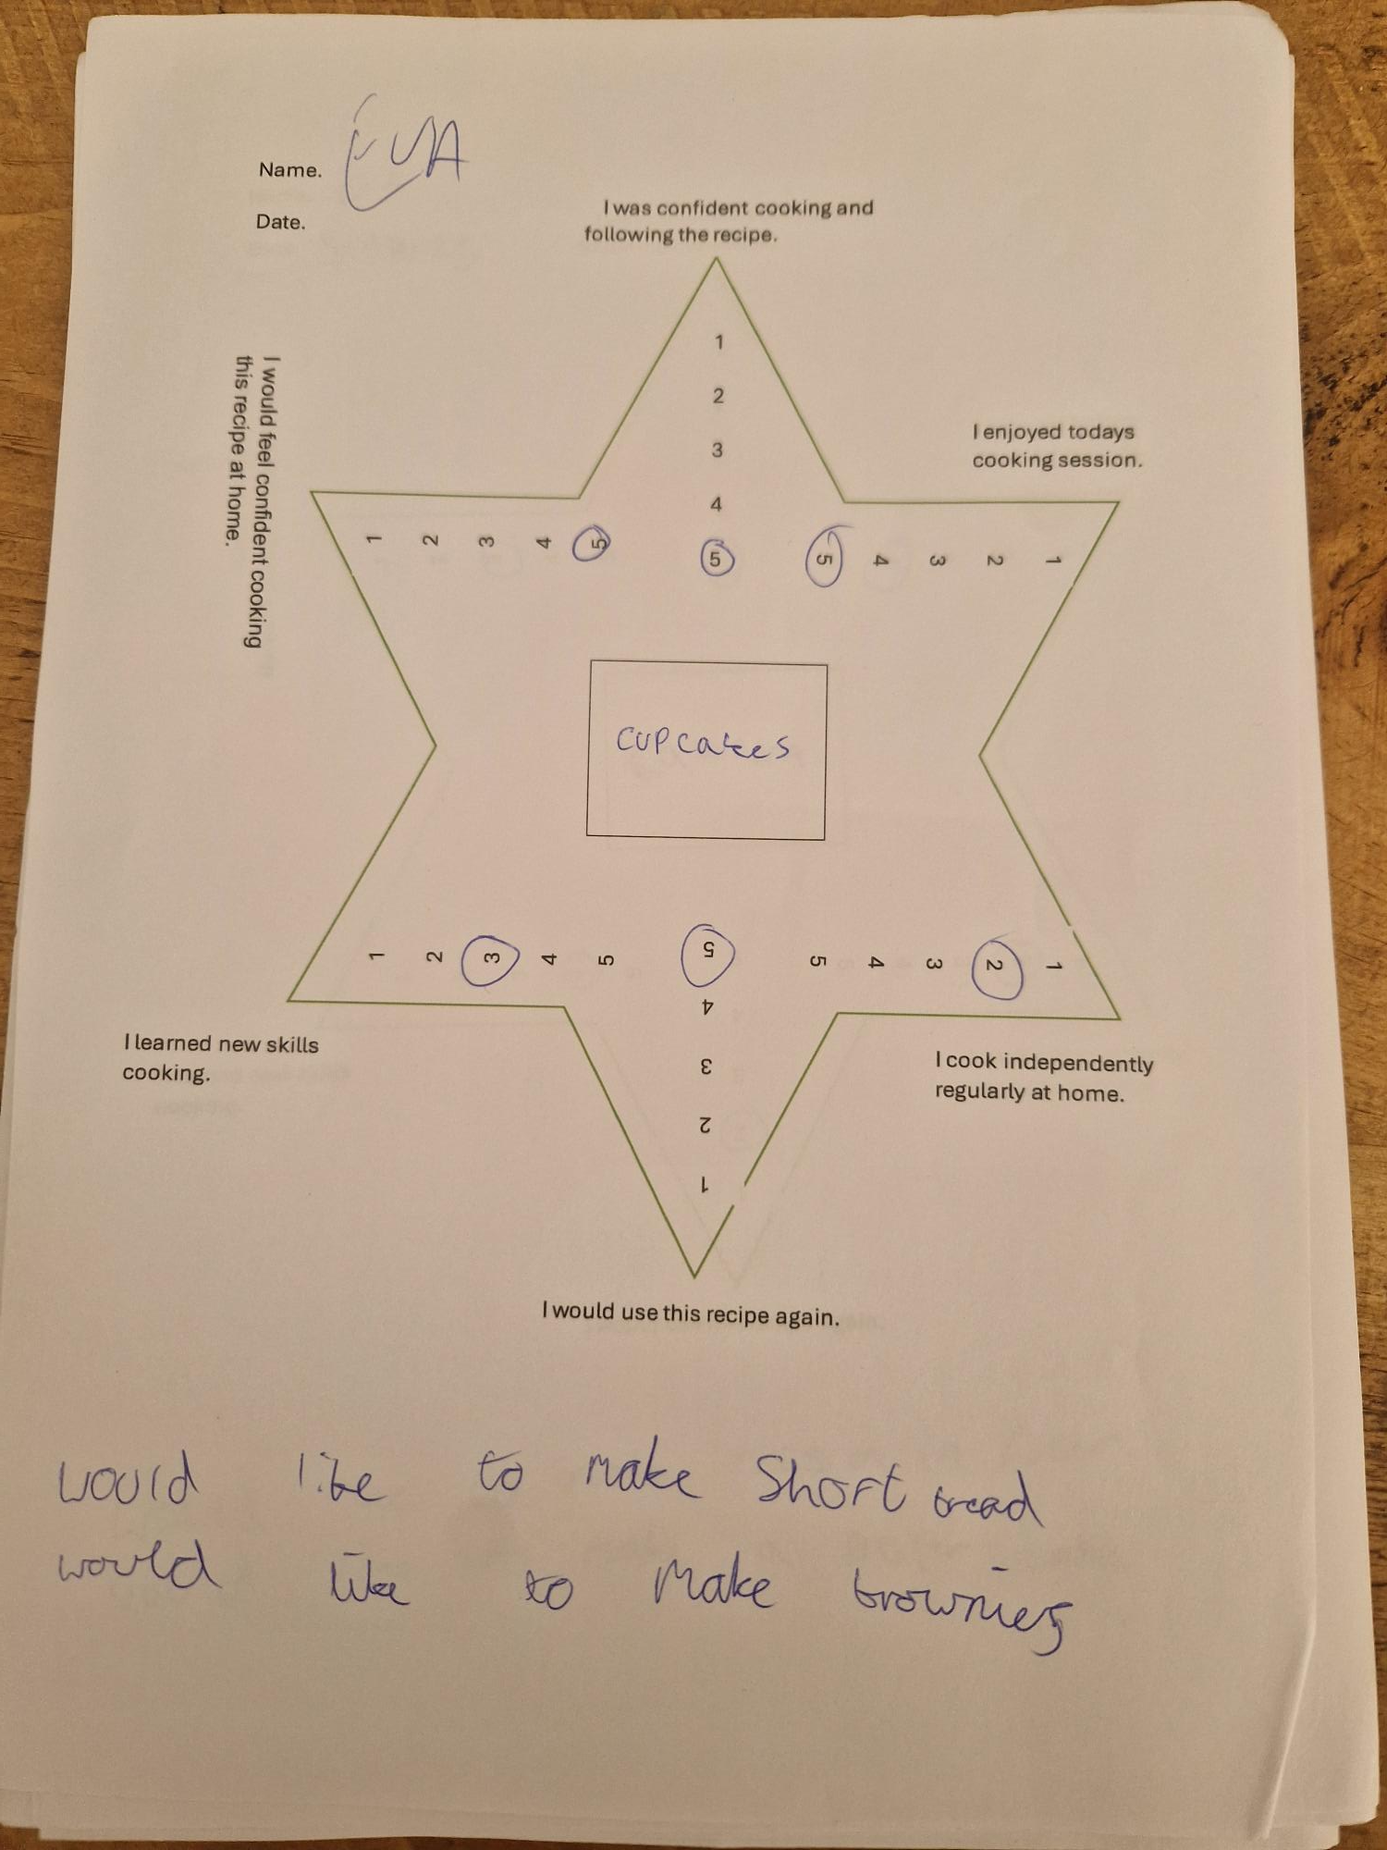

References.

GOV.UK (2022) Healthy Schools Rating Scheme, Healthy schools rating scheme Guidance for schools. Available at: https://assets.publishing.service.gov.uk/media/634fca66e90e0731aa0fcc8f/Final_Healthy_schools_rating_scheme.pdf (Accessed: 27 February 2025).

Gov Wales (2023) Food Hygiene Resources for young people in Wales, Food Standards Agency. Available at: https://www.food.gov.uk/safety-hygiene/food-hygiene-resources-for-young-people-in-wales#:~:text=3%20January%202024-,Food%20Safety%20and%20Hygiene%20e%2Dlearning%20course,anyone%20aged%2014%20and%20over. (Accessed: 13 February 2025).

GOV Wales (2019) Youth work strategy for Wales, Youth Work Strategy for Wales. Available at: https://www.gov.wales/sites/default/files/publications/2019-06/youth-work-strategy-for-wales.pdf (Accessed: 04 March 2025).

Home - steer - the enterprise academy (2022) STEER. Available at: http://www.steerwales.org.uk/ (Accessed: 26 February 2025).

Hughes, M. (2025) Home, MindTools. Available at: https://www.mindtools.com/abyj5fi/forming-storming-norming-and-performing (Accessed: 04 March 2025).

Youth Work in Wales (2022). Principles And Purposes. Youth Work in Wales Review Group.

Metadata (2024) Pupils eligible for free school meals by local authority, region and year. Available at: https://statswales.gov.wales/Catalogue/Education-and-Skills/Schools-and-Teachers/Schools-Census/Pupil-Level-Annual-School-Census/Provision-of-Meals-and-Milk/pupilseligibleforfreeschoolmeals-by-localauthorityregion-year (Accessed: 26 February 2025).

Mental Health Foundation (2022) Physical Health and Mental Health, Mental Health Foundation. Available at: https://www.mentalhealth.org.uk/explore-mental-health/a-z-topics/physical-health-and-mental-health (Accessed: 04 March 2025).

Mindtools (2025) Forming, Storming, Norming and Performing, MindTools. Available at: https://www.mindtools.com/abyj5fi/forming-storming-norming-and-performing (Accessed: 15 March 2025).

MSEd, K.C. (2024) How does observational learning actually work? Verywell Mind. Available at: https://www.verywellmind.com/social-learning-theory-2795074 (Accessed: 04 March 2025).

NHS (no date) Learning cycle (Kolb, 1984) - health education england, Learning cycle Kolb 1984. Available at: https://www.hee.nhs.uk/sites/default/files/documents/Kolb%20learning%20cycle.pdf (Accessed: 28 January 2025).

Participation, E. (2009) Healthy Eating in Schools (wales) measure 2009, Legislation.gov.uk. Available at: https://www.legislation.gov.uk/mwa/2009/3/contents (Accessed: 26 February 2025).

PHW.NHS (2024) Proposed national standards for health and well-being ..., Proposed National Standards for Health and Well-being Promoting Schools in Wales. Available at: https://phw.nhs.wales/news/views-sought-on-new-standards-for-health-and-well-being-in-schools/proposed-national-standards-for-health-and-well-being-promoting-schools-in-wales/ (Accessed: 27 February 2025).

Sapin. K. Essential Skills For Youth Work Practice (2013). Sage Publications Ltd.

UK Parliament (2023) The impact of the cost-of-living crisis on young people - youth select committee 2024, The impact of the cost-of-living crisis on young people. Available at: https://publications.parliament.uk/pa/cm5804/cmselect/cmyouth/cost-living-crisis-young-people/report.html (Accessed: 27 February 2025).

UNICEF. Model of Youth Participation Model. No date. UNICEF.

Youth Work National Occupational Standards. CLD Standards Council Scotland, (2019).

