Student Name: Daniel Ross David James
Student Number: 0451155

Programme: BSc Cloud Computing
Module: Introduction to Web and Database Concepts
Module Code: ACCA4023
Lecturer: Bev Holland
Date: 05 May 2022

Contents
Introduction 3
Context Diagram 4
Level 0 DFD 5
Entity Relationship Diagram 6
Microsoft Access – Information & User Guide 7
Main Menu 7
Relationships 8
Customer Table 9
Customer Form 10
Orders Table 11
Order Form 12
Stock Table 13
Stock Form 14
Supplier Table 15
Supplier Form 16
Queries 17
First Editions 17
Rare Items 18
Check All Orders 19
Newsletter Review 20
Reports 21
Save Stock Report to File 21
Print Stock Report 22
Print Customer List/Report 23
Conclusion 24

Introduction

In this report, I aim to demonstrate what I have learnt for this module. I will be looking at a fictional bookstore named, Dylan’s Book Store, of which I will be analysing their current set up and then designing a new digital system to use within their store.

I will be implementing as many features as possible of which the store would benefit from, and I will show the process throughout this report.

Context Diagram
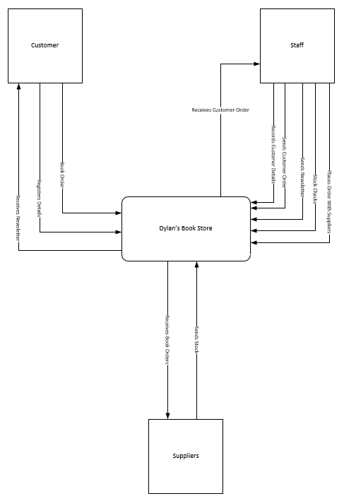

Level 0 DFD

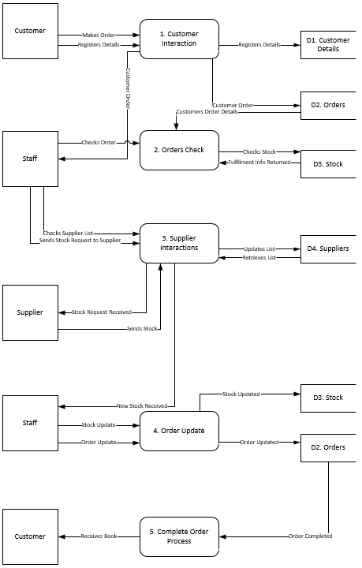

Entity Relationship Diagram

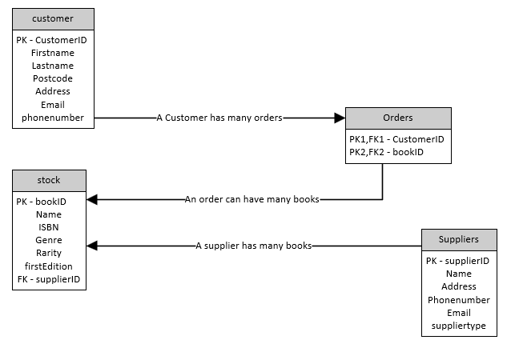

Microsoft Access – Information & User Guide
In this section I will demonstrate the tables, queries, forms, and reports. Within each subsection I was provide screenshots of what the user will see and information on how to use each page or the functionality included.
Where possible, I have included text-based buttons as an easier way for a first time user to understand what they are looking at and choose exactly what they want to do. On the forms, I did however use familiar buttons for forward and back as I believed these are globally recognisable.

Main Menu
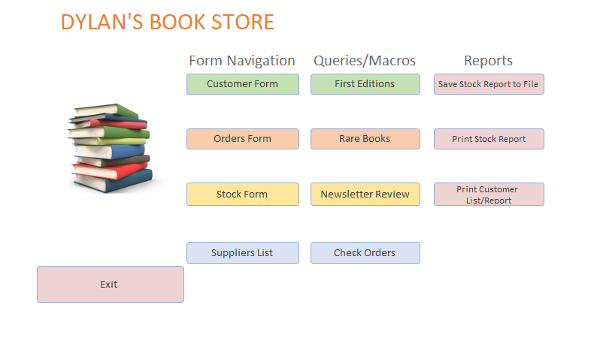
The Main Menu has a button led system, whereby navigation to either forms, queries or reports are done in one central location. There is also an “Exit” button of which is a Macro that will save all forms upon it being pressed. This is to ensure that no data is lost by the bookstore.
The Main Menu is also set as the default form displayed immediately after the database has been opened.

Relationships
Here you can see how the tables are linked together. The are done through the use of primary and foreign keys in a one-to-many relationship.
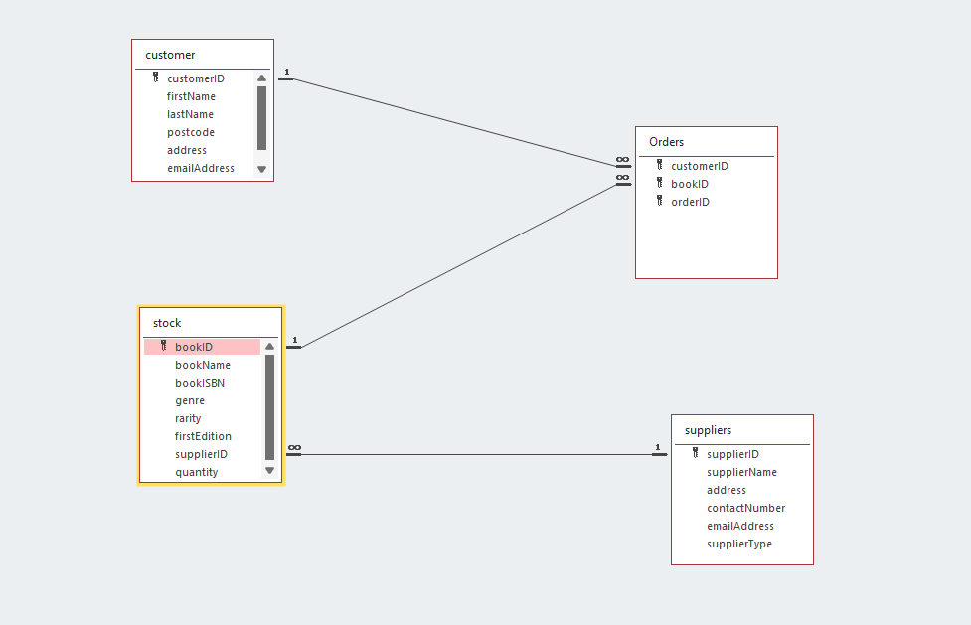

Customer Table

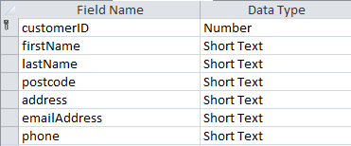

Here you can see the relevant field names and data types. Things to note:
- customerID is set as the primary key
- Postcode is using an input mask of “>LL00\ 0LL;0;_”
- phone is using an input mask of “0000\ 0000000;;_;;_”

Customer Form
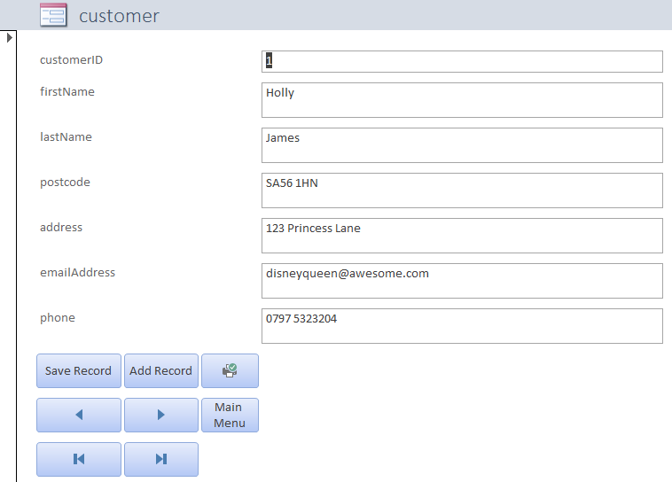

The customer form has the following functionality:
- Save record
- Add a record
- Navigation:
  - First record
  - Last record
  - Previous record
  - Next record
  - Go to Main Menu
- Print Current Form

Orders Table

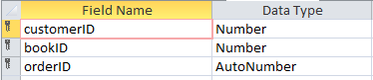

Here you can see the relevant field names and data types. Things to note:
- All three fields are set to be the primary key
- customerID is the foreign key linked with the customer table
- bookID is the foreign key linked with the stock table
- orderID is not a foreign key and auto increments upon design

Order Form
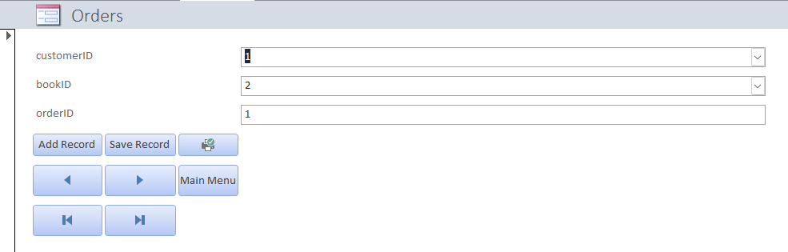

The order form has the following functionality:
- Save record
- Add a record
- Navigation:
  - First record
  - Last record
  - Previous record
  - Next record
  - Go to Main Menu
- Print Current Form

Stock Table

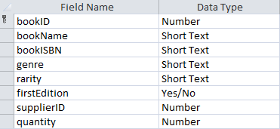

Here you can see the relevant field names and data types. Things to note:
- firstEdition is Boolean Yes/No data type as it will be used with queries
- supplierID is the foreign key linked with the suppliers table

Stock Form
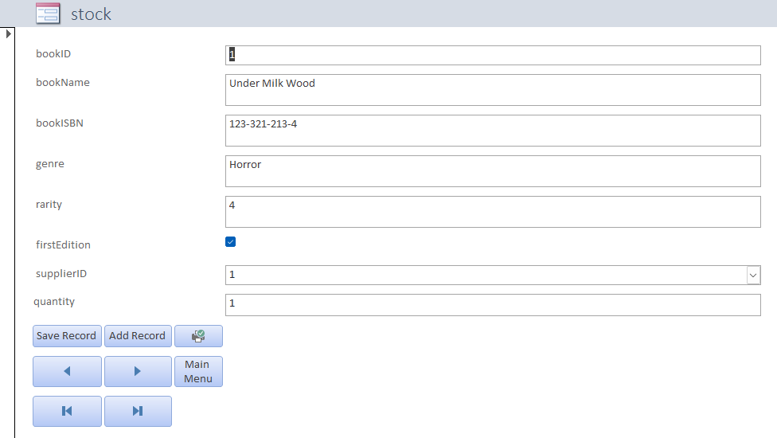

The stock form has the following functionality:
- Save record
- Add a record
- Navigation:
  - First record
  - Last record
  - Previous record
  - Next record
  - Go to Main Menu
- Print Current Form

Supplier Table
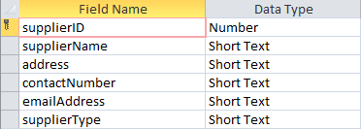

Here you can see the relevant field names and data types. Things to note:
- contactNumber is using the same input mask as in customer table “0000\ 0000000;;_;;_”

Supplier Form
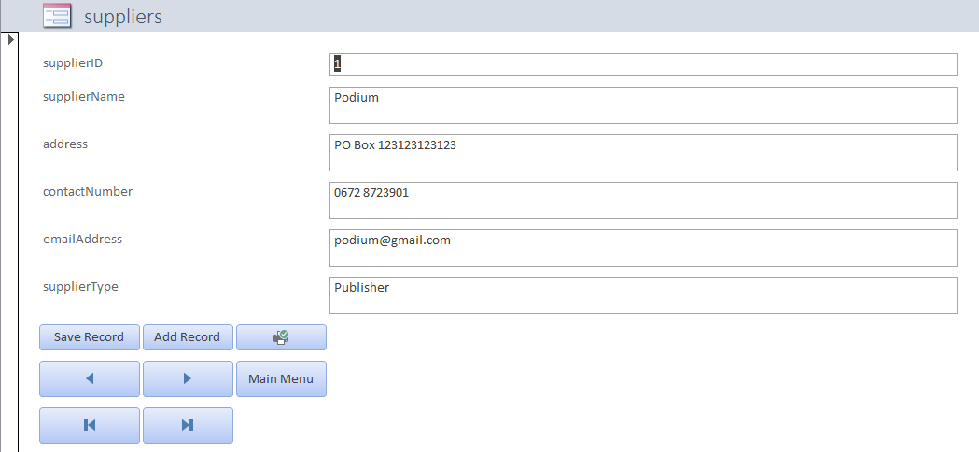

The supplier form has the following functionality:
- Save record
- Add a record
- Navigation:
  - First record
  - Last record
  - Previous record
  - Next record
  - Go to Main Menu
- Print Current Form

Queries

First Editions
The first edition query is designed to supply a list of any books that is simply a first edition. As was seen in the stock table, you can select the Boolean Yes/No option as to if this is a first edition or not. The criteria assigned to the query is simply checking the value is true or essentially “Yes”

Here is the output of the query:

Here is the query in the design view:
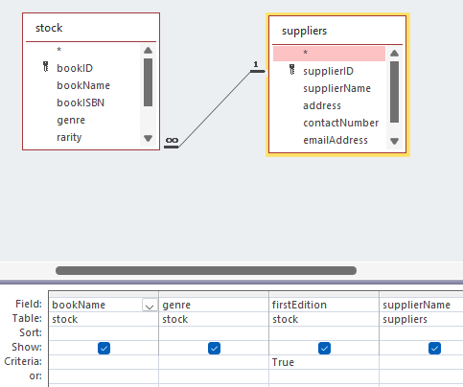

Rare Items
With in the stock table, there was also a rarity field. The purpose of this field is for the user to set a rarity rating when inputting the books, of which this is purely to identify any potential books of interest that can be used in the store’s newsletter

Here is the output of the query:
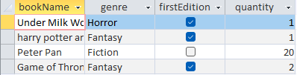

Here is the design view of the query:
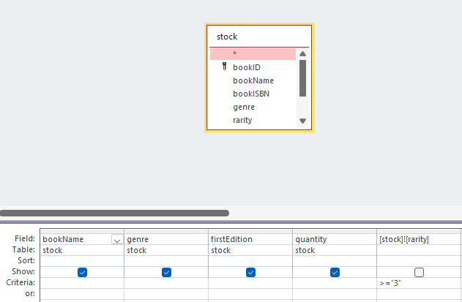

Check All Orders
The purpose of this query is to display a list of all the orders at the store. It is accessible like the other queries via the Main Menu.

Here is the output of the query:
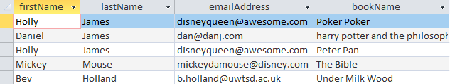

Here is the design view behind the query:
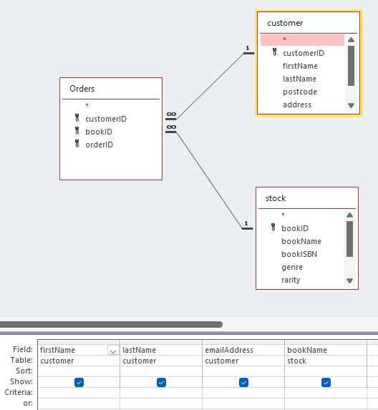

Newsletter Review
Accessible via the Main Menu, this query will utilise the previously created query that will locate all stock with a rarity value greater than or equal to 3. The newsletter is constructed historically from “current interesting stock” and in a way to ensure no stock is forgotten, I have included this rating system within the table. The number rating something much like their method of intuition and guessing around new stock purchases and I feel would be a good fit within the business.

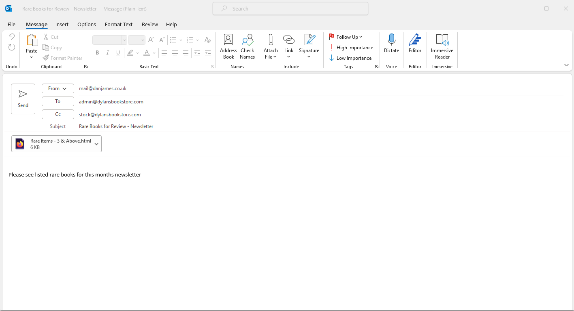

After clicking the button on the Main Menu, the user will have the email box open up sending the list/results of the rare items greater than or equal to 3 to a designated admin email address. It will also be cc’d into the stock email address. The idea here is that the items can be reviewed by both management and stock control before the newsletter is constructed and sent.

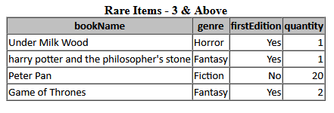
The above picture here is a screenshot of the attached document to the email.

Reports

Save Stock Report to File
Accessed via the Main Menu should the user wish to save a list of the stock inventory for any purpose, it can be done so via the button of the same name.

Here is a screenshot of the report saved as a pdf:
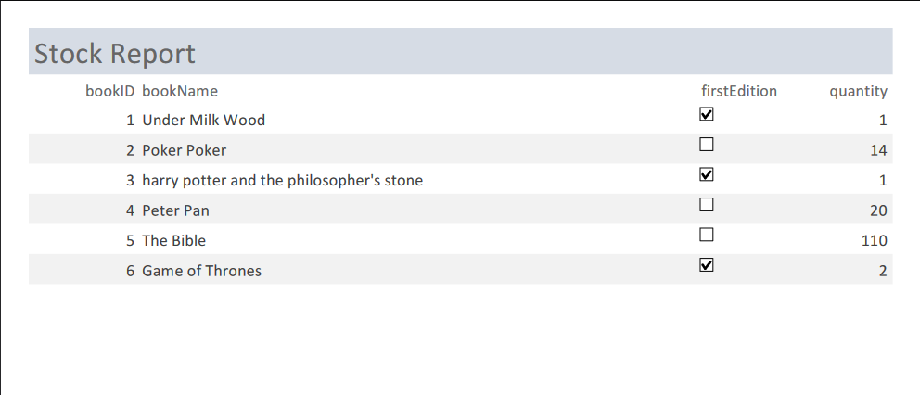

Print Stock Report
This report is generating the same as the above however, rather than save the report to file, it will allow the user to print it directly.

Here is the screenshot of the Microsoft Print to pdf:

Print Customer List/Report
This report will allow the user to print of all the details their customers. The information is held within the customer table but will not display the customerID. The information has also been reordered for better visual reading.

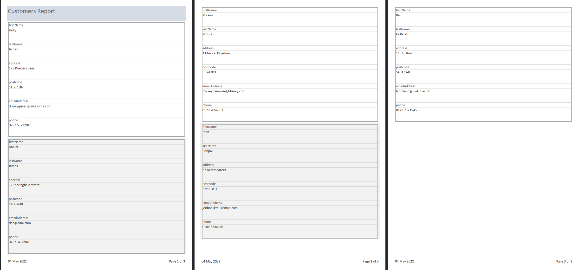

Conclusion

Overall, I was happy I was able to implement the database and functionality I included. I found Microsoft Access to be quite challenging at times and had to start over with my database twice due to unforeseen errors.
I believe the tables created were suitable for the given scenario and I selected suitable fields within those tables. I included input masks and lookups of which were fiddlier than initially thought to be, but ultimately, I believe I was able to achieve third normal form as there was no duplication.
I managed to create a relationship between the tables through use of foreign keys and I enforced the referential integrity without any errors in my final database of which I was particularly pleased with.
When I look back at the brief and what was created, I think I have given a good effort in meeting the requirements set out.
If I was to come back to this project in the future, I feel I would spend more time on the analysis/research. With more practice in these scenarios, I feel I could come up with a better design and make the implementation a lot easier than it ended up being.

