Community Mental Health Services

Aribah Shaffiq

2504748

LCHS4003

Daniel Hanura

Introduction to public health and social care
Task 1 poster

COMMUNITY MENTAL HEALTH SERVICES


Supporting People to Live Healthy, Independent Lives

What are Community Mental Health Services?

Community Mental Health Services (CMHS) are social care services that provide support, treatment and advice to people experiencing mental health conditions while allowing them to remain in their own homes and communities. These services are designed to help individuals recover, improve their wellbeing and maintain their independence instead of staying in hospital for long periods.
Mental health conditions can include depression, anxiety, bipolar disorder, schizophrenia, obsessive compulsive disorder (OCD), post-traumatic stress disorder (PTSD), eating disorders and many other illnesses. Community Mental Health Services support people of different ages, including children, adults and older people, depending on their individual needs.
The service works using a person-centred approach, meaning that care is tailored to each individual’s needs, wishes and goals. Professionals work closely with service users, families and carers to develop personalised care plans that encourage recovery and improve quality of life.
The overall aim is to promote independence, prevent mental health crises, reduce unnecessary hospital admissions and help people live safely within their local communities.

Brief History of Community Mental Health Services
Before the 1950s, many people with severe mental health conditions lived in large psychiatric hospitals, often called asylums. Patients could spend many years in these institutions and were separated from their families and communities. Treatment during this time was often limited and focused more on long-term care than recovery.
During the 1950s and 1960s, attitudes towards mental health began to change. New medications, improved understanding of mental illness and changing public attitudes encouraged healthcare professionals to look for better ways to support people.
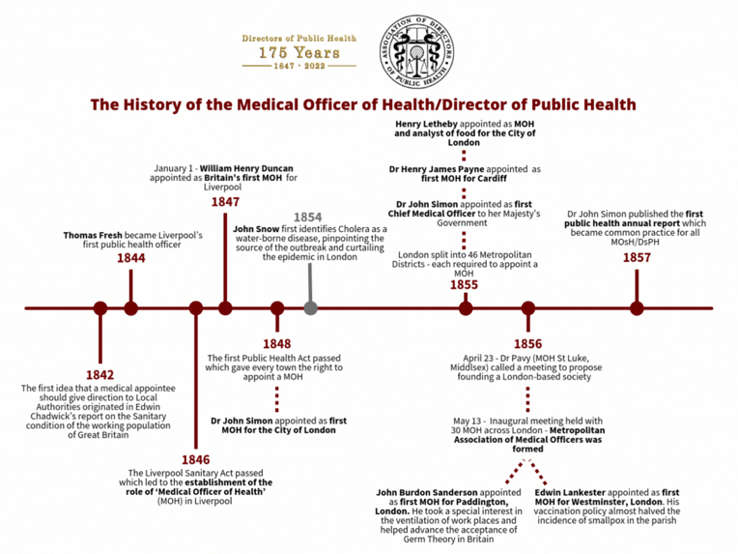
In the 1980s, the UK Government introduced the Care in the Community policy. This policy aimed to close many long-stay psychiatric hospitals and replace them with services based within local communities. Instead of remaining in hospital, people could receive treatment while continuing to live at home. Today, Community Mental Health Services continue to develop by focusing on recovery, early intervention, social inclusion and personalised care. Modern services encourage individuals to remain active members of society while receiving the support they need.

How Community Mental Health Services Function Today
Community Mental Health Services are made up of multidisciplinary teams that work together to meet the needs of each service user. These teams may include:
- Psychiatrists
- Mental Health Nurses
- Social Workers
- Clinical Psychologists
- Occupational Therapists
- Support Workers
- Counsellors
People are usually referred through their GP, hospital or another healthcare professional, although some services also accept self-referrals.
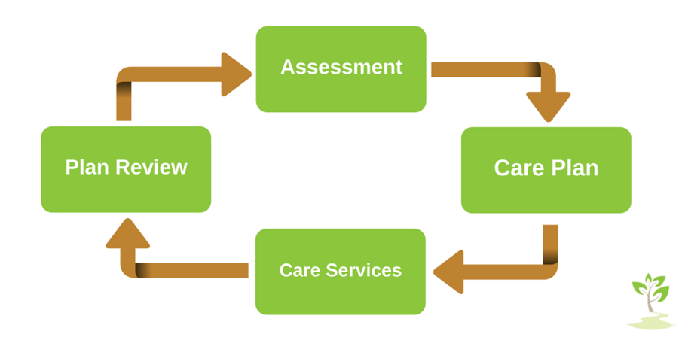
Following an assessment, a personalised care plan is created based on the person’s needs and recovery goals.

Services provided may include:
✔ Mental health assessments
✔ Counselling and psychological therapies
✔ Medication reviews and monitoring
✔ Crisis intervention
✔ Home visits
✔ Support groups
✔ Family and carer support
✔ Help with education, employment and independent living
Professionals regularly review care plans to ensure they continue meeting the person’s changing needs. Community Mental Health Services also work alongside GPs, hospitals, housing providers, schools, charities and voluntary organisations to provide joined-up care.

Benefits of Community Mental Health Services
Community Mental Health Services have many benefits for both individuals and society.
They help people remain independent while receiving professional support within familiar surroundings. Receiving care at home or within the local community often reduces stress and improves confidence.
The services promote recovery by helping individuals manage symptoms, develop coping strategies and achieve personal goals. They also reduce unnecessary hospital admissions, allowing hospitals to focus on people requiring urgent specialist treatment.
Families and carers also receive advice, emotional support and education, helping them understand mental health conditions and support their loved ones effectively.
Overall, Community Mental Health Services encourage dignity, inclusion, equality and improved quality of life.

Challenges Faced by Community Mental Health Services

Challenge One – Increasing Demand
Mental health problems are becoming more common across the UK. More people are seeking help than ever before, meaning services are under increasing pressure.
This high demand often leads to long waiting lists for assessments, counselling and specialist treatment. Delays can result in people’s mental health worsening before they receive the support they need.

Challenge Two – Staff Shortages and Funding
Many Community Mental Health Services struggle with staff shortages due to difficulties recruiting and retaining qualified healthcare professionals.
Limited funding affects staffing levels, training opportunities and the availability of specialist support. Existing staff often carry heavy workloads, increasing pressure and making it more difficult to provide timely care.
Despite these challenges, professionals continue working hard to provide safe, high-quality and person-centred care.

Legislation Supporting Community Mental Health Services
Several laws guide how Community Mental Health Services operate and protect service users’ rights.

Mental Health Act 1983 (amended 2007)
Allows people with severe mental illness to receive treatment when necessary while protecting their legal rights.

Mental Capacity Act 2005
Protects individuals who may be unable to make certain decisions independently and ensures decisions are made in their best interests.

Care Act 2014
Places a duty on local authorities to promote wellbeing, assess care needs and provide appropriate support.

Equality Act 2010
Protects individuals from discrimination and ensures equal access to health and social care services.

Health and Social Care Act 2012
Promotes integrated care and improves the quality and accountability of health and social care services.

Why Community Mental Health Services Matter
Community Mental Health Services play an essential role in improving the lives of thousands of people across the UK. They provide early support, encourage recovery, reduce stigma surrounding mental illness and help people remain independent within their communities.
By working together with healthcare professionals, families and local organisations, these services improve physical, emotional and social wellbeing. Although they face challenges such as increasing demand and staff shortages, they continue to make a significant difference by promoting dignity, respect, independence and inclusion for everyone who uses the service

Harvard References

Care Quality Commission (2024) Mental health services. Available at: https://www.cqc.org.uk
Department of Health and Social Care (2024) Mental health and wellbeing. Available at: https://www.gov.uk
Mental Health Foundation (2024) Mental health information. Available at: https://www.mentalhealth.org.uk

NHS England (2024) Community mental health services. Available at: https://www.england.nhs.uk

Task 2

Community Antenatal Midwifery Services: Origins, Development and Contemporary Significance
Another important aspect of community antenatal midwifery services is their contribution to reducing health inequalities through early intervention and personalised care. Midwives are often the first healthcare professionals to build a trusting relationship with pregnant women, allowing them to identify safeguarding concerns, domestic abuse, mental health difficulties and wider social issues that may affect pregnancy outcomes. By working collaboratively with health visitors, GPs, obstetricians and social care professionals, community antenatal services ensure women receive holistic support that addresses both medical and social needs. This multidisciplinary approach reflects current public health priorities by focusing not only on preventing illness but also on promoting long-term wellbeing for mothers, babies and families. Although pressures on staffing and resources continue to affect service delivery, the emphasis on prevention, education and continuity of care demonstrates that community antenatal midwifery remains an essential component of modern healthcare. Continued investment in workforce development and equitable access to services will be necessary to ensure all women receive high-quality, safe and person-centred care regardless of their background or location.

Community antenatal midwifery services play a central role in supporting women throughout pregnancy, promoting maternal and fetal wellbeing while enabling care to be delivered within community settings. These services provide routine antenatal assessments, health education, screening, and emotional support, aiming to ensure safe pregnancy outcomes and positive birth experiences (NHS England, 2019). Over time, antenatal midwifery has evolved significantly in response to social, medical and policy developments.

Historically, childbirth was managed within the home and supported by traditional midwives. However, during the late nineteenth and early twentieth centuries, concerns regarding maternal and infant mortality prompted increased regulation of midwifery practice. The Midwives Act 1902 marked a key milestone in the UK, introducing formal training and professional registration (Donnison, 1988). Throughout the twentieth century, maternity care became increasingly medicalised, with a shift toward hospital-based obstetric care, particularly after the establishment of the National Health Service (NHS) in 1948.

From the 1990s onwards, policy reforms began to emphasise continuity of care, woman-centred approaches and community-based provision. Reports such as Changing Childbirth (Department of Health, 1993) highlighted the importance of informed choice and personalised maternity care. More recently, the Better Births review (NHS England, 2016) reinforced the need for continuity of carer models and strengthened community antenatal services. These reforms reflect a broader recognition that pregnancy is not solely a medical event but also a significant social and psychological experience.

Today, community antenatal midwifery services operate through structured programmes of care. Women typically access services via referral from a general practitioner or through self-referral to maternity units. Midwives conduct booking appointments, risk assessments, blood tests, blood pressure monitoring, fetal growth assessments and screening for conditions such as gestational diabetes (NICE, 2021). In addition to clinical monitoring, midwives provide education on nutrition, breastfeeding, smoking cessation and mental health.

A major strength of contemporary antenatal services is their focus on continuity and relationship-building. Continuity of carer models, where a woman is supported by the same midwife or small team throughout pregnancy, have been associated with improved maternal satisfaction and reduced intervention rates (Sandall et al., 2016). Community-based care can also improve accessibility and reduce unnecessary hospital attendance.

However, despite these strengths, significant challenges remain. Workforce shortages within maternity services have raised concerns regarding safety, continuity and workload pressures (The King’s Fund, 2022). High caseloads may limit the time midwives can spend providing holistic support, potentially undermining the person-centred ethos of antenatal care. Furthermore, inequalities persist in maternal outcomes. Women from deprived communities and minority ethnic backgrounds experience higher rates of maternal morbidity and mortality (MBRRACE-UK, 2023). This highlights structural and systemic issues that extend beyond service design alone.

Critically evaluating current functioning reveals a service that is policy-driven, evidence-based and prevention-focused, yet constrained by resource limitations. While guidelines from NICE (2021) promote standardised, high-quality antenatal care, implementation can vary across regions. The ambition of continuity of carer is not always achievable in practice due to staffing pressures. Therefore, although community antenatal midwifery services align strongly with principles of preventive and woman-centred care, sustainability remains a concern.

The significance of community antenatal midwifery services in enhancing quality of life is substantial. Effective antenatal care reduces complications, supports informed decision-making and promotes maternal confidence. Early identification of physical or mental health concerns can prevent long-term adverse outcomes for both mother and baby. Moreover, community-based provision enhances accessibility and supports families within their social context, strengthening public health outcomes.

In conclusion, community antenatal midwifery services have evolved from informal, home-based practice to regulated, professional and evidence-informed community care. Shaped by historical regulation, NHS development and modern policy reforms, these services now prioritise safety, continuity and holistic wellbeing. While challenges relating to workforce and inequality remain, antenatal midwifery continues to play a vital role in improving maternal and infant health and enhancing overall quality of life.

Reference List (UWTSD Harvard Style)

Department of Health (1993) Changing Childbirth. London: HMSO.

Donnison, J. (1988) Midwives and medical men: A history of inter-professional rivalries and women’s rights. London: Historical Publications.

MBRRACE-UK (2023) Saving lives, improving mothers’ care 2023. Oxford: National Perinatal Epidemiology Unit.

NHS England (2016) Better Births: Improving outcomes of maternity services in England. London: NHS England.

NHS England (2019) The NHS Long Term Plan. London: NHS England.

NICE (2021) Antenatal care (NG201). London: NICE.

Sandall, J., Soltani, H., Gates, S., Shennan, A. and Devane, D. (2016) ‘Midwife-led continuity models versus other models of care for childbearing women’, Cochrane Database of Systematic Reviews, 4, CD004667.

The King’s Fund (2022) The health care workforce in England. London: The King’s Fund.

