
Hotel Trinity Menu


Teacher Name: Steve Jones
Student Name: Munni Begum
Student Id: 2118236
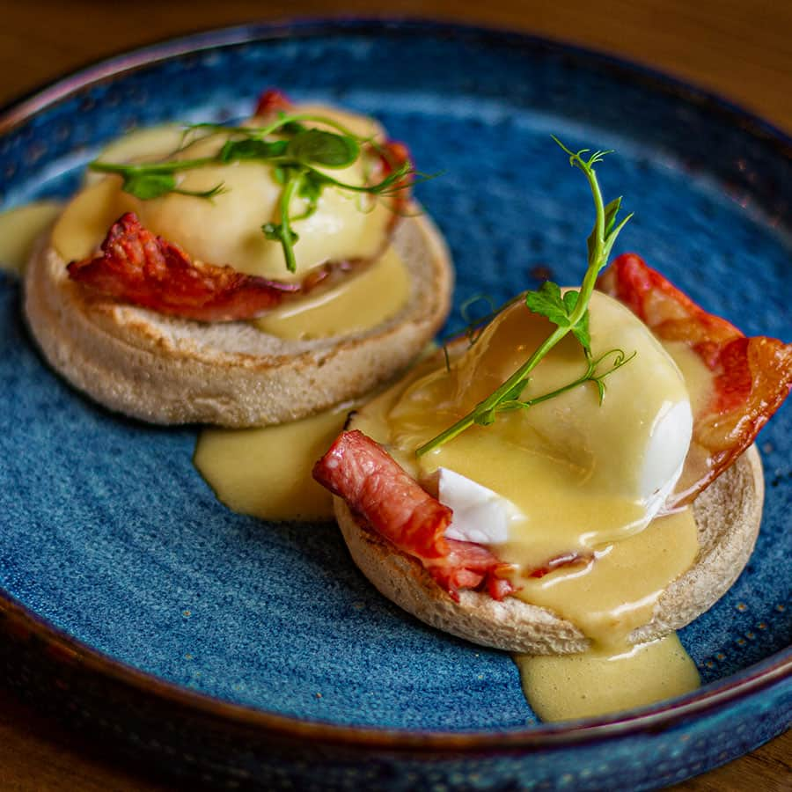
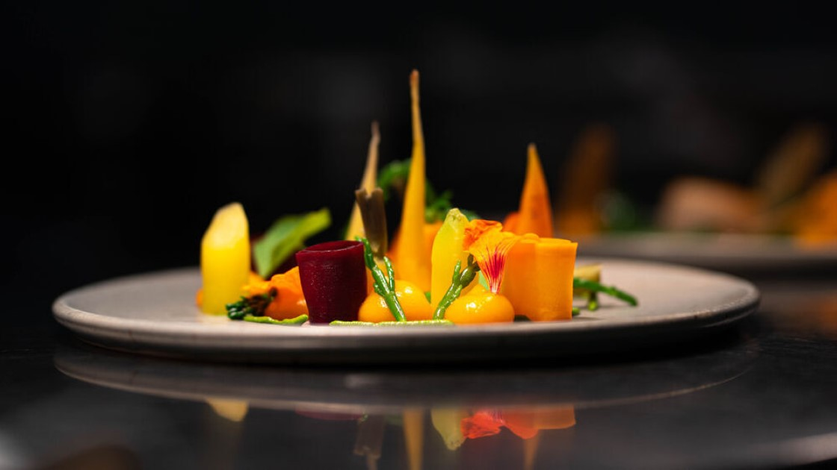
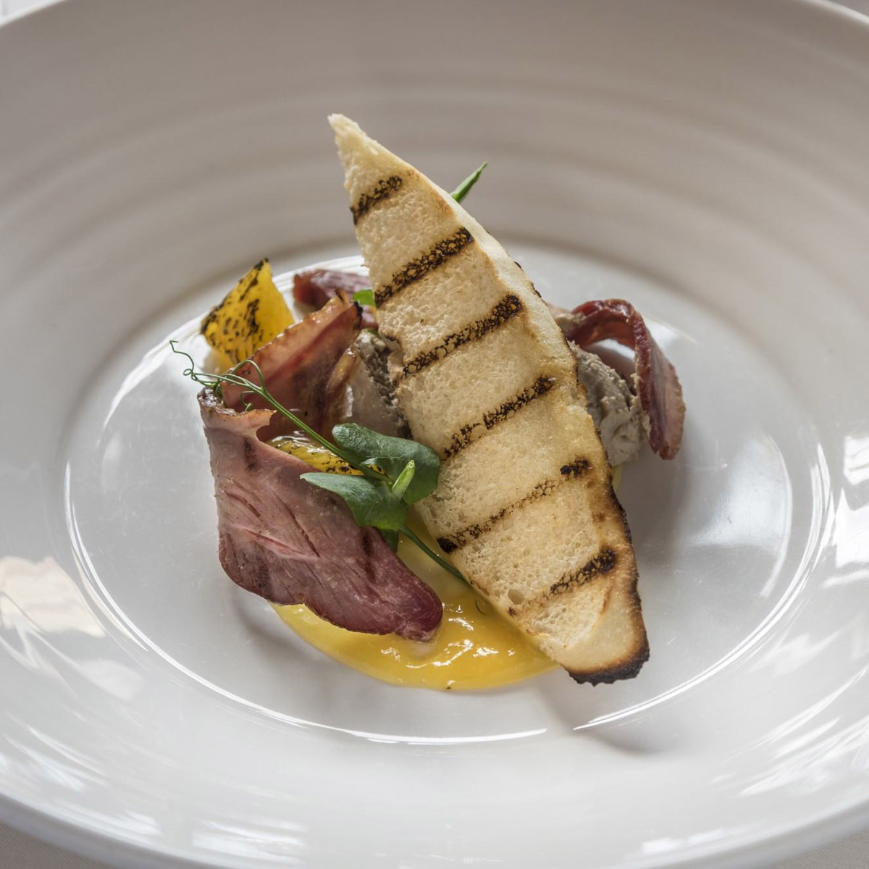
Breakfast
Trinity Special Breakfast £9.50
Soft boiled/poached eggs with 1 toast / 1 muffin / 1 croissant with maple syrup, chocolate cereal, butter or Nutella, yoghurt, and any kind of seasonal fruit with mango/strawberry, tea or coffee
Indian Breakfast £15.50
Idli or dosa with chutney of cilantro, coconut, lassi and papadh
Regular British Breakfast £7.50
Bread with peanut butter, two eggs of any style, strawberries, yoghurt, mango juice, cheese, tea or coffee
Asian Breakfast £16.00
Basmati Rice, Vegetables mashed with salt and chillies, Dal, Chicken Curry, Soft Drinks
English Coffee Breakfast £6.00
Two eggs, toast bread, butter, cheese, muffins, pancake, croissant, fruits, fresh juice, tea or coffee
Fruits Breakfast £7.50
Mixed fruits salad, avocado toast, Strawberry yoghurt, berry salad, mango juice, strawberry juice, banana Oreo shake, milkshake, mini cake & muffin, tea or coffee
Main Dishes (Lunch or Dinner)
Tintern Mead Sauce £25.50
Meadowsweet Cured Apple, Smoked Mackerel, Meadowsweet Pickle, Crisp Leaves
Full Grilled Salmon or Swordfish £17.25
A full grilled Salmon or Swordfish with the classic four pieces of garlic and butter nun with regular salad
Cornish Cod £16.50
Purple Sprouting, Bay Mussels, local cod fish, and Pearl Barley with Sea Spinach
Seafood Rice Bowl (Fusion) £27.50
Rice with a mixture of local salmon, crabs, prawns, squid, coleslaw, and soft drinks with blue cheese
Chicken Strips with Mushroom Sauce £18.50
Grilled or fried or regular or special with bottom mushroom sauce with butter, garlic, milk, and pepper
Gulf Oysters Delight £20.50
Hand-breaded and golden-brown local oysters with rosemary and jalapeno sauce
Grilled Tuna Fish with Asparagus Sautee £17
Fried with Cajun and garlic with locally seasoned mayonnaise and tomato sauce, and asparagus sautéed with butter, salt, and pepper
Huntsham Ryeland Hogget £25.50
Buttered Jalapeno with Salsify, Oyster Mushrooms sauce, Our freshly chopped Garden Kales
Wye Valley Rhubarb £25.50
Toasted Birch Wood Ice Cream, crushed and roasted Hazelnut with Medlar
Welcome to Hotel Trinity
Address: 247, Swansea, South Wales.
Contact Info:
Tel: +44 (0) 334 575 8888
Website: http//www trinity_wales.com
Mail: info@hoteltrinity.co.uk
Payment: Cash, Mastercard, paypal
Time: Morning (6 to 10 AM), Lunch (12 to 2 PM), Dinner (5 to 8 PM)

- A rich menu with a lot of variations and delicacies, Hotel Trinity provides you with the best experience based on the 4 Star service standard in South Wales.
- We are offering a whole menu combining the local and international cuisines with the fusion of some cuisines done by our professional culinary experts.
- Customer satisfaction is our number one priority with the high-quality food served with authentic flavor in our luxurious interior with your family.
- We are now offering discounts on all kinds of wines for 10%. The rest of the food is discounted by 20%. Due to the ongoing redecoration process of our hotel, these privileges are offered for our valuable customers which will be validated for this month only.
- We provide 2 pairings of red wine for our selected special dishes.
- We have started customizing our cuisines for our younger customers from the age range of 2 to 15 years in which the chef avoids using any form of alcohol specially prepared for them.
- The use of sugar, spices, and salts can be customized for the children’s orders with the condition applied.
- We are open for 24 hours with 24/7 home delivery services even through the websites and other social media platforms available including our Facebook Page, WhatsApp, and Instagram. Also, now the customers can order our food from UberEATS.
- We are obliged to deliver the food within 20 minutes while accepting master cards, PayPal, and cash for payments.
- We provide money-back service to the customers if facing any discomfort or degrading quality foods after placing the order.
- For any issues, please contact our waiters and managers for support. Any complaints about home delivery service should be placed through the hotel websites.
- We are charging £3 for the delivery charge. If the distance gets increased, the delivery charge will get increased at the same time.
- A takeaway service option is also available in our hotel.
Hotel Trinity MENU

Wines
White Wines (Pinot Blanc, Chardonnay)
1 Bottle £38.90
1 Glass £1.00
Red Wines (Merlot, Ventoux)
1 Bottle £42.50
1 Glass £1.20

Soft Drinks
Sprite £1.00
Seven Up £1.00
Sparkly water £2.00
Milk Shake £4.00
Chocolate Shake £5.00
Fresh Juice £7.00

Specials with Wines and Fusions
Truffle Baked Parsnip with White Wine £65.50
Salted Plum, with Brassica, Hen of The Woods and slated and peppery Mushroom, Wiltshire Black Truffle, and one glass of Pinot Blanc red wine and one glass of Chardonnay
Day Boat Turbot with Red Wine £60.50
Smoked Roe, Jersey Royals, Estuary Vegetables with and one glass of Merlot red wine and one glass of Ventoux
Asian Fusion 1 (Chinese) £35.50
Hot and Sour Soup, 2 Piece chicken fry, mixed fried rice, poached eggs, vegetables, soft drinks
Asian Fusion 2 (Indian) £45.50
Hydrabadi Biriyani, chicken tikka masala, papadh and raita with soft drinks
Asian Fusion 3 (Korean) £35.50
Toktokkie, beef bulgogi with kimchi, regular coleslaw, soft drinks
Hotel Trinity MENU

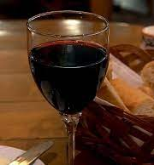
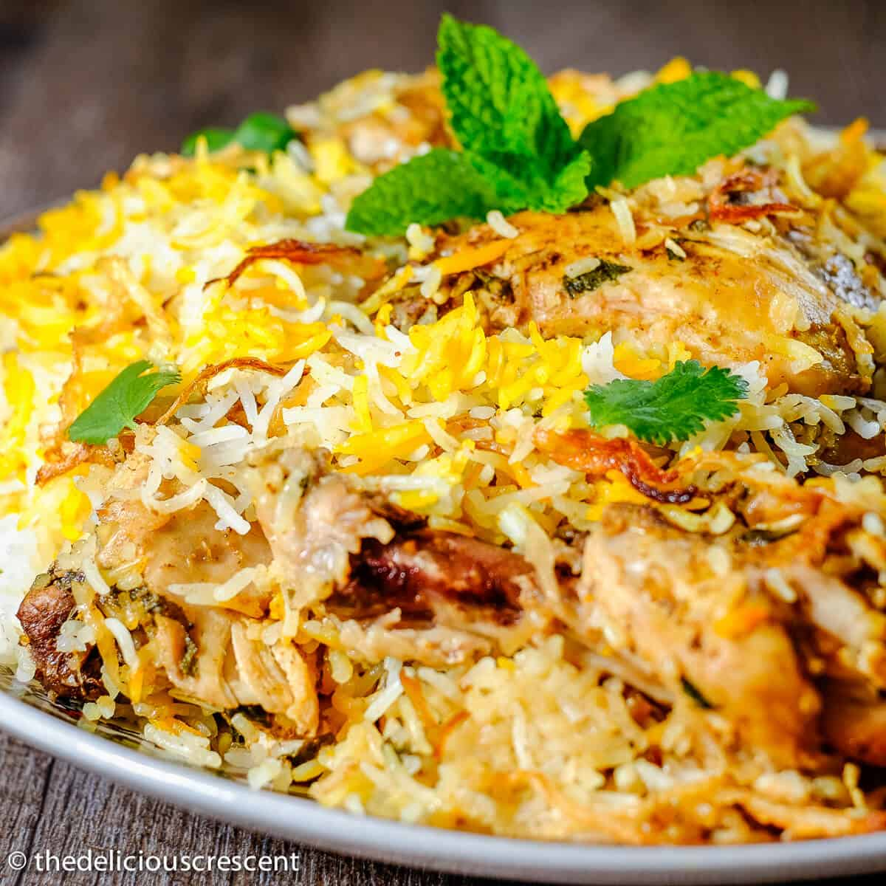

Appetizer
Wye Valley Asparagus £7.50
Hogweed, Tintern Meat, and maritime pine with the local spices
Cashew nuts Salad £7.20
The mixture of Cashew nuts, spring onions, and mayonnaise
Shellfish Salad £6.21
Crabs and prawns with extremely creamy mayonnaise and some garlic
Mushroom Fiesta £4.5
Deep-fried mushroom with cheddar cheese, tomato sauce, onions, garlic butter
Fruit Salad £5.21
Any two fruits salad (Mango or Strawberry), yogurt, butter, honey, juice, or soft drinks

Side Dishes
Mashed or Fried Potatoes £5.00
Onion Rings with Beer £4.00
Potato Wages or French Fries £2.00
Calamari Sautee or fry £5.00
Apple Crumble £5.20
Deeping Sauce 1 (garlic) £5.20
Deeping Sauce 2 (Cilantro) £6.20
Deeping Sauce 3 (Mayonnaise) £6.20
Spinach Sautee £3.20
Asparagus Sautee£4.20
Coleslaw £3.20

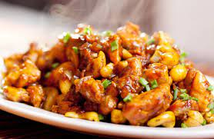

Note: Some dishes of our hotel contain nuts, dairy, eggs and some allergens. In case of lactose intolerance of medical issues, please inform us while ordering and make suggestions of your choices in alternate. We will change those dishes according to your suggestion and instruction. Customer satisfaction with high quality service and food is always our main concern.
References
De Souza, C., 2014. Charge for delivery. [Cape Town]: Books of Africa.
Jones, E., 2015. The man of manners and COD service. London: Printed for J. Roberts, near the Oxford-Arms in Warwicklane.
Kim, Y., Sauerwald, P., & Sukpatch, K. (2021). Are you looking for special menu? An examination of variety seeking behavior for Promotional Menu (VaPM) Model. International Journal Of Gastronomy And Food Science, 23, 100295. https://doi.org/10.1016/j.ijgfs.2020.100295.
Tili, D. (2019). Tingkat Popularitas dan Profitabilias Menu A’la carte Melalui Metode Menu Engineering Di Restaurant Rajo Makan Hotel Daima Kota Padang. JURNAL PENDIDIKAN DAN KELUARGA, 11(1), 23. https://doi.org/10.24036/jpk/vol11-iss1/577

