University of Wales Trinity Saint David
LONDON CAMPUS
Individual Report
Module Name: Digital Skills and Research Methods
Module Code: LCHS 4007
Student name: Kendralyn Pegenia
Student ID: 2511437
Lecturer’s Name: Patronella Ganza

Table of Contents
Research Topic: Staff Shortage 1
Introduction 1
Problem Statement 1
Justification 2
Information Sources and Justification 4
Task 2: Research Methodologies 5
Give a brief overview of quantitative and qualitative research. 5
What type of research methodology will you use for your research and why? 5
Task 3: Data Collection 5
Overview of primary and secondary data collection 5
What form of data will be used to address your research problem, and why? 6
Conclusion 6
References 6

Research Topic: Staff Shortage

Introduction
In healthcare, doctors, nurses, and all other staff serve different purposes to help people in need and provide assistance. This report will outline and discuss one current issue facing the healthcare sector. The objective is to classify the problems, causes, and solutions that could be used to address the shortage of staff in health care. This will also include the investigation and research methods used to gather information and will show who, how, and what is affected by this problem. In addition, this information will provide details on why this issue keeps occurring and how it makes other challenges more difficult.

Problem Statement
One of the current problems the health and social care sector faces is staff shortages. According to BMA (2025), the UK has not trained enough qualified doctors and nurses, leading to workforces working many hours and taking extra shifts. One of the reasons also is some doctors, nurses and other healthcare professionals leave to retire, or for other inevitable reasons, reward compensations, for instance, health problems, work time management. In addition, lack of funding to hire new medical professionals is also a main cause of this issue in healthcare. By this means of this challenges, it affects the patients from delayed appointments, there are some instances that appointments could be rescheduled, there is a long waiting lines especially in emergency area, care workers have to do extra shifts just to cover up the shortage of staff and it affects the organisation as hospitals or GP’s in accommodate patients. (BMA, 2025)

England has a growing and ageing population that NHS and social care sector is requiring more staff to help and give excellent health and social care at the amount of required capacity. In accordance with The King’s Fund (2024), that shortage of staff can be seen by checking through the vacancy rates. It tells the difference between the number of posts in vacancies and that are already filled in. The overall NHS vacancy rate in September 2023 was 8.4% or 121,000 full-time equivalent (FTE) roles. The past overall social care vacancy was 9.9% or 152,000 roles in the year 2022/23. From the years 2022/23, both are significantly higher than the overall UK vacancy rate with 3.4%. (The King’s Fund, 2024)

The information stated by Shemtob et al. (2023), workforce in health and social care is affecting and limiting the delivery of services. More importantly, in GP there are struggles with the services that makes queuing line gets longer, despite the appointment made. The amount of patients that come to GP are rising and shortage of staff is one of the problem that it could not accommodate or fill in the gaps between the staff in every patients that could be seen and checked. (Shemtob et al., 2023)

Justification
According to BMA (2025), the graph data below shows that per capita, England has fewer doctors than other countries. By comparison on other EU countries, UK needs an additional 40,000 doctors to attain the OECD EU average. On the other hand, the distribution of doctors in important regional variation with some areas are falling number even further below with the OECD EU average.
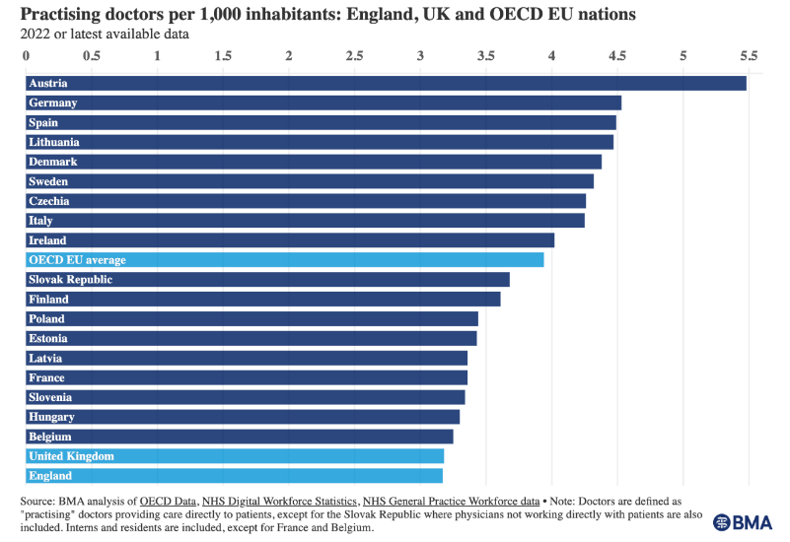

The graph below shows that the gaps between present numbers of doctors and quantity that is demanded to reach the total standing aligned with other comparable nations in England. The lack of doctors in medical causing problems and overtime working for the current doctors in NHS.
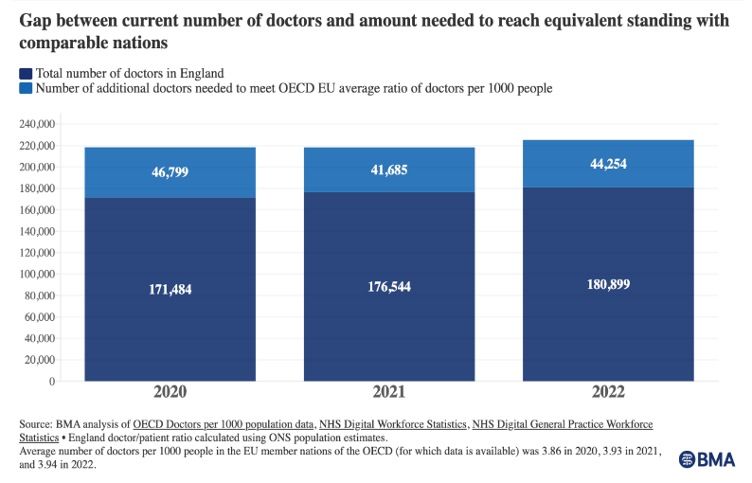

The information indicates important regional variation in the administering of doctors on some other areas are descending further under the OECD EU average. For example, in East of England, it has only 2.5 doctors per 1000 people.

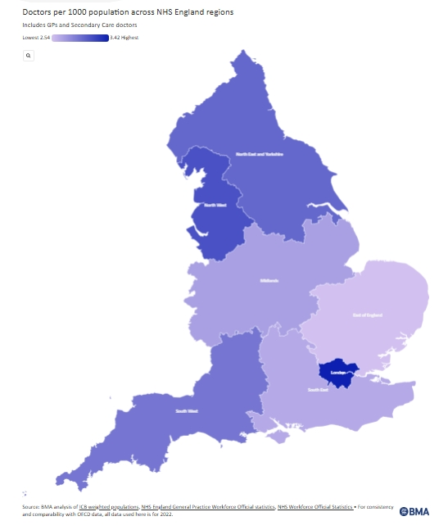
(BMA, 2025)

On the chart below shows the vacancies vary by role in both NHS and social care. The graph shows the data about staff shortage by role affects the NHS and social care when it comes on offering and providing enough and high-quality services. Having this vacancy by role, the statistics are only by routine availability for doctors and nurses. In social care, direct care workers and professionals have higher vacancy rates compared to managers or supervisors.
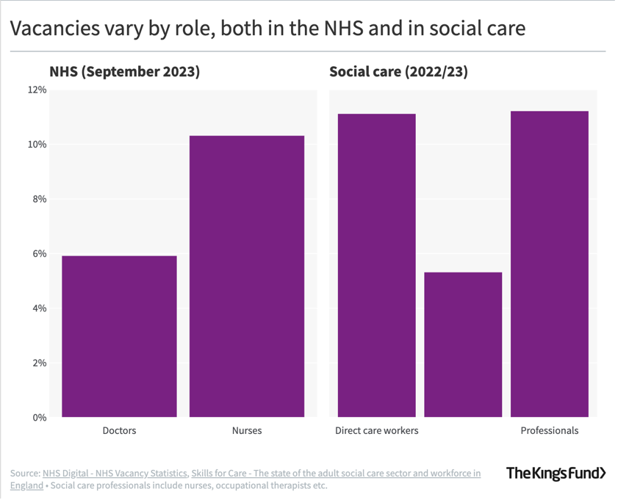
(The King’s Fund, 2024)

The information that Shemtob et al. (2023), there are increased of 9% total registered patients in GP since 2015. The total number of full-time GP’s per 1000 patients has been dropping since 2015 while in health and care number of posts have escalated by almost 450 000 in the past decade the population’s needs. On the NHS workforce data from June 2021 to June 2022 appears that there are 200 000 joiners compared to 170 000 leavers. The lack of staff makes it difficult to fill in the gaps in work. It results on some staff to work force than normal. (Shemtob et al., 2023)

Information Sources and Justification
The shortage of staff is one of the crises that the NHS in the UK is facing right now, even has been for years. This problem is causing significant issues in health and social care services, affecting many people who need medical help. As stated by the BMA (2025), the UK’s one problem is that there are not enough trained doctors due to insufficient funding. The UK is falling behind in terms of the number of doctors compared to other comparable countries. In accordance with The King’s Fund (2024), vacancies by region in England have higher rates for direct care workers and professionals, who are the ones that the health and social care system lacks. Data declared by Shemtob et al. (2023) that with this problem is resulting in workforce to be able to fill the gaps in work.
I have selected the sources for my research because they provide accurate information on my topic. It shows graphs and data that compare with different details of how much percent the medical sector is increasing or decreasing between the years provided. It is also up to date and a guarantee that the information and data are reliable. These sources are valid websites and authorised organisations.

Task 2: Research Methodologies

Give a brief overview of quantitative and qualitative research.
The quantitative research method is for analysing data from the past and current information by numbers and statistics with the test hypothesis of “how many/much”. It is gathering information or data by recording by graphs, rates, percentages and other numerical data forms. It has a generalised result that gives large information. Qualitative research method is a way that uses experiences, words and observations to investigate the “why” and “how” to understand more of the small details and in-depth samples by doing interviews, non-biased and only subjective but pure on insights.

What type of research methodology will you use for your research and why?
For my research, I will use mixed-methods as they will give much more details and information needed. The mixed-method gives the firm data that includes detailed data by words and numerical form. This will include by data of graphs, percentages and rates, it is much important to have both kind of data because it will serve a reliable and strong information and can be also a solid proof to justify a research.

Task 3: Data Collection

Overview of primary and secondary data collection
Primary data collection is a research method that is raw, fresh and original. It is getting information first-hand that only the researcher has. This kind of data collection is done by physically gathering information and data through interviews on a specific research topic. The challenges with primary data collection are that it costs a lot of money for the researcher because travelling is required to get the information needed. It also very time-consuming for the researcher, who may also face some difficulties during their research. Secondary data collection is a research method that does not require as much effort as primary data collection. This data collection can be accessed through reliable and valid sources online. As it is called secondary, it is secondary information that has been collected by the researcher; the information has already been summarised and giving the readers the most direct information.

What form of data will be used to address your research problem, and why?
Secondary data collection is more useful for addressing my research problem, for it is accessible and much quicker. There is a lot of information online, but I have to make sure that it is a reliable and valid source. Using primary is difficult for me to use for it will also take too much time to do my research. In these days, secondary data collection is more helpful and useful.

Conclusion
One of the big challenges of health and social sector in the UK is staff shortages. It affects the community because it causes delays, rescheduling appointments, and leads to long waiting time queues. It is an issue as well that leads other professional staff to work overtime and fill in the gaps. Having this issue also affects the quality of services that can be given to people. Through my research, I have found solid sources and information that have given a better understanding and the insights that I was looking for. It shows graphs and patterns across different timescales. This data has demonstrated clear and essential information for my research, as primary data collection is convenient for it only uses enough time for my research and the only struggle I only face is that there are many sources I can find online and getting the right, reliable, accurate and solid source. In mixed-method research are more helpful to get and give information for research. It will offer data and information in paragraphs and show graphs, charts, differences and how many or how much of the percentage and rates. In my opinion, with this method, it is more reliable than using either quantitative or qualitative research methods.

References
British Medical Association (2025) Medical Staffing in the NHS, https://www.bma.org.uk/advice-and-support/nhs-delivery-and-workforce/workforce/medical-staffing-in-the-nhs
Shemtob L., Asanati K., Pahl N., Majeed A. (2023) British Journal of General Practice
The Kings Fund (2024) Staff shortages, Staff Shortages | The King's Fund

