

Research Methods Assignment 1 – Research Proposal
Title: SO2 Abatement System - Research Proposal

Project Manager: David Whitmore
Email: David.Whitmore@vale.com
Number: 01792 841331
Address:
Vale Europe Limited,
Clydach Refinery,
Clydach,
Swansea,
SA6 5QR



- Executive Summary

As part of the ongoing improvement works at the Clydach Refinery, Vale are looking to reduce the sulphur dioxide (SO2) emissions from the main stack.
The Main Stack is the primary emission point for all gaseous effluent from the site. During recent routine third party emission monitoring of the area a high SO2 concentration was detected.
The Stabilisation Kilns, particularly line 2, have been highlighted as a major source of the SO2 that is contributing to the elevated stack emissions observed.
At present the flue gas exiting the kiln passes through one of a pair of ceramic filters then a once through water scrubber before being discharged via the main stack. The water scrubber will reduce the amount of SO2 reaching the stack, but not to any worthwhile extent. As a result Vale are looking to replace this water scrubber with a purpose built SO2 abatement system designed to reduce the amount of SO2 in the exit gas to an acceptable level.

Problem Statement

The overall objective of this research study is to propose an abatement system for Stabilisation Kiln 2 that will reduce the SO2 concentration in the exit gas stream from 10,000 ppm to below 270 ppm without disturbing the operation of the main stack.

The consent limit for SO2 is set by Natural Resources Wales (NRW) and is part of the refinery's environmental permit. Vale is required to report any exceedance of the permit concentration limit or mass emission limit to NRW. The impact of such exceedances includes a risk of a fine from NRW, and potentially being served a prohibition notice that could effectively stop production at the refinery. Additionally, there would be an increased subsistence charge from NRW of £15-£20k. It has been identified that a major source of SO2 are the Stabilisation kilns where SO2 is released into the air stream being used to oxidise the nickel product.

- Objectives

To investigate and subsequently propose the design of a SO2 abatement system capable of achieving the required 270 ppm consent limit whilst incorporating the following considerations:
- Capital Expenditure.
- Meet the NRW implementation deadline.
- Optimise running costs.
- Minimise the shutdown requirements to install the new proposed system.
- Consider the requirements to replicate the system on Kiln line 1.
- Minimise the impact on existing plant operation.
- Fully automated system.

4.0 Process Requirements
The stated process requirements for the project based on Vale Europe’s requirements are stated in the following table.
 | Requirement |  |  | Value
Air flowrate |  |  | 250 – 500 Nm³/hr
Inlet SO₂ concentration |  |  | 10000 ppm max
Inlet air temperature |  |  | 250 – 450°C
Outlet SO₂ concentration |  |  | <270 ppm
Outlet pressure |  |  | -50 mmWG

In the majority of Industrial SO₂ scrubbers the SO₂ is removed by reaction with sodium hydroxide (caustic) in a packed column. The proposed location for the scrubber however imposes height restrictions on the scrubber so an alternative style of scrubber may be required.

Another alternative is the use of magnesium hydroxide as the scrubbing medium. Magnesium hydroxide has historically been used in the power generation industry to remove SO₂ from the flue gas stream. This results in the formation of magnesium sulphate which is commonly used as a fertilizer.

- Literature Review.

The process of removing SO2 from a flue gas has been well documented, with a diverse selection of methods and technologies being proposed based on the numerous proven chemical reactions. Scrubbing technologies are used in a variety of industries with Shareefdeen et al (2015) providing details of the specific usages of various desulphurisation technologies for waste incinerator plants.

The main factors determining the selection of a SO2 removal technology are its efficiency, capital/operating costs and the extent of the disposal or handling of waste, be it water or a sorbent.

The most common method of SO2 removal used in industry is a scrubber. Scrubber systems are a diverse group of contrivances that are used to remove particles and/or gases from industrial exhaust streams. Scrubbers are essentially pollution control devices that use a liquid (wet scrubbers), dry reagent or semi-dry slurry (dry scrubbers) to "scrub" pollutants from a gas stream.

There are two principle methods of dry absorption systems that are currently being used in industry, dry otherwise known as dry sorbent injectors (DSIs) or semi-dry also known as spray dryer absorbers (SDAs). Unlike a wet scrubber this method does not saturate the flue gas with moisture. In a dry system absolutely no moisture is added while in a semi-dry design only the amount of moisture that can be evaporated in the flue gas without condensing is added.

In a dry system the addition of an alkaline material such as hydrated lime or soda ash is injected into the gas stream to react with the acid gases. The alkaline material can be injected into several different locations, the combustion process, the flue gas duct ahead of the particulate control system, or if included in the design an open reaction chamber. The acid gases react with the alkaline sorbents to form solid salts which are then removed in the particulate control system/device. These simple systems can achieve only limited acid gas removal efficiencies.

In a semi-wet absorber, the flue gases are passed through an absorbing tower/dryer, where the gases come into contact with a finely atomized alkaline slurry. The acid gases are absorbed by the slurry mixture and react to form solid salts which are again removed by the particulate control system/device. The heat of the flue gas is used to evaporate all the water droplets, leaving a dry flue gas to exit the absorber tower. Semi-dry systems are capable of achieving a high acid gas removal efficiency in excess of 80%.

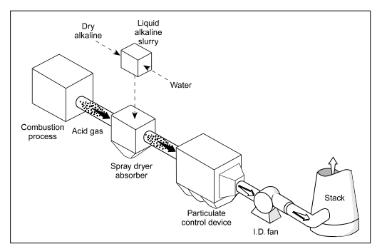

Fig 1. Semi-wet absorber system.

Wet scrubbers are designed to remove the pollutants from the gas by dissolving them in water or a scrubbing liquor they will also remove particles by capturing them in the liquid droplets. The most effective design for the removal of both pollutant gases and particles is a Venturi scrubber as discussed by Wang et al (2004). Venturi scrubbers work on the principle of absorption and the Venturi effect. The pollutant gas and scrubbing liquor is made to pass through a constricted throat where they both come into close contact at a high velocity, forming large number of droplets, thereby creating a large area for the particles to get absorbed into the liquid droplets. The Venturi scrubber is a particularly effective design if the gas stream contains low levels of other contaminants that can be readily absorbed by a low ph. range, as you can capture these along with the particles with a water spray at the Venturi stage without the need for additional chemicals. The use then of an alkali chemical such as Sodium Hydroxide NaOH to create a scrubbing liquor to remove the high concentrations of SO2 in a tower scrubber has been discussed by many (Bandyopadhyay & Biswas 2008, Hikita et al 1978, Chang & Rochelle 1981, Schultes 1998).

In industries where there is a heavily polluted flue gas, it is common practice to utilise a multistage scrubber system where two or more scrubbers are placed in series. The benefit s of a multistage system is that each scrubber can be designed with an absorbent specific to the targeted pollutant or pollutants. Higher total removal efficiencies are achieved with a multistage system than would otherwise be possible with a single-stage scrubber. However, Srivastava et al (2001) states “Among the worldwide FGD technology installations completed through 1998, the majority (522 out of 668) are composed of wet FGD systems.” This reasoning is augmented by Wang et al (2004) where the below 4 common types of wet scrubber are discussed and in the case of the packed column design an extremely high pollutant removal efficiency of typically 99% is stated.

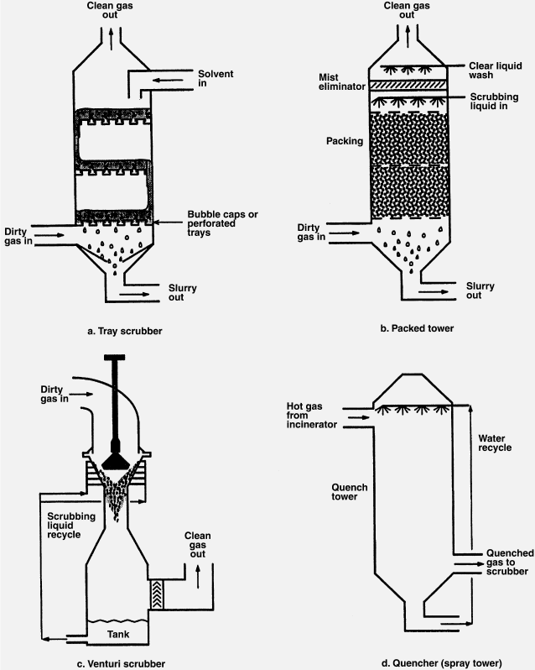

Fig 2. Four main wet scrubber designs.

- Supplier Review.

A number of alternative potential suppliers have been approached and there comments are reflected below. The suppliers approached include:

- ACWA

- ETA Process plant

- Hygrade
- Parsons UK

- MECS

ACWA

ACWA propose using a simple packed column to effect the scrubbing of the kiln gases. The hot gases from the process will enter the scrubbing tower through a quench elbow. The gases will come into contact with a spray of scrubbing liquor which will flow co-current with the gas stream into the inlet of the main scrubber body.

The cooled, saturated gases then enter the scrubber column itself and flow upwards through a packed section before leaving to the stack discharge system through a droplet separator.

The pH of the scrubbing liquor is used to control the addition of sodium hydroxide to the recirculation liquor at a point before it enters the scrubber column by modulating the speed of a dosing pump. The conductivity of the liquor is also monitored and used to open an actuated valve allowing liquor from the recycle liquor circuit to be discharged to the effluent disposal system. This allows the scrubber liquor to be maintained below its saturation concentration preventing precipitation of salts within the scrubber packing.

The concentration of caustic in the scrubber is continuously maintained at 0.8 – 1.0% caustic by pumping caustic soda from the day tank through a trace heated line to the scrubber. The dosing pump will receive a modulating control signal from the pH controller on the scrubber.

A fully bunded and heated storage tank is provided for the storage of 47% sodium hydroxide used to dose into the scrubber. Caustic is pumped periodically from the main storage system to replace that used in the scrubber.

ACWA don’t see the need for a cooler in the liquor circulation line as the gases are cooled adiabatically by evaporation of water from the liquor in the quench elbow.

They calculate that the temperature of the liquor will stabilize at approximately 60 – 65°C. Operating a scrubber at this sort of temperature is not an issue for them.

ETA Process Plant

ETA Process Plant propose the use of a 2 two stage process comprising of a Quench vessel followed by a conventional packed column. The Quench vessel would be located upstream of the gas inlet to the packed column and be fed from a separate quench water supply. The quench vessel will reduce the temperature of the incoming gas stream before it enters the scrubbing column, by contacting it with water to reduce the temperature to below 65°C.

The column will be a conventional packed column manufactured from stainless steel complete with a recirculation system incorporating a heat exchanger, designed to run with dilute Sodium Hydroxide.

The gas flow through the plant will be maintained by an extract fan. This will discharge to the existing stack. The unit is designed to provide the SO₂ absorption using a reactive system, utilizing 10% caustic, to provide a suitably low outlet concentration.

The use of magnesium sulphate has been considered. However since Magnesium Sulphate has a lower solubility than sodium sulphate it is likely a higher water addition rate would be required to the column sump.

The scrubbing column, quench column, heat exchanger, pumps and fan will be manufactured in stainless steel. The Pipework will also be provided in stainless steel.

Hygrade

In order to maximize the scrubbing ability in the available space, Hygrade suggest the use of 3 No Venturi Scrubbers mounted on a common Recirculation / Sump Tank. There will also be an outlet Demister Pot also mounted on the same Sump Tank. This would affect the required reduction of SO₂ in the airstream in a compact unit.

The use of a venturi unit will allow the use of either a magnesium hydroxide slurry, Mg(OH)₂, or sodium hydroxide (caustic) as the scrubbing medium without having to make any other alterations.

The temperature of the entering gas stream combined with the heats of absorption and reaction will require the inclusion of a cooler in the liquor circulation line.

Parsons UK

Parsons UK propose the use of a 2 two stage process comprising of a venturi scrubber followed by a conventional packed column. The Venturi scrubber would be mounted at the gas inlet to the packed column and be fed from a common recirculation system. This is designed to prevent any solids which may find their way through the ceramic filter in the gas stream from entering the scrubber and prevent them blocking the column packing.

The column will be a conventional packed column manufactured from stainless steel complete with a recirculation system incorporating a heat exchanger and a self-cleaning filter, designed to run with dilute Sodium Hydroxide.

The gas flow through the plant will be maintained by an extract fan. This will discharge to the existing stack.

The unit is designed to provide the SO2 absorption using a reactive system to provide a suitably low outlet concentration. The sump will be filled with ~5% Caustic soda solution, this will be neutralized by the SO2 and when a pH of 7.2 is reached the sump contents will be disposed of to the effluent and the sump refilled. This batching in of the caustic will reduce the amount of caustic wasted to drain over a continuous system with a constant bleed.

The use of a magnesium hydroxide slurry as the scrubbing medium is not recommended by Parsons.

The scrubbing column and the venturi scrubber would be manufactured in stainless steel. The Pipework will also be provided in stainless steel.

MECS Global

In order to fully investigate the possibility of using Mg(OH)2 as a scrubbing reagent MECS were approached. MECS propose utilizing their “Dynawave” SO2 scrubber. The Dynawave scrubber is capable of using a wide range of scrubbing reagents including:

Sodium Hydroxide, NaOH

Calcium Hydroxide, Ca(OH)2

Calcium Carbonate, CaCO3

Magnesium Hydroxide, Mg(OH)2

The scrubber consists of a Column with Inlet Spray Barrel and top outlet. The scrubber will perform the following duties:

Quench incoming gas (in the inlet spray barrel froth Zone).

Remove acid gases (in the inlet spray barrel froth Zone).

Eliminate particulate (in the inlet spray barrel froth Zone).

When using Mg(OH)2 as a scrubbing reagent, oxidation of the insoluble sulphite salts produced as a result of the scrubbing action would generally be oxidized in the scrubber sump however due to the height limitations imposed on the scrubber design this will have to take place in a separate oxidation vessel in this instance (1m diameter x 5m high).

The inlet spray barrel is manufactured from stainless steel. Generally the scrubber itself would be manufactured from FRP however a stainless steel column could be provided

- Conclusions

Scrubbing Medium

Based on the literature read and the responses from the various suppliers, sodium hydroxide solution is the recommended solution for the SO₂ removal. The use of magnesium hydroxide, while feasible, is not considered practicable.

Magnesium hydroxide is practically insoluble in water and so will form a slurry rather than a solution. The use of a slurry as the scrubbing medium restricts the design of the scrubber and will be more problematic with regard to the handling of the waste stream.

There is a wealth of information, including mass transfer data, on the use of sodium hydroxide for scrubbing duties. There is however significantly less information on the use of magnesium hydroxide.

This lack of information makes the design of any scrubber based on the use of magnesium hydroxide more open to uncertainty which must subsequently be offset against the reduced operating cost of using magnesium rather than sodium hydroxide.

Materials of Construction

Due to the potentially high inlet gas temperature the preferred material of construction is generally stainless steel. This is true for all process items including the heat exchanger and circulating pumps. PVC or GRP can be used for the outlet gas stream as the exit temperature will be greatly reduced.

With a metallic construction the issues of high temperature are reduced. Stainless steel can easily withstand temperature up to the 450°C anticipated in the kiln gasses.

Stainless steel is also suitable for low concentrations of caustic (10 – 20%) at temperatures above the operating temperature

Where non-metallic components are incorporated into the design then care will need to be taken to ensure that the temperature is controlled such that the components are not exposed to temperatures greater than that for which they are designed. If there is a possibility that temperature excursions may occur then suitable safeguards need to be put in place.

Cooling

The suppliers have slightly differing approaches to accommodating the temperature of the inlet air stream.

The ACWA design cools the incoming gases using a quench elbow on the inlet to the scrubber. They do not include a recirculation cooler as their calculations suggest that the scrubber will equilibrate at approximately 65°C. They have no concerns about operating their equipment at this sort of temperature.

ETA advocate the use of a water quench on the inlet gas stream to reduce the temperature of the incoming gas. However they also include a recirculation cooler in their design.

MECS utilize a spray barrel on the inlet to the column which, in addition to removing the acid gases and eliminating particulates, also quenches the incoming gas stream.

The remaining suppliers, Hygrade and Parsons both advocate the use of a cooler in the liquor circulating line.

The use of a water quench in the inlet line is worth exploring as it may simplify the construction of the scrubbing system. This can be achieved using either a quench elbow as advocated by ACWA or possibly using the existing scrubber. Temperature checks on the existing column need to be undertaken during the next Phase if this solution is being considered.

Suggested Design

From the above it is suggested that the scrubber should incorporate an inlet quench to reduce the temperature of the inlet gas, followed by a packed column scrubber.

Although magnesium hydroxide has historically been used in the scrubbing of flue gases from power generation plant, it is less commonly used in the chemical industry. Its use in the power industry results in large quantities of magnesium sulphate being produced for use as fertilizers. For the scale of plant we at Vale are looking at and the proposed technology, the use of magnesium hydroxide as the scrubbing media is not recommended.

6.0 References

- Wang, L.K. et al. (2004) Vol 1, Handbook of Environmental Engineering. Humana Press, Totowa, NJ, 2004, 604 pp. ISBN: 1 58829 161 8 eISBN: 1 59259 778 5Edited by: L. K. Wang, N. C. Pereira, and Y.-T. Hung © The Humana Press, Inc., Totowa, NJ
- Srivastava, R.K., W. Jozewicz, and C. Singer (2001) “SO2 Scrubbing Technologies: A Review”. Environmental Progress, 20(4): p. 219-228
- Hikita, H. (1976) “Absorption of carbon dioxide into aqueous sodium hydroxide and sodium carbonate-bicarbonate solutions”, Chemical Engineering Journal, 11(2): p. 131.
- Bandyopadhyay, A. and Biswas M.N. (2008) “Critical flow atomizer in SO₂ spray scrubbing”. Chem. Eng. J. 139: 29-41.
- J. Kuropka (2011), “Removal of Nitrogen Oxides from Flue Gases in a Packed Column,” Environmental. Protection Engineering, 37 (1), 13; http://epe.pwr.wroc.pl/2011/1_2011/02kuropka.pdf
- Zhong, Y et al (2008) “A model for performance optimization of wet flue gas desulfurization systems of power plants”. FUEL PROCESSING TECHNOLOGY, 89: p. 1025-1032.
- Shareefdeen, Z. et al. (2015) “Review of current technologies used in municipal solid waste-to-energy facilities in Canada”. Clean Technologies and Environmental Policy 17(7)
- Deshwal, B. and Lee, H. (2009) “Mass Transfer in the Absorption of SO2 and NOx using Aqueous Euchlorine Scrubbing Solution,” J. Env. Sciences, 21, 155 jesc.ac.cn/jesc_en/ch/reader/create_pdf.aspx?file_no=2009210204.
- Glowinski, J. et al (2009). Chemical Process Engineering, 29 (7), 1492

