

Creating an Artificial Intelligence that can interpret Map Data

by
Joshua Burge

Supervisor: Gordon Dickers
Second Marker: Andrew Baker

Project submitted as part of the requirements for the award of ….
BSc (Hons) Computer Games Development

May 2019

DECLARATION

I, Joshua Burge declare that I am the sole author of this Project; that all references cited have been consulted; that I have conducted all work of which this is a record, and that the finished work lies within the prescribed word limits.
This work has not previously been accepted as part of any other degree submission.
FORM OF CONSENT

I Joshua Burge hereby consent that my Project, submitted in candidature for the B.Sc. Computer Games Development degree, if successful, and that the title and abstract may be made available to outside organisations.

Abstract
The overall aims and objectives of this project are to successfully develop and implement a pathfinding artificial intelligence that can take map data in a format chosen by myself, ASCII, and have it navigate to the exit regardless of complexity. Once this has been achieved, the artificial intelligence is to then be integrated into the ID Tech 1 engine video game DooM. Contained within is research conducted with the Positivism methodology, development conducted alongside the deductive methodology, the design requirements and implementation of the artificial intelligence itself as well as the performance results and end results of the project. Whilst the methods implemented worked, more practical and optimal algorithms may have instead been implemented to facilitate a better pathfinding artificial intelligence overall.

Table of Contents
Introduction 6
Research and Review of Literature 8
Research and Development Methodology 12
Design 14
Implementation 18
Evaluation, Conclusions and Recommendations 23
Reflection 25
References 26
Bibliography 26

Introduction

Artificial Intelligence is a very broad field which has changed over the years. Whilst initially developed as a problem solving tool it has in recent years, thanks to advances in technology regarding storage capacities and faster central processing units capable of calculating and computing information at a higher rate than those found within old computer mainframes such as Colossus, advanced significantly. Today, Artificial Intelligence finds itself being applied in a variety of real life situations ranging from automotive transportation [1] to data mining which Microsoft offers as a service as part of their Azure artificial intelligence framework [2].
Within the confines of the video game industry, artificial intelligence is more-often used for navigational purposes for the non-player characters within the video game itself. To achieve this, algorithms such as A* are used to compute the path that the entity would need to take to reach its goal, be that driving a vehicle at high speeds around a track or moving to a more advantageous position to fire at someone or something. Sometimes these algorithms are used for decision making as well as navigation as evidenced in F.E.A.R, where-in A* is utilised in tandem with STRIPS for the hostile entities within the aforementioned video game to make choices on how best to react in a given situation [3].
The implementation of artificial intelligence in video games has been an interesting development over time to reach the point presented in F.E.A.R and to this day still finds itself being used in interesting ways with the easiest, and most relevant for this project, example being ViZDooM, a fork of the ZDooM source port that was developed for research purposes into Visual Machine Learning, where-in the artificial intelligence could only learn by what it was able to “see” through the rendering buffers [4].
The aim of this project however is to develop a pathfinding artificial intelligence that can navigate towards a goal in a given map structure in the hopes that such an artificial intelligence may prove beneficial in both a video game entertainment setting as well as having a real world application. At minimum, it must search through the space provided until it finds the required item or designated exit thus demonstrating that it can understand the map data provided to it. Once such an artificial intelligence has been developed, it is to be further improved upon with features such as identifying multiple desirable objects that must be obtained prior to exiting with the end result being the hopeful integration into the ID Tech 1 engine, also known as the DooM engine due to the aforementioned game being the primary user of the engine. The reasoning behind the selection of the ID Tech 1 engine is discussed later on.
Please note that due to ID Software’s release of DooM, as well as the ID Tech 1 engine, to the general public under the GNU General Public Licence, a vast majority of modern developments and research conducted into the modification, and understanding, of the engine is largely third-party in the form of internet forum communities, open-source ports such as ZDooM and what little was released by ID Software themselves.

Research and Review of Literature
Pathfinding is a well-documented and researched application of artificial intelligence, as can be demonstrated by the conception and development of algorithms designed for pathfinding ranging from Dijkstra’s algorithm [5] and the aforementioned A* algorithm to more complex algorithms such as Prim’s algorithm and Kruskal’s algorithm [6]. Depending on what it is that you need to be calculated there exist many algorithms that can achieve what you are trying to do. Dijkstra’s algorithm is relatively simple to implement but lacks the finesse and speed found with A* due to the lack of heuristics to help narrow down the direction that the search should take across the vertices and edges within a given graph however neither algorithm can handle negative weight values whilst Bellman-Ford can whilst sacrificing computational speed.
Indeed, as mentioned within the introduction section, Jeff Orkin came to the decision that A* should be used to handle the decision trees for the enemy entities within the game F.E.A.R rather than using a standard finite state machine to help allow a more organic and dynamic entity for the player to fight [3], resulting in an artificial intelligence that seemingly demonstrates high level thinking in regards to tactics employed by the hostile non-playable characters when it actually ends up being the case that the individual decisions made by each entity just so happen to mimic a more cohesive unit. Were the game to not use a combination of STRIPS and A* for the decision making the entities present within the game would seem no more advanced than those found in other video games at the time.

In relation to the attempts at developing a pathfinder for the ID Tech 1 engine, it must first be established that there is no pre-existing pathfinding algorithm within the engine already. Enemy entities, referred to as Things within the code, do not follow a set of nodes to reach the player nor do they have any in-depth awareness of the levels they are placed within. There exists a single exception to this rule which lies with the boss creature called the “Death Wyvern” from Hexen which required extensive coding to utilise a node-based path pre-placed within the map it appears.
For everything else however, the method of Things pursuing the player relies upon a random number generator, the eight cardinal directions and the occasional solid wall. Once a Thing has been awoken, in this example it will be the Imp from DooM, it begins wandering in random directions until it “sees” the player. During this wandering section of its activation a random number is chosen relating to a direction which the Imp will proceed to walk in until the end of that movement cycle where it will then look around for the player and if they still have yet to be seen by the Imp the process repeats itself until either the player runs into view of the Imp or the Imp wanders somewhere it can see the player. If the Imp were to walk into a wall, the generator picks a direction with a preference to moving away from the wall to avoid bumping into it and getting no-where.
At this stage the random generator dictating the direction the Imp moves in begins generating with a bias towards the player’s position. Occasionally, the Imp may interrupt its own movement to either attack or react to being shot via entering the pain state where all actions are interrupted. Where as before the random directions would try to move away from solid walls should the Imp walk into one, it now has a higher priority on getting the Imp up close to the player which can result in the Imp becoming stuck as it tries to move through a wall towards the player with only the occasionally rare moment where it will take a few steps away before walking back into the solid object. [7]
Whilst this may not be the most graceful attempt at moving Things towards players, it is understandable as to why this method was implemented. Given the technological constraints at the time of DooM’s development and release it is not hard to see why a potentially intensive pathfinding algorithm was not implemented. Some levels within DooM and DooM 2 contain roughly one hundred enemies that can be “awoken” at once. Having to calculate one hundred pathfinding algorithms in real time would have been taxing for the average computer either due to the cripplingly small storage size of the random access memory available back then, or the low clock speeds and thus low processing power of the central processing units installed in many home computers. In addition, a case could be made that due to DooM being distributed on floppy disks the lack of a pathfinding algorithm could be related to the storage capacity of said floppy disks.
There have been attempts over the years to develop or otherwise integrate a pathfinding algorithm or artificial intelligence into DooM itself though usually these projects are discontinued for various reasons.
For example the most well known of the attempts is Cajun Bot, a “bot” that was developed for Deathmatch and Co-operative purposes [8] and was later integrated into ZDooM before eventually being replaced and phased out completely. [9] CajunBot’s primary issues were relating to the lack of map awareness that the artificial intelligence had, a problem that persists through to the modern iteration of ZDooM and the primary forks of it, GZDooM and Zandronum. The bots controlled by the artificial intelligences within these source ports struggle to understand the usage of doors and switches resulting in most of the popular deathmatch and otherwise competitive game-mode maps being developed without doors, elevators or other “moving parts” to help prevent issues arising from multiplayer game sessions where bots are present.
The bots do however navigate open spaces rather well due to using an improved navigational method derived from the ID Tech 1 engine. By moving at a high speed and being slightly more proactive in avoiding solid objects the bots put up a challenge against most casual players of DooM.
The ViZDooM project meanwhile utilised deep learning to teach the artificial intelligence what an enemy looked like, what health looks like, weapons and so forth. After training the artificial intelligence in a few settings, such as a “Survive as long as you can” maze map where the floor damaged the player but health spawned in through-out the maze or a simple box room where the player has to do the minimum amount required to shoot a demon, the artificial intelligence was then put into a tournament-style deathmatch against numerous other trained artificial intelligences and one human player. Some quirks arose as a result of the trainings in the first year of the competition with one of the bots learning how to crouch, causing it to go unrecognised by many of the enemy bots as none had been given the visual data on what the crouching sprite was resulting in it being ignored.

The examples given show two different methods people have attempted when it comes to implementing an artificial intelligence capable of navigation within the ID Tech 1 engine. Whilst CajunBot had some map awareness in-so-far as knowing what was a wall and what wasn’t, it was far from perfect and would be incapable of navigating even the first level of DooM. Meanwhile, it’s possible that ViZDooM could eventually be trained in what a switch does or how to open a door but the information gathered is purely visual rather than already known. If you were to put them both into a maze, CajunBot would most likely reach the exit first due to knowing the full layout of the maze whilst ViZDooM would have to discover it.
Meanwhile the implementation I hope to develop would require taking the map data in the raw LUMP format provided for the ID Tech 1 engine and process it into a readable format for a pathfinding algorithm that would be able to plan a route from the start of a level to the exit, rather than rely upon CajunBot’s navigational methods described earlier. This would result in being able to pass through a WAD of any level design not using modern map-making techniques, such as false floors and lakes, to the pathfinder and it would be able to complete the level without issue. Note that there would be no combat component integrated into the pathfinder which therefore requires that all levels be developed or loaded without Things present which isn’t too difficult given how the file data is split into LUMPS.
The reason as to why the ID Tech 1 engine has been chosen as the end-result development platform is primarily down to my own familiarity with the engine having worked on a variety of projects relating to DooM, Hexen and Strife. The initial development phase will be focused upon ASCII maps, typically found within video games such as Angband and Dwarf Fortress and is simple enough to implement and create maps for.
One concern held with using the ID Tech 1 engine is that the age of the engine may add to the difficulty of implementing a pathfinder as there is no native support for any pathfinding algorithm in the original source code, whilst most modern source ports have neglected or otherwise decided to not develop this area of the ID Tech 1 engine.

Research and Development Methodology
For a research methodology, Positivism has been selected since something either is or isn’t with regards to artificial intelligence. Either it can navigate through all the symbols of an ASCII map to the designated exit or it cannot, there is little to interpret. Conversely there is much to analyse and review during the development cycle of the artificial intelligence such as which algorithm is best suited to the task at hand and can there be any optimisations made in the execution of the algorithms and file handlers that would speed up the overall process?
The only area that could be open to Interpretivism would be in regards to parsing the information within the DooM Community as some information presented will be anecdotal or assumptions made by people who may not be well versed in the area they’re commenting on or providing input to. Discretion will need to be exercised with regards to reading through the forums and Wikis operated by various communities as whilst some are maintained by the source port development teams, such as the ZDooM Wiki being maintained by the ZDooM team, others are maintained in a more traditional “Wikipedia” setting where anyone can contribute to an article which is then reviewed by a trusted member of the website.
However it is despite this that I still believe that Positivism is the better option for the research methodologies and that it may be that the focus on hard evidence and a more logical approach will help filter the information presented by the communities. This leads into the deductive methodology.
The selection of the deductive methodology is again born from the nature of developing code and algorithms where something either is or isn’t. The theory for the project is that it is possible to develop an artificial intelligence that can take a given set of map data in a format developed for it, such as ASCII or hopefully LUMP, and that it can parse the information provided to navigate it successfully whilst the hypothesis is that it may be possible to develop an artificial intelligence that can understand map data, however it would be impractical to try and use a “one size fits all” solution. Specifically, each type of map data may require that the artificial intelligence be tailored for it rather than the map data for the artificial intelligence.
The test will come as part of the development cycle for the project. Specifically, at least three ASCII maps will be created with varying levels of complexity which the artificial intelligence must successfully navigate without any issues. Issues are defined as the following:
- The AI must search the area and find the exit without crossing any “walls” on the map.
- The AI must not get stuck in one location.
- The AI must not loop around endlessly.
- The AI must identify the exit.
The development environment will be Visual Studio 2017, largely due to familiarity with the program as well as the inbuilt analysis functions that will help establish the time taken for the artificial intelligence to reach an exit in a given map. 2017 also has integrated version control features that will help ensure that regardless of where development takes place, the most recent version of the project is always accessible.
Should the initial phase of developing an ASCII Map compliant artificial intelligence be completed with sufficient time remaining, the original DooM source code will be obtained and used rather than any current source port.

Design
Before the implementation of an artificial intelligence can begin, a suitable map data type needs to be selected for development. One of the easier maps to try and develop for would be a graph used by Dijkstra and A* because of the simplicity. However, it can be difficult to understand visually what exactly is going on with the pathfinder when the program is ran, especially if the graph is arrays of numbers connected together.
An ASCII map however is a slightly more complex yet easier to visualise map that requires more work to implement, but allows greater flexibility with how to implement different parts of a pathfinder. One way to handle an ASCII map is to use it as an influence map where every symbol holds a value that affects the path the artificial intelligence will take. Examples of this include walls having large values, undesirable areas having higher values than safe or desired areas and the exit having an “empty” value of 0 to be certain that it’s used before anything else. Alternatively, it can be handled as a minimum spanning tree where all of the symbols have values and the artificial intelligence builds the graph itself by linking the closest nodes to each other.
On one hand, such a method would be incredibly useful for expansion into other map data types and would allow implementations of Dijkstra and A* just as though a regular graph had been implemented. The primary disadvantage with this technique however would be that the artificial intelligence would effectively have to be run twice minimum in a two pass manner. The first pass being either Prim’s or Kruskal’s algorithm to set up the nodes and their paths with the second pass being Dijkstra or A* to actually perform the navigation.
Instead, the method that will be used in conjunction with an ASCII map is to have every symbol representing a walk-able area, identified by a “.”, start at a value of 0 which is incremented every time the artificial intelligence moves to that location. This will result in two things occurring, firstly that the artificial intelligence will not backtrack on itself unless a path in a direction has been exhausted of spaces (Such as reaching a dead end in a maze) whilst also allowing for alternate algorithms to be developed and tested relatively quickly in the future without requiring a rework of the ASCII map itself.
If I were more adept at developing using graphical options such as OpenGL or another language that permits visual data another map option would be to take a picture of something such as a maze or city and utilise that for the map rather than a pseudo-text based option. Unfortunately, I am not confident enough in my capabilities to attempt implementing this map option despite the factor of having a more obvious real-world benefit being demonstratable. If the AI were to work on such a map type it wouldn’t be too much work to further develop the pathfinder and have it perform similarly to a route planning tool such as the ones found in Google Maps.
Another advantage for ASCII map development presents itself in the form of the ease by which someone can develop an ASCII map. At minimum all anyone requires is a keyboard and a text editor such as notepad to create the maps. They should be built in a uniform manner to a pre-decided key. Typical ASCII maps follow the convention of the player or entity navigating the map being represented by a “@” symbol, areas where the player or entity can move to being shown as a “.” whilst the exit appears as “<”. Later developments of the artificial intelligence could include a list of letters or other symbols that represent required items before leaving a level though the ease of which this could be implemented depends upon both the algorithm selected for the artificial intelligence and any alterations developed to accommodate the requirements for the project.
Since an ASCII map has been chosen, a suitable data structure will be needed to handle loading the map into. Whilst an array would be the fastest option it would prove inflexible as it would only be able to handle maps of up to a certain size requiring that either the array container be considerably large and thus a waste of memory, or that the artificial intelligence is limited in what maps can be loaded into it. A more versatile option is to utilise a vector data structure as it is dynamic in its memory allocation and thus would be able to handle any map passed to the artificial intelligence regardless of size. One reason as to why a vector would be preferable to a list is that when handling small amounts of data, a vector iterates through itself much faster than a list does however should the data get too large or if any of the loaded nodes be re-arranged or deleted the vector will start to reduce the speed by which the algorithms will work more so than a list. Thus a consideration that must be remembered is that once the data has been read in from a file it should not require re-arrangement for any reason.
If the data must be rearranged then a list should be implemented in place of a vector. Likewise, if the data is sufficiently large enough that there is hardly any difference between a vector and a list, it may be worth utilising the list regardless. Until that point is reached however, the primary data structure will be a vector.
To handle the nodes themselves, a structure will be used rather than any other data structure type. The information for each node should be quickly accessible and may require frequent changes which would be slower if done through a class using accessors. In addition, using a structure allows each node to be able to contain a variety of information such as the X and Y position of the node, how many times it has been visited and whether it is a start, item or end position.
A potential issue with using a vector of structures comes in the form of the map itself. If the pathfinder artificial intelligence itself uses a pointer to a “new vector<struct>” form of the map it could result in all sorts of strange interactions when pathing through, especially if another form of the map is retained somewhere else as a back-up. It’s entirely possible that the wrong map will be accessed at some point although conversely it would prove faster to iterate through pointers than the whole map itself for the sections where the entire map must be examined for pathing routes.
Thus, due to my own uncertainty with pointers I will choose the less elegant and more time-consuming option of passing the entirety of the map to the artificial intelligence. However, to help mitigate the impact the pathfinder will pool the adjacent movable positions into a separate vector of structures and perform the algorithms to that instead, thus reducing the number of nodes from however many are in the map to four.
The file handler should be exactly and only that, reading in from the .txt file that the ASCII map is contained within and processing it into a vector of structures which is then passed to the artificial intelligence. The confines of the map, specifically the length and the height, are all that should be set-up within the file handler primarily for ease of printing to the console later down the line.
To adhere to good coding practice, everything should be compartmentalised into their own header and cpp files.
All files created for the project will be referenced in from a custom header similar to stdafx.h whilst standard c++ libraries will be in a separate header serving the same function.
Specifically in relation to the ID Tech 1 engine side of the project, extensive examination of the inner workings of the DooM file handler will be required to understand at what point the LUMP file pertaining to sectors and linedefs are loaded. Both are vital to compiling some form of a map for the artificial intelligence. Sectors are composed of linedefs and contain information such as the height of the floor and ceiling, any special effects for that area including but not limited to damage floor types, special lighting effects, being a door or elevator as well as teleportation destinations when used in tandem with a teleport Thing. Linedefs meanwhile handle what is a physical wall and what is not, what’s a switch or an exit. Being able to parse these two LUMPs is vital for being able to have the artificial intelligence be able to navigate a level. Otherwise, there’s no way to tell the difference between a wall and the exit switch, or where a teleport may lead to.
Once the method by which the LUMPs are loaded has been established, the next step of development is to try and decide upon the best way to implement movement for the artificial intelligence. The most likely solution would require that the player Thing move in relation to how the pathfinder navigates the map.

Implementation
During development of the pathfinding artificial intelligence, two issues arose specifically with the first “phase” of the project. The first was relating to the ASCII map whilst the second was the pathfinder itself.
The primary issue that arose was that when reading the map data into the vector of structures, the values for the length and height were being overwritten by the x and y values. This resulted in the maps being either one row or one column long and was directly caused by a section of code being incorrectly implemented with regards to the counters for the data being read in. The wrong variables were used for keeping track of what X or Y position the symbol was, resulting in the old nested loops being in a perpetual loop until the end of the file. This was remedied by refactoring the code to vastly cut down on the amount of nested loops being utilised and had the benefit of increasing the computational speed of the code overall by reducing the complexity.
The second issue was that after the artificial intelligence was finished processing which node it was going to move to, it would then remove the @ from the map due to a mistake in the implementation of swapping the current position of where the pathfinder was, and where it was going to go. The pathfinder would still find the exit and finish as all the checks are ran from the current X and Y position of the pathfinder itself rather than the position of the @ which just serves as a visual aid, however it proved hard to tell what the pathfinder was doing without the aforementioned @ symbol. This too has been fixed and reversed so that all visited nodes now also show the @ symbol allowing a visual guide as to where the pathfinder has and has not been. Unfortunately, colours have not been implemented and thus it can be confusing as to where the pathfinder has backtracked the most.
Unfortunately, several issues arose with the attempts to implement the pathfinder into DooM. Primarily, the source code was released for Linux due to a combination of licencing issues with regards to the audio synthesiser as well as the Windows version disappearing as far as the developer of DooM and person who released the source code, John Carmack, is concerned. This led to an issue in trying to establish a virtual machine on the development computer where-in Linux did not run when hosted inside of the virtual machine. An alternate boot partition was created and used to try and circumvent this issue and worked. The next issue to try and fix was that Visual Studio 2017 doesn’t run on Linux and I myself am unfamiliar with any other development environments. This in turn resulted in a strange development cycle where the computer would need to be rebooted for a development cycle, then booted up again into the Linux operating system for testing before cycling back into Windows for further development.
Despite my best efforts, I could not get further than understanding the LUMP loading and level building within the ID Tech 1 engine at this time. Were I more familiar with both Linux and Linux-friendly development environments I anticipate being able to at least be able to get the LUMP data into a format that the pathfinder could understand. It would have required some minor reworks to the file-handler side of the artificial intelligence as well as a check to see what file type was being opened but in turn could have allowed a debug run through of the level.
Attached below are the results from the ASCII map analysis runs. The relevant specifications of the development and testing machine are as follows:
1x AMD Threadripper 2920x overclocked to 4.1ghz.
32GB DDR4 3200mhz RAM in Quad Channel Configuration.
1TB PCI-E NVME SAMSUNG 970 EVO SSD.

Figure 01. Map 1:
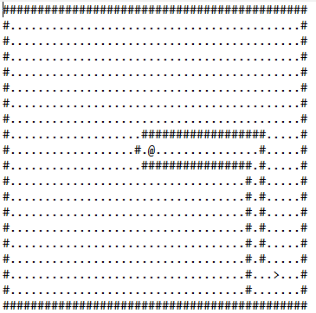
Figure 02. Map 1 Performance Analysis results:
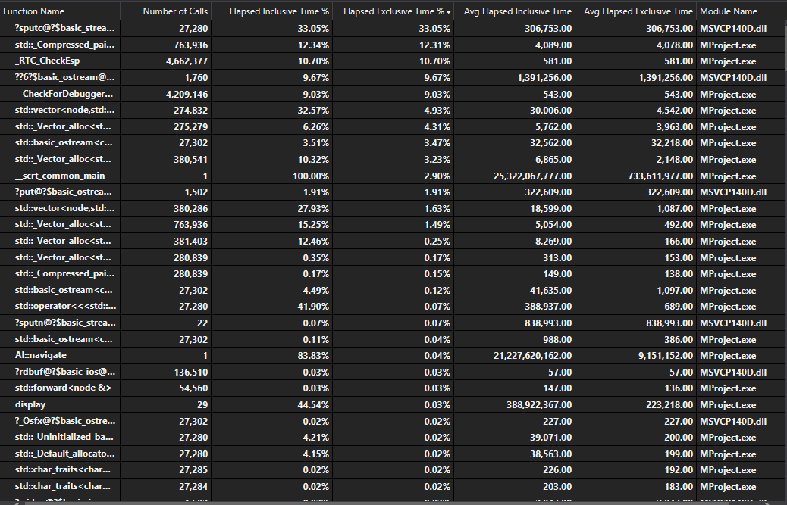

Figure 03. Map 2:
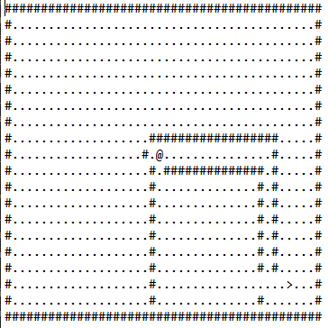
Figure 04. Map 2 Performance Analysis results:
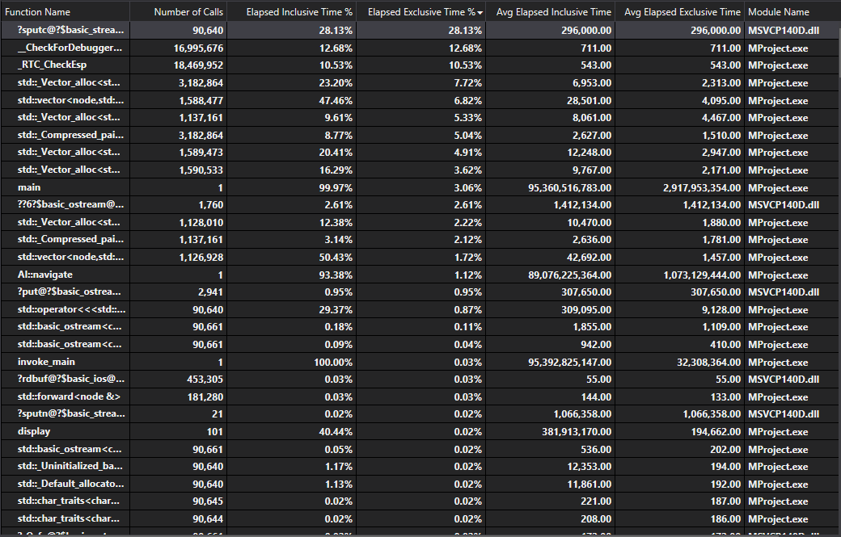

Figure 05. Map 3:
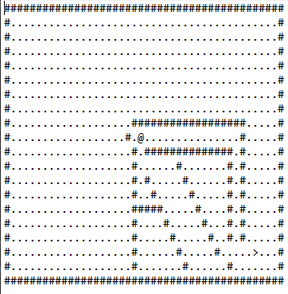
Figure 06. Map 3 Performance Analysis results:
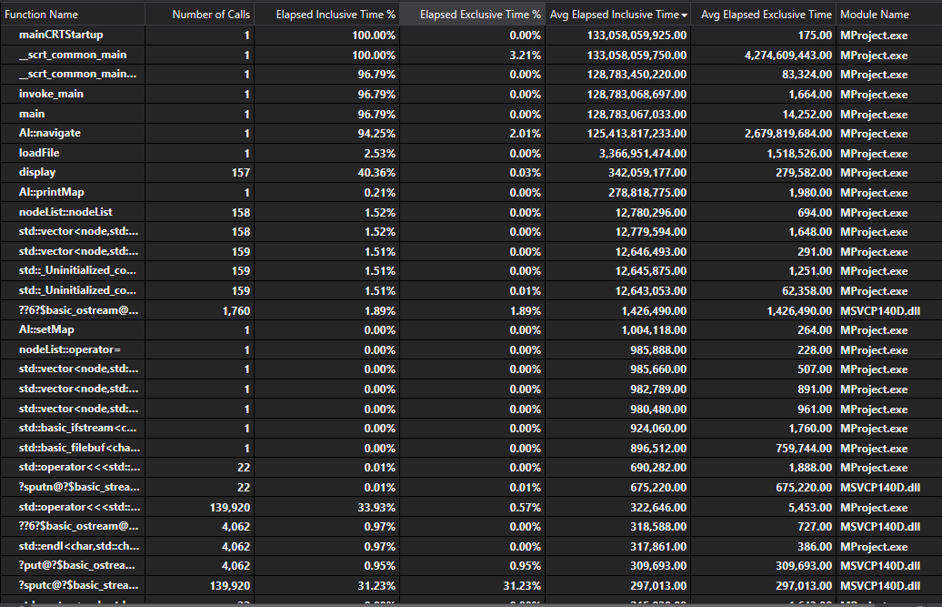

Evaluation, Conclusions and Recommendations

One of the conclusions that can be drawn from the data is that the AI Navigation function is time consuming and most likely because of inefficiencies in the design and implementation of it. Whilst it does reach the end quickly, it would be faster if A* were implemented as it would then go directly for the exit. The caveat to that being that it would not then search the nearby areas which, if it were transplanted into DooM as originally hoped, would end up being a catch 22 situation. A* would complete a level faster than the current algorithm would, however it would be under-equipped and potentially lower on health than the current algorithm. Conversely, the A* is less likely to wander into a trap or get itself stuck somewhere whilst there’s little to stop the current pathfinder from not encountering that issue in the context of DooM.
In developing this project, I have come to understand why it is that people have burned out in the past on developing some sort of pathfinder for the ID Tech 1 engine. It is far easier to take what is already present and developed by ID Software and alter that for the purpose required than to metaphorically reinvent the wheel and try to slide it into DooM. However, it seems that it could be feasible given enough time and, if implemented to any degree, could then be shared and distributed to the current popular source port forks such as ZDooM and those that have branched from it.
Whilst an artificial intelligence has been developed that reads data from a map, it’s clunky and poorly implemented due to a combination of my own failures to try and develop at a slow and steady rate rather than as much as possible as fast as possible, leading to poor coding practices at the very least.
If I were to revisit or otherwise re-attempt this project, I would certainly investigate Prim’s and Kruskal’s algorithms and look at implementing either one into the pathfinder. Doing so may have alleviated or otherwise avoided the issues with the pathfinder and could have improved the navigation despite the longer start-up and initialisation time.
I would also have better documented the developmental cycles with a demonstratable test harness, clear Agile development methodology and reviews after each cycle of what works and what doesn’t.
It’s possible that if reworked as defined, with the two-pass Kruskal / Prim’s and Dijkstra / A* algorithms that this could prove beneficial in a real world setting such as navigating a city for emergency services. Were they to have a real-time feed through to the artificial intelligence from some form of video feed from above such as a helicopter, the pathfinder could assist police in the pursuit of a criminal in a vehicle or alternatively, the algorithm could attempt to predict where that individual may flee to. It could also be utilised in automotive racing to improve lap times or, if used in settings such as the Dakar Rally, allow either the drivers to safely navigate from point to point or allow rescue teams to find missing competitors.

Reflection
On reflection, I’ve come to learn that I have two large flaws when it comes to developmental work. I’m too quick to dismiss what I’m doing as something that’ll work, and I need to be quicker to ask for help. If I had asked for assistance earlier with the project with my supervisor, many of the issues that I encountered could have been avoided. Similarly, I have a habit of attempting something and getting stuck with it, spinning my wheels in the metaphorical mud and getting no-where or going about the solution to a problem in a rather overly complicated and convoluted manner possible because I can’t see any other way to solve it. This too could be avoided if I were more open to asking for help when needed.
Several times during the developmental cycle I started again from scratch because I believed what I was doing was completely wrong and not going to be worth the marks, rather than taking it to the project supervisor and getting a second opinion. At the end of it all, I’ve only got myself to blame for this and would do well to change my behaviour with regards to my work in the future.

References

[1] | Tesla, “Tesla Autopilot,” Tesla, [Online]. Available: https://www.tesla.com/en_GB/autopilot. [Accessed 22 November 2018].
[2] | Microsoft, “Microsoft Azure AI Platform,” Microsoft Azure, [Online]. Available: https://azure.microsoft.com/en-gb/overview/ai-platform/. [Accessed 28 November 2018].
[3] | J. Orkin, “Three States and a Plan: The A.I of F.E.A.R,” in Game Developers Conference, San Jose, 2006.
[4] | M. Kempka, M. Wydmuch and e. al., “ViZDoom: A Doom-based AI Research Platform for Visual Reinforcement Learning,” Institute of Computing Science, Poznan University of Technology, Poznan, 2016.
[5] | E. Dijkstra, “A Note on Two Problems in Connexion with Graphs,” in Nmerische Mathematik 1, Amsterdam, Mathematisch Centrum, 1959, pp. 269-271.
[6] | H. J. Greenberg, “Greedy Algorithms for Minimum Spanning Tree,” University of Colorado, Denver, 1998.
[7] | DooM Community, “Monster Behaviour,” DooM Community, 7 September 2007. [Online]. Available: https://doomwiki.org/wiki/Monster_behavior. [Accessed 6 December 2018].
[8] | C. Mellow, “Captain Mellow's Bots Page,” Captain Mellow, 16 August 2000. [Online]. Available: https://www.doomworld.com/mellow/bots.shtml. [Accessed 8 December 2018].
[9] | DooM Community, “CajunBot,” DooM Community, 29 April 2015. [Online]. Available: https://doomwiki.org/wiki/CajunBot. [Accessed 8 December 2018].

