UNIVERSITY OF WALES TRINITY SAINT DAVID
WALES INSTITUTE OF SCIENCE AND ART



ULTRASONIC ATTENUATION COEFFICIENT
DETERMINATION AND PROBABILITY OF SIZING ACCURACY
STRUCTURAL INTEGRITY AND MATERIALS EVALUATION (ACEA7013)

Mr Vishnuvardhan Reddy Kesavarapu
2215387
Automotive Engineering
University of Wales Trinity Saint David, Swansea, SA1 8PH

CONTENT
1.Abstract 4
2.Apparatus 4
2.1. Attenuation coefficient for rectangular block and Brake disc 4
Figure 1. Digital Ultrasonic flaw detector 4
Figure 2. Rectangular block 4
Figure 3. Brake Disc 4
Figure 4. Probes 5
Figure 5. Vernier callipers 5
Figure 6. Ultrasound couplant gel 5
2.2. sizing accuracy of the individual technicians through Linear regression and Statistical analysis. 6
Figure 7: Defect Measurements of True size and Operator 6
3.Introduction 6
3.1. Attenuation coefficient for rectangular block and Brake disc by Ultrasonic flaw detector 6
Figure8: Attenuation coefficient graph 7
3.2. sizing accuracy of the individual technicians through Linear regression and Statistical analysis 7
4.Procedure 8
4.1. Attenuation coefficient for rectangular block and Brake disc by Ultrasonic flaw detector 8
4.2 sizing accuracy of the individual technicians through Linear regression and Statistical analysis 8
5.Measurements and Graphs 9
5.1. Attenuation coefficient for rectangular block and Brake disc by Ultrasonic flaw detector 9
Figure 9: Measurements of values from Ultrasonic flaw detector for rectangular block 9
Figure10 : Measurements of values from Ultrasonic flaw detector for Brake disc 9
5.2. sizing accuracy of the individual technicians through Linear regression and Statistical analysis 10
Graph 1. Linear regression graph between True size and Operator 1 10
Graph 2. Linear regression graph between True size and Operator 2 10
Graph 3. Linear regression graph between True size and Operator 3 11
Graph 4. Linear regression graph between True size and Operator 4 11
Graph 5. Linear regression graph between True size and Operator 5 12
Graph 6. Linear regression graph between True size and Operator 6 12
Graph 7. Linear regression graph between True size and Operator 7 13
Graph 8. Linear regression graph between True size and Operator 8 13
Graph 9. Linear regression graph between True size and Operator 9 14
Graph 10. Linear regression graph between True size and Operator 10 14
Graph 11. Normal distribution curve for Operator1 15
Graph 12. Normal distribution curve for Operator2 15
Graph 13. Normal distribution curve for Operator3 16
Graph 14. Normal distribution curve for Operator4 16
Graph 15. Normal distribution curve for Operator5 17
Graph 16. Normal distribution curve for Operator6 17
Graph 17. Normal distribution curve for Operator7 18
Graph 18. Normal distribution curve for Operator8 18
Graph 19. Normal distribution curve for Operator9 19
Graph 20. Normal distribution curve for Operator20 19
6.Calculations 20
6.1 Attenuation Coefficient Calculations for the Rectangular Block: 20
Figure 11: Rectangular block Measurements from the experiment 20
6.1.2. Attenuation Coefficient Calculations for Brake disc
Figure 12: Brake disc Measurements from the experiment 21
7.Results and Discussions 22
7.1. Material attenuation coefficient by time-of-flight method 22
7.2. sizing accuracy of the individual technicians through Linear regression and Statistical analysis 23
Graph 21. Graph of R-squared values from the equation 23
Graph 22. Normal distribution curve of 10 Operators 24
8.Conclusion 24
9.Reference 25
1.Abstract:
Ultrasonic non-destructive testing (NDT) is a dependable experimental method for characterising materials. This study suggests a method for measuring wave attenuation quantitatively utilising a contact ultrasonic transducer for non-destructive testing. In this we have taken samples of two solid materials which are rectangular block and Brake disc and by using the formulas we have calculated the Attenuation coefficient values for the taken readings from the experiment. On the other part it discusses about the Linear regression and statistical analysis of the performance of the individual technician’s performance and the equipment performance. This has done by calculating the linear regression graphs and then finding out the normal distribution curve by calculating the mean, standard deviation and plotting the graphs.
2.Apparatus:
2.1. Attenuation coefficient for rectangular block and Brake disc
Figure 1. Digital Ultrasonic Flaw Detector
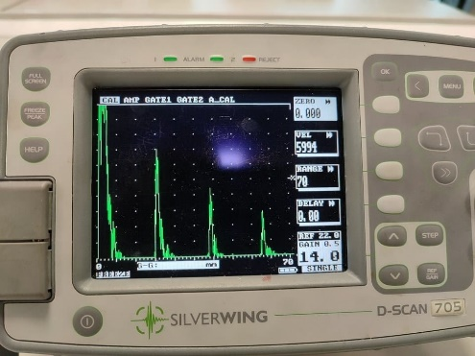
Figure 2.Rectangular Block
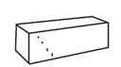
Figure 3.Brake disc
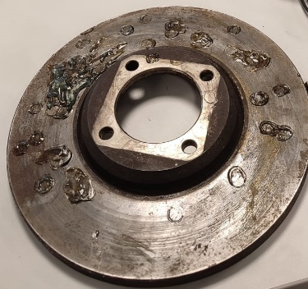

Figure 4. Probes
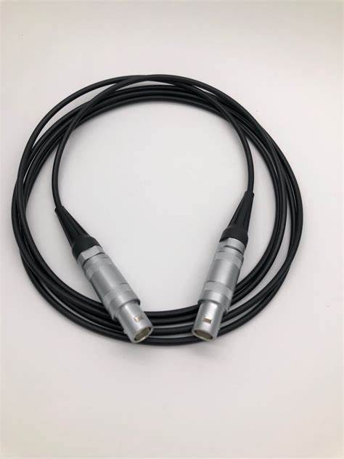
Figure 5. Vernier Callipers
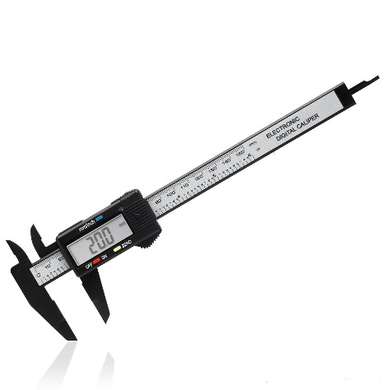
Figure 6. Ultrasound Couplant gel
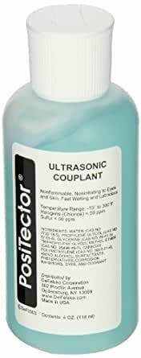

2.2. sizing accuracy of the individual technicians through Linear regression and Statistical analysis.
Defect | true size | Op1 | Op2 | Op3 | Op4 | Op5 | Op6 | Op7 | Op8 | Op9 | Op10
A | 0.25 | 0.50 | 0.50 | 0.00 | 1.00 | 0.00 | 0.50 | 0.50 | 0.80 | 1.00 | 0.30
B | 0.27 | 0.73 | 1.20 | 0.50 | 1.00 | 0.00 | 1.00 | 0.50 | 0.80 | 1.00 | 1.20
C | 0.28 | 0.76 | 1.00 | 1.20 | 1.00 | 0.00 | 0.50 | 0.50 | 1.30 | 1.00 | 0.70
D | 0.40 | 0.91 | 0.50 | 1.00 | 1.20 | 1.00 | 1.00 | 0.60 | 1.50 | 1.00 | 0.80
E | 0.40 | 0.98 | 1.20 | 1.00 | 1.40 | 1.00 | 1.10 | 0.20 | 1.60 | 1.00 | 0.90
F | 0.50 | 0.79 | 0.90 | 1.00 | 1.10 | 1.00 | 0.80 | 0.00 | 1.00 | 1.20 | 0.50
G | 0.52 | 1.01 | 1.50 | 1.10 | 0.90 | 1.50 | 1.00 | 1.00 | 0.90 | 1.00 | 0.70
H | 0.55 | 0.96 | 1.20 | 0.80 | 0.50 | 0.90 | 1.20 | 1.30 | 1.60 | 1.00 | 0.40
I | 0.70 | 1.35 | 1.50 | 0.90 | 2.00 | 1.60 | 1.20 | 1.60 | 2.20 | 1.00 | 1.00
J | 0.98 | 1.31 | 1.00 | 0.80 | 1.90 | 2.00 | 1.60 | 0.50 | 1.80 | 1.00 | 1.40
K | 1.12 | 1.37 | 0.50 | 1.00 | 1.00 | 1.80 | 1.80 | 1.80 | 2.00 | 1.50 | 1.30
L | 1.15 | 1.56 | 1.80 | 1.30 | 2.20 | 1.00 | 1.50 | 1.80 | 2.00 | 1.50 | 1.20
M | 1.10 | 1.60 | 2.00 | 1.40 | 2.00 | 1.60 | 1.50 | 0.50 | 2.20 | 2.00 | 1.60
N | 1.30 | 1.73 | 2.10 | 0.90 | 2.20 | 2.00 | 2.00 | 1.70 | 2.00 | 1.50 | 1.70
O | 1.60 | 1.56 | 0.80 | 0.90 | 2.00 | 2.00 | 1.50 | 1.20 | 2.00 | 2.00 | 1.50
P | 1.80 | 2.14 | 2.00 | 1.40 | 2.40 | 2.00 | 3.20 | 2.20 | 2.50 | 2.50 | 1.10
Q | 2.10 | 2.49 | 1.80 | 2.30 | 3.50 | 2.50 | 3.00 | 2.00 | 3.20 | 2.00 | 2.60
R | 2.70 | 2.97 | 3.00 | 3.20 | 2.80 | 2.50 | 3.50 | 2.50 | 3.50 | 3.50 | 2.20
S | 4.90 | 4.87 | 4.50 | 4.50 | 5.70 | 4.50 | 4.40 | 4.20 | 5.40 | 5.50 | 5.50
T | 6.00 | 6.17 | 5.50 | 6.20 | 7.00 | 6.50 | 5.50 | 5.30 | 6.70 | 6.50 | 6.00
U | 7.50 | 6.99 | 6.00 | 6.25 | 8.00 | 7.20 | 6.50 | 6.50 | 6.90 | 8.00 | 6.50
Figure 7: Defect Measurements of True size and Operator
3.Introduction:
3.1. Attenuation coefficient for rectangular block and Brake disc by Ultrasonic flaw detector
The attenuation coefficient, also known as the ultrasound attenuation coefficient, is a measurement of how easily a material may be pierced by an incident energy beam. Flaw detection is the oldest and most popular industrial ultrasonic testing application. Simple structured mechanical vibrations, whether they are moving through a solid, liquid, or gas, are what constitute sound waves. When these waves reach a boundary with another medium, they will be reflected or transmitted in accordance with clear-cut principles. These waves will move through a given medium at a specific speed or velocity and in a predictable direction. Every sound wave has an oscillation at a particular frequency, or number of vibrations or cycles per second, which humans perceive as pitch in the typical audible sound spectrum. Sound energy does not efficiently move through air or other gases at megahertz frequencies, but it does so freely through the majority of liquids and typical engineering materials. The density and elastic qualities of the medium that a sound wave travels through have an impact on the speed of the wave. A wavelength is the separation between any two corresponding points in a wave cycle as it moves through a medium and is assigned to any kind of wave.
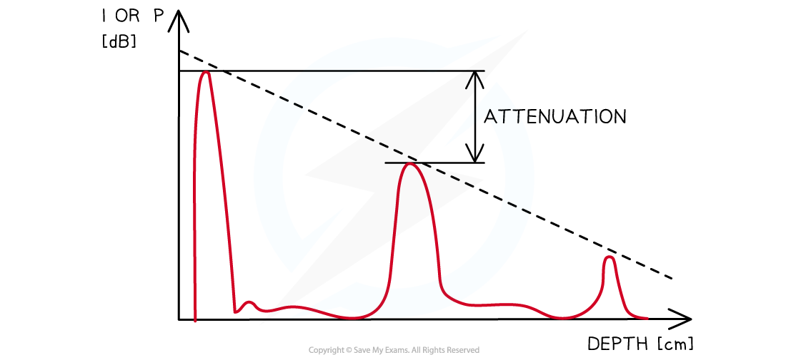
Figure8: Attenuation coefficient graph (Source: Google)
3.2. sizing accuracy of the individual technicians through Linear regression and Statistical analysis.
By applying a linear equation to the observed data, linear regression can be used to determine the relationship between two variables. There are two different kinds of variables; the first is referred to as an independent variable, and the second is a dependent variable. Predictive analysis often uses linear regression. Regression's main goal is to look at two things. First, can an outcome (dependent) variable be accurately predicted using a collection of predictor variables? Which variables significantly predict the outcome variable is the second item on the list. The idea of the linear regression equation, its formula, and the properties of linear regression will all be covered in this article.
Because the normal distribution is symmetrical on both sides of the mean and is a continuous probability distribution, the right side of the centre is the opposite of the left side. Probability is represented by the area under the normal distribution curve, and the total area under the curve equals one. In a normal distribution, the majority of continuous data values tend to cluster around the mean, and the more away from the mean a value is, the less probable it is to occur. The tails approach but never quite touch the horizon because they are asymptotic. The apex of the curve, which is a visual representation of the mean, median, and mode for a completely normal distribution, will have the same value. Because the probability density graph of the normal distribution resembles a bell, it is frequently referred to as the bell curve. In honour of the German mathematician Carl Gauss, who initially characterised it, it is often referred to as the Gaussian distribution.
4.Procedure:
4.1. Attenuation coefficient for rectangular block and Brake disc by Ultrasonic flaw detector
Electrical waves are transformed by a transducer into high-frequency sound waves that travel throughout the test object. When sound waves come into contact with a break in their course, they reflect back to the receiver, where they are changed into electrical waves and shown on an oscillator display. To preserve the smooth propagation of sound waves, a couplant gel is used. By examining the graph that is shown on the oscillator display, UT made it feasible to find thickness, cracks, and other problems.
4.2. sizing accuracy of the individual technicians through Linear regression and Statistical analysis.
A statistical strategy or technique called linear regression is used to examine the relationship between two continuous quantitative variables. This method involves predicting the value of a dependent variable using independent variables. Simple linear regression occurs when there is just one independent variable; multiple linear regression occurs when there are numerous independent variables. Through the process of fitting a linear equation to the observed data, linear regression models establish a link between dependent and independent variables. The term "linear" describes the way we fit our data using a line. The response or predicted variables used in regression analysis are also known as the dependent variables, while the explanatory factors or predictors are also known as the independent variables. The least-squares method, which minimises the sum of squares of departure of data points from the line, is typically used in linear regression to choose the best fit line for observed data.
We have a dataset of a few people who have used the equipment, along with information about the features of their performance. Select the X and Y columns of the dataset, along with their headings, first. Select the scatter thumbnail option from the insert and expand options for scatter charts. With the scatter plot now visible, we can add a regression line to it by right clicking any data point and choosing add Trendline. Choose the R-squared equation, which is the coefficient of determination used as a measure of the goodness of fit, and the Display equation on the chart options. It ranges from 0 to 1. After linear regression, a normal distribution curve must be drawn, Calculate the standard deviation after determining the mean for the errors between true size and the operator. The curve will be steeper and less likely to spread out the less the standard deviation is, and vice versa. Find Range values that are used as the X-values to set the curve's X-values using Mean and Standard deviation. For each x-axis value, calculate the values from the normal distribution. Make a scatter plot using values that are smooth. Create the label data and add the information to the chart.
5.Measurements and Graphs:
5.1. Attenuation coefficient for rectangular block and Brake disc by Ultrasonic flaw detector
 | Thickness = 19mm |  | Frequency = 5MHZ
Position | A1 | A2 | A3
1 | 92 | 49 | 32
2 | 78 | 45 | 32
3 | 60 | 40 | 28
4 | 72 | 34 | 20
5 | 70 | 30 | 18
6 | 62 | 28 | 15
Figure 9: Measurements of values from Ultrasonic flaw detector for rectangular block
 | Thickness = 12.6mm |  | Frequency = 5MHZ
Position | A1 | A2 | A3
1 | 97 | 24 | 7
2 | 99 | 24 | 7
3 | 90 | 19 | 5
4 | 80 | 17 | 5
5 | 93 | 23 | 6

Figure 10: Measurements of values from Ultrasonic flaw detector for Brake disc

5.2. sizing accuracy of the individual technicians through Linear regression and Statistical analysis.

Graph 1: Linear regression between True size and Operator1

Graph 2: Linear regression between True size and Operator2

Graph 3: Linear regression between True size and Operator3

Graph 4: Linear regression between True size and Operator4

Graph 5: Linear regression between True size and Operator5

Graph 6: Linear regression between True size and Operator6

Graph 7: Linear regression between True size and Operator7

Graph 8: Linear regression between True size and Operator8

Graph 9: Linear regression between True size and Operator9

Graph 10: Linear regression between True size and Operator10

Statistical Analysis for Linear regresson charts:

Graph 11: Normal distribution curve for Operator1

Graph 12: Normal distribution curve for Operator2

Graph 13: Normal distribution curve for Operator3

Graph 14: Normal distribution curve for Operator4

Graph 15: Normal distribution curve for Operator5

Graph 16: Normal distribution curve for Operator6

Graph 17: Normal distribution curve for Operator7

Graph18 : Normal distribution curve for Operator8

Graph 19 : Normal distribution curve for Operator9

Graph 20: Normal distribution curve for Operator10

6.Calculations:
6.1. Attenuation Coefficient Calculations for the Rectangular Block:
Here we have taken 6 readings for the rectangular block which has thickness 19 mm and Frequency 5Mhz
 | Thickness = 19mm |  | Frequency = 5MHZ
Position | A1 | A2 | A3
1 | 92 | 49 | 32
2 | 78 | 45 | 32
3 | 60 | 40 | 28
4 | 72 | 34 | 20
5 | 70 | 30 | 18
6 | 62 | 28 | 15
Figure 11: Rectangular block Measurements from the experiment
Formula for Calculating Attenuation coefficient is α = (20/d) *ln(A2/A1)
Whenever we are considering A1 and A2, A2 and A3 we need use distance = 2 * thickness= 2*19=38mm
Whenever we are considering A1 and A3 we need to use distance = 4 * thickness= 4*19=76mm
1.α = (20*(2*Thickness)) *Ln(A2/A1) = (20*38) * Ln (49/92) = -0.144dB/mm Whenever we are considering A1 and A2, A2 and A3 we need use distance = 2 * thickness= 2*19=38mm
Whenever we are considering A1 and A3 we need to use distance = 4 * thickness= 4*19=76mm
2.α = (20*(2*Thickness)) *Ln(A3/A2) = (20*38) * Ln (32/49) = -0.097dB/mm
3. α = (20*(4*Thickness)) *Ln(A3/A1) = (20*76) * Ln (32/92) = -0.120dB/mm
4. α = (20*(2*Thickness)) *Ln(A2/A1) = (20*38) * Ln (45/78) = -0.125dB/mm
5. α = (20*(2*Thickness)) *Ln(A3/A2) = (20*38) * Ln (32/45) = -0.619dB/mm
6. α = (20*(4*Thickness)) *Ln(A3/A1) = (20*76) * Ln (32/78) = -0.372dB/mm
7. α = (20*(2*Thickness)) *Ln(A2/A1) = (20*38) * Ln (40/60) = -0.092dB/mm
8. α = (20*(2*Thickness)) *Ln(A3/A2) = (20*38) * Ln (28/40) = -0.0815dB/mm
9. α = (20*(4*Thickness)) *Ln(A3/A1) = (20*76) * Ln (28/60) = -0.0871 dB/mm
10. α = (20*(2*Thickness)) *Ln(A2/A1) = (20*38) * Ln (34/72) = -0.171dB/mm
11. α = (20*(2*Thickness)) *Ln(A3/A2) = (20*38) * Ln (20/34) = -0.121dB/mm
12. α = (20*(4*Thickness)) *Ln(A3/A1) = (20*76) * Ln (20/72) = -0.146dB/mm
13. α = (20*(2*Thickness)) *Ln(A2/A1) = (20*38) * Ln (30/70) = -0.193dB/mm
14. α = (20*(2*Thickness)) *Ln(A3/A2) = (20*38) * Ln (18/30) = -0.116dB/mm
15. α = (20*(4*Thickness)) *Ln(A3/A1) = (20*76) * Ln (18/70) = -0.155dB/mm
Here we have taken 5 readings for the Brake disc which has thickness 12.6 mm and Frequency 5Mhz
 | Thickness = 12.6mm |  | Frequency = 5MHZ
Position | A1 | A2 | A3
1 | 97 | 24 | 7
2 | 99 | 24 | 7
3 | 90 | 19 | 5
4 | 80 | 17 | 5
5 | 93 | 23 | 6

Figure 12: Brake disc measurements from the experiment
Whenever we are considering A1 and A2, A2 and A3 we need use distance = 2 * thickness= 2*12.6=25.2mm
Whenever we are considering A1 and A3 we need to use distance = 4 * thickness= 4*12.6=50.4mm
- α = (20*(2*Thickness)) *Ln(A2/A1) = (20*25.2) * Ln (24/97) = 0.481dB/mm
- α = (20*(2*Thickness)) *Ln(A3/A2) = (20*25.2) * Ln (7/24) = -0.424dB/mm
- α = (20*(4*Thickness)) *Ln(A2/A1) = (20*50.4) * Ln (7/97) = -0.453dB/mm
- α = (20*(2*Thickness)) *Ln(A2/A1) = (20*25.2) * Ln (24/99) = 0.488dB/mm
- α = (20*(2*Thickness)) *Ln(A3/A2) = (20*25.2) * Ln (7/24) = -0.424dB/mm
- α = (20*(4*Thickness)) *Ln(A2/A1) = (20*50.4) * Ln (7/99) = -0.456db/mm
- α = (20*(2*Thickness)) *Ln(A2/A1) = (20*25.2) * Ln (19/90) = 0.536dB/mm
- α = (20*(2*Thickness)) *Ln(A3/A2) = (20*25.2) * Ln (5/19) = -0.460dB/mm
- α = (20*(4*Thickness)) *Ln(A3/A1) = (20*50.4) * Ln (5/90) = -0.498dB/mm
- α = (20*(2*Thickness)) *Ln(A2/A1) = (20*25.2) * Ln (17/80) = 0.533dB/mm
- α = (20*(2*Thickness)) *Ln(A3/A2) = (20*25.2) * Ln (5/17) = -0.421dB/mm
- α = (20*(4*Thickness)) *Ln(A3/A1) = (20*50.4) * Ln (5/80) = -0.477dB/mm
- α = (20*(2*Thickness)) *Ln(A2/A1) = (20*25.2) * Ln (23/93) = 0.481dB/mm
- α = (20*(2*Thickness)) *Ln(A3/A2) = (20*25.2) * Ln (6/23) = -0.463dB/mm
- α = (20*(4*Thickness)) *Ln(A3/A1) = (20*50.4) * Ln (6/93) = -0.472dB/mm

7.Results and Discussion:
7.1. Material attenuation coefficient by time-of-flight method
The average Attenuation coefficient of rectangular block is 0.166dB/mm and the average attenuation coefficient for the Brake disc is 0.4711dB/mm. Geometric spreading and intrinsic attenuation are the two main factors that make up the ultrasonic wave attenuation coefficient. Scattering on air void inclusions and absorption in solid materials are two types of intrinsic attenuation. Given that the geometric spreading for different-sized specimens changes, the attenuation coefficient, which is a material attribute, can be derived by eliminating it. DB/mm is a unit that can be used to express attenuation coefficient. According to the experimental findings, the attenuation coefficient increases sustainably with the quantity of air voids present, as well as with the size of the materials' grains and to a significant extent with thickness. Additionally, the attenuation coefficient is more sensitive to higher frequencies the thinner the material is, the higher the attenuation coefficient happens. Grain size can occasionally be determined using attenuation coefficients. An identifiable impact on ultrasonic attenuation can be observed when a grain size distribution is present. The effect that a distribution might have on mean grain size is demonstrated by longitudinal attenuations, which are calculated at various thicknesses and frequencies (Yim, Kwak and Kim, 2012).

7.2. sizing accuracy of the individual technicians through Linear regression and Statistical analysis

Graph 21: Graph of R-squared values from the equation
R-squared assesses the scatter of the data around the regression lines, as opposed to the mean, which is the focus of the regression coefficients and predicted values. The two R-squared values are so dissimilar because of this. Lower R-squared values are produced for a given dataset when the regression line is surrounded by more variability. The equation with the least difference between all the observed values and their fitted values is identified via linear regression. Linear regression determines the dataset's least sum of squared residuals. To examine the relationship between a continuous outcome and independent factors, linear regression models are frequently used; however, it should be noted that binary outcomes may also be utilised to satisfy "the" normality assumption. We demonstrate that linear regression models without normally distributed errors are valid when the sample size is high enough in this succinct summary of much larger theoretical works. Despite this well-known trait, outcome modifications are frequently used indiscriminately in an effort to make the residuals conform to a normal distribution. As was previously mentioned, such transformation frequently biases slope coefficients (as well as parameter estimates) and ought to be avoided. Naturally, the definition of a big sample size varies depending on the analysis. Before, we mentioned a ratio of 21 observations per parameter, but lower values have also been determined to be enough (Austin and Steyerberg, 2015). Examine the graph on the left. We're employing estimates when we use the data points to create a regression line. We want to identify the line that most accurately captures the data. We can utilize the "hat" notation. when dealing with estimates. When using estimates, the "best fit line" will be drawn using the same formula as the straight line, but with that notation.

Graph 22: Normal distribution curves of 10 Operators
We refer to the pattern of values obtained when we measure a quantity across a significant number as a distribution. For instance, the image above displays a histogram of the distribution of various technicians who utilised the equipment to conduct measurements. This distribution is experimental. There are theoretical distributions as well, with the normal distribution being the most well-known. From the above graph it is shown that the probability of errors is low for the technicians whose standard deviation is high. The Operators graph which is higher or taller the standard deviation is lower.
8.Conclusion:
In this paper we have successfully done the experimental calculations to find out attenuation coefficient by using two samples which are rectangular block and brake disc and explained briefly about the Ultrasonic Attenuation coefficient and about the Variation of attenuation coefficient depending on their grain size, frequency and also their thickness of the specimen. On the other hand, we discussed about the Linear regression and Statistical analysis of the Technicians and their performance of taking measurements on the equipment and noted their performance on the graphs by using Mean, Standard deviation and Normal distribution formulas.

9.References:
1.Aitken, A. (1936). IV.—On Least Squares and Linear Combination of Observations. Proceedings of the Royal Society of Edinburgh, 55, 42-48. doi:10.1017/S0370164600014346.
2.Austin, P.C. and Steyerberg, E.W. (2015). The number of subjects per variable required in linear regression analyses. Journal of Clinical Epidemiology, [online] 68(6), pp.627–636. doi: 10.1016/j.jclinepi.2014.12.014.
3. Nayfeh, A.H. (1991). Elastic wave reflection from liquid-anisotropic substrate interfaces. Wave Motion, 14(1), pp.55–67. doi:10.1016/0165-2125(91)90048-s.
4. Yim, H.J., Kwak, H.-G. and Kim, J.H. (2012). Wave attenuation measurement technique for non-destructive evaluation of concrete. Non-destructive Testing and Evaluation, 27(1), pp.81–94. doi:10.1080/10589759.2011.606319.
5. How to Create a Normal Distribution Bell Curve in Excel - Automate Excel
6. Linear Regression in Excel | How to do Linear Regression in Excel? (educba.com)
7. Attenuation coefficient - Wikipedia

‌

