
LEVEL 4 ASSESSMENT SPECIFICATION

Certificate of Higher Education Skills for the work

STUDENT NAME: Khairuzzaman Rob

STUDENT ID NUMBER: 1915327

MODULE: DIGITAL SKILLS AND RESERCH METHODS

MODULE CODE: BMSW4003

LECTURER: CHRIS FELICES

ASSIGNMENT TITLE: 500 WORD ON WEBSITE REPORT

SUBMISSION DEADLINE: Report- 10/07/2020

WEEBLY : LOG IN DETAILS : 1915327KROB@GMAIL.COM
PASSWORD : MILLHILL1999
MY WEBSITE DESIGN

AM DESIGNING A WEBSITE FOR MY NEW BUSINESS WHICH WILL CO SIDE MY OLD BUSINESS . HAVING BEEN A TAXI COMPANY IN CARDIFF AND RHONNDA OVER 5 YEARS I HAVE DECIDED TO EXTEND MY BUSINESS ON TO THE AIRPORT AND PORT TRANSFERS. HOPEFULLY ALONG WITH MY LOCAL TAXI BUSINESS AND WIDENING MY OPTION SHOULD INCREASE MY TAKINGS FOR THE BUSINESS. AND HOPEFULLY IF IT ALL GOES WELL THEN HOPEFULLY I CAN WORK LESS AND EARN MORE BY DOING AN AIRPORT OR PORT JOBS ONCE A DAY OR 5 A WEEK.

WHY I CHOSE THOSE IMAGES AND WHY?
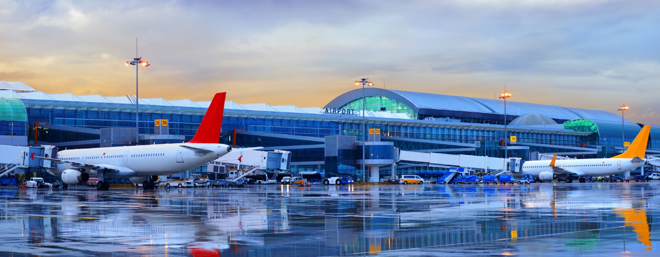

THE REASON I CHOSE THIS IMAGE FOR MY WEB PAGE IS FIRST IT TELLS YOU EXACTLY WHAT I WANTED TO LET YOU KNOW ITS AN IMAGE OF AN AIRPORT AND WHAT MY BUSINESS REPRESENTS AIRPORT TRANSFER AND THE MAIN REASON I CHOSE THIS IMAGE OVER OTHER ONES IT’S THE COLOURS AND THE LOVELY SUBTLE TONE . ITS LIKE A DUSK AND DAWN TONE IN ONE WHICH WILL MAKE THE CLIENTS, I WISH TO APPROCH WILL SEE THE THOUGHT GONE INTO THIS IMAGE . I WANT TO APPROCH FREQUENT FLYERS LIKE BUSINESS CLIENTS WHO FLY FOR MEETINGS AND ALSO WHO FLY TO AND FROM WORK ON A WEEKLY BASIS . THE IMAGE ALSO SHOWS BIG PLANES WHICH MEANS HOLIDAYS AND LONG HAUL FLIGHTS WHICH I WILL ALSO BE HAPPY TO DO AS I HAVE 6 TO 16 SEATER VEHICLES TOO.
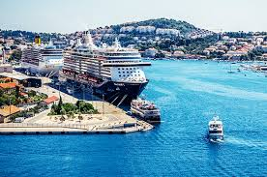
MY SECOND IMAGE OF THE PORT SHOWS WHAT EVERYONE WANTS TO SEE WHEN THEY GO ON A CRUISE HOLIDAY . LOVELY , BRIGHT, SUNNY DAY ALONG WITH A BEAUTIFUL IMAGE OF THE CRUISE SHIPS , AND A STUNNING PORT . THIS WILL HOPEFULLY GET ME CLIENTS WHO WISH TO BOOK TO GO ON A CRUISE OR HOPEFULLY CLIENTS THAT WORK ON THE SHIPS TOO.
ALONG WITH MY IMAGES MY SEO ( SEARCH ENGINE OPTIMIZATION) ON THE WEBSITE SETTINGS SHOULD HELP ME TOO BY GETTING CLIENTS THROUGH TO MY WEBSISITE . MY SEO SHOULD INCREASE THE QUANTITY AND QUALITY OF TRAFFIC THROUGH TO MY WEBSITE OF THE KEY WORD AM USING LIKE TAXI AIRPORT AND PORTS SO I SHOULD FALL UNDER FEW CATEGORIES WHICH GIVES ME MORE POTENTIAL CLIENTS.
SEO IS AN ACRONYM WHICH PROCESSES YOUR WEBSITE TO GET ORGANIC OR UN-PAID TRAFFIC FROM SERCH ENGINE RESULTS PAGE. IN OTHER WORDS , SEO MEANING INVOLVES MAKING CERTAIN CHANGES TO YOUR WEBSITE DESIGN AND CONTENT THAT MAKE YOUR SITE MORE ATTACTIVE TO A SEARCH ENGINE . YOU DO THIS IN HOPES THAT THE SEARCH ENGINE WILL DISPLAY YOUR WEBSITE AS A TOP RESULT ON THE SEARCH ENGINE RESULTS PAGE.
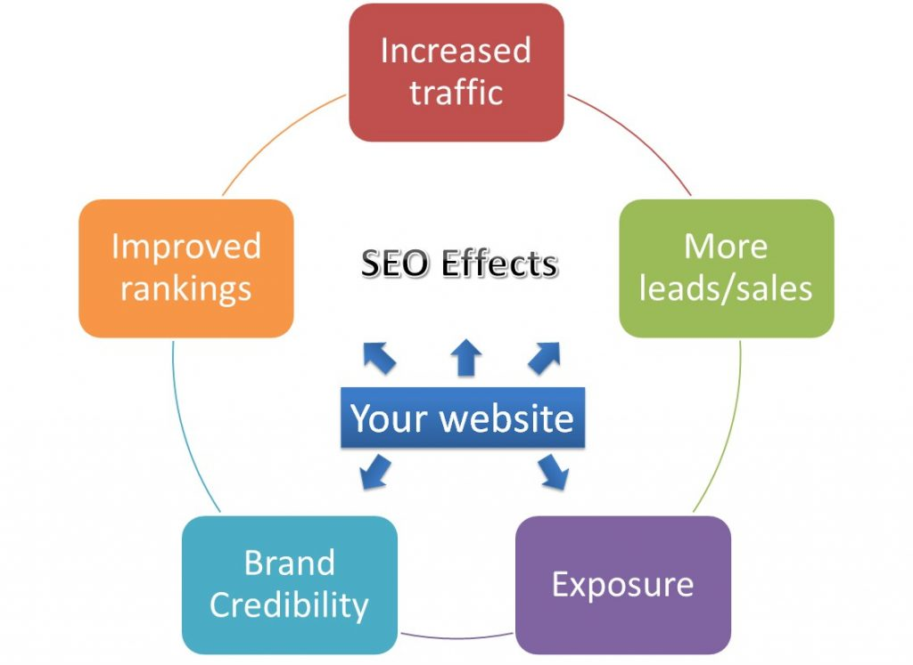
SEARCH ENGINES WANT TO PROVIDE THE BEST SERVICE FOR THEIR USERS . THIS MEANS DELIVERING RESULTS ON THE SEARCH ENGINE PAGES THAT ARE NOT ONLY HIGH QUALITY BUT ALSO RELEVENT TO WHAT THE SEARCHER IS LOOKING FOR.

