UNIVERSITY OF WALES TRINITY SAINT DAVID
Independent Project Dissertation Methodology
Researcher: Callum Rhys Samuel – ID : (1801402)
MA Criminal Justice and Policing
September 2022

Table of Contents
Chapter 3 – Methodology 4
3.0 Introduction 4
3.1 The Research Onion 5
3.1.1 Research Philosophy 6
3.1.2 Research Approach 8
3.1.3 Research Strategy and Choice 9
3.1.4 Time Horizon 10
3.1.5 Techniques: Data Collection and Analysis 11
3.1.5.1 Data Collection 11
3.1.5.2 Survey Design 11
3.1.5.3 Interview Design 12
3.1.5.4 Pilot Study 13
3.1.5.5 Matrix Analysis 13
3.1.5.6 Analysis 13
3.2 Sample 14
3.3 Reliability and Validity 14
3.3.1 Triangulation 15
3.4 Limitations 15
3.5 Ethical Considerations 16
3.6 Conclusion 17
Reference List: 17
Appendix X (Blank copy of Questionnaire / Survey) 19
Appendix X (Literature Review and Question Matrix: Questionnaire/Survey) 33
Appendix X (Questionnaire / Survey Answers) 36
Appendix X (Blank copy of Interview Sheet) 36
Appendix X (Literature Review and Question Matrix: Interview) 50
Appendix X (Interview Transcript / Responses) 54

Chapter 3 – Methodology

3.0 Introduction
The previous chapter of the dissertation achieved objectives 1 and 2 of this study, with the analysis of existing academic literature providing a solid foundation for understanding the way in which contemporary terrorist organisation’s function and behave, as well as how terrorism should in fact be defined.

With regards to the third objective of this study, objective 3: “3. Gather and conduct primary research as well as analyse data that will be obtained through interviews of counter terrorism experts on the topic of terrorism and its evolution.”. This chapter will seek to identify and outline the research methods that will be utilised to both inform and achieve this objective.

There are many research umbrella models observed in academic writing, with the Research Onion by Saunders (et al., 2016) having been chosen as the guidance and structure provided by each layer of the research model enables the researcher to clearly identify and select the most appropriate research strategy, data collection methods, and data analysis techniques that are most suited for this dissertation.

Research is the enhancement of one’s knowledge surrounding a given topic (Collis and Hussey, 2014), with Turabian (2010) observing that individuals are always researching throughout our lives, with the act of asking a question and seeking an answer, demonstrating this apparent innate behaviour in life. Saunders (et al., 2016) further notes that in academic writing, research is no different, with research and the need for answers and additional knowledge either providing confirmation, or denial of research theories.

In a given study, information is often pulled from two main sources of data, with Bryman (2016) acknowledging that these two main sources are often either primary or secondary research. Primary research according to Bryman (2016) is information and data that has been personally gathered and obtained with a specific intention or individual study in mind, with this information often tailored to answer or investigate a certain research area. Whereas secondary research, Bryman (2016) illustrates, is information that has been gathered and obtained by another researcher but holds valid and relevant information that can be utilised by others.

Following the research conducted and presented in the literature review, an academic gap was identified in the form of little to no expert or public views regarding the future direction of terrorism, with existing research entirely found in a theoretical setting, therefore, primary research will be required to assist in seeking an improved understanding of future terrorist threats. To ensure thorough understanding of the entirety of the research process, this chapter will now state the intended research methodology for this research project.

3.1 The Research Onion
The Research Onion developed by Saunders (et al., 2016) will be the primary tool in outlining the research process for this particular project. The way in which the diagram should be observed would be to firstly look at the outer layer, and then work towards the centre and to the left of the diagram, developing each layer as you progress. The following Figure X demonstrates the intended pathway of this project:

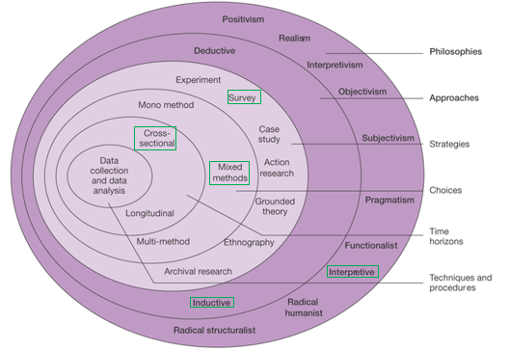

Figure X - The Research Onion (Source: Saunders et al., 2016)

3.1.1 Research Philosophy
The outermost layer or “Research Philosophies” represents the perspective the researcher will be viewing their research from, with the chosen philosophy often providing insight into the assumptions or expectations a researcher may have about their chosen area (Saunders et al., 2019).

Research philosophies provide varying ontological and epistemological theories regarding both the nature of reality and how knowledge and research of this reality is obtained (Mauthner, 2020), with the philosophical implications of each approach potentially informing the mindset of a researcher, as well the conscious or unconscious assumptions a researcher may have during each stage of the study (Saunders et al., 2019).

“Interpretive” is the philosophical perspective that will be observed for this project, with Bryman (2016) discussing how an interpretive perspective is best suited when dealing with complex and layered research topics such as human behaviour, with potential terrorist ideological mindsets and strategies being the focus of this project, a human insight or qualitative analysis for human actions will be most suited. Furthermore, Saunders (et al., 2019) highlights that investigations into social science and human strategy is more suited towards this philosophy, as opposed to concrete statistical analysis and new universal “laws” that may be seen and put forward in more positivist and quantitative designs.

The following Figure X provided by Bryman (2016) outlines the main steps in conducting qualitative research, with the figure further informing the reader as to why an interpretive approach will be taken and why it is the most suited for this project.

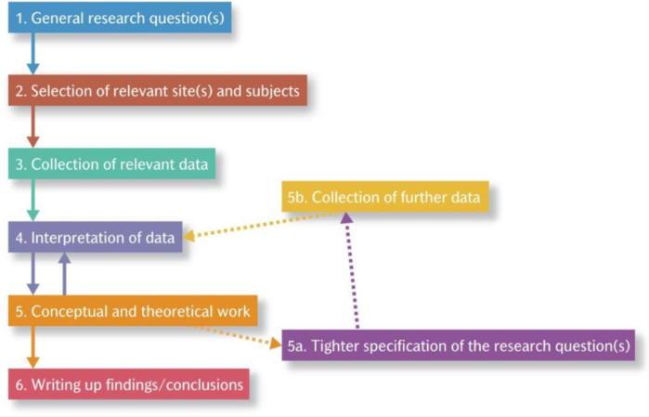
Figure X - Outline of Qualitative Research (Source: Bryman, 2016)

3.1.2 Research Approach
As demonstrated in Figure X (Onion) provided by Saunders (et al., 2016), when it comes to academic writing there are two “Research Approaches” that are most prominently used. They key differences between the two approaches of “Deductive” and “Inductive” are illustrated by Bryman (2016) where they state a deductive approach begins with a theory, with the objective of the researcher to prove or disprove their initial theory or hypothesis, whilst an inductive study is thematically the opposite, where the researcher may notice or observe trends and come across patterns or findings, and then set out to further collect data to reach a conclusion.

Due to the inherit way in which this study will be conducted, an “Inductive” approach will be utilised for this project, with additional insight provided in Figure X (Ded vs Ind) by Bryman (2016), presenting the distinctions between the two processes, with the aim of this project to eventually provide a theoretical outlook on the future, based on contemporary understanding.
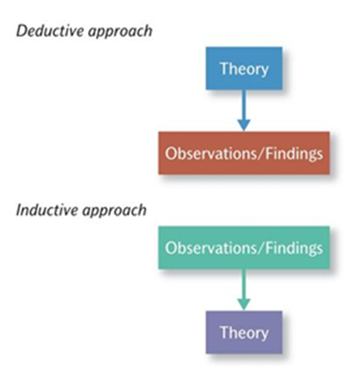

Figure X - Deductive and Inductive Approaches to the Relationship Between Theory and Research (Source: Bryman, 2016)

3.1.3 Research Strategy and Choice
There will be two components of data collection for this study. Firstly, an online questionnaire will be conducted and analysed, as the results of this research may inform the more in-depth qualitative research which will make up the secondary data collection and will be in the form of expert qualitative interviews. This therefore results in the need for a “Mixed Method” approach to be implemented as part of the data collection.

The online questionnaire will provide a contemporary foundational view of terrorism from the perspective of the public, with the qualitative expert interviews providing greater insight into the topic areas that will be asked in the online questionnaire, as well as provide opportunities to delve deeper into the themes identified and focused upon in the literature review.

Through conducting “Survey” questionnaires, as well as expert interviews, information can be obtained in both a quantitative nature, as well as qualitative as the information acquired from varying viewpoints can better inform the analysis and research conclusions. Furthermore, the demographic of participants will be broad as the questionnaire will be available online for anyone to complete, as well as the participants of the qualitative interviews being retired former counter-terrorism police officers. Interviewing and questioning individuals from a plethora of backgrounds and perspectives will better inform the research project and will offer insight into the public perceptions of terrorism, as well as the expert views on the future direction of terrorist strategy.

Due to the use of a “Mixed Method” research choice, with the research strategy behind this being the utilisation of two “Survey” strategies, triangulation of these findings will need to occur as Grix (2004) defines triangulation as “A process in which the researcher uses two or more research methods to investigate the same phenomena”.

3.1.4 Time Horizon
“Time Horizons” is the last section of the research onion that is important to acknowledge, with this section illustrating how long the research collection for the project can take (Saunders et al., 2016). Due to the size of this study being relatively small and not a multi-year endeavour, “Cross-sectional” is the most suited time horizon for this research project, this also provides the opportunity for future “Longitudinal” research to occur if needed.

3.1.5 Techniques: Data Collection and Analysis

3.1.5.1 Data Collection
Using multiple methods to collect data will enable broader and greater understanding (Saunders et al., 2016), as the questionnaire to the public may provide results that warrant further analysis which can then occur in the qualitative interviews. Furthermore, by gathering data through both quantitative and qualitative research methods, the primary data obtained from the combining methodologies can be triangulated and enable a joint conclusion to be pulled from the two sources of data, thus providing a more thorough conclusion.

Due to time constraints and individual circumstances, the data collection regarding both the quantitative survey, and the qualitative interview will take place in the form of an online survey, as well as an interview sheet sent to participants with pre-written questions. A blank copy of the questionnaire and interview sheet can be viewed in Appendix X&X of the dissertation.

3.1.5.2 Survey Design
The questionnaire that will be distributed to the public will have 15 questions, with 5 scenarios also provided for the respondent to judge and determine which incidents would be considered terrorism, and what incidents would not, in their view.

The logic behind this line of questioning is to put the views of the respondents at the forefront of the data collection, with additional questions including generic behaviours on the internet, and if the respondents were aware of any infrastructure measures seen in public places to counter-terrorism. Additionally, respondents will be asked how they would define the word terrorism, as well as whether they consider security or freedom of expression to be the most important regarding online and harmful material. Finally, the respondents will also be asked to consider which form of terrorism, or what type of attack do they most fear to occur in their day-to-day lives, as well as what in their view, the future of terrorism could look like.

3.1.5.3 Interview Design
The researcher conducted X interviews with individuals who have previously provided help and contribution into the topic of terrorism, as seen in the researcher’s undergraduate dissertation. The participants were chosen due to their expertise and experiences of being former counter-terrorism police officers, demonstrating a non-probability or non-random sample of participants. All of the participants were interviewed via an interview sheet that was emailed individually to each respondent. Due to the unknowingness of individual circumstances, as well as the busyness of day-to-day lives, an interview with pre-written questions was chosen as the best method as online complications regarding live virtual interviews can hinder the data collection of primary data, as a recording or download error could result in loss of data.

3.1.5.4 Pilot Study
To ensure the accessibility of the online questionnaire and to ensure the principles of reliability and validity were observed, as well as the ethical considerations regarding the questions themselves, the online questionnaire was viewed and approved by faculty prior to its distribution. Furthermore, the questionnaire was opened and completed on an alternative computer to ensure the questionnaire could be conveniently opened and accessed, as well as completed anonymously.

The interview questions were similarly approved by faculty prior to the distribution of the interview sheet, with anonymity also provided to ensure the privacy and safety of the respondents.

3.1.5.5 Matrix Analysis
A literature review and questionnaire / interview matrix analysis can be viewed in Appendix X&X of the dissertation.

3.1.5.6 Analysis
When analysing the quantitative data provided by the questionnaire, data analysis software will be utilised to present the data in numeral form to assist in the statistical analysis. The open-ended questions of the questionnaire, as well as the qualitative interview responses will be analysed through a thematic approach to identify any common themes or patterns. The transcripts of all interview responses as well as all answers from the questionnaire can be viewed in Appendix X&X of the dissertation. Following the analysis of both the qualitative and quantitative data, the researcher will then triangulate the combining methodologies in the study.

3.2 Sample
To ensure the collection of the most relevant and credible primary data, the participants for the interviews were chosen to be individuals with a counter-terrorism background. Due to the inherent nature of the topic of terrorism, expert and experienced individuals are difficult to contact. Therefore, the response and sample volume with regards to the interviews may be limited, however, it is important to note that volume of participants does not equate value or limit the important data that can be extracted from participants to be utilised for this study.

The recommended sample size for quantitative data collection on a shorter time scale is one hundred people (Collins and Hussey, 2014). This figure should be reasonable enough to reach as the intention behind the quantitative aspect of this primary data collection is to ask for the views of the public, with no limit on the number as well as no occupational experience required for individuals to respond or add value to the research, unlike the specific requirements seen in the qualitative interviews.

3.3 Reliability and Validity
Reliability is observed when results are consistently obtained using the same method for gathering information, with validity meaning the data collected is in fact accurate, valid, and academically agreed upon (Saunders et al., 2016). The reliability of a study is crucial in ensuring the results of a project can be repeated, or if the study can occur and be conducted again (Bryman, 2016). Furthermore, the validity of a project is vital as any conclusions made within the study should stand alongside the integrity of the researcher and research process itself, with Bryman (2016) arguing that quantitative research should demonstrate: measurement, causality, generalisation, and replication. Bryman (2016) also argues that qualitative research should also demonstrate: credibility, transferability, dependability, and confirmability, with expert interviews fitting these aspects.

3.3.1 Triangulation
Data triangulation will be essential for combining the two differing methodologies with regards to data collection. Methodological triangulation enables mixed methods to be compared, contrasted, and potentially combined, with one source of findings coming from the questionnaire, and another through interviews (Denscombe, 2004). Denscombe (2004) highlights that the benefits of triangulation are the improvement in accuracy, which also provides validation of findings, and can also provide a fuller picture and more completeness, as any conclusions will come from a mixed method approach as opposed to a limited mono method.

3.4 Limitations
As a result of time constraints due to the project being cross-sectional as opposed to a longitudinal study, complete analysis of obtained data will not be possible. To assist with the management of the project, a Gantt chart was created to help organise time effectively and ensure each stage of the project was completed in time. Furthermore, due to the ever-changing landscape of individuals working from home, or working in person, individual’s availability to thoroughly respond to either the questionnaire or interview can potentially be an issue, as some individuals may lack the ability to download, complete and return the questionnaire or interview due to lack of technical capabilities or online error, as well as individuals IT capabilities. As well as this, as previously outlined, access to individuals with terrorist expertise or professions in countering terrorism can be difficult, so response rate may be a minor issue.

3.5 Ethical Considerations
When researching a sensitive research topic, ethical considerations are at the forefront of the researcher’s mind, hence the urgency in completing an ethics form prior to the start of the project, to ensure approval for all aspects of the project. Furthermore, prior to any distribution of data collection, approval was sought for all questions asked to all participants. When it came to this collection of primary data, all participants for both the questionnaire and interviews were informed on the purpose of the study, as well as the nature of the questions, and how responses will be utilised for data analysis.

As established in the approved ethics form provided by UWTSD, all participation was voluntary and anonymous, with the right to withdraw from the process maintained throughout. Additionally, despite the more casual nature of the interview process, as evidenced in the back-and-forth correspondence of participant and researcher, the confidentiality of all participants was upheld to ensure the individuals who willingly give their time and assistance were protected, with data held and stored on a password protected device.

3.6 Conclusion
This chapter has successfully outlined the methodology for this study, as well as highlighted the way in which the project intends to achieve objective 3 of the project. The next chapter of the dissertation will present and analyse the data collected and obtained during the collection phase of the research project.

Reference List:
- Bryman, A. (2016). Social Research Methods. 5th ed. Oxford: Oxford University Press.
- Collis, J. & Hussey, R. (2014). Business Research: A Practical Guide for Undergraduate and Postgraduate Students. 4th ed. Basingstoke: Palgrave Macmillan Higher Education.
- Denscombe, M. (2010). The Good Research Guide: For Small-Scale Social Research Projects. 4th ed. [ebook] Berkshire: McGraw-Hill Education. Available at: https://www.researchgate.net/file.PostFileLoader.html?id=582a0dbf217e20276533f5a5&assetKey=AS:428404664213506@1479151039119 [Accessed 22 August 2022].
- Grix, J. (2004). The Foundations of Research. Basingstoke: Macmillan Publishers Limited.

- HM Government. (2012). Crowded Places: The Planning System and Counter-Terrorism. [ebook] London: HM Government. Available at: https://assets.publishing.service.gov.uk/government/uploads/system/uploads/attachment_data/file/375208/Crowded_Places-Planning_System-Jan_2012.pdf [Accessed 22 August 2022].
- Home Office. (2022). Terrorism and National Emergencies. [online] Available at: https://www.gov.uk/terrorism-national-emergency [Accessed 22 August 2022].
- Mauthner, N. (2020). Research Philosophies and Why They Matter. In: Loudoun, R. Morrison, E. Saunders, M., and Townsend, K. (ed.). How To Keep Your Doctorate On Track. [online] Cheltenham: Edward Elgar Publishing. Available at: https://www.researchgate.net/publication/340268223_Research_philosophies_and_why_they_matter [Accessed 22 August 2022].
- Saunders, M., Lewis, P. & Thornhill, A. (2016). Research Methods for Business Students. 7th ed. Essex: Pearson Education Limited.

- Saunders, M., Lewis, P. and Thornhill, A. (2019). Research Methods For Business Students. 8th ed. [ebook] London: Pearson. Available at: https://www.researchgate.net/profile/Mark_Saunders4/publication/330760964_Research_Methods_for_Business_Students_Chapter_4_Understanding_research_philosophy_and_approaches_to_theory_development/links/5c53056f299bf12be3f0e2cf/Research-Methods-for-Business-Students-Chapter-4-Understanding-research-philosophy-and-approaches-to-theory-development.pdf [Accessed 22 August 2022].

- Turabian, K. (2010). A Manual for Writers of Research Papers, Theses, and Dissertations. 8th ed. [ebook] Chicago: The University of Chicago Press. Available at: https://books.google.co.uk/books?hl=en&lr=&id=fqkgAgAAQBAJ&oi=fnd&pg=PR5&dq&ots=lHJkjChjHn&sig=UuN9nuvAVrLkkek7VOPjMSXYh-U#v=onepage&q&f=false [Accessed 22 August 2022].

Appendix X (Blank copy of Questionnaire / Survey)

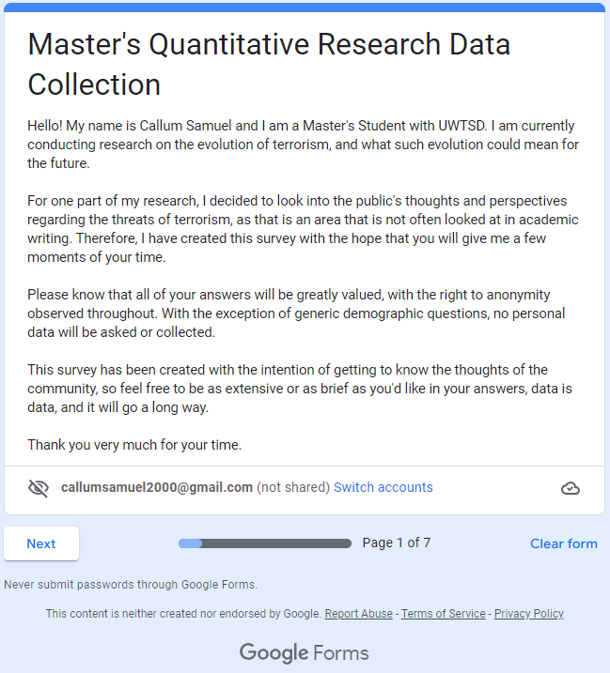
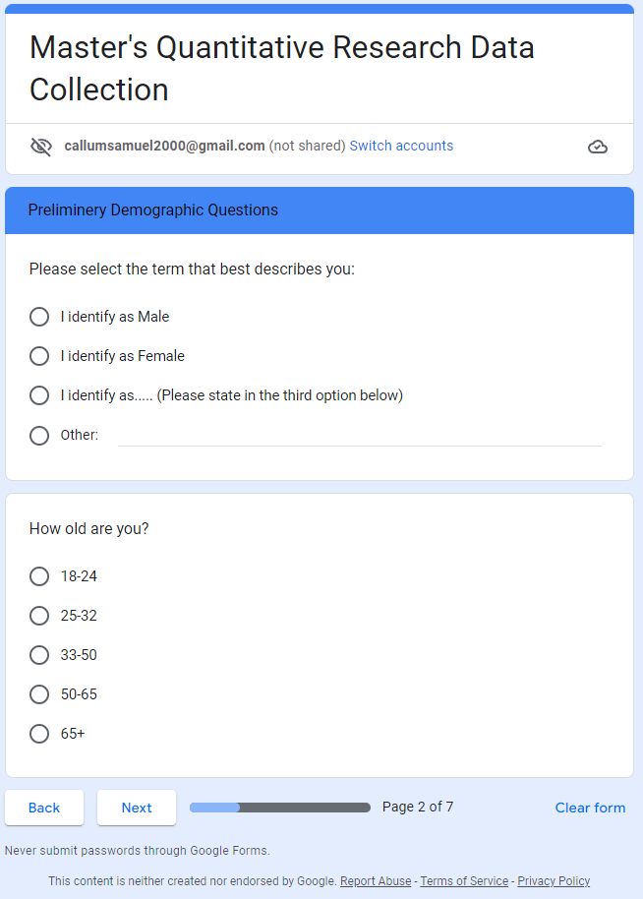
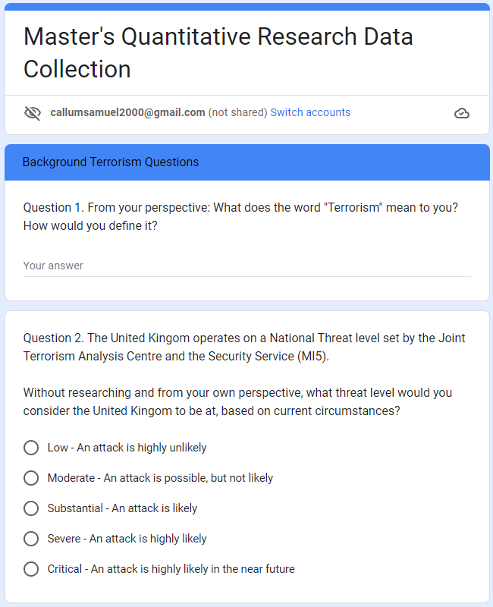
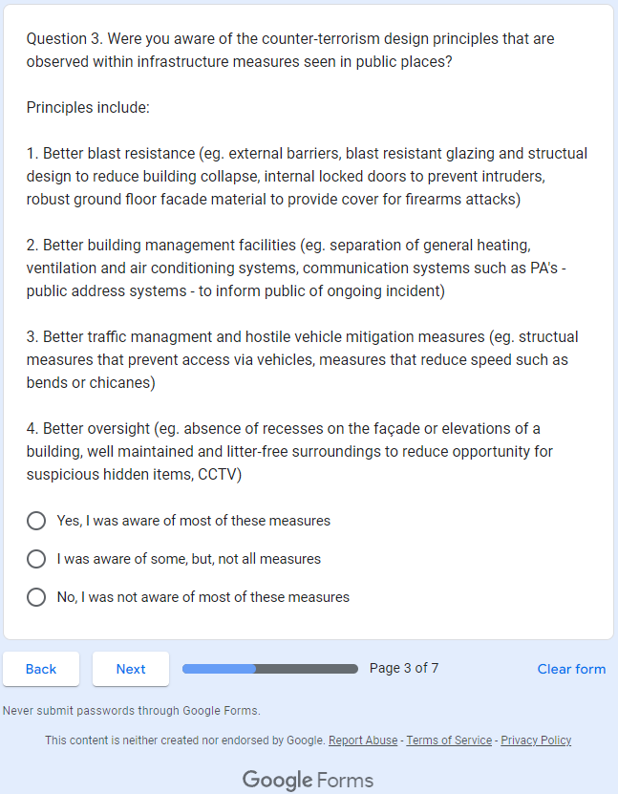
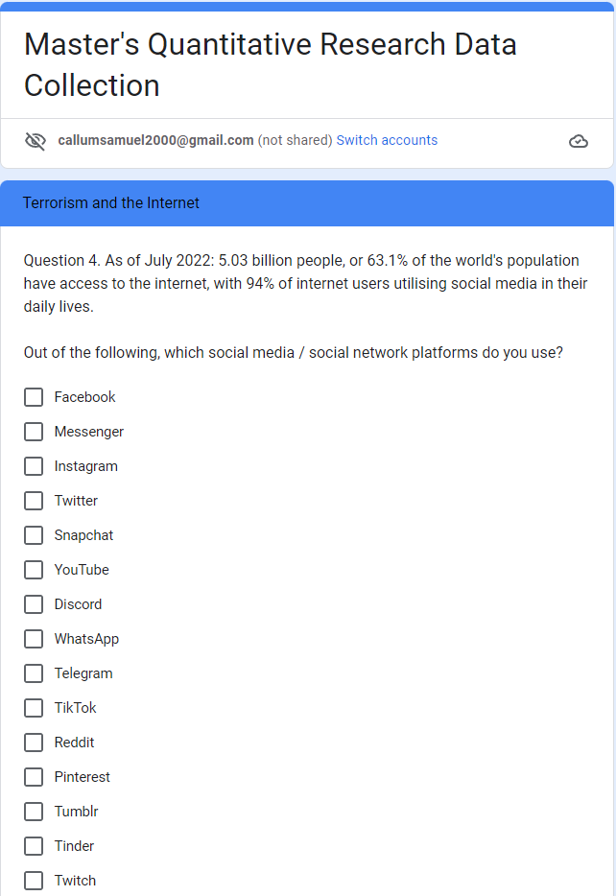
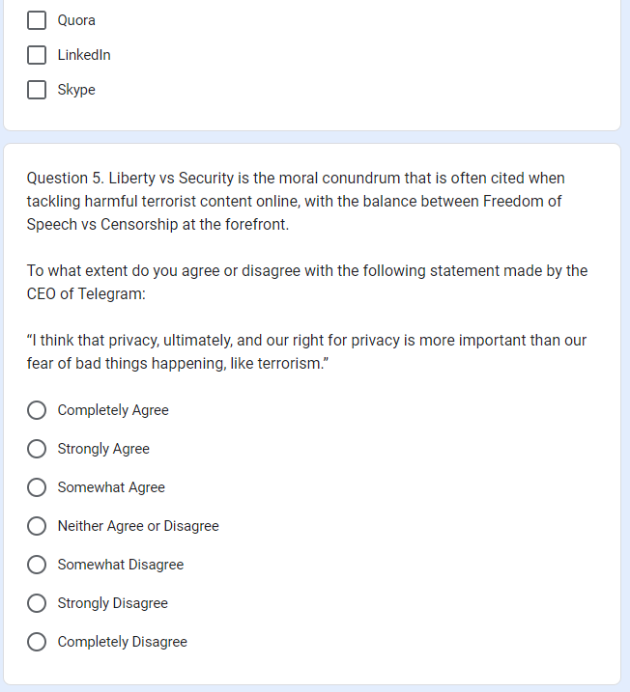
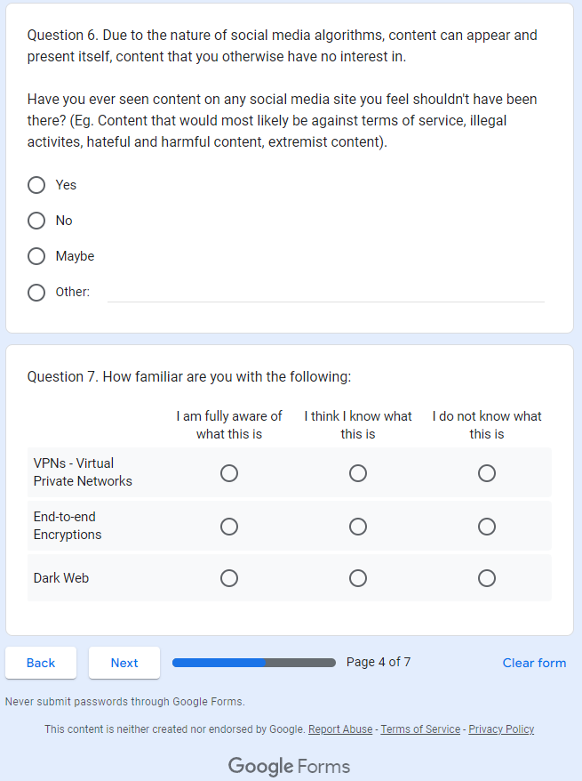
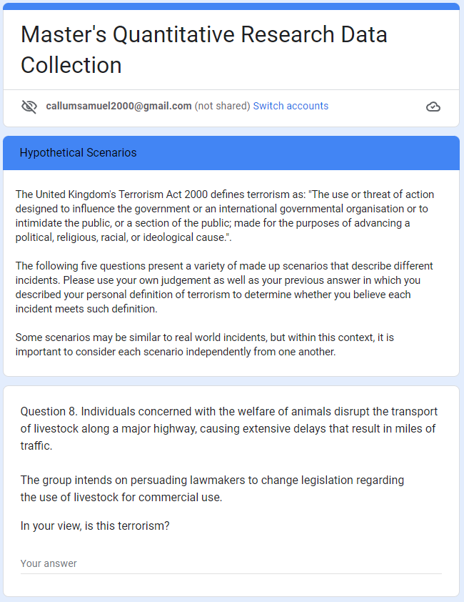
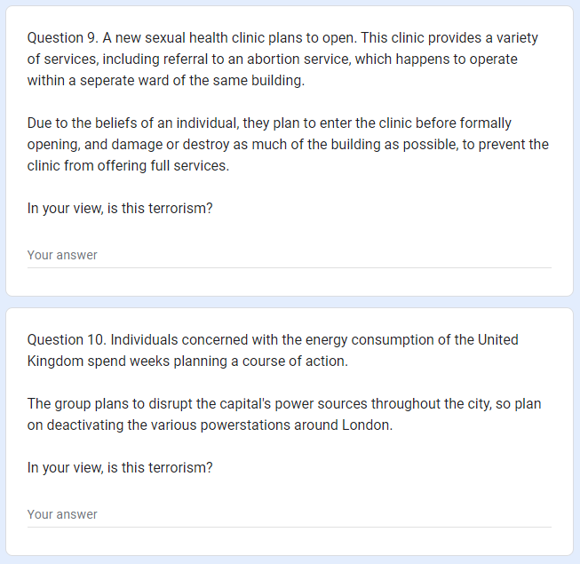
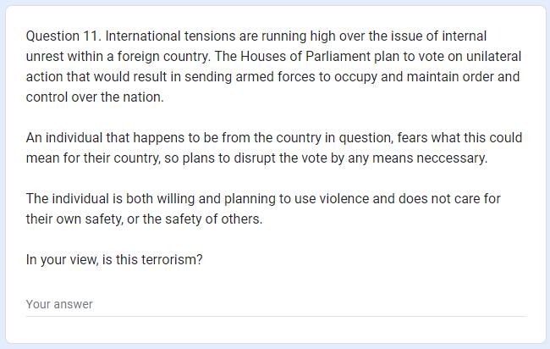
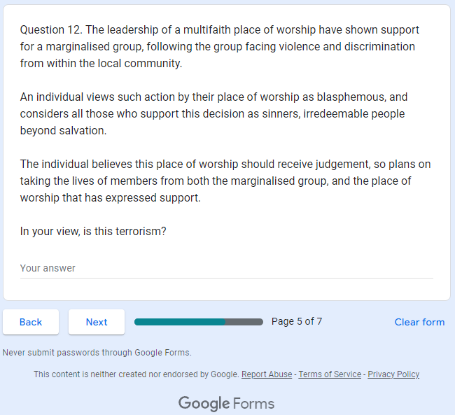
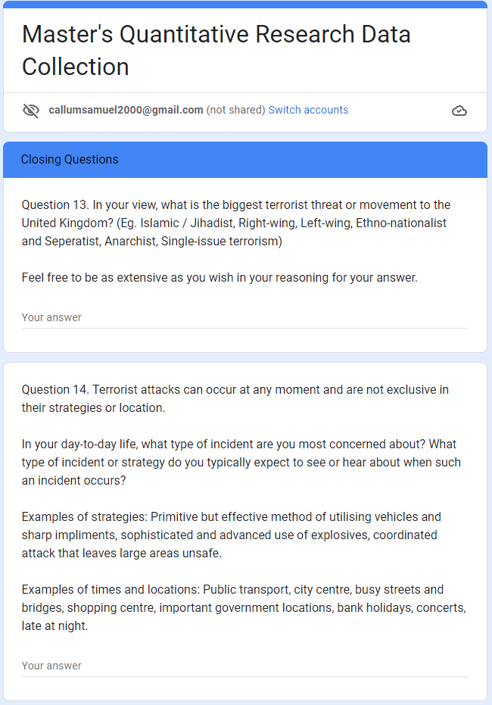
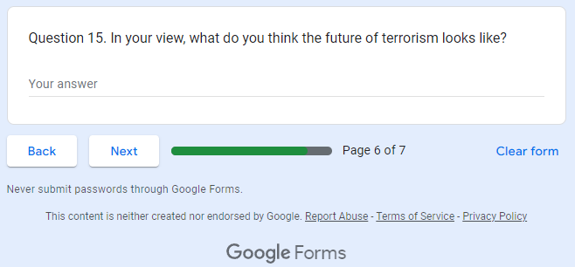
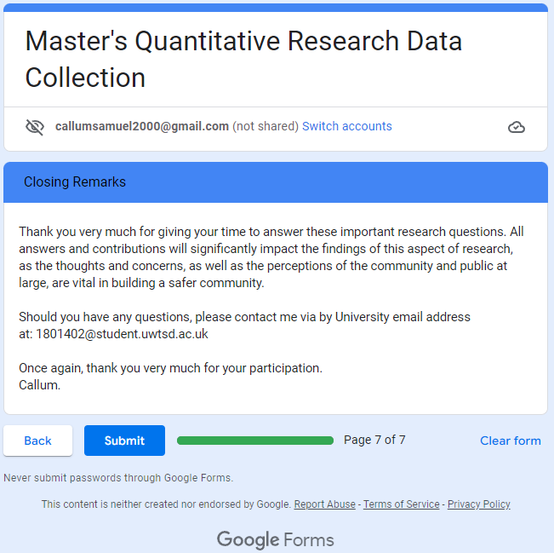

Appendix X (Literature Review and Question Matrix: Questionnaire / Survey)

Questions in Survey | Rationale and Relation to Literature Review
PDQ 1. Please select the term that best describes you:  PDQ 2. How old are you? | The first two were preliminary demographic questions and were asked in the event that such data wished to be looked at.
Q1. From your perspective: What does the word "Terrorism" mean to you? How would you define it? | As established in the literature review - with an entire section dedicated to the complexities of defining terrorism - different people define terrorism differently (Ganor, 2013).
Q2. Terror Threat Level | Similar to Q1, the public may have heard or perceive the UK to be at a higher or lower threat level, so a benchmark of their view can set expectations.
Q3. Infrastructure Design Measures | There are many counter-terrorism policies in place, with this question illustrating the physical characteristics or measures that anyone can observe in public that are there to protect them. This question also opens up and allows the participant to think critically of why things are the way they are in public.
Q4. Out of the following, which social media / social network platforms do you use? (List of app and sites) | Similar to the demographic questions at the start of the survey, this question was asked should an analysis of social media use be required, with potential investigations into what sites were the most popular, and potential correlations between popular public platforms, and that of terrorist recruiters.
Q5. Statement Question - Agree / Disagree | This question asks the participants whether they believe freedom of speech or censorship should take priority, citing the views of the CEO of Telegram, as discussed by Weimann (2016)
Q6. Have you ever seen content on any social media site you feel shouldn’t have been there? | This question was asked to see if the observations by Behr (et al., 2013) and Weimann (2016) of traditional social media sites housing extremist content are still correct today in 2022.
Q7. Familiarisation with VPNs, encryptions, and dark web. | Harrison (2018) outlines how these three separate services are utilised by terrorist organisations, with all technically accessible to the public, questions regarding its familiarity may provide insights into their public relevance.
Q8-12. Hypothetical Scenario Questions | These questions were designed to include a range of scenarios, ranging from: animal welfare, environmentalists, anti-abortion, “freedom fighting” political terrorism, and religious terrorism. The idea was to include a wide scattershot of scenarios, all of which would technically fit under the definition of the Terrorism Act (2000), to see the views of the public, and see which scenario they are most responsive to.
Q13. Opinion on what or who is the biggest terrorist threat | Public perceptions regarding terrorism were covered within the literature review, with Hewitt (2003) and Koehler (2020) highlighting the varying perceptions of what is and what is not terrorism, as well as what is widely, and mass reported as terrorist threats.
Q14. Type of attack participant believes is most likely in UK | This is a question designed around attack methodology, with Pantucci (2018) discussing how simple attack methods have been more popular due to their simple and low means criteria, with household or commonly accessible items and forms of transport utilised by terrorists. But also, events such as the Manchester Arena bombing in 2017 and the Paris shootings in 2015, show that advanced attacks can still occur, despite not being as common in the years after 7/7.
Q15. What do you think terrorism will look like in the future? | This question is arguably the most important in the survey, as it is effectively the research question, given that an analysis of past, present, and future directions of terrorism has been observed, with this question from the public providing additional insights.

Appendix X (Questionnaire / Survey Answers)
ADD AFTER DATA COLLECTION

Appendix X (Blank copy of Interview Sheet)

Master's Qualitative Research Data Collection

Greetings, my name is Callum Samuel, and I am a Masters; Criminal Justice and Policing student with the University of Wales Trinity Saint David (UWTSD). For some, this may seem somewhat familiar, as I may have previously reached out for your help for my undergraduate dissertation, where your contribution significantly impacted and developed the direction of my research. The wealth of knowledge acquired from previous interviews, as well as the generosity and assistance shown, has informed my decision to write my final dissertation in a similar manner as my first. For others, this may be our first correspondence, and I would like to extend my gratitude for your assistance.

The theme and working title of the dissertation is “An Investigatory Insight Into the Pillars of Extremism: How Has Terrorism Evolved in Contemporary Times And What Are the Implications for the Future?”.

With specific emphasis on five areas:

1. How Should We Define Terrorism? – The Definitory Side of Terrorism

2. How Has the Internet and Technology Been Utilised by Terrorists – The Digital and Technological Side of Terrorism

3. How Have Terrorist Organisations Accumulated Large Quantities of Wealth? – The Financial Side of Terrorism

4. What are the Mindset and Motivations of Terrorists and Radicalised Individuals with Regards to Their Goals? – The Psychological and Criminological Side of Terrorism

5. How Do Terrorists Conduct Attacks in Contemporary Times, and What Will Future Attacks Look Like? – The Strategic Side of Terrorism

The questions throughout this interview sheet reflect these five areas, but also, include similar questions that were asked to the public, and questions that warranted further research.

It cannot be understated how useful and impactful any information you provide will be for my research project, you may answer or skip any and all questions, and provide as much or as little detail as you wish, any contribution is greatly appreciated, and I can only thank you for your generosity and your time.

This section simply seeks to frame a brief context to determine the background of participants, all answers relating to personal information will be anonymised and not included in any submitted or published works. In a traditional interview, this would be a small chat or section not included in the recorded and documented interview and would simply be used to frame questions around.
You reserve the right to not answer any questions within the document, including the first three which will not be recorded outside of professional correspondence, however, experience or job title at the very least would provide great insight and assist when analysing data.

Participant Name:
Participant Age:
Participant Current or Former Occupational Experience or Job Title:

Should additional space be required, continue to type and the table will expand to accommodate, do not consider the boundaries as a target or a limit for word count.

Question 1. In your experience and having potentially dealt with terrorists, how would you define terrorism?
Please answer below.

Question 2. The United Kingdom operates on a definition of Terrorism provided by the Terrorism Act 2000. However, many countries around the world have differing definitions, with the U.S alone having six differing definitions of the same word despite being within the same country and operating on the same legal system.

For what reason do you believe there is no universally agreed upon definition of terrorism?
Please answer below.

Question 3. The blurred lines between freedom fighters and terrorists are often exploited by terrorists or governments to justify actions, with Saul (2006) stating: “the more confused a concept, the more it lends itself to opportunistic appropriation”.
Richardson (2006) observes this subjectivity of defining terrorist acts, and calls for a system without preference; “The legitimacy or otherwise of the goals being sought (by a group) should be irrelevant to whether a group is (defined as) a terrorist group”; “A terrorist is a terrorist, no matter whether or not you like the goal s/he is trying to achieve, no matter whether or not you like the government s/he is trying to change”.

With both the abuse of individuals labelled - as seen with China characterising Uighur separatists in Xinjiang as terrorists - and the title of freedom fighter utilised as a shield by terrorists - as seen throughout history and across all spectrums of terrorism - to what extent do you agree with the statement provided by Richardson (2006) where they argue a universal definition should be used?
Please answer below.

Question 4. The internet continues to gain popularity as the technology becomes cheaper and more widely available throughout the world. For example, as of July 2022, 5.03 billion or 63.1% of the world’s population had access to the internet, with 94% of internet users utilising social media (Kemp, 2022). Many studies have been conducted to observe terrorist’s exploitation of the internet.
Why in your view, do terrorists continue to use the internet, and what more could be done to tackle this exploitation?
Please answer below.

Question 5. Terrorist attack methodologies in recent years have fluctuated between low tech and high tech means. For example, 7/7 required thorough planning and knowledge of the tube system, as well the use of explosives. The 2015 Paris attacks required extensive coordination with regards to three teams comprising three attackers each, with suicide bombings and additional utilising of firearms seen throughout the city during the attack.

Low tech incidents were then seen in the following years, with the utilisation of simple means such as cars and knives, as seen in the 2017 Westminster attack, followed by high tech means as seen in the Manchester Arena Bombing, and then low tech means as seen in the 2017 London Bridge attack.

Why in your view, do these fluctuations in attack methodologies occur?

Please answer below.

Question 6. It is feared that as technology becomes more advanced, sophisticated, and more widely available, such technology can fall into the wrong hands. For example, technology such as AI or Artificial Intelligence are already utilised by terrorists to spread online propaganda (Sultan, 2019). Additionally, drones armed with grenades according to Veer (2020) have been utilised by terrorists on the Syrian battlefield, but it is believed that such cases are rare. As well as this, 3D printing of firearms have also been utilised, as seen in a 2019 German Synagogue far-right terror attack, with the attacker stating, “All you need is a weekend worth of time and $50 for the materials”.
In your view, how likely is the future use of such technology to be seen and integrated within terrorist attack methodologies? Is the likely use of such technology increased when it comes to right-wing extremists, due to the “Celebrating the Warrior, but Shunning Death” mentality (Koehler, 2020), as opposed to the willingness of Islamic / Jihadist to embrace suicidal tactics?
Please answer below.

Question 7. How do terrorists typically finance their operations or attacks? In what way is the gathering of funds different, when it comes to organisational finances, and that of individual lone-wolf attackers?
Please answer below.

Question 8. Have there been any significant changes regarding the generation of terrorist finances within the last 20 years? Has digital cryptocurrencies impacted the way in which services could traditionally monitor suspicious transfers seen within traditional banking services?
Please answer below.

Question 9. It is estimated that the IRA received roughly $3 million in donations to Ireland from the US group NORAID between 1971-1981, with the value of that money being worth just shy of $22 million in today’s value (Smith and Woodford, 2018). Furthermore, ISIS at its height amassed a wealth of $6 billion, making it the wealthiest terrorist group in history.
In your view, how important are finances to the success of a terrorist organisation, and what ways could authorities hinder the impact of finances, as well as prevent assets from reaching either the organisation themselves, or its operatives throughout the world.
Please answer below.

Question 10. In your experience, why do you think individuals are drawn to terrorism, or why do you think individuals may have been targeted for radicalisation?
Please answer below.

Question 11. In your experience, what do most terrorists and radicalised individuals actually want?
Please answer below.

Question 12. In your experience, what was the method by which most individuals were radicalised? Did it involve connections and associations with specific people, did it occur online, or were the individuals specifically targeted because of any known or assumed vulnerabilities? Did the “us vs them” dichotomy play a part when terrorist individuals belonged to a specific community and later became extreme in their views?
Please answer below.

Question 13. Contemporary terrorist attacks often use the internet in some form. Whether it be for research on the targeted area, online manuals, and instructions to maximise effectiveness of attacks, or to coordinate attacks themselves (Harrison, 2018).
How problematic are social media platforms with regards to content appearing online? How should governments and policing services respond to claims similar to the CEO of Telegram where they stated: “I think that privacy, ultimately, and our right for privacy is more important than our fear of bad things happening, like terrorism.” (Weimann, 2016).
Please answer below.

Question 14. Right-wing extremism has been notably on the rise in recent years, with seemingly copy-cat strategies employed by such actors, as seen when the far-right extremist Darren Osborne committed his terror attack in 2017 in a similar fashion to Khalid Masood’s Islamic extremist attack in the form of utilising a vehicle to hit as many civilians as possible (BBC News, 2017; Rawlinson, 2018).
Additional similarities in strategies have been seen with the use of Telegram by far-right groups after the app became popular with Islamic extremists, far-right use of Telegram includes the coordination of the US Capitol Hill Insurrection in 2021.
In your view, will far-right ideology continue to rise and lead to attack methods similar to Islamic extremism, in the form of suicide or martyr type attacks, or will the differences remain?
Please answer below.

Question 15. In the US, despite abortion clinic bombings (Hewitt, 2003), and other targeted attacks that meet the criteria of ideological, political, or religious motivation, fitting the FBI and other organisations definition of terrorism, why do the U.S authorities fail to label incidents as such?
Furthermore, when violent and targeted attacks occur against marginalised groups within the UK, why too are these incidents not considered terrorism despite technically fitting the criteria or definition provided by the Terrorism Act 2000?
Please answer below.

Question 16. From your occupational experience and knowledge of contemporary terrorist strategy, what are the priorities of an attack conducted by terrorists that act on behalf of an organisation or on the behalf of themselves? What are the typical targets or objectives of their incidents?
Please answer below.

Question 17. In your view, what is the biggest terrorist threat or movement to the United Kingdom? (Eg. Islamic / Jihadist, Right-wing, Left-wing, Ethno-nationalist and Separatist, Anarchist, Single-issue terrorism)
Please answer below.

Question 18. In your view, what do you think the future of terrorism looks like?
Please answer below.

Following the completion of Question 18 and once you are contempt with your answers throughout, please save your version of this document, and then please email a completed copy of this interview, back to the address you were initially contacted by, for clarity it will be the student address: 1801402@student.uwtsd.ac.uk

To the participants of this research collection,
We have now reached the end of this unique style of interview, and I would like to very much take this opportunity to thank you for participating. The answers to this interview will greatly assist in my analysis for the research project and will form the backbone of the research findings and conclusion, so your contribution and my gratitude cannot be accurately put into words.
The deadline for this research project is quickly approaching and the final submission will be on the 25th of November, should you wish to know how your contribution assisted with the research project you may contact me on my university email, which is the same email address previously mentioned, at: 1801402@student.uwtsd.ac.uk
Once the deadline has passed and the dissertation has been marked, I will be more than happy to send you a copy of the completed project should you be interested.
Whether this is our last correspondence or the last for now, I would once again like to take this opportunity to thank you for your participation. It has been a privilege to gain such unique and expert insight into such a sensitive topic.
Thank you for all your help,
Callum Samuel.

Appendix X (Literature Review and Question Matrix: Interview)
Questions in Interview | Rationale and Relation to Literature Review
PDQ 1-3: Name, Age, Occupational Experience | The first three were preliminary demographic questions and were asked in case analysis of age was considered when comparing and triangulating to the findings of the survey. Furthermore, due to the potential of me not having had a previous exchange with any experts that may have reached out and wished to respond to the interview, names were important to differentiate the data and were kept anonymous and away from any analysis. Occupational experience was asked to determine the background of the individual, with the group of respondents classified and referred to as experts in the project, as opposed to naming their specific job or field to ensure confidentiality.
Q1. Define Terrorism | Many governments and organisations use different definitions of terrorism (Ganor, 2013).
Q2. Why isn’t there an agreed definition of terrorism? | Ganor (2013) asks the same question.
Q3. Do you agree there should be a universal definition? | Richardson (2006) provides the justification and need for an appropriate definition to be adopted.
Q4. Why do terrorists use the internet and how could it be stopped? | Behr (et al., 2013) and Harrison (2018) highlights terrorists prolific use of the internet.
Q5. Why is there a fluctuation between high tech and low tech means of terrorist attack methods? | Veer (2020) highlights the idea that IS and AQ have tried to “Keep it simple” with attacks.
Q6. Will technology such as drones, AI, and 3D printing be used by terrorists? | Veer (2020) speculates on the same question, with the opportunity to ask experts making this question relevant.
Q7. How do terrorists get finances? | Dion-Schwarz, Johnston and Manheim (2019) as well as Zarate (2004) cover how groups often get finances, important to ask experts the same question.
Q8. Has there been a change in the way in which terrorists generate finances in the 21st century? | This question links to technological developments as there are often new and innovative ways to generate finances, such as ISIS’s early investments in cryptocurrencies (CISAC, 2021).
Q9. How important are finances to the success of terrorist organisations? | Important to get the perspective of experts on this issue, as it was researched in literature review (Zarate, 2004).
Q10. Why are individuals drawn to terrorism? | This question relates to the psychological and criminological aspect of terrorism that wishes to be covered.
Q11. In your experience, what do terrorists actually want? | Bartlett and Miller (2012) state that the identity of individuals can play a role in their feelings of the outside world. With confusion on what individuals want occurring often in research findings.
Q12. In your experience, what method was mostly used to radicalise individuals? | This is a question tailored to look at how individuals were radicalised, is it a combination of multiple things or is there a consistent theme or pattern observed in their experience.
Q13. How problematic are social media sites and how should governments and services tackle the issues of social media | This question is similar to a question asked in the survey, with the intention to observe the potential differences in answers depending on individuals background, experiences and perspectives.
Q14. Will far-right terrorists continue to adopt Islamic attack methods, will there eventually be suicide style attacks? | Relates to the research and conclusions made by Koehler (2020) regarding the comparisons of right wing and Islamic suicide style attacks, or incidents that result in the death of the perpetrator.
Q15. Why is there hypocrisy to the application and label of terrorism in the US, where abortion clinic bombings are not considered terrorism despite fitting criteria, or marginalised groups targeted in the UK | Generalised question relating back to the definitory aspect of terrorism that has been covered throughout.
Q16. What are the modern priorities or typical targets or objectives of terrorists during attacks? | A question that seeks to understand whether the traditional goal of “fear” is still a priority of contemporary terrorists.
Q17. What is the biggest terrorist threat to the UK? | This question is the same as the one presented in the survey, to compare and contrast the differences. With regards to the literature review, Pantucci (2018) stated that the British counter-terrorism commander believed right-wing was the biggest threat, so this question was asked to the public and experts to determine if the perspectives are the same or different.
Q18. What do you think the future of terrorism looks like? | This is the same question as the one presented in the survey. This question is essentially the research question, with views from experts important in reaching a research finding and conclusion.

Appendix X (Interview Transcript / Responses)

ADD AFTER DATA COLLECTION

