UWTSD
Problem Solving and Decision making
BMSK 4004
lecturer: Molly Jack
Problem Solving

Sharif Uddin
1605545
Group 6
August 2018

Contents
Introduction: 1
Case study: 2
P.E.S.T.L.E Analysis: 3
S.W.O.T Analysis: 4
The Problem: 7
Conclusion: 10
Reference: 12

Introduction:

In this report the task is to identify a problem at a workplace and find different options for how they can be solved, it’s a very challenging task in which first the problem has to be identified, first to this it needed to look into the root of the problem before going to solve any them, so what is a problem, a problem is something hard and difficult causing trouble and disruption to certain places, there is lots of different tools available to solve the problems such are SWOT and PESTLE analysis, by using these tools it helps to identify what the potential problem is and also what solutions are available, to complete this I will try to look into all the aspects of the company, and what are the causes of the problem I will be reporting about, I shall be using all my knowledge and other sources available to solve the problem or problems, another section of this report is decision making, to make a decision first we have to do all analysis and researches without identifying all the problems and any researches we won’t be able make the decision, and if the decision is made without all the analysis it might backfire or example in the parliament the decisions are taken after talking over and over then analysing the good and the bad sides even after that they take votes after all these they go with the majority, it needs to be very carefully consider all the aspects before making a final decision, problems are everywhere there is no place perfect even there will be minor issues but solving the problems takes lots of skills and knowledge also experiences plays a factor, the more we work in places with problems more we can learn how to identify and solve it, decision making is very tough and it takes lot of courage to make some decisions sometimes, lot of decisions are painful but for better for long term sometimes short term losses are better, also different people think differently some look at bigger picture and future but some look at everyday life and short term fix, sometimes short term problem solving decisions can be good but it’s better to look for permanent solutions, if it’s not fully solve then it will rise again and again we have to go look more solutions, also sometimes it can a success to stable and calm things down for present and then look for permanent solutions, like on road works they sometimes keep fixing one side and leave one side open with temporary traffic lights so motorists can travel, but if the problem is big they have to close the road and divert the route to a different road, therefore the analysis is important after researching and calculating all the losses and gains then we go with final decision, the decision not be taken in a rush if it’s taken in a quickly without analysing it will be more problems than solutions, throughout the I will try to use all my knowledge and experiences to identify a problem and come up with the solutions and a decision.

Case study:

In the year 2006 I went to work in small Indian restaurant in Westbourne park, from the beginning I noticed it was small but nice newly done restaurant with clean kitchen and hallway and staircase, also the business was not bad either, also the food was one of the best I had, it was opened in early that year it was a nice location as well, we were 6 staffs working and day by day basis as the business was improving and building up a good reputation with loyal local customers, whose’ word of a mouth publicity were helping the restaurant doing well, our service also very good as customers the customers were really happy with our food and service, after 3 months we had to hire 2 more staff to provide a better service and handle the growing business so it won’t have problems in service which the place is known for at that moment, if we analyse the PESTLE (Oxford College of Marketing Blog, 2018) which is Political, Environmental, Social, Technical, Legal and Economic aspects of this restaurant we come to know the potential of the business,

P.E.S.T.L.E Analysis:

Political:
In the year 2006 politically the country was more stable although the house prices were going up as interest rates were quiet low, in that period people were happy to invest especially in housing and properties as the economy was stable as it was recovering from few years after the terrorist attacks of 9/11 in USA businesses were doing well, also fast food was growing rapidly, so this restaurant was benefiting, in that time the VAT was 17.50% compared to todays’ rate of 20%, so the profit margin was little bit higher
Economic:
Inflation was reasonable low as well as national wages for over 25 years was £5.35 per hour and was increasing slowly, the local rates for the business was not extremely high so the business was going in right direction, as the business was on up economically it was steady, the tourists level were increasing due to lot of new constructions was happening, London eye was a big attraction, the millennium dome was another one and the national Wembley stadium was redevoping, also all high rise buildings in docklands was an tourists attraction, these were very good for economy of the country,
Social:
Social factors is more looking at the external side of businesses, like demographic, population growth, cultural and health and safety factors, location of the restaurant was in a very good place it was near a well known the Portobello market, where lots of people visits every Saturdays from different places, therefore Saturday was most busiest, the population was growing in the area new people were moving in from other area, the area has different cultures as they celebrate the Notting Hill carnival every August when almost a million people come, not just from UK but from other countries to participate for two days event, these factors were excellent for the growth this restaurant,
Technological:
As it is an a catering sector it has less technical issues involved, its more creative, the idea was to lower the cost and higher production, technological factor also is looking at internal aspects theses can equipment’s and décor and atmosphere
Legal:
Legal factors is to compliant with the current law, follow the rules and regulations, follow the health and safety rules, all the businesses have to have an accountants and they have to submit end of the year accounts to the HMRC for taxing, every three months they have to pay VAT, these are must
Environment:
This factor is about looking at the surroundings, weather, climate and geographical position, surroundings is what is happening nearby like what sort of other stores are there what kind of people are there and who comes there, weather can affect businesses because the products can change according to the weather for example in hot weather cold drinks ice creams will sell more, and cold weather it will be hot drinks like coffee, tea and hot chocolates, climate change causes problem such as there is the premises is based when the location is good it helps to business grow quicker

S.W.O.T Analysis:

Every organisation needs to do a SWOT analysis it gives a full view of the structure of the business, SWOT analysis (it,2018) is used in a business plan to identify the Strength, Weaknesses, opportunities and threats in a business, it’s a very useful tool which can help to analyse and identify a business structure, it can be used in the business plan and in future after opening a business to review the company’s performances, to find out the company performance below is the SWOT analysis of this company,
Strength:
The strengths of this restaurant are, good location, lower price menu, home delivery and take away service, nice décor, good food and very good service, these are the positive strength of the business,
and it was doing well for these factors, the lower price menu was due to the Portobello market where some of the vegetable suppliers were able to supply goods for lower prices, the local Tesco was giving good offers on alcohol and soft drinks which also helped keep the menu prices low,
then home delivery service was very demanding as lot of customers after long day’s work were able to get food and drink delivered to their door free of charge, they would come in for eating in at the weekend, and some would do vice versa, and some would like to come and have a take away collection themselves,
the décor was also very nice and cosy with new Italian leather chairs with mahogany shiny wooden floor, as well as orange and green wall paint colour,
the food was good and service provided with best our ability like we were friendly with the customers, help them chose right food by giving suggestions, and the chef used less powder spices and more natural spices like African naga chilli paste made by himself for spicy foods, and more fresh herbs and vegetable rather than frozen products,
the location was one of the biggest strength as lot of tourists come there and it was residential area

Weaknesses:
The weaknesses are the size of the premises is small, no space for expansion, less innovative staff, certain suppliers don’t have all the stocks, limited staff, health and safety challenges,
as the premise was not very spacious it was just limited to one way of doing the business due to no scope for expansion or add extra additions,
the staff were good but most of them were not much innovative which is everyone not had much idea for changes, although they were good at customer service,
some of the items on the menu sometimes most suppliers wouldn’t have in stock therefore it means the management has arrange it so the stock is there,
as it was about 7 or 8 employees maximum the owners can afford if one person is off sick or couldn’t come to work for any reason the rest would have to work more extra hours,
due to the health and safety concerns which included hygiene and cleanliness very important most of the staff were required to do these courses it’s hard to find staff who are trained and hygiene certificate holders,
Opportunities:
The opportunities are tourist’s attraction, good offers for customers, expand the menu and launch new menus, as well as open full day on Saturdays due to market therefore lot people will be around, and in carnival selling drinks and food generates extra income,
these are reasons why the business improving, the it was doing well it had chance to open another branch soon, with right management there was always room for improvement,
Threats:
The threats are more similar restaurants were opening nearby minimum wages going up, suppliers were hiking their prices, so it is hard to find a cheaper supplier, menu prices cannot be put up too high due to the competitions, as well as energy prices are very high and every year business rates and rent of the premises increases,
when other business owners observe that there is a similar business doing well they try to open one nearby, this is one of the major threat because if another similar business opens nearby then customers will be divided as it’s the same customers will go and try the new restaurant,
minimum wages were going up rapidly so if the business is not doing well it was hard to pay everyone right amount or cut their hours which staff would not be happy,
the goods prices and energy prices were also going up, so it was hard to keep the menu prices low, if the price go up then the customers would not be happy

The Problem:

According to Robertson,S.(2001) we face problem in our daily life, every step we can come across certain problem , for example an two old faces a problem that how they will climb out of the cot, an teenager has problem of how they can convince their parents to increase their pocket money, an adult who have responsibilities has the problem that how to earn and make ends meet, therefore always we face problems in life, when we walk in the street there always problems, I faced a problem one day I was coming after buying my son a scooter me and my family were walking to the car and there was this incident one man was trying to kill another man due to some arguments and we were stuck there until police came and got the situation under control we were able to come home safe and securely, therefore problem can come in any form, the restaurant I worked was very clean as it was newly opened after the alteration work and new painting and decorating cleanliness was not the issue, the actual problem was there were mouse in the restaurant, the much as the cleaners clean the premise every day we found mouse droppings in the kitchen and staircase, and storage areas, the kitchen and the storage area were in the basement so the mouse’s were there mostly, the nature this problem is very severe as its risk for public health as well as the employees, even though the premises was cleaned twice every day the risk was intact due the nature of the business involved food, this was causing big anxiety within the staff but the management not that much focused, they were new to the business were more interested in profits rather than trying to solve the problem, the communication wasn’t bad between the staff and the management but it’s the management who were not paying attention to the issue, every time the issue brought up they were not too much keen on the subject, they said keep cleaning and soon we will hire pest control, so while waiting for the pest control staff were using mousetraps for the time being which was helpful but not great extent, soon the mouse’s were not reducing but growing more than one day unexpectedly an environmental health officer came for inspection he was satisfied with the other cleanliness but when found mouse droppings in some places he wasn’t happy, after asking for the pest control report which couldn’t be provided as we didn’t have the services, the officer has no choice but close the restaurant until further notice, he put a notice on the door and gave the information to the local newspaper who printed with some pictures which was provided by the health inspector, this caused major issue, as the customers read they were very upset, the food and service was good but when a business gets shut down especially for health and safety reasons this can be the biggest damage to the business, the below diagram gives the impact of this problem better to understand , that how can this closure can create more problems to the company, staff, reputation and financial status,
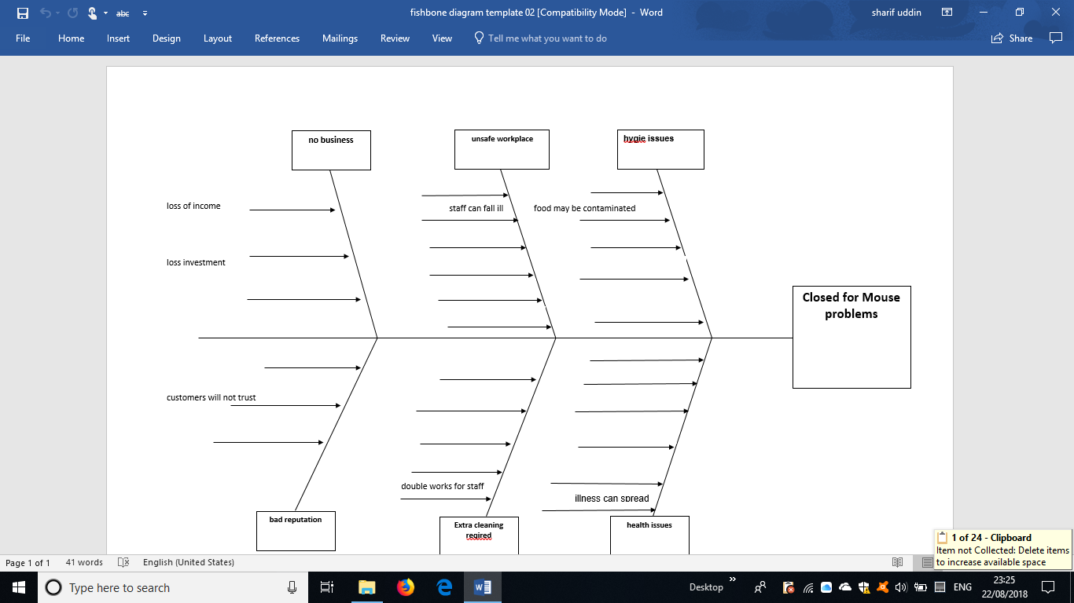
When a business shut down then the consequences are really painful, as this above diagram shows that how one problem can create more problems, like when the business is shut there no sales which loss of business and finances, the staff get redundant or jobless, the suppliers don’t get any more orders, the company loses trusts of customer which will be more damaging if they were to open again, if the staff were there they have big task to do, therefore the problem becomes even bigger and harder to solve,
after the restaurant was closed the health inspector gave long list of to do tasks which includes more cleaning and changing few appliances, also to get in pest control services, as well the staff and management should complete new health and safety courses as every year they introduce new laws and regulations and all the catering section should comply with the new regulations and follow it,
the owners were so much in pressure they hired a third party company and they came in and helped them reopen again, it took one full week of hard work and changing few appliances, also they gave the staff few basic training food and recommended to go for more advanced training courses, in the process the chef had to be fired as he didn’t fulfil his job properly, as a chef he had full responsibility and it was his duty to look into every department especially if the place have issues like this, but he did raise the issue to the management which management were not much keen on, the chef had to be replaced and get a better and qualified chef who can take the company forward,
after a week with the help of this third party company and new chef coming in, the environment officer was happy enough to reopen and take the notice off but suggested to have pest control all the time and keep the storage tidy and clean,
the problem didn’t end here as now was the bigger challenge ahead to maintain the procedure which was given by the health inspector,
but the where the mouse were coming from that wasn’t addressed and it might arise again, although the health inspector said that mouse’s are everywhere try to reduce it,
to keep the mouse and other insects level low as possible I have suggested few options they are:
A:
All the business should pest control services, there job is to visit the premise every 3 months or even earlier depending on how big the problem is, on the visit they leave mouse bait boxes and spray in certain areas and check if there is any holes which can bring in mouse’s,
B:
Before hiring a staff the recruitment department should check the candidate thoroughly and carefully that they meet the requirement qualifications and certificates,
C:
Always follow and apply the new health and safety rules and implement them in the company so everyone is up to date with the new law and regulations, if required then go for training when necessary
D:
To prevent not to face this problem again and maintain the standards high the company should have regular meetings and communicate with each other, also keep regular book keeping of hygiene records and also monitoring fridge freezer temperature,
To do all these might be tough and will take time for everything to implement, therefore doing all this helps reduce the problem if not solving permanently, it will be less loss as the businesses won’t shut down and reputation and investments will be intact,
Therefore, the actual problem is lack of not taking the problem seriously and neglecting the situation, the management should have more understanding when they are informed about any problem has occurred, which would have prevented to not to shut down the company and they wouldn’t have suffer this much loss and bad reputation would have not suffered either,
every problem can be identified and prevented by looking at what is the root of the problem, in this case the root was lack of commitment from the management when the who would not so much interest to prevent the problem, always analysing the bigger picture is best way of planning ahead,
Decisions needs to be taken for betterment of the business, when the business is good it is good for the staff as their job is secured, also they can demand a pay rise and more business will have more vacancies, so they can bring extra staff in, when the business doing well then it can have more branches in different cities and areas,

Conclusion:

Problem solving and decision making is very important topic, it’s a very difficult task to make decisions after identifying problems, different problems have different consequences like in report we have seen a chef got fired due to not doing his job correctly, but the management had to take this decision due their own lack of commitment, they lost their customers, reputation and their finances, to solve the problems of any business it needs to be investigated properly, who ever try to solve problems must have the skills to how to solve problems, and to do that a person have to learn the process from experts or taking courses which will help a person able to analyse a situation and have the knowledge to tackle the situation, if a person or management have these qualities they will be successful in their position, also it will be good for the business, as they will be doing their job according to the requirement of company regulations and any legal procedure required to maintain high standards of the company,
When the problem is identified and dealt correctly and accordingly there no scope for a company to close down, or occur big losses financially, an business must have a good structure of management from top to bottom, every department should be aware of their duties, an company should hire who are capable to their job, and if they don’t have skill full employees they can be sent on training so they can gain all the knowledge and skills for the work they are assigned to do,
in this case management was at fault, as a small company which had all the potential to do even further well was forced to close and face these consequences,
to avoid problems like this management should follow all health and safety procedures, get staff trained, hire pest control and have regular meetings with the staff, so any problem arises can be identified and solve it.

Reference:

1.
It, S. (2018). SWOT Analysis: What It Is and When to Use It. [online] Business News Daily. Available at: https://www.businessnewsdaily.com/4245-swot-analysis.html [Accessed 19 Aug. 2018].
2.
Oxford College of Marketing Blog. (2018). What is a PESTEL analysis? - Oxford College of Marketing Blog. [online] Available at: https://blog.oxfordcollegeofmarketing.com/2016/06/30/pestel-analysis/ [Accessed 16 Aug. 2018]
3.
Robertson, S. (2001). Problem Solving. London: Psychology Press.

