Modernism in Fallingwater

Frank Lloyd Wright was a famous American architect, born in June 1867 in Richland Center, Wisconsin. He started his architecture career in 1887 in Chicago at the office of Joseph Lyman Silsbee and later at the firm of Adler and Sullivan, as Louis Sullivan as supervisor. Besides from the beautiful creation of Frank Lloyd Wright Home and other creations of his, he met with one of the Kaufmann family members which lead on to Wright’s next project “Fallingwater”. (Frank Lloyd Wright, u.d.)
The Kaufmann family’s introduction to the work of Wright came in 1934 when Edgar Kaufmann jr. being recommended to read an autobiography of Frank Lloyd Wright’s from 1932. The Kaufmann family had wanted a weekend house to vacate to, so Edgar Kaufmann sr. went to Frank Lloyd Wright in 1935 and asked him to create a design for their family house. Wright was given various specifications by the family on some features that they would want the building to have, including the concept of building it into the waterfall located near Bear Run, in Pennsylvania. Wright immediately set out on the work, completing the floor and perspective plans in January 1936. His original drawings were also the last drawings in plan of Fallingwater and even the name “Fallingwater” was decided at this time by Wright. Construction began for Fallingwater later in April, from which point it continued until December 1937 where it was complete. The project moved quickly with foundations being completed in just four months. Additionally, after the construction of Fallingwater, a secondary guest house was also completed in 1939. Famously Albert Einstein was invited by the Kaufmann family to stay in the guest house of Fallingwater. The Kaufmann family continued to own Fallingwater and use it as a weekend house for many years, until 1963 when Edgar Kaufmann jr. deeded it to the Western Pennsylvania Conservancy. It then opened as a public tourist attraction in 1964. (Timeline, u.d.) (The Kaufmann Family, u.d.)
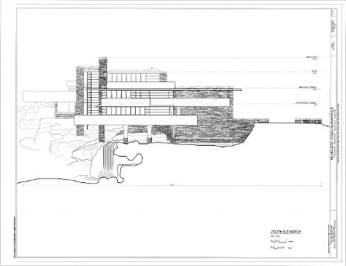
The key feature in Fallingwater is the contrast from the geometric shapes of the building and the more organic feeling you get from the waterfall. Fallingwater has a very unique shape, featuring many flat overhangs that appear to have little support to hold them up. This is possible because the structure is built into the surrounding rock with support beams, which naturally gives strong support to hold up the entire building. Wright utilises the structural support greatly by making an impossible appearing structure. The way this is built creates a special picture and gives a feeling that not many can recreate.
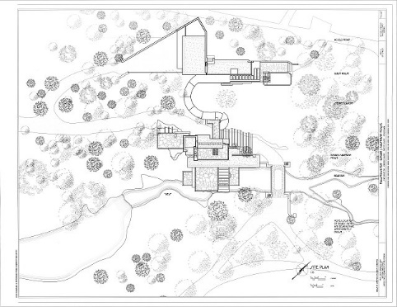
Fallingwater was constructed using many materials that were picked out by Frank Lloyd Wright for how they reflect his view of “organic architecture”. The materials used primarily in the structure include concrete, sandstone, steel, wood and glass. Aesthetically, Wright featured a large use of natural looking sandstone on the exterior of Fallingwater to capture the appearance of the surrounding rocky landscape. This makes the building look somewhat natural in its environment. On the other hand, a large us e of concrete creates a contrast by appearing as a more modern structure. These portions form the majority of the outside of Fallingwater, helping it to appear as if it is a part of the natural waterfall itself. Glass and wood feature to make up the walls of the house, with glass making up most of them. This allows the floors of the building to be practically looked through by onlookers. The usage of these less obvious materials brings instead attention to the concrete that overhangs, helping them to seem impossibly built.
South Elevation – Library of Congress prints
Site plan – Library of Congress prints
Interestingly, for the six interior bathrooms Edgar Kaufmann jr. suggested the use of cork tiles for both the floors and the walls. Although they were well suited to repel water, signs of damage have shown in places on the tiles including in the guest house. The damage became so serious in the guest house that the bathroom had to be restored in 2007, while in the main building, signs of damage still persist. Despite the aesthetic use of these materials, they are not the most suited for the environment they are in. Pennsylvania suffers a combination of both humid and freeze-thaw conditions, making the maintaining of any material a great importance. Preservation technicians regularly replace and repair parts of the structure that have been damaged by the environment or that have deteriorated over time.
All of Fallingwater’s concrete is painted in a light ochre colour as chosen by Frank Lloyd Wright in 1937. However, due to organic waste falling from surrounding trees, the concrete required six repaints between its construction and 1959. Furthermore, it was decided in 1978 to sandblast all of the paint off of the concrete and replaced it with acrylic paint. Even with this great effort they still required a new paint type and tester over 100 paints between 2001 and 2006. They came to a conclusion for which paint type to use and even still Fallingwater is regularly repainted to this day. This issue was clear to Edgar Kaufmann jr. as when he deeded Fallingwater he included a $500,000 endowment to help the conservation and the maintenance of the building. Natural light is also a large part of Fallingwater. The use of glass walls allows natural light to pass through the building, reinforcing the natural feeling of the house. As well as these, a large area of the outside features glass stretching from the ground floor to the second floor. This not only allows a natural light to reach every floor, but also makes these floors feel connected and splits up the use of sandstone creating a contrast instead. (Preservation history, u.d.)
Modernism in architecture developed and gained traction during a phase from 1930 to 1970 in which many new architects adopted a style of modernism into their work. The concept of modernism was first introduced to America by the 1893 Chicago World’s Fair. Included in the many people who were influenced by the fair is Frank Lloyd Wright. Within modernism there are many styles, including American modernism, European modernism, Googie modernism, International style modernism, Brutalist modernism, Expressionist modernism and New Formalist modernism. After Frank Lloyd Wright constructed Fallingwater, which was stylistically inspired by modernism, it became a staple of American style modernism. (Marcum, 2018)
In conclusion, Fallingwater is a symbol of American modernism in architecture and both a unique and largely renowned tourist attraction. The original inspirations for the project came from both the Chicago World’s Fair and a natural, organic aesthetic. This combination of contrasting inspirations creates the unique appearance and design of Fallingwater. Throughout time the house has seen lots of use by the Kaufmann family in a practical manner and by tourists in recent years. Frank Lloyd Wright collaborated with the Kaufmann family with the design and planning as they saw eye to eye on many concepts and ideologies within architectural design. While Fallingwater is widely celebrated as a great achievement, some issues still arose in the maintaining of its materials and are still being fixed and exchanged today. Fallingwater is a fully geometric build, but the waterfall is helping to create an organic contrast towards the rest of the square shaped structures. Wright is an extraordinary architect and Fallingwater shows the potential that he was able to do and create. A lot of people, including me, would see it as almost impossible to create a huge overhanging concrete structure sticking out of a building like the way the concrete sections do in Fallingwater. There are so many thoughts and hidden techniques that Wright took the use of which have never been used before. The use of these techniques at this time was what brought this building so much fame and made it so unique. Frank Lloyd Wright was the starting point of American modernism and is most likely never going to be forgotten, because he is such a huge part of modern history.
I think the design of Fallingwater is in a perfect location and nothing would have made it look better. The building does not belong anywhere else and the few recreations of the structure do not give the same appearance and the connection to nature that Fallingwater captures. Wright was perfect for the project and I believe no one could have done it any better. When it comes to architecture, he is looked up to by so many architects and people in general, including myself. Frank Lloyd Wright is a great idol for a lot of both new and experienced architects.

