How a school develops one aspect of its SDP: a report that critically reflects on the actions, impact and evidence base.

Introduction

A School Development Plan, or an SDP, is a strategic document that serves to outline a school’s priorities, targets, and subsequent action plans, which drives continuous improvement in order to enhance the learning environment, guide decision-making, assess outcomes and promote growth for the benefit of all stakeholders (Haynes et al.,1996).

This essay will focus on one of a particular school’s targets for the period 2023-2026. In order to protect the anonymity of the establishment (BERA, 2018), it shall be referred to as ‘School X’ for the duration of this assignment. School X is a Roman Catholic primary school in the Archdiocese of Cardiff. It has 226 pupils aged 3 to 11 years of age, 14.3% of which are eligible for Free School Meals. The backgrounds of pupils are varied, and includes a minority of economically disadvantaged families. 0.5% of pupils are looked after by the local authority, more than three times the local and regional averages. As of September 2023, 3.5% of pupils are identified as having additional learning needs, whilst 20.3% of pupils recorded their ethnic backgrounds as other than white-British or Welsh. 6.3% of pupils in September 2023 come from homes where English is an additional language, although no pupils speak Welsh as a first language (Estyn, 2023).

The aforementioned School X target under scrutiny is, ‘To sharpen self-evaluation and improvement processes to ensure that they focus on the most important areas of school improvement’ (School X, 2023).

Literature Review

The importance of an SDP cannot be understated when considering the long-term direction a school will be taking, and how that journey will be navigated and affected by all stakeholders involved. The Welsh government states that schools should be clear when outlining their responsibilities, actions, accountability, and timescales in the SDP, whilst making sure that the national priorities of raising standards of literacy and numeracy are addressed (Welsh Government, 2014b). Clearly, the outcomes of a school’s SDP can play a significant part in a child’s future, as shown in the Figure below.

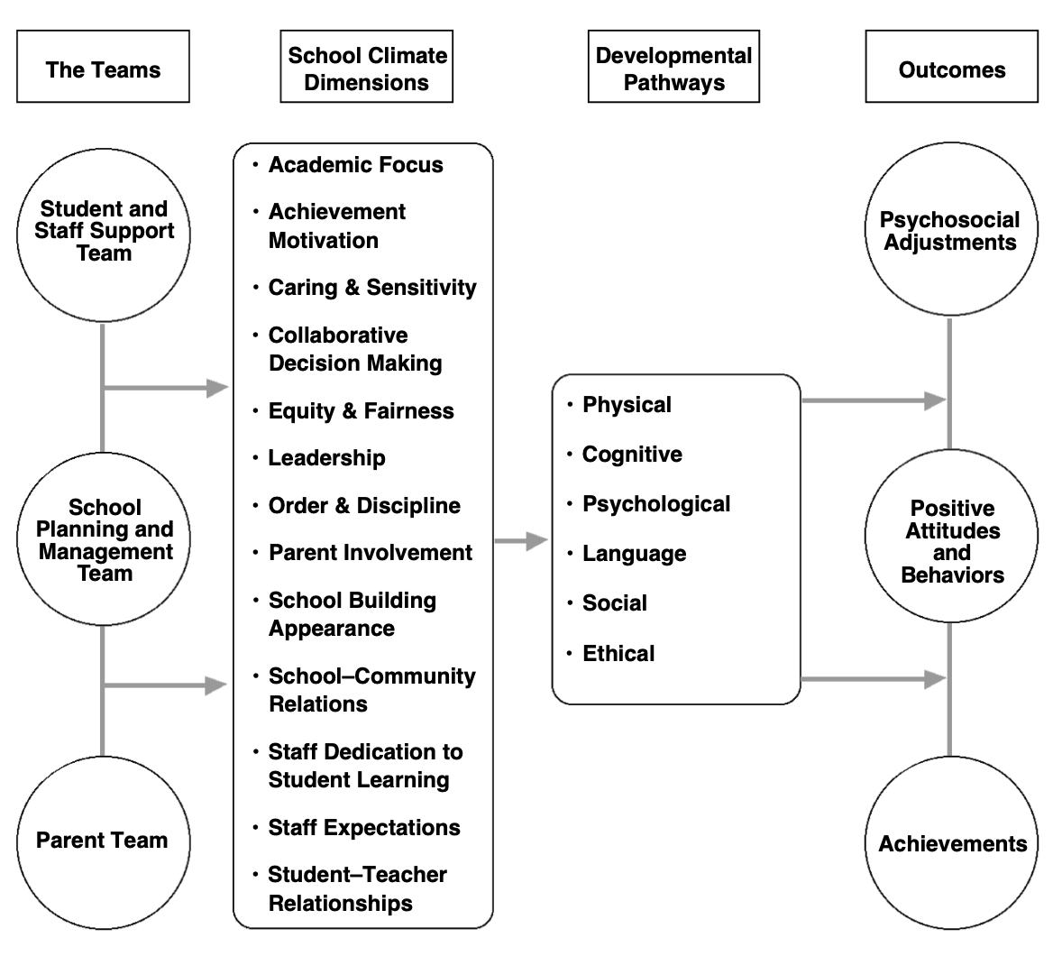
Figure 1: The School Development Program (SDP) model of effects (Haynes et al.,1996: 125).

The culture of the school environment is important when considering the impact of the SDP on classrooms. Fullan (2007) recognised the need for collaborative leadership in order to initiate continuous improvement when making systemic change within schools and other educational establishments so that strategies address not only academic outcomes, but also to help create a culture of organisation, where stakeholder engagement and community partnerships can be developed fully. When the surroundings are influenced by strong leadership from the headteacher and Senior Leadership Team, the school ecosystem is shown to be more positive as a result of shared trust, belief and perception, evidenced by over two hundred case studies worldwide (Day and Sammons, 2013). Leithwood and Strauss (2009) concur, stating that teachers who do not feel supported by their superiors inadvertently create an unsavoury school climate in which a shared vision is not followed.

PLCs, a group of practitioners collaborating to create excellence in schools, can enhance standards within academic networks (Welsh Government, 2013). Research evidence highlights the benefits of using PLCs to enhance teachers’ professional learning (Elmore, 2002), professional practice (DuFour, DuFour and Eaker, 2009), and improve learner outcomes (Andrews and Lewis, 2004). A school’s involvement in PLCs ‘...also makes a significant contribution to building the school’s capacity for continuous improvement, especially in relation to the national focus on literacy, numeracy and tackling disadvantage’ (Welsh Government, 2013, p.3), a previously mentioned important aspect of SDPs nationally.

Action plans are therefore formed and implemented into ‘...executable, measurable and accountable [schemes]...specifying objectives, outputs, strategies, responsibilities and timelines’ (Chang, 2008, p.1). Hargreaves and Fullan (2012) discovered that a targeted approach to school improvement that identifies key areas for change can be the most beneficial to institutions. Earl (2000) agrees, noting that a robust self-evaluation framework that encompasses multiple sources of information, such as pupil data analysis, feedback from stakeholders, and evidence of teaching and learning practices, can be highly effective in improving learner outcomes.

There are arguments for and against sharpening self-evaluation and improvement processes as School X plans to. A positive factor would be the alignment with the direction of the Welsh government, notably presented in policies such as ‘Education in Wales: Our National Mission’ and the ‘Successful Futures’ review that formed the basis for the new Curriculum for Wales, in which a coherent strategic direction has been set. The policies in these documents urge the prerequisite for clear objectives and targets for improvement in schools that are actionable, pragmatic, and advantageous, whereby pupils benefit from any changes made (Donaldson, 2015; Welsh Government, 2023). Similarly, accountability is important, meaning regular Estyn inspections that assist in setting SDP objectives and helping provide unbiased opinions on what improvements can be made, are key to any school reforms. The National School Categorisation System, an annually reviewed classification process that provides communities with useful information on the performance of schools, is also essential in providing challenge to institutions most in need of development (Welsh Government, 2020b), particularly given the recent publication of concerning PISA (Programme for International Student Assessment) results (Lewis, 2023).

Budget constraints because of ‘inflationary pressures of £177m in 2023-24’ and ‘real-terms funding...falling by around 6% since 2009/10’ (NAHT, 2024) continue to restrict schools’ ability to spend. Therefore, optimised resource allocation as a result of focusing on the most valuable aspects of school improvement allows efficient budgeting plans to be implemented to improve learner outcomes as, ‘There is evidence that high quality, modern infrastructure can contribute to improvements in the educational outcomes of young people’ (Welsh Government, 2021, p.48).

On the contrary, there may be valid concerns that focusing on certain areas of school improvement could be detrimental to pupils’ learning or wellbeing. The new Curriculum for Wales strongly encourages children to be given a broad and balanced education that should develop their academic, social and emotional skills, making them ethical and informed citizens of their homeland and the world (Donaldson, 2015), as research suggests that a cynical school climate can have an adverse impact on a child’s mental health (Comer, 1980). By limiting the scope of an SDP’s attention to an important area such as the improvement of literacy or numeracy skills in the classroom, for example, there is a possibility that another factor, such as pupil welfare or sustainable learning, becomes neglected.

Many stakeholders are affected by any changes made to an SDP, including teachers, pupils, and governors. As such, there is a risk that the aspirations of some may not be met when inclusive and participatory decision-making is instead replaced by a tunnel-vision focus from the headteacher, for example. The education sector is constantly being reformed, and so schools must also be flexible in their approaches to the emerging trends and challenges they face. Therefore, the SDP must be wide-ranging and adaptable to the needs of all stakeholders, and cannot be viewed from a limited perspective.

Developing an Action Point

The target that School X has set for the period 2023-26, as a set focus for this assignment, is as a result of the recommendation provided by Estyn in its recent inspection report. The processes that were in place at the time of the inspection were deemed to be ‘...overly complex, [as] leaders identify too many priorities’, whilst governors ‘...are aware of the school’s priorities, [although] their direct contribution to self-evaluation is limited’, with ‘...too little focus on how well pupils have developed their skills, knowledge and understanding’ (Estyn, 2023). Consequently, the school has self-evaluated (whilst also ensuring the ‘next steps’ identified from the previous cycle’s SDP of continued effective leadership are maintained) to form an action plan that has created a ‘success criteria’ to be followed. This only appears to be available in the SDP document itself, however, meaning that only the headteacher and members of the Senior Leadership Team (SLT) within the building have regular access to it. It could be suggested that teachers and support staff should be regularly interacting with this checklist in order to make sure they are aware of its expectations, rather than discussing it collectively on infrequent occasions.

Some of these measures include an amendment of the leadership structure, whereby governors contribute directly to the longer-term strategic direction of the SDP; continued school self-evaluation using the National Evaluation and Improvement Resource (NEIR), giving prompts for the SLT to evaluate against; a strengthening of partnerships with other schools in the region; and the development of the Cluster Assessment Model ensuring that a range of assessment approaches to monitor pupils’ achievement against the knowledge, skills and experiences identified in the curriculum progression maps are effective (School X, 2023). All of these standards are measured using key milestones of once a term, which may be too frequent to actually assess the impact of a policy, or perhaps not regular enough if a system has been implemented that may not be functional, therefore potentially having a negative influence on a child’s education.

In December 2023, staff were informed of the reviewed school vision and were provided with MER (Monitoring, Evaluation and Review) and Professional Learning timetables, whilst the school’s NEIR was updated. By Spring of 2024, Cluster Assessment Models will have been agreed, Curriculum Link Governor meetings will be held, and the Annual Governing Body Report will be given to parents and carers so that by the Summer, Individual Leadership Reviews will have been completed, and MER and Professional Learning timetables for the next academic year can begin to be formulated. Including parents, governors and those in the local area appears to be a sensible strategy when considering effective involvement of all stakeholders as more opinions and viewpoints can be shared.

The actions taken as a result of the priorities are detailed and vast. Adults in the wider community are informed about the school’s improvement initiatives through newsletters and an Annual Governing Body Report, and a Governing Body (GB) page on the school website has been created that is maintained and kept up to date, providing minutes from termly GB meetings. Partnerships with the cluster through trialling and sharing agreed assessment approaches means School X plans to create a Cluster Assessment Model, monitored through MER activities and evidenced by its analysis and Pupils’ Learning Journeys. AoLE (Areas of Learning and Experience) teams are instructed to complete a Curriculum Development Review based on findings from the Estyn inspection; SWOT (Strengths, Weaknesses, Opportunities and Threats) analysis and outcomes of MER activities from the previous SDP cycle produce Curriculum Development Review documents and Leadership Action Plans on INSET days; and ‘SMART’ (Specific, Measurable, Achievable, Relevant and Time-Bound) goals are set that align the school’s vision, self-evaluation reports, and recommendations from the Estyn inspection.

All of these actions are reviewed at the end of the academic year, using a RAG (Red, Amber, Green) system to rank their effectiveness and to evidence their implementation. They are each placed under the subtitle of ‘Professional Learning’ or ‘Collaborative Working’ so that they are matched with titles of the five professional standards for teaching and leadership within the Welsh Curriculum (Welsh Government, 2019). The School Improvement partner supports the improvement of processes in place for governors to contribute directly to the school self-evaluation and longer-term direction of the School Development Plan, and the Archdiocesan education team assists in the recruitment of further foundation governors, who will undertake their own Professional Learning in order to contribute directly to the long-term direction of the SDP. Whilst comprehensive and admirable in their scope and vision, these plans may not prove viable when put into practice without suitable staffing numbers and regular training opportunities for teachers, which can prove difficult to accommodate for in the timetable. I would suggest that the headteacher consult a challenge adviser that would be able to oversee, condense, and suggest changes to, any SDP planning, bringing their experience and expertise of leading a successful school, as well as their ability to assist in organising guidance as part of the national model for school improvement (Welsh Government, 2014a), that would help to sharpen the self-evaluation arrangements as per the Estyn recommendation.

Reflection and Evaluation

The phrase ‘the thicker the plan the less it affects classroom practice’ (Davies and Ellison, 2003, p.1) seems to reflect School X’s SDP. Despite being comprehensive and intricate in its detail, many of its policies and action plans do not seem to impact pupils directly, nor do they involve teachers, governors or members of the wider community. The headteacher’s input seems to weigh heavily on the SDP, leaving little room for others to contribute.

It is difficult to balance the many aspects of an SDP as there are many barriers to school improvement, such as a limited scope to innovate, lack of awareness of proven practice, absence of expert support and guidance, and a weak diagnosis of a need to innovate, as well as external factors such as lack of collaboration at a local level, insufficient funding and the inability to recruit suitably skilled teaching staff (NAHT, 2020). It is clear that the school is aiming to change its approach by considering the target set by Estyn, so the incorporation of the FaCE (Family and Community Engagement) toolkit into the SDP as a priority would help to reduce the single-vision perspective and involve families, communities and outside agencies when assisting with school development (Welsh Government, 2016).

A report by Estyn on effective practice at St Mary’s R.C. Primary School in Wrexham has already shown the benefits of involving active staff members in the self-evaluation process. Previously, ‘...staff and governors were involved and aware of the SDP through staff and governors’ meetings and training opportunities, [but] there was limited involvement in its creation and on-going evaluation’ (Estyn, 2020). However, as a result of becoming concerned that staff should be taking greater control of their own professional development, the headteacher took steps to ensure that teachers were given specific responsibilities (such as becoming a literacy coordinator or Successful Futures Cluster Lead), as well as being given the ability to share research and good practice with their peers in workshops and training sessions. They also have full-time access to a ‘live’ SDP that they can contribute to, and challenge, in meetings. Consequently, opportunities for professional learning have increased, staff have become empowered to trial innovative and contemporary pedagogy without judgement, and there has been greater communication and support between and from colleagues, the SLT, and those outside the school (Estyn, 2020).

Clearly, self-evaluation whereby ‘...members of staff in a school reflect on their practice and identify areas to stimulate improvement in areas of pupil and professional learning’ (Chapman and Sammons, 2013, p. 2) can be beneficial to all parties involved. Although self-evaluation is often seen by schools as a mandatory exercise in order to meet the requirements of outside agencies, it can be useful for teachers to provide a critical standpoint to school leaders as the feedback can be given informally, spontaneously and voluntarily (Swaffield and Macbeath, 2005).

Conclusion

I now believe that, however well-researched and detailed an SDP is, its measures cannot be implemented and maintained without a cohesive, collective staff and without a clear direction that is being followed by all. Self-evaluation can be a formidable task when a school is being asked to scrutinise its employees’ practice and challenge accepted norms and traditional procedures, yet it is a vital process in improving standards and increasing positive outcomes for staff and students alike.

It is now clear to me the power a school’s SDP holds over the lives of the teachers and pupils under its care. An SDP should recognise ‘...that good health and well-being are important to enable successful learning’ (Welsh Government, 2020a), and that ‘Schools are only as good as the people who work in them’ (NAHT, 2020, p.2). Going forward in my own practice, I will aim to be more aware of schools’ SDPs by conversing with senior members of staff, and I will attempt to help make the process more transparent, inclusive and wide-ranging as ‘School improvement should be a collaborative, collective endeavour’ (NAHT, 2020, p3). Teachers often know what is best for their students, so they must be part of the decision-making process – only then can the most important areas of school improvement, such as quality teaching, inclusion and equity, and parent and community engagement, truly be prioritised.

References

Andrews, D. and Lewis, M. (2004). Building sustainable futures: emerging understandings of the significant contribution of the professional learning community. Improving Schools, 7(2), pp.129–150.

BERA (2018). Ethical Guidelines for Educational Research, Fourth Edition (2018). Available at: https://www.bera.ac.uk/publication/ethical-guidelines-for-educational-research-2018-online [Accessed 26 February 2024].

Chang, G-C. (2008). ‘Strategic Planning in Education: Some Concepts and Methods’. Directions in Educational Planning. Available at: http://dr-ama.com/wp-content/uploads/2013/04/strategic-education.pdf [Accessed 26 February 2024].

Chapman, C. and Sammons, P. (2013). ‘School self-evaluation for school improvement: What works and why?’. CfBT Education Trust. Available at: https://files.eric.ed.gov/fulltext/ED546801.pdf [Accessed 26 February 2024]
Comer, J. P. (1980). School power. New York: Free Press.

Day, C. and Sammons, P. (2013). Successful Leadership: A Review of the International Literature. ERIC, CfBT Education Trust. Available at: https://eric.ed.gov/?id=ED546806 [Accessed 26 February 2024].

Davies, B. and Ellison, L. (2003). The New Strategic Direction and Development of the School: Key Frameworks for School Improvement Planning. London: Taylor & Francis Group.

Donaldson, G. (2015). Successful Futures: Independent Review of Curriculum and Assessment Arrangements in Wales. Available at: https://www.gov.wales/sites/default/files/publications/2018-03/successful-futures.pdf [Accessed 26 February 2024].

DuFour, R., DuFour, R., Eaker, B. (2009). ‘New Insights into Professional Learning Communities at Work’, in Fullan, M. (ed.) The Challenge of Change. California: Corwin Press, pp. 87-105.

Earl, L. M. (2000). Assessment as learning: Using classroom assessment to maximize student learning. California: Corwin Press.

Elmore, R. F. (2002) Bridging the Gap Between Standards and Achievement: The Imperative for Professional Development in Education. Washington DC: Albert Shanker Institute.

Estyn (2020). Including all staff in the self-evaluation process. Available at:
https://www.estyn.gov.wales/effective-practice/including-all-staff-self-evaluation-process [Accessed 26 February 2024].

Estyn (2023). A report on St Joseph’s R.C. Primary School. Available at: https://www.estyn.gov.wales/system/files/2023-07/Inspection%20report%20St%20Joseph%27s%20R.C.%20Primary%20School%202023_0.pdf [Accessed 26 February 2024].

Fullan, M. (2007). The new meaning of educational change (4th ed.) New York: Teachers College Press.

Hargreaves, A. and Fullan, M. (2012). Professional capital: Transforming teaching in every school. New York: Teachers College Press.

Haynes, N. M., Emmons, C. L., Gebreyesus, S. and Ben-Avie, M. (1996). ‘The School Development Program Evaluation Process’, in Comer, J.P. (ed.) Rallying the whole village: the Comer process for reforming education. New York: London Teachers College Press, pp. 123-145.

Leithwood, K., and Strauss, T. (2009). Turnaround schools: Leadership lessons. Education Canada, 49(2), pp. 26–29.

Lewis, B. (2023). ‘Pisa: Wales slumps to worst school test results’ (2023). BBC News, 5 December. Available at: https://www.bbc.co.uk/news/uk-wales-67616536 [Accessed 26 February 2024].

NAHT (2020). Improving Schools: A Report of the School Improvement Commission. Available at: https://www.naht.org.uk/Portals/0/PDF%27s/NAHT%20Improving%20schools%20final.pdf?ver=2021-05-31-090628-853/ [Accessed 26 February 2024].

NAHT (2024). ‘School leaders in Wales sound alarm over budget cuts’. NAHT Cymru. Available at: https://www.naht.org.uk/About-Us/NAHT-Cymru/ArtMID/606/ArticleID/2301/School-leaders-in-Wales-sound-alarm-over-budget-cuts#:~:text=Nearly%20nine%20in%20ten%20school [Accessed 26 February 2024].

School X (2023). School X School Development Plan document.

Swaffield, S. and Macbeath, J. (2005). ‘School self-evaluation and the role of a critical friend’. Cambridge Journal of Education, 35(2), pp. 239–252.

Welsh Government (2013). Professional learning communities Guidance. Available at: https://hwb.gov.wales/storage/0cea3b99-dd80-4f03-beb7-8df17e76de0e/professional-learning-communities.pdf [Accessed 26 February 2024].

Welsh Government (2014a). National Standards for challenge advisers. Available at: https://www.gov.wales/sites/default/files/publications/2018-03/national-standards-for-challenge-advisers.pdf [Accessed 26 February 2024].

Welsh Government (2014b). School development plans Guidance. Available at: https://www.gov.wales/sites/default/files/publications/2018-03/school-development-plans.pdf [Accessed 26 February 2024].

Welsh Government (2016). Theme 1: Leadership for a self-improving system. Available at: https://www.gov.wales/sites/default/files/publications/2018-12/theme-1-leadership-for-a-self-improving-system-resources-1-7.pdf [Accessed 26 February 2024].

Welsh Government (2019). Professional Standards for Teaching and Leadership. Available at: https://hwb.gov.wales/api/storage/19bc948b-8a3f-41e0-944a-7bf2cadf7d18/professional-standards-for-teaching-and-leadership-interactive-pdf-for-pc.pdf [Accessed 26 February 2024].

Welsh Government (2020a). Health and Well-being: Introduction. Available at: https://hwb.gov.wales/curriculum-for-wales/health-and-well-being [Accessed 26 February 2024].
‌
Welsh Government (2020b). National School Categorisation System: A guide for parents and carers. Available at: https://www.gov.wales/sites/default/files/publications/2020-01/national-school-categorisation-system-guidance-for-parents-and-carers-2.pdf [Accessed 26 February 2024].

Welsh Government (2021). Wales Infrastructure Investment Strategy. Available at: https://www.gov.wales/sites/default/files/publications/2021-12/wales-infrastructure-investment-strategy-2021.pdf [Accessed 26 February 2024].

Welsh Government (2023). Our national mission: High standards and aspirations for all. Available at: https://www.gov.wales/sites/default/files/publications/2023-03/our-national-mission-high-standards-and-aspirations-for-all_0.pdf [Accessed 26 February 2024].

