

E-Portfolio

Name: Aissatu Abubacar Soares Bangura
Student ID: 2019279
Module: BMHP5014
Lecture: Diola Bijlhout
Tasks: 1 and 4


Introduction

In this E- portfolio I will present my own idea about a new project about community for homeless young ladies, I present task 1 a Mind Map and task 4 Flyer, I chose to develop this project, because in my perspective women are more vulnerable and unprotected, my community for homeless young girls is unique in its approach to providing support and resources. Unlike other organizations that may offer temporary housing or basic needs assistance, our community focuses on long-term solutions that address the root causes of homelessness. We prioritize education and job training programs, as well as counselling services, to empower these young women to become self-sufficient and independent.

TASK 4
Community for Young Ladies
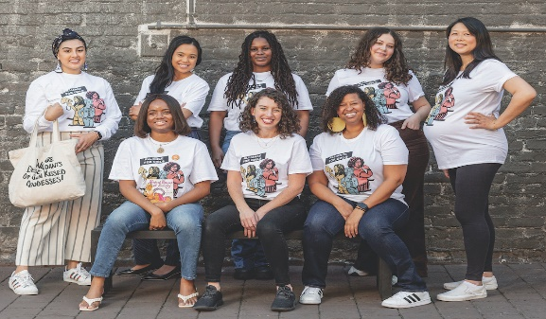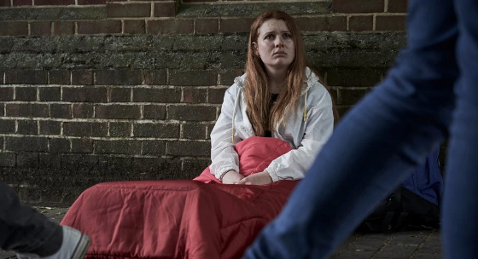
https://www.givinglistbayarea.com/2022/11/18/for-young-women-and-girls-community-is-power/F
https://www.actionforchildren.org.uk/blog/what-is-the-extent-of-youth-homelessness-in-the-uk/
UJLOK
B
We got WARM place for you to SLEEP.
Say NO to homeless.
You are NOT alone.
We got FOOD and DRINK for you.

O
JUBE COMMUNITY- The Market Gates, G. Yarmouth NS31 2BG
Open Time- 8am-11pm

Info: 01493745151/07650512889
Email- Communityforyoungladies@gmail.com
Web-www.communityportal.co.uk

In visual platform, my young ladies' community is unique. First and foremost, we promote young women's empowerment and education. We acknowledge that girls have traditionally been disadvantaged and devalued, and our goal is to create a secure environment for them to study, grow, and develop into strong leaders. Our programmes are designed to foster critical thinking, problem-solving, communication, and collaborative skills. We also focus on the significance of self-care and mental wellness. My community is unique because of the extensive services and assistance we provide. We provide a secure and encouraging atmosphere for these women to reconstruct their lives and reclaim their freedom. Our programme provides them with lodging, meals, counselling, job training, and educational opportunities to assist them in obtaining stable work and permanent housing. In addition, we collaborate closely with local groups to link our people to resources such as healthcare, legal assistance, and transportation.

Task 1 
Avoid Sickness

Stop spread HIV.
Warm place to sleep.
Cooking Classes
Protection during winter
Health
Ballet
Dance
Benefits
Staff/ Teamwork
Family
Someone to listen you.
Planning
Swimming Classes
Help
Support
You are not alone.
Hot Food and Drink
Help with drugs consumes
Skills
Find your own way.
Build a career.
Build your own life project.
Caring

According to the ONS, violence against women can have substantial and long-term consequences such as mental health concerns, suicide attempts, and homelessness. Domestic abuse, sexual assault, childhood maltreatment, female genital mutilation, forced marriage, and workplace and public harassment are all manifestations of violence against women’s (VAWG). Women are affected (By:https://www.ons.gov.uk/peoplepopulationandcommunity/crimeandjustice/articles/thelastingimpactofviolenceagainstwomenandgirls/2021-11-24). " In the United Kingdom, one in every five women is a victim of sexual assault, one in every four is a victim of domestic violence, and one in every five is stalked by others victim of a crime, most of this victims may not be aware of their experiences.By:(https://vanquishtherapies.co.uk/violence-against-women-and-girls/).
To create and manage this community, one must first define the target population and their demands. The community should have clear standards outlining its goal, norms of interaction, and member expectations. It is critical to have moderators or administrators who supervise group activity and ensure that the information provided adheres to the stated criteria. Creating chances for members to promote their work through contests or features may also assist generate momentum while instilling a feeling of belonging in participation. Lastly, consistent involvement on social media sites may help promote the group, recruit new members, and keep existing members interested.

REFERENCES
- Juliet Watson Lecturer (2023) 'just a piece of meat': How homeless women have little choice but to use sex for survival, The Conversation. Available at: https://theconversation.com/just-a-piece-of-meat-how-homeless-women-have-little-choice-but-to-use-sex-for-survival-101113 (Accessed: March 05, 2023).
- What is the extent of youth homelessness in the UK? (2022) Action for Children. Available at: https://www.actionforchildren.org.uk/blog/what-is-the-extent-of-youth-homelessness-in-the-uk/ (Accessed: March 7, 2023).
- Staff, G.L. (2022) For young women and girls, community is power, The Giving List. Available at: https://www.givinglistbayarea.com/2022/11/18/for-young-women-and-girls-community-is-power/ (Accessed: March 7, 2023).
- Action for Children. (n.d.). What is the extent of youth homelessness in the UK? [online] Available at: https://www.actionforchildren.org.uk/blog/what-is-the-extent-of-youth-homelessness-in-the-uk [Accessed 09 Mar. 2023].
- ‌ Centrepoint. (n.d.). Youth homelessness: the causes. [online] Available at: https://centrepoint.org.uk/youth-homelessness [Accessed 31 Mar. 2023].
- Eden Project Communities. (n.d.). Support your community. [online] Available at: https://www.edenprojectcommunities.com/support-your-community [Accessed 6 Apr. 2023].
- ‌The lasting impact of violence against women and girls - Office for National Statistics. (24 Nov 2021). The lasting impact of violence against women and girls - Office for National Statistics. Available at https://www.ons.gov.uk/peoplepopulationandcommunity/crimeandjustice/articles/thelastingimpactofviolenceagainstwomenandgirls/2021-11-24.( Accessed 7 Apr. 2023)
- A Rising Concern - Violence Against Women and Girls | Vanquish Therapies. (2023). Vanquish Therapies. Available at https://vanquishtherapies.co.uk/violence-against-women-and-girls/. (Accessed 9 Apr. 2023)

