
MBA Masters of Business Administration: Skills for the Workplace

Marketing Strategies, Brand Equity and Customer Journey Management of the Coca Cola Company

NAME: Shefa Begum
STUDENT NUMBER: 1711382
MODULE TITLE: Marketing Management 1
MODULE NUMBER: LCMB 7001
LECTURER: Tushara Balendran

Contents
Introduction 1
Company Overview 1
Communication 2
Communication Model 2
Integrated Marketing Communication 4
Promotional Strategies Coca Cola Company Can Use for Raising Brand Awareness 4
Branding and Brand Equity 6
Branding 6
Brand Equity 6
Keller’s Brand Equity Model 7
Advantages and Disadvantages of Keller’s Brand Equity Model 8
Keller’s Brand Equity Model in Coca Cola 9
Customer Journey and Touch-Point of Coca Cola 10
Customer Journey Map of Coca Cola 12
Total Engagement Model 13
Total Engagement Model in Coca Cola 14
Conclusion 15
References 16

INTRODUCTION
Integrated marketing communication can be conceptualized as an approach that makes sure all the communication approaches are linked with one another. Basically it means, integration of all promotional and communication tools, to ensure a harmony among them all (Thorson, 2013). Customer journey can be defined as the customers’ movement and the path throughout different touch points that leads to decision of purchasing a product (Varnali, 2018). However, for the purpose of this report, the Coca Cola Company has been chosen. This company is one of the most leading manufacturing companies of beverages that is currently operating in around 200 countries.
Throughout the report, the following discussions will take place; an overview of the Coca Cola Company, what is communication, communication model, integrated marketing communication, current promotions used by the company, new suggested promotion strategies for the company, branding and brand equity, Keller’s brand equity model, customer journey and touchpoints, customer journey map, total engagement model.

COMPANY OVERVIEW
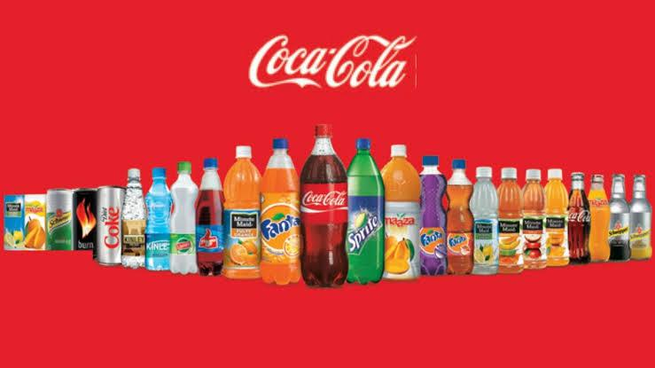
The Coca Cola Company was established on 29th January 1892, in Atlanta, United States. This is at present a beverage manufacturing company that sells different types of syrups and drinks with main concentration on the Coca Cola brand. It has around 2800 products supplied in around 200 countries and it is one of the largest beverage producers and sellers in the United States and the world. It is headquartered in Atlanta and Georgia (Elmore, 2013).

Figure 1.1: Products of the Coca Cola Company (official website)
The vision statement of this company is to inspire each other to be the best they can be through rendering a great environment to work in. The mission statement of Coca Cola Company is, to refresh the whole world in body spirit and mind, to encourage optimistic moments and spread happiness by the brands and functions and to create unique value to make a difference. Currently, it is one of the world’s most famous and largest carbonated beverage producers with its brand being very well known to customers of all generations (YAO, 2017).

COMMUNICATION
Communication refers to receiving and giving or sharing and exchanging information, thoughts, emotions etc. According to Turnage (2007), “When the factors that cause any negativity or conflict are known, it helps the users of this era of technology to understand the different aspects of a message that might lead to a conflict”. According to Rogers (1998) & Darsanti (2012), Communication refers to the process through which ideas are transmitted from one source of sender to one or more receivers with an intention to change behaviour (Broadbent, 2013).

COMMUNICATION MODEL
There are two basic models of communication, macro model and micro model. The macro model illustrates nine elements of the communication process. The macro model is briefly described below.
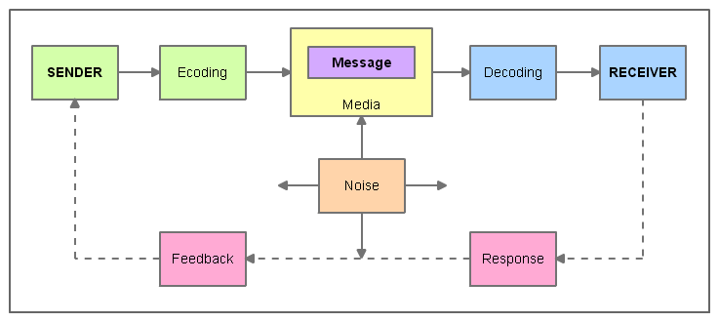

Figure 1.2: The communication Model (Kotler, 2016)

Sender: The party who commences the communication with a message. In the case of
marketing communication, it is the company who sends a message to a customer.
Receiver: It is the party to whom the message is sent from the sender who intends to share information. In case of marketing communication the receiver is a consumer who receives a message about a new product from the company (Kotler, 2016).
Message: this is the main content that is designed based on the objective of the communication . The companies design an impactful message to be sent to the consumers That will fulfill their communication goals.
Media: this is the tool or mechanism of transmission of information. This can be a post office, online media, radio television Telephone or any other similar media. Marketers nowadays mostly use online media or SMS to communicate their personalized messages to the consumers. (Castronovo and Huang, 2012).
Encoding: This is the process of transforming different objectives and different aspects of information into a meaningful and well-structured message.
Decoding: This is the process of interpretation of the message by the consumer.
Response: This is the reaction of the consumer To whatever message they received. the activities and behaviours of the consumers after receiving the message. The way they are acting upon this. After learning about a new product, whether they are interested in purchasing it or no more information about it.
Feedback: This is the final stage of the communication process where the receiver responds to the message or the sender. Getting feedback through surveys helps to understand whether the message was successful to achieve the communication objective. Whether the message was able to communicate what it was intended for (O’Donoghue, Peter and Mayes, 2013).
Noise: Sometimes there can be disruption in the communication due to some uncontrollable reasons for example, poor Internet connection or network failure, poor signal etc.
INTEGRATED MARKETING COMMUNICATION
According to Philip Kotler, the integrated marketing communication or IMC approach is a concept through which companies coordinate and integrate their several communication channels for transferring the message clearly and more consistently about the products (Angelopulo, GC and Barker, 2013).
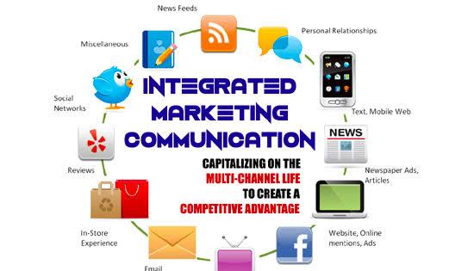

Figure 1.3: Integrated marketing communication
As reported by Keegan (1992), it is a tactical management of every media and communication tool that an organization uses to influence its realized brand value. It is stated by Kliatchko (2005), cohesive marketing communication is a hypothesis or method of dealing customer focused and media positioned and goal driven plan brand communication programs (Finne and Grönroos, 2017).

PROMOTIONAL STRATEGIES COCA COLA COMPANY CAN USE FOR RAISING BRAND AWARENESS
Sponsorship and collaboration: The Coca Cola company can make sponsorships and collaborations with different educational institutions, cafes and there's different events like sports and extracurricular.
Create shareable lucrative info-graphics: The company can design their contents and organize them into attractive info-graphics that have to be posted on social media and make them shareable to reach a greater number of audiences and grab new markets. The social media algorithm promotes the shared posts from family and friends more than the brands. As info-graphics catch more attention, the company can leverage its advantages to enhance their brand awareness (Bilgin, 2018).

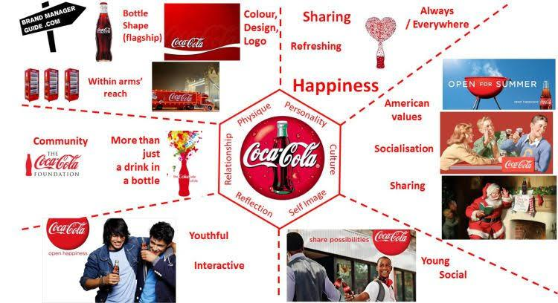

Figure 1.4: Coca Cola promotions
Start podcast: The Coca Cola company can start podcasting that can add more value to the customers lives and the customers are more likely to remember the brand in this way. Creating unique and creative podcasts will attract more customers from this generation.
Leverage Facebook, Instagram and Twitter ads: The Coca Cola company can also launch different campaigns on Facebook Instagram and Twitter to improve brand recall. They can also set their bid amount with increased impressions and optimize their tweets and campaigns on Twitter (S, 2016).
Partnership with influencers for brand review: nowadays it is very popular that the influencers give reviews of different brands on social media. The Coca Cola company can partner with different influencers who are popular on online media to grab the people who are their followers and get influenced by the reviews of their favourite influencers. The company can provide them with some free products or in case of new products they can provide some free samples in exchange for the advertisement or review.
The Coca Cola Company can also partner with the influencer for creating different contents. They can collaborate with creative video creators to leverage their unique and attractive ideas to make advertisements more interesting to the customers of this generation.

BRANDING AND BRAND EQUITY

Branding
Branding is supplying commodities and amenities through the power of brand (Kotler and Keller, 2015). As explained by Jay Baer, branding is an ability of associating what one desires people to think about the company with what people essentially think about the company. According to Brian Eisenberg, the sum totals of all experiences of the customers have with the company. Successful branding should have consistency, anchoring and frequency (Fetscherin and Usunier, 2012).

Brand Equity
Brand equity is made up of brand accountabilities and properties connected to the brand or its symbol and name that subtracts from or adds to the value a product provides to a firm and its customers. Keller (1993), suggests that the distinguishing outcome of brand information on response from customers to marketing of brand. Kotler and Keller (2006), state that it is a bridge between the consumer’s brand knowledge and the marketing investments of the products for creating a brand (Theurer, Tumasjan and Welpe, 2018).
KELLER’S BRAND EQUITY MODEL
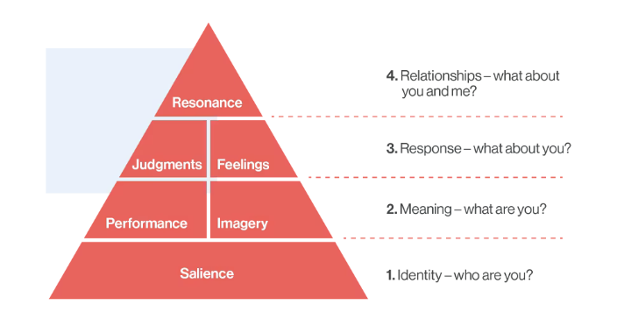
One of the pillars of the CBBE model was established by Kevin Keller, who illustrated the customer relationship and journey with a brand from recognizing to resonance.

Figure 1.5: Keller’s brand equity model (Farjam and Hongyi, 2015)
Keller depicted six components in this model as shown in the picture, all these contribute to consumer brand equity and how consumers feel about a brand. The components are briefly described below:
Salience: At the basement of the pyramid of brand equity is salience. This signifies how conscious people are about the reality of the brand generally. This is very useful and required at first stage of building consumer brand equity. This phase is not only about the customers recognizing the brand; it’s more about making sure people are recognizing it right. Consumers should be given a clear, accurate and consistent presentation of the brand’s identity (Farjam and Hongyi, 2015).
Performance: Performance and imagery are the two parts that make up the second stage of the brand equity model. The area of performance represents the real characteristics and capacities of the products. This area includes- reliability, durability, design, customer service, functionality and customer satisfaction.
Imagery: Besides performance there is imagery. It is more about the way a brand is meeting its customer’s psychological and social needs. It thinks of the brand as a human. The brand imagery is basically what people actually think in their mind when they see the brand. How happy the customer would be to be associated with the product due to its reputation.
Judgements: The third phase of this brand equity pyramid consists of two things, judgment and feelings. Judgement is about opinions about the brand that customers form. Judgment typically is broken down into four parts, quality which means the brands perceived or actual quality, consideration meaning the brands relevance, credibility meaning the brands reputation and superiority which means the brands position against its competitors (Jara and Cliquet, 2012 ).
Feelings: Another part of the phase is Feelings. It presents what people feel regarding the brand. There can be six positive feelings of customers that companies should focus on: excitement, fun, security, self-respect, warmth, and social approval.
Resonance: This is the peak level of the pyramid. In this phase, customers are fully aware of the brand and already buying from it. In this stage, positive customers are already advocating for the brand. This stage typically has 4 categories:
Sense of community: This is the bond consumers feel for other people who use the brand.
Attitudinal attachment: The connection and love consumers have for the brand.
Behavioural loyalty: This represents how frequently a consumer purchases from the brand.
Active engagement: This shows how much engaged consumers are with the brand even if they are not buying from this (Hsu and Assaf, 2012).

Advantages and Disadvantages of Keller’s Brand Equity Model
Advantages: The brand equity model can be operated as a measure to monitor the way marketing communication can develop active and intense loyal relationships and how this affects the brand equity. Through this model Friend can be successful by excelling in all the six phases of the building blocks through this model. Brands that achieve resonance with customers can reap impressive benefits.
Disadvantages: Some critics of this model found out that feelings do not play a significant role in the business-marketing field. They also suggest that the phase of resonance might need some modifications so that it can be more relevant. They also suggested that business representatives can play a vital role in developing the brand equity; hence this model should indicate the need for human element and recognize it in a brand equity model (Vukasović, 2016).

KELLER’S BRAND EQUITY MODEL IN COCA COLA
Coca Cola is strong on both right and left sides of the resonance pyramid. There is a great synergy between both emotional and functional attributes of the Coca Cola brand.
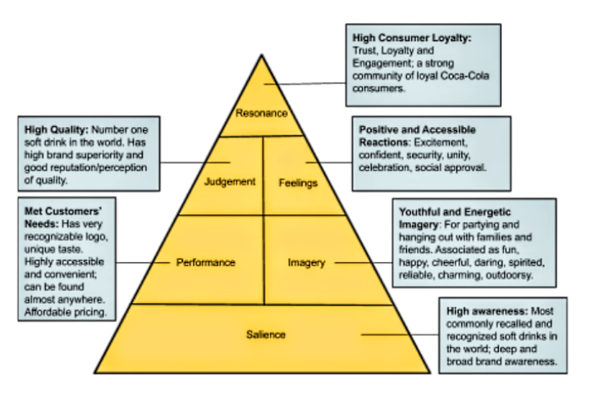

Figure 1.6: Brand resonance pyramid of Coca Cola
Salience: The Coca Cola Company has high brand salience. Based on the conclusion from a focused group discussion it is clear that Coca Cola is one of those brands that all the members of that group could easily recognize even though the logo was blurred. It shows how much deep awareness the Coca Cola brand has Compared to other brands who produce soft drinks. Moreover most of the members of that group had chosen Coca Cola for enjoying a hang out or party with friends and family. This proves that Coca Cola has a very wide range of brand awareness.
Performance and imagery: several views have been collected to understand how the brand is perceived regarding its performance. The packaging of Coca Cola is never changing and iconic. The price of larger models are cheaper compared to the price of smaller ones which shows that the brand used a discount pricing strategy on volume which proves to be effective for its loyal customers. This brand is involved in imagery of being happy, young, energetic, charming and reliable.
Judgment and feelings: the Coca Cola brand has highly good perceptions about its credibility, quality , superiority and consideration. Most of the members from that focus group see Coca Cola as the most reputed brand of soft drinks. The members concluded that Coca Cola is obviously more refined and superior then other competitive brands. It has unique and rich flavour and several product lines. They said the advertisements are fun, beautiful and energetic and their feelings towards the brand matched the image.
Resonance: The Coca Cola brand has overall high brand resonance. Five out of seven people consider Coca Cola as their first choice when buying a soft drink and most of them actually miss drinking it if it is out of the market. It shows that most customers have deep attachment personally for the brand, and would like to recommend the brand to others. The brand actually has a strongly loyal customer community (Çal and Adams, 2014 ).
CUSTOMER JOURNEY AND TOUCH-POINT OF COCA COLA
Coca Cola has been successfully using touchpoint in their integrated marketing communication channel. A map that represents the way a company can understand its customer’s behaviour can be defined as a customer’s journey (Jennifer Clinehens, 2019). Generally customers don’t buy immediately, they are more likely to observe and research about the brand then the product several times before buying from it which can be considered touchpoints (Alan Paul Ford and Paul Smith, 1999).
Following are a brief description of the customer journey and touchpoint of Coca Cola.
Advertisement: Coca Cola uses different media for conveying its encoded message to targeted customers. The channels they effectively use include TV commercials, newspaper social media etc (Susanthi and Pramita, 2020).
Personal Selling: The Coca Cola company uses staff for selling face to face. Most customers are excited with the indication “cold cokes right here”
Public relation: A smarter way is PR used by coca cola to influence consumers. They organize popular events to grab the attention of customers. Also they are able to gain new potential consumers' brand awareness (Bui, 2020).
Sales Promotion: Coca Cola uses big sale offers when launching new products. They use this tool in both food and retail.

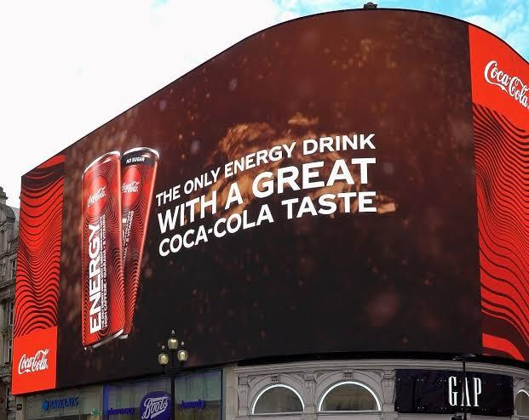
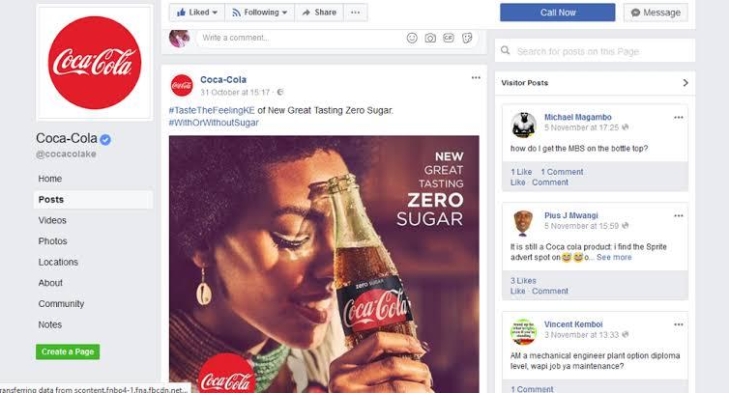
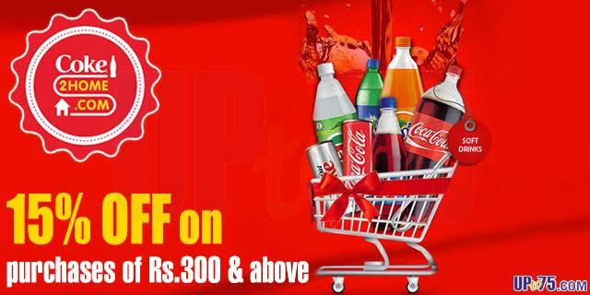
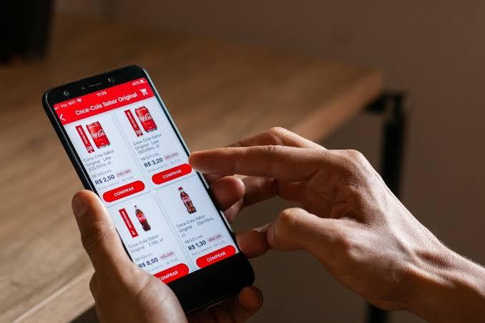
Figure 1.7: Touchpoints of Coca Cola

Customer Journey Map of Coca Cola
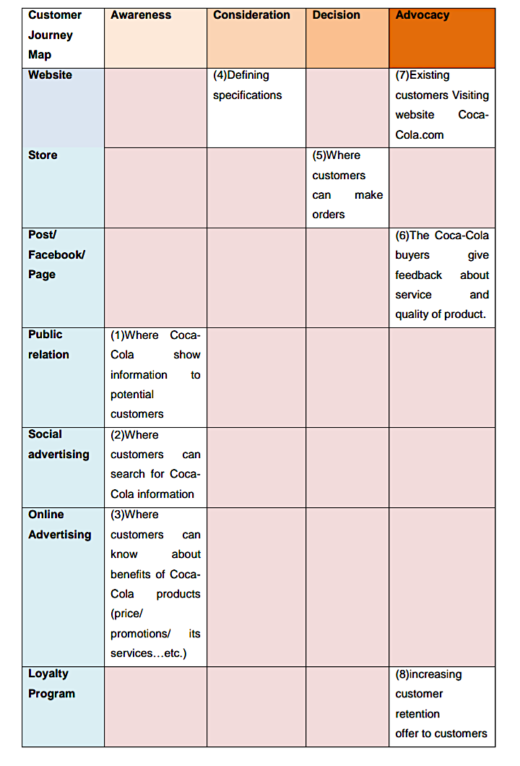

Figure 1.8: Customer journey map of Coca Cola (Bui, 2020)
In the awareness stage, Coca Cola uses word of mouth channels. The company has been using this channel for motivating and driving customer awareness about their brand. Typically most of the potential buyers can know and observe no Coca Cola products on televisions or stores or events and especially on social media.
In the consideration stage, customers think about their decision of buying the product, whether the product satisfies their needs compared to the substitutes. The Coca Cola Company has been using online advertisements as a touchpoint at this stage. The customers can easily search for different information about the brand and the products on the Internet. They can also easily compare prices and promotional offers of Coca Cola with other substitutes or brands (Moon and Hong, 2016).
In the decision stage the customers actually decided to buy the product that can satisfy their needs and bring more benefits at the lowest price with the highest value and quality. Coca Cola brand shows all their essential information on the Internet and lets the customer review when finally purchasing it.
In the retention stage, the company's likelihood to be successful can be understood. The Coca Cola Company tries to collect data through different surveys on their customers through which they know whether their customers’ requirements are matching with the feedback on Facebook or other media. Coca Cola has produced improved and new products To satisfy wider ranges of customers for example Diet Coke (Yoo and Pan, 2014).
In the last stage, advocacy, the customers become loyal and advocate for the brand, recommending them to others. Coca Cola uses promotional programs for this where customers get different vouchers or combo packs with lower prices when they come in a group to purchase.

TOTAL ENGAGEMENT MODEL
Someone who is devoted to a specific trademark and endorses the trademark and the products to others is known to be an engaged customer. Through the total engagement model, companies can get more engaged customers.

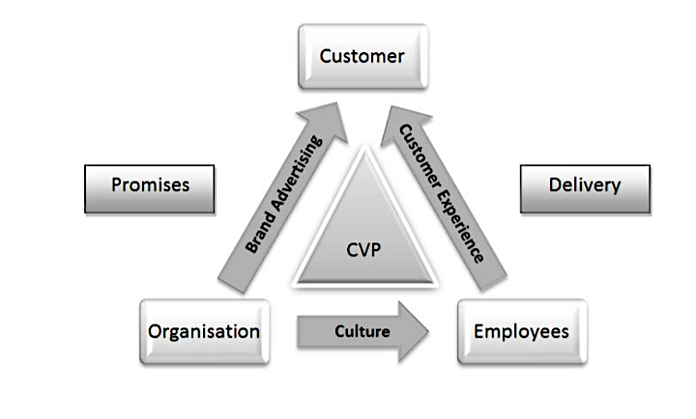

Figure 1.9: Total engagement model (Roberts and Alpert, 2012)
T0 start off with, the model projects a plan of some fundamental tactical parts that requires business needs to design and align to get more engaged customers. The basic elements of this model are as follows:
Customer Value Proposition (CVP): This is the main reason consumers go to purchase anything from the brand and not from the competitors (Roberts and Alpert, 2012). This is how the brand is valued to a customer.
The brand: Brand refers to the sum of the identity and the mission. it doesn't merely mean the logo or name. The key part of the value proposition must form the brand advertisement.
Culture: here, the term culture means the way companies do different activities. It represents the goals and values of another internal behaviour of the organization. Now companies should design their culture to create a flexible environment to enhance the capabilities of their staff.
Customer experience: This is an integration of emotional and physical elements which is the customers experience during their interaction with a brand (Roberts et al., 2016).

TOTAL ENGAGEMENT MODEL IN COCA COLA
CVP: The Coca Cola company provides their customers value. Consider customers as their source of energy. They start providing value with their products involving the packaging, pricing, affordability, and quality. Besides, Coca-Cola focuses on their customers' lifestyles to meet their needs at a greater level. For example their Diet Coke has been specially designed for the people who are on a diet. One of their popular slogans is “open happiness”. Coca Cola have also used as a slogan “the coke side of life” (Gehani, 2016).
Brand advertisement: The Coca Cola Company uses different advertising media to create brand awareness among potential customers. Some of the different media they use are television commercials, print media, point of purchase and outdoors advertising.
Culture: The Coca Cola Company has proven to have a highly strong culture. They have aligned their culture with their vision that depicts a long-term strategy and road map to understand the forced entrance that possibly will shape the business in future. The company considers it as a preparation for designing the future opportunities. Their roadmap shows a winning culture. Their values include collaboration, accountability, integrity, diversity, passion, leadership and quality.
Customer Experience: The company is turning to big data for enhancing customer experience. They have previously launched different campaigns and apps focusing on different customer groups. They consider CX as their growth (Baker, 2016).

CONCLUSION
The Marketing and communication strategies are the most crucial parts of a company’s ultimate strategy without which they will be able to make products but they can’t sell those. Moreover, only selling is not enough to remain competitive in the industry. Businesses thus have to retain their customers and make sure they recall the brand and advocate for this to achieve its goals in the long run. The Coca Cola Company has proved to be an icon of excellence in marketing communication and branding. Still the company must strive to be more adaptive to changing situations and needs.

References
Angelopulo, GC and Barker (2013) Integrated Organisational Communication, 2nd edition, Cape Town: Juta.
Baker (2016) 'Customer Experience 3.0: High-Profit Strategies in the Age of Techno Service', Quality Progress, vol. 49, no. 7, p. 60.
Bilgin, Y. (2018) 'The effect of social media marketing activities on brand awareness, brand image and brand loyalty', Business & Management Studies: An International Journal, vol. 6, no. 1, pp. 128-148.
Broadbent, D. (2013) Perception and communication, Elsavier: Pergamon Press.
Bui, N.T.H. (2020) 'CUSTOMER JOURNEY AND CUSTOMER TOUCH-POINT OF COCA-COLA', International Journal of Economics, Commerce and Management, vol. 8, no. 6, June, pp. 415-420.
Çal and Adams (2014 ) 'The effect of hedonistic and utilitarian consumer behavior on brand equity: Turkey–UK comparison on Coca Cola ', Procedia-Social and Behavioral Sciences, vol. 150, pp. 475-484.
Castronovo and Huang (2012) 'Social media in an alternative marketing communication model', Journal of marketing development and competitiveness, vol. 6, no. 1, pp. 117-134.
Elmore, B.J. (2013) 'Citizen Coke: An Environmental and Political History of the Coca-Cola Company', Enterprise & Society, vol. 14, no. 4, December, pp. 717-731.
Farjam and Hongyi (2015) 'Reviewing the concept of brand equity and evaluating consumer-based brand equity (CBBE) models', International Journal of Management Science and Business Administration , vol. 1, no. 8, pp. 14-29.
Fetscherin and Usunier (2012) 'Corporate branding: an interdisciplinary literature review', European Journal of Marketing, vol. 46, no. 5, May, pp. 733-753.
Finne, Å. and Grönroos, C. (2017) 'Communication-in-use: customer-integrated marketing communication', European Journal of Marketing, vol. 51, no. 3, April, pp. 445-463.
Gehani (2016 ) 'Corporate brand value shifting from identity to innovation capability: from Coca-Cola to Apple ', Journal of technology management & innovation, vol. 11, no. 3, pp. 11-20.
Hsu and Assaf (2012) ' A customer-based brand equity model for upscale hotels ', Journal of Travel Research, 51(1), pp.81-93., vol. 51, no. 1, pp. 81-93.
Jara and Cliquet (2012 ) 'Retail brand equity: conceptualization and measurement ', Journal of Retailing and Consumer Services, vol. 19, no. 1, pp. 140-149.
Kotler, P. (2016) A framework for marketing management , Boston: Pearson.
Moon and Hong (2016) 'A design process for a customer journey map: a case study on mobile services', Human Factors and Ergonomics in Manufacturing & Service Industries, vol. 26, no. 4, pp. 501-514.
O’Donoghue, Peter and Mayes, A. (2013) 'Performance analysis, feedback and communication in coaching', Routledge handbook of sports performance analysis , pp. 173-184.
Roberts and Alpert (2012 ) 'Total customer engagement: designing and aligning key strategic elements to achieve growth',. Journal of Product & Brand Management.
Roberts, Christopher, Alpert, F. and Roberts, C. (2016) 'Strategic Drivers of Customer Engagement: Practical Applications', Contemporary Issues in Customer Engagement, pp. 171-192.
S, K. (2016) 'Social media marketing', Asian Journal of Multidimensional Research , vol. 5, no. 4, pp. 6-12.
Susanthi, D. and Pramita (2020 ) 'The Types of Meaning in Coca Cola Company Advertisement', no. 15-16.
Theurer, Tumasjan and Welpe (2018) 'Employer branding: a brand equity‐based literature review and research agenda', International Journal of Management Reviews, vol. 20, no. 1, pp. 155-179.
Thorson, E. (2013) Integrated communication: Synergy of persuasive voices, Psychology Press.
Varnali, K. (2018) 'Understanding customer journey from the lenses of complexity theory', The Service Industries Journal, vol. 39, no. 11-12, March , pp. 820-835.
Vukasović (2016) 'An empirical investigation of brand equity: A cross-country validation analysis', Journal of Global Marketing, 29(5), pp.251-265., vol. 29, no. 5, pp. 251-265.
YAO, L. (2017) 'Nationalism on Their Own Terms: The National Products Movement and the Coca-Cola protest in Shanghai, 1945–1949', Modern Asian Studies, vol. 51, no. 5, September, pp. 1439-1468.
Yoo and Pan (2014 ) 'Expanded customer journey map: interaction mapping framework based on scenario ', International Conference on Human-Computer Interaction , June, pp. 550-555.

