ENAKSHI CHAOWDHURY | 1713199
REFLECTION OF PERSONAL VALUES ALIGNMENT TO THE ORGANISATIONAL VALUES

Taylor (2000) came up with the research that throwing back of memories, thought and other in cognitive act such as any form of concentration, to meditate and to make some contextually changes if needed is reflection (Nottingham.ac.uk, 2020)
While Critically reflecting over how my values could be aligning to that of the chosen organisation ,in here that is “Poundland” the model which could be discussed in this context is Graham Gibbs reflective cycle, to find out what he tried to established in the cycle , as systematically thinking of people in the circumstances of a particular event or given situation’, “critical journey means to find a reflection, where it start from the very beginning of an essential journey by doing critically reflection it bring the gap closer of the between the core or original theory and how it is being used ”(Jasper ,2003).
Poundland is an organisation that do tells lot of promising values that came up while researching but proper evaluation of those values from the annual report can be done through the Gibbs model.
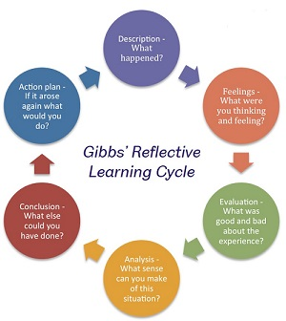

Here if each stage of the Gibbs model is to be critically aligned with pound lands values, attitude and beliefs , it could go like this in the, description -what is the finding about pound land , next step feelings about the organisation , next is to evaluate Poundland truly and then to analysis the organisation and in the very last what can be done in my point of view if I am being seen as a potential employee in Poundland .

Description – finding out the core value, attitude and belief of Poundland
Interpretation – making a thorough research about the organisation evaluate the effectiveness Evaluation – the truth what Poundland is reporting in the paper or media is it true or not?
Planning Ahead - placing myself as a potential employee and planning for the future what I should I plan for the growth of the company.

Values are key part of our day to day activity in our system, they dignify our culture, personal unique dignity. Business coach Scott Jeffery did bring out the fact that the highest level of fulfilment is achieved when we respect personal core value. (Jefferey,2019).
In organisation behaviour value is symbolized as total conception of what is considered as good or bad, desirable or non-desirable and proper or in proper in a culture. (Iedunote.com2020)
My core values of my life are commitment, helpful, loyalty, among them I believe loyalty is the key to achieve any measure of success in life. Even though it’s hard to be loyal but at least I try to be loyal to stick to my honesty whenever possible, example it’s very hard sometimes to come out with the truth about some opinion which were asked by my close family and friends , but still I try to put my loyalty towards my honesty first to give my words towards it While researching about Poundland’s value it is really surprising that even though they speak about putting the preference of their customers first, keeping it simple, responsibility in team delivering still they are not completely loyal towards their customers. (Poundlandcorporate.com,2020).

In critically discussing personal value with that of Poundland the Barrett model of consciousness can be taken as a tool which clearly signifies, individual needs, wants and development is fulfil by creating leaders” (Intelligence, Awareness and Consciousness, 2019),

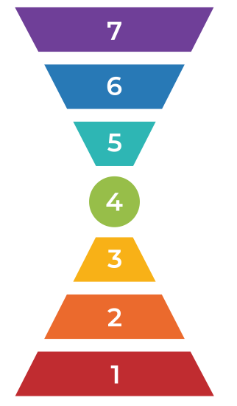

The seven level of consciousness can be taken as a tool to find out my strength in detecting personal values, hence it came out that personally I am honest and ethically strong as per the result of the query (Barrett Value Centre,2020) .Research on the point of ethics and honesty it is found that Customers in Poundland have a real doubt about some of the product that was sold in the stores ,doubt is their about the product is produced in not a very ethical way in some of the country where they are made , neither follow the minimum standard requirement (Mumsnet.com, 2020), so clearly the quality which Poundland speaks about comes under serious question in this context .Even though they are in conception of £1 shop ,still the quality have to be there .

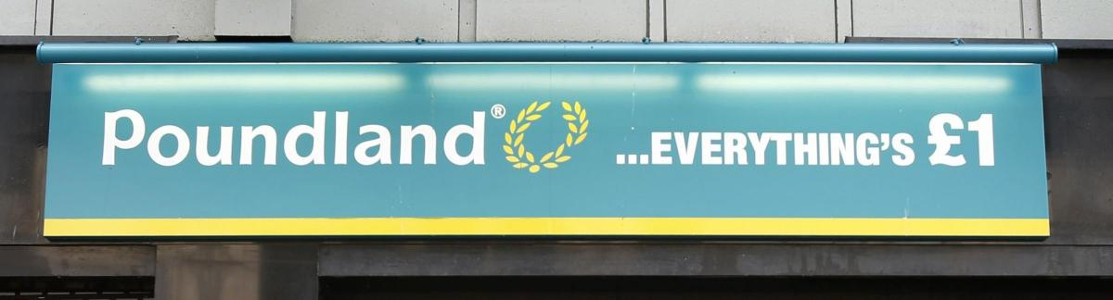

My personal core value of loyalty ,honesty do contradict with their values in this terms .Even if I am being considered to be a probable employee in future this points will hold me back a bit to join the organisation ,where as in the same time I will try to put my recommendation to come up with solution of this core issue .

Another significant model in this context is Dilts logical level , where it is understood why some of the changes is easier to get than the other and why it stay for a substantial period of time ,it is basically a logical changes whether it is personal or of an organisation .

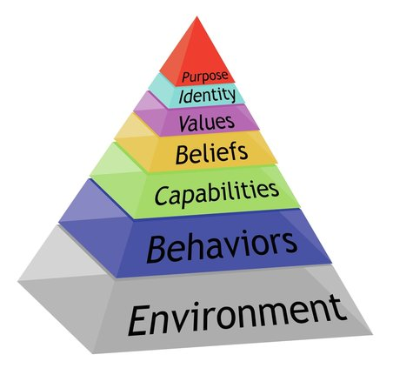

They describe six level of situation -spirituality and identity, belief, capability, competence, environment and behaviour, they stand for the hierarchy level (Dilts' Logical Levels | SkillsYouNeed,2020). To relate critically the level of situation with Poundland ,identity can be seen ethically a relating point to that of the organisation ,personally as the core identity Poundland stand in each and every bodies mind as a shop where almost all the product can be bought for £1 and the quality should be the same as the brand states but now the story tells somethings different as discussed already .Even it is also noticed that the product as selling in the store of much more higher value rather than a £1 ,so it will seriously question the identity of the organisation .

To conclude the reflection, it is clearly understood that there is clear and crystal contradiction of core personal value with that of the organisation (Poundland) values. Although since 2011poundland have brought an individual internal audit system to maintain the standard of quality of the product ,have joined SEDEX , the production is based on (ILO) and have started to involve in lot of charity work ,still the authenticity of the ethically produced is a question mark (Poundland.co.uk, 2020). This in long term can hurt the organisation, staff retention could be a probable risk as the issue of less foot fall for the ethical problem can result to see store closer like other high street brand. Staff moral could be affected if issues could not be solved ,the management have to be proactive so that in store as well as customers relation process can be handled nicely .More emphasis have to be given in looking up to the production house where the product is source from so that it ethical moral remain high .

Reference

Barrett Values Centre. (2020). Personal Values Assessment (PVA) - Barrett Values Centre. (online) Available at: https://www.valuescentre.com/tools-assessments/pva/ (Accessed 5 Mar. 2020).

Dilts' Logical Levels | SkillsYouNeed. (online) Skillsyouneed.com. Available at: https://www.skillsyouneed.com/lead/logical-levels.html (Accessed 4 Mar. 2020)

IEduNote.com. (2020). Values: Definition, Characteristics, Importance, Types of Values. (online) Available at: https://iedunote.com/values (Accessed 2 Mar. 2020)

Intelligence, E., Awareness, S. and Consciousness, S. (2019). Seven Levels of Leadership Consciousness - BusinessBalls.com. (online) Businessballs.com. Available at: https://www.businessballs.com/self-awareness/seven-levels-of-leadership-consciousness/ (Accessed 3 Mar. 2019)

Jefferey, s. (2020). (online) Available at: https://scottjeffrey.com › personal-core-values (Accessed .2nd March 2020)

Jasper, M. (2003). Beginning reflective practice. 1st ed. London: Nelson Thornes ltd, p.5.
Mumsnet.com. (2020). (online) Available at: https://www.mumsnet.com/Talk/am_i_being_unreasonable/1906373-To-think-that-Poundland-might-have-sold-me-fake-Colgate (Accessed 4 Mar. 2020)
Nottingham.ac.uk. (2020). Definitions of Reflection. (online) Available at: https://www.nottingham.ac.uk/nmp/sonet/rlos/placs/critical_reflection/origins/reflection_definitions.html (Accessed 4 Mar. 2020)

Poundland.co.uk. (2020). (online) Available at: https://www.poundland.co.uk/wordpress/poundland/wp-content/uploads/2013/03/Corporate-and-Social-Responsibility.pdf (Accessed 4 Mar. 2020).
Poundlandcorporate.com. (2020). (online)Available at: http://www.poundlandcorporate.com/~/media/Files/P/Poundland/reports-and-presentations/poundland-ar-2016.pdf (Accessed 5 Mar. 2020)

