BMHP5014
Creativity and Value Creation
Component 1
Online Portfolio of Set Exercises

Student Name: sharm gill
Student ID:2322794
Table of Contents
Introduction 3
Weekly Module Activities 3
Application of Learning 4
Creativity and Innovation 4
Leadership and Collaboration 5
Value Creation 6
Technology Application 7
Reflection 8
Conclusion 9
Reference List 10

List of Figures
Figure 1: Value creation 3
Figure 2: Creativity and Innovation Thinking Course 5
Figure 3: Business Value Creation 7

Introduction
It is a portfolio that is to be demonstrated to demonstrate that a student has gained knowledge in a health and social care setting. The core aim of it is to show the innovativeness, leadership, value generation, and practical application of technology by the student. The portfolio will signify the learning that I have accomplished over the week, both as an active individual and as a reflective individual as a result of the activities that I have undertaken throughout the module, exercises and lectures (Oppert et al., 2023). A portfolio of this kind will show how the student has applied the module materials in solving real-life problems in the field of health and social care, how the student has come up with creative solutions and leadership skills through working in a team. Moreover, it will show how technology can be deployed in the learning process of students and whether it is effective in developing innovative and progressive solutions to the health and social care environment.

Weekly Module Activities
Here, the section is a description of the evidence of the participation and learning of the student in both of the weekly module activities. The exercises, the class activities, and discussions that the student receives each week make the student actively participate in the learning process of the module content. The student has also been creative and innovative by the weekly activities, e.g. the student has come up with new approaches to solving problems or has applied new concepts to real-life problems of health and social care.
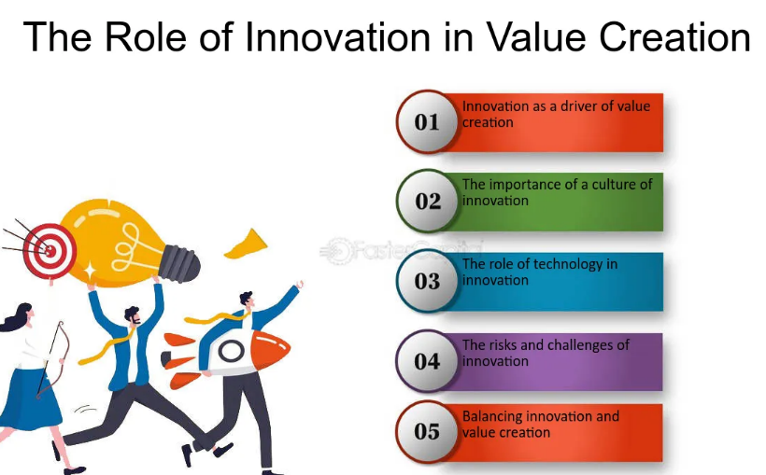
Figure 1: Value creation
Source: (Booth & Kellogg, 2014)
A short description of all activities performed every week is listed in the portfolio, and the action that the student performed in the activity and the results obtained. Besides these, the student has also provided visual presentation in terms of images, charts, screen shots besides the audio/video clips as one of the representations of the participation of the student that can more clearly represent the learning process (Bozward & Rogers-Draycott, 2020). Not only is the student in this portfolio demonstrating that he or she has completed the activities, but the student has also tested his or her ability in terms of transferring the knowledge learned in one activity to real-life issues. Moreover, it also shows continuity of knowledge and improvement by the student every week, which is a strong indication of a positive and reflective attitude toward learning by the student.

Application of Learning
Under the application of learning section, the students would show how they have been applying the concepts and knowledge they learned during the module into practical health and social care issues. It will also examine how the ideas learned in lectures, module notes and tests have been utilised in coming up with new solutions among the students. Indicatively, a student may be able to enhance patient care in a medical facility by applying new methods or technologies, e.g. to find patient data more efficiently and faster using a digital record system. Students will also get an opportunity to learn about the real life problems and consider the possibilities of solutions in such a way that to choose the most effective one (Ranjbarfard & Heidari Sureshjani, 2018). With the help of this, the students are not only able to apply the theoretical knowledge of the module in practice, but also, test its efficiency in the implementation to a real-life situation, through the process of relating the module to already existing research and new ideas. The evidence of such application will be concrete case studies, concrete outcomes, and their reflection at the portfolio that will be able to prove the fact that the student will be able to apply the learning into practice and is already involved in the development of innovative solutions within the health and social care environment.

Creativity and Innovation
The learners in this instance will illustrate how they have enhanced creative thinking and imagination in tackling health and social care environments. To achieve this, the students will explain how they have been able to acquire a new perspective on the old problems and devise new ideas on how to address them in the most effective solution to the problems (BREM et al., 2016). In one instance, the students can use the integration of digital technology, online tools, or new ways of operation, which will be achieved through the recognition of the problems in patient care, not only efficient but useful to enhance the experience of the patient and the quality of the service provided. It is also noted that the students have been able to exercise leadership through the application of new ideas of teamwork, collaboration and problem-solving.
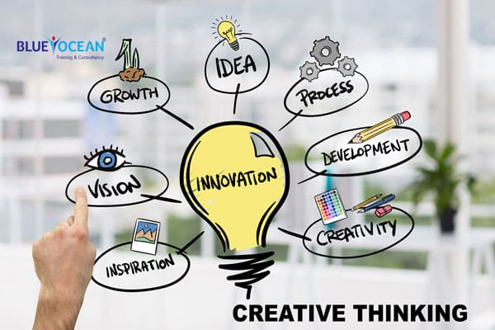
Figure 2: Creativity and Innovation Thinking Course
Source: (Brookes, 2018)
During the process, the students have not only been in a position to practically apply the theoretical knowledge, but also to assess the application, the possible impact and how the innovative solutions can be implemented. The evidence of such innovation and creativity may be provided in the form of projects, activities, images, charts or short videos in the portfolios of the student who will demonstrate that he/she did not simply think about learning, but applied it to real-life issues and was successful in it. As can be seen in this section, the student was innovative and creatively addressed problem-solving skills and problem implementation skills in the health and social care environments.

Leadership and Collaboration
In this section, the learners will show how they have applied the skills of leadership and collaboration skills in a teamwork situation in a health and social care setting. Students will discuss how they have managed to build a team, assign roles to the team members and successfully organise them to accomplish team goals (Wang et al., 2023). An instance is where the students have the possibility of being leaders in the process of service delivery or solution development which is to lead a team in a project of clinical or social care where the strengths and aptitudes of a set of members are mobilised to realise optimal effectiveness. The team discussions can also be used to solve problems whereby the various perceptions are discussed and solutions are reached which is not only improve the communication, coordination and critical thinking skills among the students. Among the items that students can add to their portfolios to show this kind of leadership and teamwork, team projects, meeting notes, reflections and outcomes, among others, can be listed. The partnership aspect of the learner and his or her potential of offering leadership and a solution to a health and social care situation is markedly evident here.

Value Creation
The Value Creation section will require the students to show how they have contributed real values by way of their actions, novel ideas and solutions, which they have induced in the health and social care contexts. The learners will be talking about the fact that every solution or initiative is not merely a theory, but there is a social, health and economic implications to it (Booth & Kellogg, 2014). To explain, it is possible to use the case when students have an electronic record system to manage the information about patients and it is not only that it is easy to store information, but also that the patient receives the appropriate treatment and saves time and enhances the quality of care. In so doing, they create value to health and social care system directly since their efforts directly affect the patients and their families.
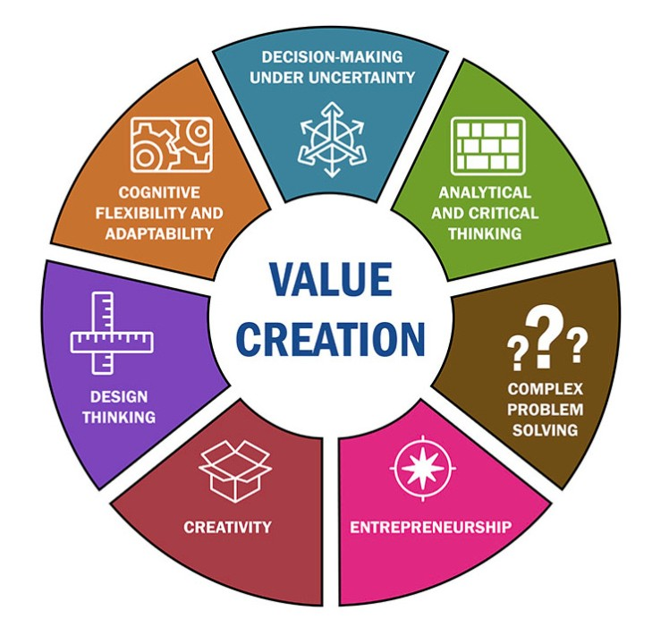
Figure 3: Business Value Creation
Source: (Grover et al., 2018)
The students will demonstrate the way in which they have connected the research, the policy thereof, and working experience to make workable solutions possible and palatable to long-term society. In the case of the social care project, the students have adopted the practices that have influenced the lives of the disadvantaged groups in positive ways or have brought inclusion in the healthcare provision process (Brookes, 2018). The output of the project, case studies, or screenshots of activities, charts or pictures can also be used as part of the portfolio by the students as evidence of these values. They will also consider the level of innovation and use of technology in the stage of achieving personal, professional and social values.

Technology Application
The Use of Technology section will entail the students showing how they have successfully implemented the use of technology in the health and social care settings and how they have consequently enhanced their practice in a creative and better way. The students will discuss how the technology has been utilised to address the existing problems of health and social care using digital tools, software, the internet, and other emerging technologies (BREM et al., 2016). In the case of electronic health record systems, access to the data regarding a patient can be acquired faster and more accurately, which is indicative and leads to the quality of patient care and decreases the service times. In addition, Internet consultation or telehealth might be used to contact patients and their families more often, at least in remote or underserved regions. The learners will explain how information on patients, planning of their treatment, health education, and monitoring of health services have been better brought under control due to the use of this technology.
During the process, the students have not only rendered available to themselves, but also learned to use the technology to solve problems, to apply the novel solutions and to test the effectiveness. The results of the actions have been studied with the assistance of different software or some other web programs and applied by the students to offer their effective solutions (Wang et al., 2023). As an example, the analysis of patient data in the form of a dashboard or charts, tracking the time frame and processes with the help of online applications and establishing beneficial coordination at the level of the team with the help of online solutions. The portfolio may include screenshots, video clips, software output, charts and outcomes of activities as evidence of using technology with the help of the student. Besides, the student will provide how putting technology into practice has contributed to bringing their innovative solution to life and providing effective results in a health and social care setting.

Reflection
The reflection part will enable the students to evaluate the learning process, their experiences and knowledge. The students will be in a position to reflect on what they have learned during the modules, lectures and weekly activities on how these things can be applied in the real-life scenario of health and social care. Here, the learners will draw their attention to the mastery of personal and professional skills, innovative thinking and problem-solving skills. The students will be able to think about what they are good at, what areas they must work on and how they will have to utilise their learning more going forward (Grover et al., 2018). The students will also evaluate their experiences of collaboration, acting as a leader and use of technology that have made contributions to the learning process. Some of the examples of such reflection as the students in the portfolio identified, are the short notes, case analysis, internal analysis or personal thoughts. A proactive attitude as evidenced in this section in order to illustrate the attitude of the student towards the process of learning depicts his critical thinking of self and the degree to which he can integrate his learning into a health and social care set-up.

Conclusion
In conclusion, the student will provide a summary of their whole portfolio and how the student has applied concepts, skills and technology learnt in the course of their learning to the development of innovative solutions in a health and social care situation. The student will describe how the knowledge he has acquired throughout the modules, lectures and other activities in the course of the week is not theoretical because it has been put to use in addressing real-life problems. According to the portfolio, the student has been able to exhibit a potential of being a creative worker, team leader, team worker, value creator and technology user and has been involved in the health and social care environment. Moreover, the learner is also in contemplation of what she/he has learned during the learning process, what more she/he has to do to be better skilled, that what he/she will apply the learning more effectively in the future.

Reference List
Booth, S.E. and Kellogg, S.B. (2014) ‘Value creation in online communities for educators’, British Journal of Educational Technology, 46(4), pp. 684–698. doi:10.1111/bjet.12168.
Bozward, D. and Rogers-Draycott, M.C. (2020) ‘Value creation programmes: Lessons from an early-stage implementation’, Entrepreneurship Education, 3(3), pp. 287–310. doi:10.1007/s41959-020-00033-5.
BREM, A., PUENTE-DIAZ, R. and AGOGUÉ, M. (2016) ‘Creativity and innovation: State of the art and future perspectives for research’, International Journal of Innovation Management, 20(04), p. 1602001. doi:10.1142/s1363919616020011.
Brookes, W. (2018) ‘On creativity and innovation in the computing curriculum’, Proceedings of the 20th Australasian Computing Education Conference, pp. 17–24. doi:10.1145/3160489.3160491.
Grover, V. et al. (2018) ‘Creating strategic business value from Big Data Analytics: A research framework’, Journal of Management Information Systems, 35(2), pp. 388–423. doi:10.1080/07421222.2018.1451951.
Oppert, M.L. et al. (2023) ‘The value of creativity: A scoping review’, Journal of Creativity, 33(2), p. 100059. doi:10.1016/j.yjoc.2023.100059.
Ranjbarfard, M. and Heidari Sureshjani, M. (2018) ‘Offering a framework for value co-creation in virtual academic learning environments’, Interactive Technology and Smart Education, 15(1), pp. 2–27. doi:10.1108/itse-08-2017-0040.
Wang, H. et al. (2023) ‘A survey on the metaverse: The state-of-the-art, technologies, applications, and challenges’, IEEE Internet of Things Journal, 10(16), pp. 14671–14688. doi:10.1109/jiot.2023.3278329.

