

LCMB7023
Human Capital Management
Programme: Master of Business Administration
Assessment component 1: Individual Report

Designing a Human Capital Architecture for Strategic Renewal at Helios Urban Mobility

Student Name: Kishan Sangani
Student ID: 2527211

Lecturer: Gladius Kulothungan and Eno Maycock

Table of Contents
Executive Summary 4
1. Introduction 5
2. Strategic Socialisation, Identity and Business Activism 5
2.1. From Administrative Onboarding to Strategic Socialisation 5
2.2. HUM Strategic Socialisation Framework 7
2.3. Organisational Identification and Inclusive Belonging 8
2.4. Ethical Professionalism and the Business Activist Mindset 8
2.5. Evaluation and Risks 9
3. Adaptive Job Design for Motivation and Innovation 9
3.1. Job-Design Diagnosis and Principles 9
3.2. Applying the Job Characteristics Model 10
3.3. Governed Job Crafting 11
3.4. Skills-Based Architecture and Internal Talent Marketplace 11
3.5. Implementation, Innovation and Measures 12
4. Reflective Report 13
4.1. Using AI Without Weakening Human Judgement 13
4.2. Personal Capability Development Plan 13
5. Conclusion 14
Reference List 15

List of Tables
Table 1: HUM Strategic Socialisation Framework 5
Table 2: Personal Capability Development Plan 11

List of Figures
Figure 1: Six Paired Tactics by Maanen and Schein (1979) 4
Figure 2: Job Characteristics Model by Hackman and Oldham (1976) 9

Executive Summary
Helios Urban Mobility (HUM) requires an integrated human capital architecture to address slow employee ramp-up, weak engagement, graduate turnover, fragmented job design, and limited career visibility. This report recommends a strategic socialisation framework covering pre-boarding through the first year, combining realistic expectations, mentoring, role clarity, cross-functional learning, ethical AI awareness, and structured career conversations. It also proposes adaptive job design based on the Job Characteristics Model, governed job crafting, and a skills-based internal talent marketplace to strengthen motivation, innovation, mobility, and retention. Organisational identification should be supported through inclusive belonging, psychological safety, stakeholder awareness, and evidence-based professional courage. AI may assist with analytics, skills matching, and workforce insights, but high-impact people decisions must remain transparent, contestable, and human-controlled. Implementation should begin with pilots, manager training, equity safeguards, and regular evaluation using measures such as engagement, ramp-up time, retention, internal mobility, skills development, workload, and innovation outcomes across HUM’s global operations.

Introduction
Helios Urban Mobility (HUM) has expanded rapidly across London, Berlin, and Singapore, but its people systems have not developed at the same speed. An eight-month ramp-up period, engagement of 54%, and the loss of high-potential graduates indicate connected problems in socialisation, work design, and career development. This report proposes an integrated human capital framework for HUM, not separate human capital initiatives. This amalgamation of strategic socialisation, organisational identification, ethical professionalism, motivating job design, skills-based mobility and human-controlled AI is their key. The aim is to create responsible organisational citizens while designing work that supports intrinsic motivation, innovation and retention.

Strategic Socialisation, Identity and Business Activism

From Administrative Onboarding to Strategic Socialisation
Traditional onboarding usually concentrates on forms, policies, compliance, and basic role information. The purpose of this report is to make a case for an integrated human capital architecture instead of individual human resource programs in HUM. It is a blend of strategic socialisation, organizational identification, ethical professionalism, motivating job design, skills-based mobility, and human-controlled AI. Maanen and Schein (1979) identify six paired tactics: collective–individual, formal–informal, sequential–random, fixed–variable, serial–disjunctive and investiture–divestiture. Although none of the tactics is effective in all contexts, institutionalised tactics generally lead to better role clarity and role adjustment (Saks, Uggerslev and Fassina, 2007).
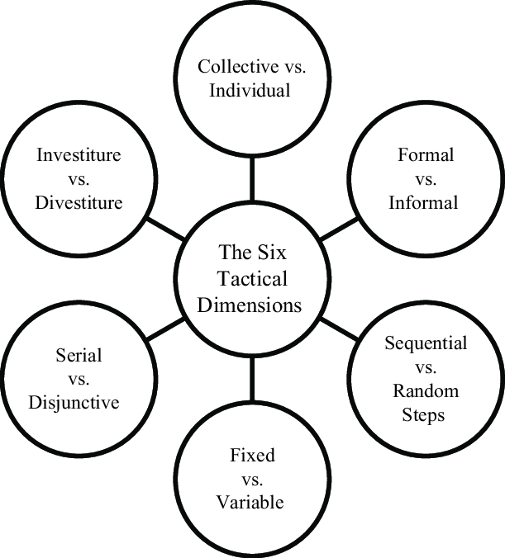
Figure 1: Six Paired Tactics by Maanen and Schein (1979)
HUM should use a structured core that is collective, formal, sequential, fixed, serial, and investiture-based. A common programme would minimize uncertainty at locations, fixed milestones to address slow ramp-up, buddies and mentors to provide credible support. Investiture would honor the current cultural heritage of those already specializing in AI and the graduates. However, if everything is completely standardised, innovation could be stifled and cultural or occupational differences could be overlooked. Therefore, HUM must be based on consistent principles and flexibility at the local level and at the role level.
Psychological contract theory explains why this matters.
Workers form ideals in relation to obligations to support, develop, have meaningful work, and move on (Rousseau, 1989). When HUM fosters innovation and quick growth, but offers limited employment and uncertain job prospects, graduates may feel cheated and abandon the institution. The psychological contract breach relationship and employee attitude and outcomes are inconsistent, with the relationship varying in strength depending on context (Topa, Aranda-Carmena and De-Maria, 2022). The task of socialisation should thus not involve merely "pitching" an attractive employer image, but should instead involve developing realistic expectations.

HUM Strategic Socialisation Framework
Table 1 presents a staged socialisation system that combines common organisational standards with role-specific and locally adaptable support.
Table 1: HUM Strategic Socialisation Framework
Stage | Main practices | Strategic purpose
Pre-boarding | Realistic preview; digital hub; skills profile; ethical AI briefing; buddy and mentor | Clarify expectations and reduce uncertainty.
Days 1–30 | Purpose and culture orientation; role clarification; weekly manager meetings; inclusion training | Build clarity, belonging, and capability.
Days 31–60 | Cross-functional shadowing; technical learning; peer group; stakeholder exposure | Develop human and social capital.
Days 61–90 | Small live project; multi-source feedback; job-crafting discussion; development plan | Create early contribution and ownership.
Months 4–12 | Quarterly reviews; communities of practice; internal projects; career conversation | Strengthen identity, networks, and retention.
Pre-boarding should present both HUM’s opportunities and pressures. For new participants, introduce them to the business model, city-government partners, commitments for sustainability, and the standards of responsible AI. A skills profile will highlight strengths and gaps, and the manager will discuss realistic opportunities for the first year. This often means that the psychological contract is more explicit and disappointment later on is minimized.
The first 90 days should combine learning with contribution. Newcomers would be contacted by the manager once a week in the first month and would have access to peer support and to all three locations. By day 60, each individual should have a small, cross-functional team and have started to connect to an urban mobility problem. The employee would present an output at day 90, give and take feedback, and agree on a development plan. Participation builds capability and identity, and Bauer et al. (2025) point out that socialisation is co-constructed by those new to the organisation and by organisational insiders.
The months 4-12 should build networks and career visibility. Quarterly reviews, communities of practice, mentoring, and cross-location projects would build social capital: relationships and trust that support knowledge sharing (Coleman, 1988).
A six-month psychological contract check would verify promises made versus experience, and a nine-month career discussion would determine future jobs and skills needed. This addresses the issue of employee turnover because it creates a visible pathway for growth before they leave for other job opportunities.

Organisational Identification and Inclusive Belonging
Organisational identification develops when membership becomes part of an employee’s self-definition (Ashforth and Mael, 1989). HUM can reinforce it by linking the technical work to cleaner and more accessible cities, providing reliable impact stories, and engaging employees in problem-solving and acknowledging responsible innovation. There would be no restriction on identification with a local team if the communities were cross-location.
Identification should never be a conformity of expression. The higher the level of identification, the greater the level of commitment, but the higher the level of identification, the less likely there will be any challenge to the decision, and the more likely there will be some defense of the decision for the staff. HUM needs to be a space of belonging and psychological safety, as well as a safe space for a voice and respect for professional identity. Employees have to be able to be loyal to decisions that pose technical, ethical, or social danger.

Ethical Professionalism and the Business Activist Mindset
Ulrich’s model shows an evolution from HR as an administrative expert towards four connected roles: administrative expert, employee champion, change agent and strategic partner (Ulrich and Brockbank, 2005). The outside-in philosophy takes these responsibilities one step further, making HR responsible for generating value for managers, as well as for customers, employees, communities, and other external constituencies. So, the business activist at HUM needs business knowledge and professional courage. This role person needs to be aware of the costs of the project, client needs, and innovation pressures – as well as challenging decisions that might have ethical, employee, regulatory, or public risks. Activism, however, should be evidence-based and constructive, and should not be personal or confrontational. Staff should recognise the issue, describe the impact on stakeholders, and suggest a viable alternative.
A stakeholder perspective recognises employees, city governments, passengers, communities, regulators, investors, and the environment (Freeman, 1984). HUM should implement a new Ethics Simulations for AI, a Review of Stakeholder impact, a Speakup Channel in privacy, and a Crossfunctional Ethics Panel. Staff members should decide how to present evidence, who is affected, and how to offer a viable alternative. This is passive compliance and unstructured activism avoided: the desired employee is commercially astute but professionally bold.

Evaluation and Risks
HUM should measure time: first meaningful contribution, role clarity, ramp-up time, 1-year retention, graduate attrition, engagement, belonging, and psychological-contract fulfilment.
Risks included mentor overload, inconsistent managers, programme complexity, and local resistance. These risks can be mitigated through manager training, recognised mentoring workload, local adaptation, and an initial pilot.

Adaptive Job Design for Motivation and Innovation

Job-Design Diagnosis and Principles
Communication is not the only solution to HUM's engagement problem. This fast growth could have resulted in disjointed work activities, specialist work roles, low feedback, and limited visibility of career progression. But, according to contingency theory, a single design approach won't work for all roles: safety-critical engineering needs more stringent controls; innovation and analytical roles more discretion (Lawrence and Lorsch, 1967). HUM should create an Adaptive Work System which will include enriched core roles, guided job crafting, and an internal talent marketplace based on skills.
The system must provide purposeful contributions of core, with limited flexibility and clear access to development. This provides a motivational focus with organisational agility, without eroding responsibility.

Applying the Job Characteristics Model
Hackman and Oldham’s (1976) Job Characteristics Model proposes that skill variety, task identity, task significance, autonomy and feedback create experienced meaningfulness, responsibility and knowledge of results. These mental states facilitate intrinsic motivation. HUM would be able to expand the variety of skills by adding stakeholder contact, testing, and project learning to technical analysis. To improve task identity, workers should own an identifiable component of a work package from problem definition through evaluation, not work completed in isolation.
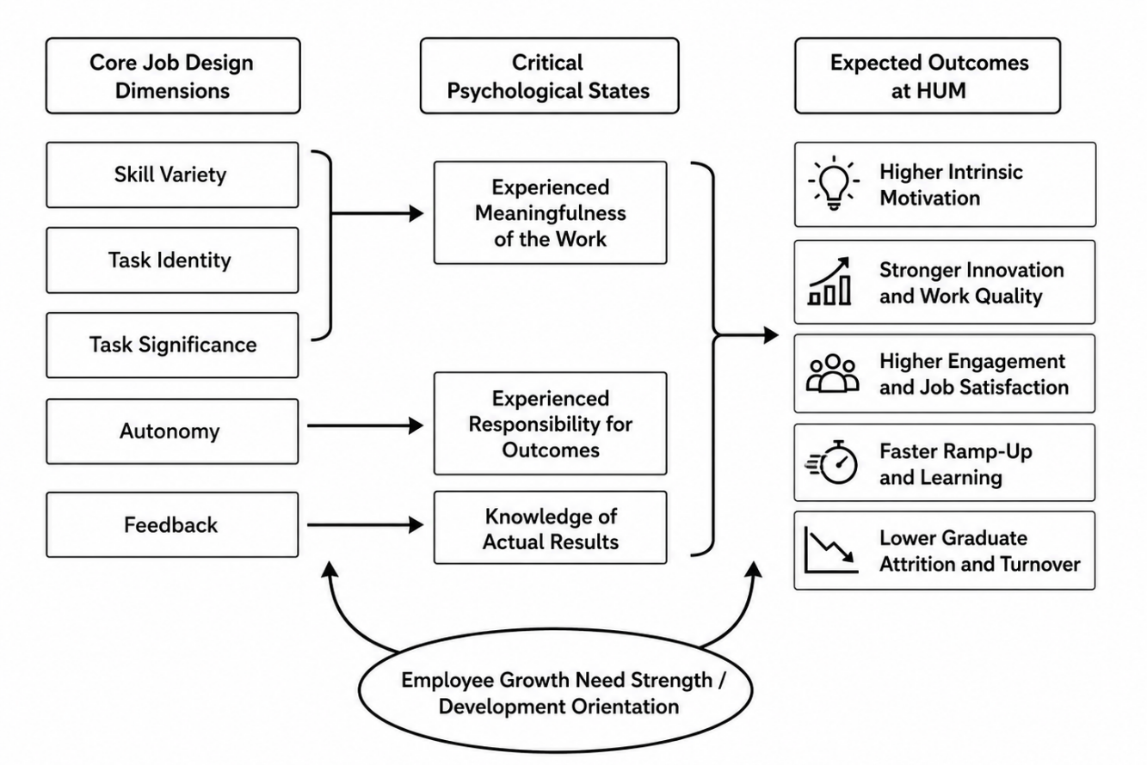
Figure 2: Job Characteristics Model by Hackman and Oldham (1976)
Task significance should be demonstrated by evidence of the impact of the task on emissions, accessibility, safety, or journey quality. Freedom from accountability is not autonomy. Autonomy does not imply freedom from accountability. Teams might choose a safety approach and/or a prototype choice within the safety, data, and regulatory constraints. Feedback from the system, users, peers, city clients, and managers. This makes it easier for graduates to see the benefits and value of their learning.
The model is helpful but inadequate. An increase in variety can turn into a workload increase, and autonomy can turn into ambiguity when priorities or capabilities are low. To this end, HUM needs to evaluate readiness, workload, and operational risk prior to enrichment. Review the challenge/ resources/ control balance for six-month periods. The model should be used to make decisions, rather than to be used as a checklist.

Governed Job Crafting
Job crafting treats employees as active designers who can alter task, relational, and cognitive boundaries (Wrzesniewski and Dutton, 2001). An engineer could introduce an accessibility task, connect with a city user group, or redefine coding as a component of inclusive transport. Longitudinal studies have also been shown to be related to later work engagement, but the results vary based on the type of job crafting used (Frederick and VanderWeele, 2020).
HUM should allow crafting via quarterly conversations, a short written agreement, and some protected innovation time. Managers would determine if the proposed change is needed from a business perspective, to support the growth of employees and the capacity of the team. Team review is significant as it can mean that a change that is appealing to one individual can be a change to another's routine. This “bounded autonomy” helps to avoid role conflict, unequal workloads and neglect of necessary tasks. Access should also be audited to ensure that well-connected and confident employees do not capture all the ‘visible projects'.

Skills-Based Architecture and Internal Talent Marketplace
A skills-based architecture shifts attention from fixed titles to capabilities required for changing work. HUM to develop taxonomy on AI, electric mobility, infrastructure analytics, cyber security, data governance, sustainability, project management, stakeholder engagement, cultural intelligence, and ethical judgement. Human capital theory argues that capability is a source for investment (Becker, 1964), and the resource-based view is based on the idea that specialized knowledge and collaborative patterns can form a hard-to-replicate advantage (Barney, 1991).
A digital internal marketplace should connect employees to projects, mentors, learning, and vacancies based on skills, interests, development goals (and verified). Graduates would have tangible paths to progression, and HUM would be able to transfer hard-to-obtain expertise to different sites without relying only on external hires. It would facilitate cross-departmental and temporary teams to address issues.
However, a marketplace is not automatically fair. Skills-first systems can expand access to work opportunities, but can also add a new level of bias, rely on poor-quality skills data, and undermine professional standards when qualifications are not considered when needed (OECD, 2025). HUM should, therefore, implement clear matching rules, human matching, employee appeal, data quality checks, and quarterly equity audits. Skills should be demonstrated by evidence, not by self-promotion. In order to avoid hidden barriers to progression due to travel or caring commitments, remote projects should be available.
Staff can also not use the platform if it is hard to use or considered a surveillance tool. HUM should reduce the amount of data collected, provide the possibility of correcting the profile, and describe how recommendations are made. Assess managers, in part, on talent development; otherwise, they will prevent talent mobility, and they will lose strong performers.

Implementation, Innovation and Measures
Job analysis, employee consultation, and mapping of skills should begin implementation. Then, HUM should pilot enriched roles and develop agreements and the marketplace in graduate and multidisciplinary teams. The pilot should be reviewed by a steering group made up of HR, employees, technical leaders, DEI specialists, and data-governance professionals.
The scale should be based on the evidence gathered from engagement, graduate retention, movement within the project, skills-gap closure, project-staffing speed, outputs of innovation, workload, and equitable access. HUM should take a holistic view of outcomes, rather than using one organizational average, and instead compare outcomes across locations and employee groups. Autonomy will not bring innovation; it will only come with purposeful objectives, varied connections, capacity, and rigorous audit.

Reflective Report

Using AI Without Weakening Human Judgement
I would use AI to organise evidence, not to make final people decisions. It might detect engagement trends, skill deficiencies, employee turnover, internal promotion opportunities, or even align employees with learning opportunities and projects. However, a prediction is not an explanation. The historical data could perpetuate inequalities, and managers might be tempted to accept an algorithmic score because it is seemingly objective.
Prior to acting, I would clarify the decision, consider data quality, look at who was impacted, check for inequity of effects, and look for context from the employee and manager. I would consider them by usefulness, individual rights, fairness, professional integrity, and impact on the stakeholders. There would need to be a documented reason for a high-impact decision, e.g., hiring, promotion, discipline, redundancy, or succession, and there would need to be an accountable human decision-maker for these decisions. Transparency, robustness, accountability, and respect for human rights are also key features of the OECD's updated principles (OECD, 2024).
I would safeguard workers by notifying them, limiting access to data, clarifying how recommendations are made, and providing a way to dispute recommendations. Audits should make comparisons between outcomes across groups and locations. Oversight must be meaningful; if the manager is just rubberstamping all the recommendations, then he/she is not using judgment.
My responsibility would be to remain sceptical, ask what the system cannot see, and record why the final decision is reasonable.

Personal Capability Development Plan
My main development need is to combine HR knowledge with stronger analytical, technological, and influencing capabilities. I also want to understand better international mobility as organisations like HUM are working across legal and cultural lines.
Table 2: Personal Capability Development Plan
Capability | Action and timeframe | Evidence of progress
Data literacy | Complete an HR analytics course and build a retention dashboard within six months. | Explain trends, limits, and uncertainty to a non-technical audience.
AI augmentation in HR | Study bias, explainability, and governance; assess one HR tool within six months | Produce an ethical and operational evaluation.
Strategic influencing | Practise stakeholder mapping and present an HR business case within nine months. | Obtain feedback on commercial and ethical persuasiveness.
Global mobility awareness | Compare mobility, cultural, and employment issues across three countries within twelve months. | Produce a practical international-assignment briefing.
Professional courage | Keep a monthly reflective decision log | Show that I raised, justified, and reviewed difficult issues
I will review the plan every three months and seek feedback from academic and professional contacts. Employability will not come from knowing tools alone; it will depend on using evidence responsibly, communicating with decision-makers and preserving human judgement under pressure.

Conclusion
HUM’s problems require one connected response. Realistic expectations, networks, identification, and ethical voice should be created through strategic socialisation, meaningful work, and bounded autonomy through adaptive job design, and movement of skills to opportunity through a fair internal marketplace. AI can help these systems, but they will not be run by AI. This architecture can be executed by way of pilot programs, trained managers, equity protections, and measurable outcomes, while not compromising professional responsibility, leading to shorter ramp-up, better engagement, graduate retention, and innovation refreshment.

Reference List
Ashforth, B.E. and Mael, F. (1989) 'Social Identity Theory and the organization,' Academy of Management Review, 14(1), pp. 20–39. https://doi.org/10.5465/amr.1989.4278999.
Barney, J. (1991) 'Firm resources and sustained competitive advantage,' Journal of Management, 17(1), pp. 99–120. https://doi.org/10.1177/014920639101700108.
Bauer, T.N. et al. (2024) 'New Horizons for Newcomer Organizational Socialization: A Review, Meta-Analysis, and Future Research Directions,' Journal of Management, 51(1), pp. 344–382. https://doi.org/10.1177/01492063241277168.
Becker, G.S. (1964) Human Capital: A Theoretical and Empirical Analysis, with Special Reference to Education. New York: Columbia University Press.
Coleman, J.S. (1988) 'Social capital in the creation of human capital,' American Journal of Sociology, 94, pp. S95–S120. https://doi.org/10.1086/228943.
Frederick, D.E. and VanderWeele, T.J. (2020) 'Longitudinal meta-analysis of job crafting shows positive association with work engagement,' Cogent Psychology, 7(1). https://doi.org/10.1080/23311908.2020.1746733.
Freeman, R.E. (1984) Strategic Management: A Stakeholder Approach. Boston, MA: Pitman.
Hackman, J.R. and Oldham, G.R. (1976) 'Motivation through the design of work: test of a theory,' Organizational Behavior and Human Performance, 16(2), pp. 250–279. https://doi.org/10.1016/0030-5073(76)90016-7.
Lawrence, P.R. and Lorsch, J.W. (1967) Organization and Environment: Managing Differentiation and Integration. Boston, MA: Harvard University Press.
OECD (2024) OECD AI Principles. Paris: Organisation for Economic Co-operation and Development. Available at: https://www.oecd.org/en/topics/sub-issues/ai-principles.html (Accessed: 11 July 2026).
OECD (2025) Empowering the Workforce in the Context of a Skills-First Approach. Paris: OECD Publishing. Available at: https://doi.org/10.1787/345b6528-en.
Rousseau, D.M. (1989) 'Psychological and implied contracts in organizations,' Employee Responsibilities and Rights Journal, 2(2), pp. 121–139. https://doi.org/10.1007/bf01384942.
Saks, A.M., Uggerslev, K.L. and Fassina, N.E. (2007) 'Socialization tactics and newcomer adjustment: A meta-analytic review and test of a model,' Journal of Vocational Behavior, 70(3), pp. 413–446. https://doi.org/10.1016/j.jvb.2006.12.004.
Topa, G., Aranda-Carmena, M. and De-Maria, B. (2022) 'Psychological Contract Breach and Outcomes: A Systematic Review of Reviews,' International Journal of Environmental Research and Public Health, 19(23), p. 15527. https://doi.org/10.3390/ijerph192315527.
Ulrich, D. and Brockbank, W. (2005) The HR Value Proposition. Boston, MA: Harvard Business School Press.
Van Maanen, J. and Schein, E.H. (1979) ‘Toward a theory of organizational socialization’, in Staw, B.M. (ed.) Research in Organizational Behavior. Vol. 1. Greenwich, CT: JAI Press, pp. 209–264.
Wrzesniewski, A. and Dutton, J.E. (2001) 'Crafting a job: Revisioning employees as active crafters of their work,' The Academy of Management Review, 26(2), pp. 179–201. https://doi.org/10.2307/259118https://www.jstor.org/stable/259118.

