THE WAY WE LIVE NOW Evaluation Form

Name: Faith Pound
After multiple attempts of using the medium format camera, using it on location and also indoors with artificial lifting. I did not have the best time with have images at the end, each time the film would only have a few images on but I was able to use them and create my final pieces which I’m very happy with. I have chosen theses as my favourite three because these three images are very different from each other in many ways. One image is in one of my words days, another is doing a daily thing that makes me happy and one is where i took the picture out of pure curiosity. At different times of different days.
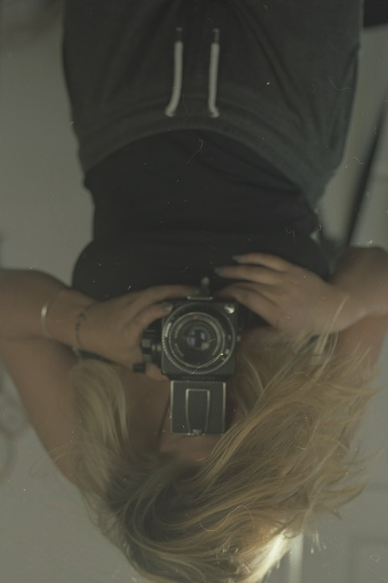
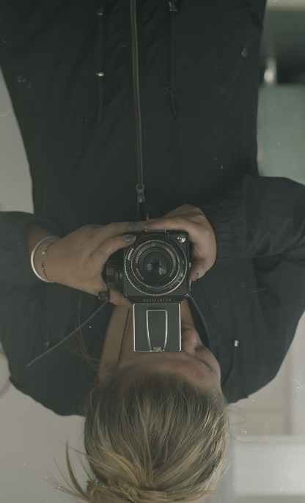
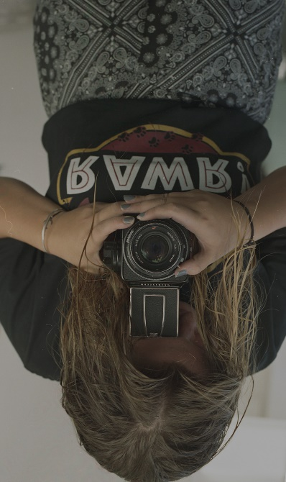

One of my main infusers was Oscar Paradela he kinds of saved my idea altogether by opening up my mind about how I could still show what I wanted to even thought It wasn’t in the way I originally wanted it. He showed me it was okay to be in your own photos and that they were still good even though the photographer was in them.
Another thing that inspired me was the camera itself. I’ve always been very interested in how it all works and how you have to hold and look down instead of looking through like a digital camera.
Corinne Day was another person how I’ve looked at a lot thought my project, her use of light more than anything, she create great depth in her work and her models face.

