A comparison of the marketing methods of two multinational hotel brands

Student Name: Florin Andrei Ghinea
Student ID Number: 2214960
Module Title: Marketing Essentials BMIH4005
Lecture’s Name: Luciana Suardi
Date: 07 February 2023

The increasing focus on marketing is an essential area that is focused on by every industry, and the hospitality industry is no exception. The hospitality industry ensures to take advantage of marketing to build a brand, maintain customer loyalty and allure new customers. With the aid of marketing, the hospitality industry ensures to keep the customer aware of the new products and services that make them unique amongst the existing competitors in the market. The aim of the current essay is to shed light on the marketing methods of two multinational hotel brands, Six Senses and the Moxy Hotel. Six Senses was established in 1995 with the ambition to deliver a unique experience to travellers. The hotel emphasises delivering a socially responsible and environmentally friendly experience to the customers. The Hotel ensured that the travellers were able to effectively disconnect from their worldly troubles and able to connect them with nature and delicious food (Six Senses 2023). On the contrary, the Moxy Hotel is a new brand of Marriott International that focuses on innovation, economy and lifestyle. The first hotel was established in Milan in 2014 and has now established more than 60 hotels across Europe, North America and Asia Pacific. The hotel reflects style, sociable services and open-mindedness (Moxy Hotel, 2023). However, both the hotel brands differ in terms of their marketing approaches which will be provided in the essay.
In order to determine the marketing strategies for the two selected hotel brands, the use of a marketing mix is appropriate as it sheds light on the tactics and actions used by companies to promote their products and services (Lahtinen et al., 2020). The marketing mix of the two brands differs in various aspects. In terms of the products, the Six Senses offers exotic resorts, private clubs, spas, luxurious residences, urban adventure and a focus on sustainability and beauty of the location. The rooms at Six Senses are designed with an organic focus, elegance and luxury reflecting from every inch (Piuchan and Prachansit 2019). Contrary to this, the Moxy Hotel offers a stylish hotel to the guests, but the rooms in the hotels are small yet smart, with vibrant social spaces that are playfully executed.
Considering the pricing aspect of the two hotel brands, a divergent approach is visible as one being luxury is a bit pricey compared to the other one being affordable for the customers. The affordability of the Moxy Hotel does not sacrifice style, comfort or services; rather, it ensures to delivery of the best services to the guests at a relatively pocket-friendly price. Considering the geographic distribution of the two hotel brands. Six Senses have a diverse global presence and is located in the prime travel locations of the world to capture consumer attention to the fullest. According to the Similar web (2023a), Six Senses gains the highest traffic share of 13.63% from Turkey, whereas from the United States, the traffic is about 9.89%. In addition, about 5.47% and 5.23% of the traffic comes from Brazil and the United Kingdom. Contrary to this, the geographical footprint of Moxy Hotel based on the statistics gathered via Similar Web suggested that the majority of the traffic at Moxy Hotel comes from the United States referring to 30.22%, whereas about 15.089% comes from the United Kingdom (Refer to Appendix A).
Furthermore, the last aspect of the marketing mix element is promotion. Gunawan and Sulaeman (2020) provided that promotion is a major aspect that needs to be determined as it entails the ways in which a brand communicates and engages with the customers and ensures that they are kept aware of the changing trends, products and services. The promotional activity of Six Senses relies heavily upon print advertisement and the use of digital marketing channels. The most preferable channels used by Six Senses include Facebook, Instagram, Twitter, Pinterest and YouTube (IHG Plc 2023). Contrary to this, the promotional activities of Moxy are less focused compared to the Six Senses, and their social media channels are also not well-active. However, they have improved with the passing of time in terms of the promotional aspects, but there are still gaps that need to be filled.
Additionally, a difference in the target market of the two multinational brands is also identified. Based on the segmentation, targeting and positioning aspect of the hotel brand, the Six Senses mainly targets luxury travellers who seek comfort during their travel. They belong to the upper-class category and look for a worthy experience by spending a hefty amount of money. Their target market also includes business travellers and leisure travellers (Urmila et al., 2023). From the statistics generated from Similar Web, the demographic distribution of Six Senses has been gathered. About 52.41% of the travellers at Six Senses are male, whereas 47.59% are females. From the age distribution, about 36.23% of travellers belong to the age group 25-34 (refer to Appendix B). This means that a young demographic visits the Six Senses Hotel.
In comparison, the target market for the Moxy Hotel includes budget-conscious travellers who look for fun and vibrant travelling experiences at an affordable price range. The hotel targets people belonging to the middle class and ensures it tailors their needs effectively. However, both hotels have established a robust position in targeting their desired set of markets (Wang and Chung 2015).
In addition to this, Moxy and Six Senses have been using a combination of traditional and digital marketing channels; however, it is undeniable that the hotels have not emphasised using social media channels. According to Yoong and Lian (2019), social media facilitates better connecting and engaging with potential customers and result in effective brand building. Six Senses leads the competition in using social media platforms, as evident from the usage of Facebook and Pinterest. Following this, LinkedIn, YouTube and Instagram have also been given slight importance (Similarweb, 2023b). In addition to this, emails and referrals have also been contributing to a significant part of the digital marketing of the two hotels (refer to appendix C).
Noorbehbahani et al. (2019) are of the view that a website is among the most powerful communications and marketing tools available, being concerned with effectively creating brand awareness. Both Moxy and Six Senses have been increasingly involved in consumer engagement using their website. This, in turn, is evident from monthly visits. Comparing the websites of the two hotels, it has been observed that Six Senses is leading the way with 410,239 visits, compared to 228,939 for the Moxy hotel. In this manner, Six Senses has achieved a bounce rate of 59.05% when compared to 67.78% of Moxy hotels (Similarweb, 2023b). The bounce rate is an indication of the percentage of visitors that leave the website after viewing a single page (Poulos et al., 2020). Analysing the positions of the two hotels from this perspective, it has been observed that Moxy hotel has a greater chance of losing customers, which might be due to the reason that the hotel has nothing to offer exciting or engaging for the audience (refer to appendix D). In addition to this, the hotels have also invested in organic search and paid search. Organic search is unpaid and is based on the relevance and reputation of an organisation (Poulos et al., 2020). Compared to Six Senses hotel, Moxy hotel is able to gain a reputation, as evidenced by greater organic searches. However, it is also undeniable that Six Sense is the top organic search term with an 8.74% traffic share, followed by Moxy hotel achieving 5.91% traffic (refer to appendix D).
Furthermore, the hotels have also become concerned about social issues, while no such specific changes have been made based on recent geopolitical events. Some of the changes have been observed in the form of the provision of clean and accessible rooms. On the other hand, Six Senses places a special emphasis on sustainability and making travel responsible. The hotel has ensured that its resorts are free of any kind of waste, specifically toxins and plastic (Six Senses, 2023b).
Based on the above-conducted discussion, the hotels would be recommended to invest more in targeting and engaging customers through digital platforms. For this purpose, it is crucial to make the most of social media, preferably Instagram, which is generally preferred by customers to make their travel-related decisions. On the other hand, the hotels should also consider investing in email marketing, which in turn, will be beneficial in targeting a range of customers, specifically those travelling for business purposes.

Conclusion
From the overall discussion of the two hotels’ marketing strategies, it can be said that a diverse marketing approach can be witnessed by comparing the two hotel brands. Since Six Senses mainly target luxury consumers and ensure the delivery of a pleasant experience, therefore, their marketing is also tailored to the specific needs of the target audience. Comparatively, the Moxy Hotel shows poor insights into marketing and needs to invest in this regard to capture a wider audience base and generate the utmost brand awareness. The Moxy Hotel is mainly famous due to its parent company and should engage consumers via the use of digital platforms to penetrate the market effectively.

Gunawan, G. and Sulaeman, M., 2020. Determining Factors in the Use of Digital Marketing and Its Effect on Marketing Performance in the Creative Industries in Tasikmalaya. Budapest International Research and Critics Institute-Journal (BIRCI-Journal), 3(3), pp.2543-2550.
IHG Plc 2023. Six Senses. [Online] Available at https://www.ihgplc.com/en/our-brands/six-senses [Accessed on 6 February 2023].
Lahtinen, V., Dietrich, T. and Rundle-Thiele, S., 2020. Long live the marketing mix. Testing the effectiveness of the commercial marketing mix in a social marketing context. Journal of Social Marketing, 10(3), pp.357-375.
Moxy Hotel 2023. At the Moxy. [Online] Available at https://moxy-hotels.marriott.com/ [Accessed on 6 February 2023].
Noorbehbahani, F., Salehi, F. and Jafar Zadeh, R., 2019. A systematic mapping study on gamification applied to e-marketing. Journal of Research in Interactive Marketing, 13(3), pp.392-410.
Piuchan, M. and Prachansit, S., 2019. Hotel pioneers' leadership styles: A case study on the founders of Oberoi Group and Soneva and Six Senses Resort and Spa. Tourism: An International Interdisciplinary Journal, 67(4), pp.375-388.
Poulos, M., Korfiatis, N. and Papavlassopoulos, S., 2020. Assessing stationarity in web analytics: A study of bounce rates. Expert Systems, 37(3), p.e12502.
Similar Web 2023a. Geography. [Online] Available at https://pro.similarweb.com/#/digitalsuite/websiteanalysis/audience-geography/*/999/3m?key=moxy-hotels.marriott.com&webSource=Total [Accessed on 6 February 2023].

Similarweb, 2023b. Comparison of Moxy Hotel and Six Senses Hotel. [online] Similarweb. Available at: <https://www.similarweb.com/website/moxy-hotels.marriott.com/#traffic-sources> [Accessed 2023].
Six Senses 2023a. Our History. [Online] Available at https://www.sixsenses.com/en/about-us/history [Accessed on 6 February 2023].
Six Senses, 2023b. Sustainable Resorts and responsible travel: Six senses. [online] Sustainable Resorts and Responsible Travel | Six Senses. Available at: <https://www.sixsenses.com/en/sustainability> [Accessed 6 Feb. 2023].
Urmila, N.P.W.D., Astuti, N.N.S. and Triyuni, N.N., 2023. The Implementation of Zero Waste Concepts in Operational Six Senses Uluwatu, Bali. Journal of Business on Hospitality and Tourism, 8(2).
Wang, Y.C. and Chung, Y., 2015. Hotel brand portfolio strategy. International Journal of Contemporary Hospitality Management, 27(4), pp.561-584.
Yoong, L.C. and Lian, S.B., 2019. Customer engagement in social media and purchase intentions in the hotel industry. International Journal of academic research in business and social sciences, 9(1), pp.54-68.

Appendix A: Geographic Distribution
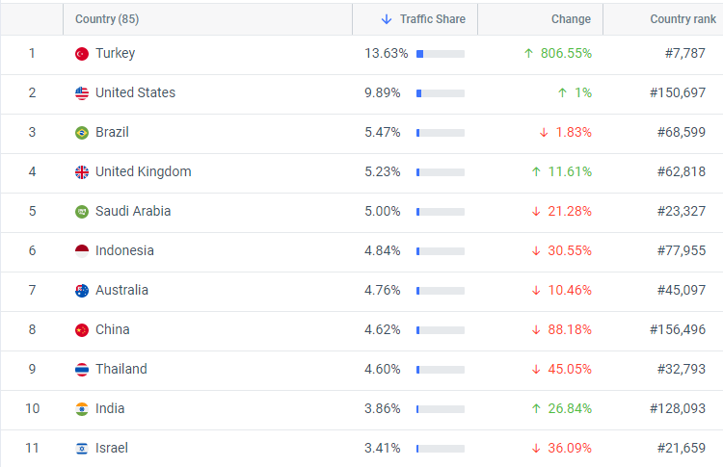
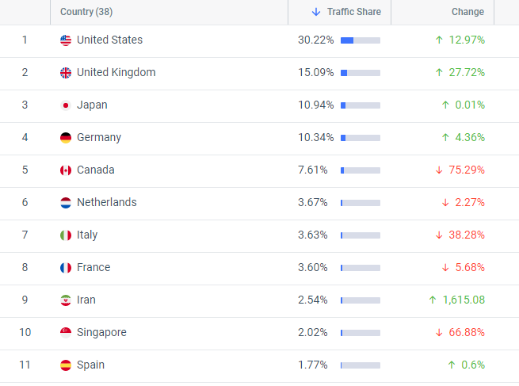

Appendix B: Demographic Distribution of Six Senses
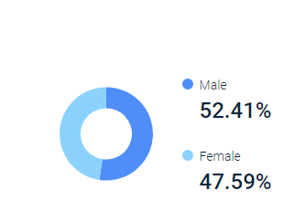
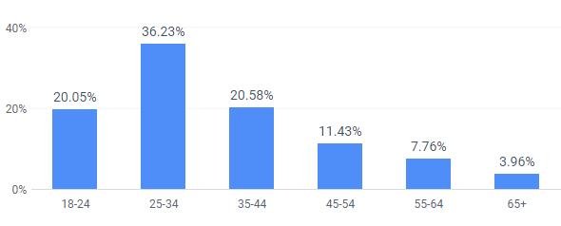

Appendix C: Marketing Communication Using Social Media
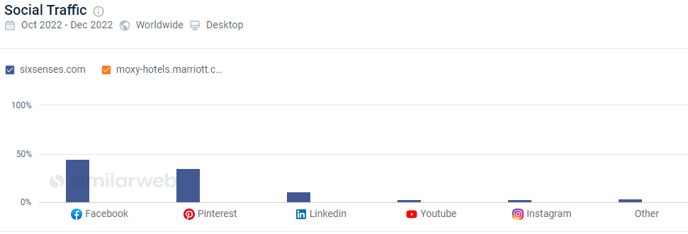

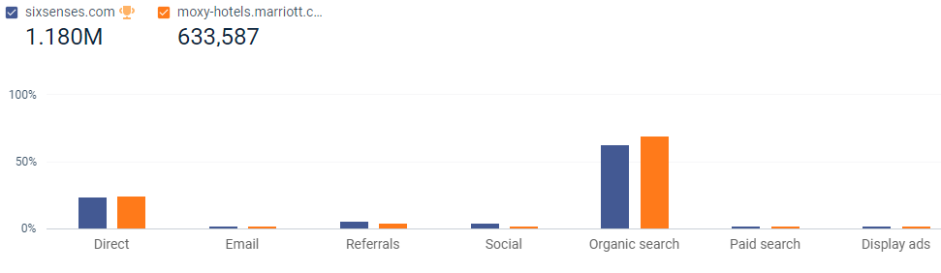

Appendix D: Marketing Communication Using Website


