Digital Skills and Research Methods
Virtual learning environment (VLE)-Moodle Platform

Student name: | Alexandra Plumb
Student number: | 2007923
Module code: | BMSW4003
Module name: | Digital Skills and Research Methods
Lecturer name | Yajesh Kumar
University name | University of Wales Trinity Saint David

Virtual Learning Environment (VLE) – Moodle platform

Table of Contents

Introduction 3
Virtual Learning Environment (VLE)-literature review 3
Objectives 4
Methods used for the study 4
Type of data 4
Sample 5
Data collection 5
Results 5
Interpretation of the results 5
Conclusion 10
References 10
Appendix 1 12
Appendix 2 14

Introduction
These days, universities are embracing the new style of learning and teaching online all around the world. The Virtual Learning Environment (VLE) represents the study model to conduct all the activities in an online environment. All the tools that VLE provides bring an improvement for both teachers and students, interacting even when they stand in front of a computer (Kerimbayev et al.,2020).
The report aims to improve the Moodle platform by finding the positive and negative aspects of improving the quality of learning and teaching online.

Virtual Learning Environment (VLE)-literature review
VLE's design provides the necessary tools for students and teachers: online courses, webinars, and a library, representing the online technology that does not have a limit and is meant to reinvent the educational system (Kerimbayev et al.,2020).
Lineses and Aguilar (2019) explain the use of VLE as a must in modern life, and their students described it as a useful, malleable system that increases their capacity of concentration and desire to learn. But the study revealed some adverse effects such as bad connection that can interrupt their session or less human interaction between the participants.
For most students, the method of learning online seems to be more suitable, considering the modern world when every person owns a smartphone and can easily access all the school materials. More some university teachers encourage the VLE for the multitude of materials (Lineses and Aguilar, 2019).
According to Cimpeanu et al. (2020), online learning needs to focus on making the content interesting for students and easy to deliver for teachers. The finest way to do this is by improving the conducting of workshops in an online environment. A class made just by reading information through a presentation became less attractive if non-practical exercises are included between the information provided.

Objectives
The study analyses the perspective of a group of students attending the University of Wales Trinity Saint David and the positive and negative effects of using the online learning platform Moodle.
We are gathering the necessary data, both primary and secondary, for improving the Moodle platform used for distance learning in the University of Wales Trinity Saint David.
The negative aspects reflect the things that need to be improved and organized in a manner to encourage everyone to use this platform. It is a study based on student's opinions through their vision of online learning.
The negative aspect will help to expand our teacher and students' experience on the Moodle platform.

Methods used for the study

Type of data
For gathering the information, we used two different types of data: primary and secondary. Primary data represents the information collected after conducting a survey on students through a questionnaire. All the participants involved in the study belong to the University of Wales Trinity Saint David, and they have access to the Moodle Platform.
The term secondary data includes the information gathered by different investigators who did similar studies. The secondary data should consist of articles, reports, or books about a specific field based on the same research (Wilson, 2015, p.188). This subject we reached in the first part of the report.
Due to the world's actual situation, the Covid-19 pandemic, we conducted the study exclusively in an online environment.
The closed-ended questions provide the study with statistical data, represented with different graphics and known as quantitative data. In contrast, the analyses of different opinions about a subject conclude in qualitative data.

Sample
We researched through a survey based on a questionnaire (Appendix 1) completed by twenty participants; all students enrolled in the University of Wales Trinity Saint David, London. A single person distributed the questionnaire by sending private emails to all the subjects involved. We asked the participants to write their initials and not the full name on the paper for confidentiality.
The data interpretation started right after the questionnaire was completed by all 20 participants, and the information stored in an excel table (Appendix 2).

Data collection
A questionnaire represents a set of questions based on a particular topic, which helps the researchers to collect data. It should be structured in the best way to obtain accurate results after conducting the survey (Brace, 2008). This type of research is the best way to analyse people's opinions and preferences regarding a subject and is the quickest method of study on a significant amount of participation (McLeod, 2018).
The questionnaire includes two open-ended and eight closed-ended questions. In the first categories, the participants had to choose between two strict answers or from five given responses based on the Likert-scale system. In contrast, the last two questions are based on the individual's opinion (Youn, Kennedy, and Kampbell, 2018).

Results

Interpretation of the results
The questionnaire starts with two closed-ended questions based on the gender and age of the participants. As can be seen in figure 1, 70% were female, and the predominant age is between 18 and 25, just eight people were older than that.

Figure 1: Questions number one and two and answers
All the participants were students at University of Wales Trinity Saint David, and this made that the responses to question three, "Do you use Moodle as a learning platform?" to be all positive.

Figure 2: Question number four and answers
Figure 2 represents the answers to the question "For what purpose do you use Moodle?". It is quite surprising that only eleven students, that being 55% of the total number of students involved in the questionnaire, are using the platform at its maximum potential. The diagram indicates that almost half of the students are not focusing on accessing the library and their student emails neither, therefore they do not realize that failing to do any of these could result in missing out on essential information or changes. If the library section is not used, it makes it harder for any student to find information for completing an assignment. Although, the students should create a habit out of regularly checking their emails so they are not missing any announcement. On the other hand, 100% of the students show interest in searching for assessment information, representing a positive outcome.

Figure 3: Question number five and answers
The diagram in figure 3 represents a certain number of students' answers when questioned how many hours they spend on Moodle weekly. The minimum time used on the platform it is between one to four hours, while the maximum remains uncertain as the last option represents anywhere over eight hours. As the case study gives a wide variation of time spent on the platform, the diagram picture is more comfortable to be read and processed by the evaluator and shows a clear view of it.
It is remarkable and meanwhile alarming that over half of the students involved, more precisely 60%, are allowing only one to four hours on Moodle. The fact could mean that the majority allows the minimum amount of time per week to use the platform in order to manage their studies. In contrast, 20% of the students utilize the venue for more than four hours a week, and the other 20% left spending more than eight hours.

Figure 4: Question number six and answers
Figure 4 shows the answers given by the twenty students when asked to describe the experience of using Moodle, having four options to choose, from "highly satisfied" to its opposite "unsatisfied".
Fifteen out of twenty students have chosen to express themselves as "satisfied" by the platform's features, while none of them have proven to be "unsatisfied". Only three individuals selected the "highly satisfied" button, while two students were "less satisfied" when operating Moodle.
The diagram reveals that using Moodle is easy and represents a pleasant experience for most students, although it definitely can be improved as only 15% of people involved expressed themselves as "highly satisfied".

Figure 5: Question number seven and answers
The diagram (Figure 5) represents the student's answers when asked how satisfied they are in terms of the Moodle platform's information. All of them, except one, expressed themselves as "satisfied" with the program's resources when seeking information or researching a specific field. Although, as the case study demonstrates, only one student is strongly satisfied while all the rest, by selecting "satisfied", indirectly agree that Moodle could be even more effective by disposing of more information material. The diagram proves that the platform provides an impressive amount of resources, but it did not yet reach its maximum potential.

Figure 6: Question number 8 and answers
The chart from figure 6 illustrates the student's answers as questioned how difficult they found it when operating Moodle. The opinions are divided almost equally, as nine of the students consider it easy to access the platform while eleven, a bit more than half of the total number, tend to describe it as "manageable". The fact that some students find it easy, while others not so easy, could be subject to the individuals' technological capabilities.
As the first question of the questionnaire shows, 40% of the students involved belong to ages twenty-six and over, which could represent why more than half might encounter difficulties when operating the platform. On the other hand, given the question's figures, it is likely Moodle could be easier to access either if some changes would be made so it would become more comfortable to operate.
The last two questions were designed as open-ended questions to identify people's personal opinions regarding the Moodle platform. The ninth question was based on the platform's negative part to find out what can be improved. Almost all the answers were "nothing," indicating that the platform does not require significant improvements. On the other hand, there were answers like "I would improve the library" or "the layout of the assignments", which reveal what could be improved and why most students expressed themselves as "satisfied" instead of "highly satisfied" at the question six.
The question number ten was designed in order to discover the platform's strengths through every student's personal opinion individually, every student having to write three matters that they liked. As answering the question, everyone involved in the questionnaire was put in the situation to detect features that they believed were most useful for using the platform. As every person is different, and the question involves a subjective point of view, a large variety of positive features was eventually created based on the answers given.
Almost all the participants mentioned that Moodle provides a various library, which is essential for any student. Also, more than half of the students believe that all the information found is detailed, and about the same amount appreciate being able to review the lessons' content at any time. Some students value that the platform is accessed easily, while others feel confident in its security. Last but not least, just a few participants simply appreciated Moodle's background.

Conclusion
The study's aim included the research done to find the negative and positive aspects of the Moodle platform. As we saw after analysing the questionnaire responses, the positives effects precede the negatives ones. The students of the University of Wales Trinity Saint David are enjoying the platform's utilization and consider that the site reached the highest potential in providing the necessary tools for better learning. Some aspects need to be improved, such as assignment layout or the library, but the security level and how easily it is to access the platform is far more essential and increases its potential. Virtual Learning Environments-Moodle Platform offers the possibility to learn and teach in an online environment providing all the tools required for replacing the class learning to a high level.

References
- Brace, I. (2008), 2ND edition, Questionnaire design: how to plan, structure, and write survey material for effective market research, Kogan Page. https://www-vlebooks-com.ezproxy.uwtsd.ac.uk/Vleweb/Product/Index/51815?page=0 Last accessed 30/12/20
- Cimpeanu, C., Lupu, R., Ungureanu, F., Dumitru, T., (2020), Virtual learning environments for never-ending learning: a survey, Bucharest: "Carol I" National Defence University, Vol.2.
- Kerimbayev, N., Nurym, N., Akramova, А. et al. (2020) Virtual educational environment: interactive communication using LMS Moodle. Educ Inf Technol 25 https://doi-org.ezproxy.uwtsd.ac.uk/10.1007/s10639-019-10067-5 last accessed 27/11/20
- Lineses, E.F., Aguilar, M.V.G., (2019), Ubiquitous Learning, Innovative Teaching: Students' Use and Perception of Virtual Learning Environment (VLE), JIRSEA, Vol.17 No. 1. https://web.a.ebscohost.com/ehost/pdfviewer/pdfviewer?vid=1&sid=932ba746-5159-45c9-9f85-435b4a812bec%40sdc-v-sessmgr01 las accessed 27/11/20
- Wilson, J. (2013) 'Using Secondary Data', in Maund, A., Schriek, M., Tinkler, P.K.. Certificate in Higher Education: Skills for the Workplace Student Yearbook, London:SAGE
- McLeod, S. A. (2018). Questionnaire: definition, examples, design and types. Simply Psychology. https://www.simplypsychology.org/questionnaires.html last accessed 27/11/20
- Seung Youn, C., Kennedy, M. and Campbell, I. (2018) 'Evidence‐Based Survey Design: The Use of Ascending or Descending Order of Likert‐Type Response Options', Performance Improvement, 57(9), pp. 9–16. doi: 10.1002/pfi.21800.

Appendix 1
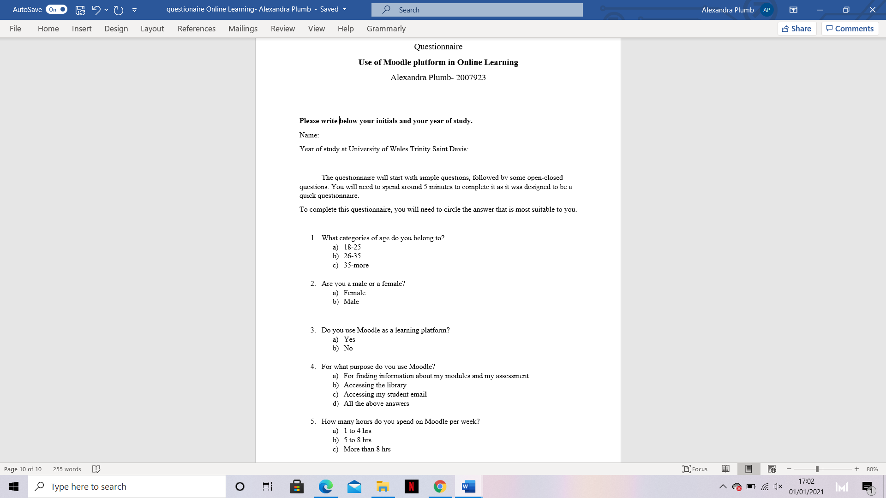
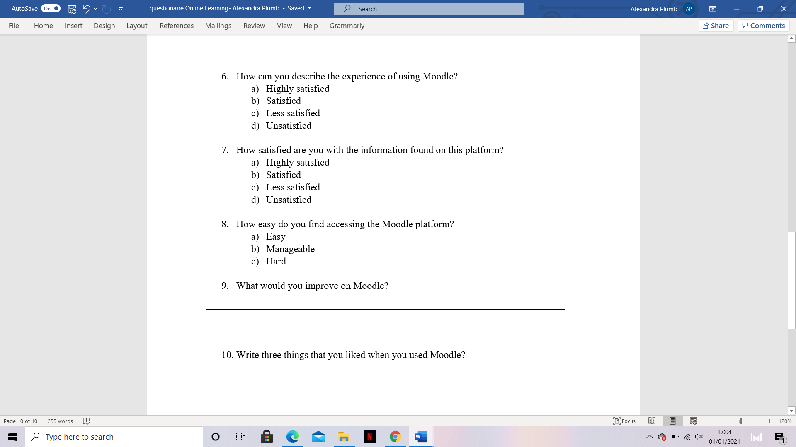

Appendix 2
Participant | Answers Q1 | Answers Q2 | Answers Q3 | Answers Q4 | Answers Q5 | Answers Q6 | Answers Q7 | Answers Q8
- RH | C | A | A | A | A | B | B | B
- CT | A | A | A | D | A | B | B | A
- MA | A | A | A | D | A | A | A | B
- PB | A | A | A | A | A | B | B | B
- CB | A | A | A | D | C | A | B | A
- MP | C | A | A | D | C | B | B | B
- FM | A | A | A | A | A | B | B | A
- DP | B | A | A | D | A | B | B | A
- SM | C | A | A | A | B | B | B | B
- LM | A | A | A | A | A | B | B | A
- FM | A | A | A | D | A | B | B | B
- AS | A | B | A | A | A | B | B | A
- FO | B | B | A | A | A | B | B | B
- CM | C | B | A | D | B | B | B | B
- AP | A | A | A | D | A | A | B | A
- AR | A | A | A | A | A | C | B | A
- IA | A | B | A | D | B | B | B | B
- PS | A | B | A | D | B | B | B | B
- RP | B | A | A | A | B | B | B | B
- MB | B | B | A | D | A | C | B | A

 | Question 9 | Question 10
Answers | The assignment should be more visible | Informations are detailed
Answers | Nothing | Easy to access the platform
Answers | The quality | Easy to access the modules
Answers | The library | Students hall union
Answers | The performance | All the lessons can be found in PowerPoint
Answers | More information about studies | The access to student email
Answers | Too much unnecessary information | Access the library through it
Answers | The layout of the assignment | Easy to log-in
Answers |  | The layout
Answers |  | High security
Answers |  | More time with family

