UNIVERSITY OF WALES TRINITY SAINT DAVID
Birmingham
Master of Business Administration
Human Capital Management | Module Code: LCMB7023
Assessment Component 1: Individual Report
Innovating New Working Practices and Breeding an Environment Where Talent May Grow
NexSpace Health Systems (NHSX) Case Study
Student Name: | Kajal Pratap Goraniya
Student ID Number: | 2610332
Programme: | Master of Business Administration
Module: | Human Capital Management
Lecturer: | Eno Maycock (Birmingham)
Word Count: | 2577 words
Submission Date: | Week 6. Thursday 15 th  October 2026. By 2 PM

Contents
INTRODUCTION 3
TASK A: Designing Innovative Working Practices 3
Critical evaluation of traditional work design versus contemporary innovative working practices 3
Recommending innovative working practices that are suitable for NHSX 7
TASK B: Breeding an Environment in which talent may grow 8
Evaluating how companies create environments in which talent flourishes 8
Developing comprehensive talent growth strategy for NHSX 10
TASK C: Reflection 11
Reflection on capability development 11
AI as strategic tool 11
Reflective analysis 12
Personal action plan 13
CONCLUSION 14
REFERENCES 15

INTRODUCTION
Kyambade et al. (2024) say that innovative work practices are employed by an increasing number of ventures because it supports long term corporate success and assist in obtaining competitive benefits. Present report is about NexSpace Health Systems or NHSX, which is fastly growing healthcare technology company with around 600 human capitals across India, United Kingdom and United Arab Emirates. It develops AI enabled digital health platforms, clinical support technologies and remote patient monitoring systems for healthcare providers along with hospitals.
The report entails designing innovative working practices, strategic talent ecosystem and reflection on capability development.

TASK A: Designing Innovative Working Practices

Critical evaluation of traditional work design versus contemporary innovative working practices
Work design plays essential function in shaping employee experiences as well as influence their productivity and wellbeing (Shuaibu and Saleh, 2025). In context to NHSX, traditional work design is reflected in its hierarchical decision making, relatively centralised managerial authority and functional boundaries. While such a structure can provide control and accountability, which is particularly significant in healthcare technology in which cybersecurity, clinical safety along with regulatory compliance are non-negotiables, it is enhancingly misaligned with needs of NHSX for fast innovation. Hierarchical structures slow down responsiveness and communication (Jerab and Mabrouk, 2023). It is evaluated that excessive hierarchy delay decisions along with discourage workforce from experimenting, directing result in corporate’s reported slow innovation and lack of creativity. Therefore, contemporary work design needs a shift from managerial control of practices towards corporate control of results.
High Performance Work Systems (HPWS)
HPWS are essential as they foster employee resilience as well as corporate agility (Bhardwaj et al., 2025). In case of NHSX, HPWS, such as recruitment, training, employee security, decision making, rewards and job design can integrate selective recruitment, performance management, continuous learning along with participation for encouraging scarce AI and healthcare competence. Through fostering skill development, empowerment and arranging essential resources, HPWS enable human resource to better cope with high demands and uncertainty. Nonetheless, intensification of performance can undermine wellbeing. Hence, its value relies on balancing high expectations despite of pursuing productivity alone.
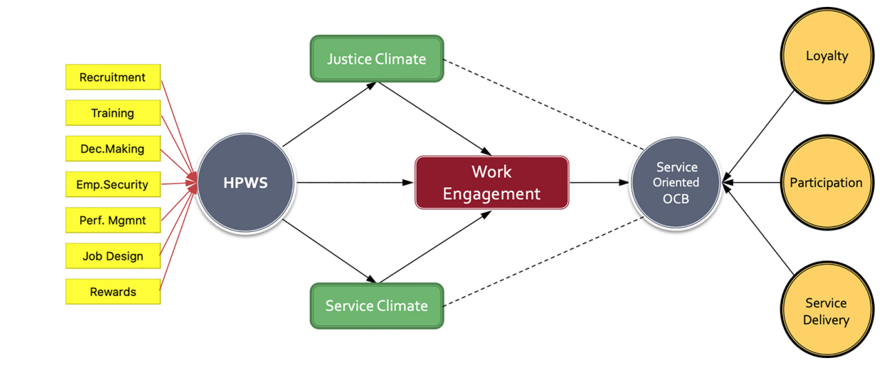
Figure 1: Conceptual model of HPWS
(Source: Kloutsiniotis and Mihail, 2020)
High Involvement Work Systems (HIWS)
HIWS are represented as overall management orientation which emphasises on providing workforce with wider involvement to improve corporate performance and competitiveness, along with experience of employees at work (Wei and Fu, 2026). NHSX can establish effective HIWS, such as power and autonomy, information, rewards and cross functional AI innovation squads wherein clinicians, data scientists, software engineers as well as product specialists collectively determine product priorities, experiment with solutions as well as evaluate user feedback. It is evaluated that this represents genuine HIWS as decision making authority is distributed to employees having relevant expertise, while senior management is able to retain governance over ethical, regulatory and clinical risks.
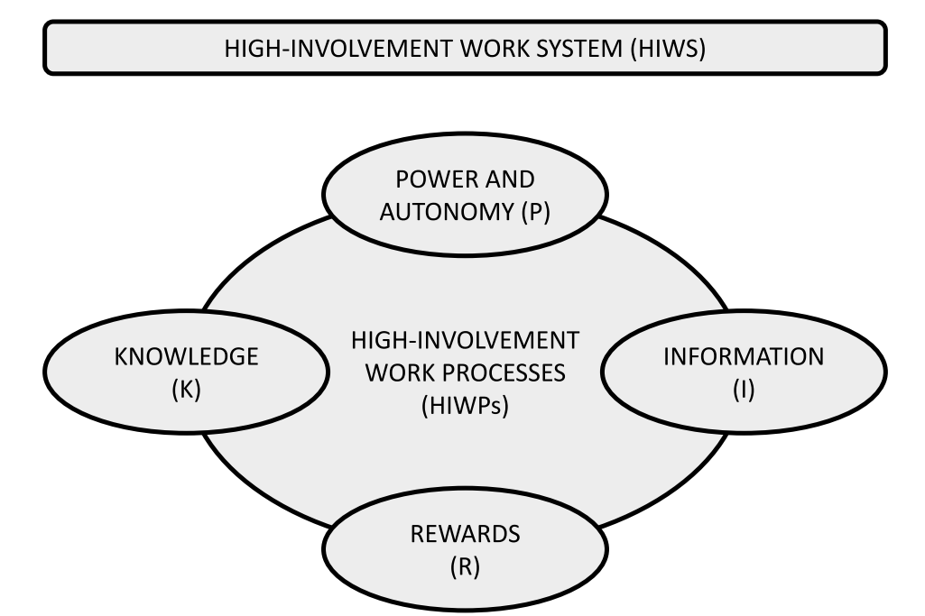
Figure 2: HIWS as well as elements of high-involvement work processes
(Source: Øygarden, Nøkleberg and Gressgård, 2023)
Agile working
Gayathri et al. (2025) say that agile work entails distributing responsibilities among employees for efficiently attaining project goals and adhere agile principles. In NHSX, agile working can enable multidisciplinary teams to prototype AI enabled health solutions fastly, employing iterative feedback from customers and clinicians. Nonetheless, agile rituals alone lack overcoming bureaucracy. The company must decentralise operational decisions as well as preserve senior oversight only where clinical safety, cybersecurity or regulatory risks justify it.
Hybrid working models
Hybrid working model serve as effective strategy to improve corporate success as well as employee satisfaction (Selvanayagam, et al., 2025). Application of hybrid working can improve international collaboration of NHSX while support workforce retention and autonomy. On other side, it is evaluated that poorly designed remote work weaken informal knowledge sharing as well as build geographically fragmented networks. The company needs to combine location flexibility with global collaboration days, asynchronous documentation along with structured cross nation knowledge sharing mechanisms.
Flexible working activities
Flexible work arrangements are strategic approach for improving efficiency, work satisfaction and productivity (Paramestri, Arifianti and Dai, 2025). Flexible hours along with personalised work arrangements can assist NHSX to accommodate diverse workforce while support retention and wellbeing of high performers. Yet excessive flexibility also complicates coordination across three nations addition to time zones. Managers of NHSX must provide autonomy within agreed collaboration windows, team level operating norms and service requirements.
Sociotechnical Systems Theory
Ang, Sankaran and Liu (2025) state that sociotechnical theory posits that corporate and work effectiveness is optimised when technical and social systems are designed for work in harmony. Sociotechnical systems theory is relevant as performance of NHSX rely on integrating AI technologies with human expertise. It is evaluated that technology cannot independently create innovation as poorly designed systems enhance workload or minimise professional autonomy. Accordingly, NHSX must co design digital workflows with engineers, clinicians as well as users, to maintain human oversight.
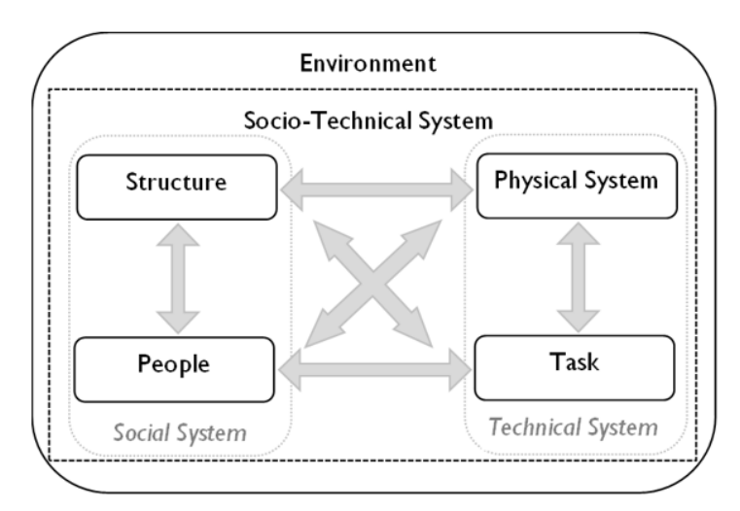
Figure 3: Sociotechnical Systems Theory
(Source: Kemp et al., 2024)

Recommending innovative working practices that are suitable for NHSX
NHSX need to execute an integrated work design model despite of isolated interventions. Below recommendations directly address its innovation, retention and collaboration challenges while recognise that decentralisation and flexibility need suitable governance.
Cross functional collaboration: Leveraging cross functional collaboration is strategic approach to foster business performance and agility in form of breaking down silos as well as encouraging teamwork across varied functions (Mohammed, 2024). NHSX is recommended to establish multidisciplinary teams which combine software engineers, UX specialists, clinicians, data scientists and product managers. It can minimise functional silos and integrate varied expertise earlier in development of product, minimising costly redesign and improving innovation quality. Nonetheless, diversity of expertise can enhance coordination costs, accordingly, clearly stated goals and decision rights are significant.
Hybrid and flexible working: Working as hybrid permits improving team performance (Ahmad, 2026). NHSX is suggested to adopt team based hybrid working, which combines individual flexibility with structured collaboration periods. It can foster wellbeing, retention addition to productivity, on other side, unmanaged flexibility might fragment geographically dispersed teams. It is evaluated that shared collaboration norms, outcome based performance and core availability hours measures can preserve accountability and coordination.
Agile project teams: Agile way of working improves team adaptive performance (Steegh et al., 2025). It is recommended to NHSX to deploy autonomous agile squads for AI as well as digital health projects, employing short development cycles, iterative experimentation and user feedback. It can minimise decision latency as well as accelerate transition from ideas to deployable solutions. On other side, excessive agility might result in role ambiguity or weaken governance, therefore, the company needs to retain senior oversight related to cybersecurity, clinical safety alongside regulatory compliance while delegate operational decisions.

TASK B: Breeding an Environment in which talent may grow

Evaluating how companies create environments in which talent flourishes
Talent management is considered as key approach to attain competitive benefit through attracting as well as retaining top talents (Schinnenburg and Boehmer, 2025). In case of NHSX, high performer turnover represents strategic capability risk, while tensions among employee wellbeing as well as performance need integrated and sustainable talent management system. In this company, talent management needs to move beyond retaining high performers towards developing an ecosystem supporting ongoing development, corporate value creation and autonomy. Global expansion along with enhanced AI investment intensified demand for scarce skills, learning and career progression.
In accordance with Patelli et al. (2026), Senge’s learning organisation are those in which individuals continually expand their competence for devising the outcomes they truly desire, where new and expansive patterns of thinking are nurtured, where collective aspirations is set free, along with where individuals are continually learning ways to learn collectively. Senge’s five principles provide NHSX with a framework to embed ongoing learning. Personal mastery develops artificial intelligence as well as digital heath expertise. Metal models foster managers for challenging hierarchical assumptions. Shared vision aligns global teams around innovation. Team learning strengthens cross border knowledge exchange. Systems thinking connects technology, performance, individuals and wellbeing. Together, these principles can transform learning from individual practice into capability of NHSX.
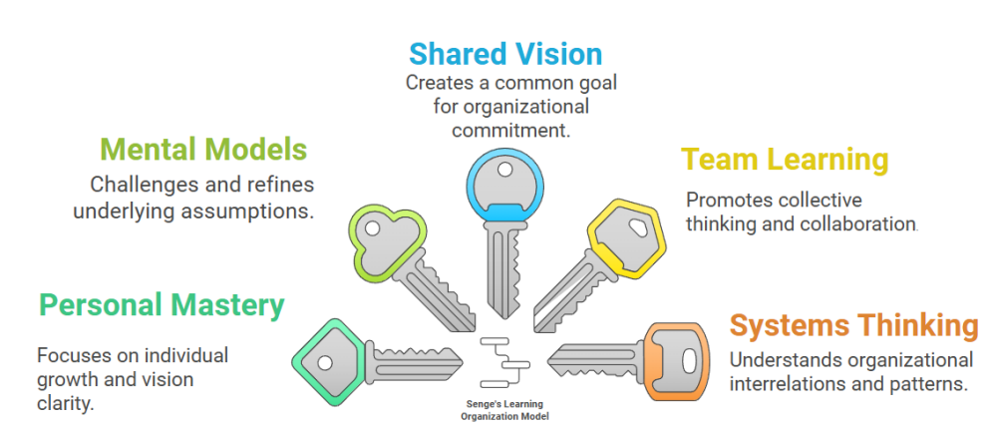
Figure 4: Senge’s Five Principles of a Learning Organisation
(Source: Burns et al., 2026)
Carol Dweck’s Growth Mindset Theory is essential to understand employee performance, team work as well as leadership dynamics (Tambun and Irawanto, 2023). Dweck’s Growth Mindset Theory states that NHSX must view abilities as developable through feedback, effort and ongoing learning, supporting adaptation to fast AI driven change. It is essential for NHSX as high performing employees left because of limited career growth along with learning opportunities. Nonetheless, it is critically evaluated that mindset alone cannot resolve excessive workloads. Managers of NHSX needs to combine coaching, supportive leadership and development pathways for balancing wellbeing with high performance expectations.
Edmondson’s psychological safety is essential to encourage an environment conducive to innovation, effective collaboration and open communication (Chinyuku and Qutieshat, 2025). In case of NHSX, Edmondson’s Psychological safety can enable employees to challenge decisions, report mistakes without fear and share ideas, supporting AI innovation alongside learning. In critical context, safety needs to coexist with accountability. In NHSX, high performer departures as well as wellbeing pressures require managers to foster development feedback, supportive leadership addition to open dialogue while maintaining demanding and sustainable performance standards.
Self Determination Theory posits that human resources are influenced when they have control over their working as well as feel sense of purpose and meaning in activities they perform (Sun and Zuo, 2023). It suggests that managers of NHSX must strengthen competence through continuous AI learning, autonomy through meaningful decision making along with relatedness in form of collaborative global teams. In critical aspect, NHSX foster motivation among employees by providing them with opportunities for development and growth, together with developing supportive work atmosphere which encourages mastery and autonomy. These can minimise high performer turnover linked to weak career development. Nonetheless, autonomy without resources intensify pressure, but supportive leadership integrate wellbeing, development as well as demanding performance expectations.
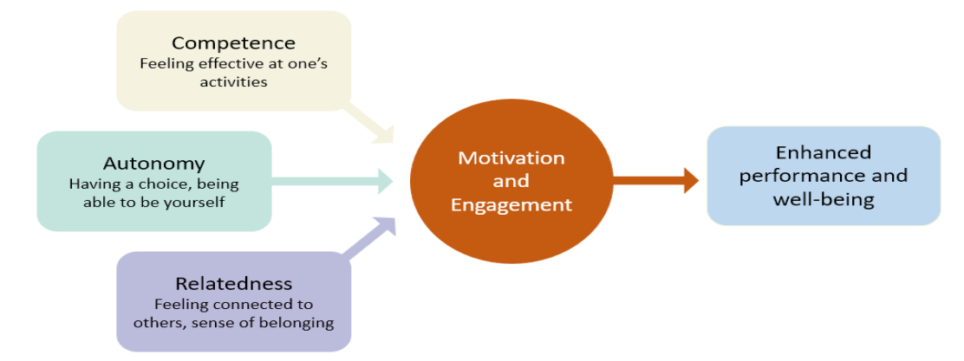
Figure 5: Self-Determination Theory
(Source: Sun and Zuo, 2023)
Job Crafting Theory is recognised as self-driven construct which needs individually driven behaviour (Paraskevopoulou et al., 2026). This enables NHSX workforce to reshape tasks, perceptions of work and relationships, which supports meaningful careers and creativity. In critical terms, job crafting theory might strengthen wellbeing and retention at workplace of NHSX, but unmanaged crafting can enhance workload. Accordingly, managers can enable purposeful job redesign while maintain workload controls, assisting in addressing high performer development alongside performance pressures.

Developing comprehensive talent growth strategy for NHSX
Talent management development is related to corporate’s future readiness (Warman et al., 2022). Loyal, highly motivated, competent and passionate talents are significant assets as future leaders, stating right talent growth strategy re required to enhance international business development readiness. NHSX must execute an integrated talent growth strategy including skills planning, personalised learning, sustainable performance and psychological safe leadership.
- Strategic skills planning must map emerging competences in data science, artificial intelligence, clinical expertise, responsible AI, digital health and product management. Through analysing existing and future skills as well as performance requirements, the organisation can effectively pinpoint skills gaps at individual, team and corporate levels (Gruenewald and Mueller, 2025). At NHSX, individual skills profiles can determine development gaps together with future requirements, shifting the company from reactive recruitment towards strategic employee planning. It is critical as rapid AI investment can devise current competencies obsolete addition to enhance competitive for scare talents.
- NHSX must provide personalised continuous learning pathways through digital health academy and artificial intelligence, which combine formal learning, coaching, project based development and mentoring. Protected learning time is significant, or else development becomes an extra workload as well as intensify wellbeing pressures that are already faced by employees and managers of NHSX.
- Development of coaching based leadership enhance psychological wellbeing, task along with contextual performance at workplace (Peláez Zuberbühler et al., 2023). Within NHSX, managers must adopt coaching based leadership, with development conversations addition to accountability for retention, psychological safety and employee growth, alongside performance.
- At NHSX, managers must launch sustainable high performance activities, combining ambitious results with workload monitoring, wellbeing interventions and flexibility. Sustainable human resource management emphasises on pluralist aspect to attain sustainability objectives for stakeholders from moral concern for companies to behave responsibly (Mariappanadar, 2022).
Overall, balanced talent approach evaluates high performer retention, skills acquisition, psychological safety, internal mobility, wellbeing along with business results. Accordingly, managers of NHSX must transform talent from recruitment challenge into ongoing renewable strategic ability.

TASK C: Reflection

Reflection on capability development

AI as strategic tool
Reflecting on NHSX, it is recognised by me that artificial intelligence can strengthen decision making of HR managers through employee analytics, identifying skills gap, predicting turnover and panning talent. To expand company operating across UK, India and UAE, artificial intelligence can assist emerging capability requirements addition to inform evidence based employee decisions. Led by artificial intelligence, companies are revising ways significant decisions are devised along with how they maintain competitive benefits (Jafari et al., 2025). Nonetheless, my analysis demonstrates that AI must remain decision support tool, despite of decision maker. Algorithmic results reproduce bias, interpersonal contexts, overlook cultural aspects or conflict with expectations of human resource concerning fairness and privacy. As future HR professional, I need to combine technological literacy with accountability, ethical judgement and empathy. Within NHSX, human oversight is significant when AI informed decisions impact recruitment, performance, promotion and wellbeing of employee.

Reflective analysis
My working on NHSX changed my knowledge related to AI from being primarily a productive technique to a mechanism needing critical professional judgement.
- First, AI was used by me to explore HRM theories, such as Senge’s Learning Organisation, Edmondson’s psychological Safety and Dweck’s Growth Mindset. AI assisted me to recognise relationship among theories as well as challenges facing NHSX, specifically, limited learning opportunities and high performed turnover. Nonetheless, I recognised that generated explanations can oversimplify scholarly debates. Therefore, I developed wider confidence in questioning AI results and verify claims against academic literature.
- Second, AI was used by me for generating and refining strategic recommendations for NHSX. It supported my competence for connecting theory with practice, including linking self Determination Theory with relatedness, competence and autonomy. Nonetheless, initially, AI encouraged wider recommendations which lacked sufficiently sensitive to global context of NHSX. Reflecting on such limitation has strengthened my competence for adapting generic HR solutions to corporate situations.
- Thirdly, AI was used by me to improve structure along with criticality of my academic writing, helping me to determine where my arguments were descriptive despite of evaluative. On other side, excessive reliance can weaken my independent voice. Accordingly, I learned that strongest professional ability emerges when artificial intelligence challenges my thinking despite of replacing it.

Personal action plan
My reflection on NHSX has identified three priority abilities for my future HR career, including strategic critical thinking, human centred leadership and digital HR expertise.
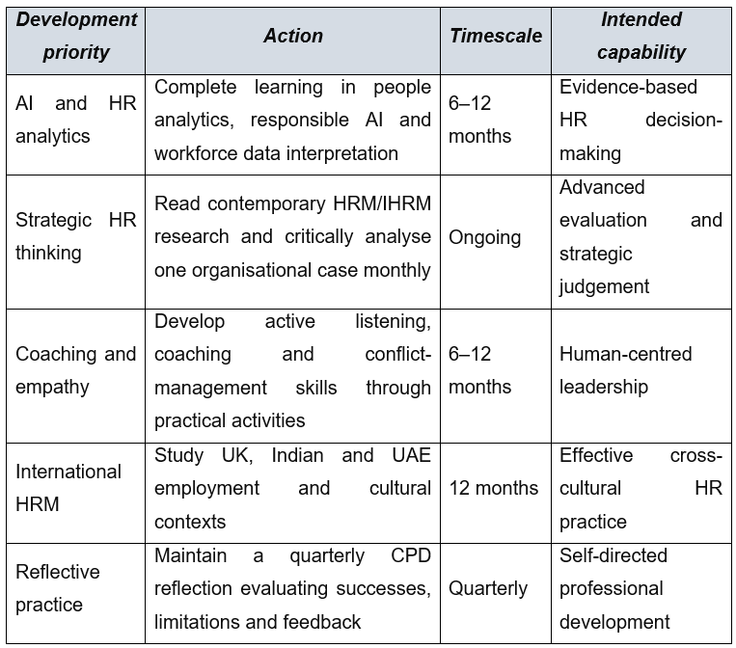
Figure 6: My action plan
(Source: Self developed)
My principal learning includes NHSX needs more than technological solutions. Artificial intelligence can recognise skills gaps along with turnover risks, yet effective HR activity needs ethical judgement, empathy along with understanding experiences of employees. Therefore, I aim for combining analytics with human centred leadership, enabling NHSX for accomplishing sustainable performance while protecting trust, wellbeing and development.

CONCLUSION
Overall, NHSX needs integrated transformation of working activities as well as talent management for sustaining innovation as well as global growth. Hybrid, agile as well as collaborative work can strengthen business agility, while learning, autonomy, career development and learning can improve wellbeing and retention. In critical terms, AI must augment despite of replacing human judgement, enabling NHSX for accomplishing sustainable performance through continuously developing human abilities.

REFERENCES
Ahmad, I. (2026). The Impact of Hybrid Work Flexibility on Team Performance: The Mediating Role of Work–Life Balance and the Moderating Role of Digital Communication Quality. Journal of Advanced Research in Social Sciences and Humanities, pp.33-47. http://jarssh.com/ojs/index.php/jarssh/article/view/300
Ang, K.C., Sankaran, S. and Liu, D. (2025). Advancing sociotechnical systems theory: New principles for human-robot team design and development. Applied Ergonomics, 129, p.104604. https://www.sciencedirect.com/science/article/pii/S0003687025001401
Bhardwaj, S., Choudhary, P., Chopra, R. and Chakraborty, D. (2025). High-performance workplace system: a literature review. International Journal of Organizational Analysis, 33(8), pp.2853-2880. https://www.researchgate.net/profile/Seema-Bhardwaj-2/publication/389131991_High-performance_workplace_system_a_literature_review/links/67b85f2c8311ce680c6ee487/High-performance-workplace-system-a-literature-review.pdf
Burns, E., Lehto, S., Mporananayo, N. and Mukingambeho, D. (2026). Building pedagogical learning organisations in Rwanda: An application of Senge’s framework. In Eapril 2025 Conference proceedings. European Association for Practitioner Research. https://www.theseus.fi/server/api/core/bitstreams/9a5f7b0b-0f2e-4a76-a6b7-ee75575d8c05/content
Chinyuku, C. and Qutieshat, A. (2025). The role of psychological safety in strategy implementation: A brief literature review. International Journal of Applied Research in Business and Management, 6(1). https://d1wqtxts1xzle7.cloudfront.net/122266403/WRP_IJARBM_Chinyuku_Qutieshat_Psychological_Safety_Strategy_Implementation-libre.pdf?1744286478=&response-content-disposition=inline%3B+filename%3DThe_Role_of_Psychological_Safety_in_Stra.pdf&Expires=1791283638&Signature=MZCb5dtDqadSRYrP98E8eXz26fJbM2aAEkmFsYVw90MAbM7kp6ptlTTlFwEyEb3hCVef96mVh6LgbOYo78uDrJbsWMYZAx6AUekJUas-6o4Z5555q8hoRrFERzoxn~c7anIbMHJSKYM0u26ad8XFUNpV6Z7bK2BklqNcA3vn7KodHaTYdx0~i~MlVoqSAf7~wp0LYZ446h8xwEo37kaUcQJWVySZRJJgGNp7lyID49GAzpa57QdYoo8psQo4UeeEOqAbEnep90mkZ9WweVDpLHKcu-25SAWU8H1doo1S6OYvuzlOrpu9lEjvdGsGuCazYpBoL21~Wvg5w~Eite8SSw__&Key-Pair-Id=APKAJLOHF5GGSLRBV4ZA
Gayathri, J., Nevashine, S., Deeksha, H.U., Ashok, S., Nithyasree, R. and Divya, S. (2025), March. AI-Powered Dynamic Task Allocation for Agile Work Environments. In 2025 International Conference on Visual Analytics and Data Visualization (ICVADV) (pp. 1253-1259). IEEE. https://ieeexplore.ieee.org/abstract/document/10961466
Gruenewald, H. and Mueller, M. (2025). Proactive Skills Planning for Targeted Growth. In Reskilling and Upskilling in a Globalized Economy: Essential Strategies for Workforce Transformation (pp. 71-99). Wiesbaden: Springer Fachmedien Wiesbaden. https://link.springer.com/chapter/10.1007/978-3-658-48384-5_4
Jafari, M., Shahbazi, A., Kawsar, M., Davoudi, S.P.M. and Janani, S. (2025). The role of artificial intelligence in strategic planning and competitive advantage. International Journal of Advanced Business Studies, 4(4), pp.258-276. https://besra-journals.net/index.php/ijabs/article/view/45
Jerab, D. and Mabrouk, T. (2023). The evolving landscape of organizational structures: A contemporary analysis. Available at SSRN 4584643. https://papers.ssrn.com/sol3/papers.cfm?abstract_id=4584643
Kemp, T., Ayton, J., Butler-Henderson, K. and Lam, M. (2024). Using socio-technical systems theory to study the health information management workforce in Australian acute hospitals. Social Theory & Health, 22(4), pp.285-300. https://assets-eu.researchsquare.com/files/rs-3071953/v1/fae0dfaa-0248-48b4-93d0-be2031f536fb.pdf
Kloutsiniotis, P.V. and Mihail, D.M. (2020). The effects of high performance work systems in employees’ service-oriented OCB. International journal of hospitality management, 90, p.102610. https://pmc.ncbi.nlm.nih.gov/articles/PMC7352112/pdf/main.pdf
Kyambade, M., Namuddu, R., Mugambwa, J. and Namatovu, A. (2024). Psychological safety and innovative work behavior: does socially responsible leadership matter?. SEISENSE Business Review, 4(1), p.1. https://pdfs.semanticscholar.org/c5b0/fffd2f3ba572e0eb5a46585b0ed8ccf321ed.pdf
Mariappanadar, S. (2022). High performance sustainable work practices: Scale development and validation. Sustainability, 14(19), p.12682. https://www.mdpi.com/2071-1050/14/19/12682
Mohammed, I.A. (2024). Leveraging cross-functional collaboration to enhance organizational agility. Archives. https://archives.publishing.org.in/index.php/archives/article/view/152
Øygarden, O., Nøkleberg, M. and Gressgård, L.J. (2023). Reforming for trust and professionalism in municipal healthcare services: implications for human resource management. BMC health services research, 23(1), p.991. https://link.springer.com/content/pdf/10.1186/s12913-023-10006-8.pdf
Paramestri, N.V., Arifianti, R. and Dai, R.M. (2025). The Flexible Work Practices and Employee Performance: An Empirical Study on Productivity Outcomes. SKETSA BISNIS, 12(1), pp.163-176. https://jurnal.yudharta.ac.id/v2/index.php/SKETSABISNIS/article/view/6521
Paraskevopoulou, L., Tzoumaka, E., Apospori, E. and Siachou, E. (2026). Active employees in the future workplace: From job crafting to selfergetic job crafting. European Management Review, 23(2), pp.445-465. https://onlinelibrary.wiley.com/doi/pdf/10.1111/emre.12703
Patelli, E., Sousa, H.S., Silva, R.A. and Santamaria, M. (2026). The Norwegian Police–a Learning Organisation? The case of the Kongsberg 2021 Mass Casualty Event. https://cmsweb.com.sg/rps2prod/esrel2026/epro/pdf/esrel26-p27811.pdf
Peláez Zuberbühler, M.J., Coo Calcagni, C., Martínez, I.M. and Salanova, M. (2023). Development and validation of the coaching-based leadership scale and its relationship with psychological capital, work engagement, and performance. Current psychology, 42(1), pp.648-669. https://www.researchgate.net/profile/Josefina-Pelaez-Zuberbuhler/publication/349234562_Development_and_validation_of_the_coaching-based_leadership_scale_and_its_relationship_with_psychological_capital_work_engagement_and_performance/links/62a73a46c660ab61f879434b/Development-and-validation-of-the-coaching-based-leadership-scale-and-its-relationship-with-psychological-capital-work-engagement-and-performance.pdf
Schinnenburg, H. and Boehmer, N. (2025). Re-focusing talent management: Frontline and essential work as the contemporary challenge. Human Resource Management Review, 35(3), p.101090. https://www.sciencedirect.com/science/article/pii/S1053482225000154
Selvanayagam, A., Venkatakrishnan, S. and Ramkumar, N. (2025). The role of hybrid work models in enhancing employee well-being, productivity, and job satisfaction. South Eastern European Journal of Public Health, 26, pp.3049-3062. https://www.researchgate.net/publication/388871674_THE_ROLE_OF_HYBRID_WORK_MODELS_IN_ENHANCING_EMPLOYEE_WELL-BEING_PRODUCTIVITY_AND_JOB_SATISFACTION
Shuaibu, H. and Saleh, M.A. (2025). Impact of workplace design on employee well-being and productivity. Frontiers in Management and Social Sciences, 1(1), pp.55-66. https://fmss.com.ng/index.php/fmss/article/view/5
Steegh, R., Van De Voorde, K., Paauwe, J. and Peeters, T. (2025). The agile way of working and team adaptive performance: A goal-setting perspective. Journal of Business Research, 189, p.115163. https://www.sciencedirect.com/science/article/pii/S0148296324006672
Sun, P. and Zuo, X. (2023). The Missing Piece: Incorporating Organizational Factors in Employee Motivation Research. Sun, P., & Zuo, X.(2023). The Missing Piece: Incorporating Organizational Factors in Employee Motivation Research. International Journal of Science and Business, 25(1), pp.24-33. https://papers.ssrn.com/sol3/papers.cfm?abstract_id=4458055
Tambun, T. and Irawanto, D.W. (2023). Value Driven Growth Mindset and Value Driven Fixed Mindset?. APMBA (Asia Pacific Management and Business Application), 12(2), pp.137-142. https://apmba.ub.ac.id/index.php/apmba/article/view/741
Warman, M.A., Maarif, M.S., Sukmawati, A. and Affandi, J. (2022). Superior talent development strategy in preparing future leaders during change. Jurnal Aplikasi Bisnis Dan Manajemen, 8(2), pp.351-351. https://journal.ipb.ac.id/jabm/article/view/40646
Wei, W. and Fu, X. (2026). Building High Involvement Work Systems in the Digital Era: Employee Experience‐Oriented Digital HRM and Employee Involvement. Human Resource Management, 65(4), pp.953-973. https://onlinelibrary.wiley.com/doi/pdf/10.1002/hrm.70058

