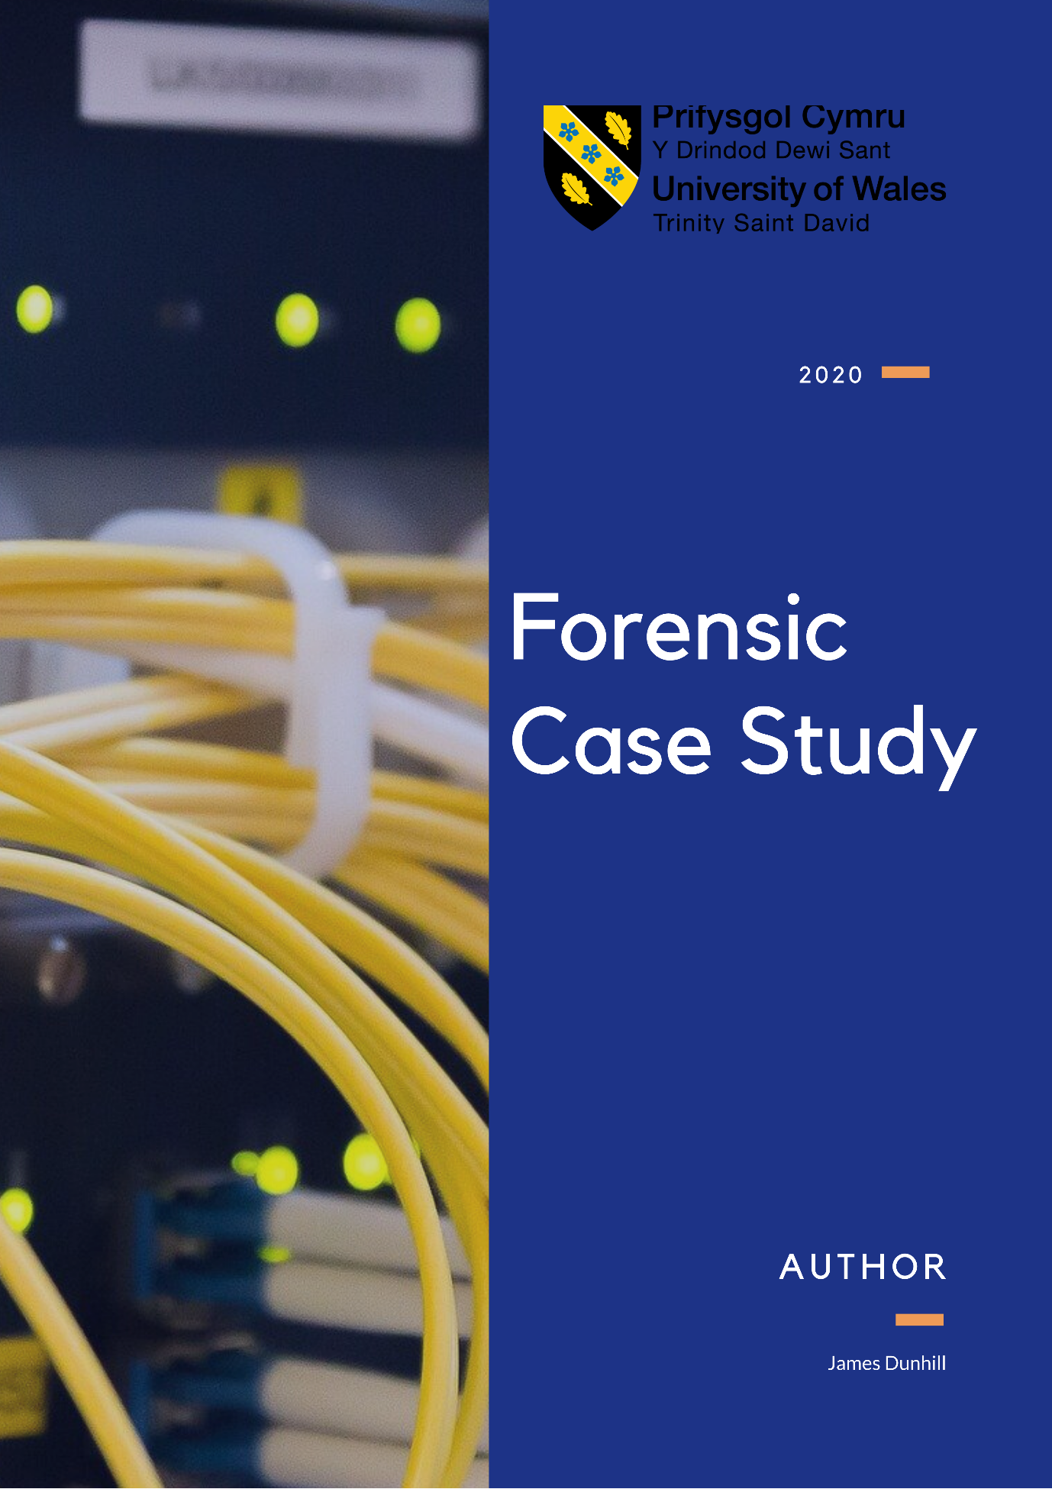

Contents
Computer Forensics 3
Computer forensics, what is it? 3
What Knowledge is needed? 3
What’s New About Cybercrime? 3
Who use computer Forensics? 3
Computer Forensics Process 3
Types of Evidence 3
UK Law in Computer Forensics 4
Methods & Tools 4
Caine OS 4
X-Ways Forensics 4
FTK 4
Sleuth Kit – Autopsy 5
iVe 5
Oxygen Forensics 5
MailXaminer 6
Volatility Framework 6
USB Historian 6
GRP Rapid Response 7
Case Study 8
Opening 8
Forensic Methods Used 8
Appendix 11

Computer Forensics

Computer forensics, what is it?
Digital forensics is using different techniques and methods to gather information on investigations to create evidence from devices that were present or used in a crime, this information is then created and formatted into a presentation slash document to be used in court of law [2]. The investigation that takes place will create a chain of evidence to log all the activity and operations that were created during the time of the crime on the device.

What Knowledge is needed?
People who start a career in digital forensics needs to learn a lot of different areas before they start with their first case [3]. The reason for this is being there's a lot of areas that the user needs to know before they can start working [4]. the investigator needs to know and understand a various number of digital devices as when they are working, they'll be interacting with many different devices such as tablets, phones, laptops, desktops, digital cameras and various other devices [5]. Networking and Software are area also to have a good understanding for, Investigators will need networking concepts and understandable knowledge as they would be investigating not only individual systems but also systems that have been connected to them in the past with LAN to be examined [5].

What’s New About Cybercrime?
Cybercrime has been growing over the years rapidly and the reasons for this is because there are no physical or geographical boundaries criminals aren't restricted to an area or a city. This means the speed of crimes that are conducted can grow very fast and rapidly into larger pools of potential victims. Overall reconnaissance is made easier and less effort by the perpetrators is done which means making crimes can be done easier with less work. There is also the ability of to access information quick and easy [6].
The biggest difference is that cybercrime is committed using technology and the Internet, they might be talked about differently, but they are still committing the same crime, it is just a different means and way of the crime being committed [7]

Who use computer Forensics?
There are lots of different organisations and companies that use computer forensics for everyday use or for emergency usage. Some of the companies or organisations that use computer Forensics are the government, law firms, criminal prosecutors, academia, data recovery firms and insurance companies [8].

Computer Forensics Process

Collecting
The first part of the Process is collecting the data and creating a chain of custody from the first point of acquiring the data, this will then record all reports and finding, keeping it logged. This will also keep a record of who has access to the data, where the original was stored, who had access to the forensic copy of the data. Also, this part of this process is the creation of the document trail and making sure the evidence is in a safe location [9, 10].

Analysing
The second part is all about analysing the evidence, looking at every detail that can be found and log it, then making sure that the evidence is supported to each finding that is made. Also being able to consider other alternatives and conclusions, so the investigator is not tunnel vision in to only one outcome [10].

Presenting
The third step is about writing an expert report, that list all the test that was conducted thought out the instigation, also what was found and then the conclusion. The aim is to show other that follow the steps to recreate the investigation to help reach a conclusion. [7,10]

Types of Evidence
There are different types of evidence, multiply of them are used in different was in court.

Real
Real evidence is very black and white, it is clear to see what is going on without relying on anything else to help. In computing this would be done with a simple system audit check, if no log has been altered in anyway [7, 11, 12, 13].

Testimonial
This type of evidence comes from a witness, if the witness is preserved reliable then the statement that the witness give is very close the real evidence. If a witness writes out into a word document then gives the statement over digital mean, Word or text document and signed it as the author then this would be able to be committed as a statement too.

Demonstrative
This form is used to directly demonstrate the evidence. This way is normally a very reliable type of evidence, Example: Photos, Videos and Recording [11, 13].

Documentary
This is commonly seeing as written forms of evidence, like letters or wills and other forms of recorded data can be email, images, news articles, videos and audio records [11, 12, 13].

UK Law in Computer Forensics
There are many laws that have been created and updated over the year to protect the public from online cybercrime, some of the laws are [16]:
- Computer Misuse Act 1990
- Data Protection Act 2018 (GDPR)
- Regulation of Investigatory Power Act 2000
- Police and Criminal Evidence Act 1984
These are some of the biggest and most known laws that are used in the UK, some of these laws have gone thought multiply updates and changed over the year to keep up with the current state of times [15,17,18].

Figure 1- United Kingdom Parliament

Methods & Tools

Caine OS
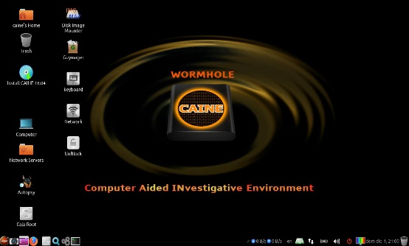
Caine (Computer Aided Investigative Environment) is a live CD that is for Linux that contains a vast amount of digital forensics tools that are the most up to date and widely used within the industry [22]. This OS offer a friendly interface that allows investigator quick and easy navigation to software packages instead of entering command line [23].
Figure 2 - caineos

Key Features:
- Preloaded with user-friendly Interface.
- Preloaded with many open-source forensics tools.
- This Particular Forensics OS follows investigation procedure by Italian laws.
- It was created with an optimised intent for deep forensic analysis.
- Quick to export reports to multiply formats

X-Ways Forensics
X-Ways Forensics is an all in one types of package, it is very good a manging resource on the devices and has a good history of device compatibility and it work efficiently. The X-Ways also has many supported tools and options that it can offer, disk imaging and cloning, detection of deleted or lost hard disk partition and viewing and editing binary data structures. Large community of support to help and guidance [29, 31].

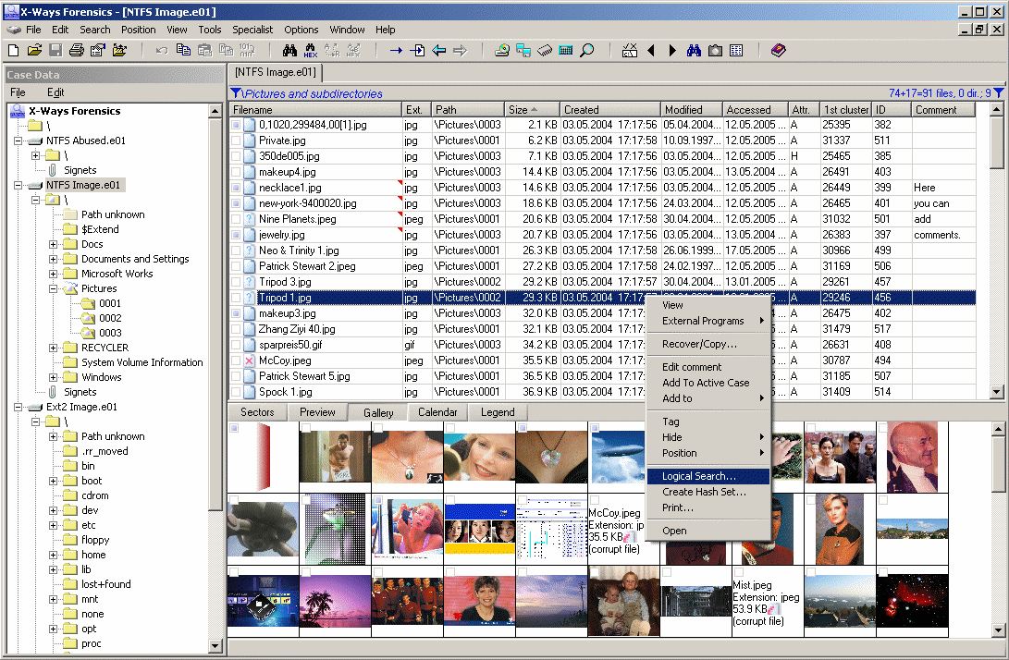
Figure 3 - x-ways.net

Key Features:
- Disk Editor, File Editor, RAM Editor.
- Data Recovery / Partition Recovery.
- File stack Capturing
- Browser for FAT, NTFS, Ext2/Ext3 and other

FTK
This software pack is cited for court use and is also one of the top data preview and imaging tool currently available. This software can examine files and folders on local hard drives, network drives, CDs/DVDs, and able to review the content of forensic images or memory dumps [22]. FTK can read deleted data if it has not had the memory block over written then it will be recoverable.
There is also a portable version of FTK, this can be used with just a USB [24].

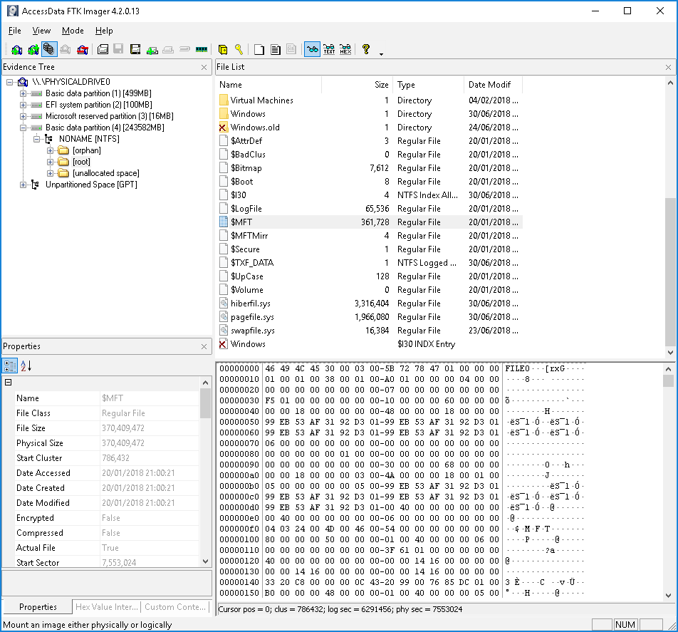
Figure 4 - techtalk.gfi.com

Key Features [31, 32]:
- Preview data and able to recover deleted data.
- FTK can support image mounting
- Software to uses multi-core CPUs to increases speed and to allow for parallelisation actions.
- FTK Is also able to Email analysis, File Decryption, Data Carving, Data Visualization, Web Viewer, Cerberus and OCR.
- Collaboration with shared case database, allowing for one central database to host everything for a single case.

Sleuth Kit – Autopsy
Sleuth Kit is very powerful investigation kit that is used to search hard drives and smartphones, it is based on windows pc that uses user graphical interface with good design for the user. For Linux users Autopsy is the only application available, but this is where most of the features lie, it does offer a user interface or command line. It is very good and fast at creating cases. A lot of the system can be controlled over a web interface. [33, 34, 35].

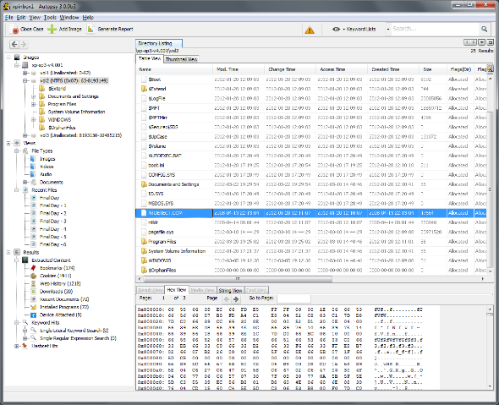
Figure 5 - sleuthkit.org

Key Features:
- Supports advanced graphical event viewing interface with simple and easy controls.
- Autopsy can flag known bad files and ignore known good with hash filtering.
- Search case files for certain word to find files or application.
- Extract history, bookmarks, and cookies from all different types of browsers like Firefox, Chrome and other.

iVe
iVe is special software that focuses on car forensics, there can support wide range of cars, but are slowly growing to in other makes. They offer a combination of custom hardware and software to investigate, the software is created to support windows. There also have an app that can be used to help investigation too. [36]

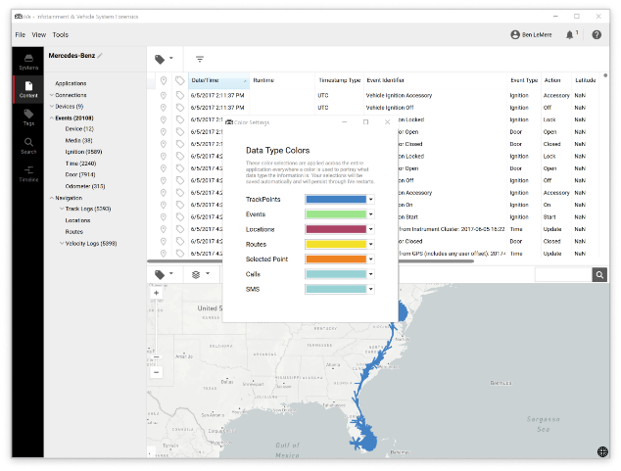
Figure 6- berla.co
Key Features:
- Discover Vehicle Data like: Routes, Vehicle events, Location Data, Connected Devices and Media.
- Predictions of what happened with data
- In depth reports
- Patterns that can show or Identify problems, that happened at the scene,
- Track history records
- How long visit to certain location lasted and when they happened.
- Trying to be provided information of who was involved or that number of people present.

Oxygen Forensics
This forensic package is used to gather evidence from mobile phone to support active case. The tool has a wide verity of tools that can be useful for example it would be able to gather device information manufacturer, OS, IMEI number, serial number. It would also be possible to get contacts, messages and recover deleted messages, call logs. [29]

There are also features that can allow the user to access and analyse mobile device data and documents. This will then generate easy to understand reports and export more detailed and complex report [30].

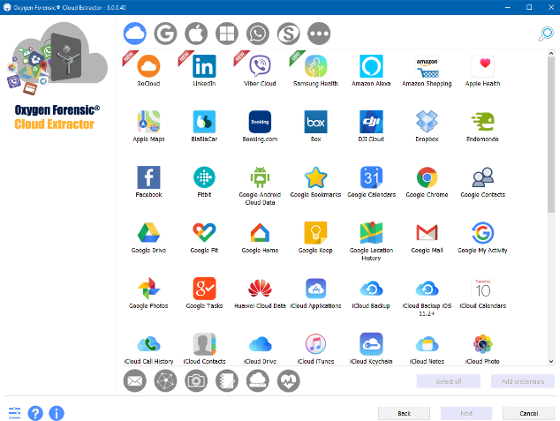
Figure 7 - oxygen-forensic.com

Key Features:
- Decrypted passwords and authentication tokens that user have set on their devices
- Extracts and decrypt data for examination form popular apps.
- Analyse calls for recordings that are obtained from wireless service providers
- Track devices location using GEO data.

MailXaminer
Email Examiner is software to is specialized in analysing emails for investigations, it is very fast and accurate with it finding in report that come with ease. MailXaminer is very efficient in working with legal service, creating cases allows for the case to be stored with MD5.

The interface works and looks a lot like MS Outlook, this allows the user to have a quick start to using the software as it looks like outlook. The powerful backend processing speed of this applications allows for quick reading of data with reports of this software processing terabytes of email data. [37]

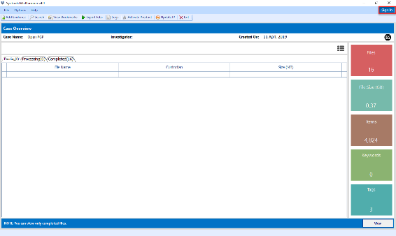
Figure 8 - mailxaminer.com

Key Features:
- Email Formats: Outlook, Lotus Notes, MAC Outlook OLX / OLM, Thunderbird.
- Wide Variety of Forensic Images like: E01, DD, LO1, Lx01.
- Cloud support: IMAP, Gmail, Hotmail, iCloud.

Volatility Framework
This forensics framework for incident response and malware analysis, this will allow the user to extract digital artefacts from volatile memory dumps, this could also be known as RAM. Once the information has been successfully extracted from the system it will be able to create log and give information about the system: network connections and sockets that are open, cached registry hives and more [22, 25].

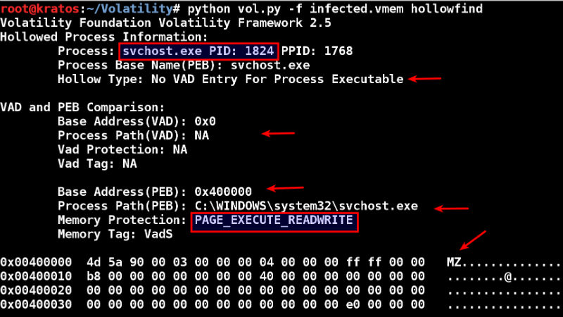
Figure 9 - digitalforensics.com

Key Features
- Volatility works on all the 3 biggest platforms, Windows, Linux and Mac.
- Developed for speed and efficient processing to analyse RAM dumps from very large systems.
- Support multiple file formats.
- Third party developers can support with API access to create extensions and scripts.

USB Historian
USB Historian is able to track and log all the activity of USB that have been used on any system drives, it logs the name of the USB and it can also give the drive it was connected and the date & time of the operation too [22]. This tool is USB to see if any data has been removed and help investigators track down the device, it is able to log serial numbers to once a device is found there user can compare the device for a match.

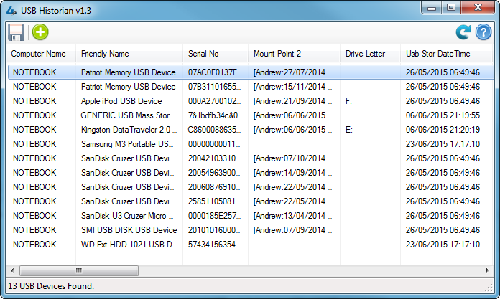
Figure 10 - techtalk.gfi.com

Key Features:
- This can deal with data and identity theft.
- Parses the computer name so it can locate USB devices
- Has a power user graphical interface for analysis
- Data and time checker

GRP Rapid Response
GRR Rapid Response is a framework that focuses on remote live forensics. GRR is to support forensics and investigations with a fast and scalable operation to allow analysts to quickly perform analysis remotely. GRR consists of 2 parts: client and server. Client is deployed on all systems, then the server will be able to work, by downloading files, listing directors and so on. The server connects to all end components and controls them through a web-based graphical user interface, also API endpoints that collects analyst’s data, and creates scheduled actions on the clients.

Figure 11 - githubusercontent.com

Key Features:
Client
- Remote memory analysis.
- Search and download for files across the system including windows registry.
- Operates at OS level.
- Built with high encryptions level for Secure communication over the internet with end devices.

Server
- Enterprise support
- Fast and simple collection of hundreds of digital forensic artifacts.
- Built with growth, able to handle large increases in deployment of devices.
- Automated scheduling for recurring tasks.

Case Study

Pre-investigation
At Heathrow airport a terrorist was shot down with the intent to boom Mason International airport at Fiji. The terrorist was shot down trying to evade police once the police caught him. The unnamed terrorist was carrying a laptop briefcase when he was shot.

The investigation has been placed in charge of Mr. Mark Wales, the Chief Investigator at The Heathrow Police Department. Mark make a call to a detective called John who is a professional investigator and asked him to investigate the items in the briefcase.

John accept the case and start to work on the information and item that he has been given.

Forensic Methods Used
1.) The investigation started when John turned up at the scene. John started to create a chain of custody, this was to be able to document the moment and the possession of the evidence. This will record location time and handling from the scene of the crime straight though until the case is closed.

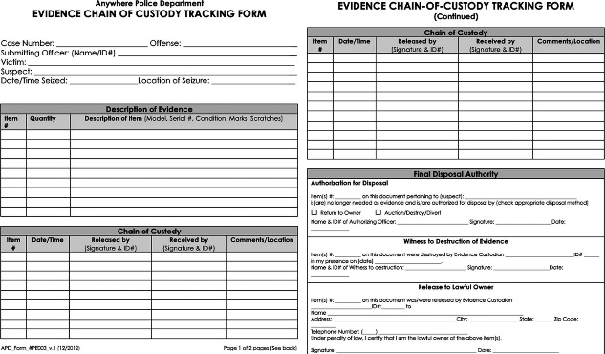
Figure 12 - Chain of Custody form
All the physical evidence that was found was given an evidence tag and was placed in the project logbook. This help provide help to prevent allegations of evidence tampering.

The fingerprints match the laptop with the terrorist from the crime since. Careful handling the laptop with gloves, John take photo of the laptop and all other evidence that he is given to look at. This will be stored in John report.

2.) John opened the laptop to see it was in standby mode, first John would need to use a tool called Volatility, this would save the CPU registers, caches, and memory into a file that can be examined at a later time, this would save all the information that is in the ram on this boot, once the pc is powered down this data would be unrecoverable. The second job is to clone the disk, this is done for multiply reason for John benefit, it preserves the original evidence, prevents alteration of the original evidence while the investigation is in progress and it also recreation if needed to be done.

3.) John take photo of the screen with a Cannon digital camera. John does this to have evidence if something failed while trying to create a clone of the hard drive. This is also done to have some evidence if the data is lost through the process.

4.) While the PC is on and working from the home screen, John was able to log that the OS is Windows XP professional with service pack 2 other information was log, time and location of the device, this will be important late for john.

5.) Once this is done John would have hashed the hard drive and stored the MD5 on record so if there was any tampering with the document then it was not be the same after. and completed the hard drive would be sealed up in an anti-static bag and then would send to a secure location where nobody would be able tamper with the evidence.

6.) John was then requested to find certain file types, the files that that was requested are list below:
- Microsoft Word
- Microsoft Excel
- PDF
- Image files: jpeg, giff, bmp, tiff
- Video files: avi, mpeg, dat, mov
- Audio files: mp3, wav, rm
Also, these file types are requested if found.
- Microsoft Outlook contacts,
- Email messages
- Messenger chat history
- Cache files
- Temporary
- Internet files
A check list was created and log to note if any of these files was found and the amount of them stored.

7.) John started to create his case with FTK, by using the cloned copy of the terrorist hard drive, John was able to start investigating without having trouble of corrupting the original.

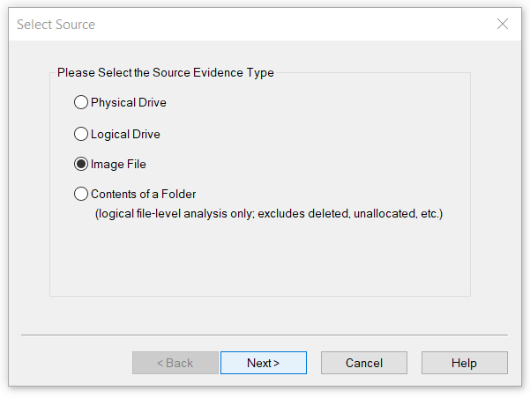  Figure 13- FTK Screenshot loading files | 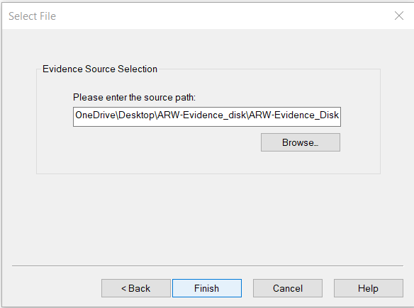

John starts investigate though the created OS image. There are lot of information John finds while he is looks around the image. Retrieving the files done by creating a filter and searching for certain file extension. These then pulled out files by extracting them to his PC, from this point John can start looking at individual files.

These files are placed in a folder for further examination.

See table for further in-depth research (Table 2).
8.) John was filtering though for certain file extensions, .mp4 brought up 13 different video files. John processed to log all the video files and report on each one. The videos showed that the terrorist was researching on terrorism, the videos showed:
- 9/11 Terrorist attack with 2 different videos.
- Detailed video show tours of Heathrow International Airport and Mason International airport at Fiji
- Show video showing Islamic State’s most wanted Terrorists.
- Speeches from the united states president
- Video showing terrorists practicing at a terror camp
- Killing of kidnapped hostages
- Motivational speeches by leaders of various terrorist organisations
(Table 3 – Video)

John would need to start created a detailed document talking about the video and listing them, each video would need to be explained with a brief about what is happening, the reason why John is doing this it to keep track of any records

10. The photo that was stored on that laptop was heavily detailing of Heathrow international airport and the Mason International Airport in Fiji. The terrorists did a lot of work to record the details of the airports as there was a significant amount of information about the lobby, check in desks, walkways, surrounding area and the different terminals. The same amount of detail was also recorded at Fiji international airport.

John was able to find hidden images within the other files; these images was hidden under different files extensions. John Reversed engineered this by changing the file extensions back to the original.
All the changes can be seen in the table.

(Table 4 – Images)

11.) Once John was done watch the video and created evidenced records of each MP4, there were a few similarities that allowed for John to make highly probably confirmation that the terrorist group that was behind this attack was Islamic State.

There was video showing the most wanted member of the group and other videos show attacks they have committed.

12.) After some time more evidence was being found that lead to documents that relate to “How to make chemical bomb”, “How to prepare for Jihad”, “How to be a suicide bomber” and also there was a PDF files on cyber-attacks, it list information that could lead to molest hacking on webservers along.

13. There are a handful of files that John found while searching, one of the files was called “How to bomb Mason International airport”. This caught the attention of John. This document then talks about how to create terror at the International airport in Fiji. This created more evidence of the accused in the crime.

14.) John noticed some files that are contacts for MS outlook, john started to load the documents up into the MailXaminer, a case was created around these contact files and to continue a flow of logging and evidence for the case.

Inside the files was matching names that was found in earlier, these names give more insight to who was being contact before and who else was a part of this attack.

15.) An Excel file was found called bank, trying to open the file there was a password in place stop anyone trying to gain access. John lunch kali Linux with a copy of Jonny running to crack the password.

Once that was all running, in less than 1 minuet the work crack found the password to be “money”. This allowed john to start looking around, 2 names were found with their account numbers, IFCS, branch and the bank name. Merlin Malcom and Ibrahim, these 2 names have shown up in the document before, with Ibrahim being found and hidden.

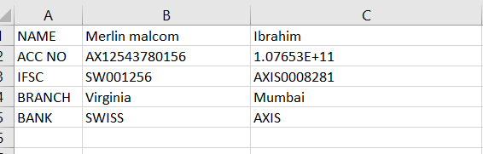

16.) Inside the laptop back there was a few documents that was belonging to the individual that was shot. One of the documents was an immigration visas, this showed and brought up his links that was with other terrorist organizations from his background.

17.) John would create a report with all the forensics analysis found inside, this would detail his investigation with all the evidence he has found and more information around the case too. This would be the stage where john send a invoice for his services too.
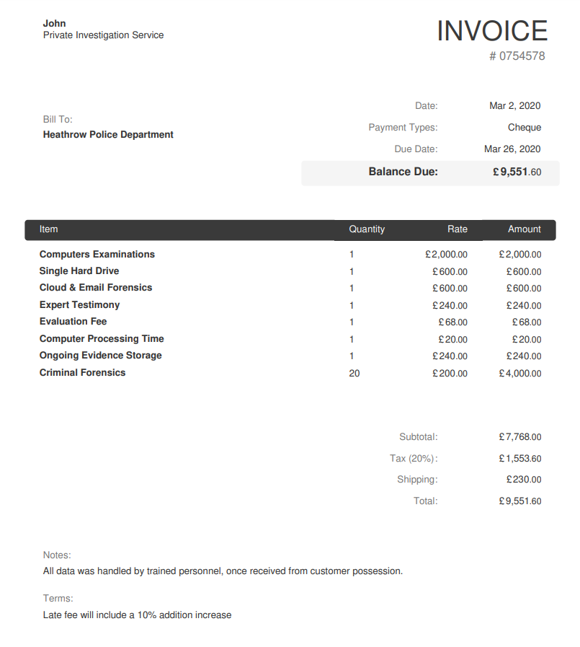

Appendix
Figure 1- United Kingdom Parliament 4
Figure 2 - caineos 4
Figure 3 - x-ways.net 4
Figure 4 - techtalk.gfi.com 5
Figure 5 - sleuthkit.org 5
Figure 6- berla.co 5
Figure 7 - oxygen-forensic.com 6
Figure 8 - mailxaminer.com 6
Figure 9 - digitalforensics.com 6
Figure 10 - techtalk.gfi.com 7
Figure 11 - githubusercontent.com 7
Figure 12 - Chain of Custody form 8
Figure 13 - FTK Screenshot loading files 8

 | Price | Platform | License | Version | Type
CaineOS | Free | Ubuntu based | CCL | 11.x | Operating System that is preloaded with tools to create a case and help with investigation
X-Ways Forensics | Approx. £2089 | Windows, | Proprietary | 19.x | Comprised as general forensic software that allows for disk analysing
FTK | Approx. £3454 | Windows, | Proprietary | 6.0.x | Scans hard drive looking for certain information or uncover deleted
Sleuth Kit + Autopsy | Free | Windows, MacOS, Linux | IPL, CPL, GPL | 4.x | flag pertinent sections of data
iVe | Quote Per Order | Windows | Proprietary | 2.6.x | Car tool to help find data about the event that happened in the vehicle
Oxygen Forensics | Approx. £6363 | Windows | Proprietary | 3.4.x | Used for phones and tablets and could base applications
MailXaminer | Approx. £2163 | Windows | Perpetual | 4.9.x | Searches and find emails and also the information about the network paths
Volatility Framework | Free | Windows & Linux | GPL | 2.6.x | Checks the Ram, Registry, CPU to save information before the computer losses it on a shut down.
USB Historian | Free | Windows | GPL | 1.3.x | Track a detailed about information about USB history
GRR Rapid Response | Free | Windows, MacOS, Linux | GPL | 3.4.0.x | A multi-site tool that allows uses to remote manage devices over the internet.

Table 2 | Total amount found | Other
Microsoft Word | 3
Microsoft Excel | 1
PDF | 3
Image Files | 21
Video Files | 18
Audio Files | 4
TXT | 2
HTML | 2
IOS | 1 | Kali Linux

Table 3 - Images | Image | File Type | Size | Dimensions
baggae1 |  | .bmp | 148KB | 275 x 183
baggae1 |  | .jpg | 14.8KB | 275 x 183
baggage2 |  | .jpg | 12.9KB | 299 x 168
blue |  | .png | 34.3KB | 500 x 375
fiji | 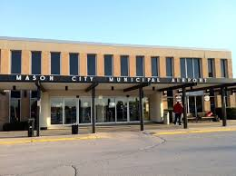 | .jpg | 8.40 KB | 260 x 194
heathrow airport | 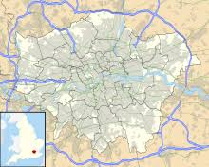 | .bmp | 113 KB | 220 x 176
heathrow airport | 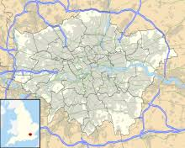 | .jpg | 8.27 KB | 220 x 176
heathrow airport | 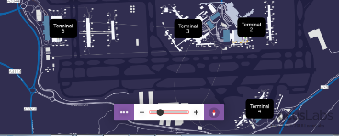 | .png | 131 KB | 796 x 322
image2 |  | .bmp | 147 KB | 380 x 132
image2 |  | .jpg | 12.0 KB | 380 x 132
image3 |  | .jpg | 11.6 KB | 302 x 167
images |  | .jpg | 11.3 KB | 259 x 194
images1 |  | .jpg | 9.38 KB | 275 x 183
india | 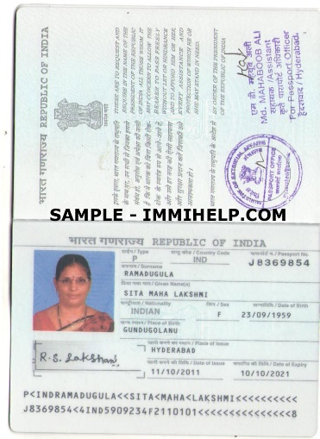 | .bmp | 137 KB | 768 x 183
London |  | .jpg | 16 KB | 275 x 183
London | 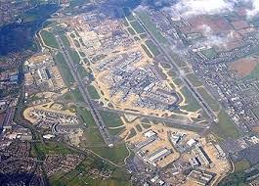 | .png | 17.1 KB | 265 x 190
mason_bar | 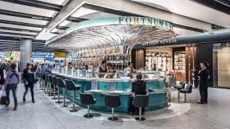 | .jpg | 12.5 KB | 300 x 168
mason_bar2 | 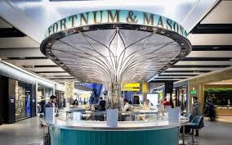 | .jpg | 12.5 KB | 284 x 177
mason1 | 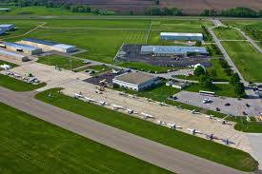 | .jpg | 10 KB | 275 x 183
passport | 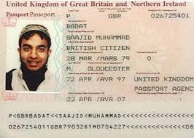 | .jpg | 10.4 KB | 266 x 190
pexels-photo-46710 |  | .jpg | 19.9 KB | 525 x 350

Table 3 - Videos | Video Name | Resolution | Time | Format | Size | Info
1 | London's Heathrow International Airport - LHR - YouTube (360p) | 360 | 00:09:55 | .mp4 | 45.6MB | Used to gather knowledge about the layout of Heathrow airport.
2 | temp (360p) | 360 | 00:05:32 | .mp4 | 19.3MB | Used to gather knowledge about the runway of Fiji airport.
3 | Vishwaroopam - Anu Vidhaiththa Boomiyile Video _ Kamal Haasan - YouTube (360p) | 360 | 00:02:21 | .mp4 | 9.20MB | Showing terrorist actions and plotting activities
4 | Vishwaroopam - Thuppaki Engal Tholile Video _ Kamal Haasan - YouTube (360p) | 360 | 00:05:55 | .mp4 | 13.8MB | Showing terrorist actions and plotting activities
5 | Vishwaroopam - Vishwaroopam Remix Video _ Kamal Haasan - YouTube (720p) | 720 | 00:02:33 | .mp4 | 19.9MB | Showing terrorist actions and plotting activities
6 | 9 11 WTC Attacks - Rare Video Quality near HD - YouTube (360p) | 360 | 00:08:18 | .mp4 | 26.9MB | Real and live footage of the 911 attacks
7 | 9_11~September 11th 2001-Attack on the World __ Trade Center - YouTube (360p) | 360 | 00:15:09 | .mp4 | 62.3MB | Real and live footage of the 911 attacks
8 | How Brussels bombing attacks happened - YouTube (360p) | 360 | 00:01:08 | .mp4 | 4.45MB | Real and live footage of the Brussels attack
9 | Terror attack at Istanbul airport - YouTube (360p) | 360 | 00:01:56 | .mp4 | 8.33MB | Real and live footage of the Istanbul airport attack
10 | The world's most wanted Islamic State terrorists - YouTube (480p) | 480 | 00:01:05 | .mp4 | 3.73MB | List of all the topmost wanted members from Islamic State
11 | PM Modi's SPEECH ON TERRORISM_ Hindustan na aatankwaad ke saamne jhuka hai, na jhukega - YouTube (480p) | 480 | 00:30:07 | .mp4 | 114MB | Speech about terrorism from a president
12 | President Obama FULL SPEECH on Strategy Against ISIS - YouTube (480p) | 480 | 00:13:09 | .mp4 | 61MB | Speech about terrorism from a president
13 | Saudi Crown Prince_ ‘Terrorism won’t distort Islam’s peaceful image’ - YouTube (480p) | 480 | 00:02:39 | .mp4 | 11.5MB | Speech about terrorism from a prince
14 | ANJANA | 1080 | 00:00:46 | .mp4 | 111MB
15 | BAARISHON KI | 1080 | 00:02:43 | .mp4 | 443MB
16 | CHALNE LAGE | 1080 | 00:03:31 | .mp4 | 336MB
17 | PYAAR YEH JAADU | 1080 | 00:04:12 | .mp4 | 558MB
18 | UNNAI PIRINDHU | 1080 | 00:04:25 | .mp4 | 511MB

References
[1]
I. Shakeel, “7 Best Computer Forensics Tools [Updated 2019],” Infosec Resources, 18-Feb-2019. [Online]. Available: https://resources.infosecinstitute.com/7-best-computer-forensics-tools/. [Accessed: 05-Feb-2020].
[2]
M. Rouse, “Computer Forensics (cyber forensics),” SearchSecurity, May-2013. [Online]. Available: https://searchsecurity.techtarget.com/definition/computer-forensics. [Accessed: 15-Mar-2020].
[3]
M. D, “Top 5 Skills for a Career in Digital Forensics,” eLearnSecurity Blog, 2018. [Online]. Available: https://blog.elearnsecurity.com/top-5-skills-for-a-career-in-digital-forensics.html. [Accessed: 15-Mar-2020].
[4]
S. Krakoff, “Top Skills Required For Computer Forensics Careers,” Champlain.edu, 2020. [Online]. Available: https://online.champlain.edu/blog/top-skills-required-for-computer-forensics-careers. [Accessed: 15-Mar-2020].
[5]
EC-Council, “6 Skills Required for a Career in Digital Forensics | EC-Council Official Blog,” EC-Council Official Blog, 07-Mar-2019. [Online]. Available: https://blog.eccouncil.org/6-skills-required-for-a-career-in-digital-forensics/. [Accessed: 15-Mar-2020].
[6]
C. Campbell, “UWTSD Moodle 2019/20: L5 - Computer Forensics (ACCB5000) (Lec1),” moodle.uwtsd.ac.uk, 01-Aug-2019. [Online]. Available: https://moodle.uwtsd.ac.uk/mod/folder/view.php?id=138690. [Accessed: 15-Mar-2020].
[7]
Protection Group International Ltd, “What is the difference between cyber crime and traditional crime?,” Protection Group International Ltd, 01-Dec-2018. [Online]. Available: https://www.pgitl.com/explore/article/what-is-the-difference-between-cyber-crime-and-traditional-crime. [Accessed: 15-Mar-2020].
[8]
C. Hodgson, “Uses of Computer Forensics,” Private Investigators UK, 07-Aug-2014. [Online]. Available: https://www.private-investigators-uk.com/detectives/digital-forensics/pc/uses-computer-forensics/. [Accessed: 15-Mar-2020].
[9]
“5 Steps for Conducting Computer Forensics Investigations,” Norwich University Online, 2017. [Online]. Available: https://online.norwich.edu/academic-programs/resources/5-steps-for-conducting-computer-forensics-investigations. [Accessed: 15-Mar-2020].
[10]
“Digital Forensics Process,” Jhigh.co.uk, 2020. [Online]. Available: http://cybersecurity.jhigh.co.uk/digitalForensics/phasesOfInvestigation.html. [Accessed: 15-Mar-2020].
[11]
D. Lomer, “15 Types of Evidence and How to Use Them in an Investigation,” i-Sight, 06-May-2016. [Online]. Available: https://i-sight.com/resources/15-types-of-evidence-and-how-to-use-them-in-investigation/. [Accessed: 15-Mar-2020].
[12]
Thomson Reuters, “Real and Demonstrative Evidence,” Findlaw, 15-Feb-2019. [Online]. Available: https://criminal.findlaw.com/criminal-procedure/real-and-demonstrative-evidence.html. [Accessed: 15-Mar-2020].
[13]
R. Leintz, “Forensic Evidence: Types, Definition & Cases - Video & Lesson Transcript | Study.com,” Study.com, 2020. [Online]. Available: https://study.com/academy/lesson/forensic-evidence-types-definition-cases.html. [Accessed: 15-Mar-2020].
[14]
Infosec Resources, “Chain of Custody in Computer Forensics,” Infosec Resources, 2019. [Online]. Available: https://resources.infosecinstitute.com/category/computerforensics/introduction/areas-of-study/legal-and-ethical-principles/chain-of-custody-in-computer-forensics/. [Accessed: 15-Mar-2020].
[15]
UK Government, “Safe computer use | nidirect,” nidirect, 26-Oct-2015. [Online]. Available: https://www.nidirect.gov.uk/articles/safe-computer-use. [Accessed: 15-Mar-2020].
[16]
“Cybercrime - prosecution guidance | The Crown Prosecution Service,” Cps.gov.uk, 07-Feb-2020. [Online]. Available: https://www.cps.gov.uk/legal-guidance/cybercrime-prosecution-guidance. [Accessed: 15-Mar-2020].
[17]
D. Emm, “Cybercrime and the law: a review of UK computer crime legislation,” Securelist.com, 29-May-2009. [Online]. Available: https://securelist.com/cybercrime-and-the-law-a-review-of-uk-computer-crime-legislation/36253/. [Accessed: 15-Mar-2020].
[18]
H. Graceful, “UK Cyber Crime Law | GracefulSecurity,” Gracefulsecurity.com, 15-Jun-2016. [Online]. Available: https://gracefulsecurity.com/uk-cyber-crime-law/. [Accessed: 15-Mar-2020].
[19]
“Cyber / online crime | The Crown Prosecution Service,” Cps.gov.uk, 07-Feb-2020. [Online]. Available: https://www.cps.gov.uk/cyber-online-crime. [Accessed: 15-Mar-2020].
[20]
Forensic Science Regulator, “Forensic Science providers: Codes of Practice and Conduct,” GOV.UK, 05-Sep-2014. [Online]. Available: https://www.gov.uk/government/collections/forensic-science-providers-codes-of-practice-and-conduct. [Accessed: 15-Mar-2020].
[21]
“Codes of Practice and Conduct for Forensic Science Providers and Practitioners in the Criminal Justice System Issue 4,” 2017.
[22]
A. Tabona, “Top 20 Free Digital Forensic Investigation Tools for SysAdmins - 2019 update,” GFI Blog, 11-Sep-2019. [Online]. Available: https://techtalk.gfi.com/top-20-free-digital-forensic-investigation-tools-for-sysadmins/. [Accessed: 19-Mar-2020].
[23]
“CAINE Live USB/DVD - Computer Forensics Digital Forensics,” Caine-live.net, 2020. [Online]. Available: https://www.caine-live.net/. [Accessed: 19-Mar-2020].
[24]
“Forensic Toolkit (FTK)®,” AccessData, 2020. [Online]. Available: https://accessdata.com/products-services/forensic-toolkit-ftk. [Accessed: 19-Mar-2020].
[25]
“The Volatility Foundation - Open Source Memory Forensics,” volatilityfoundation, 2014. [Online]. Available: https://www.volatilityfoundation.org/. [Accessed: 19-Mar-2020].
[26]
Igor Mikhaylov, “See Results from the 2016 Volatility Plugin Contest!,” Digitalforensics.com, 07-Dec-2016. [Online]. Available: https://www.digitalforensics.com/blog/see-results-from-the-2016-volatility-plugin-contest/. [Accessed: 19-Mar-2020].
[27]
“GRR Rapid Response: remote live forensics for incident response - LinuxLinks,” LinuxLinks, 2019. [Online]. Available: https://www.linuxlinks.com/grr-rapid-response-remote-live-forensics-incident-response/. [Accessed: 19-Mar-2020].
[28]
Parrot Security, “Parrot Security,” Parrotlinux.org, 2013. [Online]. Available: https://parrotlinux.org/. [Accessed: 19-Mar-2020].
[29]
“Popular Computer Forensics Top 21 Tools [Updated for 2019],” Infosec Resources, 17-Feb-2019. [Online]. Available: https://resources.infosecinstitute.com/computer-forensics-tools/. [Accessed: 19-Mar-2020].
[30]
“Oxygen Forensics - Mobile forensic solutions: software and hardware,” Oxygen-forensic.com, 2020. [Online]. Available: https://www.oxygen-forensic.com/en/products/oxygen-forensic-detective. [Accessed: 19-Mar-2020].
[31]
X-Ways Software Technology AG, “X-Ways Forensics: Integrated Computer Forensics Software,” X-ways.net, 2012. [Online]. Available: http://www.x-ways.net/forensics/. [Accessed: 19-Mar-2020].
[32]
X-Ways Software Technology AG, “Computer Forensics Software,” X-ways.net, 2020. [Online]. Available: https://www.x-ways.net/winhex/forensics.html. [Accessed: 19-Mar-2020].
[33]
“15 BEST Digital Forensic Tools in 2020 [Free/Paid],” Guru99.com, 23-Feb-2020. [Online]. Available: https://www.guru99.com/computer-forensics-tools.html. [Accessed: 19-Mar-2020].
[34]
“Autopsy,” Sleuthkit.org, 2020. [Online]. Available: https://www.sleuthkit.org/autopsy/. [Accessed: 19-Mar-2020].
[35]
“The Sleuth Kit: File and Volume System Analysis,” Sleuthkit.org, 2020. [Online]. Available: https://www.sleuthkit.org/sleuthkit/desc.php. [Accessed: 19-Mar-2020].
[36]
“What’s Included? – Berla.co,” Berla.co, 2020. [Online]. Available: https://berla.co/whats-included/. [Accessed: 20-Mar-2020].
[37]
MailXaminer, “MailXaminer,” Mailxaminer.com, 2020. [Online]. Available: https://www.mailxaminer.com/. [Accessed: 20-Mar-2020].
[38]
“Computer Forensics Tools & Techniques Catalog - Tool Search,” Nist.gov, 2018. [Online]. Available: https://toolcatalog.nist.gov/search/index.php?all_tools=all&ff_id=31&1%5B%5D=any&4%5B%5D=any&5%5B%5D=any&6%5B%5D=any. [Accessed: 20-Mar-2020].
[39]
A. K. Shrivastava, N. Payal, A. Rastogi, and A. Tiwari, “Digital Forensic Investigation Development Model,” 2013 5th International Conference on Computational Intelligence and Communication Networks, Sep. 2013.
[40]
J. Zeng, S. Shi, Y. Li, and Q. Lu, “Practical inspection workflow for digital image forensic authentication,” 2016 4th International Symposium on Digital Forensic and Security (ISDFS), Apr. 2016.
[41]
F. R. Van Staden and H. S. Venter, “Adding digital forensic readiness to the email trace header,” 2010 Information Security for South Africa, Aug. 2010.
[42]
Amped Software, “The Complete Workflow of Forensic Image and Video Analysis,” Forensic Focus - Articles, 28-Jul-2014. [Online]. Available: https://articles.forensicfocus.com/2014/07/28/the-complete-workflow-of-forensic-image-and-video-analysis/. [Accessed: 21-Mar-2020].
[43]
belkasoft, “Retrieving Digital Evidence: Methods, Techniques and Issues,” Forensic Focus - Articles, 11-Jul-2012. [Online]. Available: https://articles.forensicfocus.com/2012/07/11/retrieving-digital-evidence-methods-techniques-and-issues/. [Accessed: 21-Mar-2020].
[44]
M. H. Sonnekus, “A comparison of open source and proprietary digital forensic software,” Core.ac.uk, 2015. [Online]. Available: https://core.ac.uk/reader/145046345. [Accessed: 22-Mar-2020].
[45]
“Course: L5 - Computer Forensics (ACCB5000),” Uwtsd.ac.uk, 2018. [Online]. Available: https://moodle.uwtsd.ac.uk/course/view.php?id=4719. [Accessed: 26-Mar-2020].
‌

