BMHP5023 Introduction to Physiology
Part 1: Written Assignment (Case Study Report)

Case Study Report: Type 2 Diabetes
Understanding blood sugar control, monitoring, and lifestyle change

Student Name: Neelam Shehzadi
Student Number: 2508687
Module Lead: Gillian Weaver
Module Name: BMHP5023_BIRM

1. Introduction
Diabetes is a chronic disease in which there is high glucose in the blood. This is because the pancreas does not produce sufficient insulin, or insulin that effectively lowers blood sugar, is called insulin resistance (NHS, 2025b). Type 2 diabetes occur much more often than type 1 diabetes. In the UK, about 90% of people who are diagnosed with diabetes are Type 2. 2024-25, more than 4.7 million people in the UK were diagnosed with a diagnosis and Diabetes UK (no date) believes nearly 1.3 million people could have type 2 diabetes without realizing it. In total, the number of individuals living with diabetes was estimated to be approximately 830 million, globally, in 2022 (World Health Organization (WHO), 2024).
There are some risk factors which cannot be changed. White people over 40 years and older and people over twenty-five from an ethnic minority background are at higher risk. Being a sibling of a relative, such as a parent, brother or sister who has diabetes also increases it (NHS, 2025a). Other risk factors, such as smoking, physical inactivity, an unhealthier diet, and being overweight are factors that could be changed (WHO, 2024).
This report is based on the perspective of a GP practice nurse in a GP surgery in an area where an increasing number of people are diagnosed as having Type 2 diabetes. Describes the regulation of blood sugar under normal conditions, why Lifestyle has changed in Type 2 diabetes and the importance of keeping a record of blood glucose levels, and what lifestyle changes the research has found to be helpful.

2. How the body controls blood sugar

2.1 Keeping blood glucose at a safe level.
Glucose is needed for energy production in every cell; the brain is the main cell using glucose (Hall and Hall, 2021). Blood glucose levels are kept in a narrow range in the body by homeostasis. This is achieved by negative feedback: When the level approaches an abnormal state the body responds by returning it too normal. The primary organ that is involved is the pancreas, which ejects tiny groups of cells called islets of Langerhans, which produce hormones directly into the bloodstream (Waugh and Grant, 2022).
Carbohydrates are broken down to glucose and enter the bloodstream after they are consumed as food. The increase in blood glucose triggers the release of insulin from beta cells in the islets. Insulin lets glucose enter muscle and fat cells by moving glucose transporters, called GLUT4, to the cell surface (Petersen and Shulman, 2018). It also signals to the liver and muscles to save on fuel, in the form of glycogen, and it instructs the liver to not release fuel. This blood glucose concentration is then restored to normal.
When blood glucose levels begin to decline, instead, alpha cells secrete glucagon. Glucagon makes the liver break glycogen down into glucose (glycogenolysis) and make new glucose from sources such as amino acids (gluconeogenesis) (Waugh and Grant, 2022). The two hormones work against each other, as Figure 1 shows. An imbalance may harm. If a person's blood glucose (sugar) level drops too low (hypoglycemia) their blood vessels and nerves can be damaged, causing confusion and unconsciousness (Hall and Hall, 2021).
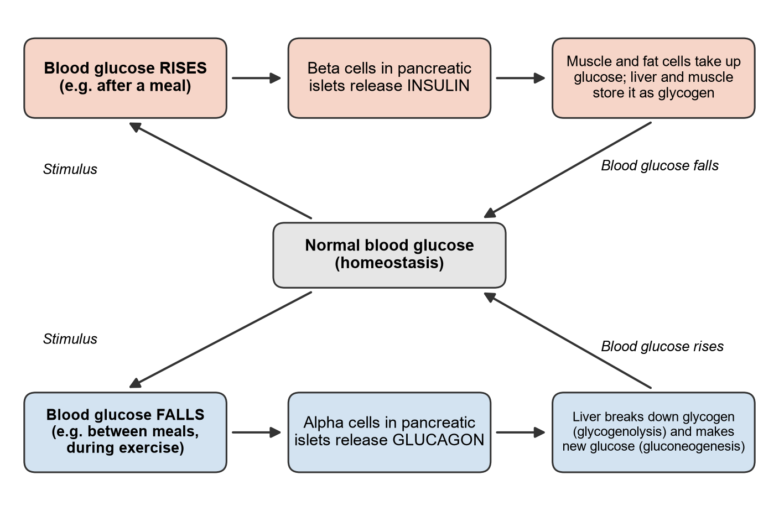
Figure 1: Negative feedback control of blood glucose by insulin and glucagon (author's own diagram, based on Waugh and Grant, 2022)

2.2 How cells use glucose and oxygen to make energy.
Cells cannot use the energy in glucose directly. They first transfer it to a molecule called adenosine triphosphate (ATP), which powers things like muscle contraction. This process is called cellular respiration:
Glucose + oxygen > carbon dioxide + water + energy (ATP)
C₆H₁₂O₆ + 6O₂ > 6CO₂ + 6H₂O + ATP
According to Hall and Hall (2021), there are three stages. Glycolysis happens in cytoplasm and splits glucose into two molecules of pyruvate. Does not require oxygen but only produces a net of two ATP molecules. Pyruvate is then transported into the mitochondria. In this cycle it is further broken down by the Krebs (citric acid) cycle with carbon dioxide released and hydrogen transferred to the electron transport chain. In this last step oxygen will combine hydrogen to form water molecules and the majority of ATP will be generated (Waugh and Grant, 2022). When there is insufficient oxygen as during severe exercise, it turns into lactic acid, and the cell obtains only 2 ATP molecules.
This cannot occur at all until glucose enters the cell, which requires insulin in muscle and fat cells. There is excessive glucose in circulation in Type 2 diabetes, but the cells cannot absorb it into the body. This could be one of the reasons why it is common to get very tired (NHS, 2025a).

3. What goes wrong with type 2 diabetes
The feedback mechanism in Figure above fails to be effective in case of type 2 diabetes. For one thing, the body's cells that make up muscle, fat and liver become less sensitive to insulin. Inside the cell, fat, found inside liver and muscle cells, blocks signals sent by insulin, as explained by Petersen and Shulman (2018). Glucose transporters are less efficiently brought to the surface of the cell, and the liver continues to produce glucose, even in high concentrations of blood glucose. Second, the beta cells produce even more insulin to compensate for the insulin resistance, but eventually they are unable to keep up (Petersen and Shulman, 2018). This causes the blood sugar to remain elevated and is known as hyperglycemia.
High blood glucose in the long term can cause heart disease, stroke, kidney disease, and nerve problems (NHS, 2025b). The study by UK Prospective Diabetes Study (UKPDS) tracked 3,642 individuals with Type 2 diabetes. Reduction of the HbA1c by 1% implied a 21% decreased risk of developing any diabetes-related complication and a 37% decrease in the risk of damaging the small blood vessels (Stratton et al., 2000). This is an observation study and as such it only proves a link and cannot show cause.
If greater energy intake than output occurs, then weight gain and increased liver and muscle fat could worsen insulin resistance (Petersen and Shulman, 2018). Exercise is important because muscles exercise does not require insulin to absorb glucose (Kanaley et al., 2022). In addition, Kanaley et al (2022) have also found an increased risk of type 2 diabetes with increasing amounts of sitting time. Even smoking is a risk factor. Active smoking even increased a person's risk of developing type 2 diabetes, and passive smoking did as well (Pan et al., 2015). However, age, ethnicity and family history remain significant, and a healthy lifestyle reduces risk, but does not eliminate it.
4. Recording and tracking blood sugar
There can be nothing obviously different about a person if they have type 2 diabetes (NHS, 2025a). Patients cannot figure out from how they feel whether their blood sugar level is under control or not; that's why regular test results are necessary.
HbA1C is the main test, measuring amount of glucose that has clogged hemoglobin in red blood cells. The National Institute for Health and Care Excellence (NICE) (2015) recommends an HbA1C evaluation every 3 to 6 months while there is fluctuation and then evaluates every 6 months. A patient's personal target is agreed (Table 1). By reviewing results over time, you can see if there is an improvement because of changing your diet, activity, or medicine. Even across services data is used. NICE (2015) recommends services to track the use of glucose-monitoring devices, and work to support those with low uptake.
Table 1: NICE HbA1c targets adults with type 2 diabetes (NICE, 2015)
Patient's situation | HbA1c target
Managed by diet and healthy living alone, or with a first medicine that does not cause hypoglycemia | Forty-eight mmol/mol (6.5%)
Taking medicine that can cause hypoglycemia | Fifty-three mmol/mol (7.0%)
HbA1c rises to fifty-eight mmol/mol (7.5%) or higher on the first medicine | Review diet, lifestyle, and medicines; aim for fifty-three mmol/mol (7.0%)

Not all people are able to get home blood glucose testing using a finger prick meter. NICE (2015) recommends it for individuals taking insulin, those who have suffered from hypertension, individuals taking tablets which may lead to hypothetically while operating a vehicle or machine and during pregnancy and whilst pregnant. For these patients it helps keep them safe. For other patients, the evidence is less clear. In a Cochrane review of twelve trials, self-monitoring was shown to reduce HbA1c by 0.3% at six months but at 12 months, this was not significant and quality of life did not improve (Malanda et al., 2012). No difference in HbA1c levels after a year in a later trial of 450 patients not taking insulin (Young et al., 2017).
What this evidence tells me is that there is not a lot of change in the numbers. They can be helpful if the patient accepts them and knows what he/she should do next. Anyone who checks themselves should be reviewed at least annually to ensure they are able to act on self-monitoring results (NICE 2015). I would have the patients make short notes opposite the reading, about their meals or activity, or illness, in clinic. They may then recognize patterns, e.g., that they take fewer readings the day after they walk after dinner.
5. Evidence-based lifestyle recommendations
NICE (2015) highlights the importance of lifestyle advice being tailored to the person's needs, culture and beliefs and providing structured group education which meets the person's language and literacy.
5.1 Diet and weight loss
The type of dietary recommendations for people with type 2 diabetes follows the same guidelines as recommended for the public (NICE, 2015). This includes consuming more carbohydrates as high fiber, low GI, less saturated fat and trans-fat, and low-fat dairy and oily fish. The foods listed above have a slow breakdown and thus do not cause a rapid blood sugar increase after eating. For patients who are overweight, losing weight makes the biggest difference (Davies et al., 2022). This was trailed in England in GP surgeries, the Direct trial. A formula diet was used for an average of 825 to 853 calories per day for 12 to 20 weeks followed by a gradual transition back up to a normal diet with continued support. Forty-six percent of those who underwent redirected therapy were in full remission a year later compared to 4% who received traditional therapy and 86% who lost 15 kg or more were in remission (Lean et al., 2018). As of two years, there were 36% who remained in remission (Lean et al., 2019). This is the approach they are recommending globally and using in the NHS Type 2 Diabetes Path to Remission Programmed (2015). But it is not for everyone. It is an extremely difficult diet to follow, and only people aged 20 to 65 and diagnosed within the past six years took part in the trial!
5.2 Physical activity
The recommendations of Kanaley et al. (2022) are at least 150 min/week of moderate-level activity, or 75 minutes of vigorous-level activity, throughout the week, including brisk walking. They also suggest resistance exercise and frequent sit breaks. This is related to Section 2, as the work muscles remove glucose from the blood without the need for insulin and training increases the sensitivity of cells to insulin. Frequently, around exercise, insulin or tablet treatment using those that increase the flow of insulin produced by the pancreas should be adjusted so that the patient does not experience a hypo (Kanaley et al., 2022). Inspecting their readings enables them to do this in a secure way.
5.3 Stopping smoking.
Stopping smoking is part of care for diabetes (WHO 2024) and in care for tobacco, NICE (2015) recommends practices to consider. People who have just quit increased their diabetes risk for a certain period before a significant decrease in risk after 7 to 24 months. (2015, Pan et al.) Many smokers have gained weight due to post smoking issues. So, when I recommend NHS stop smoking service for my patients it makes logical sense that I give them diet and activity support at the same time.
6. Conclusion
Type 2 diabetes is the result of the negative feedback system that regulates blood glucose levels becoming disrupted. Insulin no longer works as it should in the cells and eventually the beta cells begin to produce insufficient amounts of insulin. Blood glucose stays, rather than being taken up into cells to be used with oxygen to produce ATP. This overtime is damaging to blood vessels and nerves, and the results of the UKPDS indicate that reducing HbA1c will reduce the risk of complications (Stratton et al., 2000).
Long-term follow-up gives an idea if the treatment is effective. Most patients will use HbA1c as their primary assessment. Among the lifestyle changes, losing weight, being active and stopping smoking have the best evidence behind them. Some people may even see type 2 diabetes go into remission when they lose weight (Lean et al., 2018).
The nurses can set acceptable goals, discuss outcomes with patients, and encourage them to access the Path to Remission Programmed and stop smoking services for structured education. Hardness of insisting on these changes is shown in the lapse in remission seen by the first and second year of Direct. Support should continue long after diagnosis.

Reference list
Davies, M.J. et al. (2022) 'Management of hyperglycemia in type 2 diabetes, 2022. A consensus report by the American Diabetes Association (ADA) and the European Association for the Study of Diabetes (EASD)', Diabetology, 65(12), pp. 1925-1966. Available at: https://doi.org/10.1007/s00125-022-05787-2 (Accessed: 19 October 2026).
Diabetes UK (no date) How many people in the UK have diabetes? Available at: https://www.diabetes.org.uk/about-us/about-the-charity/our-strategy/statistics (Accessed: 19 October 2026).
Hall, J.E. and Hall, M.E. (2021) Guyton and Hall textbook of medical physiology. 14th edn. Philadelphia: Elsevier.
Kanaley, J.A. et al. (2022) 'Exercise/physical activity in individuals with type 2 diabetes: a consensus statement from the American College of Sports Medicine', Medicine and Science in Sports and Exercise, 54(2), pp. 353-368. Available at: https://doi.org/10.1249/MSS.0000000000002800 (Accessed: 19 October 2026).
Lean, M.E.J. et al. (2018) 'Primary care-led weight management for remission of type 2 diabetes (Direct): an open-label, cluster-randomized trial', The Lancet, 391(10120), pp. 541-551. Available at: https://doi.org/10.1016/S0140-6736(17)33102-1 (Accessed: 19 October 2026).
Lean, M.E.J. et al. (2019) 'Durability of a primary care-led weight-management intervention for remission of type 2 diabetes: 2-year results of the Direct open-label, cluster-randomized trial', The Lancet Diabetes and Endocrinology, 7(5), pp. 344-355. Available at: https://doi.org/10.1016/S2213-8587(19)30068-3 (Accessed: 19 October 2026).
Malanda, U.L. et al. (2012) 'Self-monitoring of blood glucose in patients with type 2 diabetes mellitus who are not using insulin', Cochrane Database of Systematic Reviews, (1), CD005060. Available at: https://doi.org/10.1002/14651858.CD005060.pub3 (Accessed: 19 October 2026).
National Institute for Health and Care Excellence (NICE) (2015) Type 2 diabetes in adults: management (NICE guideline NG28). Last updated 18 February 2026. Available at: https://www.nice.org.uk/guidance/ng28 (Accessed: 19 October 2026).
NHS (2025a) Symptoms of type 2 diabetes and how it is diagnosed. Available at: https://www.nhs.uk/conditions/type-2-diabetes/getting-diagnosed/ (Accessed: 19 October 2026).
NHS (2025b) What is type 2 diabetes? Available at: https://www.nhs.uk/conditions/type-2-diabetes/what-is-type-2-diabetes/ (Accessed: 19 October 2026).
Pan, A. et al. (2015) 'Relation of active, passive, and quitting smoking with incident type 2 diabetes: a systematic review and meta-analysis', The Lancet Diabetes and Endocrinology, 3(12), pp. 958-967. Available at: https://doi.org/10.1016/S2213-8587(15)00316-2 (Accessed: 19 October 2026).
Petersen, M.C. and Shulman, G.I. (2018) 'Mechanisms of insulin action and insulin resistance', Physiological Reviews, 98(4), pp. 2133-2223. Available at: https://doi.org/10.1152/physrev.00063.2017 (Accessed: 19 October 2026).
Stratton, I.M. et al. (2000) 'Association of glycaemia with macrovascular and microvascular complications of type 2 diabetes (UKPDS 35): prospective observational study', BMJ, 321(7258), pp. 405-412. Available at: https://doi.org/10.1136/bmj.321.7258.405 (Accessed: 19 October 2026).
Waugh, A. and Grant, A. (2022) Ross and Wilson anatomy and physiology in health and illness. 14th edn. Edinburgh: Elsevier.
World Health Organization (WHO) (2024) Diabetes. Fact sheet, 14 November. Available at: https://www.who.int/news-room/fact-sheets/detail/diabetes (Accessed: 19 October 2026).
Young, L.A. et al. (2017) 'Glucose self-monitoring in non-insulin-treated patients with type 2 diabetes in primary care settings: a randomized trial', JAMA Internal Medicine, 177(7), pp. 920-929. Available at: https://doi.org/10.1001/jamainternmed.2017.1233 (Accessed: 19 October 2026).

