Financial Management for the Hotel Industry
Module Code: BMIH5007
Assessment 2
Case Study: The Seacrest Lodge
Sumaiya Begum Tanni
Student ID: 2211676

Table of Contents
Introduction 3
Financial Performance of Seacrest Lodge 4
Current Ratio 4
Quick Ratio 6
Debt-to-Equity Ratio 8
Return on Assets (ROA) 10
Return on Equity (ROE) 12
Reasons Behind the Decline in Profitability 14
Internal Reasons 14
Poor Quality of Services 14
Outdated Amenities 14
External Reasons 14
Competition 14
Globalisation and Technological Advancements 15
Comprehensive Turnaround Strategy to Revitalise the Financial Health of Seacrest Lodge 16
Budgeting 16
Sustainable Accounting Practices 16
Working Capital Management 16
Upgradation of Amenities 16
Improvement of Services 17
Lowering Debts 17
Marketing Strategies 17
Conclusion 18
References 19

Introduction
One of the main sectors of the hospitality industry is the accommodation sector, which offers accommodation services to guests (Walker, 2021). There are hotels, motels, resorts, lodges, and different star hotels that cater to customers for their stay. With these technological advancements, new hotels and resorts are coming with new and advanced technologies to make guests' stay comfortable and enjoyable (Choudhary, 2013). The report is on a case study at Seacrest Lodge in the United Kingdom and its financial performance in recent years.

Financial Performance of Seacrest Lodge
The financial performance of Seacrest Lodge can be analysed by using a ratio analysis of the company. Ratio analysis gives insights into the company's profitability, liquidity, solvency and efficiency conditions. It also enables one to understand whether the company's financial health is improving or not through comparison (Atrill and McLaney, 2021). So, some of the key financial ratios for Seacrest Lodge are calculated and interpreted below.

Current Ratio
The current ratio is the most common form of liquidity ratio, which measures whether the company is being able to repay its current debts through current assets. It also enables one to understand how strongly and efficiently the company can manage its working capital (Guilding and Ji, 2022).
Seacrest Lodge
Current Ratio
Known that,
 | Current Ratio = Current Assets / Current Liabilities
Data Extracted from the Balance Sheet,
 |  | 2021 | 2022 | 2023
 | Cash and Equivalents | £100,000.00 | £80,000.00 | £20,000.00
 | Accounts Receivables | £50,000.00 | £40,000.00 | £30,000.00
 | Accounts Payables | £30,000.00 | £40,000.00 | £50,000.00
Here,
 |  | 2021 | 2022 | 2023
 | Current Assets | £150,000.00 | £120,000.00 | £50,000.00
 | Current Liabilities | £30,000.00 | £40,000.00 | £50,000.00
Now,
 |  | 2021 | 2022 | 2023
 | Current Ratio for Seacrest Lodge | 5.00:1 | 3.00:1 | 1.00:1

Seacrest Lodge
Current Ratio
2021 | 5.00:1
2022 | 3.00:1
2023 | 1.00:1

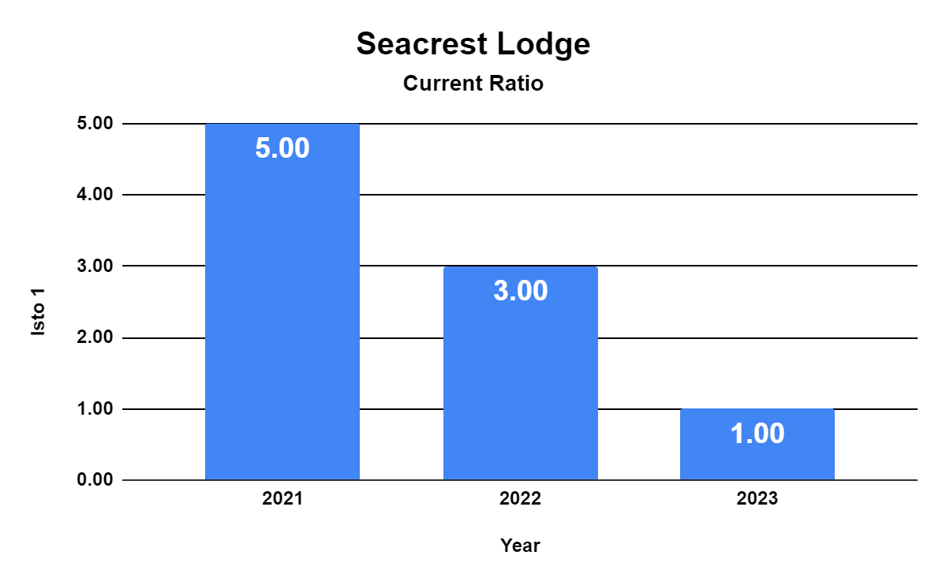
Figure 1: Current Ratio of Seacrest Lodge Over Three Years
The current ratio of the lodge has decreased over the past three years. It indicates that the company's liquidity position is very low. In 2023, it was below the standard. Along with that, the company may face a crisis in working capital management in the upcoming years with such a level of liquidity.

Quick Ratio
The quick ratio is also known as the acid test ratio. It deducts the inventories from the current assets to calculate the value. Since inventories take more time to replenish, the actual liquid condition may not be understood through the current ratio. Therefore, the quick ratio deducts inventories.
Seacrest Lodge
Quick Ratio
Known that,
 | Quick Ratio = (Current Assets - Inventory) / Current Liabilities
Data Extracted from the Balance Sheet,
 |  | 2021 | 2022 | 2023
 | Cash and Equivalents | £100,000.00 | £80,000.00 | £20,000.00
 | Accounts Receivables | £50,000.00 | £40,000.00 | £30,000.00
 | Accounts Payables | £30,000.00 | £40,000.00 | £50,000.00
Here,
 |  | 2021 | 2022 | 2023
 | Current Assets | £150,000.00 | £120,000.00 | £50,000.00
 | Inventory | £0.00 | £0.00 | £0.00
 | Current Liabilities | £30,000.00 | £40,000.00 | £50,000.00
Now,
 |  | 2021 | 2022 | 2023
 | Quick Ratio for Seacrest Lodge | 5.00:1 | 3.00:1 | 1.00:1

Seacrest Lodge
Quick Ratio
2021 | 5.00:1
2022 | 3.00:1
2023 | 1.00:1

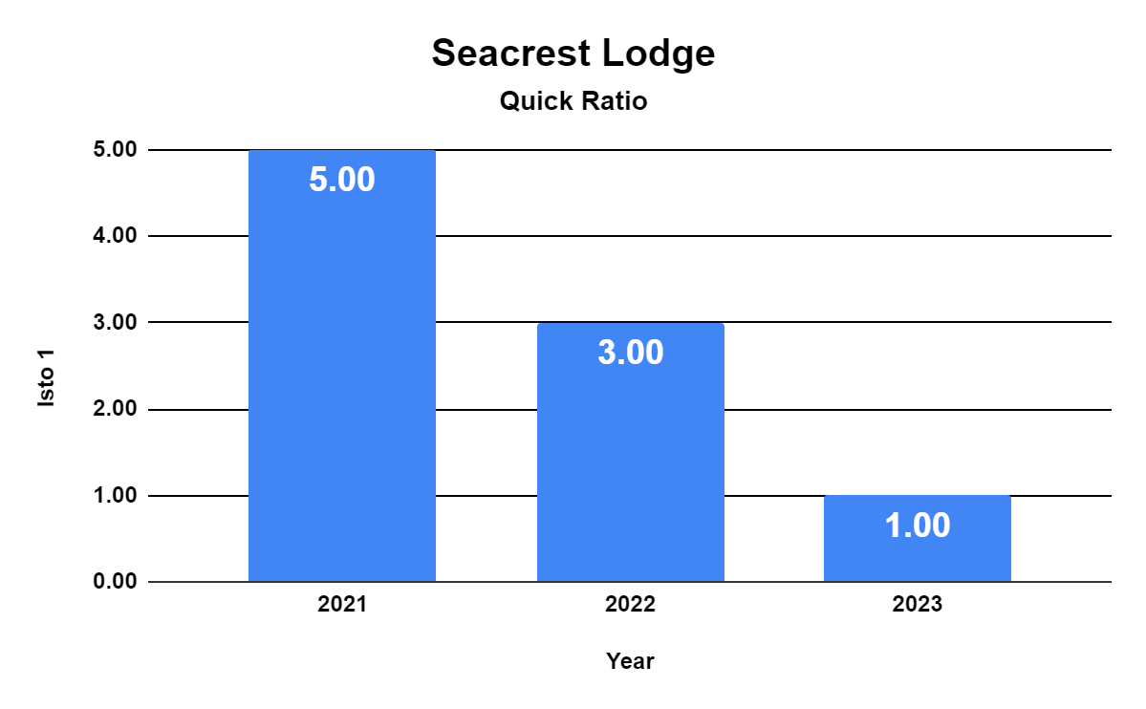
Figure 2: Quick Ratio of Seacrest Lodge Over Three Years
In this scenario, Seacrest Lodge does not have any inventory since it is a service-based company. For this reason, the calculation of the current ratio and quick ratio generates the same result.

Debt-to-Equity Ratio
The debt-to-equity ratio is one of the leverage ratios. It shows how much of the capital is financed by its debts. The lower debt-to-equity is good for the financial health of the company (Seal et al., 2008).
Seacrest Lodge
Debt-to-Equity Ratio
Known that,
 | Debt-to-Equity Ratio = Total Debt / Total Equity
Data Extracted from the Balance Sheet,
 |  | 2021 | 2022 | 2023
 | Accounts Payables | £30,000.00 | £40,000.00 | £50,000.00
 | Long-term Debt | £1,500,000.00 | £1,500,000.00 | £1,500,000.00
 | Equity | £620,000.00 | £580,000.00 | £300,000.00
Here,
 |  | 2021 | 2022 | 2023
 | Total Debt | £1,530,000.00 | £1,540,000.00 | £1,550,000.00
 | Equity | £620,000.00 | £580,000.00 | £300,000.00
Now,
 |  | 2021 | 2022 | 2023
 | Debt-to-Equity Ratio for Seacrest Lodge | 2.4677 | 2.6552 | 5.1667

Seacrest Lodge
Debt-to-Equity Ratio
2021 | 2.4677
2022 | 2.6552
2023 | 5.1667

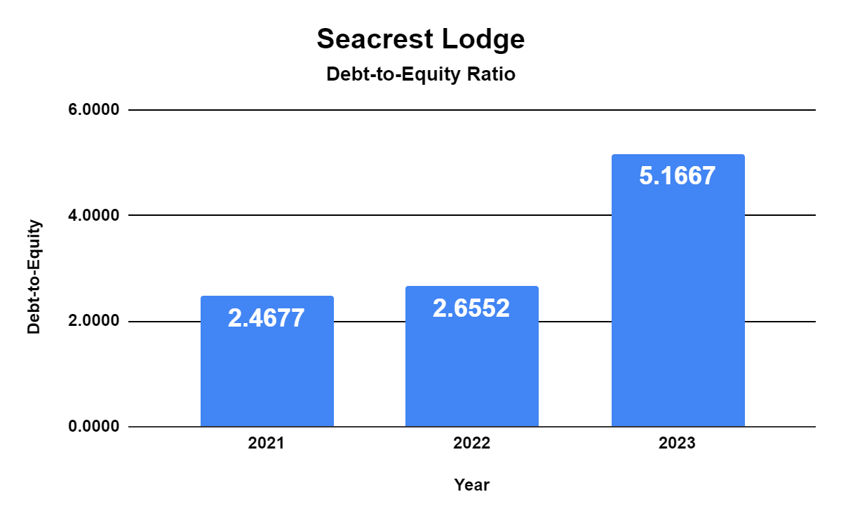
Figure 3: Debt-to-Equity Ratio of Seacrest Lodge Over Three Years
The debt-to-equity ratio has been increasing in the last three years. It shows that the company adds up new short-term or long-term loans to finance its capital. As Seacrest Lodge is facing a crisis, it is borrowing money on different terms for the company. The leverage condition is declining for Seacrest Lodge.

Return on Assets (ROA)
Return on assets is one of the profitability ratios that enables the business to understand how much return is generated by utilising the company's assets over a specified period. A higher return on assets is better for the company's financial health (Guilding, 2014).
Seacrest Lodge
Return on Assets (ROA)
Known that,
 | Return on Assets (ROA) = Net Income / Total Assets
Data Extracted from the Balance Sheet,
 |  | 2021 | 2022 | 2023
 | Net Income | £300,000.00 | £150,000.00 | -£150,000.00
 | Cash and Equivalents | £100,000.00 | £80,000.00 | £20,000.00
 | Accounts Receivables | £50,000.00 | £40,000.00 | £30,000.00
 | Property and Equipment | £200,000.00 | £200,000.00 | £180,000.00
Here,
 |  | 2021 | 2022 | 2023
 | Net Income | £300,000.00 | £150,000.00 | -£150,000.00
 | Total Assets | £350,000.00 | £320,000.00 | £230,000.00
Now,
 |  | 2021 | 2022 | 2023
 | Return on Assets (ROA) for Seacrest Lodge | 0.8571 | 0.4688 | -0.6522

Seacrest Lodge
Return on Assets (ROA)
2021 | 0.8571
2022 | 0.4688
2023 | -0.6522

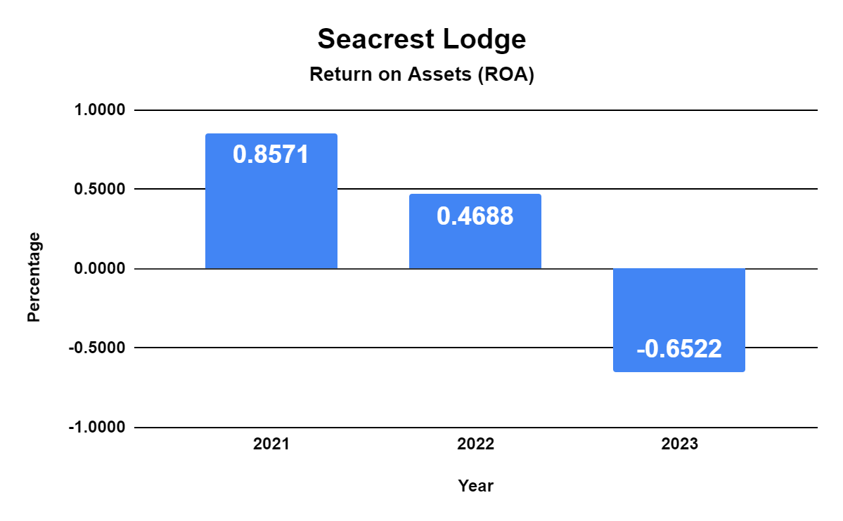
Figure 4: Return on Assets (ROA) of Seacrest Lodge Over Three Years
The return on assets for Seacrest Lodge has declined in recent years. Even in 2023, the company has undergone losses since the return on assets shows a negative value.

Return on Equity (ROE)
Return on equity is another profitability ratio which measures the return on each pound invested through the capital (equity) in a particular period (Seal, 2019).
Seacrest Lodge
Return on Equity (ROE)
Known that,
 | Return on Equity (ROE) = Net Income / Total Equity
Data Extracted from the Balance Sheet,
 |  | 2021 | 2022 | 2023
 | Net Income | £300,000.00 | £150,000.00 | -£150,000.00
 | Equity | £620,000.00 | £580,000.00 | £300,000.00
Now,
 |  | 2021 | 2022 | 2023
 | Return on Equity (ROE) for Seacrest Lodge | 0.4839 | 0.2586 | -0.5000

Seacrest Lodge
Return on Equity (ROE)
2021 | 0.4839
2022 | 0.2586
2023 | -0.5000

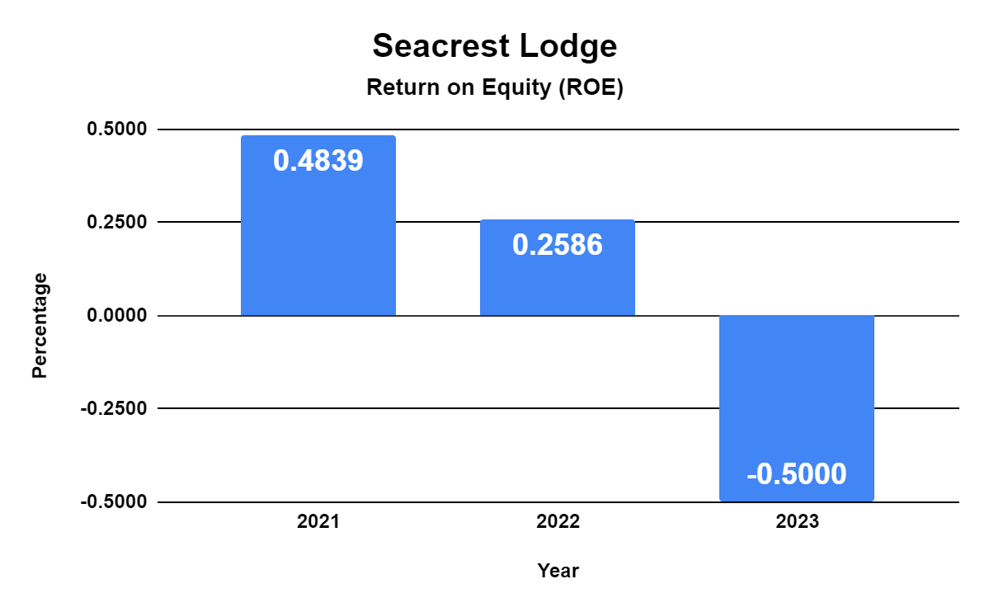
Figure 5: Return on Equity (ROE) of Seacrest Lodge Over Three Years
The return on assets for Seacrest Lodge has declined in recent years. A higher return on equity is better for the company's financial health because it shows higher ability to generate profit (Wild, 2018). In 2023, the company has undergone losses since the return on equity shows a negative value.

Reasons Behind the Decline in Profitability
There are several reasons behind the decline in profitability for Seacrest Lodge. The reasons can be categorised into two. They are explained below.

Internal Reasons
The internal reasons are the causes inside the lodge that are liable to a decline in revenue and profit.

Poor Quality of Services
Seacrest Lodge used to offer high-end services previously. But recently, the quality of the service is very poor. It is understood from the customer reviews. The poor quality of services would dissatisfy guests. This dissatisfaction would spread negative word of mouth for the company. Therefore, the potential guests would not like to visit and stay at Seacrest Lodge. For this reason, revenues and profitability have declined (Tranter et al., 2014).

Outdated Amenities
Along with the poor quality of services, the amenities used for serving guests are outdated. People who want to stay on a vacation want a comfortable and enjoyable experience. If these are served with outdated amenities, they would not like to visit the hotel.

External Reasons
There are several external reasons behind the loss of the lodge.

Competition
The market competition is one of the greatest factors of the declining profitability of Seacrest Lodge. In the competitive market, customers would like to visit and stay in hotels and resorts that offer relaxing, enjoyable, and comfortable services (Powell, 2016).
Seacrest Lodge
Year | 2021 | 2022 | 2023
Average Room Rate (ARR) | £260.00 | £240.00 | £210.00
Occupancy Rate | 65.00% | 60.00% | 50.00%
Even if Seacrest Lodge has declined its average prices for rooms, the occupancy rate has declined because, within such room rates, guests would like to stay in resorts that offer better services and modern amenities.

Globalisation and Technological Advancements
Due to globalisation and technological advancements, guests are very much aware and vocal about the services they get (French, 2018). When companies offer quality services, word of mouth goes viral on social media. Lack of social media marketing and new technologies in the hotel industry are liable to attract customers. However, Seacrest Lodge is offering old services and is lagging in the market. The new trends and demands have shifted customer preferences as well.
Finally, the Covid-19 pandemic was one of the core reasons behind the decline in the hospitality industry in the United Kingdom. Brexit is also a matter of fact, as citizens of the European Union have to get a visa to travel to the United Kingdom. It raised costs, and some tourists have shifted their travel destination (Lockyer, 2021). Besides, the current economic condition is turbulent and unstable after the COVID-19 pandemic, Brexit, and the resignation of Prime Ministers of the United Kingdom.
All factors combined impact the profitability performance of Seacrest Lodge.

Comprehensive Turnaround Strategy to Revitalise the Financial Health of Seacrest Lodge
Seacrest Lodge has been facing severe troubles in its business. The lodge is not able to generate profit. Along with that, the reputation of the lodge is declining. The reasons behind the dissatisfaction of guests and the declined revenue and profit have been underlined. Now, it is high time Seacrest Lodge must take some steps to revitalise its financial health and reputation. For that reason, there can be some suggested turnaround strategies that can be helpful. They are explained below.

Budgeting
Budgeting would be very beneficial for Seacrest Lodge. Budgeting can be done to reduce costs as well as compete with the target. The budget must have the target performance to be fulfilled. It would give directions to the lodge on how to spend money to generate more income.

Sustainable Accounting Practices
The accounting practices of the lodge must be sustainable. The lodge must use new accounting software to record the transactions and prepare financial statements. It would add value to the company by reducing waste, time and resources. It would make the accounting practices smoother and easier. In addition, miscalculation, fraud, or any type of mistake can easily be tracked online through good accounting practices (Chand and Ambardar, 2013).

Working Capital Management
Seacrest Lodge has been facing severe issues in working capital management since its current quick ratio is declining. The lodge does not have enough cash to repay its short-term debts such as salaries, wages, rent, utilities, etc. A lower liquidity would pose a severe crisis to the lodge (Drury, 2021). For this reason, a strong working capital must be managed.

Upgradation of Amenities
Seacrest Lodge must add new amenities for the guests to be served. Guests would not like to have outdated amenities. The new amenities would attract new guests and may generate revenue in future.

Improvement of Services
The quality of the services provided by Seacrest Lodge to the guests must be improved. It can be improved by focusing on the customer reviews. If customers want a service to be improved or corrected, the lodge must take immediate action to correct it and satisfy the guests (Bhimani, 2006).

Lowering Debts
The leverage condition of Seacrest Lodge is not good at all. Therefore, the debts must be reduced. The lodge must reduce the debts by repaying them as soon as possible.

Marketing Strategies
Some modern marketing strategies should be considered by Seacrest Lodge. After improving the quality of the services with modern amenities, Seacrest Lodge can consider social media marketing, influencer marketing, promotional offers and campaigns on social media to attract guests. Besides, it must be actively present on social media to be in the competition (Tan and Despotis, 2021).

Conclusion
In the case study on Seacrest Lodge, it can be said that the lodge's performance has not been satisfactory in recent years due to several internal and external factors. The Seacrest Lodge must revitalise its performance through new and innovative ideas to attract potential guests and provide quality services to existing guests to spread positive word of mouth. In the hospitality industry, the quality of the services and positive word of mouth is very beneficial for revenue generation, customer retention and loyalty.

References
Atrill, P. and McLaney, E. (2021) Management Accounting for Decision Makers. Harlow: FT Prentice Hall.
Bhimani, A. (2006) Contemporary Issues in Management Accounting. Oxford: Oxford University Press.
Chand, M. and Ambardar, A. (2013) 'Management Accounting Practices in Hospitality and Service Enterprises: A Comparative Research', Journal of Commerce and Accounting Research, 2(3), pp. 1–9.
Choudhary, V. (2013) Hospitality industry. New Delhi: Centrum Press.
Drury, C. (2021) Management and Cost Accounting. 11th ed. London: Prentice Hall.
French, S. (2018) 'Between globalisation and Brexit: Migration, pay and the road to modern slavery in the UK hospitality industry', Research in Hospitality Management, 8(1), pp. 23–32. doi:10.1080/22243534.2018.1501185.
Guilding, C. and Ji, M.K. (2022) Accounting essentials for hospitality managers. 7th ed. London: Routledge.
Guilding, C. (2014) Accounting Essentials for Hospitality Managers. 3rd ed. London: Routledge.
Jagels, M. (2007) Hospitality Management Accounting. London: Wiley.
Lockyer, T.L.G. (2021) Global cases on the hospitality industry. Florence: Taylor and Francis.
Powell, T. (2016) Hospitality Industry: Development and Management. Forest Hills: Willford Press.
Seal, W. (2019) Management Accounting. 6th ed. London: McGraw-Hill Education.
Seal, W., Garrison, R.H. and Noreen, E.W. (2008) Management Accounting. London: McGraw-Hill Education.
Tan, Y. and Despotis, D. (2021) 'Investigation of efficiency in the UK hotel industry: A Network Data Envelopment Analysis Approach', International Journal of Contemporary Hospitality Management, 33(3), pp. 1080–1104. doi:10.1108/ijchm-07-2020-0641.
Tranter, K.A., Stuart-Hill, T. and Parker, J. (2014) Introduction to Revenue Management for the Hospitality Industry. London: Pearson.
Walker, J.R. (2021) Introduction to Hospitality. Harlow: Pearson.
Wild, J.J. (2018) Fundamental Accounting Principles. New York: McGraw-Hill.

