BMSW4003
Digital Skills and Research Methods
Assignment 2
Lecturer name: Joy Botu
Student name: Otilia Ramona Pal
Student number: 1905863

Content:
Introduction………………………………………………………………………………………1
Background………………………………………………………………………………………1
Aim and objectives……………………………………………………………………………...3
Method……………………………………………………………………………………………3
Results……………………………………………………………………………………………4
Discussion………………………………………………………………………………………..8
Conclusion……………………………………………………………………………………….9
References……………………………………………………………………………………..10
Appendix……………………………………………………………………………………......12

Impact of Moodle on students’ learning experience at the University of Wales Trinity Saint Davis London

Introduction
This study explores the effect the Virtual Learning Experience has on the student learning experience. In this study, we will find out if Moodle ‘s usage has an impact on studying students at the University of Wales Saint David in London campus. In order to establish the effect of utilizing the university’s VLE(Moodle) on learning, the present study gathered data with the help of a questionnaire, from a sample of 20 students, from the second term, following a level 4 course in Health and Social Care. The study was focus on three research questions that investigate: whether the use of Moodle has a positive effect on student performance, whether Moodle’s use in learning helps improve independent thinking, and whether Moodle’s use for thinking improves student enthusiasm for learning. The findings which are statistically significant indicate that the students’ usage of Moodle increases the performance of the students.

Background
According to Moodle developers “Moodle is an Open Source Course Management System (CMS) also recognized as a Virtual Learning Environment (VLE)”. Moodle is an incredibly helpful and successful E-learning tool. It is used by several institutes as their platform. Moodle helps educators to use one efficient device to monitor and maintain all aspects of course content and distribution (Brooks-Young,2008). Empirical proof suggests that the usage of a Virtual Learning Experience (VLE) has been improved student performance, facilitated material and autonomous research delivery, and strengthened student passion for training (JISC, 2008).
An analysis of the literature describes the creation of VLEs to promote learning. This begins with broadly optimistic and then negative impacts of using VLE accompanied by an analysis of different impacts of VLEs on self-learning.
Positive impacts of VLEs
Downing and Chim (2004) analyzed data related to the usage of an online debate platform at the City University of Hong Kong during the first-semester psychology course in a study performed in a higher education background on VLE usage. Their results indicate that in online chat introverts behave much like extraverts and are more involved in the online conversation than in school one.
A further study made by Roger (2004) confirms Downing and Chim’s results. Roger analyzed the effect of Web CT on the student from history university. He wanted to determine if educational technology would enhance learning experience.79% of students believed that learning by VLE had a significant effect on studying and that they learned more, but 28% of students have shown a preference for conventional methods of teaching.
Ofsted looked at VLE’s growth in a number of educational settings throughout 2008. Ofsted inspected 41 facilities including 18 universities, six elementary schools, and two high schools. Officials considered the idea of VLEs to be fairly recent in all environments. Universities allowed the most use of it, while the primary school did the least. More than three-fourth of the VLEs analyzed had good characteristics, however, the usage of topics and institutional distribution remain variable (Ofsted, 2009). Interactive resources such as blogs and other chat platforms have been made less use of. Success in the usage of VLE tended to be related to an individual teacher’s passion for utilizing technology (Ofsted,2009). Ofsted suggested utilizing VLEs as a consent to the research to enhance understanding and should not be used simply as storage. In the same year, Means at al (2009) published an overview of the online schooling study for the U.S. Department of Education. The final result showed that students doing online courses gained more that students traditionally doing courses.
In conclusion, VLEs have a variety of positive impacts such as: encourage reflection, increase motivation and trust, enhance preparation to know, meet student’s expectations, and increase success in course evaluation.

Negative impacts of VLEs
Robertson and Klotz (2002) conclude that the resources and advantages of organized discussion and sense of collective meaning created in a typical classroom on-location settings are missing for students in an online learning world.
A JISC (2007) survey performed for the study of the higher education leaners analyzed the learner perspective. The study suggests that VLEs are mostly used not for active learning but for passive.
Finally, on two-final year undergraduate courses, Demian and Morrice (2012) published an overview of the HE student academic results. The VLE has no effect on academic success for one, however, for the others, its accomplishment has moderate influence.

Aims and objectives
The work goal to be carried out would be to understand and get insight into whether students are finding that the usage of Moodle has a beneficial effect on their success as a student if using Moodle helps improve autonomous thinking, and if using Moodle for studying improves the desire of students to study. The method which will be used is a questionnaire that I have developed and will send out to other students in my university and analyze data that I can obtain from it.

Method
Quantitative research was performed in the word questionnaire format. The questions are arranged and organized around the three issues of the study questions (see appendix 1).20 students from term 2, at Health and Social Care Course, group 3 were asked to complete the survey. The study was funded by student email, and the student was expected to complete it on their own time.
It has posed three academic concerns:
Q1. Does the use of Moodle have a positive impact on your effectiveness as a student?
Q2. Does the use of Moodle in learning help develop student independent learning?
Q3. Does the use of Moodle for learning increased student’s motivation to learn?
The questionnaire consisted of two parts. The first part, which included questions 1 to 4, used closed, multiple-choice questions that questioned the respondents regarding using Moodle. The second part, which included questions 5 to 7 asked closely posed questions relevant to the topics of the three Qs. The answers to the questionnaire were confidential and were told to the students before finishing the study. The study was available for one week to complete and the participants were encouraged to fill out the survey, to ensure significantly large sample to be collected.

Results
The first question of my questionnaire was about the range of age.

Figure 1

The second question was about the type of device used to access Moodle.

Figure 2
The third question was about how often they access Moodle.

Figure 3

The fourth question was about their experience using Moodle.

Figure 4
The fifth question was about if Moodle positively impacts student efficiency.

Figure 5
The sixth question was about if Moodle in learning helps to improve independent thinking among students.

Figure 6
The last question of my questionnaire was about if Moodle may help increase the enthusiasm for learning for students.

Figure 7

Discussion
The results of this research contribute to understanding of the use of Moodle can help students in their learning.
12 useable questionnaires were completed over the one week, reflecting an answer rate of 60% from a group of 20-second term students. For those who replied, 100% had a good experience in using Moodle (Figure 4). With regard to how frequently the Moodle is used, 50% of respondents access Moodle weekly, 42% of respondents access Moodle frequently(daily) and a small figure of 8% did access Moodle rarely (Figure 3). Figure 2 is a histogram showing which kind of device respondents use to access Moodle, 58% of respondents use a laptop to access Moodle and 42% of respondents use the phone to access Moodle.
The next three questions are associated with the usage of Moodle for learning students. From figure 5, that is a pie chart, we can see that majority of 83% of respondents agreed with the fact that Moodle had a beneficial impact on their student performance and a small figure of 17% disagree with that. With the regard to the use of Moodle in learning, helping to develop autonomous thinking (Figure 6) and to the use of Moodle helping to increase enthusiasm for learning (Figure 7), we can see that 67% of respondents agreed and 33% of respondents neither agreed or disagreed. We can deduct that Moodle’s usage is a significant factor influencing student results.
The research published in the literature suggests that the usage of VLE facilitates individual study with the ability to practice informally at a period, location, and duration that fits the learner, allowing students with the flexibility to adapt the function of the course to busy lives(JISC, 2007). The study of the literature provides proof for using a VLE enhances the desire of students to study, encourage collaboration and collective learning through the use of online discussion, talk and email and promote direct participation (JISC,2009b).

Conclusion
The research showed that utilizing Moodle has a strong influence on learning for students, through their desire to read, improving their academic learning, and making a significant impact on their school effectiveness. This research has drawbacks because of the time available and also because of the limited number of students the questionnaire was sent to.

References
Brooks-Young, S. (2008)’Got Moodle?’, T.H.E.Journal, 35(4),pp.28-30. [Online]. Available from: https://thejournal.com/Articles/2008/04/01/Got-Moodle.aspx (Accessed: 29 April 2020).
Demian, P., and Morrice, J. (2012) The use of virtual learning environments and their impact on academic performance. [Online]. Available from: http://www.heacademy.ac.uk/assets/documents/subjects/engineering/Engi neering_Journal/demian_EE_7-1.pdf (Accessed: 4 May 2020).
Downing, K., and Chim, T. M. (2004). ‘Reflectors as online extraverts?’, Educational Studies, 30(3), pp. 265-276. [Online].Available from: https://www.tandfonline.com/doi/full/10.1080/0305569042000224215 (Accessed:4 May2020).
JISC (2007) In Their Own Words -Exploring the learner’s perspective on e-learning, Bristol: HEFCE.
JISC (2008) Exploring Tangible Benefits of e-learning External Relation, Newcastle: Northumbria University.
JISC (2009b). Effective Use of VLEs. [Online]. Available from: www.jiscinfonet.ac.uk (Accessed 6 May 2020).
Means, B., Toyama, Y., Murphy, R., Bakia, M., and Jones, K. (2009) Evaluation of Evidence-Based Practices in Online Learning (The US, Dept of Education Centre for Technology in Learning).
Moodle (2018): [Online]. Available from: https://docs.moodle.org/38/en/About_Moodle
(Accessed 29 April 2020).
Ofsted (2009) Harnessing technology – transforming learning and children’s services (1296-2005DOC-EN), DfES 2005. [Online]. Available from: www.dcsf.gov.uk/publications/e-strategy (Accessed: 1 May 2020).
Robertson, T. J. and Klotz, J. (2002) ‘How can instructors and administrators fill the missing link in online instruction’, Online Journal of Distance Learning Administration, 5(4). [Online]. Available from: http://www.westga.edu/∼distance/ojdl a/winter54 /roberson54.htm (Accessed: 29 April 2020).
Rogers, G. (2004). ‘History, learning technology and student achievement: Making the difference’, Active Learning in Higher Education, 5, pp. 232-247. [Online]. Available from: https://journals.sagepub.com/doi/10.1177/1469787404043811
(Accessed: 30 April 2020).

Appendix 1

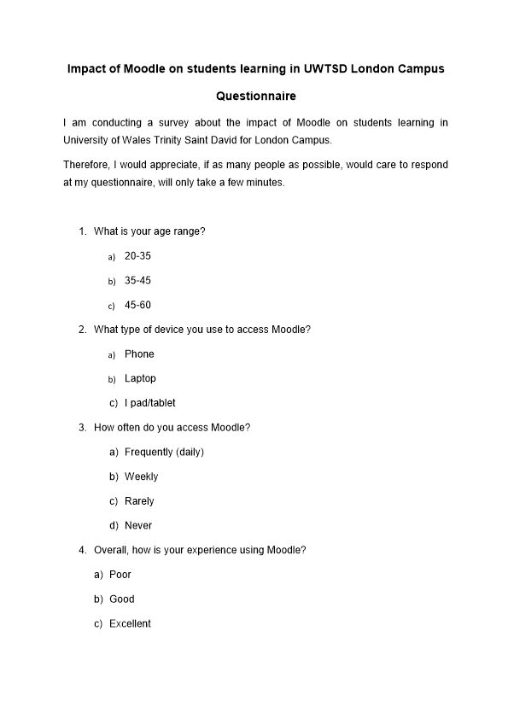
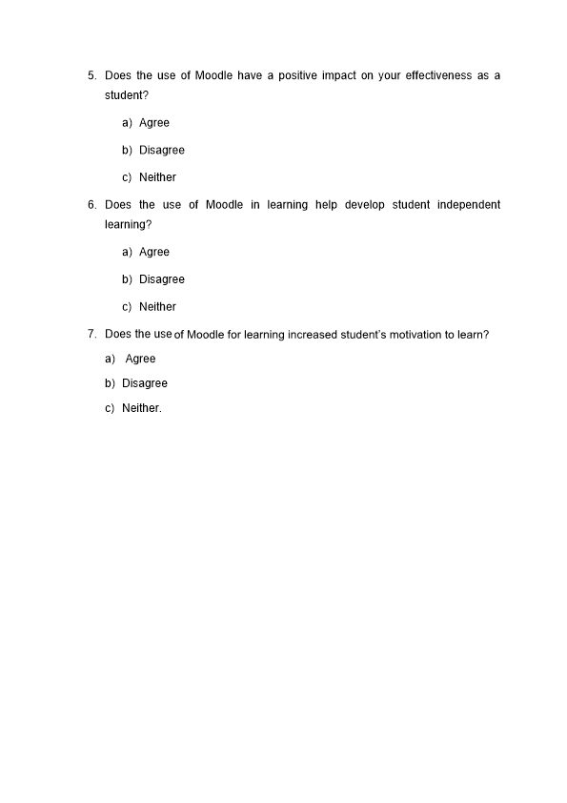
Appendix 2
Range of age | Responses
20-35 | 5
35-45 | 3
45-60 | 4
 | 12

What type of device do you use to access Moodle? |  |  |  | Responses
Phone |  |  |  | 5
Laptop |  |  |  | 7
ipad/tablet |  |  |  | 0
 |  |  |  | 12
How often do you access Moodle? |  |  |  |  | Responses
Frequently |  |  |  |  | 5
weekly |  |  |  |  | 6
Rarely |  |  |  |  | 1
 |  |  |  |  | 12
Overall, how is your experience using Moodle? |  |  |  |  | Responses
Poor |  |  |  |  | 0
Good |  |  |  |  | 12
Excellent |  |  |  |  | 0
 |  |  |  |  | 12
Does the use of Moodle have a positive impact on your effectiveness as a student? |  |  | Responses
Agree |  |  | 10
Disagree |  |  | 0
Neither |  |  | 2
 |  |  | 12
 | Does the use of Moodle in learning help develop student independent learning? | Responses
 | Agree | 8
 | Disagree | 0
 | Neither | 4
Does the use of Moodle for learning help increase student's motivation to learn? | Responses
Agree | 8
Disagree | 0
Neither | 4
 | 12

